BSc Computing - Introduction to Web and Database Concepts
By Sharla Passariello (1903420)

Contents
Introduction 3
Requirements 3
Implementation 4
Layout and Content 4
Colour Scheme and Font 6
Search Engine Optimisation 6
Completed Screenshots 7
Code Validation 9
Page Validation – Home 9
Validation Page – About Us 10
Validation Page – Products 11
Validation Page – Contact Us 12
Validation Page – Coming Soon 13
Evaluation 14
Usefulness 14
Search Engine Optimisation 14
Accessibility 15
References 16
Appendices 17

Introduction
In January 2021, it was estimated by the Hosting Tribunal that there were roughly 2 billion websites currently on the internet, with 400 million of those websites active. These figures are continuously growing [1]. Through 2020, there were 835,494 new UK businesses registered [2]. With more people opening their own businesses and an ever-growing number of websites being created, a company’s web-presence is an important tool for building their brand and accountability. This report will detail the design and implementation of a website for a company called Pocket Potions. The company was created by Zoe Hooper, sister of the author, during the coronavirus pandemic. As well as detailing the design and implementation of the website, an evaluation will be provided to discuss the usefulness of the website, the Search Engine Optimisation techniques applied, and the accessibility of the website.

Requirements
During the coronavirus pandemic, the author’s sister Zoe Hooper created a new business called Pocket Potions. The goal of Pocket Potions is to provide pocket-sized notecards for GCSE and A Level chemistry revision, with each set covering an exam topic of the subject.
Although Pocket Potions has a social media presence, the company does not currently have its own website. A request was made to Zoe Hooper to see if Zoe would allow a website to be designed for Pocket Potions. Although the website will not be hosted on a live webserver, it was proposed that it could be used as a concept design for the business in the future.
To gain requirements for the design of the website, Zoe Hooper was asked for her desired outcome, including content she would like to display, colour themes, and search engine optimisation needs.
As per Appendix 1, Pocket Potions provided permission to use their images and requested the following requirements for the website design:
- The website must have a sleek and simple design
- The website must have a colour scheme consisting of grey, white, and black to match the Pocket Potions logo
- The website must display the products available
- The website must display and link to the Pocket Potions Facebook and Instagram pages so that users can contact the company
- The website would like to be brought up as a search engine result with the terms “GCSE revision notecards” and “A Level Revision Notecards”

Implementation
The following areas were created to meet the requested requirements of the website design.

Layout and Content
The first requirement stated that the website must have a sleek and simple design. As Pocket Potions is new, the content is minimal whilst the business grows and continues to develop products. Based on the requirement and minimal content available, the Z-Layout design was chosen as the basis of the layout. This was modified slightly to have the main logo central with the page title above the navigation bar. The navigation bar was placed horizontally to align with the basis of the Z-layout. This will direct users to the navigation bar where the main action buttons are as Western readers eye-movement will likely move top to bottom, left to right, in the same way that they would read a book [3].
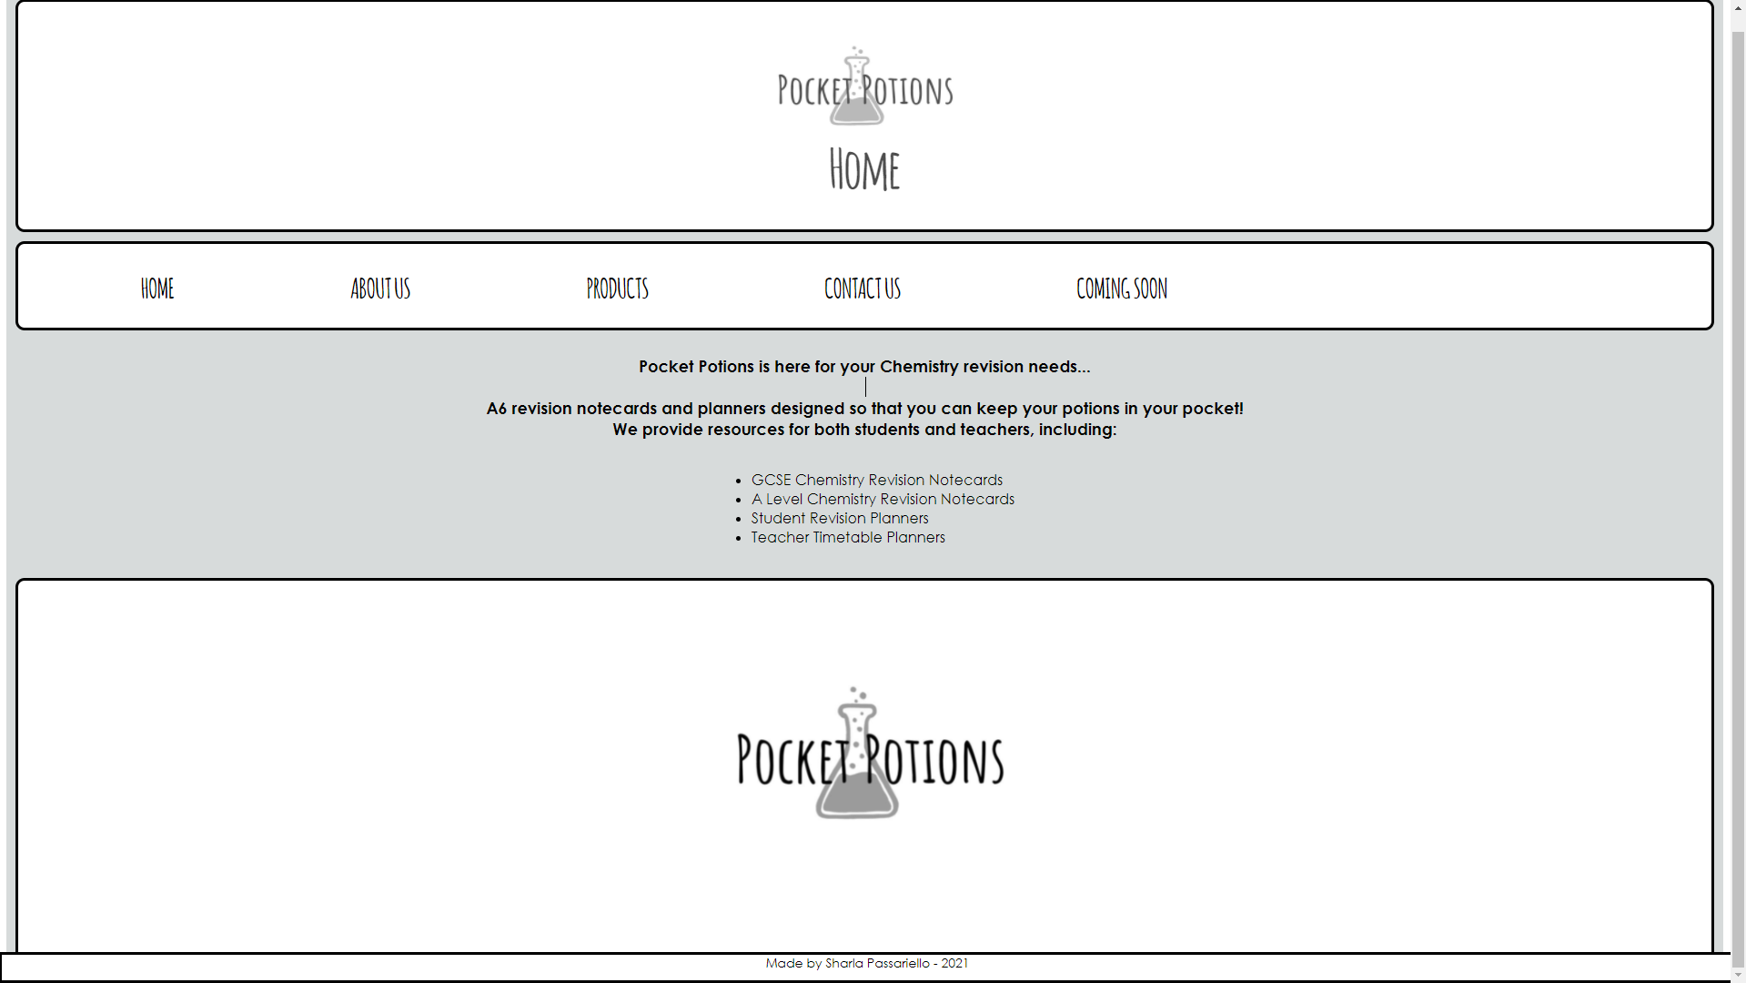

The website grid was set to one column and three rows to keep the layout simple and decluttered. This allows the user to focus on the main content of the page without being drawn to look at menus or text on the sides as one might see with an F-Layout design. The footer is fixed to the bottom of the page and remains displayed while the user scrolls through the content.
Content requirements included that the products must be displayed within the website and that the social media accounts should also be available to access. To achieve the display of products, a Products page was created where the Pocket Potions online shop was embedded into the webpage. This allows any new products that are added or removed in the Pocket Potions online shop to automatically show up in this Pocket Potions website. This removes the need for the business to manually add or remove any new product on this website to align with their online shop. Users are unable to add items to their cart within this website as the embedded page does not currently allow for the purchase of products to be completed through page embedding. For the user to complete the transaction from this website, they must open the link of the product in a new window.
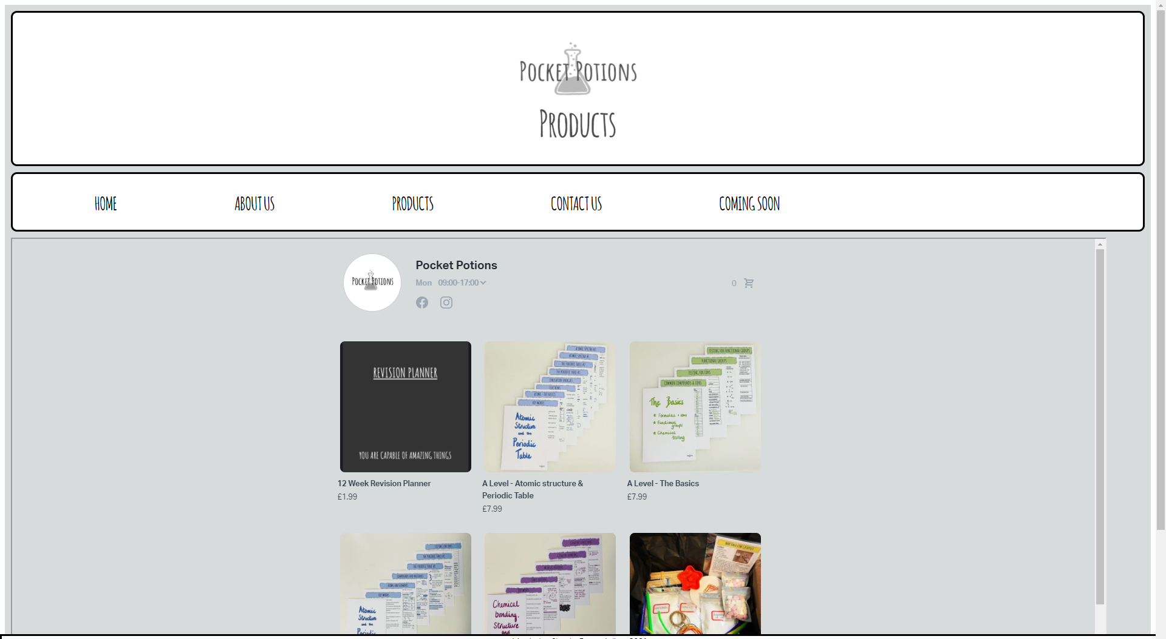

A Contact Us page was added to include the social media links for users to contact Pocket Potions. The contact page was also designed with a ‘Contact Us’ form. As the website is not currently connected to a live webserver or database, the form entries do not currently action a form to be sent anywhere. The social media links direct users to both the Pocket Potions Facebook page and Instagram page where Pocket Potions can be contacted.
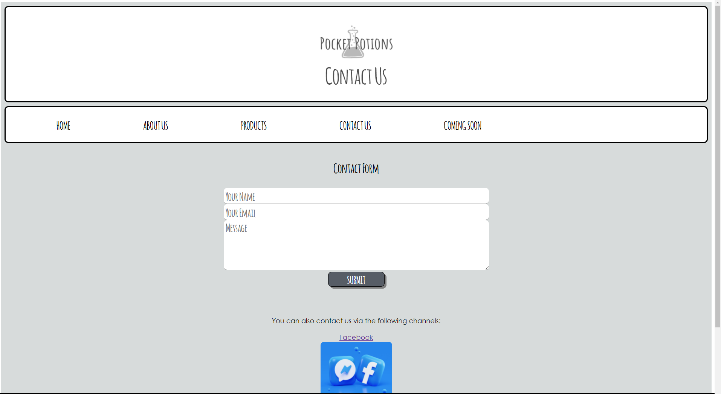

Additionally, an About Us and Coming Soon page was created for users to see how Pocket Potions was created and what future products are on the way.

Colour Scheme and Font
As requested in the requirements the colour scheme of grey, white and black was implemented. This matches with the Pocket Potions logo and provides consistency of the design to the current business aesthetics. To match the font of the Pocket Potions logo and cards, the font ‘Amatic’ was used for the headings and page titles to ensure that the font style was also encompassed within the webpage as well as the colour scheme.

Search Engine Optimisation
Search Engine Optimisation (SEO) is the process of strategies that can improve a website’s traffic through non-paid or “organic” search engine results. The higher a website appears on a search engine, the more visitors the website is likely to receive [4].
Although paid advertisements and social media will draw website traffic, organic search engine results still account for bringing the most traffic to a website. The search engine performs three primary functions: crawling, indexing, and ranking.
The crawling function is when a search engine sends out robots to find new and updated content, regardless of the format. These webpages, and links that are connected to the webpages are then added to a database of the discovered URLs which get retrieved in the future when a searcher is looking for content that may match with that on the gathered URLs. The indexing function refers to storing and processing of the content they have discovered in the crawling function. The ranking function is then started when a search is performed in the engine, the search engine will scour their index/database for the relevant content and orders the content geared towards the searchers query. The higher the ranking, the more relevant the content is believed to be by the search engine.
To meet the requirement provided for Pocket Potions where the website should appear for the terms “GCSE revision notecards” and “A Level revision notecards”, the content of the Pocket Potions website needed to align with these phrases for when search engines crawl and index, thus helping to achieve the goal of the website getting a good ranking when these terms are searched. Although it is important that these terms were included, it was important not to design the website with only the search engines in mind, but to make the webpages first and foremost for the users but with SEO in mind. To achieve this, key words were inserted primarily in the About Us and Coming Soon webpages where the terms could be used fluently in original paragraphs that gave a background to the business and upcoming projects for users, without being primarily SEO based content but still contributing to SEO. As the designed website is not stored on a webserver, the search engines will not crawl, index, and rank the website to test the effectiveness of the SEO. However, relaying the knowledge of how SEO works will be important for helping Pocket Potions to meet their SEO needs in the future.

Completed Screenshots
The following displays screenshots of all pages for the Pocket Potions website. Some screenshots may only display a cropped view of the page content.
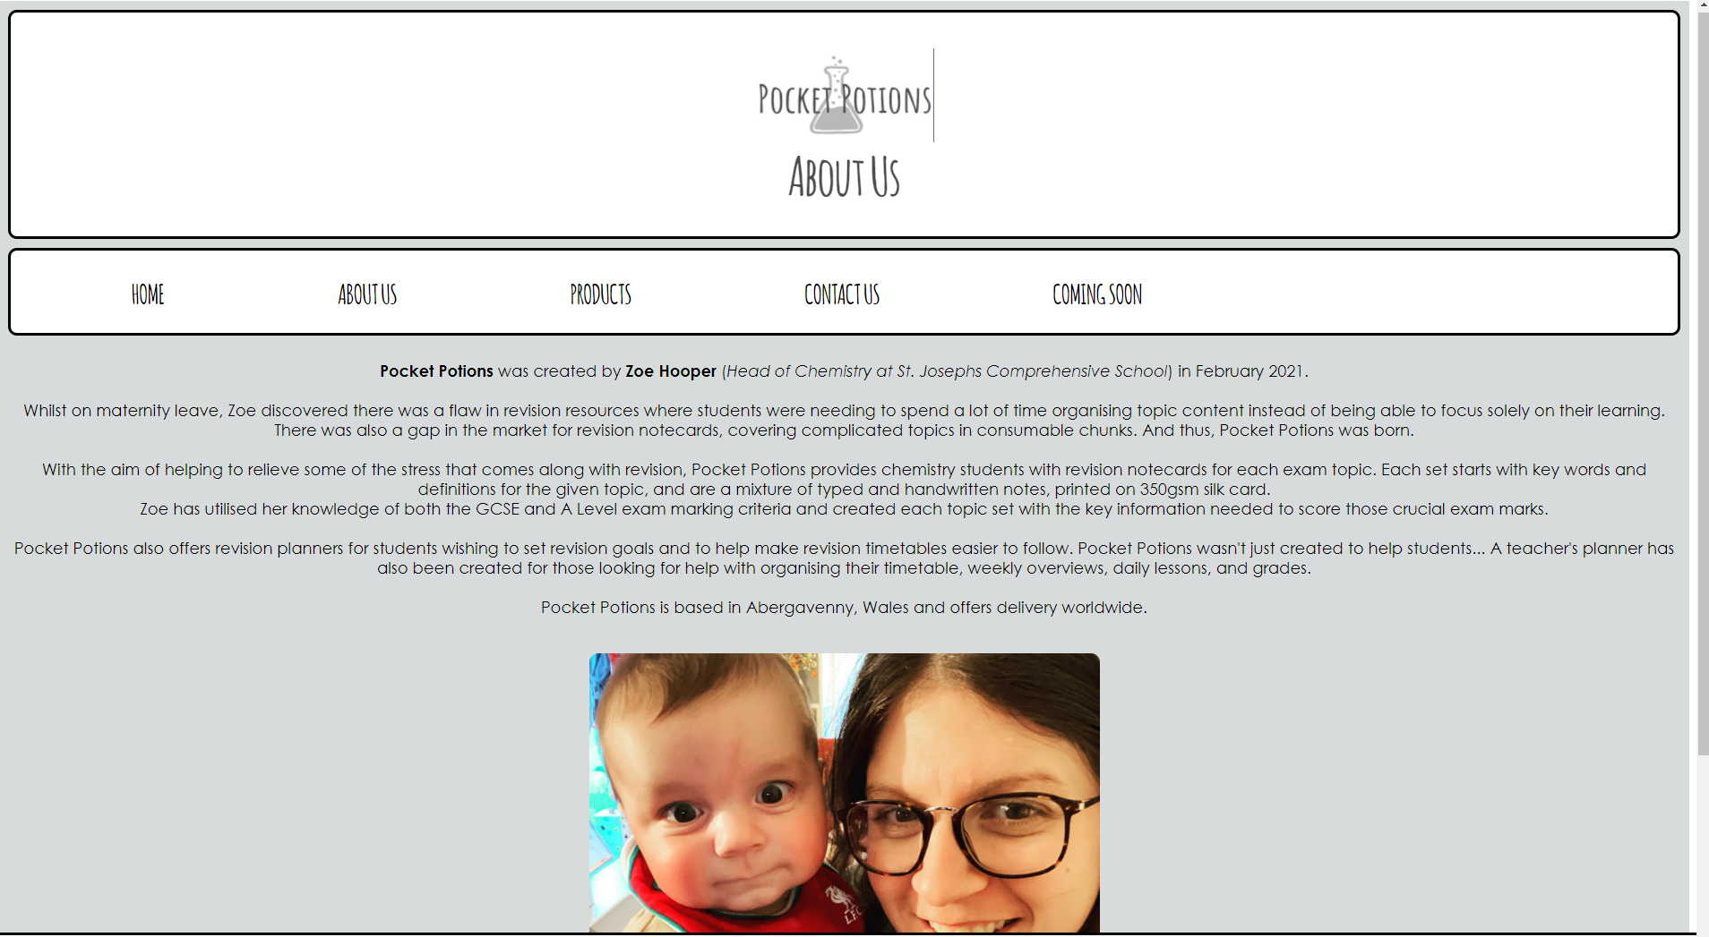
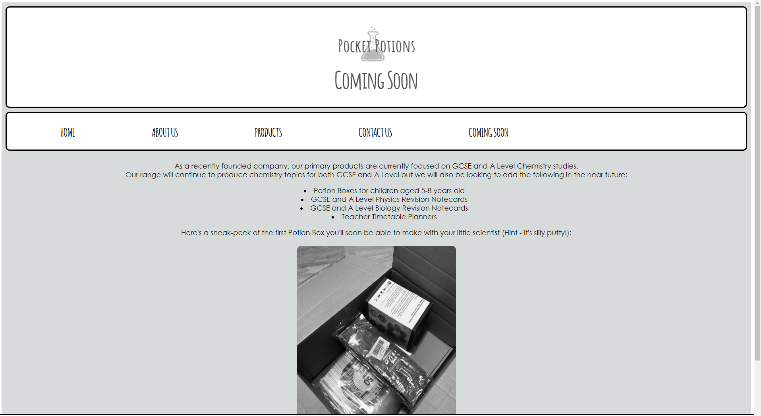

Code Validation
A validation of the HTML and CSS that composes the Pocket Potion website was conducted on all webpages of the site using http://validator.w3.org/ and http://jigsaw.w3.org/css-validator/. The results are displayed below.

Page Validation – Home
No errors were reported during the validation of HTML and CSS. A recommendation was provided to consider adding a lang attribute to the html start tag to declare the language of the document.
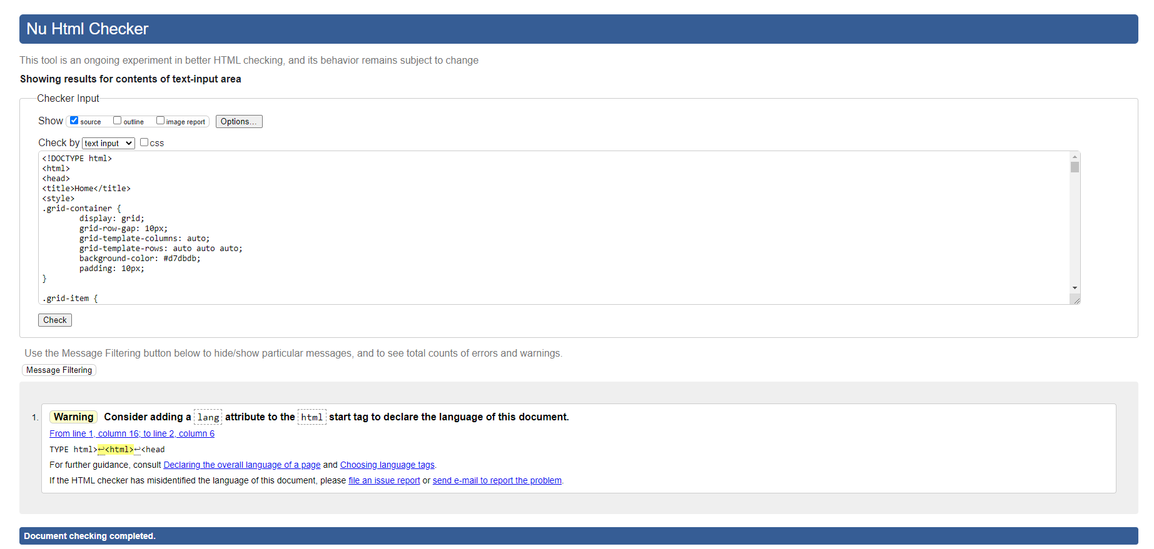
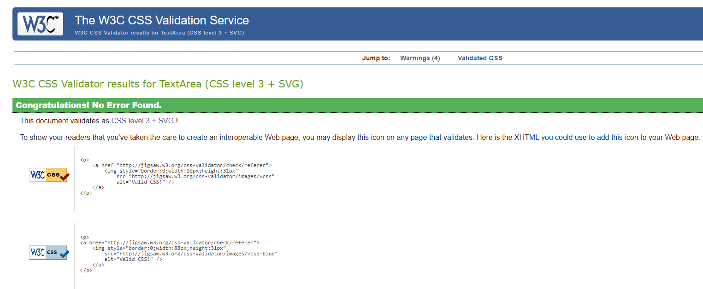

Validation Page – About Us
No errors were reported during the validation of HTML and CSS. A recommendation was provided to consider adding a lang attribute to the html start tag to declare the language of the document.
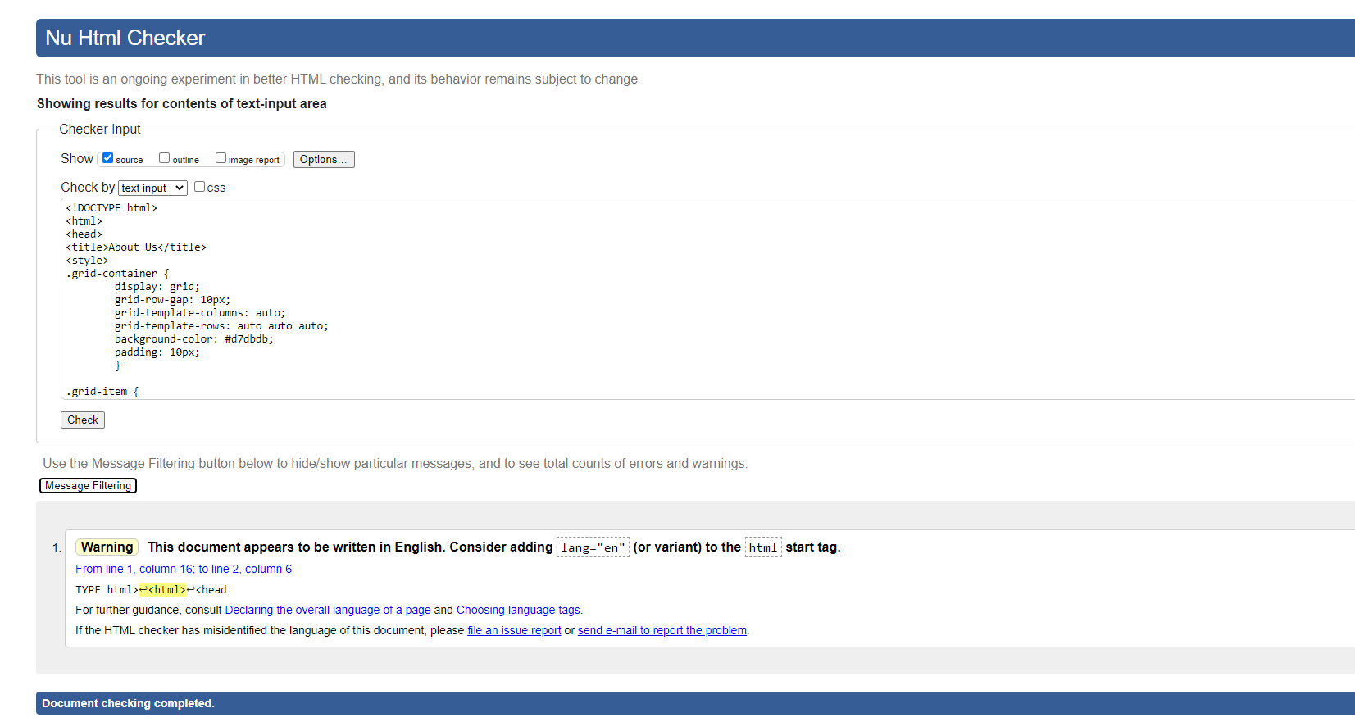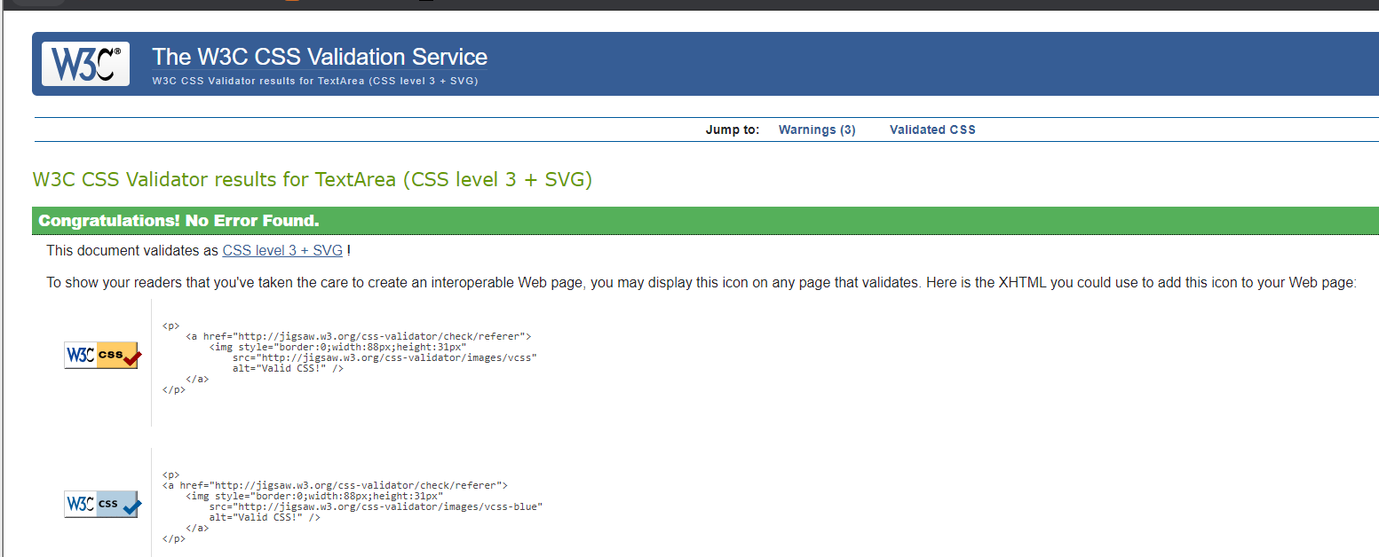

Validation Page – Products
No errors were reported during the validation of HTML and CSS. A recommendation was provided to consider adding a lang attribute to the html start tag to declare the language of the document.
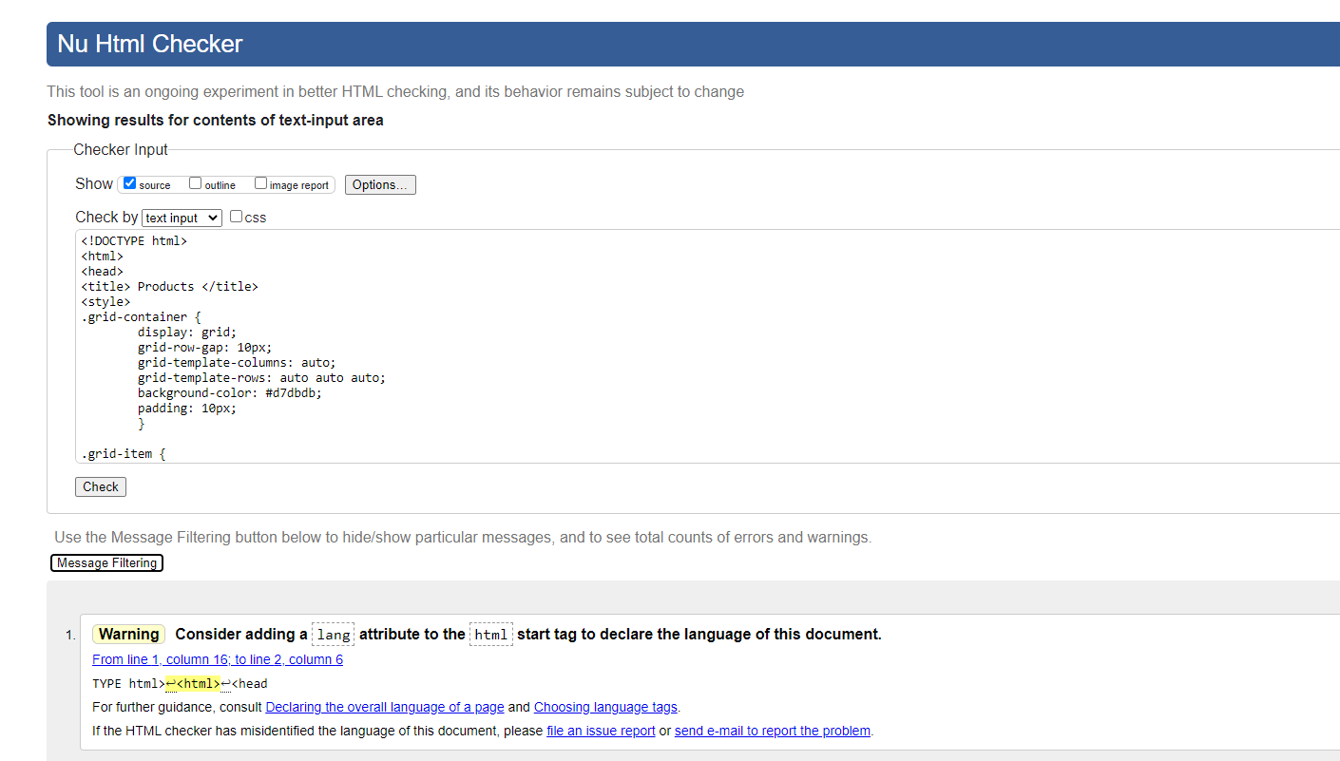
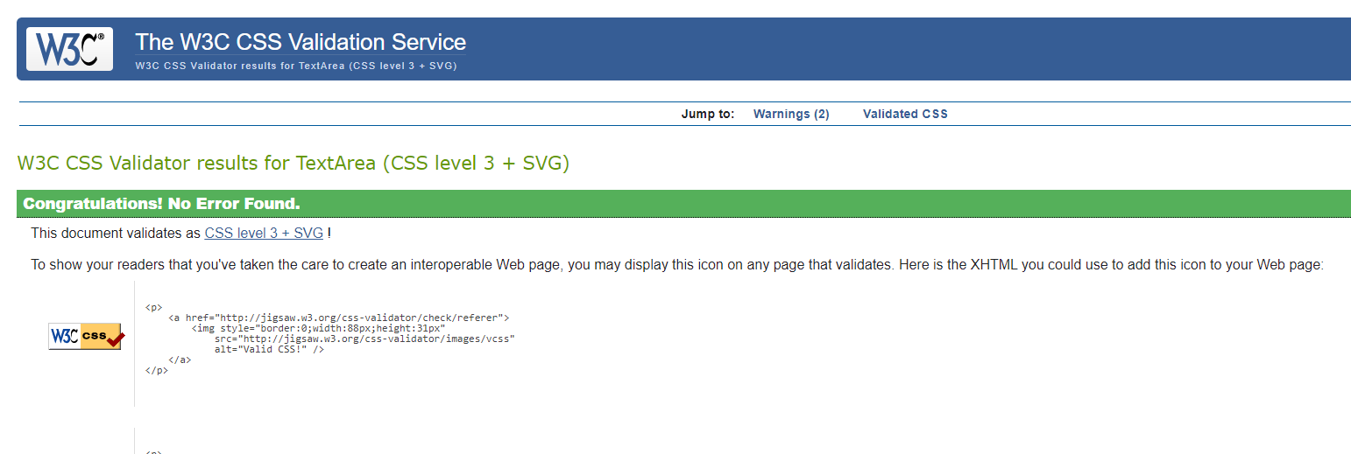

Validation Page – Contact Us
No errors were reported during the validation of HTML and CSS. A recommendation was provided to consider adding a lang attribute to the html start tag to declare the language of the document.

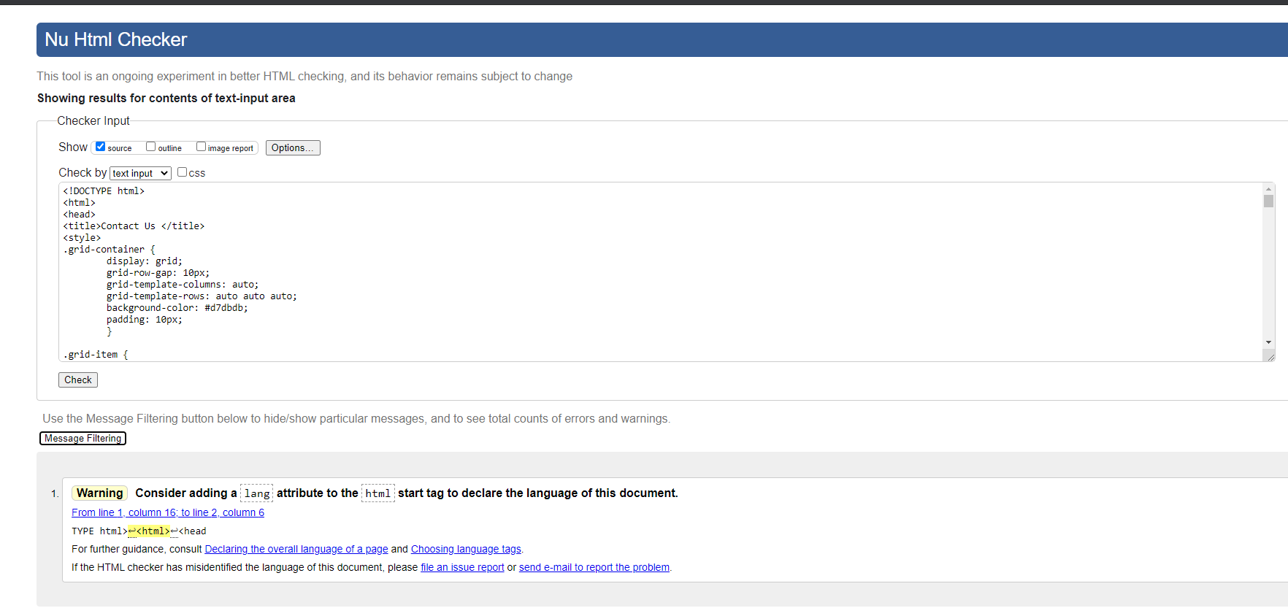
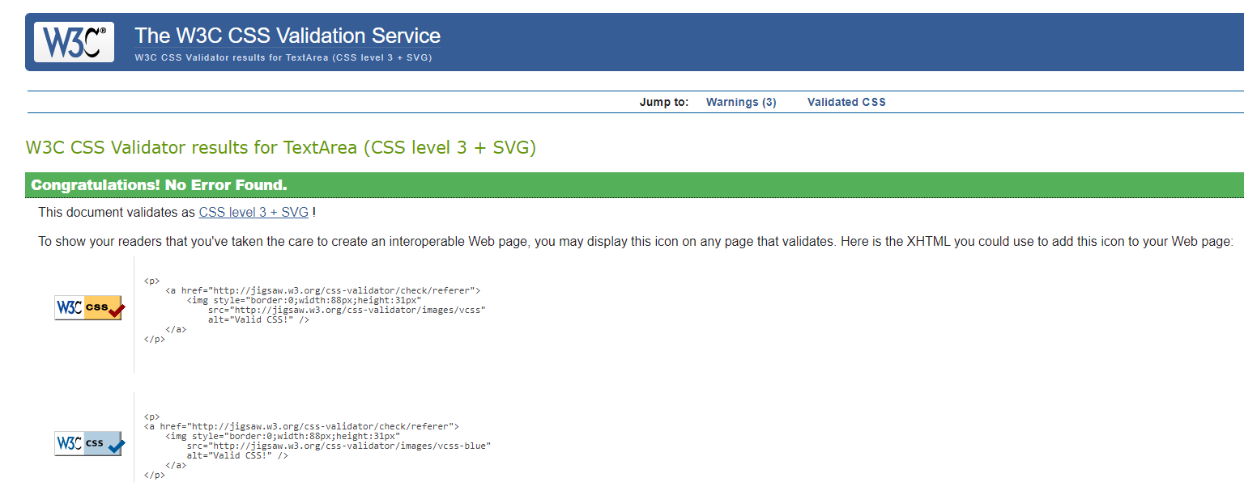

Validation Page – Coming Soon
No errors were reported during the validation of HTML and CSS. A recommendation was provided to consider adding a lang attribute to the html start tag to declare the language of the document.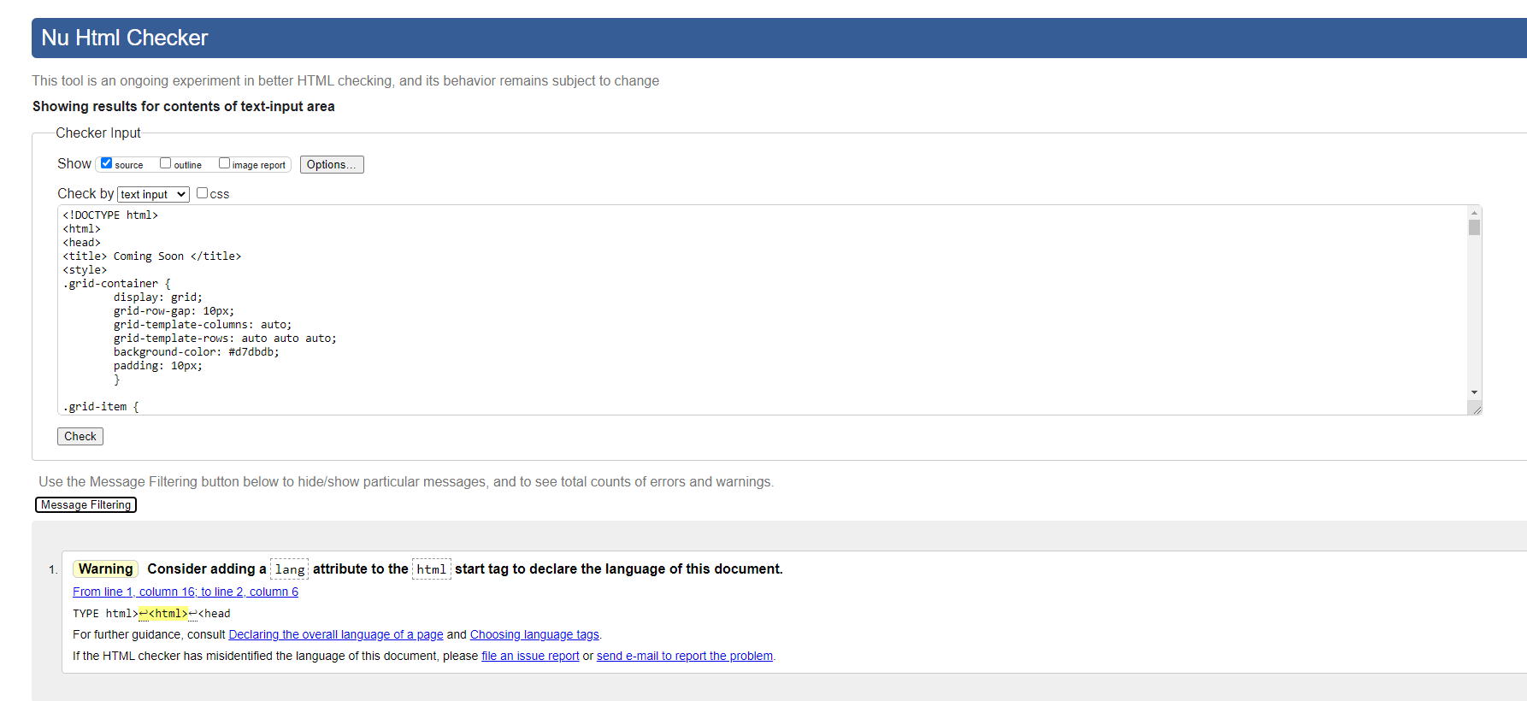
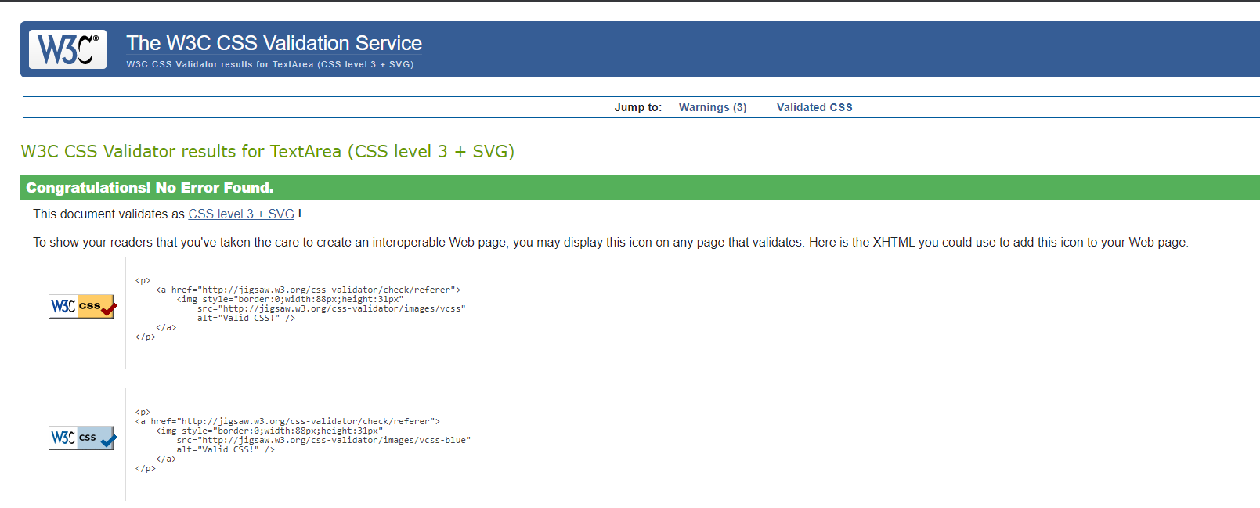

Evaluation
The evaluation of the success of the website will be based on the usefulness, the search engine optimisation, and the accessibility.

Usefulness
The following factors make a website useful to visitors: a simple interface, useable and searchable, a simple layout, well organised categories, and a quality review.
A simple interface and simple layout may seem similar as they intertwine. It is important for the interface to be user friendly; which can be achieved by producing a simple layout. For the website to be useable and searchable, it must be attractive, visually effective and laid out so that it is easily found and used by a visitor. Organising categories well make products easy to find and the website easy to understand. A quality review can be achieved from user testing to see if the requirements have been fulfilled. [7]
The Pocket Potions website has been designed with simplicity in mind. Using a Z-layout it has made the minimal content clear and easy to follow with the navigation bar placed horizontally to help categorise the areas of the website that will be of interest to users. Users are easily directed to the products page where all products are displayed as set in the Pocket Potions online shop. A user review is needed to confirm that the website has met the satisfaction of the requirements set by Zoe Hooper, and to obtain any future recommendations for improvements.

Search Engine Optimisation
As detailed in the Implementation section of this report, search engine optimisation is the strategy of improving a website’s traffic through non-paid or “organic” search engine results. The higher a website appears on a search engine, the more visitors the website is likely to receive.
As described in “Estimating Google's search engine ranking function from a search engine optimisation perspective”, Google is said to include over 200 factors in its ranking algorithm, of which is a sealed company secret that no SEO firm or industry professionals know. [8] As there is no concrete model to manipulate the SEO of a website to achieve the highest organic result, the best model focuses on user needs that can then be integrated with SEO objectives. This can also provide good usability with positive SEO consequences.
The Pocket Potions website was designed to become an organic search result for “GCSE revision notecards” and “A Level revision notecards”. To keep the website user friendly, these terms were implemented into sections that would seem natural to the user and service their needs, but would still capture keywords for SEO. This was done by creating an About Us webpage where original text with keywords could describe the history of Pocket Potions whilst simultaneously displaying keywords that search engines could index and rank. A Coming Soon page was also created to layout future projects and further enhance SEO objectives.
In 5 pages of the website, the following terms were used to service the user while contributing to SEO:
GCSE – 6 times
A Level – 6 times
Chemistry – 7 times
Revision – 14 times
Notecards – 8 times
Additionally, there are two linked social media accounts which further the content picked up from the search engine indexing as well as an embedded store which contains the details of the products available.

Accessibility
There are a set of internationally recognised Web Content Accessibility Guidelines, known as WCAG 2.1, for improving web accessibility to users. These guidelines emphasise the need to think about the different ways users may need to interact with content based on the following four principles: perceivable, operable, understandable, and robustness. [9]
To be perceivable, the design must ensure users can use and recognise your service with their available senses. In evaluating the Pocket Potions website for perceivability, the content was structured in a logical and easy to read way. The text colours display clearly against the backgrounds and the features can be used when text size is increased to 200%. Pocket Potions does not display video or audio files. However, as images are displayed an improvement could be made to add in text alternatives for this non-text content.
To be operable, the design must have the ability for users to find and use the content however they choose to use it such as using only a keyboard. In evaluating the Pocket Potions website for operability, the content features were accessible and functional using either a mouse or a keyboard. Titles and links are descriptive so users can easily locate content they may be looking for. Improvements that could be made for the operability of Pocket Potions include adding a voice command feature, improving the colour when a link is hovered over for further clarity, and to allow users to create shortcut keys.
To be understandable, the design should communicate the content and purpose of the service clearly. In evaluating the Pocket Potions website for understanding, the content used plain English however it did not always contain short sentences. The features and the look of the website are consistent throughout all webpages. The form fields have visible and meaningful labels to indicate to users what each field is for and a validation on the contact form is present to help users understand errors when filling out the contact form fields.
To be robust, the design should allow the content to be displayed across a variety of anticipated web browsers and technologies. Pocket Potions currently displays as expected across Google Chrome, Internet Explorer, and Microsoft edge.
Overall, the accessibility is at a good standard for the Pocket Potions website, but additional improvements could be made to further meet WCAG 2.1 guidelines.
The Pocket Potions website meets the design requirements provided and displays content in a minimal, user-friendly way.

References

[1] C. Radoslav, "How Many Websites Are There? How Many Are Active in 2021?", HostingTribunal, 2021. [Online]. Available: https://hostingtribunal.com/blog/how-many-websites/#gref. [Accessed: 10- Apr- 2021].
[2] A. Jordan, "Over 835,000 new UK businesses were registered in the last year", Small Business, 2021. [Online]. Available: https://smallbusiness.co.uk/over-835000-new-uk-businesses-were-registered-in-the-last-year-2552211/. [Accessed: 10- Apr- 2021].
[3] B. Jones, "Understanding the Z-Layout in Web Design", Web Design Envato Tuts+, 2021. [Online]. Available: https://webdesign.tutsplus.com/articles/understanding-the-z-layout-in-web-design--webdesign-28. [Accessed: 12- Apr- 2021].
[4] A. Veglis and D. Giomelakis, "Search Engine Optimization", Future Internet, vol. 12, no. 1, p. 6, 2019. Available: 10.3390/fi12010006 [Accessed 12 April 2021].
[5] B. Muller, "SEO 101: What is it, and why is it important? The Beginner's Guide to SEO", Moz, 2021. [Online]. Available: https://moz.com/beginners-guide-to-seo/why-search-engine-marketing-is-necessary. [Accessed: 12- Apr- 2021].
[6] B. Muller, "How Search Engines Work: Crawling, Indexing, and Ranking | Beginner's Guide to SEO", Moz, 2021. [Online]. Available: https://moz.com/beginners-guide-to-seo/how-search-engines-operate. [Accessed: 12- Apr- 2021].
[7] "What Makes A Website Useful to Visitors?", Web Unlimited | Web Design in College Station, 2021. [Online]. Available: https://www.webunlimited.com/what-makes-a-website-useful-to-visitors/. [Accessed: 10- Apr- 2021].
[8] C. Luh, S. Yang and T. Huang, "Estimating Google’s search engine ranking function from a search engine optimization perspective", Online Information Review, vol. 40, no. 2, pp. 239-255, 2016. Available: 10.1108/oir-04-2015-0112.
[9] "Understanding WCAG 2.1", GOV.UK, 2021. [Online]. Available: https://www.gov.uk/service-manual/helping-people-to-use-your-service/understanding-wcag. [Accessed: 12- Apr- 2021].

Appendices

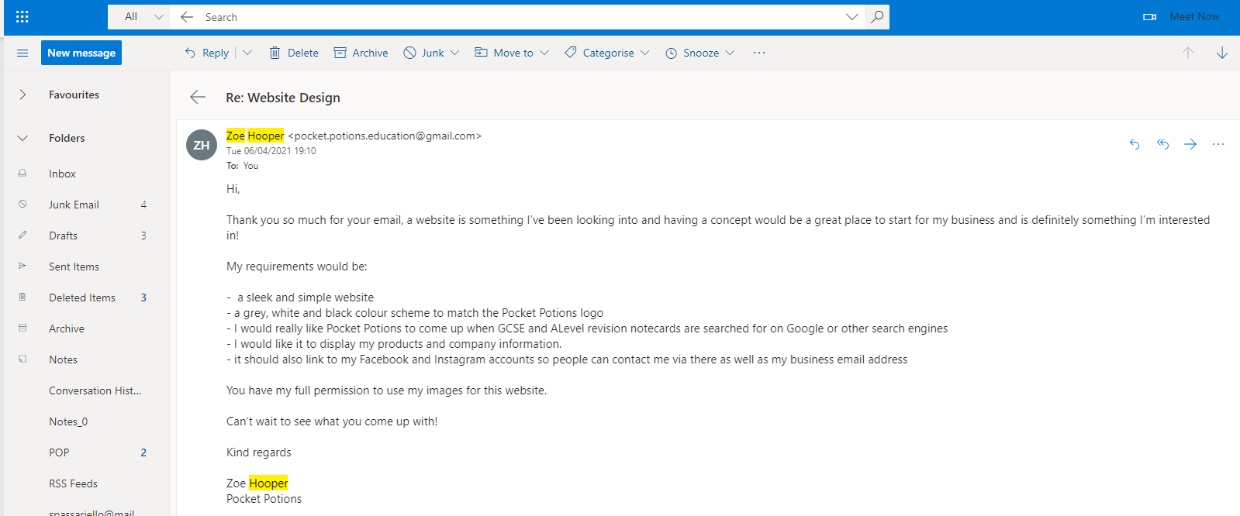
Appendix 1

