Problems at Tesco-Do they still understand and engage with their customers?

TESCO’S ETHICS AND SUSTAINABILITY POLICIES
by Grigorean Alina Mihaela

Understanding and Engaging in Customer Experience
Maria Heffernan
University Trinity Saint David
Swansea
03/07/2020

Executive Summary
Ethics and sustainability are essential in navigating today’s highly competitive global markets. As such, organisations must strive to live within the carrying capacity of their natural and social systems. The arrival of new market entrants coupled with emerging trends such as online shopping, has significantly increased Tesco’s competition and threatened its market share. As such, the company must critically review the relationship with its customer to understand how it can maintain sales, market share, and grow profit margins amidst the increased rivalry. The report examines the various benefits of engaging in ethical trading and building sustainable resources to the customer relationship. How Tesco’s policies in ethics and sustainability have improved will be discussed to examine their impact on customer experience. The recommendations suggested help improve the company’s CRM systems and ensure it remains a recognised market leader in ethic sustainability while maintaining an excellent quality profile.

Executive Summary 2
1.1 Introduction 4
2.0 Findings 4
2.1Development of Tesco 4
2.2 Ethics and Sustainability 4
2.2.1 Animal Rights, Welfare, and Testing 6
2.2.2 Honey Production 7
2.2.3 Cocoa and Palm Oil 8
2.3 Quality 9
2.3.1 Quality Models and Improving Ethical and Sustainable Policies 9
2.3.2 The IDIC Model 9
2.3.3 The Quality Competitive Index (QCI) Model 11
2.3.4 Payne’s Five Forces model 12
3.0 Conclusion 14
4.0 Recommendations 15
Reference List 17

1.1 Introduction
This report examines the possible impact of the company’s quality systems on customer relationships. The first part investigates how the ethics and sustainability policies have improved (or not) the customer experience while the second section demonstrates the variety of quality theories showing how TESCO may improve its ethics and sustainability practices. Finally, the overall impact of these practices on the quality of CRM in TESCO will be reviewed, and recommendations suggested based on development points highlighted. The report is significant because it provides evidence showing that the company should move towards becoming a recognised market leader in ethic sustainability while maintaining a excellent quality profile rather than adapting ALDI and LIDL’ strategies and abandoning its focus on societal interests in favour of profit and survival.

2.0 Findings

2.1 Development of Tesco

When TESCO was a stall in East London, the founder’s mission was to avail affordable food in the reach of everybody (Tesco.com 25/1/19). It is until 1980 that TESCO transited to its second stage as a business whose aim was to offer affordability while encouraging its consumers to practice healthy’ eating. This was its societal obligation/ The launch of ‘Every Little Helps’ increased TESCO customers by 1.3 million ((Hassan and Parves,2013). Also, the introduction of One in Front’ initiative “helped TESCO to reduce congestion. The 2010 strategy of ‘Putting the customer at the heart of everything’ saw the supermarket role out new programs and invest in local communities ‘for free fruit instore for children in an aim to change eating habits and eight fresh food and to support healthy eating at low prices. The ‘launched of Jacks sought to bring a message that the supermarket aims at bringing ‘great tasting food at the lowest possible prices.

2.2 Ethics and Sustainability
Over the years, TESCO has attempted to increase its profitability by underpinning its role within the society as a socially responsible supermarket. In the initial years of inception, Tesco’s mission statement aimed at putting “affordable food in the reach of everybody” (Tesco, 2020). However, in the 1980’s this changed, and the business entered a new vision stage focused on providing not only affordability but also healthy and high-quality products. Tesco’s move towards being a socially responsible supermarket towards its customers and environment was a new development for supermarkets and played an essential role in acquiring new customers and gaining a strategic market position. Young, Hwang, McDonald, and Oates (2010) define ethical sustainability is an organisation’s ability to avoid the depletion of natural resources to maintain an ecological balance. Specifically, ethics are defined as the moral principles governing an origination’s behaviour in the way it conducts business (Blowfield, 2003). While Tesco has always been identified as being engaged in ethics and sustainability, their policies in these areas have significantly improved the overall customer experience at TESCO. For example, the company’s current code of ethics requires it to collaborate with the WorldWide Fund for Nature (WWF) to create a novel metric for helping customers track their overall environmental impact of some of its popular products (George, 2020). By positioning itself as an environmentally responsible supermarket, it can retain eco-conscious consumers. Thus, TESCO can survive the ever-increasing competition and increase its profitability by reinforcing its role within the society as a socially responsible supermarket.
As the U.K grocery market becomes increasingly competitive in the past decades, Tesco maintains the leading market share due to its augmented focus on ethical and sustainable consumption policies. Figure 1 shows that Supermarket share between 2015 and 2020 with Tesco marinating a healthy lead. Evidence gathered by Wuaglobal (2018) shows how effective the company’s policies with regards to ethical and sustainable consumption policies have improved its customer experience. Tesco won the online customer experience benchmark study conducted in the U.K. Customers noted that based on their first impressions, Tesco seemed to care more about their customer journey and made them feel responsible for their environment. Ultimately, they felt more compiled to shop at Tesco than any other place. Wuaglobal (2018) was able to determine customer preference, experience, and consumption behaviours as some of the critical factors that influenced their decision-making process in the U.K groceries market. The evidence shows once again that improved ethics and sustainability are an absolute necessity and have been essential in helping Tesco beat the competition.
Figure 1. U. K’s market share from 2015 to 2020
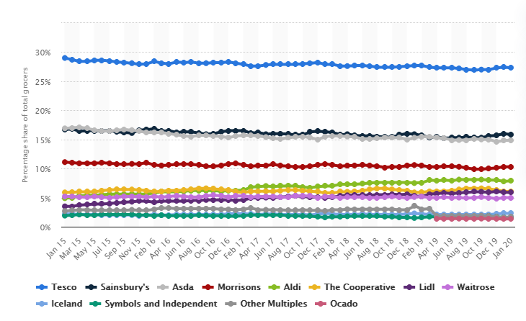
Source: Statista, 2020
Today, U.K consumers are increasingly demanding ethical and sustainable foods from supermarkets. As such, almost all supermarkets have attempted to engage their customers in these areas. With regards to ethical and sustainable policies, supermarket’s scores and ranking are mainly focused on animal rights and welfare, honey production, and cocoa and palm oil production.

2.2.1 Animal Rights, Welfare, and Testing
Major supermarkets have successfully engaged their customers in the areas of ethics and sustainability some better than Tesco. However, despite these supermarkets cashing in on the growth in veganism, they have failed to ingrain animal rights and welfare values in their supply chains. Except for Tesco and vegan companies such as Unicorn, Infinity, and Suma, other significant outlets are ranked low in the Animal Rights and Welfare dimension (Ethical Consumer, 2020). Tunçel, Kavak, and Karademır (2017) examine the concepts of consumer social responsibility and ethics using Hofstede’s cultural dimensions theory. The study results suggest that Hofstede’s model influences the interchangeability of consumer social responsibility (CSR) activities. As such, the overall effect of cultural dimensions on CSR and consumer ethics varies for different countries which suggest that the success met in one market may not be replicated in another concerning engaging their customers in the areas of ethics and sustainability. Thus, while supermarkets across the U.K have successfully engaged their customers in the areas of ethics and sustainability, they may not enjoy the same level of success in other, markets as was evidenced by Tesco’s failure in generating a substantial market share in the U.S. The company also engages in Carroll's CSR Pyramid. This framework highlights how and why organisations should meet their social responsibilities (Visser, 2006). The company engages with Carroll's four-part definitional framework because its CSR seeks to meet the economic, legal, ethical, as well as the discretionary (philanthropic) expectations that the society has about organisations.

2.2.2 Honey Production
Ethical and sustainable policies in the production and consumption of honey argue that the regular removal of honey from hives contributes to declining honey bee populations, particularly when the product is derived from a business driven by profit. Some supermarkets have engaged their customers in the areas of ethics and sustainability through increased emphasis on bee welfare. In this dimension, three companies appear to have better and more comprehensive bee welfare policies than Tesco which include Wainwrights, Equal Exchange, Hilltop Honey, and Littleover Apiaries (Clayton, 2020). Young, Hwang, McDonald, and Oates (2010) argue that the rise in ethical consumerism across the world makes it essential for supermarkets to strategically position themselves as promoters of ethically produced products that support local and small scale farmers and manufacturers. As a result, supermarkets are engaging their customers in the areas of ethics and sustainability by ensuring their honey suppliers are conscious about the overall welfare of bees.

2.2.3 Cocoa and Palm Oil
Cocoa and palm oil provide supermarkets with unique opportunities to engage their customers in the areas of ethics and sustainability. Ingram et al. (2018) argue that cotton is problematic produce due to issues related to forced labour, high chemical use, and most farms growing genetically modified cotton. As such, the supermarkets that result to selling their own-branded cotton products are poorly better rated, especially if they lack adequate policies in the areas of workers’ rights, pollution, and controversial technologies (Blowfield, 2013). The top three companies that have set specific targets for sourcing sustainable cotton but have not yet achieved them include Tesco, Sainsbury, and Waitrose. Palm oil is equally controversial and is found in over 50 percent of supermarket products, from cleaners to food (Disdier, Marette, and Millet, 2013). The product is perceived to be one of the confronting factors to deforestation and land grabbing issues, especially in developing countries. Moreover, it negatively impacts local communities and damages biodiversity at a global scale (Bateman et al., 2010 and Pulker, Trapp, Scott, and Pollard, 2018). Thus, supermarkets that decide to go palm oil free are, thus, better able to gain more traction in response to the industry’s slow uptake of ethical and sustainable practices.
The leading supermarkets that score well in ethical consumer rating for their approach to palm oil are Marks and Spencer, Suma, Waitrose, and Tesco which avoids where possible 50 percent of organic palm oil. The theory of reasoned action can be used to develop a better understanding how the policies implemented by these supermarkets can be used to improve the customer experiences because it centres its analysis on the significance of pre-existing consumer attitudes in their decision-making process (Montano and Kasprzyk, 2015). The theory posits that consumers act on cues based on their intention to achieve a particular outcome. In this perspective, Tesco consumers can be assumed as rational actors who only choose to act in their best interests. Consequently, consumers will not necessarily engage with Tesco’s policies if the action taken does not help them meet their objectives in becoming ethical and sustainable consumers.

2.3 Quality
This section provides a critical evaluation of the various models and theories on quality. The evaluation incorporate examples of how TESCO has engaged in the quality process to measure and improve its CRM system.

2.3.1 Quality Models and Improving Ethical and Sustainable Policies
Tesco utilises total quality management (TQM) to improve the quality of products and services it provides to its customer. The TQM technique is useful as it enables the company to achieve higher customer satisfaction due to the high elimination of defects and waste (Seow, Delaney-Klinger, Boyer, and Frohlich, 2003). At their core, quality models are designed to measure and improve an organisation’s customer relationship management to gain a competitive advantage. There are three main quality models and theories that help in highlighting how TESCO can improve its ethical and sustainable policies to provide its customers with superior value compared with competitive offerings. They include the IDIC model, the QCI model, and the Payne’s Five Forces model.

2.3.2 The IDIC Model
The IDIC model is a generic blueprint that helps organisations in designing and implementing CRM activities in a variety of situations. IDIC stands for the main stages of CRM implementation which include identifying, differentiating, interacting, and customising (Fabio, 2014) (Figure 1). The first stage, identifying, involves isolating the customers, which Tesco can impact with its ethical and sustainable policies by gathering information such as the customer’s name, address, and purchase history at each point of contact (Ahmadi, Osmani, Ibrahim, and Nilashi, 2012). Thus, the supermarket can improve its policies and practices by gathering as much data as possible on each customer to better understand their needs, wants, as well as purchase behaviours.
The second step involves differentiating and segmenting customers based on both their current and projected lifetime value. However, Tesco must take into account the fact that not all customers will share the same value to ethical and sustainable policies. Nonetheless, by differentiating its customers based on their perceived value to the company, Tesco will be able to prioritise them. Murray, Gao, and Kotabe (2011) add that differentiating helps an organisation by focusing its customer relationship efforts on the most valuable consumers thereby tailoring its interactions to best fit each segment for optimal profitability. The third stage involves applying Tesco’s CRM strategies to increase its interactions with customers with regards to ethical and sustainable policies. Ferrell (2004) recommends that once the customers are analysed and categorised appropriately, the firm should immediately start developing customised interactions. For example, for valued customers, Tesco might offer rewards and loyalty benefits to encourage continued spending and retention. The company must also bear in mind that it ought to be learning from every interaction to persistently improve future interactions with its ethical and sustainable policies. Finally, after Tesco has documented its customer interactions, it can then analyse and measure them to develop more customised one-to-one services. Thus, the primary objective is to measure and evacuate all its customers’ needs and expectations to ensure the current strategies and policies can meet them individually.
Figure 2. The IDIC Model
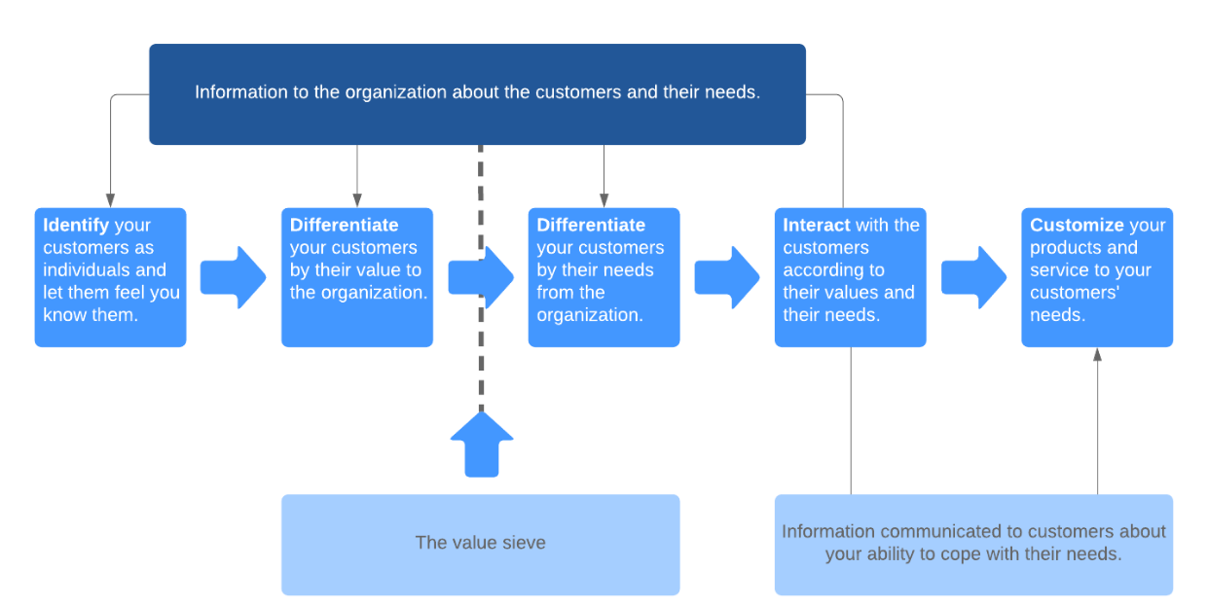
Source: Lucid Chart Content Team, 2019

2.3.3 The Quality Competitive Index (QCI) Model
The QCI model is an effective quality model that can be used to help TESCO improve its ethical and sustainable policies. Described as a customer relationship management model, the QCI focuses on three main activities which include acquisition, retention, and penetration (Feng and Jiadong, 2008). The model is effective because it helps in measuring and improving Tesco’s customer relationship management. Figure 2 shows that the model starts with the customer’s external environment at the top with all the pain points, business goals, among other factors affecting whether clients are ready to interact or buy, which in turn impacts the overall customer experience (Meyer and Schwager, 2007). Therefore, the customer experience affects the customer management activities and proposition, which involves the offer Tesco offers to its clients. From the enlarged version of the inner circle (Fig. 3), most of the activities are focused on acquiring and retaining customers. The QCI model provides an effective measure of quality on Tesco’s ethical policies customer relationship management because it takes into consideration the technology and people involved with keeping its whole system sustainable.
Figure 3. The QCI model
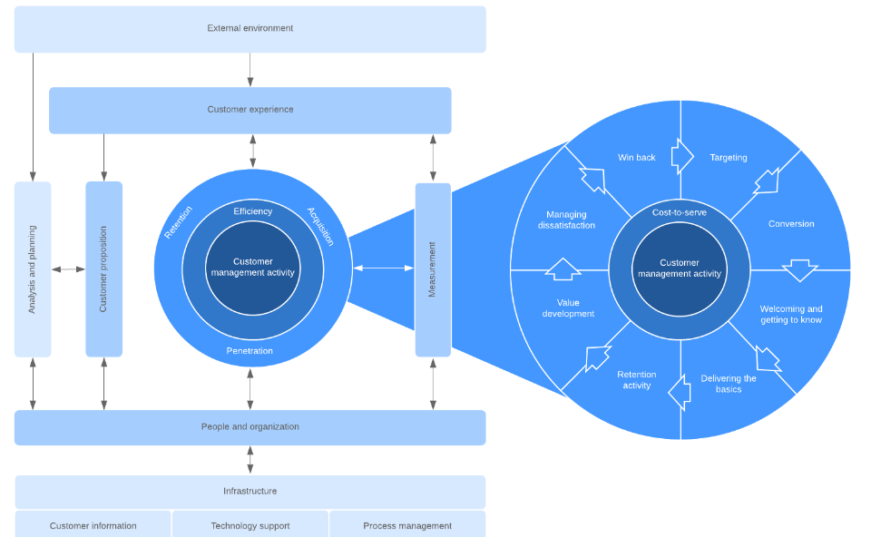
Source: Lucid Chart Content Team, 2019

2.3.4 Payne’s Five Forces model
The Payne’s five forces model is a CRM theory developed by Pennie Frow and Adrian Payne, which emphasizes a cross-functional framework for ensuring effective CRM processes. There are two main components to the model, which include the key elements of CRM implementation and the cross-functional CRM processes (Gebert, Geib, Kolbe, and Brenner, 2003). The model outlines the following five main processes of strategy development, value creation, multichannel integration, information management, and performance assessment. Figure 4 shows that there are four primary elements essential for a successful CRM implementation, which include CRM readiness, change management, project management, and employee management. When implementing its CRM strategy, Tesco should first focus on conducting a CRM readiness evaluation to determine how prepared it is to implement a novel CRM process.
Moreover, since CRM mainly involves cultural and operational shifts, Tesco must invest in CRM change management as well as project management as its new ethical and sustainable policies are introduced and its complexities with regards to CRM initiatives grow. Finally, Tesco’s human resources buy-in is crucial for successful CRM. Thus, the company needs to ensure its employees develop a comprehensive understanding of the various processes and strategies that maximise engagement with its customer-centric culture.
Figure 3. CRM Value Chain Model
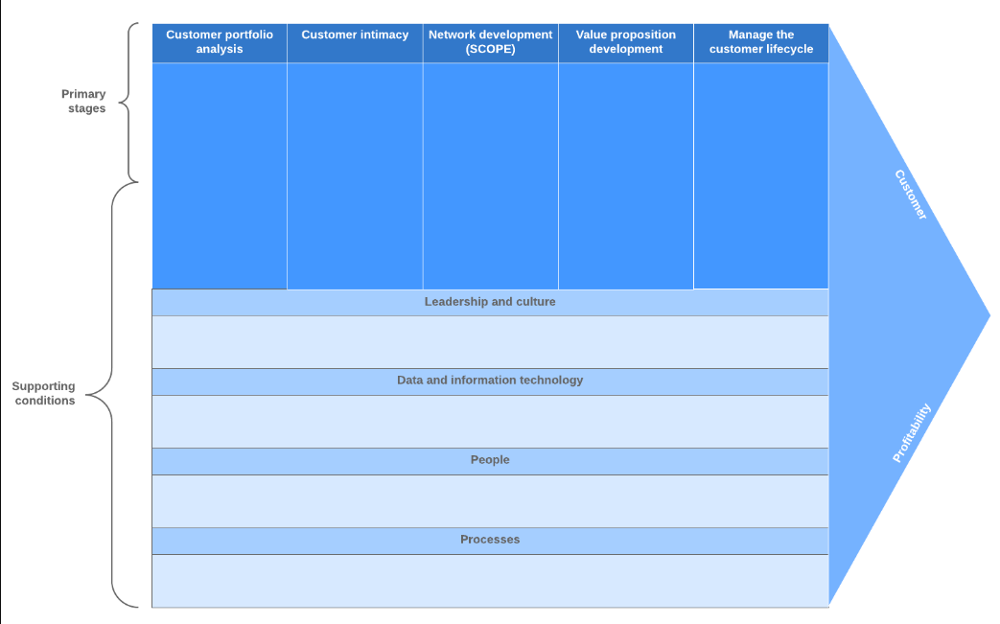Source: Lucid Chart Content Team, 2019
Finally, Tesco’s CRM approach utilises a customer segmentation strategy where the company divides its customer base into small groups that share similar characteristics. For example, younger customers are targeted for new and trendy food items that suit their tastes while the older ones are presented with healthier alternatives. The company also leverages the loyalty ladder to reinforce its CRM approach and understand how its customers gradually move from being a prospect to top advocates who are intensely loyal brand champions (Mollah, 2014). With regards to Tesco’s McKinsey 7S model, there is a direct linkage between seven separate elements of the business which all work towards increasing the overall effectiveness. The Tesco embraces a cost leadership business strategy and its organisational structure is highly hierarchical with numerous layers of management between store sales assistant and the CEO. There are shared values in sustainability and the staff are highly skilled and focused towards achieving the organisational objectives. With regards to systems, the supermarket chain relies on a wide range of systems on a daily basis to sustain its operations.

3.0 Conclusion
This report was requested by Tesco’s major shareholder. At their request, Tesco’s management team will review the benefits of engaging in ethical trading to foster sustainable customer relationships. The report shows that Tesco should not abandon its focus on societal interests in favour of profits and economic survival as is the case with new market entrants such as ALDI and LIDL among others. Therefore, Tesco must continue providing healthy and affordable products and eco-conscious. The company’s increased focus on being socially responsible towards its customers and the environment is a key success factor in acquiring new customers maintaining a strategic market position. While the Tesco has always been identified as being actively engaged in ethics and sustainability, its policies in these areas have significantly improved the overall customer experience a trend which is expected to continue. Thus, TESCO will be able to survive the ever-increasing competition and grow its profitability by reinforcing its role within the society as a socially responsible supermarket. The impact of Tesco’s ethical and sustainability policies on the quality of its CRM is twofold. First, it helps the company maintain a strategic market position amidst the increasing competition and it ensures it taps into the ever-growing consumer segment that is eco-conscious. Over the years, the company has developed several ethical and sustainability policies, which have all been successful in underpinning its contribution to what a socially and ethical retailer should be. However, with the arrival of fierce competitors such as ALDI and LIDL which offer affordability to customers, the competitive forces in Tesco’s business environment are expected to continue increasing. Moreover, new customers are now discovering that there are new and more engaging shopping experiences from online platforms such as Amazon which tend to shift their focus from food to clothing. Some of the implications of these trends for Tesco include reduced market share, profit margins, and lost businesses.

4.0 Recommendations
Some of the major downsides with Tesco’s policies and actions include a complex ethical and sustainability policies, a multifaceted and complicated social responsibility policy, and non-realistic goals. The following recommendations have been suggested to mitigate these downsides improve TESCO’s CRM systems. The recommendations also ensure the company remains a recognised market leader in ethic sustainability while maintaining a good quality profile. First, Tesco should simplify its ethical and sustainability policies so that all stakeholders including the employees and customers clearly understand it. Currently, these policies are included in the company’s Corporate Responsibility commitments where few customers or employees are likely to ever read (Tescoplc, 2016). A simplified ethical and sustainability policy is one that is clear on re-using and recycling practices. Secondly, Tesco should incorporate these policies into Tesco's core purpose and mission statements. The approach is effective because it ensures the company’s mission, values, and vision are all interrelated and operate as a whole in shaping Tesco’s identity as an ethical and socially reasonable entity (Teo, Devadoss, and Pan, 2006). Thirdly, Tesco’s social responsibility policy should be applied throughout the origination. Windsor (2006) notes that it is essential for firms to actively encourage their employees to partake in projects that will support the community in which they operate. Frederiksen (2010) further adds that the policies concerning ethics and corporate social responsibility play a crucial role in increasing customer experiences and engagements. Thus, Tesco must strive to act responsibly and accountably (Adams and Zutshi, 2004). Fourthly the company should establish realistic goals. Kokich (2011) notes that after setting up the mission, the company should start thinking about what it is going to do and the resources available to achieve the set objectives. The company should also organise an in-house social responsibility team. This recommendation is meant to ensure employees dedicate some of their time to crowdsourcing ideas, which helps in figuring out the most appropriate way to have a more positive impact with regards to Tesco’s ethics and sustainability practices. Finally, the company must try to achieve its core values with regards to ethical and sustainable practices by implementing an environmental policy aimed at minimising non-recyclable waste as well as reducing carbon footprint along its supply chain. These recommendations are effective as they also help Tesco engage more with its customers.

Reference List
Adams, C., and Zutshi, A., 2004. Corporate social responsibility: why business should act responsibly and be accountable. Australian accounting review, 14(34)
Adams, C., and Zutshi, A., 2004. Corporate social responsibility: why business should act responsibly and be accountable. Australian accounting review,
Ahmadi, H., Osmani, M., Ibrahim, O., and Nilashi, M., 2012. Customer relationship management model for UTM Alumni Liaison Unit. history, 2(5).
Bateman, I. J., Fisher, B., Fitzherbert, E., Glew, D., and Naidoo, R., 2010. Tigers, markets and palm oil: market potential for conservation. Oryx, 44(2)
Blowfield, M., 2003. Ethical Supply Chains in the Cocoa, Coffee and Tea Industries. Greener Management International, (43).
Clayton, A., 2020. In this guide we investigate, score and rank the ethical and environmental record of 22 supermarkets. [online] Ethical Consumer. Available at:<https://www.ethicalconsumer.org/retailers/shopping-guide/supermarkets> [Accessed 30 May 2020].
Disdier, A. C., Marette, S., and Millet, G., 2013. Are consumers concerned about palm oil? Evidence from a lab experiment. Food Policy, 43
Fabio, N., 2014. Customer Relationship Management and the IDIC Model in retail banking (Doctoral dissertation).
Feng, C., and Jiadong, J. (2008, May). Quality Competitiveness Index (QCI) Model Based on Experts' Rules and ANN. In 2008 International Symposiums on Information Processing IEEE.
Ferrell, O. C. (2004). Business ethics and customer stakeholders. Academy of Management Perspectives, 18(2)
Frederiksen, C. S., 2010. The relation between policies concerning corporate social responsibility (CSR) and philosophical moral theories–an empirical investigation. Journal of Business Ethics, 93(3)
Gebert, H., Geib, M., Kolbe, L., and Brenner, W. (2003). Knowledge‐enabled customer relationship management: integrating customer relationship management and knowledge management concepts. Journal of knowledge management.
George, S. (2020). Tesco to help customers visualise the environmental impact of their shopping. Edie. [online] Available at:<https://www.edie.net/news/7/Tesco-to-help-customers-visualise-the-environmental-impact-of-their-shopping/> [Accessed 30 May 2020].
Ingram, V., van Den Berg, J., van Oorschot, M., Arets, E., and Judge, L., 2018. Governance options to enhance ecosystem services in cocoa, soy, tropical timber and palm oil value chains. Environmental management, 62(1)
Kokich, V. G. (2011). Create realistic objectives. American Journal of Orthodontics and Dentofacial Orthopedics, 139(6), 713. https://www.ajodo.org/article/S0889-5406(11)00389-1/fulltext
Lucid Chart Content Team, 2019. CRM Models That Boost Customer Loyalty. [online] Lucid Chart. Available at:<https://www.lucidchart.com/blog/crm-models> [Accessed 30 May 2020].
Meyer, C., and Schwager, A. (2007). Understanding customer experience. Harvard business review, 85(2)
Mollah, A.S., 2014. The impact of relationship marketing on customer loyalty at Tesco Plc, UK. European Journal of Business and Management, 6(3), http://www.academia.edu/download/34230438/The_Impact_of_Relationship_Marketing_On_Customer_Loyalty_At.pdf
Montano, D. E., and Kasprzyk, D. (2015). Theory of reasoned action, theory of planned behavior, and the integrated behavioral model. Health behavior: Theory, research and practice, 70(4)
Murray, J. Y., Gao, G. Y., and Kotabe, M. (2011). Market orientation and performance of export ventures: the process through marketing capabilities and competitive advantages. Journal of the Academy of Marketing Science, 39(2)
Pulker, C. E., Trapp, G. S., Scott, J. A., and Pollard, C. M., 2018. Global supermarkets’ corporate social responsibility commitments to public health: a content analysis. Globalization and health, 14(121)
Seow, C., Delaney-Klinger, K., Boyer, K.K. and Frohlich, M., 2003. The return of online grocery shopping: a comparative analysis of Webvan and Tesco’s operational methods. The TQM Magazine. https://www.emerald.com/insight/content/doi/10.1108/09544780310469334/full/
Statista, 2020. Market share of grocery stores in Great Britain from January 2015 to January 2020. [online] Statista. Available at:https://www.statista.com/statistics/280208/grocery-market-share-in-the-united-kingdom-uk/> [Accessed 30 May 2020].
Teo, T. S., Devadoss, P., and Pan, S. L., 2006. Towards a holistic perspective of customer relationship management (CRM) implementation: A case study of the Housing and Development Board, Singapore. Decision support systems, 42(3)
Tesco. (2020). About Tesco. [online] Tesco. Available at:<https://www.tesco.com> [Accessed 30 May 2020].
Tescoplc. (2016). An update on our Corporate Responsibility commitments. [online] Tescoplc. Available at:<https://www.tescoplc.com/media/475739/corporate-responsibility-update_nov-2016-final.pdf> [Accessed 30 May 2020].
Tunçel, N., Kavak, B., and Karademır, A. Ç. (2017). Are “Consumer Social Responsibility” and “Consumer Ethics” Concepts Interchangeable? The Effect of Hofstede’s Cultural Dimensions 1. Tüketici ve Tüketim Araştırmaları Dergisi= Journal of Consumer and Consumption Research, 9(1)
Visser, W., 2006. Revisiting Carroll’s CSR. Corporate citizenship in developing countries: New partnership perspectives, http://www.academia.edu/download/32149285/chapter_wvisser_africa_csr_pyramid.pdf
Windsor, D., 2006. Corporate social responsibility: Three key approaches. Journal of management studies, 43(1)
Wuaglobal, 2018. Tesco.com wins digital customer experience benchmark study “Online Groceries” in the UK. [online] Wuaglobal. Available at:<https://www.wuaglobal.com/sparks/tesco-com-wins-digital-customer-experience-benchmark-study-online-groceries/> [Accessed 30 May 2020].
Young, W., Hwang, K., McDonald, S., and Oates, C. J., 2010. Sustainable consumption: green consumer behaviour when purchasing products. Sustainable development, 18(1), pp. 20-31.
Hassan, A., & Parves, M. (2013). A Comparative Case Study Investigating the Adoption of Customer Relationship Management (CRM) The Case of Tesco and Sainsbury's. International Journal of Managing Value and Supply Chains, 4(1),

