Bryoni Keighley
Student Number: 1908160

Information Engineering – Practical test analysis of systems requirements

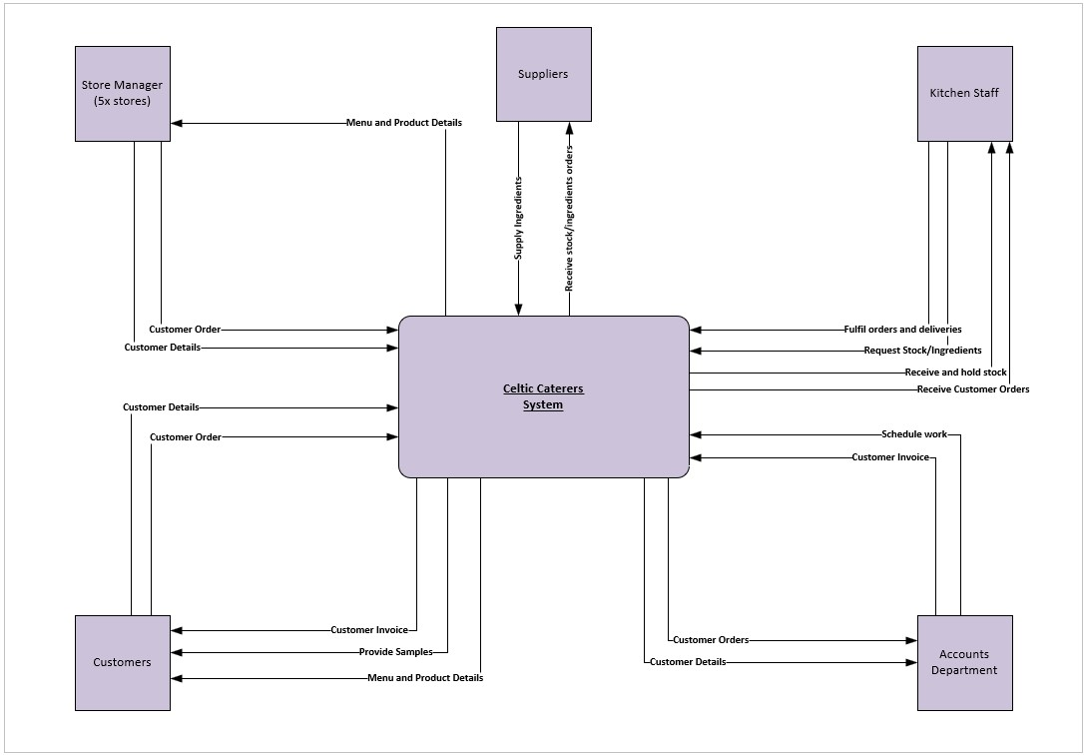
Data Flow Diagram – Context Diagram

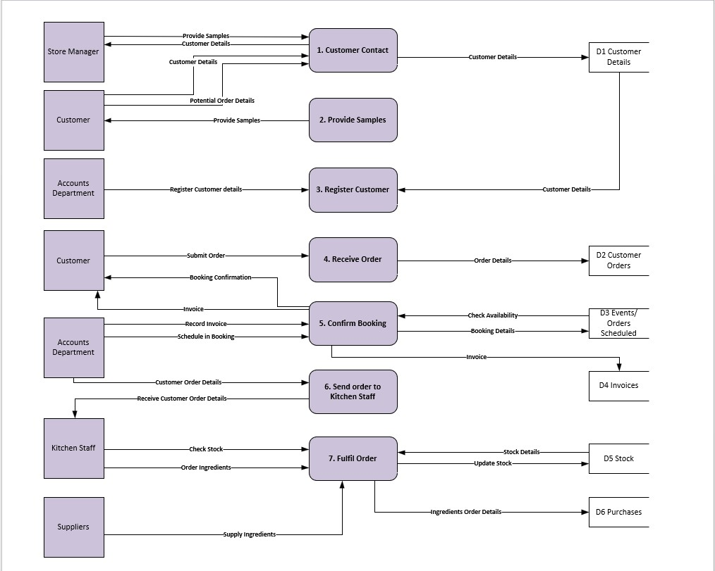
Data Flow Diagram – Level 0

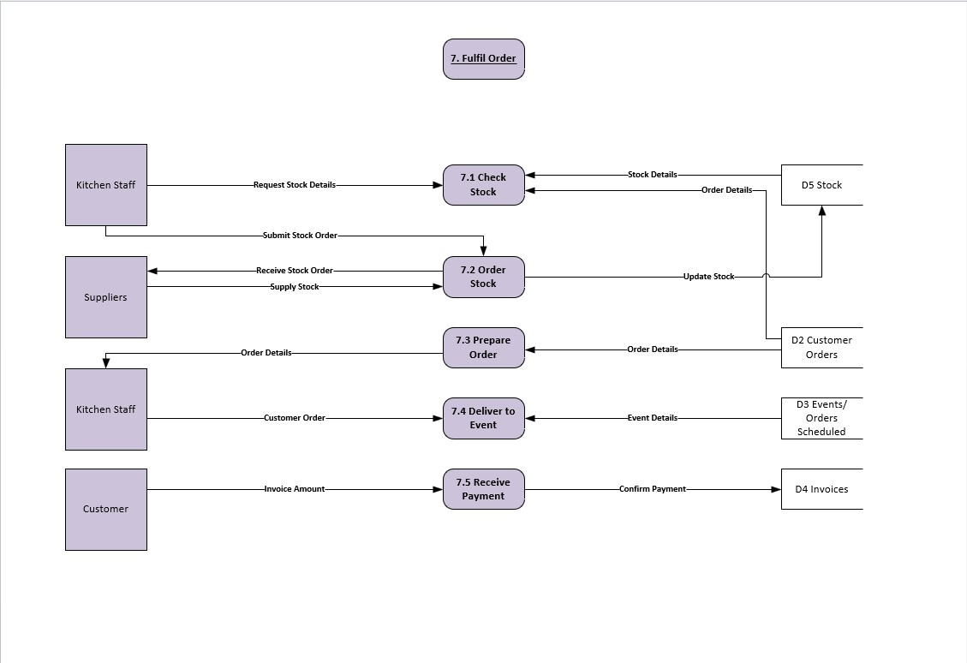
Data Flow Diagram – Level 1

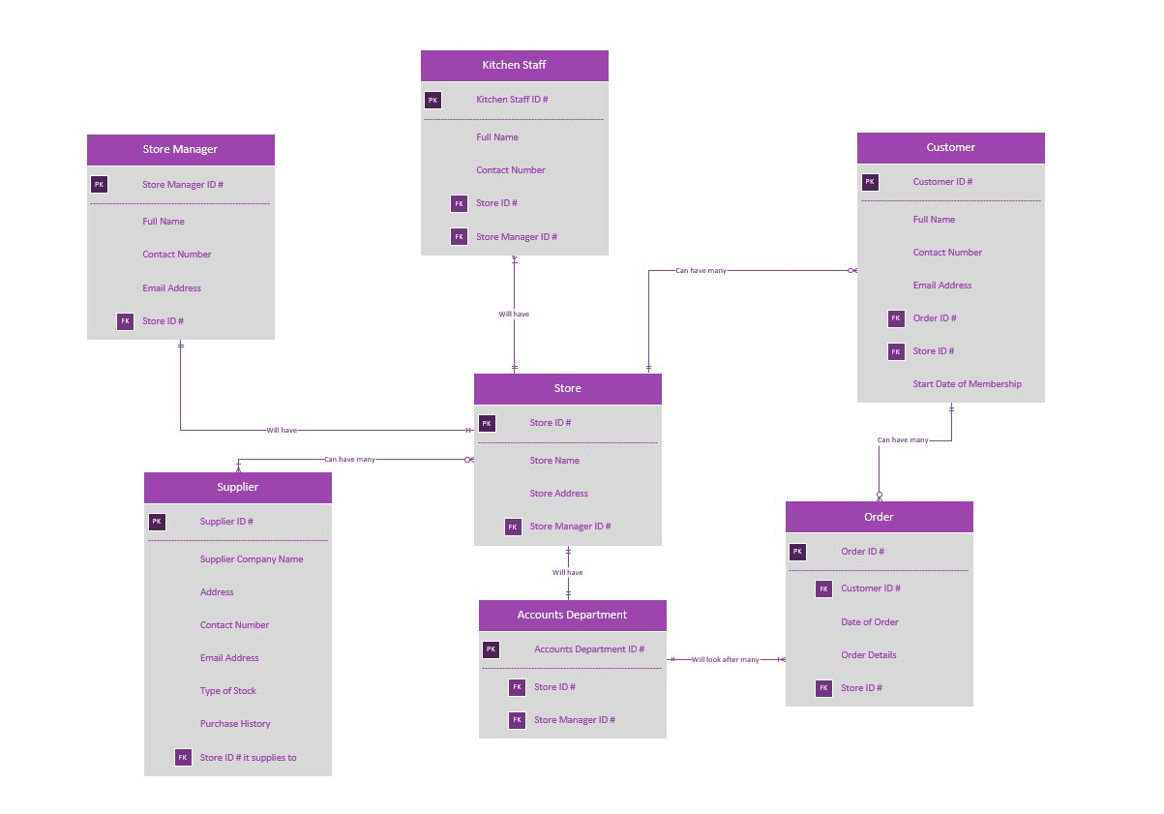
Entity Relationship Diagram

