International Marketing

Martina Perencin

2024812

Table of Contents

- Introduction
- Company Background
- The Macro environment
- Porters 5 Forces model
- SWOT Analysis
- Marketing mix elements (7Ps)
- Directional development strategy
- Conclusions and recommendations
- References

Introduction

Figure 1 Barilla logo
Barilla is an Italian company that has represented the values ​​of Italian society at its best for 143 years. These values ​​are family, simplicity, and tradition, but also the freshness and quality of the products. The company has managed to expand into the international market, building its factories around the world. In this assignment we will compare Barilla's Italian market with the English one, trying to underline their similarities and inequalities.
If we wanted to explain the success of the company, we should certainly name some key factors such as quality, price, and corporate image. The product is certainly like a quality product, greedy but also healthy, sustainable (sold in cardboard boxes), and varied. Another important factor is certainly the loyalty to the brand on the part of its customers. One of Barilla's most famous pay-offs read "Where Barilla is, there is home" and exactly the summary message that the company wants to convey, creating a parallelism between the sense of protection and familiarity that gives one's home and Barilla brand. An almost emotional relationship is therefore established between customer and company. The strong point of the brand is therefore the company itself, not the product. This becomes clear by examining the company's adv campaigns, in which it is not necessary to immediately name the brand name, which does not need presentations, unlike other food competitors.

Company Background
Historical Background
The founder of the company Pietro Barilla (1845 - 1912) opened the first pasta and bread bakery in 1877. After a few years of crisis, in 1905 the oven was able to produce 25 quintals of pasta daily. In 1910 Gualtiero and Riccardo, Pietro's sons took over the family business and transformed it into industrial production, building a new factory and employing eighty workers with a daily production of 80 quintals of pasta per day.
After the death of Pietro Barilla, his sons Riccardo and Gualtiero took over the reins of the family business, increasing the production and distribution of products, thanks to the technological innovations that allowed the company to transform rapidly. In 1947 the management passed to the third Barilla generation with Pietro and Gianni. The company experienced a phase of great development and in 1952 the production of bread was suspended to focus exclusively on pasta. In those years, Barilla quickly transformed from a regional company to a company with a strong presence in Northern Italy, thanks to the quality of the products, the balanced prices, and its innovative capacity, such as the use of cardboard to package pasta.
In 1960 Barilla was transformed into a joint-stock company, and in the following years, it opened new factories which marked Barilla's entry into the cracker and breadsticks sector, and in Pedrignano, on the outskirts of Parma.
In 1993 Pietro Barilla died at the age of 80 and the management of the company passed to his sons Guido, Luca, Paolo, and Emanuela. Thus, was born the fourth Barilla generation, and throughout the nineties the company continued the internationalization process begun at the beginning of the decade under the leadership of Pietro, opening in 1999 the first production plant in Iowa, in the United States. This expansion continued with the acquisition of several foreign companies in the food sector. Since December 2013, to have a direct relationship with the American clientele, the company has opened some restaurants in the United States.
At the beginning of 2021 Barilla acquired the majority stake in Pasta Evangelists, a London start-up for the production of fresh pasta.

Economic overview
The group produces many types of pasta and is the first pasta maker in the world with 24.5% of the Italian market. Barilla has 30 production sites, 15 in Italy and 15 in the rest of the world. In 2019 the company had a turnover of 3,627 billion euros, with a net profit of 227 million euros. In 2020, turnover was 3.890 billion euros (with an increase of 7% compared to the previous year), while net profit reached 351 million euros (+55% compared to 2019).

The Macro environment
The analysis of the Macro Environment is essential for predicting external threats and opportunities and establishing a sustainable competitive advantage over other competitors. We analyze the political, economic, social, legal, technological, and environmental factors for the Barilla company in the Italian and English markets, emphasizing congruence and differences.
Political factors
Political factors play a huge role not only in companies' investment decisions. The political environment and other factors not only affect costs but also long-term sustainability. Some of the political factors are the system of governance, democracy, and institutions, the likelihood of armed conflict.
International trade: both countries adhere to international treaties with international partners-
Role of non-governmental organizations, civil society, and activist groups: Italy has always had a strong presence of non-governmental and activist associations, while in England this type of association is rarer.
The political system of government: Both countries have a stable government
Democracy: in Italy, it is necessary to strengthen the role of democracy in political institutions to better address the rampant corruption in the country. On the other hand, in England, the situation is more transparent.
Regulatory Practices: Regulatory practices are facilitated by global rules that have helped both countries in the overseas market.

Economic factors
The economic factors of a country and a region have a direct impact on the potential attractiveness of a given market. Some of the economic factors that Barilla should evaluate are the inflation rate, the GDP growth rate, and the level of disposable income.
GDP trend and economic growth rate: The higher GDP growth rate signals growing demand in the UK economy. Barilla can take advantage of this trend by expanding its product range and targeting new customers in England. On the other hand, in Italy, due to Covid-19, demand decreased slightly.
Consumer disposable income: Italian household income has steadily increased over the last decade, while in England it has always been medium-high. Barilla can exploit this trend to expand the market beyond its traditional customers through a differentiated marketing campaign.
Workforce productivity: it is high in both countries and can allow Barilla to hire a skilled workforce at competitive salaries.
Price fluctuations in both local and international markets: the prices of Barilla Pasta products and the prices of overall products remained stable, while in England the prices of products from abroad increased after Brexit.
Occupancy rate: If the occupancy rate is high, it will impact Barilla's strategies in two ways: it will provide enough customers for the products and it will make it expensive for Barilla to hire talented and skilled employees. In Italy, there is a huge gap in the employment rate between the north and south of the country, while in England the situation is more or less homogeneous everywhere.

Social factors
Social factors such as demographic trends, the structure of power in society, the female component, participation in the workforce have an immense impact not only on the country's economy but also on the availability of talent in the workforce and the level of demand for workers. consumers.
Demographic trends: demographic trends are one of the key factors in forecasting the demand of an economy. For example, as the population of England and Italy is aging, the demand for products primarily targeting this segment will increase. Barilla analyzes demographic trends before developing new products and integrates features that target this segment. As the population is aging, fewer technological products will be needed.
Level of social concerns and awareness in society: a higher level of social concern in society often results in greater consumer activism and pressure from non-governmental organizations. High levels of social concern have been recorded in both countries since Covid-19.
Birth rate: the birth rate is also a good indicator of future demand. Countries belonging to Europe have a stagnant birth rate.
Immigration policies and level of immigration: in this case they are opposed in the two countries. Italy does not have strict immigration policies while England, after Brexit, allows very few people to enter the country and only if they already have a job and a contact. Barilla determines thanks to this factor; it can hire talents at a global level to work in that particular market.
Level of education in society: The level of education in society affects both the quality of jobs and the level of income. A high level of education often translates into better jobs, higher income, and higher spending on complex and ambitious products. In fact, in England, it is easy to have a relatively high salary compared to Italy, where almost the majority of young people do not finish their studies.

Technological factors
Technology is rapidly revolutionizing business models across all industries. Some of the technological trends that are influencing the macro environment are the development of artificial intelligence, the use of machine learning, and the analysis of big names.
Levels of investment in research and development: If there is a high level of investment in the technological development sector, then there are high possibilities of building a self-sufficient ecosystem. Barilla can take advantage of such a situation to hire the best people in the business world, however, research and development are not yet fully enhanced in Italy, while in England it has reached excellent levels.
E-Commerce and development of related infrastructures: since E-Commerce is fundamental for Barilla's business model, the company always evaluates this factor before entering a new market. In both countries, the opportunities to sell their products in e-commerce are very satisfying.
Transparency: Barilla uses digitization to overcome corruption in the local economy, especially in Italy.
Mobile Phone and Internet Penetration: Barilla assesses the level of penetration of the Internet and mobile telephony on the market. In this case, the level of penetration is high in both countries.

Environmental factors
Environmental factors are rapidly gaining ground not only among consumers but also among corporate policies. Climate change and ecosystem change are becoming more and more important issues by the day.
Recycling policies: recycling policies in Italy do not seem to work in the south, while in England they can be strengthened with more sustainable strategies.
Level of consumer activism regarding environmental concerns: Barilla needs to know the level of consumer activism regarding environmental concerns to develop environmentally friendly products. In England and all the countries of Northern Europe, there is greater activism than in the countries of Southern Europe.
Per capita and national carbon emissions: What is the country's per capita carbon emissions and what is the country's overall carbon emissions level? This will help better predict the environmental policy of the two countries that have similar carbon emission levels.

Legal factors
Legal factors such as conditions for entering the market, laws for operating in the market, and procedures for resolving disputes with other stakeholders. In England, these regulations are much clearer and more transparent than in Italy.
Transparency in the system and judicial processes: Transparency is essential for a fair and consistent decision-making process. As mentioned above, transparency has never been a point in Italy's favor.
Protection of intellectual property rights: Barilla should assess the level of protection that intellectual property rights obtain in the legal system of both countries.
Data protection laws: Barilla must assess what data laws are in the country and what it must do to comply with them. In both countries, citizen data is only saved in the same countries.
Health and Safety Laws - What are the health and safety laws in the country. Different countries have different attitudes towards health and safety, for example, in England, there is greater attention on this issue than in Italy.

Porters 5 Forces model
First published in 1979, Michael E. Porter's "How Competitive Forces Shape Strategy" revolutionized the field of academic research and provided a map for rigorously analyzing competitive forces.
The Porter Five Forces model is heavily borrowed from the traditional field of microeconomics. Let's apply the five forces to the two countries:
1. Threat of new entrants - If there is a strong threat of new entrants, current players will be willing to earn fewer profits to reduce the threats. In Italy, the threat of new competitors is high since raw materials are available to everyone and in the same way. England, on the other hand, is low because, to have raw materials, companies would have to import them from outside.
2. Rivalry between existing players - If competition is intense, it becomes difficult for existing players like Barilla to earn sustainable profits. Competition in Italy is high since there are so many companies that produce quality pasta and bread. In England, however, the level of competition between existing competitors remains stable.
3. Threat of substitute products and services - If the threat of substitutes is high, the Barilla company must continuously invest in research and development. In Italy, this threat is low as the product has been part of the Mediterranean diet for centuries. On the other hand, in England, the threat is high since pasta can be easily replaced with foreign products such as Noodles.
4. Barilla's buyers' bargaining power - If buyers have strong bargaining power, they usually tend to lower their prices, thus limiting the potential of Barilla Pasta to make sustainable profits. The price of the product in Italy is relatively low as pasta is considered a simple and poor product. In England after Brexit, all products from Europe increased their price and the same was true for Barilla pasta.
5. Barilla's suppliers' bargaining power - If suppliers have strong bargaining power, they will get a higher price. Supplier power in Italy remains stable and relatively low, while in England it continues to rise due to Brexit.

SWOT Analysis
The four key elements of SWOT analysis are strengths, weaknesses, opportunities, and threats. Barilla can use the strengths to create a niche positioning in the market, it can strive to reduce and remove the weaknesses to compete better with competitors, try to exploit the opportunities provided by the structure of the sector, by the regulations in the external environment and finally develop strategies to mitigate the threats that can undermine the corporate business model. The analysis retraces the four points for both countries.

Strengths
The strengths are the capabilities and resources of Barilla that it can exploit to build a sustainable competitive advantage in the market. Strengths derive from the positive aspects of human, physical, financial resources, experiences and successes, activities, and processes.
Strong relationships with existing suppliers - Over time, Barilla has forged strong ties with its suppliers in Italy, however, due to Brexit, relations with suppliers in England have tightened.
Strong brand value and brand awareness - brand recognition play a significant role in attracting new customers and in Italy Barilla is nationally recognized as the first and most bought pasta brand. In England, on the other hand, it is recognized by customers as a quality company, but the British also buy English brands or substitutes for pasta.
First Mover Advantage - Barilla has the First Mover advantage. In both countries, Barilla was one of the first players in the food market, in England in particular, the first Italian pasta brand.
Successful track record in the pasta market - Barilla has a very successful track record both in launching new products in the national market and in satisfying the various international markets based on the insights of local consumers. The company has tested different strategies in different markets, adapting well to the needs of both Italians and the British.
A solid balance sheet from Barilla helps it invest in new and diversified projects that can further differentiate the revenue stream and increase sales in both countries.
Intellectual property rights - the company owns the patents and copyrights through the purchase of these rights from the creators. This can help Barilla tackle the challenges of competitors in various sectors both in Italy and in England.

Weaknesses
The weak points are the areas, skills, or competencies in which Barilla is limited. The weak points derive from the lack or absence of financial resources, physical resources, human resources.
Customer dissatisfaction - even if the demand for products has not decreased, some wrong communication strategies and some negative comments by Barilla's CEO have recently created a certain dissatisfaction with the brand, not only in Italy but all over the world. It is reflected in the reviews on various online platforms.
Lack of critical talent - the company in the field of technology and digital transformation struggles to restructure technological processes in light of developments in the field of Artificial Intelligence (AI) and machine learning in both countries.

Opportunities
Opportunities are factors and developments in the macro-environment that Barilla exploits to consolidate its existing market position. Opportunities can emerge from factors such as political changes, technological innovations, changes in consumer preferences, increased income, and economic growth.
Opportunities in adjacent markets - Barilla can explore adjacent industries Competitive strategy for further market growth, in particular by extending the characteristics of current products and services. In Italy, the company expanded into the breadsticks and biscuits market, while in England there is a strong presence of Barilla pasta and various sauces.
Developments in artificial intelligence - Barilla can use developments in artificial intelligence to better predict consumer demand, cater to niche segments, and build better recommendation engines. However, as we have already said, Barilla still has to grow in this field in both countries.
Increase standardization - Barilla can exploit this trend to reduce the number of offers on the market and focus marketing efforts only on the most successful products, which for Italy is pasta and biscuits, while for England sauces for pasta.

Threats
Threats are factors and developments in the macro-environment that can destroy Barilla's business model. Threats can emerge from political changes, technological innovations, economic growth, changes in consumer preferences.
Threats from new entrants due to cost reduction and increased efficiency - As well as Barilla can leverage the low cost to reach customers using social media and e-commerce, so can both local and international competitors. It has been noted that the competitors in Italy above all are implementing truly valid marketing strategies to compete with Barilla.

Increased cost component of working in developed markets due to environmental regulations - Barilla faces these costs as governments are trying to impose environmental taxes to promote cleaner options. For Barilla it can lead to higher logistics costs and higher packaging costs, especially in England where there is more attention in this field.
The middle class - Growing inequality is one of the greatest threats not only to globalization but also to capitalism. Barilla sees the impact of lower demand for its products from middle-class customers in the European and British markets.
International geopolitical factors - developments such as Brexit and other factors are affecting the international economic context and can represent a problem for both the Italian and the English markets.

Marketing mix elements (7Ps)
The seven elements of the Marketing Mix are:
1. Product: the products that Barilla makes.
2. Price: pricing strategy that Barilla uses in the various markets and segments.
3. Location: Barilla's distribution channel through channels such as Amazon.
4. Promotion: the emergence of social media and online advertising has changed the landscape of the communication mix and the Barilla communication strategy.
5. People: not simply intense as customers or consumers, but rather as human personnel who manage and work in a company. It is the internal competitive advantage represented by human capital that makes the difference.
6. Process: in this case, we mean the organizational processes and systems that influence the creation of the product or the execution of the service.
7. Physical Evidence: this parameter identifies the proof of the material existence of a product as such and even of service. It can be found in the perception that the brand that delivers it leaves in the consumer's mind or, more simply, in the context of the market. Physical Evidence is a factor strongly interconnected with so-called branding: if a brand is known, its physical evidence is confirmed.
The analysis of all seven points of the Marketing Mix will be conducted for both countries. In the end, the analysis of the segmentation, targeting, and positioning of the brand will also be added.

Product
Although in marketing, the product is not seen as a tangible product, but the source of value to be provided to customers, Barilla's products are varied and differentiated. Bread, pasta, breadsticks, snacks, biscuits, sauces. Each product is different and has its specific marketing strategy. At Barilla we can identify four phases of product management:
• Identification of opportunities - Market research and customer research are carried out to identify the needs that Barilla can collect with its resources. In England, the demand for pasta and sauces is greater, while in Italy almost all Barilla products have strong demand from the public.
• Design and Test - The product is designed based on the value proposition that customers are looking for and that Barilla can offer. Lately, Barilla has changed the color of its packaging from deep blue to light blue in both markets to rejuvenate the brand image.
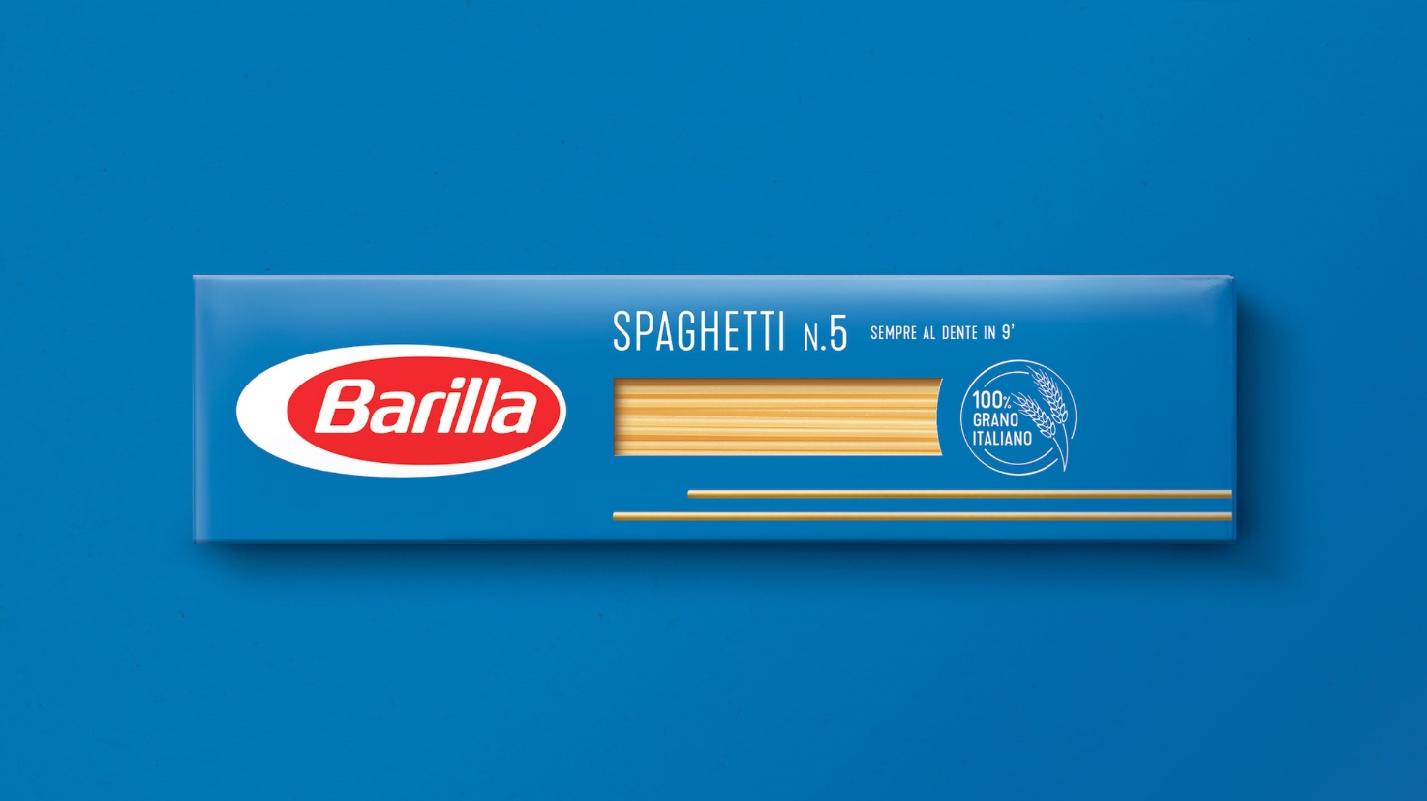
Figure 2 New Brand Color
• Product Launch - Includes decisions regarding pricing, communication strategy, distribution channel management, and post-purchase services.
• Management of the product life cycle of Barilla products - Once the product is launched, the company must manage the life cycle of the product through its various phases such as - introduction, growth phase, maintenance, and finally decline.
Decision on product line planning
There are three main product line planning decisions that Barilla's Pasta can make: product line width decision, product line length decision, and product line depth decision. Some of the considerations marketers need to make when making product line decisions are:
1. How the launch of the new product brand will affect the overall brand equity of the brands and products featured.
2. The product launch can satisfy the potential needs and wants of customers in a way that can deliver profits to the company.
3. The product will be considered completely different from the company's existing products and will have different marketing strategies focused on its promotion.
4. The choice of the breadth of the product line for Barilla. As Barilla's position in its industry is well established, it can expand where customers use complementary products from other brands to get the most value from products, such as biscuits, sauces, cakes.

Price
To a large extent, the price depends on the other 3Ps of marketing: product, place, and promotion.
Cost base price
With a cost-based pricing strategy, Barilla can understand what is needed to produce the product. In a highly competitive strategy with dynamic pricing, the strategy may not be feasible.
Value-Based Pricing
The base price of Value-Based Pricing is a pricing strategy based on the customer's perception of value.
Market penetration prices
Barilla often uses this strategy, for which it launches a new product at a loss or a new product to obtain a high revenue. This occurs especially in markets where the brand must make itself known by the customer, such as England,
Good value for money
Offering the right mix of product features, quality, and service at a fair price. Barilla uses this strategy in Italy where the price remains stable and the quality of the product too.
Prices on the competition
The strategy is the price is based on competition in the market. In this strategy, Barilla's objective is to focus on reducing operating costs to increase profitability compared to competitors. This happens both in Italy, where new market players are born continuously and in England where existing English competitors have very low prices.

Place
It is the place or distribution channel where Barilla delivers its products to customers. There are two main decision criteria relating to the distribution channel:
1. Design of the channel
Barilla has to choose whether it wants to implement a distribution system that is - direct (stores), indirect (distribution agents like Amazon), or both. The channel design decision involves: understanding the customer's value proposition, the customer's current convenience points, the breadth and depth of the product line, and the competitor's distribution systems. Barilla uses both distribution systems, but in Italy, it mainly uses the direct channel as customers prefer to go to the supermarket to buy products. While in England both, as there is not always a great variety of products in supermarkets.
2. Channel management
Channel management concerns the management of the various centers within the delivery system and their management based on the bargaining power of each actor in the value chain.

Promotion
Barilla's promotion strategy consists of elements such as advertising, sales promotion, personal sales, public relations. Barilla mainly uses social media to communicate with its younger target. In Italian social networks, we find posts in which Barilla products are the protagonists of a famous event, such as a football match or the Olympics, where the aim is to celebrate Italian or English victories through irony. The English promotion is more focused on the freshness of Barilla products and social networks, it is possible to find posts or videos with recipes. Other promotion strategies are newsletters with special discounts or offers directly in the store.

People
At Barilla, everyone is considered vital for the achievement of specific marketing objectives, each has a specific role and place in the organization's hierarchical scale. Without the right people, the most famous brand is not successful, and the reason is simple. In Italy, in the Barilla production factories, most of the workers are of foreign origin, the higher we climb the ladder, the more we find people with logistical and administrative tasks in the offices, and finally almost all men at the top of the company. In England, there are different ethnicities in the production systems and the right mix of women and men in the management levels.

Process
That is the organizational processes and systems that influence the creation of the product or the execution of the service. Today, companies try to minimize the margin of error, limiting economic expenses and maximizing profits, finally offering increasingly customized solutions for the individual user. Barilla achieves these results through an in-depth study of its customer and their needs, using advanced technology that exploits customer data provided by databases.

Physical Evidence
This parameter identifies the proof of the material existence of a product and a service in the perception of the brand that delivers it leaves in the mind of the consumer or in the market. Physical Evidence is a factor strongly interconnected with so-called branding: as I have repeatedly stressed, the Barilla brand in Italy is known to everyone, young and old. However, in England as well as in other parts of the world, a sort of protest was made against some statements that the CEO of Barilla had made about homosexuals. The image of the brand has therefore changed because it has not been able to adapt to the ever-changing world context.

Segmentation
Market segmentation is the process by which Barilla's marketing managers can divide the market into smaller segments based on distinct consumer needs, characteristics or behaviors. Barilla can segment based on the following criteria: geographic, demographic, income, lifestyle, value proposition priority, desired benefits, loyalty status, gender, social class, self-perception, psychographic factors, and other attitudes. In Italy, the most followed criteria in this analysis are factors of income and brand loyalty, while in England the main factors are lifestyle and psychological factors such as attention to communication and particular burning issues.

Targeting
Once the overall market has been divided into various segments, Barilla chooses its target. First comes and an analysis of the maturity of the market is carried out. Customer loyalty and behavior are then studied. Finally, the competitors in the same segment and for the same target are analyzed.
Therefore, the target to which Barilla addresses is large, but consumers who prefer niche products are excluded. The direct Italian competitors are: Knorr, Rana, Althea, Star, De Cecco, Le conserve della Nonna, commercial brands, De Cecco, Garofalo, Delverde, La Molisana. The main indirect competitor is the artisanal producer. The Italian target is large as the product is easily accessible due to its central position on supermarket shelves. However, the main consumers are single individuals, workers, off-site students, or more general categories of people who are looking for a product that is quick to consume and does not give up on tradition. Instead, the English target can also include niche customers such as Italians abroad who are looking for the Barilla brand.
Positioning
The positioning process concerns how Barilla differentiates its products and services on the market from its competitors. Positioning is the position of the Barilla brand or products in the minds of its target customers.
It is, therefore, necessary to identify a competitive advantage or a unique value proposal on which to position the brand in the minds of consumers. Choose competitive advantages compatible with Barilla's marketing strategy. Finally, position the brand as a brand with a higher value than the target segment and effectively communicate this position to consumers using the marketing mix and the promotion mix.

Directional development strategy
In the two images below we can understand which will be the next markets that Barilla will want to tackle and which could be not profitable for the company. The best opportunities in the English market are to introduce Mulino Bianco biscuits (Barilla biscuit manufacturer). These cookies have very good quality and are of different shapes and sizes, plus they could represent something new in the English market.
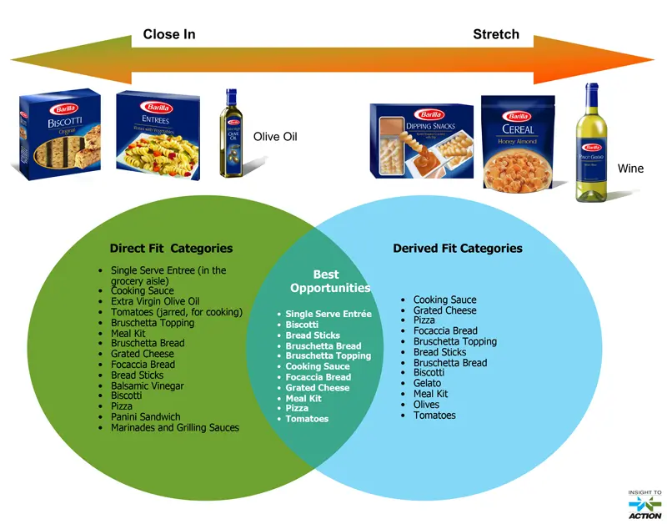
Figure 3 Expansion zones for Barilla
As for the already saturated Italian market, Barilla could try to produce something completely new like olive oil or wine.
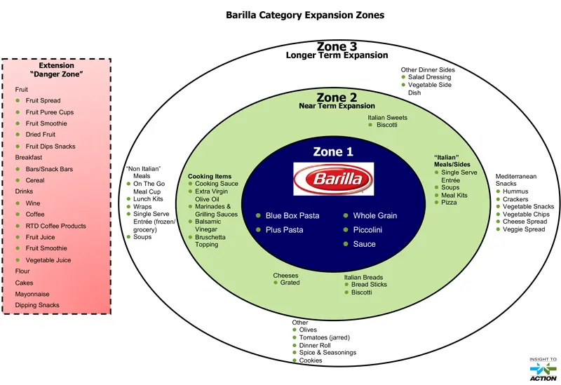
Figure 4 Category Expansion Zones

Conclusions and recommendations
The life cycle of the Barilla product begins with agriculture and ends in agriculture. The product of the Italian company is highly sustainable, both the raw material itself and the cardboard packaging that is recycled for new uses.
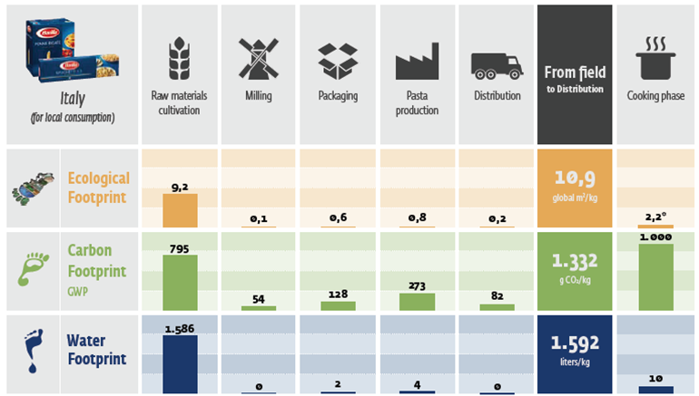
Figure 5 Product Life Cycle Model
The recommendation I can make concerns the choice of communication strategies. Barilla is a centenarian company and represents made in Italy with pride and dedication. As already mentioned, the company uses a rather traditionalist approach in both marketing and communication. It puts the traditional family (or at least Barilla's idea of ​​a family) at the center of its campaigns, made up of a father, the only source of income, a mother, an angelic house, and hearth of the house, and two children. In the last period, Barilla has often been criticized for this anachronistic image that it wanted to spread without considering the changes in the outside world. In addition, to support this little open message, statements were made by the company's CEO against homosexuals. This prehistoric vision of the world has been strongly criticized especially in America where the market is unstable. The company had to release an apology video on social media.
To conclude, it is therefore clear that Barilla must know how to better adapt to the changes that occur around it in the world, by studying its customers and the different markets in which it operates.

References
Lowe R., Kenyon A., Doole I., 2019, International Marketing Strategy: Analysis, Development and Implementation, 8th edition.
Harvey, Janell, 2020, Localizing Global Marketing Strategies: emerging research and opportunities.
Hooley, Graham J., 2020, Marketing Strategy and Competitive Positioning, Seventh edition.
Information Resources Management Association, 2020, Global branding: breakthroughs in research and practise, Information Resources Management Association, Hershey Pennsylvania.
Sood T., 2017, Strategic Marketing Management and Tactics in the Service Industry, JECRC University, India.
Duffy S., 2021, International Brand Strategy: A Guide To Achieving Global Brand Growth, 1st Edition.
https://www.barillagroup.com/it
https://www.barillagroup.com/en

