Problem Solving and Decision Making

Student name:Cristian Lungu.
Student ID number:2026298.
Module:Problem Solving and Decision Making.
Module code:BMSW 4004.
Lecturer’s name:Chijioke Uba.

Contents
Introduction 3
Nature and impact of the complex problem on employees and their organisations. 3
Cause-and-effect analysis of the complex problem. 4
A PESTLE analysis of the macro-environmental factors contributing to the complex problem. 6
An evaluation of alternative solutions to work-related stress to choose the most appropriate solution among these alternatives 7
Plan to implement the decision to solve the complex problem 9
Discussion of success indicators to measure the effectiveness of your decision 9
Conclusion 11
Reference List 12

Introduction:
The report aims to highlight the complex problem that the UK workplace have been experiencing like work-related stress. Among the UK employees, this is one of the severe issues that has led to physical symptoms like chest pain, circulatory problems, female health conditions and others (Chandola et al., 2019). In the report, with the help of the Cause-and-Effect analysis, the issue has been identified and proposed with alternative solutions that will work for the employees and improve their health.

Nature and impact of the complex problem on employees and their organisations.
Recent research shows that around 90% of UK workers are stressed ‘most’ of the time (van Stolk, 2021). The impact of stress at work can cause any problem in future and serious health problems, the worker who keep their work life and personal life separated tends to at less pressure. After work-related stress financial stress takes the lead, the 18-25 age group tends to be more in stress. For both men and women work is the main cause of stress, around 38% of women and 35% of men suffer from stress whereas 30% are stressed due to work for both genders. The main reason for stress at work is 84% of the workload, 79% over-emphasis and 76% in dealing with incompetence of colleagues, due to stress even the productivity of the company decreases only 27% of employee do not perform to the best of their ability (Cartwright and Roach, 2021).
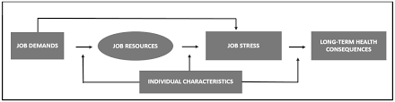
Figure 1: Conceptual Flowchart of the Work-Related Stress
(Source: Created by the learner)
A survey shows that the employee of Customer Services experiences the most stress of 25% at work where 37% is due to work-related politics, 34% is due to lack of communication, 33% due to performance of others and many more to count (Haddon, 2018).

The leader rarely discuss with the teammate or they fail to communicate coherently, workers inside the organisation are often afraid to say what they think and the concept and approach of the company are also more concerned with society. Due to stress the confidence and the self-motivation of the employee are severely dragged down at present the work stress can be said as the worldwide epidemic. Around 1.4 million workers suffer due to ill health and the annual expenditures sum up to 14.7 billion and about 5.5 million patients are ill due to stress-related conditions and 68.9 million patients make an appointment with a GP due to stress (Burman and Goswami, 2018). The most common symptom diagnosed is chest pain, gastrointestinal problems, female health issue and circulatory issue were also major health issues. Employees go through lots of issues like depression, anxiety and some major mental issues.

Cause-and-effect analysis of the complex problem.
The main cause of stress is as follows:
some people don’t love their job but they do it just because they need to earn it, this can be a major problem, though the worker does not realize it, it can cause major health issues like depression.
- Poor performance management – stress can affect the worker mentally and result in poor performance, poor quality of work and an increase in error rate (Burman and Goswami, 2018). While working in a team if the individual does not have a say, poor management or with unclear motive it can result in poor productivity that can be a huge loss for the company.
- High work demand – heavy workload and working overtime can exhaust the employee, it may be beneficial for the company but the load is on the employee's shoulder and it can affect productivity.

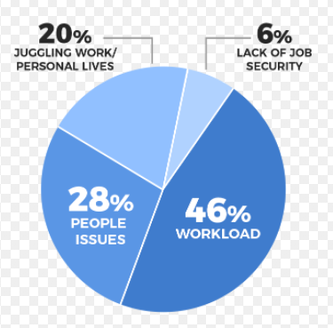
Figure 2: Work Stress and real issues among employees
(Source: Burman and Goswami, 2018)
- Lack of management decision – the employee may not think rationally and may take what can be against the team.
- Poor leadership – People can be confident but when it comes to speaking upfront there is always a thought in mind of what the listener is thinking and getting negative feedback can affect the worker mentally (Mansour and Mohanna, 2018).
- There is a high risk in working for a big company like being at risk of termination, facing discrimination or harassment at work especially when the colleagues are not supporting (Untarini et al., 2020).

The effects of stress can be a serious threat to workers health such as:
High mental stress- Stress can lead to health issues such as headaches, high blood pressure, diabetes, heart problems, anxiety, depression, irritability, insomnia and others.
Long-term stress weakens one's immune system. Hormones fluctuate due to stress which can be harmful to females, it can also affect the respiratory and cardiovascular systems.
Reduce workflow- it becomes difficult to concentrate which automatically affects the work and its flow.
Family conflict- working overtime and workload can create a fuss in a family it becomes difficult for an employee to make time for family.
Improper work-life balance- the professional life and personal life gets mixed and an employee can hardly make time for himself.

A PESTLE analysis of the macro-environmental factors contributing to the complex problem.
PESTLE Analysis is the strategic framework that influences an organisation from outside (Shtal et al., 2018). The analysis is flexible and can be used in different scenarios, it is also used as a tool to track down the environment they are operating in.
ANALYSIS | Factors Affecting the Issue
POLITICAL | Political stability is the greatest strength, Brexit is a debatable topic and has created an atmosphere of uncertainty (Kalleberg and Vallas, 2018). For some, it will create opportunities and chaos. The recent debate over Brexit has caused serious concerns. The government comprises low corruption and effective government policies. The social and cultural values between UK and US makes them strong ally.
ECONOMIC | The UK is the sixth-largest economy in the world but the lockdown due to the pandemic has put enormous pressure and destroyed the business and industries (Li and Wang, 2020). Diversity is the reason for the flow of equal opportunity for the business to grow and the economy attracts the attention of many in the world. The tax rate for the company is 19% and the unemployment rate is 3.8%.
SOCIAL | At present United Kingdom’s population is over 68 million and has a big consumer market and the companies that have gained a lot of profit are insurance companies, real estate and health care. The education system includes modern mythologies. Therefore, the demands are increasing and however, there are a lot of opportunities. The market comes up with a variety of new concepts and products to meet the expectation of consumers of different races and religions.
TECHNOLOGICAL | Technology contributes the majority to the UK economy and London being the technological hub it frequently develops and innovates new technology. The UK is progressing in the tech field and the economy provides great opportunities for entrepreneurs.
LEGAL | The Employment Act 1996 protects the rights of the employee, it looks towards maternity, paternity leave, wage, holiday pay, sick pay and legally protects the other rights (Commenced, 2021). The Equality Act 2010 protects people from discrimination against their race, gender, colour or any other differences.
ENVIRONMENTAL | The UK government has taken innovation in creating an eco-friendly environment. The private organization and other charities are taking steps towards recycling and the use of less plastic waste. The country faces the problem of bad weather but the summer attracts the tourist.
Table 1: PESTLE analysis of the factors that can affect the business
(Source: Created by the learner)

An evaluation of alternative solutions to work-related stress to choose the most appropriate solution among these alternatives
The work-related problem drags down the satisfaction and confidence level of the employee, the negative impacts are so strong that the stress can be considered as the World Wide Epidemic. As the manager of the company, one should look towards their employee creating a stress-free environment. Here are some alternative solutions:
Quality over quantity- It is understandable that the works are more in number but the company can hire more employees to cope up with the problem in this way the employee can efficiently work in a stress-free environment and can boost the productivity level (Iskamto, 2021). Everything cannot be done perfectly especially in jobs instead one can thrive to do better

Figure 4: Solutions for Work-Related Stress
(Source: Created by the learner)
Motivation- It is the most important point, every person needs motivation whether it is in professional life or personal life, every human being needs to get emotional support it can help the worker in maintaining the balance in life.
Forget multitasking- it’s a way in which workers can do multiple things at the same time but what’s the guarantee that the work is perfectly done therefore it is better to do one thing at a time and perfectly.
Flexible hours and remote working- the company should not be concerned about finishing the work on time rather the company should define the job by the quality and timeless of their work.
Encourage social activity- the first thing that a worker needs to do is to get to know the fellow worker, interaction is a must it is better for teamwork (Kim and Beehr, 2018). The more they will interact the less they will be stressed.
Recognize the employee- every individual love to be praised and praising the employee for their success may help in boosting their work. Getting praised and appreciated will make the employee more comfortable.
Encourage workplace wellness- encourage the worker to exercise and live a healthy life. Once in a while host social family get together, after-work dinner and outing.
Among the alternatives, the best option can be determined to be choosing quality over quantity that will foster productivity as well as boost the employee’s mental set-up

Plan to implement the decision to solve the complex problem
Even a thoughtful business plan is just a sheet of paper unless implemented, it just needs to be through certain guidelines.
Discussion with the manager- firstly the project should be discussed with the manager his thoughts and concerns should be noted and if he thinks the plan needs to be correct and presented.
Feedback - knowing others thoughts is the most important thing therefore one should ask for the coworker's feedback.
Clear objectives- the objective should be crystal clear as the whole project is based on that objective. The objective should be tough, reachable and be implemented. Only through objectives, the action can be translated.
Breaking it into a task- break the projects into different tasks and assign them to the groups, emphasize the result and start the task accordingly.
Team motivation- the project completely depends on the team; the team should be cooperative. Each team should be focused throughout the process and help each other.
Allocate the time- set the time and try to complete it within that frame of time, some tasks can consume more time. Talk it out with more experienced people don’t just focus on completing the task and perform the task orderly and accordingly.
Making progress- the person assigned should take the responsibility for monitoring the progress of the task. Implement the task efficiently. When the task gets delayed try to get to the root of the problem
Regularly review the plan- the progress should be checked and compared regularly to see what are the changes and if the project can be completed within the budget.

Discussion of success indicators to measure the effectiveness of your decision.
There can be a negative impact on an organisation due to employee turnover, turnover level varies between occupation and industries it also varies from region to region. the turnover rates are higher where there are more unemployment and least where it is easy for people to secure alternative job. UK’s unemployment rate was estimated to be 75.2% (ons.gov, 2021). By tracking the employment retention rate the company helps in measuring the new initiatives as well as ideas. The strategy should be to focus on retaining top workers and engaged employees, the one's who enhance the culture and drive the business forward. Losing an employee can cost one-third of their annual salary and financial salary can be much more. 23% of employees are more likely to stay in the company if the manager clearly explains to them their responsibilities and role.
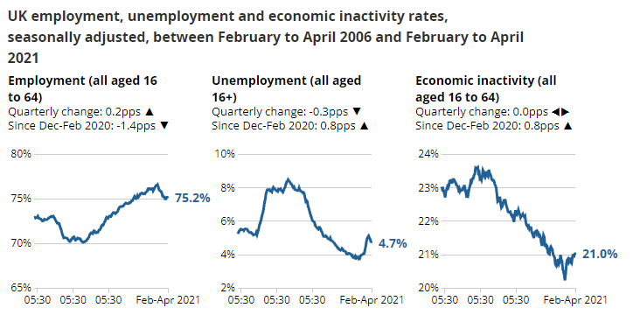
Figure 5: UK unemployment status
(Source: ons.gov, 2021)
The retention rate is often calculated on an annual basis. The strategy to keep the top performers is firstly by recruiting the smarter ones, secondly by implementing an employee referral plan through building a better talent pipeline and increasing the talent of the pipeline, thirdly by creating two-way communication, implementing an employee recognition program, building a better company culture and promoting professional development. through the use of these measures, the company can make assessments of how the plan has been working.
for example:- If the retention rate within the next 6 months has been positive then the plan has been working positively and if it is negative then a refine plan would be needed.
The manager should ask for weekly feedback from the worker and the company should recognize the employee's which will make them more loyal.

Conclusion:
From the report, an analysis has been drawn on the different causes of the work stress among the UK employees and the employers have been identified to be having the main hand behind it. It has been increasing day by day that has caused all the more issues for the organization. From the report, it can be concluded that some external factors do have an impact like the social or the economic factors on the complex problem. However, motivation or quality over quantity preference can change the scenario and be beneficial for the employees.

Reference List:

Burman, R. and Goswami, T.G., 2018. A systematic literature review of work stress. International Journal of Management Studies, 5(3-9), pp.112-132.
Cartwright, A. and Roach, J., 2021. The wellbeing of UK police: a study of recorded absences from work of UK police employees due to psychological illness and stress using freedom of information act data. Policing: A Journal of Policy and Practice, 15(2), pp.1326-1338.
Chandola, T., Booker, C.L., Kumari, M. and Benzeval, M., 2019. Are flexible work arrangements associated with lower levels of chronic stress-related biomarkers? A study of 6025 employees in the UK household longitudinal study. Sociology, 53(4), pp.779-799.
Commenced, D., 2021. 3.5 Equal Employment Opportunity. Policy.
Haddon, J., 2018. The impact of employees’ well-being on performance in the workplace. Strategic HR Review.
Iskamto, D., 2021. Stress and Its Impact on Employee Performance. International Journal of Social and Management Studies, 2(3), pp.142-148.
Kalleberg, A.L. and Vallas, S.P., 2018. Probing precarious work: Theory, research, and politics. Research in the Sociology of Work, 31(1), pp.1-30.
Kim, M. and Beehr, T.A., 2018. Can empowering leaders affect subordinates' well-being and careers because they encourage subordinates' job crafting behaviours?. Journal of Leadership & Organizational Studies, 25(2), pp.184-196.
Li, L.Z. and Wang, S., 2020. Prevalence and predictors of general psychiatric disorders and loneliness during COVID-19 in the United Kingdom. Psychiatry Research, 291, p.113267.
Mäcken, J., 2019. Work stress among older employees in Germany: effects on health and retirement age. PloS one, 14(2), p.e0211487.
Mansour, S. and Mohanna, D., 2018. Mediating role of job stress between work-family conflict, work-leisure conflict, and employees' perception of service quality in the hotel industry in France. Journal of Human Resources in Hospitality & Tourism, 17(2), pp.154-174.
ons.gov.uk 2021. Employment in the UK - Office for National Statistics [Online]. Available at: <https://www.ons.gov.uk/employmentandlabourmarket/peopleinwork/employmentandemployeetypes/bulletins/employmentintheuk/june2021> (Accessed: 10 November 2021).
Pignata, S., Boyd, C.M., Winefield, A.H. and Provis, C., 2017. Interventions: Employees’ perceptions of what reduces stress. BioMed research international, 2017.
Shtal, T., Buriak, M., Ukubassova, G., Amirbekuly, Y., Toiboldinova, Z. and Tlegen, T., 2018. Methods of analysis of the external environment of business activities.
Untarini, N., Sayyida, S. and Singh, S.K., 2020. Occupational stress management in managerial employees: an analysis of level and source of work stress. BISMA (Bisnis dan Manajemen), 13(1), pp.47-68.
van Stolk, C., 2021. The cost of stress to UK employers and employees. In A Research Agenda for Workplace Stress and Wellbeing. Edward Elgar Publishing.

