

Postgraduate/Distance Learning
Assignment coversheet & feedback form

THIS SHEET MUST BE THE FIRST PAGE OF THE ASSIGNMENT YOU ARE SUBMITTING (DO NOT SEND AS A SEPARATE FILE)

For completion by the student:
Student Name:
Hàìghlèàgh Eilish Winslade BA BA MRes
Module code:  HPCA7014  Module title:  Sacred Geography Supervised Research Project: How does the Curvilinear Enclosure / Llan Churchyard of St Mary’s Bepton in the Sussex Western Weald incite a phenomenological response and / or Eliadian hierophany ? | Student ID number:  2413581 |  |  | Educational support needs:  Yes/No – Yes Differentiated Deadline of 12/1/26
Module tutor:
Dr Bernadette Brady

Assignment due date: 12 /1/2026 differentiated deadline
If your module has multiple submissions please indicate which piece of work this is.

1st 2nd 3rd 4th 5th 6th
I confirm that this is my original work and that I have adhered to the University policy on plagiarism.
Signed Hàìghlèàgh Eilish Winslade BA BA MRes (electronically signed)……………………………………………………………
Email submission: if you are submitting this form via email, please tick this box □
(as a substitute for your signature) to confirm that you agree to the above declaration.
Assignment Mark
Final Mark | WILL BE GIVEN ON TURNITIN

NB. All marks are provisional until confirmed by the Final Examination Board.

PLEASE NOTE: ALL COMMENTS WIL BE POSTED ON TURNITIN

For completion by Marker 1 :
Comments:

Marker’s signature: |  |  | Date:
For completion by Marker 2/Moderator:

Comments:

Marker’s Signature: |  | Date:
AGREED INTERNAL MARK (where necessary):

Comment on process of arriving at agreed mark:

External Examiner’s comments (if relevant)

External Examiner’s Signature: |  | Date:

Introduction:
This paper examines the use of both phenomenology and OI-Organic Inquiry methodologies in the fieldwork visit to St Mary’s churchyard in Bepton Sussex, a scarp foot settlement in the Western Weald that took place on 24/09/2925. The paper commences with a background section that explains the origins of my deep love and understanding of the Weald and Downland landscape located in southeast Britain in the English counties of Hampshire, Sussex, Kent and Surrey, together with a topographical and geological summary of this landscape including a definition of the archaeological feature of curvilinear enclosures. The paper then focuses on the methodologies that have been used in this research and that is followed by a literature review. The next section is the phenomenological and OI- Organic Inquiry based account and reflection of my visit to St Mary’s churchyard on the 24/09/2025. Finally, a brief conclusion sums up this fieldwork and its impact of my understanding of St Mary’s Churchyard as a sacred and liminal place.

Background and Geology and Topography:
The South Downs Where I Grew Up:
I grew up in Catherington, a hilltop settlement on Catherington Hill a hill in the southwest of the South Downs. There are few hilltop settlements on the downland due to height, thin soils, which result in fewer tree coverage and therefore expose, and prior to modern water extraction the need to dig deep wells over 300 feet /1000 metres deep to extract water from the variable water table of the downland chalk aquifer. The need for deep wells resulted in a treadwheel being installed over the well head at Kinches Farm . It has now been restored and is on display at the Weald and Downland Living Museum near Chichester. The treadwheel and its undaubed timber framed building date to the seventeenth century, but the well shaft at Kinches Farm is most probably Roman, as the Romans imported this treadwheel technology into Britain. The churchyard of All Saints Church occupies the highest spot on the crest of Catherington Hill and is trapezoid in shape with a bank that runs the entire length of the churchyard’s northern boundary and has been dated as Roman due to finds of local Roman Greyware recorded in the Hampshire Historic Environment Record ID: 2544, suggesting that the churchyard is Roman. There is no evidence that All Saints churchyard is built on an earlier curvilinear enclosure as the bank is the only bank and does not enclosure the churchyard – this point relates to the discussion on curvilinear enclosures below. Richard Coates considers the ‘Cather’ element in the placename Catherington to be cognate with the Cymraeg ‘Cader’/’Cadiar’ for ‘chair’ and argues that this is a topographical reference to Catherington as a lofty place on the South Downs.
Having lived most of my life on the South Downs I have developed a deep attachment to the landscape of the Weald and Downland, which has been a major influence in my choice of career as a landscape archaeologist (even though I am an ‘enabled archaeologist’ due to my neurological disability and associated mobility problems) and an anthropologist of religion.
The South Downs are a chalk escarpment running in a northwest – southeast alignment from in the southeast, Beachy Head on the coast of Sussex across the counties of Sussex and Hampshire to in the northwest, St Catherine’s Hill to the east of the city of Winchester in Hampshire. The South Downs runs around the southern part of the Weald and the Western Weald. The Weald which lays between the South Downs and the North Downs (another downland chalk escarpment) geologically comprises of clays, sands and gravels.

Defining The Weald and Downland:
The Western Weald:
The Western Weald an extension of the Weald between in the east the settlement of Midhurst, Sussex and in the west the settlements of Alton, Hampshire and Farnham, Surrey. The Western Weald was only recognised as a western extension of the Weald, in the later twentieth century.
Lying at the foot of the north facing scarp of the South Downs is a terrace or bench of Upper Greensand a calcareous siltstone. In Sussex Greensand is called ‘Malmstone’ and around the Weald that lies directly to the north of the Greensand terrace Malmstone has been used as a building material for hundreds of years for houses and walls. Due to its geological composition, there are numerous springs throughout the Greensand Terrace. Unlike the dry downland the Weald and Western Weald are watery places.
The Extent of the Weald and Downland:
Both the Weald and Downland were for many years viewed within the framework of the county community model where landscape was defined according to county boundaries. Within this model the South Downs were seen as ending abruptly at the county border of Hampshire and Sussex an artificial boundary. As with the Weald and Western Weald, in recent decades there has been the acknowledgement that the South Downs stretch as far west as Winchester. The development of these changes in the extent of the Weald and Downland is reflected in the work of the human geographer, the late Peter Brandon. Brandon, whose career began in the 1950’s when the Weald and Downland were seen within the respective county boundaries and encompassed the changes in the understanding described here, so that by the 1990’s and 2000’s Brandon was writing about the South Downs ending at Winchester Hill.
Curvilinear Enclosures / Llan Churchyards in the Weald and Downland
A Curvilinear enclosure (sometimes informally called a Llan churchyard) are ancient, scared sites often being bounded by large banks that are marked by a clear ‘D’ or curvilinear shaped bank that forms their boundary. Curvilinear enclosures are usually a Christian site that is built on an earlier pre-existing prehistoric non-Christian site and most curvilinear enclosures date to the first millennium BCE - to the Iron Age or even earlier Bronze Age. For much of the period of modern archaeology it has been the belief that curvilinear enclosures are only be found in Cymru and Cornwall but not in England. This view is now being overturned, and archaeologists are now writing about finding curvilinear enclosures in other parts of the UK and particularly in England, for example, M. Calder’s research into curvilinear enclosures in Somerset. In terms of the accepted view of sites like curvilinear enclosure, in Sussex the narrative has been that Christianity only came to Sussex following the mission of St Augustine of Canterbury in 597 CE and in particular the mission of St Wilfrid to the South Saxons in Sussex in the seventh century CE. This view held that prior to this, the area that became Sussex was pagan. Secondly, archaeologists have also held the view that the Weald (and therefore also the Western Weald) wasn’t colonised until relatively late – late being the later medieval period. But archaeological research is now overturning this long-held view and

archaeologists such as Martin Bell and Andy Margetts now talk about the Weald having a long history of colonisation that stretches back into prehistory.
In my visit to St Mary’s Churchyard on 24/09/2025 I encountered a ginormous bank on the eastern and southeastern side of the churchyard and the churchyard itself is on a mound. Below I discuss this in detail but in this encounter I was prompted to consider if St Mary’s churchyard is sited on a curvilinear enclosure. Thinking about St Mary’s churchyard as a sacred place with a long history that stretches back into prehistory firstly situates it within the current thinking about the Weald having a long history of human occupation as discussed above. Secondly, understanding St Mary’s churchyard as a sacred place with a long history that began long before the mission of St Wilfrid to the South Saxons in the seventh century CE chimes with Durkheim’s arguments about places and their layers of the past. But my encounter with the bank and the trees that form the eastern / southeastern boundary of St Mary’s churchyard was very much an Eliadian hierophany because as a landscape archaeologist I am drawn to sacred sites in the landscape and so when I encounter and engage with sacred sites and the archaeological elements that sacred sites are made of I experience a hierophany.

Methodology: Desk Based Online Research and Archaeological Fieldwork
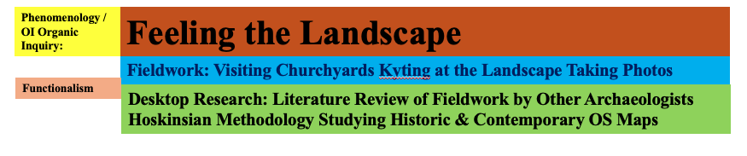
Figure 1: Diagram illustration the relationship between the methodologies of Functionalism, Phenomenology and OI Organic Inquiry
The above diagram in figure 1 illustrates the ‘stratigraphic’ relationship of the methodologies that I used to undertake my fieldwork at St Mary’s churchyard. As a landscape archaeologist and anthropologist of religion I am trained in functionalist theory and methodology where the researcher is separate from the research subject. Undertaking the Sacred Geography module of this MA has allowed me to develop a more personal perspective on the landscape of the Weald and Downland using the methodologies of phenomenology and OI – Organic enquiry. Organic Inquiry is another methodology very similar to phenomenology. In OI - Organic Inquiry the researcher treats their subjects not as subjects but as co-researchers in their research project. Using OI – Organic Inquiry therefore allows the landscape as a co-researcher to be an active participant in the research project. In my visit to St Mary’s churchyard, I considered the churchyard, and the wider landscape to be my co-researcher rather than my subject and I opened myself up to what my experience of St Mary’s churchyard as an ancient sacred site was and what this place taught me about its being in the cosmos.

Functionalist Based Methodologies:
The archaeological techniques that I used in my research are based on functionalism include the following:
Desk based pre and post fieldwork research including:
Online digital format historic and contemporary OS maps, and LIDAR images. Online research in online archives using the online repository of SAC Sussex Archaeological Collections at the ADS – Archaeology
Data Service online repository to see if what previous research has been undertaken into St Mary’s churchyard at Bepton.
Observation of archaeology and landscape features – ‘kyting’ at the landscape during visit to St Mary’s Churchyard on 24/09/2025.and
Phenomenological and OI – Organic Inquiry Methodologies:
The archaeologist Christopher Tilley was a major proponent of the development and use of phenomenology in archaeology. Tilley describes phenomenology as:
The key issue in any phenomenological approach is the manner in which people experience and understand the world. Phenomenology involves the understanding of things as they are experienced by a subject. It is about Being and Being-in-the-world.
The point here is how people experience and understand the world in which they are in. In the context (no pun intended) of the archaeologist’s fieldwork experiencing and understanding the subject of their research (their world) is not normally included in the process of archaeological fieldwork which is solely undertaken within a functionalist framework. In using phenomenology and OI – Organic Inquiry in sacred geography fieldwork there is a foundation of functionalism in the process of pre site research such as studying hard copy and / or digital online OS maps and LiDAR images, aerial photographs and historical documents (also in hard copy format or on an online archive). Together with photographs and plans taken and made during or following the visit to the sacred geography site. The use of phenomenology and OI – Organic Inquiry is the methodological layer that is added to the functionalist foundation, and this is illustrated in figure 1 above which shows a diagram of the relationship between functionalism, phenomenology and OI- Organic Inquiry as undertaken in my fieldwork. In my use of phenomenology and OI – Organic Inquiry.
To sum up my methodology. I am using the standard methodology of functionalism with phenomenology and OI – Organic Inquiry in my fieldwork visit to the churchyard of St Mary’s church in the scarp foot settlement of Bepton, Sussex, which my desk based pre site research of the study of historic and contemporary OS maps and LiDAR images suggests is built in a curvilinear enclosure. The aim was to enable me during the visit to St Mary’s churchyard to engage with the churchyard/curvilinear enclosure to experience the churchyard as a place of sacred geography.

Literature Review:
Theories About Sacred Geography:
I have already mentioned the archaeologist and anthropologist Christopher Tilley in the discussion about phenomenology. Tilley’s major work is his book ‘A Phenomenology of Landscape.’ Although as already noted, Tilley says that phenomenology is about people’s experience of their world, this book It is very technical and Tilley does not discuss topics like sacred hierophany or sacred geography. My interpretation of Tilley is that following publication of this book, which is now over 30 years old, his conceptualisation of phenomenological experience developed over time.
In my experience of undertaking this module on sacred geography it seems to me that there are two points of perspective when it comes to experiencing sacred geography and sacred landscapes:
There are conflicting understanding of what is sacred. Durkheim sees sacred as being socially constructed, while Mircea Eliade and his work on peoples’ experience of the sacred as hierophany the person encountering the already present sacredness that may have been created by other non-human beings such as elements in the landscapes, trees, water, animals or possibly humans but in an unsocially structured Durkheimian way or even by God.
Eliade defines hierophany as the manifestation of the sacred. Durkheim’s perspective as sacred being socially constructed is very much a product of his time as he was writing in the long nineteenth century a time when western society was highly organised due to its industrialisation. In my readings of Durkheim and Eliade in the context of my own research I see Durkheim as providing a functionalist perspective which works with the functionalist foundation of my fieldwork. While Eliade’s ‘hierophany’ provides a framework for me to experience the sacred on a personal level.
Belden Lane is an American author whose work has focused on the role of landscape and place in sacred geography, the open landscapes in the continental United States and their sacredness to indigenous Americans. Building on Eliade, Lane says:
Sacred Place, therefore, is a construction of the imagination that affirms the independence of the holy.
Whilst this fits well with Eliade’s hierophany, whose influence Lane acknowledges. Lane’s next sentence underlines that Lane is writing from what could be perceived as a dominant western Christian perspective:
God chooses to reveal himself only where he wills,
Lane shouldn’t be dismissed though for his apparent dominant western Christian perspective. His book ‘Landscapes of the Sacred,’ provides an insight into how both indigenous and non- indigenous Americans engage with and experience the American landscape.

The Weald and Downland: Literary Inspiration
The best way to experience the South Downs in terms of their place within the landscape is at a distance from out in the Weald. To do this is to appreciate the South Downs in a way that is similar the words of writers like Rudyard Kipling or Hillaire Belloc. Two writers whose place of home was in the Weald and who experienced and engaged with the South Downs from a Wealden perspective and in Wealden places: Kipling, who lived near Burwash called the South Downs:
Our blunt, bow-headed, whale-backed Downs
Belloc lived in the windmill at Shipley, and in his poem ‘The South Country,’ he wrote of the South Downs as:
the great hills of the South Country
Kipling and Belloc’s words reflect the hierophany that the South Downs can inspire and their words resonate with my own many hierophanies that I have experience from being on and near to the South Downs. Although I strongly disagree with Belloc the South Downs are not hills – they are mountains !
The late Mervyn Stockwood, Bishop of Southwark between 1959-1980, in his memoir talked about communing with the landscape when he visited Chanctonbury Ring one of the large hills of the South Downs that is further to the east of Bepton. An experience which Stockwood noted allowed him to have a deep connection with the landscape and the skyscape – as Stockwood includes in his account of his experiences of visiting Chanctonbury Ring a beautiful sunset that he experienced while standing on Chanctonbury Ring. Although Stockwood didn’t frame his experience in Eliadian terms he was experiencing hierophanies in his connection and communion with the sacredness of the landscape and skyscape of the South Downs.

Sacred Geography Fieldwork - St Mary’s Churchyard, Bepton, Sussex:
Location Maps & LiDAR Images:
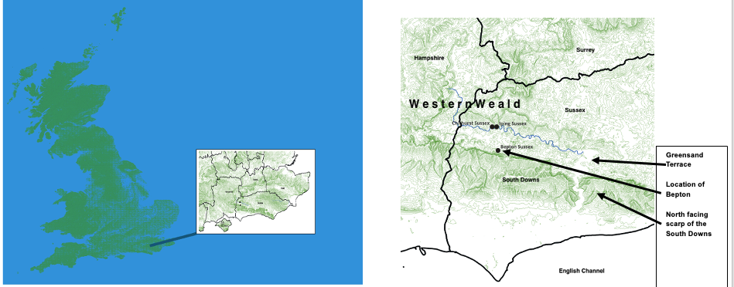
Figure 2: Location Maps: Left: Southeast England within the British Isles, Right: Location of the settlement of Bepton, Sussex, in the scarp foot zone showing its physical relation to the north facing scarp of the South Downs

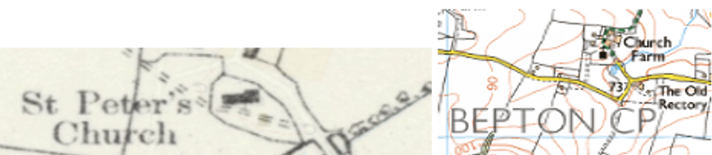
Figure 3 Above: OS Maps of St Mary’s Churchyard Bepton, Sussex: Right the c. 1883-1913 6” map. Right: the modern OS Map. The distinctive ‘D’ shaped curvilinear enclosure is clear

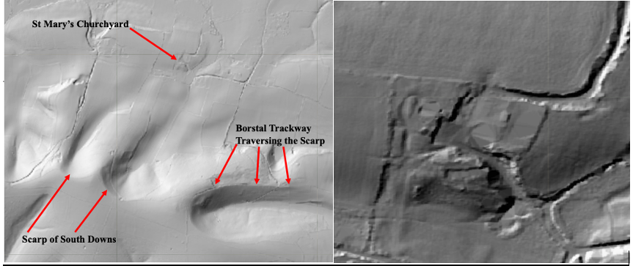
Figure 4 Above: LiDAR images of St Mary’s Churchyard in Bepton, Sussex showing its place/relationship in the landscape and the distinctive ‘D’ shaped curvilinear enclosure of the churchyard

Geology & Topography
St Mary’s Churchyard (NGR SU 85513 18279) is in the village of Bepton in Sussex St Mary’s churchyard in the Western Weald. The churchyard is located on the Greensand terrace (see figure 2 above). Examination of both the historic and contemporary OS maps reveals that there is a pond to the southeast of the churchyard (NGR SU 85552 18238) fed by a stream that originates further to the north on the Greensand terrace.
Phenomenological Experience of Encountering St Mary’s Churchyard on the 24^{th of} September 2025
In my desk based functionalist pre site research undertaken prior to visiting St Mary’s churchyard I had studied St Mary’s churchyard using digital OS maps, and aerial and street views via Google Earth. I visited St Mary’s churchyard late in the afternoon of the 24th of September 2025 with my friend Dr Dawn West Cansfield who helps me with my fieldwork due to my mobility issues. We parked in the parking laybys either side of the lane that leads to St Mary’s Churchyard and to the farmyard that is located to the north. In both aerial and street view in Google Earth I had extensively studied the landscape of St Mary’s churchyard and the surrounding landscape. Google street view did not show the extent of the pond or how the pond’s surface acted as a reflective mirror of the landscape and the Oak trees that are growing on the bank next to the pond. We first looked at the pond, and I marvelled in the fact that in the late early autumn afternoon which had a blue sky and was sunny that the pond’s surface acted as a mirror with areas of light reflecting the sky and darkness where the canopy of the Oak trees was reflected. This was markedly different from Google street view which showed the pond as a small dark area hidden by foliage.
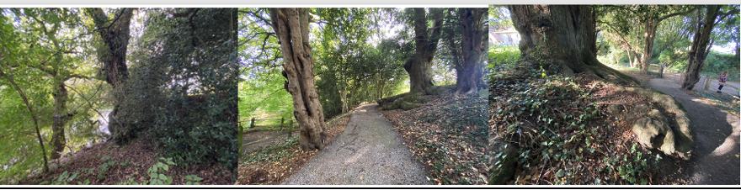
Figure 5 Above: Three photographs of the bank on the southeastern side of the curvilinear enclosure that contains St Mary’s Churchyard Bepton, Sussex:
Right: the bank from outside the enclosure showing the pond that is to the southeastern of the churchyard.
Centre: On the path that traverses the bank on the southeastern side of the curvilinear enclosure – looking south along the path.
Right: Standing at the other to the west of the bank looking back along the path

We then turned to the churchyard and were met by a ginormous bank (see photographs in figure 5), which was not apparent when looking at the southeastern and eastern boundary of the churchyard on Google street view. There was a small gate on this side of the churchyard boundary that opened onto a path that traversed the bank in a northeast – southwest direction. Entering through the gate and walking along the path and therefore up and along the top of the bank was a very liminal experience that felt to me as though I was crossing a limen. As we walked up the path to our right there were large trees growing on it and where this section of the bank terminated at its southeastern end there was a massive Oak tree with very large roots and then the path immediately turned right to the west skirting around the end of the bank. This allowed me to study the bank and the Oak tree and the Oak’s large roots. Large trees growing on ancient banks are one of my favourite features in the landscape. I love examining the relationship and asking “Bank – Tree? or Tree – Bank?” in terms of the stratigraphy does the bank have a terminus ante quem (before) relationship to the tree and the tree a terminus post quem relationship to the bank? Standing there looking at this bank which I was standing on instead of my normal position of examining a bank while being adjacent to it, I realised that St Mary’s churchyard is sited on a probable curvilinear enclosure or llan churchyard that is a very ancient site.
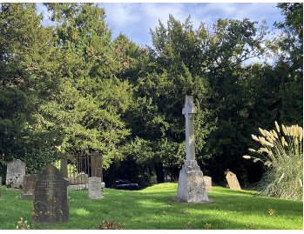
Figure 6 Above: Photograph of the interior of St Mary’s Churchyard Bepton, Sussex standing on the top of the curvilinear enclosure. The height of the enclosure is clear from the view of the roofs of our cars (visible in the lower centre of the photograph) parked in the lane to the east of the churchyard/enclosure.

My thoughts about St Mary’s churchyard being placed on an earlier curvilinear enclosure were reinforced when I moved from the bank to the area of churchyard to the south of the church and looked back I was now looking down on the roof of my car that was parked in the lane below because the enclosure area of the churchyard/curvilinear enclosure was a mound so high that I was physically not just above the ground surface of the lane but above the roof of my car (see figure 6 above).

My Hierophany in St Mary’s Churchyard
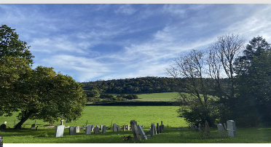
Figure 7 Above: a bench placed in the churchyard deliberately in a position that allowed the view of the scarp of the South Downs (seen here is Bepton Down) to be enjoyed

After we had walked around St Mary’s Churchyard we sat on a bench that had been deliberately placed in a location so that sitting on the bench one would have a magnificent view of the scarp of the South Downs which at this point in the scarp was Bepton Down (see figure 7). While sitting there I told my friend Dawn about what Christopher Tilley wrote in his foreword in Space Place Religious Landscapes: Living Mountains that while he was writing the foreword in his study in his home, he could see the scarp of the South Downs from his study window:
As I am writing this I can see the ridge top of the South Downs through my study window…Threaded like pearls by Neolithic long barrows & far more numerous Bronze Age round barrows the ridge [scarp of the South Downs] forms a memorious ancestral landscape in which temporality has seemingly been arrested.
I explained to Dawn that from Tilley’s description of this encounter that he had with the scarp of the South Downs from a particular place – his home that in being able to see some of the many Bronze Age round barrows that are situated on the scarp of the South Downs – the scarp in that place had to be bare of afforestation. While we were sitting on this bench in St Mary’s churchyard we could only see and experience the scarp of the South Downs as a wooded hillside, which hid barrows that are there from sight/view. At that point I unlocked my iPhone and open my OS map app, and we looked at the OS map to see where on the scarp the barrows were located. The digital OS map showed us that the wooded hillside

that we could see was Bepton Down. The map also showed us that just to the east of Bepton Down and still within our view was a small hill on the scarp of the South Downs called Linch Ball, and marked on the digital OS map on Linch Ball tin the antiquated typescript that the OS uses for archaeological antiquities in the landscape was the word ‘tumuli’ denoting more than one Bronze Age barrow. Had Linch Ball not been afforested we could have encountered these tumuli in the same way as Tilley “Threaded like pearls” and as “a memorious ancestral landscape in which temporality has seemingly been arrested.”
But we couldn’t see the barrows “threaded like pearls” because of the afforestation of the scarp. Still sat there we then discussed the role of the many Bronze Age round barrows that are found along the scarp of the South Downs and the role that they would have played in functioning like a calendar in the landscape for the people who lived and worked in the scarp foot zone of the Weald and Downland in the time before the invention in the early modern period of modern time and mechanical clocks.; and before then these people living here would have used particular barrows located at particular places of the scarp in conjunction with the rising sun to the east / south east in order to mark particular times in the agricultural year (and I’m typing this on Plough Monday!). In comparison to my one sided account of Tilley’s encounter with the barrows on the scarp, this part of our conversation was more shared as Dawn being a prehistorian was familiar with this acknowledged role of the barrows on the scarp and their role in the Long Neolithic of time – the concept that the Neolithic is still with us through the monuments that it has left.

The Blue Sky & the Sun & the Yew Tree, the Trees & Their Shadows & the Reflections in the Pond

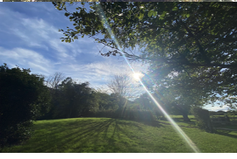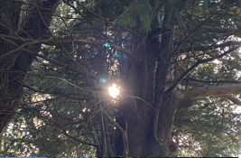
Figure 8 Above: The visit occurred on the 24/9/25 in the late afternoon after 4PM BST. The sun was low in the sky (left photograph) casting shadows of the trees on the ground and light radiated through the branches of this ancient Yew (right photograph)
It was a beautiful warm sunny autumn day with a blue sky, but we had arrived at St Mary’s Churchyard after 4PM and so the sun was by then low in the sky and its late afternoon position was casting shadows of the trees onto the ground which gave the churchyard a magical and liminal feel. In shining through the branches of one of the several ancient yew trees that were growing in St Mary’s churchyard, the sun appeared as a solar disc between the branches and for me this experience invoked the ancientness of this sacred and liminal site. The large yew trees in St Mary’s churchyard probably predated the church, being planted in the time when this curvilinear enclosure was frequented by pre-Christians. Looking at this Yew tree – and Yew trees are my favourite species of tree – with the sun appearing as a solar disc shining through its tall branches really allowed me to feel that I was at that moment experiencing a hierophany in a liminal place. I asked myself: “Was the Yew tree deliberately planted in that spot in order that people might

experience the solar disc of the sun as the sun was low in the sky?” The Yew tree was not the only tree that enabled an engagement with the sun in the late afternoon. A smaller tree had its shadow cast on the ground of the churchyard.

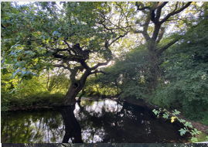
Figure 9 Above: After leaving the churchyard we looked at the pond to the southeast of the churchyard
We left the churchyard by the same path and the same gate and then we took a few minutes to study the pond. The bank in the southeast of the curvilinear enclosure extends in a southeastern direction but has been cut through by the pond with the pond’s waters flowing through the cutting – giving the pond a terminus post quem (after) relationship to the bank which thus had a terminus ante quem (before) relationship to the pond. I also studied the giant Oak trees that were growing on the bank and at the termini of the two parts of the bank.
The surface of the pond was also very indicative of the time of day with the sun low in the sky was casting many shadows of the Oak trees growing on the bank onto the reflective surface of the pond. The shadows formed dark areas on the pond’s surface while the areas were there weren’t any shadows were light so that the surface of the pond was acting like a mirror in its reflection of the landscape of the bank and trees and the skyscape of the blue autumnal sky. For me this was another hierophany a moment where I felt connected to this ancient landscape and ponds as bodies of ancient water are another of my favourite landscape features.

Reflection On My Hierophanous Fieldwork
Functionalist Reflections:
My fieldwork was based on functionalist principles of archaeological fieldwork. In the pre site visit desk-based research – the study of online digital historical and contemporary OS maps and studying the landscape of the site via Google Earth. My biggest takeaway is that Google Earth did not show that St Mary’s churchyard is a probable curvilinear enclosure and therefore a very ancient pre-Christian sacred site. But: after my visit to St Mary’s churchyard, I looked online at LiDAR images of St Mary’s Churchyard (figure 4 above)and these clearly show the shape of the churchyard that it is a probable curvilinear enclosure. So, whilst Google Earth is not always good at showing a site, LiDAR images are different and are good at showing the sites topography.

Phenomenological Reflections:
The view of the scarp close up in parts where it is afforested result in a very different experience of engagement because the scarp is wooded and its not possible to see the archaeology on the scarp such as the Bronze Age round barrows as Tilley could see them on the part of the scarp that he could see from his study window in his home out in the Weald. The best way to appreciate the scarp of the South Downs is from slightly further out in the Weald where a stretch of the scarp is in view, or at viewpoints on the top edge of the scarp where the South Downs are seen to be snaking through the landscape.
The hierophany that I experienced when visiting St Mary’s churchyard in person or rather the hierophanies – plural – several hierophanies rather than a single continuous hierophany, allowed me to engage with this ancient sacred site and to feel that I was a part of the landscape and that it was a beautiful sacred and liminal place. I was communing with the landscape. My many numerous experiences of being on or seeing the South Downs from the Wealden scarp foot are experiences of my communion with this landscape of which I’m very much an integral part. The Weald and Downland is my place in the cosmos.
Conclusion:
I have been undertaking archaeological fieldwork in the Weald and downland my entire archaeological career, but my fieldwork in my visit to St Mary’s churchyard in Bepton, Sussex was the first time that I deliberately included the methodologies of phenomenological and OI – Organic Inquiry into the fieldwork in allowing myself to commune with this sacred landscape and to treat it as a co-researcher rather than just as a subject of my research and undertaking the research in a solely functionalist way where I was detached and outside of the fieldwork. In doing this I opened myself up to experiencing hierophanies while there and in doing so I experienced the sacredness and liminality of St Mary’s churchyard a place that the archaeological evidence suggests is a curvilinear enclosure and which has therefore been a sacred and liminal place for at least two millennia. This experience of using phenomenology and OI- Organic Inquiry to study this sacred and liminal place will now become a core methodology in my ongoing archaeological research and fieldwork in the probable 68 curvilinear enclosures in the Sussex Weald and Downland.

Acknowledgement:
I would like to thank my friend Dr Dawn West Cansfield for assisting me with the visit to St Mary’s Churchyard on the 24/09/2025 due to my mobility problems.
[word count = 5379 words excluding footnotes and bibliography]
Bibliography:
Bell, Martin, Making One’s Way In The World: The Footprints and Trackways of Prehistoric People (Publisher, 2020)
Brandon, Peter, The Kent & Sussex Weald, Phillimore, 2003
——, The North Downs, Phillimore, 2005
——, The South Downs, Phillimore, 1999
——, The Sussex Landscape, Hodder & Stoughton, 1974
Calder, Michael, ‘Early Ecclesiastical Sites in Somerset: Three Case Studies’, Somerset Archaeology & Natural History, 147 (n.d.), pp. 1–28
Coates, Richard, Hampshire Place-Names, Batsford & Ensign, 1989

Curry PhD, Deah, and Steven J. Wells, An Organic Inquiry Primer for the Novice Researcher: A Sacred Approach to Disciplined Knowledge (Infinity Publishing, 2913)
Durkheim, E. (trans. J.W. Swain), The Elementary Forms of the Religious Life, Allen & Unwin, 1912
Eliade, M, The Sacred and the Profane: The Significance of Religion, Myth, Symbolism and Ritual Within Life and Culture, Harcourt, Brace and World Inc., 1959
Hunter, Jack, ‘Introduction II’, in Sacred Geography Conversations with Place, ed. by Bernadette Brady and Jack Hunter (Sophia Centre Press, 2024)
King, Andy, ‘Historic England Strategic Stone Study A Building Stone Atlas of West Sussex (Excluding Part of the South Downs National Park)’, preprint, SDNPA South Downs National Park Authority, 2015 <https://www.southdowns.gov.uk/wp-content/uploads/2016/12/West_Sussex_building_stone_Atlas.pdf> [accessed 24 December 2025]
Lane, Belden C., Landscapes of the Sacred (John Hopkins University Press, 2001)
Margetts, Andrew, The Wandering Herd: The Medieval Cattle Economy of South-East England, c. 450-1450 (Windgather Press, 2021)
Stockwood, Meryn, Chanctonbury Ring the Autobiography of Mervyn Stockwood (Hodder & Stoughton, 1982)
Tilley, Christopher, A Phenomenology of Landscape: Places, Paths and Monuments (Explorations in Anthropology), Berg, 1994
——, ‘Foreword’, in Space, Place and Religious Landscapes Living Mountains, ed. by Darrelyn Gunzburg and Bernadette Brady, Bloomsbury, 2021
Websites:
ADS Archaeological Data Service: https://archaeologydataservice.ac.uk/library/browse/organisationDetails.xhtml?organisationId=1912

Google Earth: https://earth.google.com/web/?authuser=0

Hampshire County Council HER: https://maps.hants.gov.uk/historicenvironment/nonmap.aspx
LiDAR Finder: https://www.lidarfinder.com/
OS Digital Maps:
https://explore.osmaps.com/?lat=50.95278&lon=-0.80889&zoom=13.0355&style=Leisure&type=2d
SDNPA South Downs National Park Authority:
https://www.southdowns.gov.uk/wp-content/uploads/2016/12/West_Sussex_building_stone_Atlas.pdf
https://www.southdowns.gov.uk/discover/heritage/writers-and-the-downs/
Weald & Downland Living Museum: https://www.wealddown.co.uk/buildings/treadwheel-from-catherington/

https://www.wealddown.co.uk/buildings/treadwheel-from-catherington/ accessed 12 January 2026
https://maps.hants.gov.uk/historicenvironment/nonmap.aspx accessed 12 January 2026
Richard Coates, Hampshire Place-Names, Batsford & Ensign, 1989.pp.49-50
Andy King, ‘Historic England Strategic Stone Study A Building Stone Atlas of West Sussex (Excluding Part of the South Downs National Park)’, preprint, SDNPA South Downs National Park Authority, 2015 <https://www.southdowns.gov.uk/wp-content/uploads/2016/12/West_Sussex_building_stone_Atlas.pdf> [accessed 24 December 2025]. p.19 accessed 24 December 2025.
Peter Brandon, The Sussex Landscape, Hodder & Stoughton, 1974; Peter Brandon, The South Downs, Phillimore, 1999; Peter Brandon, The Kent & Sussex Weald, Phillimore, 2003; Peter Brandon, The North Downs, Phillimore, 2005.
Michael Calder, ‘Early Ecclesiastical Sites in Somerset: Three Case Studies’, Somerset Archaeology & Natural History, 147 (n.d.), pp. 1–28.
Martin Bell, Making One’s Way In The World: The Footprints and Trackways of Prehistoric People (Publisher, 2020); Andrew Margetts, The Wandering Herd: The Medieval Cattle Economy of South-East England, c. 450-1450 (Windgather Press, 2021).
E. (trans. J.W. Swain) Durkheim, The Elementary Forms of the Religious Life, Allen & Unwin, 1912.
Deah Curry PhD and Steven J. Wells, An Organic Inquiry Primer for the Novice Researcher:A Sacred Approach to Disciplined Knowledge (Infinity Publishing, 2913).
https://explore.osmaps.com/?lat=50.95278&lon=-0.80889&zoom=13.0355&style=Leisure&type=2d accessed 12 January 2026
https://archaeologydataservice.ac.uk/library/browse/organisationDetails.xhtml?organisationId=1912 accessed 12 January 2026
Christopher Tilley, A Phenomenology of Landscape: Places, Paths and Monuments (Explorations in Anthropology), Berg, 1994. pp.11-12
Tilley, A Phenomenology of Landscape: Places, Paths and Monuments (Explorations in Anthropology).
E Durkheim . (trans. J.W. Swain), The Elementary Forms of the Religious Life, Allen & Unwin, 1912. In Jack Hunter, ‘Introduction II’, in Sacred Geography Conversations with Place, ed. by Bernadette Brady and Jack Hunter (Sophia Centre Press, 2024). p.11
M Eliade, The Sacred and the Profane: The Significance of Religion, Myth, Symbolism and Ritual Within Life and Culture, Harcourt, Brace and World Inc., 1959. p.11
Belden C. Lane, Landscapes of the Sacred (John Hopkins University Press, 2001). p.19
Lane, Landscapes of the Sacred.p.19
Rudyard Kipling poem ‘Sussex’, published on the Kipling Society website: accessed 12 January 2026
The South Downs National Park Authority website: https://www.southdowns.gov.uk/discover/heritage/writers-and-the-downs/ accessed 12 January 2026
Meryn Stockwood, Chanctonbury Ring the Autobiography of Mervyn Stockwood (Hodder & Stoughton, 1982).pp.99, 103,193, 196,201, 206,211
OS 1:25,000 map on the OS website and OS map app on my iPhone
https://earth.google.com/web/?authuser=0 accessed 22 September 2025
Christopher Tilley, ‘Foreword’, in Space, Place and Religious Landscapes Living Mountains, ed. by Darrelyn Gunzburg and Bernadette Brady, Bloomsbury, 2021. Kindle edition location 130 of 6296

