IS ARCHAEOLOGY A POLITICAL PRACTICE?
Evan Davies

Introduction to Archaeology HPAR4002
Quentin Drew
University of Wales Trinity Saint David
Nov 19, 2023

Is the nature of Archaeology political? To answer this question with one word. Yes, Archaeology is a political practice. It is political in many ways. Ranging from the morals and ethics, funding, and people weaponizing Archaeology for their own goals. However, in this essay the main focus on the political side of Archaeology will come from the morals and ethics behind the practice and examples such as Saartjie Baartman, a Griqua woman of the Khoisan that was stolen by Europeans, the indigenous populations of both Australia and America and their perspectives of the discipline, and many more examples. This essay will also mention the xenophobic and nationalistic people that use Archaeology to attack people and further their xenophobic beliefs. Xenophobia by definition is prejudice to someone due to their origins, such as the country they come from. When talking about the xenophobic issues with Archaeology, the source that will be used for this will be Gustafsson and Karlsson. For the ethics and morals side of the argument, the sources that will be relied on will be Drews presentation on Archaeology and Politics and Watkins with their book on Indigenous perspectives on Archaeology. McGuire’s article on Politics in Archaeology will also be used, to give an idea on some archaeologists view on the political side of the discipline.
The political party in Sweden, named The Sweden Democrats, are an ultra-right wing political party with a xenophobic standpoint and goal. They have xenophobic views on the immigration and integration policies Sweden has put in place (Gustafsson & Karlsson, 2011, p. 12). The Sweden Democrats have turned to cultural heritage with an interest in the field and the possibilities it holds, that can help the party promote their xenophobic political views (Gustafsson & Karlsson, 2011, p. 12). The political party are wanting to construct an image on what ‘Swedishness’ is. The Sweden Democrats have turned to material culture in order to have a clear view on the image of ‘Swedishness’ (Gustafsson & Karlsson, 2011, p. 12). Swedish Archaeologist have been concerned on the invasion of xenophobia and nationalism into their fields. However, they have had discussions on how they can continue their work and continue forwards without the invasion of xenophobia and nationalism from political parties such as The Sweden Democrats. For example, the Archaeologist of Sweden can contribute to the conversations and discuss the concerns they have including strategies and how they should adopt the current relations with the political parties with the embrace ultra-right wing parties have with Archaeology (Gustafsson & Karlsson, 2011, p. 13). The Sweden Democrats wish to gain better relationships with institutions and organisations that have the aim to preserve the Swedish cultural heritage, the party say that the multiculturalism in Sweden has pushed a neglect onto the cultural heritage of Sweden and are saying that it is threatened under the current political party (Gustafsson & Karlsson, 2011, p. 17). At the end of the article Gustafsson and Karlsson mentioned that it will be difficult to carry out the strategies, especially considering they are relying on the parliament and the policies they put in place. They are also worried on the growth of The Sweden Democrats, and if they are to grow this could potentially dangerously harm Archaeology in Sweden. However, the main goal is to protect the multicultural and solidaristic Swedish society from the dangers of xenophobia and nationalism (Gustafsson & Karlsson, 2011, p. 32).
There are many examples of politics being very present in Archaeology. An example of politics being present in Archaeology would be the indigenous populations issues with the practice. The indigenous communities of both America and Australia have been threatened by archaeologists since the practice came across the shores of the new world. The communities have been threatened, items ‘stolen’, and many more instances where the indigenous populations have been abused and taken advantage of. To gain a perspective, the use of a questions and answers from an article written Kelley and Neller was used. Kelley said they there must be consideration and respect to the artefacts archaeologists and collectors have. They must take into consideration the relativity of the objects, whether it is spiritual or not. As it was owned by someone beforehand, therefore, there must be respect (Kelley, Neller, Carlton Shield Chief Gover, & AAP Thematic-Issue Editors, 2022, p. 3). Using an article written by Joe Watkins, called Through Wary Eyes: Indigenous Perspectives on Archaeology. There will be points in providing evidence on how Archaeology is a political practice. During the 19th century archaeologist would use the discipline to rationalise the Euro-American prejudices against the native populations of the American continent. Today, rather than being more supportive of indigenous populations, archaeologist have ignored them all together. Kehoe argued in 1998 that the archaeologists have been continuing to ignore the populations of the natives in America and have viewed them to belonging outside of the sciences, and act like they only could understand and present the process that leads to the development of Native American culture (Watkins, 2005, p. 433).
In the United States of America, archaeologist must have communication with Native Americans in order to carry out the practice. The reason they must do this is due to the legislations of the Graves Protection and Repatriation Act of 1990, the National Historic Preservation Act of 1966, and the Archaeological Resources Protection Act of 1979. The legislations push both archaeologist and Native American populations to cooperate with each other in order for the archaeologist to consider carrying out fieldwork (Watkins, 2005, p. 434). Proving to us that archaeology relies on legislation and political communications with indigenous populations. These conversation between both are formal and take time and resources to have. However, the Native American population value their sites. Therefore, archaeologist must be careful and considerate of them if they mean to do investigations on the sites of the Native American population. Canada does not have anything that governs their Archaeology. However, the relations of the First Nations in Canada and the archaeologists is strong (Watkins, 2005, p. 434). An example of the good relationship the First Nations and archaeologist have in Canada is the Simon Fraser University in British Columbia and the Secwepemc, also known as the Shuswap Nation. They have led a collaborative programme. There are many more examples of the First Nations and archaeologists working collaboratively with each other. Including the Yukon Heritage Branch’s relationship with the Carcross also known as the Tagish (Watkins, 2005, p. 435).
In Australia the native Aboriginals have been using Archaeology to strengthen their claims to land. Through physical remains and material culture found in archaeological excavations of certain areas. The Aboriginals of Australia have also been using Archaeology to strengthen their native claims to repatriation of their cultural items. They have also used Archaeology for the protection of their dead (Watkins, 2005, p. 439). This example infers that there are not just negative relationships between the indigenous populations and archaeologist. In some cases, there are positive conclusions to the native populations when Archaeology is involved, as it can help strengthen claims, as seen by the Australian Aboriginal communities and their use of Archaeology and relationships. Archaeology has had a dark past with these sorts of situations. However, with the evolution of the discipline and archaeologists being more ethical, it becomes much more comfortable to study and to have relationships with indigenous communities.
Saartjie Baartman was a woman born in c. 1789. She was a woman of the Griqua tribe of the eastern Cape. Which were a subgroup of the Khoisan. She was the last member of her tribe and was captured in 1810 by the European colonists. She would unfortunately die in captivity in 1815. Saartjie’s life would be miserable, she would be in a freakshow, parading around being used due to her body type. She would also go into sex work at such a young age. Saartjie Baartman would be taken into display after she died. Her body on showcase due to her ‘exoticness’ as she had a different body type, as she was pygmy (Drew, 2023). She had steatopygia which is the reason that resulted in her “extremely protuberant buttocks due to a built up of fat” (Parkinson, 2016). Her brain skeleton, and sexual organs would continue to be put on showcase by the Paris’ Museum of Man until 1979 (Parkinson, 2016). Her body would be stuffed and would be taken into the crypt of the Museum, where only private audiences would be held that had to be arranged. She would eventually be repatriated in 2002. Saartjie Baartman’s funeral would be held in Port Elizabeth on the 9th of August 2002 (Drew, 2023). This is a sensitive topic, and is highly unethical, archaeologist would be involved with the study of Saartjie Baartman, and this would prove to be very political due to the morality behind it. Raising questions on the ethics of Archaeology. This is a very disgusting past behind archaeology, anthropology and the humanities in general. In the future, the disciplines can only hope to improve and not make the same mistakes of ethics. Fortunately, the discipline has been learning from its past mistakes, and is continuing to be more ethical and moral in many cases.
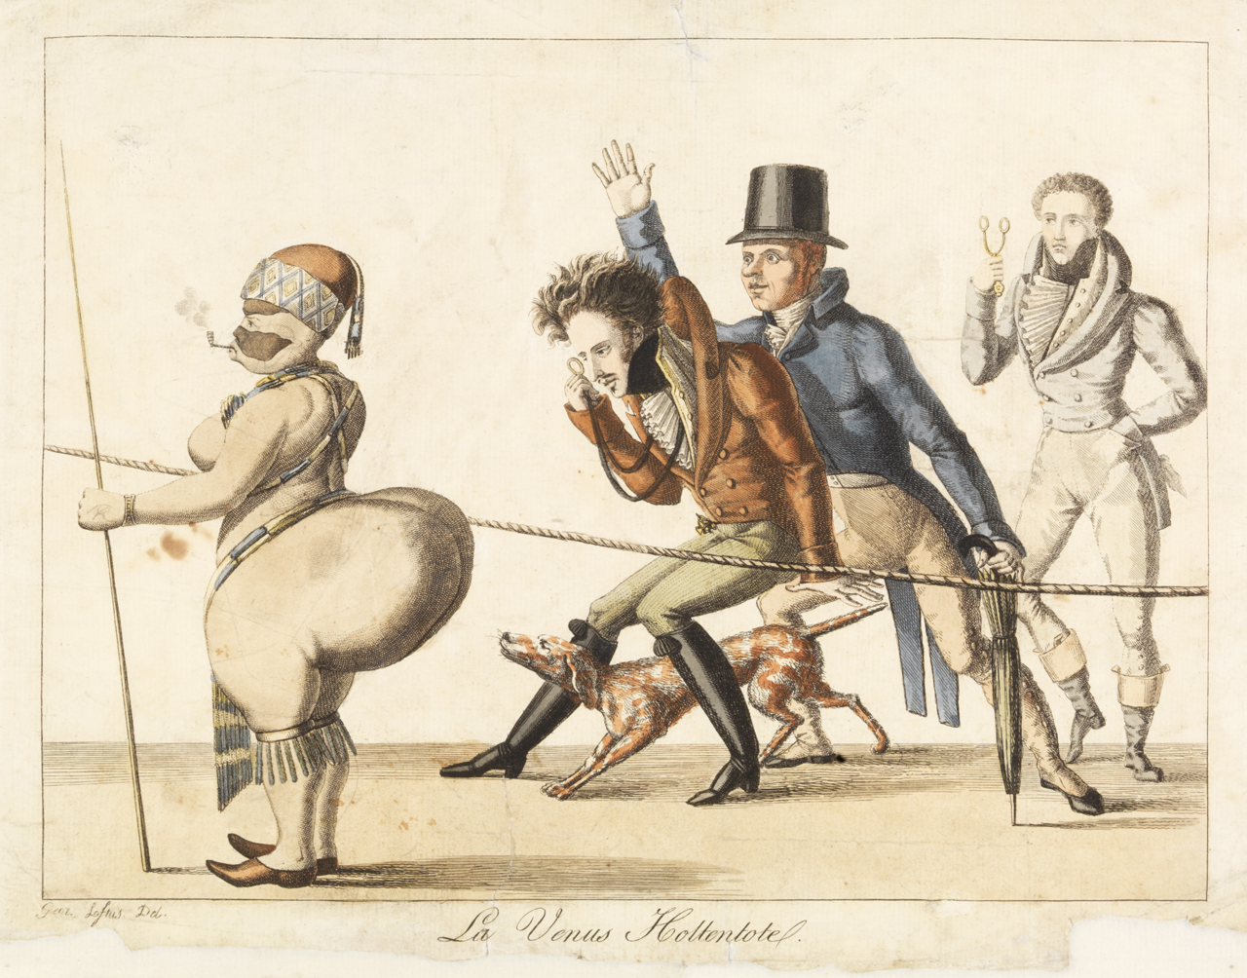
La Venus Hottentote (Loftus, 1814).
In Archaeology there is an issue of some shying away from the political sides of it. Seeing politics as the dirty business, full of dishonesty. Another reason why archaeologist hide from many political discussions is due to the emotional topics of morals and ethical attitudes, and how many people may argue about these topics due to the practice having a history behind it (McGuire, 2011, p. 17). Despite this small issue in Archaeology, the attitudes many other archaeologists have with the politics behind the discipline is good. There have been many conversations on the ethics, such as the cooperation and collaboration archaeologists have had with the indigenous populations. Ensuring not to offend the native populations and gaining permission on carrying out investigations, rather than being inconsiderate like they have been in the past and just carrying out excavations and work without the native populations granting access first. The Aboriginal population in Australia have also used Archaeology as a weapon to help them with native claims on land, cultural items and the dead. Therefore, even though Archaeology has harmed these indigenous communities in the past, there have been efforts on Archaeology aiding them and support them in many ways, intentionally or unintentionally. The look at the history of some of the unethical and immoral instances where archaeology was involved, looking at the history of Saartjie Baartman and the issues behind what happened, and what can be learnt from it. Also considering the issue of nationalism and xenophobia being dangerously close to taking control of Archaeology in Sweden, and how the political party of the Sweden Democrats, which are ultra-right wing have been ‘supporting’ the Archaeological world in Sweden in many ways. To conclude, yes, Archaeology is a political practice, and has always been. There are always issues with ethics and morality with Archaeology, and archaeologist must always ask themselves whether the excavations they do is ethical enough and will not harm communities by carrying out the excavation. As well, there is always a threat of dangerous politics coming into Archaeology, which can affect the discipline for the worst.
Reference List:
Drew, Q. (2023). Introduction to Archaeology: Archaeology and Politics, People and Place. Accessed: Moodle. (Accessed: 9 Nov 2023).
Gustafsson, A. & Karlsson, H. (2011). A Spectre is Haunting Swedish Archaeology – The Spectre of Politics: Archaeology, Cultural Heritage and the Present Political Situation in Sweden. Current Swedish Archaeology.
Kelley, A.D. Neller, A.J. Carlton Shield Chief Gover. AAP Thematic-Issue Editors. (2022). Some Indigenous Perspectives on Artifact Collecting and Archaeologist-Collector Collaboration. Cambridge: Cambridge University Press.
Loftus, G. (1814). La Venus Hottentote. [Print]. Special collections. Available at: https://www.rmg.co.uk/collections/objects/rmgc-object-254860. (Accessed: 12 November 2023).
McGuire, R.H. (2011). Archaeology as Political Action. Berkeley: University of California Press.
Parkinson, J. (2016). ‘The significance of Sarah Baartman’, BBC News, 7th January. Available at: https://www.bbc.co.uk/news/magazine-35240987. (Accessed: 12 November 2023).
Watkins, J. (2005). Through Wary Eyes: Indigenous Perspectives on Archaeology. Albuquerque: University of New Mexico.

