Mocanu, Sonia
A Feasibility Study for a MICE Event Focused on Equality, Diversity, and Inclusion
Sonia-Lorena Mocanu (2233341)
International Meetings Management for the Hotel Industry (BMIH6007)
Lecturer: Kathryn Flynn

Unlocking Opportunities: Building Diverse and Inclusive Careers in Hospitality

AI Tools

I acknowledge the use of Grammarly (https://www.grammarly.com/) to check my work using the prompt(s):
1. Please check the following text for readability, grammar and syntax.
I confirm that I have not presented any AI-generated text as my work. I confirm I
have copies of my drafts, notes, and other resources I used before, and after the use of
AI tools which I may be asked to provide in evidence.

I acknowledge the use of Google and Google Scholar to support my research.
I confirm that I have not presented any AI-generated text as my work. I confirm I
have copies of my drafts, notes, and other resources I used before, and after the use of
AI tools which I may be asked to provide in evidence.

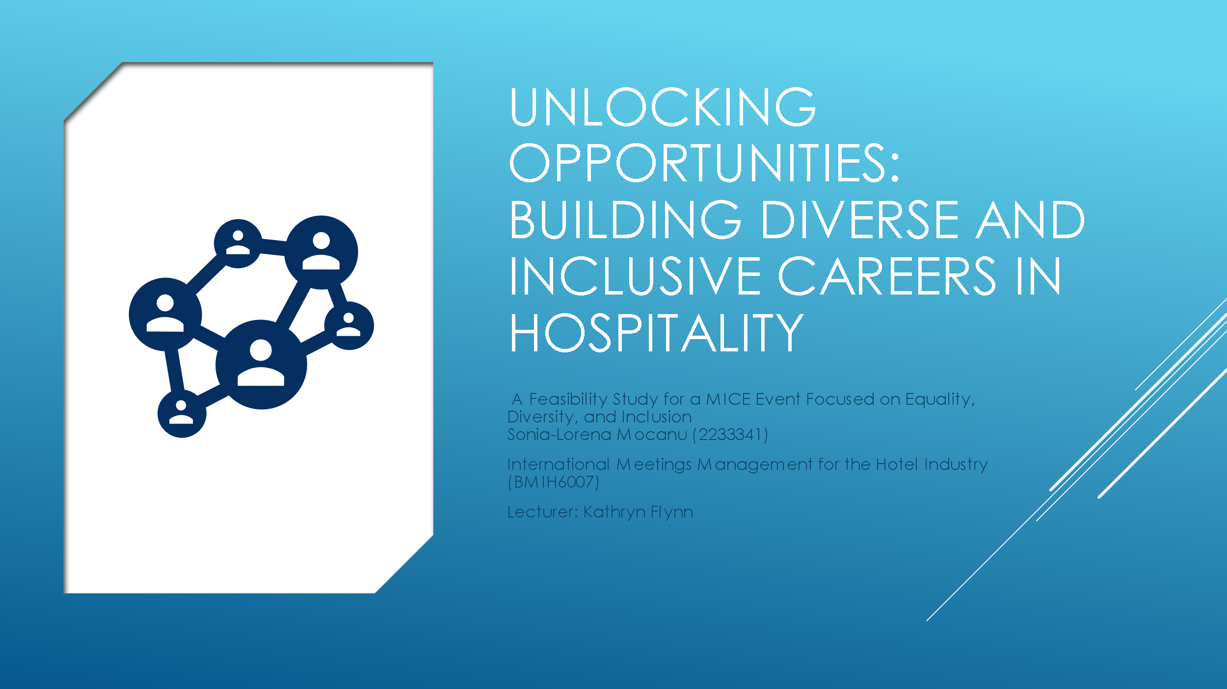
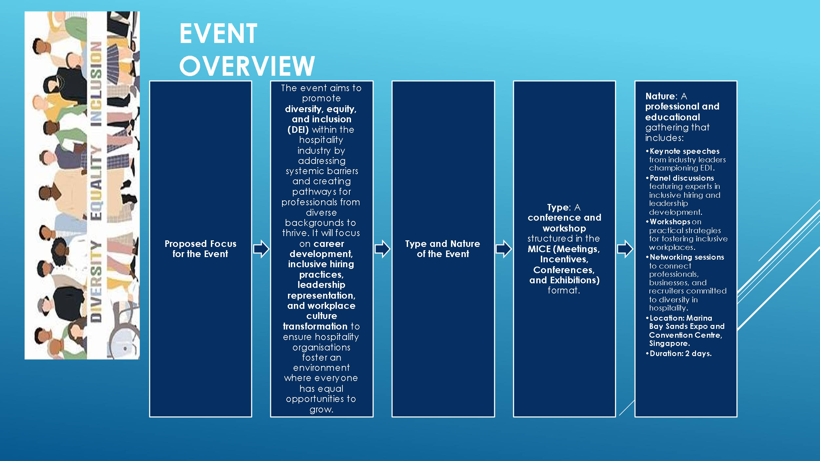
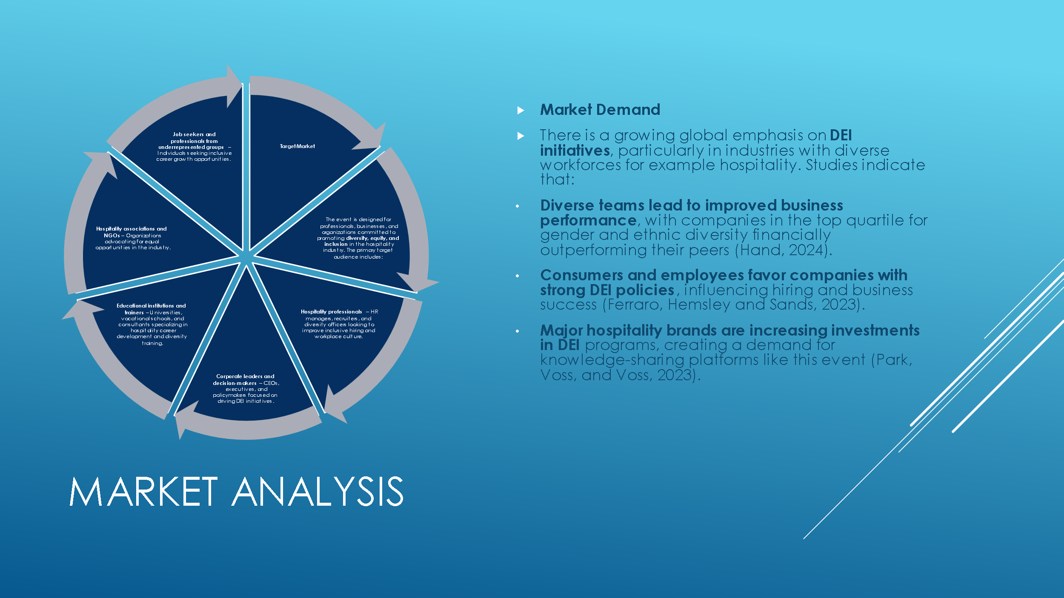
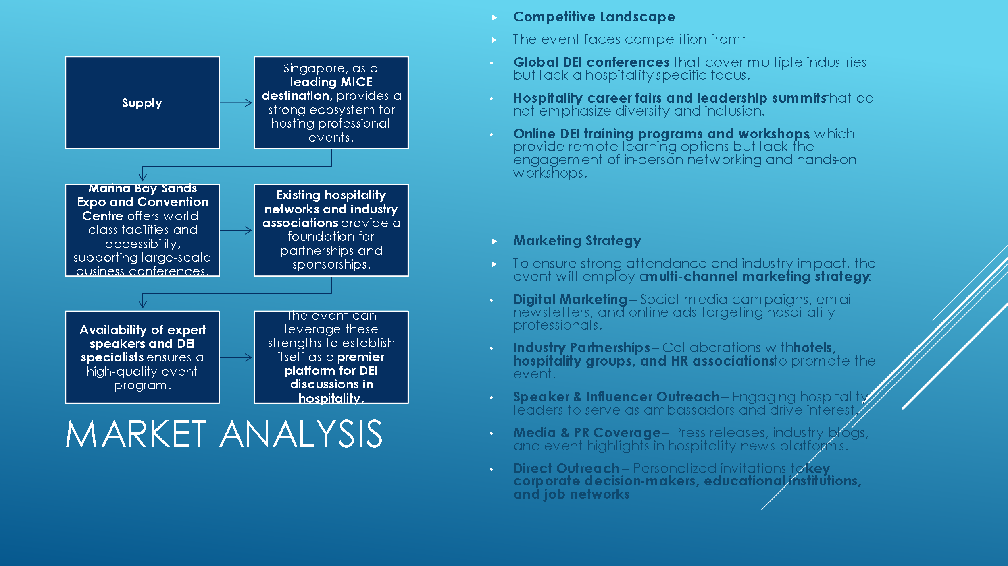
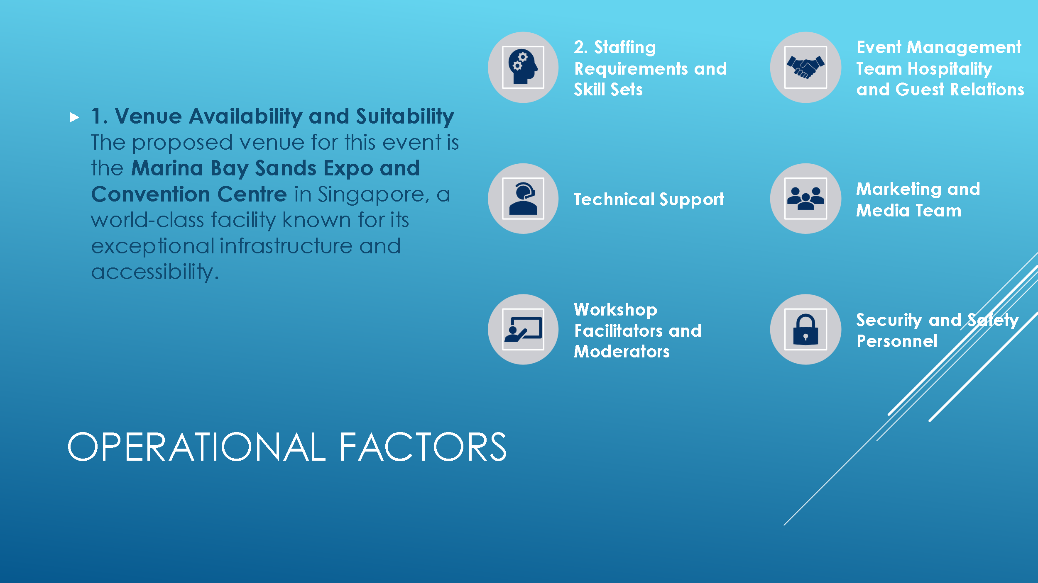

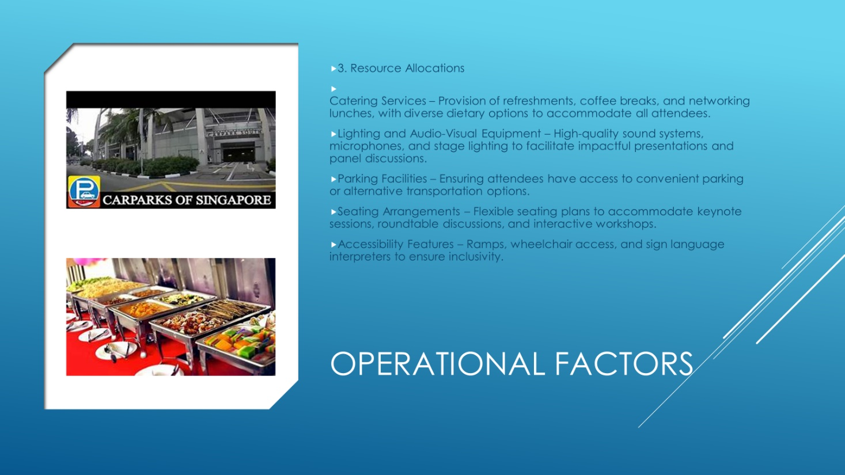
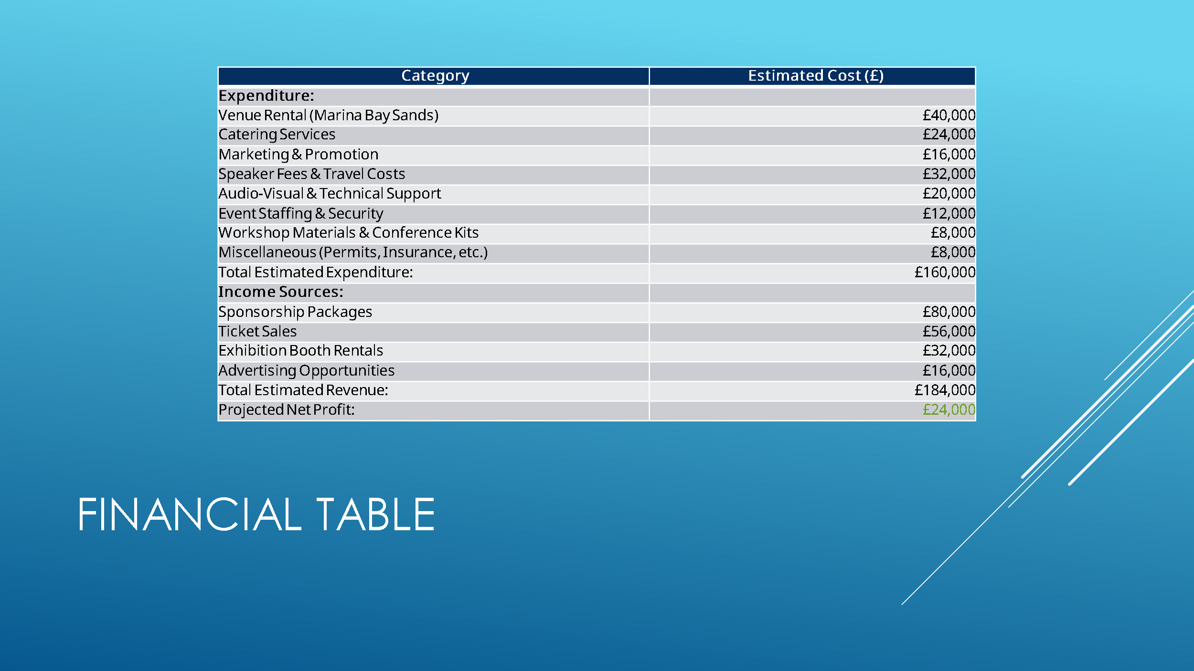
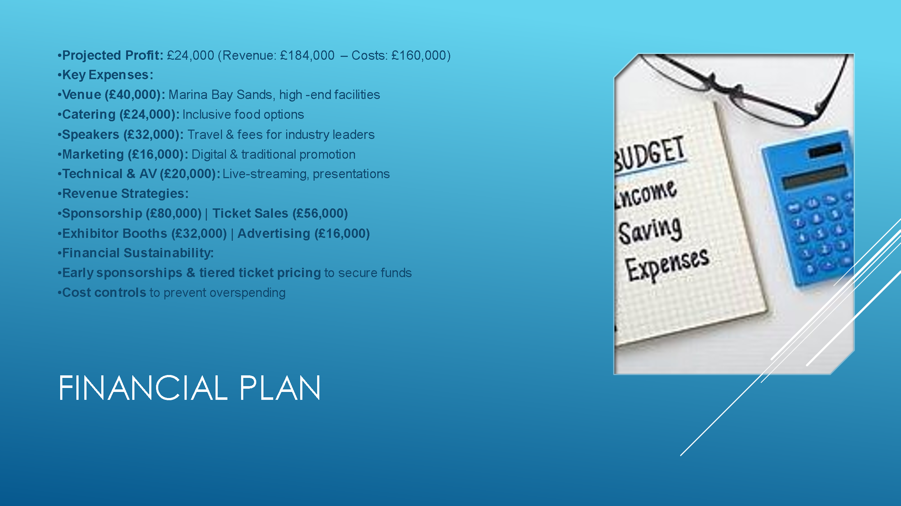
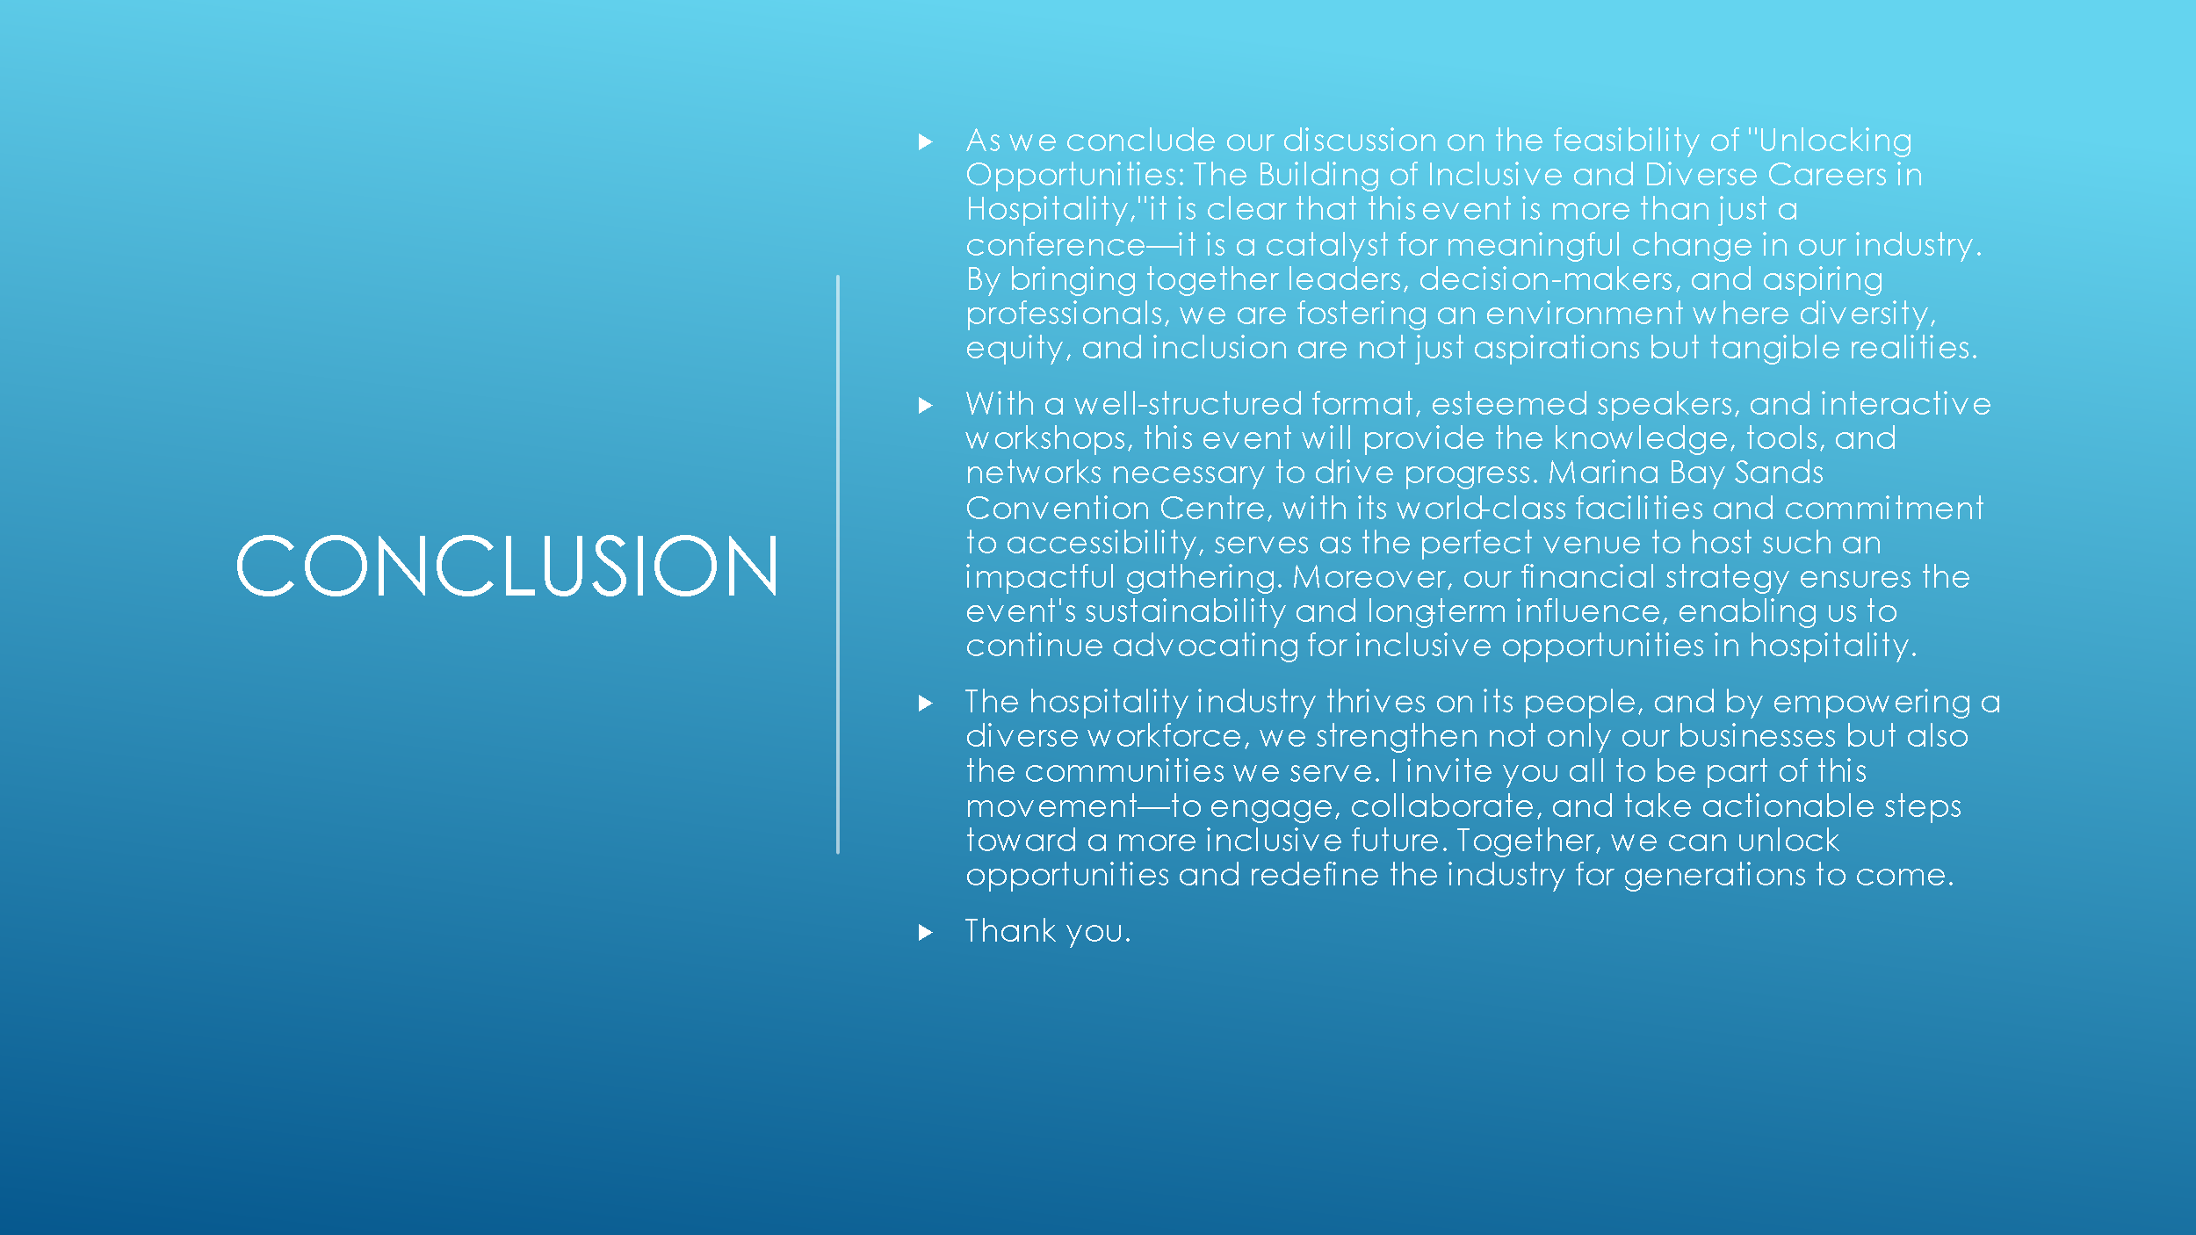

References list

Anon (2012) New venue for Asian Work Boat 2013 - Marina Bay Sands, Ausmarine. Melbourne: Baird Publications Pty. Ltd, pp. 13–13.
Bernauer, V.S., Bhati, A. and Thirumaran, K. (2023) ‘Guest editorial: (In)equalities in hospitality and tourism – exploring diversity and equity issues’, Equality, Diversity and Inclusion: An International Journal, 42(4), pp. 465–468. Available at: https://doi.org/10.1108/EDI-05-2023-378.
Bowdin, G.A.J. (2011) Events management. 3rd ed. Oxford: Elsevier Butterworth-Heinemann.
Dashper, K. and Finkel, R. (2020) ‘Accessibility, diversity, and inclusion in the UK meetings industry’, Journal of convention & event tourism, 21(4), pp. 283–307. Available at: https://doi.org/10.1080/15470148.2020.1814472.
Elliott, B. and Elliott, J. (2013) Financial accounting and reporting. Sixteenth edition. Harlow, England; Pearson Education.
Ferraro, C., Hemsley, A. and Sands, S. (2023) ‘Embracing diversity, equity, and inclusion (DEI): Considerations and opportunities for brand managers’, Business Horizons, 66(4), pp. 463–479. Available at: https://doi.org/10.1016/j.bushor.2022.09.005.
FHA HoReCa (2024) Diversity, Equality, and Inclusion (DEI) in Hospitality[blog].29 October. Available at: https://fhahoreca.com/blog/dei-in-hospitality-industry/ (Accessed: 29 January 2025).
Getz, D. and Page, S. (2024) Event studies: theory and management for planned events. Fifth edition / Donald Getz and Stephen J. Page. London: Routledge.
Hand, J.R.M. (2024) McKinsey’s Diversity Matters/Delivers/Wins Results Revisited’, Econ journal watch, 21(1), pp. 5.
Image (n.d) Marina Bay Sands open car park, Singapore. Available at: https://uk.images.search.yahoo.com/yhs/view;_ylt=AwrEoWNdDJxnLckpZW6e3olQ;_ylu=c2VjA3NyBHNsawNpbWcEb2lkA2I2NDBhZGNkZWQxODgyODFhYTEzNmE4YTFkOGNiNGY2BGdwb3MDMQRpdANiaW5n?back=https%3A%2F%2Fuk.images.search.yahoo.com%2Fyhs%2Fsearch%3Fp%3Dparking%2Bmarina%2Bbay%2Bsands%2Bexpo%26ei%3DUTF-8%26type%3Dfc_A5F50A81416_s69_g_e_d_n2002_c999%26fr%3Dyhs-fc-5214%26fr2%3Dp%253As%252Cv%253Ai%252Cm%253Asb-top%26hsimp%3Dyhs-5214%26hspart%3Dfc%26param1%3D7%26param2%3DeJwtj81qwzAQhF9ljwlIysqSnCg61YnzAKWnij04tuoI%252F2I7uPTpi0OYywczAzN1rLyjz6tENIk2nlHvHSWIiWe0WZ5R6R1Zaz2jOG6YCI0iVcJqz6gOg3dU3z2jZ%252BEddcNfbNviYATCbo19Nawz9AtIFOhgjX2qHfymeg%252FFOLZhDfcmLgejjkKlsGseS9cyaGMToA5lM%252ByhfExDFw5SSYGbYC5%252Biim%252BK9uoOb6HPucwvfiitMouBvk1tzmXMr%252Fxj%252BymeW50pqWyqPPTli%252Br19nEcJRc4RfiWcqzUkLZ4%252Fc%252FqG9RWw%253D%253D%26tab%3Dorganic%26ri%3D1&w=1280&h=720&imgurl=i.ytimg.com%2Fvi%2FdJckIO8PNbU%2Fmaxresdefault.jpg&rurl=https%3A%2F%2Fvymaps.com%2FSG%2FMarina-bay-sands-open-car-park-1080016%2F&size=295KB&p=parking+marina+bay+sands+expo&oid=b640adcded188281aa136a8a1d8cb4f6&fr2=p%3As%2Cv%3Ai%2Cm%3Asb-top&fr=yhs-fc-5214&tt=Marina+bay+sands+open+car+park%2C+Singapore&b=0&ni=90&no=1&ts=&tab=organic&sigr=1lzB0NC0oZsi&sigb=piK6hskVfe3t&sigi=jx6iLjdv3vhg&sigt=x4sRHZk8Nt3D&.crumb=nAJ0hqgItZ3&fr=yhs-fc-5214&fr2=p%3As%2Cv%3Ai%2Cm%3Asb-top&hsimp=yhs-5214&hspart=fc&type=fc_A5F50A81416_s69_g_e_d_n2002_c999&param1=7&param2=eJwtj81qwzAQhF9ljwlIysqSnCg61YnzAKWnij04tuoI%2F2I7uPTpi0OYywczAzN1rLyjz6tENIk2nlHvHSWIiWe0WZ5R6R1Zaz2jOG6YCI0iVcJqz6gOg3dU3z2jZ%2BEddcNfbNviYATCbo19Nawz9AtIFOhgjX2qHfymeg%2FFOLZhDfcmLgejjkKlsGseS9cyaGMToA5lM%2ByhfExDFw5SSYGbYC5%2Biim%2BK9uoOb6HPucwvfiitMouBvk1tzmXMr%2Fxj%2BymeW50pqWyqPPTli%2Br19nEcJRc4RfiWcqzUkLZ4%2Fc%2FqG9RWw%3D%3D (Accessed: 30 January 2025).
Image (n.d.) Budget. Available at: https://tse3.mm.bing.net/th?id=OIP.V2mIeXkg-V26SkxE8vhLWQHaE7&pid=Api&P=0&h=180 (Accessed:30 January 2025).
Image (n.d.) Catering Services. Available at: https://tse1.mm.bing.net/th?id=OIP.v1v594kJsQPEJ_jZiFShZwHaEK&pid=Api&P=0&h=180 (Accessed: 30 January 2025).
Image (n.d.) Diversity, equality and inclusion. Available at: https://tse4.mm.bing.net/th?id=OIP.NllX_H6DiuvrGyl93Qc1RAHaD_&pid=Api&P=0&h=180 (Accessed: 30 January 2025).
Kalargyrou, V. and Costen, W. (2017) ‘Diversity management research in hospitality and tourism: past, present and future’, International Journal of Contemporary Hospitality Management, 29(1), pp. 68–114. Available at: https://doi.org/10.1108/IJCHM-09-2015-0470.
Marina Bay Sands (2025) Meeting and Conventions. Available at: https://www.marinabaysands.com/expo-and-convention/spaces/meetings-and-conventions.html (Accessed: 28 January 2025).
Marina Bay Sands: one integrated resort, endless possibilities: captivating to the eye, Marina Bay Sands also reaches the heart of every event held here (2011) Meetings & conventions. NorthStar Travel Media, LLC, pp. S24-.
O’Toole, W. and Taylor & Francis (2022) Events feasibility and development: from strategy to operations. Second edition. Abingdon, Oxon; Routledge.
Park, Y.W., Voss, G.B. and Voss, Z.G. (2023) ‘Advancing customer diversity, equity, and inclusion: Measurement, stakeholder influence, and the role of marketing’, Journal of the Academy of Marketing Science, 51(1), pp. 174–197. Available at: https://doi.org/10.1007/s11747-022-00883-6.
Rasson, J. (2018) An exploration of social media strategies in the Meeting, Incentive, Conference, Exhibition; (MICE) market in France. Available at: https://esource.dbs.ie/server/api/core/bitstreams/137bc825-91dc-4955-85bf-b634a21ec90a/content (29 January 2025).
Richardson, C.W. (2012) Diversity Performance as a Factor in Marketing Programs: A Comparative Analysis across Ethnic Group Target Audiences’, Journal of Marketing Development and Competitiveness, 6(5), pp. 62.
Vítek, M. et al. (2021) ‘Events as an Effective Marketing Communication Tool’, SHS web of conferences, 90, pp. 1022-. Available at: https://doi.org/10.1051/shsconf/20219001022.

