Proposal

Research Proposal

A critical analysis of the challenges of the UK Moving Towards a Cashless Society

Introduction

The purpose of this dissertation is to conduct a comprehensive examination of the obstacles and complexities inherent in the UK’s progression towards a cashless economy. By delving into various facets of this transition, ranging from socio-economic impacts to technological infrastructure, this study aims to provide insights that can inform policymakers, businesses, and individuals alike.

Another critical aspect is the impact on small businesses and local economies. While large corporations may readily adapt to cashless payment methods, smaller enterprises, particularly those in rural or underserved areas, may face challenges transitioning from cash. Issues such as transaction fees, technological barriers, and consumer preferences can significantly affect the viability of cashless solutions for those businesses.

1.1 Industry background
Ganrner (n.d.) notes a profound transformation in UK financial transactions, driven by technology and changing preferences. Cash, traditionally dominant, is being supplanted by digital payments, altering how transactions are conducted.

As mentioned by UK Finance (2021), the UK's financial industry is driving the digital revolution, promoting cashless payment solutions through fintech innovation and traditional institutions. From contactless cards to mobile wallets, a variety of digital payment options offer consumers greater convenience and security.

Moreover, government initiatives and regulatory frameworks have played a pivotal role in promoting the transition towards a cashless society. The introduction of policies aimed at reducing cash usage, such as the discontinuation of paper cheques and the encouragement of electronic payments in public services, has contributed to the normalization of digital transactions.

Societal and demographic changes are hastening the transition to cashless payments. The surge in e-commerce, alongside widespread smartphone uses and internet access, has driven a desire for smoother payment processes. According to Negreiro (2020), younger generations favour digital methods for financial management and purchases, accelerating the adoption of cashless payment options.

Despite the considerable progress made towards a cashless economy, significant challenges remain that warrant careful consideration and analysis. These challenges encompass a wide range of issues spanning technological, regulatory, socio-economic, and cultural dimensions. Understanding and addressing these challenges is essential to ensuring a smooth and equitable transition towards a cashless society that benefits all stakeholders.

1.2 Rationale
According to Wilkinson (2023), digital payment methods often offer enhanced security features compared to cash transactions. Encryption technologies, biometric authentication, and fraud detection mechanisms help protect against theft, counterfeiting, and other security risks associated with physical currency. Furthermore, theft at ATMs will be reduced indefinitely since there would be no need for cash retrievals.

Another benefit following on from Wilkinson (2023), payments can also be processed efficiently and faster, furthermore since cashless transactions are often faster and more efficient than cash transactions it shows that it is more beneficial than usual cash transactions. With digital payment methods, transactions can be completed almost instantly, reducing waiting times and streamlining the payment process for both consumers and businesses.

1.3 Literature Review

Taking into consideration two sources that are based on the topic that is being introduced which is being a cashless society. One of the sources stated by Duignan (2022) a cashless society refers to a scenario where traditional physical currency, such as banknotes and coins, is no longer used in financial transactions. Instead, individuals and businesses rely on digital methods like credit or debit cards, electronic transfers, cryptocurrencies, and various online or mobile payment platforms like PayPal and Apple Pay. While no society has fully transitioned to being entirely cashless, there is growing belief among economists that factors such as consumer behaviour, business competition, banking incentives, and governmental initiatives aimed at promoting cashless transactions may pave the way for partial or complete cashless societies shortly.

According to the Bank of England (2019), it is crucial to distinguish digital currency schemes like Bitcoin or Ripple, which introduce new payment systems and currencies. Bitcoin transactions, for example, involve purchasing Bitcoins initially with traditional currencies like pounds or US dollars. Contactless technology is widespread in debit and credit cards, while platforms such as PayPal and Apple Pay enable contactless transactions via computers or smartphones. Some services link your mobile number directly to your bank account for payments via text messages. These advancements aim to streamline payments using secure systems like those for debit card transactions, whether contactless, PIN-based, or for in-store or online purchases.

The literature review examines cashless societies, where traditional currency gives way to digital transactions. Duignan (2022) stresses the growing reliance on digital methods like cards, electronic transfers, and online/mobile platforms, driven by consumer behaviour and government policies. Conversely, the Bank of England (2019) explores digital currency schemes like Bitcoin and the integration of contactless technology in cards, along with platforms like PayPal and Apple Pay. Both sources highlight the challenges of transitioning to cashless societies, considering technological advancements, consumer preferences, and regulations.

Aims and Objectives

Aims
The dissertation is to investigate the possible changes and approaches of a cashless society, whilst researching different existing sources about the ideals and realities of cashlessness and how that can be put into practice in today’s society.

Objectives
- The first objective to put this dissertation for the creation is to research through secondary sources of articles, scholars and credible online sources about the approach and current existence of a cashless society.
- To investigate those researched sources that have been mentioned previously as well as having critically analysed the researched sources and kinds of literature that can then therefore summarise and how possible implications of this kind of society can be made.

Research Design

Research method.
According to Jansen (2023), qualitative research involves the collection and analysis of words (written or spoken) and textual or visual data, while quantitative research focuses on measuring and testing using numerical data. Qualitative analysis can also extend to "softer" data points such as body language or visual cues. By researching using these research methods it allows the option to bring in the retrieved information it can be used as an approach to compare information and bring about how information can be used for the topic of choice. The mixed-method methodology endeavours to merge the strengths of both qualitative and quantitative methodologies to incorporate various viewpoints and generate a comprehensive understanding.

According to George (2023) for the use of quantitative and qualitative data, initially secondary research entails the utilisation of data collected by another party. In simpler terms, whenever you conduct research using pre-existing data, you are engaging in secondary research. This is exactly how research for the two data methods will be achieved.

Research methodologies.
As for the possibilities that can be put in place in research methodologies that can be utilised, the best one could be the questionnaire. A questionnaire is a set number of questions according to Clint (2022) to gather information from a small group from a local area or large-scale area that is known, this allows for information to be retrieved for that specific topic as well as getting the opinions of others locally, allowing it to be more credible as they would be affected in a future of cashless societies.

An example of Google form questionnaires:

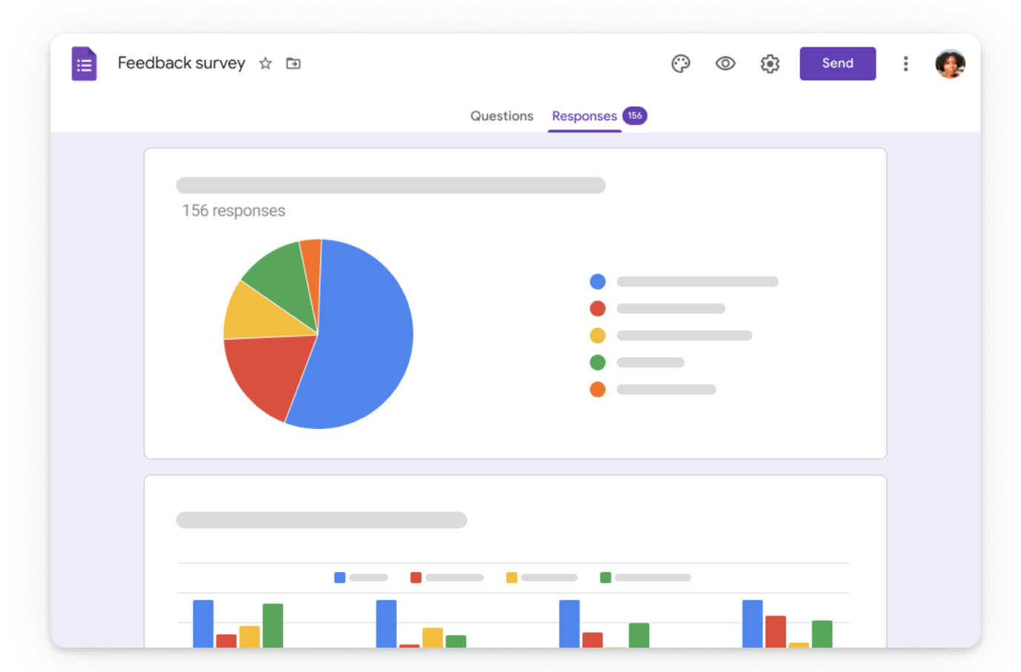

Google Forms (2019)

3.0 Data Analysis and Collection

3.1 Sample
A distribution of the same set questionnaire will be shared among members of the public, whilst retaining a total of 100-sample data. I know personally to sample data needed for the primary information gained to be forwarded towards the dissertation, there is no general specific age group other than it being aimed towards sixteen years and above taking into consideration most personal bank accounts cannot be opened till sixteen unless possessing a child account. Furthermore, the use of deductive and inductive research will be used along-side the collected data so that it can use any existing ideals in correlation with the aims that are expected to be achieved.

3.2 Collection and Analysis
Data collection will involve utilizing the internet to gather information from various sources such as articles, blogs, and news. Additionally, distributing questionnaires will provide insights into the perspectives of individuals affected by the shift to a cashless society. Comparing the data from these sources allows for assessing correlations and differences between secondary online sources and primary questionnaires.

3.3 Ethical Considerations
According to Bhandri (2022) whilst being aware of ethical considerations within this, it mainly will refer to the data gathering and how it is approached, for example taking into consideration the questionnaire that needs to be constructed it is important to formulate the questionnaire in a way everyone that would be a part of a cashless society is included or even people who work for cash-in-hand. Furthermore, the questionnaire must be constructed so that it will not ask for any private or personal information otherwise that may bring confusion or second thoughts to the users who do take part in the questionnaire.

As for the secondary information, it is important that when gathering all sources are accessed to be free of use or if an article needs to be accessed through payments, then payments must be made, as any kind of pirating would be illegal, with information being supported by Jenkins (2019).

3.4 Limitations
The only limitations that are possible within this would be within the questionnaires for people who do not currently have access to a bank account or are under sixteen, meaning possibly not all questions would be met, however, it does still provide a part of information, nevertheless. Another limitation of a questionnaire could consist of the short amount of depth put into a response, as mentioned by William (2023)

4.0 Resources and Planning

4.1 Resources
All resources will be collected by a researcher, as mentioned before all resources will be retrieved through articles, journals, credible online sources and more that allow me to retrieve credible information to put towards the dissertation at hand for a cashless society. Additionally, if data is being retrieved on a website it is important to take into consideration the credibility of the sources available. As mentioned, the primary sources also known as questionnaires will probably all be opinion-based so taking consideration of what is valid or not is important.

Gantt Chart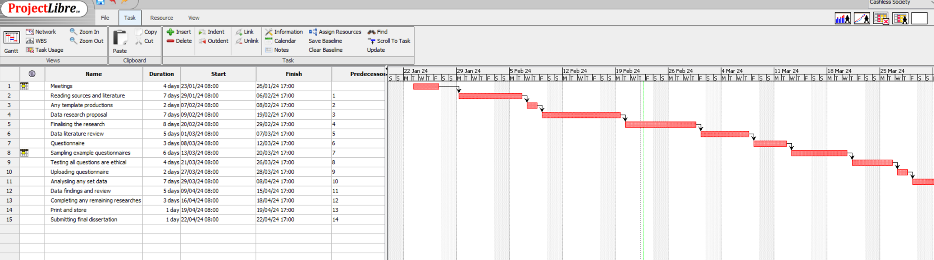

As shown the dissertation does cut short of time but this is just an ideal shortened task time, however, due to other life schedules it is possible to extend each task a variable amount of time even before the submission data for the dissertation, leaving the milestone around May 2024 time

Reference list
Bank of England (2019). Will Cash Die out? [online] www.bankofengland.co.uk. Available at: https://www.bankofengland.co.uk/explainers/will-cash-die-out [Accessed 15 Feb. 2024].
Bhandari, P. (2022). Ethical Considerations in Research | Types & Examples. [online] Scribbr. Available at: https://www.scribbr.co.uk/research-methods/ethical-considerations/ [Accessed 22 Feb. 2024].
Cint (2022). What Is a Questionnaire | Types of Questionnaires in Research. [online] CintTM. Available at: https://www.cint.com/blog/what-is-a-questionnaire-and-how-is-it-used-in-research [Accessed 16 Feb. 2024].
Duignan, B. (2022). What Is a Cashless Society and How Does It Work? | Britannica. [online] www.britannica.com. Available at: https://www.britannica.com/story/what-is-a-cashless-society-and-how-does-it-work [Accessed 15 Feb. 2024].
Garner, J. (n.d.). Future of Payments Review. [online] Available at: https://assets.publishing.service.gov.uk/media/6557a1eb046ed400148b9b50/Future_of_Payments_Review_report.pdf [Accessed 22 Feb. 2024].
George, T. (2023). What is Secondary Research? | Definition, Types, & Examples. [online] Scribbr. Available at: https://www.scribbr.co.uk/research-methods/secondary-research-explained/ [Accessed 16 Feb. 2024].
Google forms (2019). Google Forms: Free Online Surveys for Personal Use. [online] Google.com. Available at: https://www.google.com/forms/about/.
Jansen, D. and Warren, K. (2023). What is research methodology? [online] Grad Coach. Available at: https://gradcoach.com/what-is-research-methodology/ [Accessed 16 Feb. 2024].
Jenkins, J. (2019). Piracy | international law. In: Encyclopædia Britannica. [online] Available at: https://www.britannica.com/topic/piracy-international-law [Accessed 22 Feb. 2024].
Negreiro, M. (2020). BRIEFING. [online] Available at: https://www.europarl.europa.eu/RegData/etudes/BRIE/2020/649341/EPRS_BRI(2020)649341_EN.pdf [Accessed 22 Feb. 2024].
UK Finance (2021). Contactless Now Accounts for More than a Quarter of All UK Payments | UK Finance. [online] www.ukfinance.org.uk. Available at: https://www.ukfinance.org.uk/press/press-releases/contactless-now-accounts-more-quarter-all-uk-payments [Accessed 22 Feb. 2024].
Wilkinson, J. (2023). Six benefits of going cashless. [online] TakePayments. Available at: https://www.takepayments.com/blog/business-growth/6-benefits-of-going-cashless-the-rise-of-card-payments/ [Accessed 18 Feb. 2024].
Williams, K. (2023). What Are Questionnaires? Benefits, Importance and Examples. [online] SurveySparrow. Available at: https://surveysparrow.com/blog/questionnaires/ [Accessed 22 Feb. 2024].

