

INDEPENDENT PROJECT (ACCA6020)
by
Thomas Cahill

Supervisor: Nabeel Masih
Second Marker: Phil Organ

Project submitted as part of the requirements for the award of BA (Hons) Computer Animation

May 2024
DECLARATION FORM AND FORM OF CONSENT

DECLARATION

I, Thomas Henry John Cahill, declare that I am the sole author of this Project; that all references cited have been consulted; that I have conducted all work of which this is a record, and that the finished work lies within the prescribed word limits.

This work has not previously been accepted as part of any other degree submission.

FORM OF CONSENT

I Thomas Henry John Cahill hereby consent that my Project, submitted in candidature for the BA (Hons) Computer Animation degree, if successful, may be made available for inter-library loan or photocopying (subject to the law of copyright), and that the title and abstract may be made available to outside organisations.

Abstract
In Independent Project I was tasked with creating an animation by continuing the pre-production work laid out in Major Project. This included the completion of all character sheets and storyboarding, then modelling, animation and rendering.

Contents
Abstract 2
Introduction 4
Pre-Production 5
Storyboards 9
Production 13
Post-production/Future Development 19
Evaluation 20
References 21

Introduction

This Project is an animated short film, that showcases the creative skills I have developed and refined over an extended period. The idea for this Project came from the first ever cinematic work I created when I was fourteen for my GCSE’s, called “Clash of Silence” [1]. It was an anime-inspired live-action film trailer, made by a teenager who’d never even heard of a storyboard. It was my first foray into a creative subject, which after a long series of events, led to me joining this university course, so it holds meaning to me despite its crudeness. I can’t pin a specific emotion to how I feel about that piece, as production was troubling at the time, and I don’t want eight years of personal bias to influence my written opinion here. All I can say is that I recognise its many flaws and some of the small displays of competency hidden within it.
It's those hints of potential that inspired me to approach this piece again, with fresh eyes along with the skills and experience I have acquired since that time, to prove to myself how I have changed.
My report will be broken down into four main sections: Pre-Production, Production, Post-Production and the Conclusion, where I will describe my creative process.

Pre-Production
During Major Project, I had planned to create an improved version of “Clash of Silence” using the 3D animation and production techniques I have learned over the past four years. This was intended to take the form of a trailer similar in concept to the original, but with a visual and choreographic style inspired by the works of Monty Oum (1981-2015), specifically his work on the early volumes of his animated series RWBY [2].
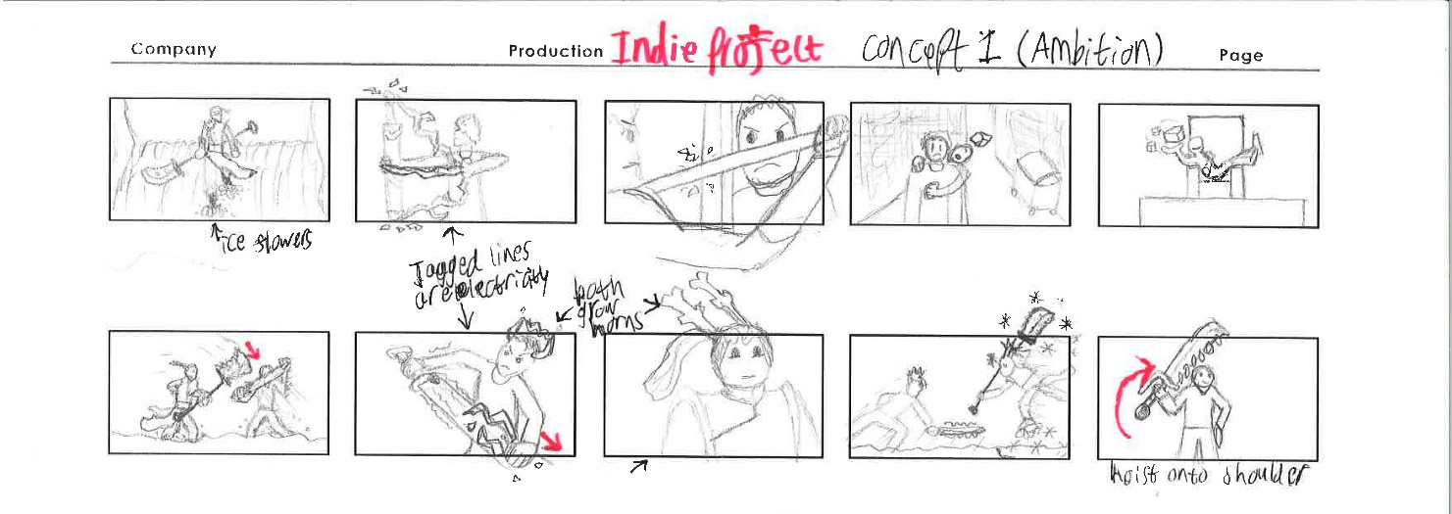
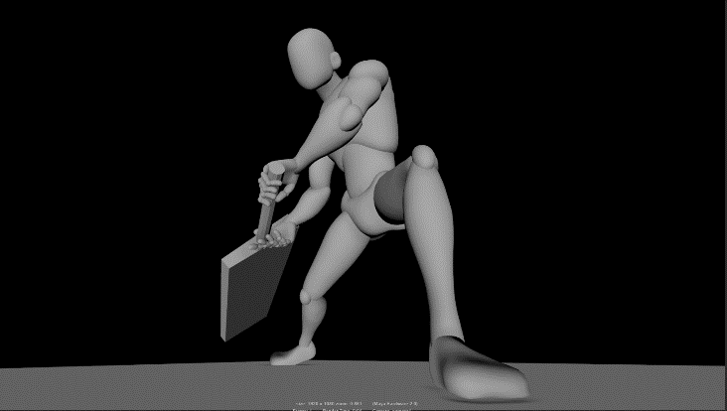
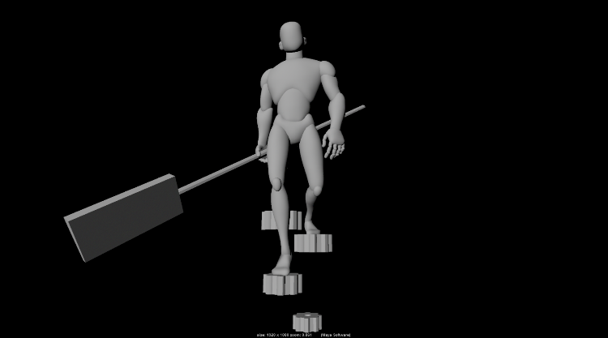
To start with, I did some posing tests in Maya to see if I could use them to replace thumbnails or storyboards. But the amount of time taken to set up these two frames made it clear that it would not be an efficient method, with simple sketches only taking a few minutes each.
These thumbnails that I started with were deliberately drawn out of order, as I was more focused on getting the imagery to paper at the time. I tried to place some of these frames in order, but it proved difficult, as trailers for movies and series usually show scenes out of context and at various points in the media’s runtime. This led me to a realisation; in order to make this trailer the way I wanted, I would have to write an outline of a full story, then only show parts of it through the trailer format. In my opinion, this would have been a waste of my limited resources and increased the workload for myself, so I decided to change my approach.
My new approach was to make a short film that streamlines the trailer’s story to fit within the Artifact time limit and reduces the scene locations to only one area. This meant that I could focus all my efforts on this reduced workload, while still retaining some identity of the original.
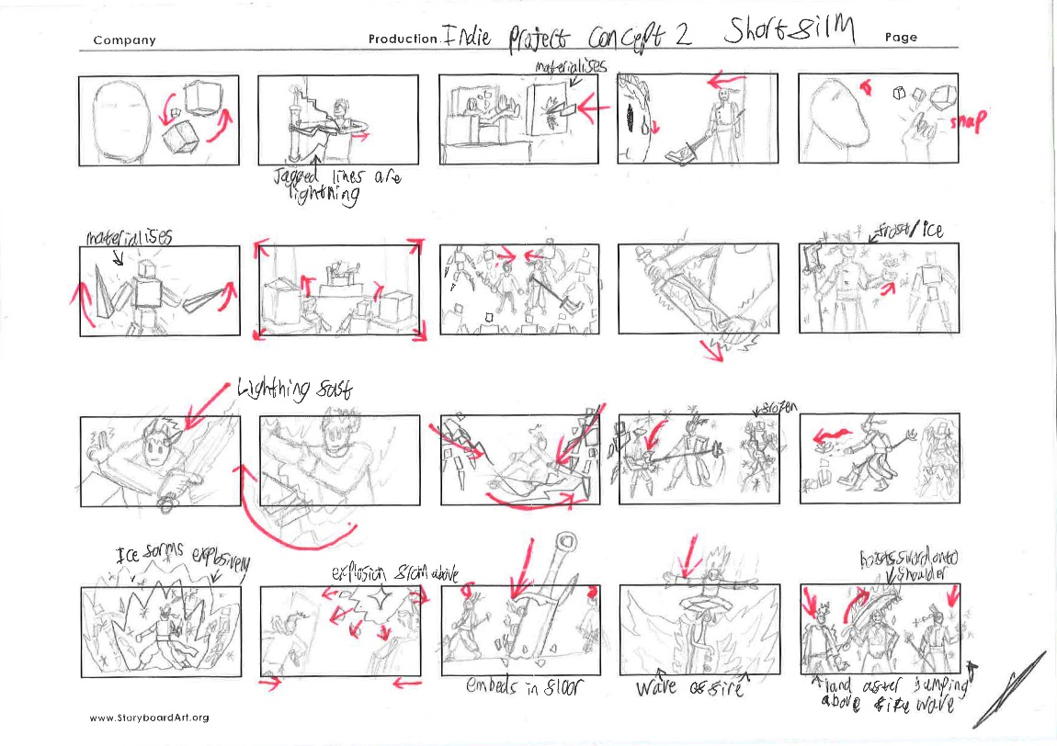
The story still focused on two protagonists teaming up to fight an ominous entity and its minions, but this time, they don’t start as enemies and a third character joins the battle at the end.
This is the story I presented in Major Project and based my character, prop and location designs off.
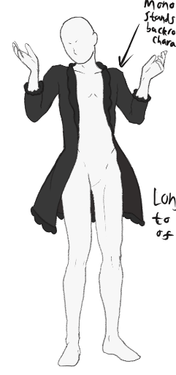
During my presentation I displayed my four character designs:
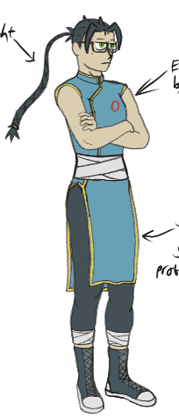
The Entity, antagonist of the story, can create and manipulate energy that takes the form of cubes, which was inspired by Sirin, Herscher of Void from Honkai Impact 3rd [3].
Leng, one of the protagonists, uses a polearm called a Guandao, he can create ice from the area around him.
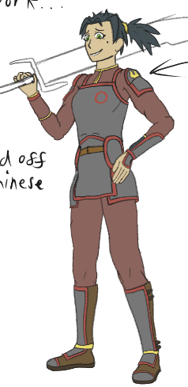
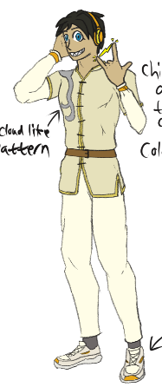
Copper, another protagonist, wields a straight sword called a Jian, he can generate lightning to enhance his physical capabilities.
Huoyan, third protagonist and twin sister to Leng, wields a broadsword called a Jiu Huan Dao, which she ignites using her fire abilities.

All presented designs can be viewed in more detail here: https://www.dropbox.com/scl/fo/88hcbufmb7vjrk79f72gq/AApFM3D38Bs9ks_PRnzYUa0?rlkey=1o47547xcfr0nq2kegwfi5mn5&st=416pv48z&dl=0

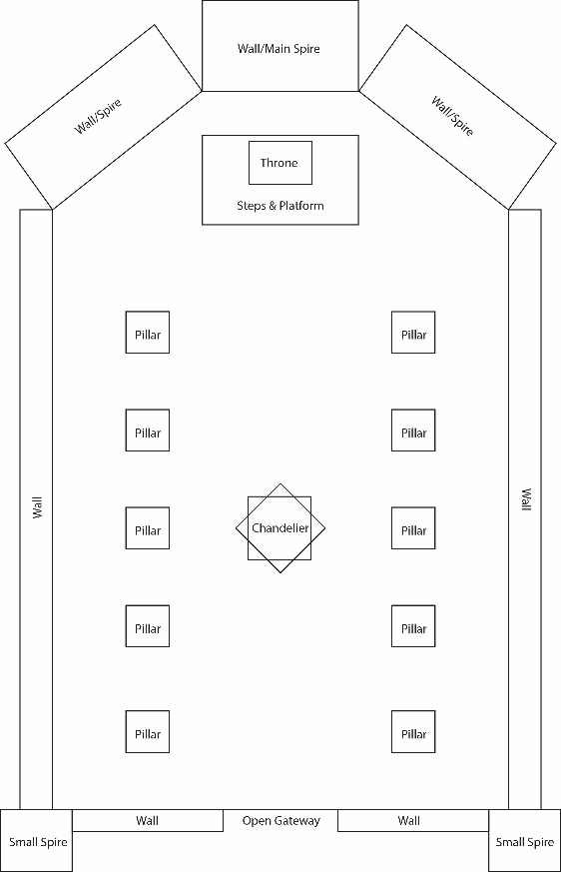
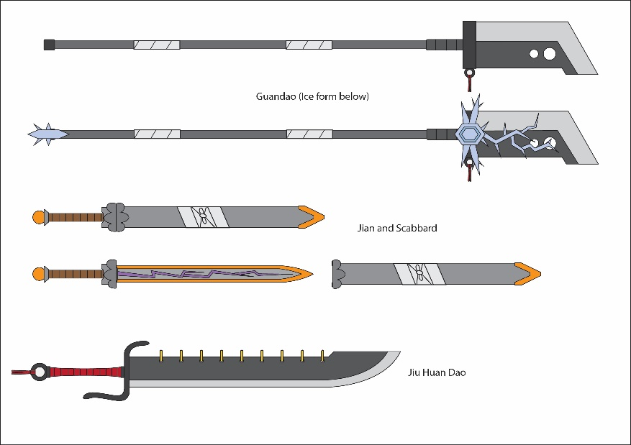
I also presented the location plan, a dark throne room, made from the same energy blocks that The Entity creates, along with the weapon designs for Leng, Copper and Huoyan in that order.

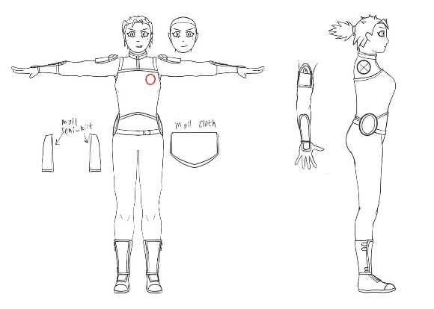
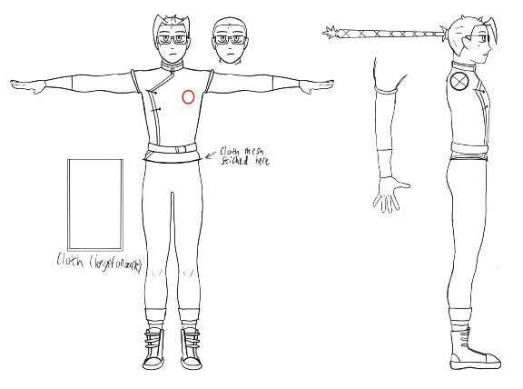
After the Pitch Presentation and during the winter holidays, I began preparing my model sheets ready for the January 2024 Viva, where the characters are T-posed in orthographic views, so that once imported to Maya, they can be used to directly influence the model geometry.
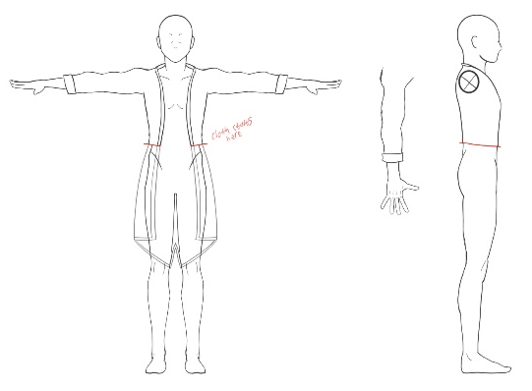
These model sheets also feature sections that would be used to model loose fabrics that would be attached to the model through Maya’s NCloth system [4]. Full images here: https://www.dropbox.com/scl/fo/61jp7p0qbuaqbso6yh22b/ACPaxtUxyaaEfB7qWqBlw3U?rlkey=o3830zmqp316wjeoblqu90zlz&st=pkqoq0or&dl=0

These were presented in the Viva alongside screenshots of testing I carried out for lightning effects and simple hair modelling, this was in order to fit within the time constraints, while still producing the visuals I wanted.
While delivering my presentation, two of the questions my lecturers asked made me reflect further on this idea: How long will it take to model all these characters? Will it fit within the 2-minute time limit? I had an answer for question 1, as I have outlined a workflow for modelling lower poly characters that still meet my design criteria within a shorter amount of time. However, question 2 made me realise that my plan would not fit comfortably in the time limit, meaning it needed further streamlining.
To accomplish this, my story needed to be shortened further. I decided the best course of action was to remove a character from the plot, so I evaluated each individual’s relevance:
The Entity and by proxy its minions are the antagonists of the narrative, without them there would not be a conflict and removing them would be a waste of unique visual design.
Leng is a character based on the original duo from Clash of Silence, meaning he has sentimental value to me. His calm and collected personality is also meant to balance out with his more bombastic fellow protagonists, which helps to create a more dynamic sense of interaction between them.
Huoyan is a new character that I created for this project, meant to serve as the hot-headed and strong-willed twin sister to Leng, which would contrast her brother in not only personality but also their respective powers: Ice and Fire. I also included several visual elements across both of their designs to make their connection clearer, given a lack of dialogue, being their shared genetic traits, clothing iconography and red ribbons attached to both of their weapons.
Copper shares his character origins with Leng, serving as the more bouncy, energetic counterpart to Leng’s seemingly cold demeanour and a mediator between the twins were they to butt heads. However, I have been unable to create a design that satisfies me in terms of colour and style, so he looked out of place compared to the other characters.
This made Copper the most logical choice to remove from storyline, but since he had such a large role, some of his attributes had to be reallocated or retooled. Specifically, I gave his lighting powers to Leng, replacing his ice, which does save me the time of having to model said ice. I also had Huoyan replace Copper’s role in the story, meaning she is present from the beginning, rather than showing up for only a few dozen seconds at the end. These were not small changes, which meant I had to choreograph new action sequences based on these altered features, which was challenging, since I had already planned out these movements in my head, so I had to overwrite those ideas. To start this process, I looked for royalty free music that fits the theme of my plan, as appropriate music helps generate choreography that works with the song’s tempo. The list of candidates was reduced to three soundtracks from the website Pixabay, A percussion heavy theme [5], a rock adjacent guitar theme [6] and a synth beat [7]. The synth was selected for its tempo fluctuations through its high and low points, which fit well with the beginning of a battle that grows in intensity as it continues.

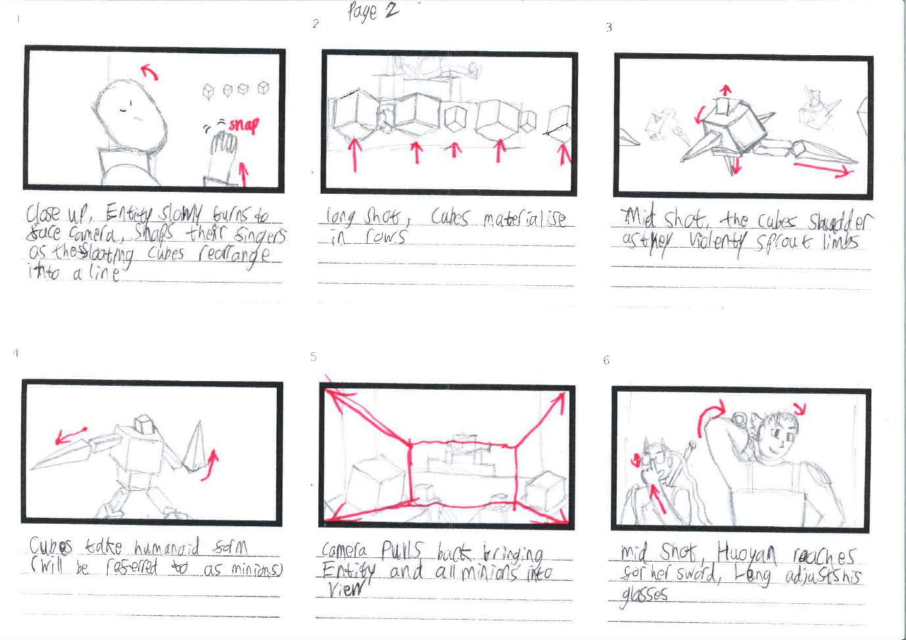
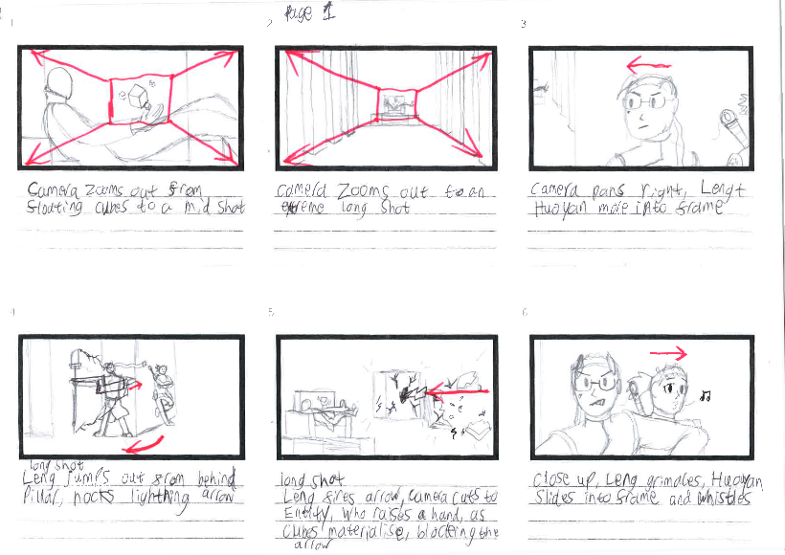
Storyboards
Using this music as inspiration, the storyboards were completed, with the action choreography timed to beat drops within the song, which should enhance their impact on the viewer.
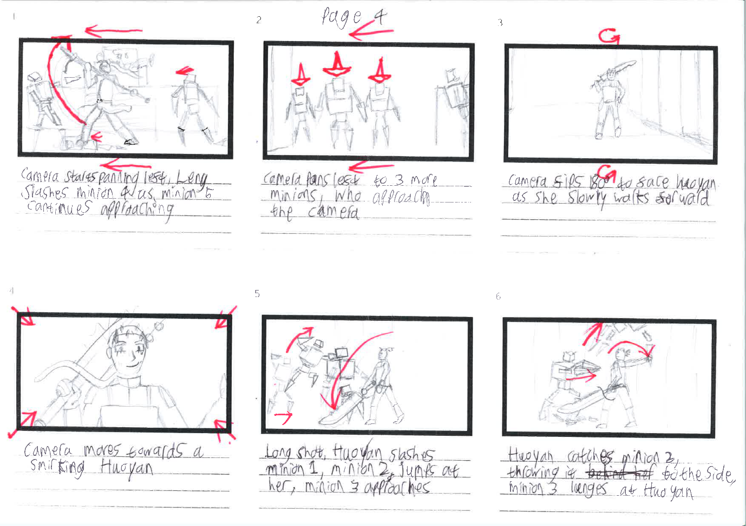
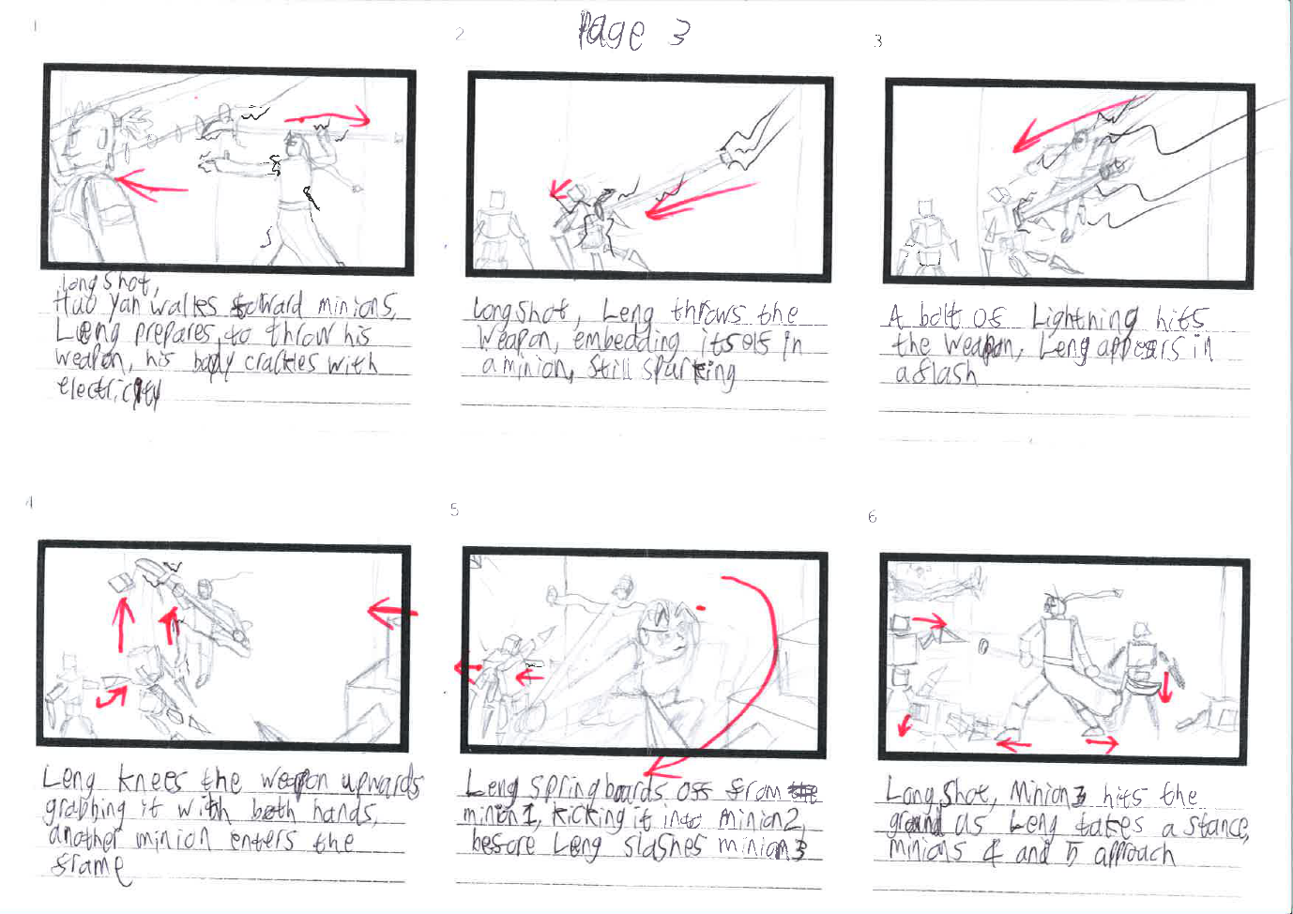
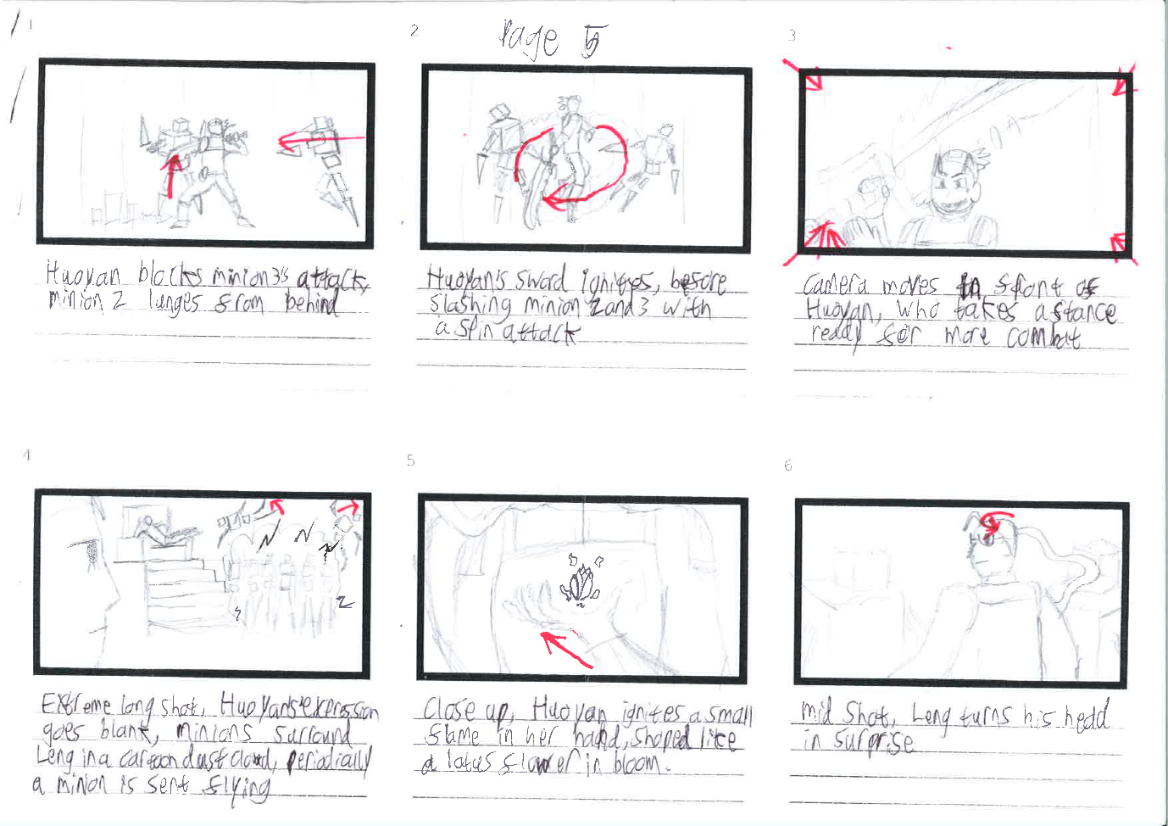
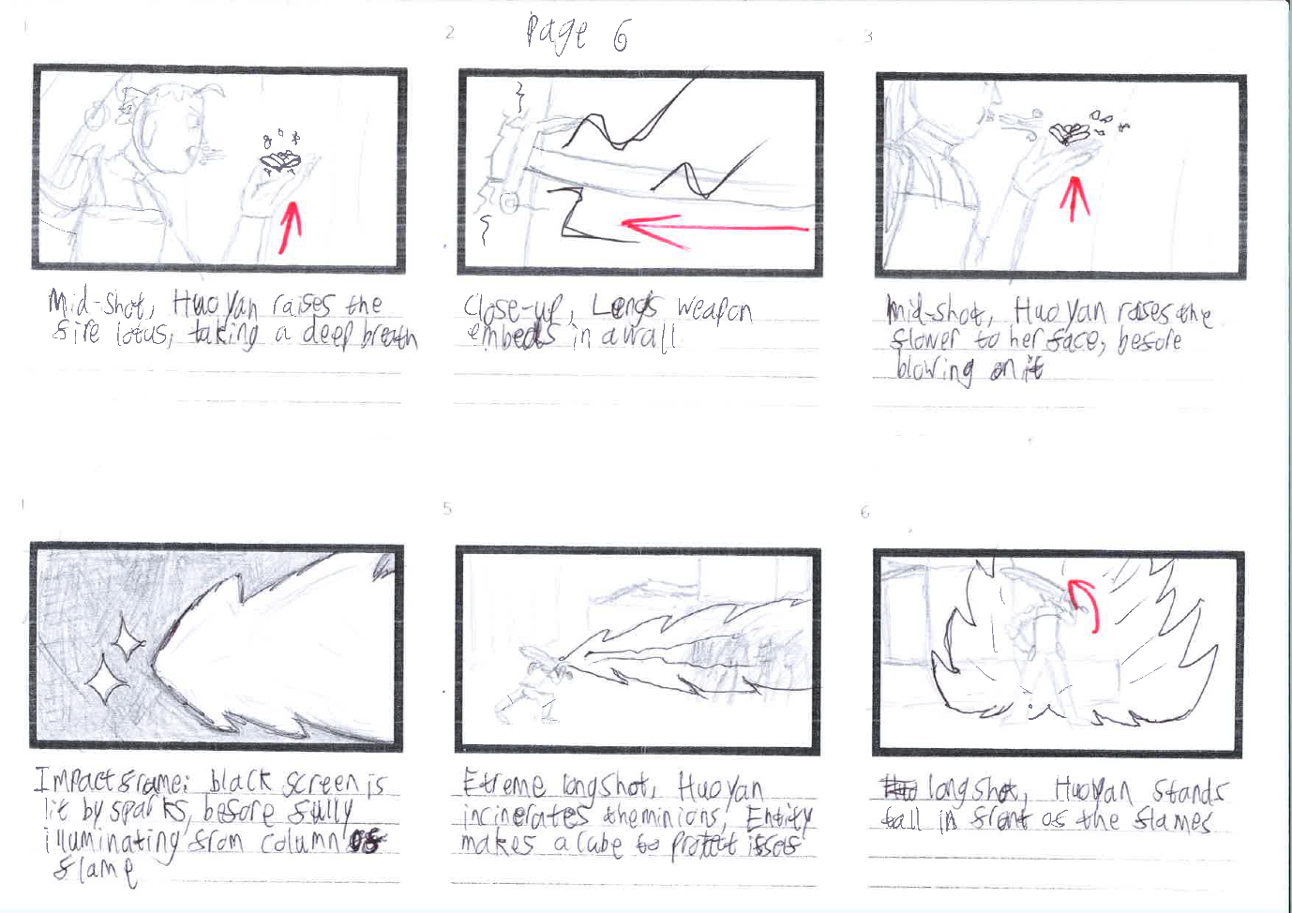
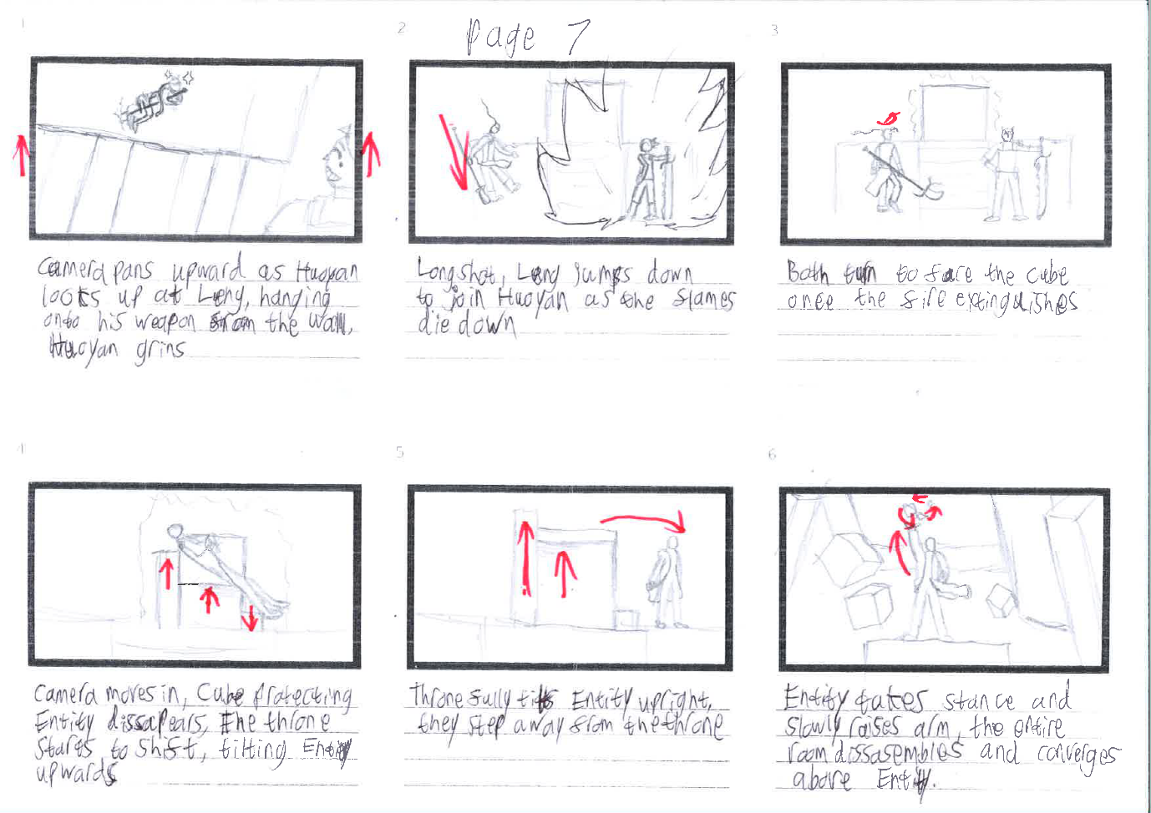

Full pages can be located here: https://www.dropbox.com/scl/fo/y7tfnybnmnipd27w8nw5h/AGcYVvoNlfabb0dp-5bEAF4?rlkey=yourclveb5zknybaf39t7qscr&st=zb3tbi2d&dl=0

Production

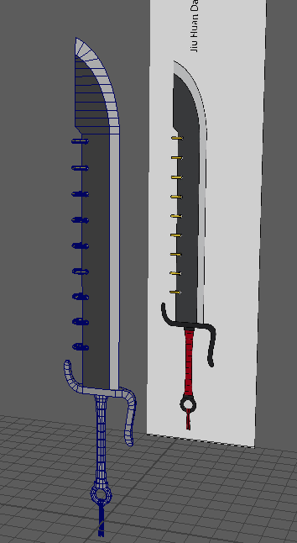
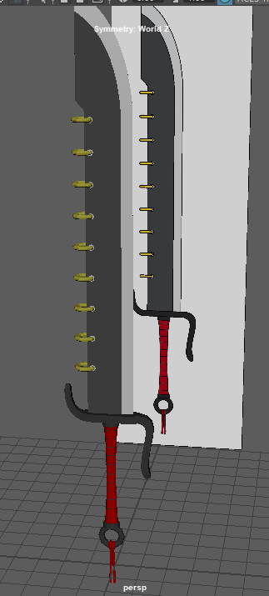
To start production, I created the weapon props that would be used by my characters.
First was Huoyan’s Jiu Huan Dao, a large broadsword featuring nine rings along its dull side. Initially I wanted to give physics to these rings, so that they would sway around when the blade moves, but I decided against it as it would take time away from the rest of the project.
I also used a method of giving colour to geometry without using textures, by using Lambert shaders applied to the appropriate sections. I will continue to use this method for my other props and characters, as it will save me a lot of time in the long run.

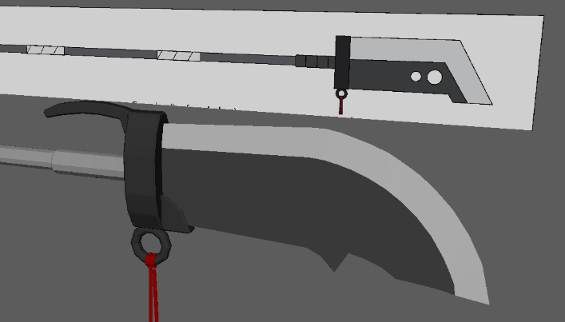
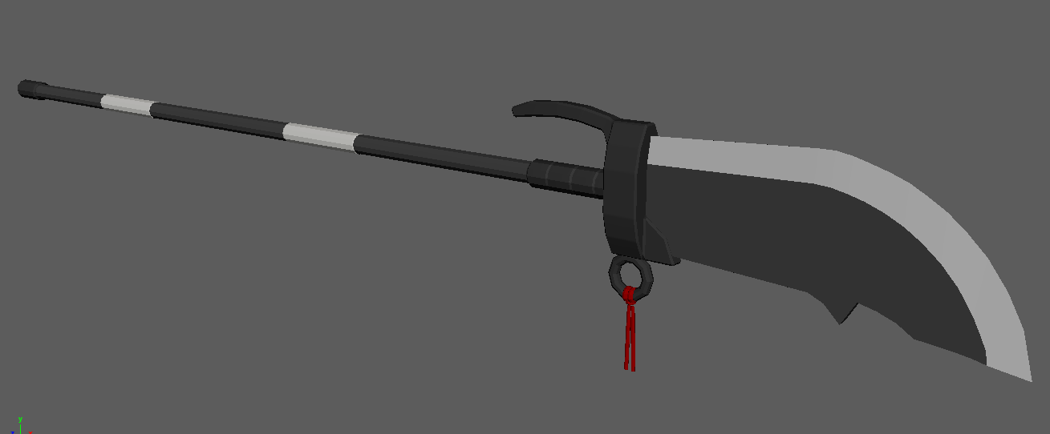
Next was Leng’s Guandao, a polearm featuring a large blade. While modelling, I surprisingly found that the original squared design was more difficult to create, so I opted to improvise a curved design which is more common among real examples of this weapon.

I also added the red ribbon present on both weapons, which is supposed to connect the two visually and made to move using Ncloths once the animation is complete. Later however, I felt this wasn’t enough, so I changed the wrappings along the handle of the Guandao to red, which will be visible in the animation.
The final prop doesn’t appear for very long but is important to my desire for distinct imagery, being the flaming lotus flower that Huoyan creates on Page 5 frame 5 of my storyboards. I had wanted this imagery for the original story where Leng would make these flowers out of ice, using them for attacks and as platforms for mobility, but the replacement of his powers meant I had to repurpose it for Huoyan.
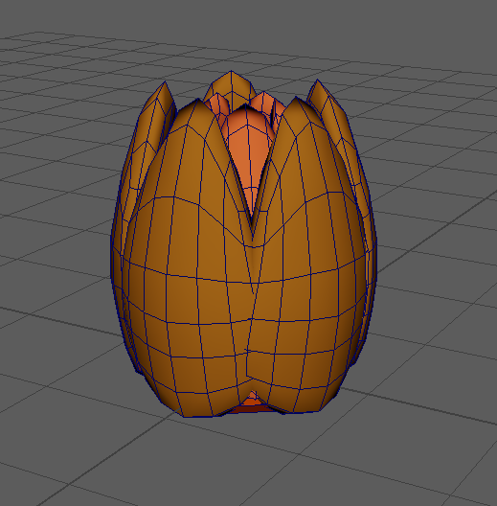
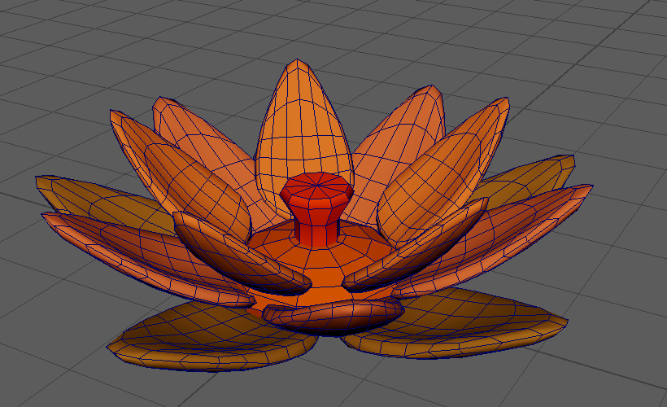
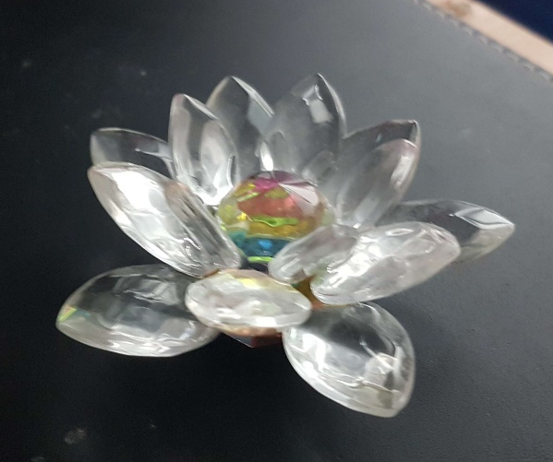
When I was searching for reference material during Major Project, I happened to come across this glass lotus ornament in a charity shop and immediately bought it for this purpose. This little trinket allowed me to look at a basic rendition of the flower’s structure from all angles, allowing me to quickly reconstruct a stylised version that is also capable of making a bloom motion. I will also add fire effects using Maya’s particle simulation once the scene is ready [8].

Full images: https://www.dropbox.com/scl/fo/tobx3wp3a9onhiuz38kt2/ACRRWkPtLxQgveKSCWNwpaI?rlkey=1lxv3k0gqkydd18lq8u59s1m8&st=0magu4wb&dl=0
With the props complete, it was time to move on to the character models, where I took a step by step approach, bringing every character to a certain point before continuing according to online tutorials [9].
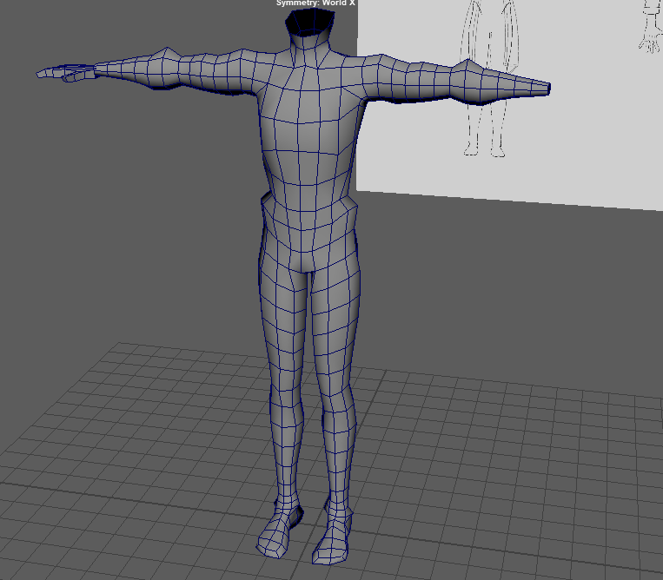
Every model began like this, blocked out using the orthographic model sheets, before subdividing to add more detail, then subdividing again, before adding the feet and hands.
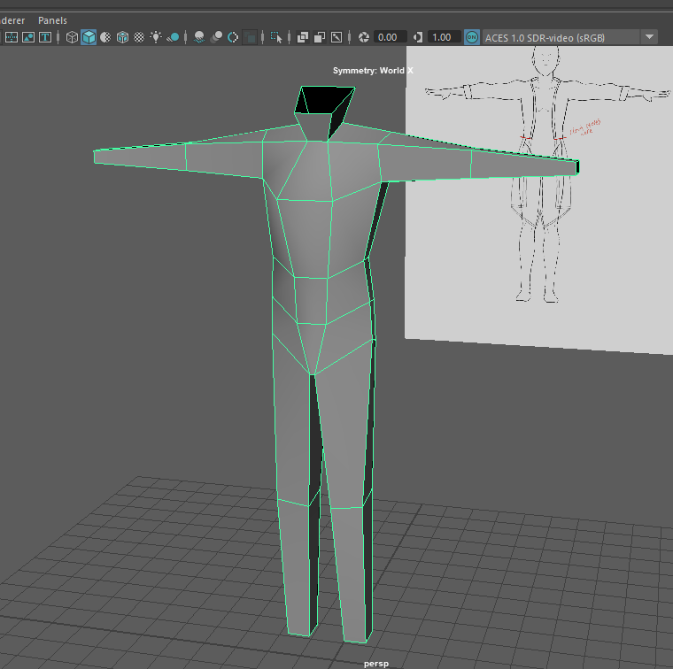

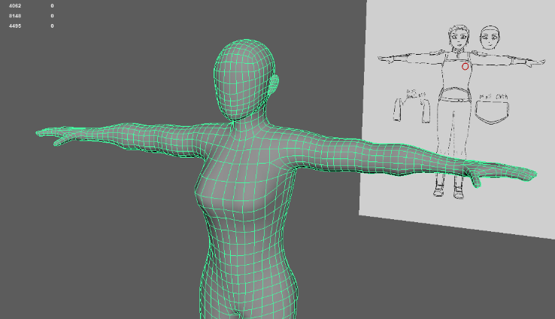
Then simple heads were added to each model, as I was going to give the characters 2D faces capable of changing expressions [10].

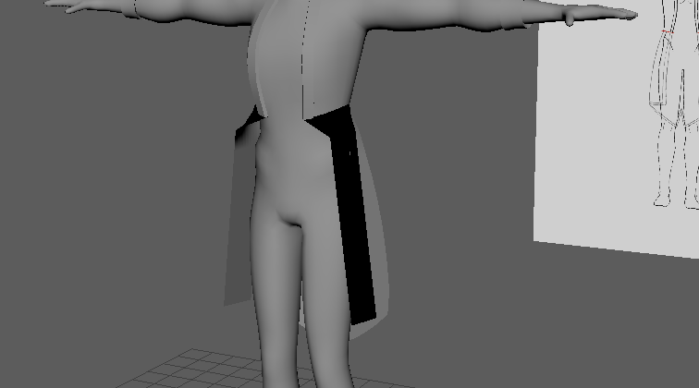
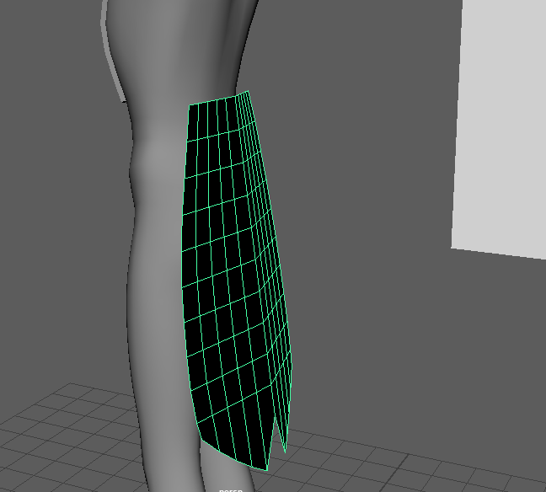
Once each character was brought to this point, I created the finer details on each character, staring with The Entity’s coat tails, using subdivided planes that were intended to be converted into Ncloths.

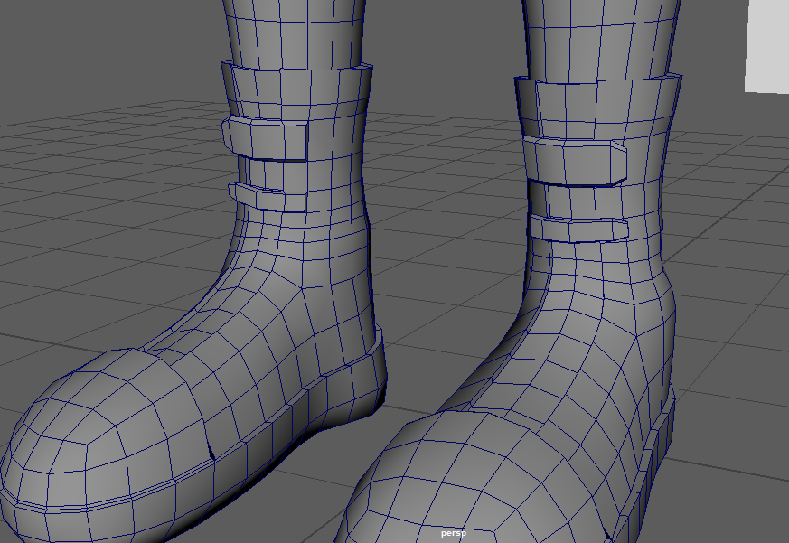
With Entity’s geometry complete for now, I moved on to Leng, which was slightly more complex, due to actually wearing clothes on his lower body. His shoes were a mild challenge, but a fun one.

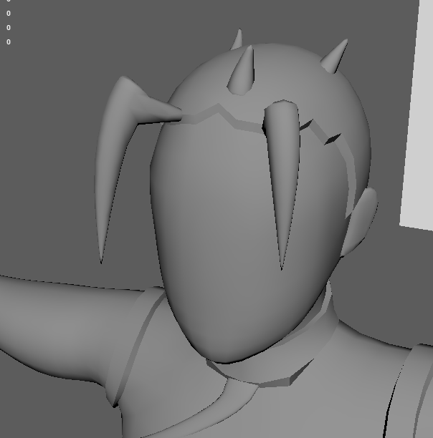

For the hair, I extruded faces on the scalp, then subdivided and placed some pyramids and combined them with the geometry. There are better ways to create hair, but the shape of the hair was all that was necessary. The rest of Leng’s geometry went without hitch.
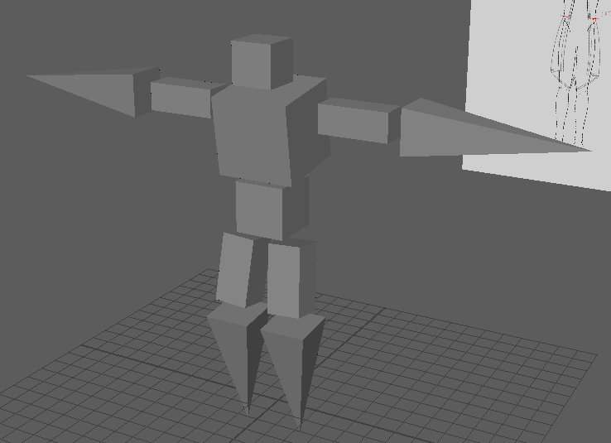
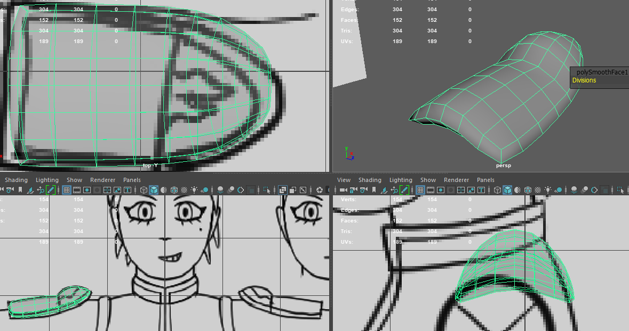
The notable things about Huoyan’s model were the armour pieces that were modelled separately, being the hip and shoulder plates, which was a new experience, but not difficult since they only needed a low polycount for the general shape. However, I decided to not model the battle skirt, since I was unable to decide how to approach modelling it.

The only remaining humanoid to model was The Entity’s minions, which are made from the same basic shapes that the Entity controls. This of course was an easy model to make, but I foresee some minor difficulties when it’s time to rig the character, due to the lack of geometry at the joints.

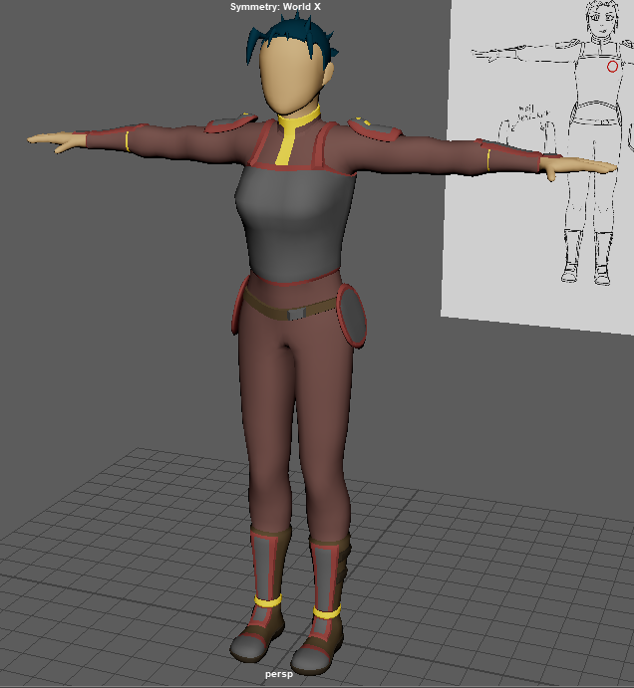
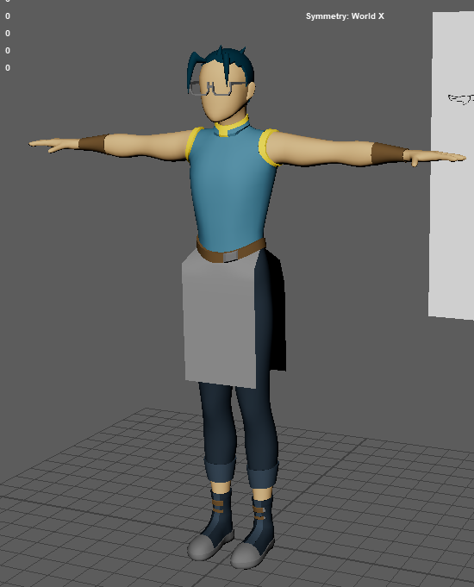
Using the coloured lambert method from my props, the geometry was given its appropriate definition, which allowed some smaller details to be visible on the designs.
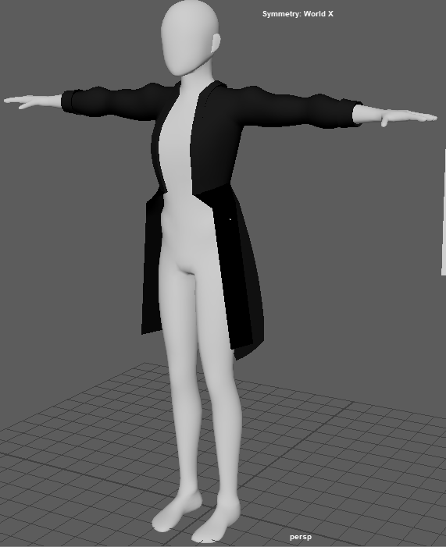

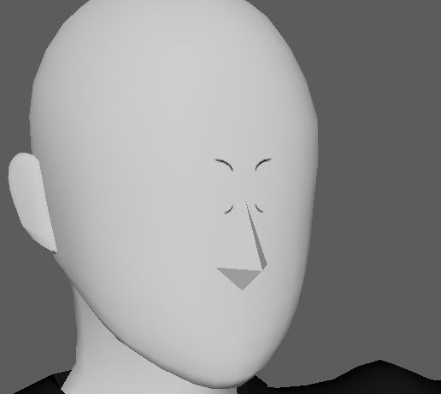
I also made simple noses using pyramids. For the character’s expressions and details, I made duplicates of the faces in the selected areas, then assigning them as a PNG texture.
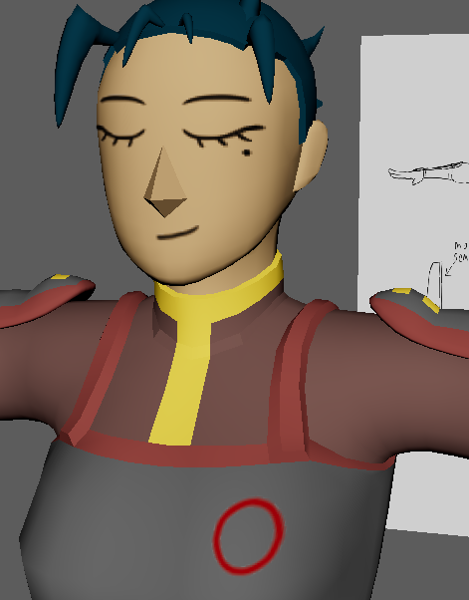

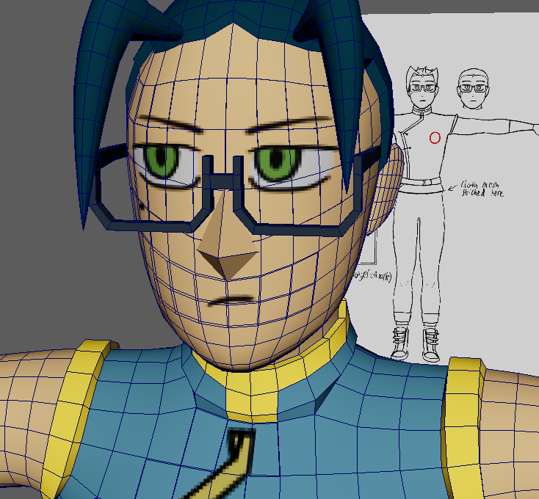
I also used this method for details I couldn’t make with geometry, being the red crests on the chests of my human characters and Leng’s lapel. For the facial expressions I made separate sections for the eyes and mouth, before assigning various keys for each expression in the attribute menu, so they can be freely swapped between during animation.

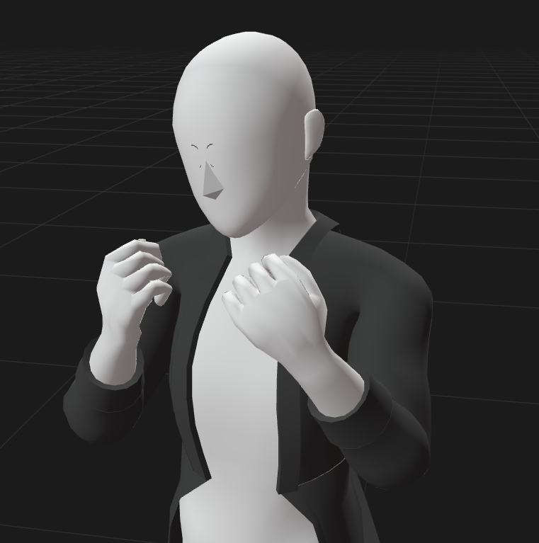
With each character created, it was time to rig them. I wanted to use Maya’s quick rig tools to make Inverse Kinematics (IK) rigs in order to streamline my animation process, but as I was searching for online tutorials, I came across a tool that would vastly improve my efficiency for rigging my characters, ActorCore AccuRig [11]. This free program takes various model file types and streamlines the humanoid skeleton creation process used by Maya’s Quick Rig and allows one to add hand controls to the rig by default, then showing a preview of the completed rig with examples of different character or even hand movements. This process takes minutes once you understand the control scheme and all that was needed afterward was to add FK controls in Maya, then check the skin weights for consistency. This allowed me to rig and weight paint all of my characters within a single day, with only some minor additions needing to be made.

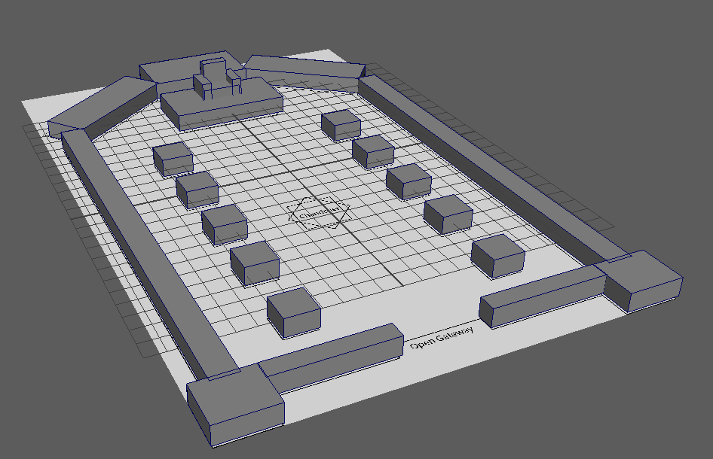
With my characters complete, I started building my environment, which is deliberately simple in design and polycount, as it is made from the same force The Entity has command over. This also saves massive amounts of time, as a detailed environment accompanied with all the other aspects of this project would be too big of a workload within the time frame. The length of the building was extended, to allow the characters more room to move about in, while enhancing the cathedral/throne room look its inspired by. The floor is a large plane while the ceiling is a large block that caps off the room. Having the building made of simple shapes will make the page 7’s frame 6 much easier to animate, as they can be easily distinguished even when grouped together.
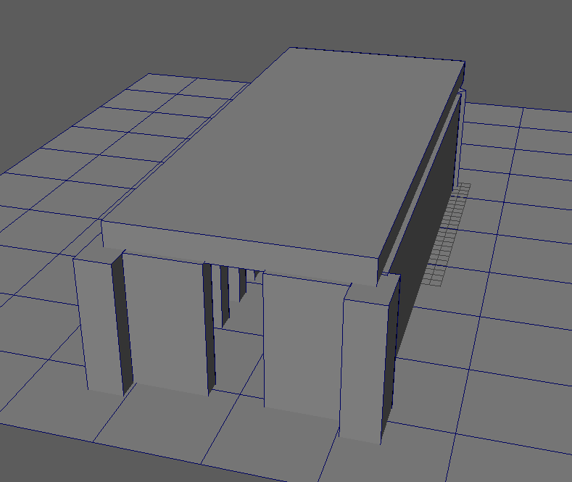
Links to modelling screenshots here: https://www.dropbox.com/scl/fo/fu5cpctkrqlm1pzfcg2qr/AHV2DrIfjKW1qbbnhfzJMrs?rlkey=p4jlen9lxsfzi4v0aqdd04q0c&st=dxn7nl3w&dl=0
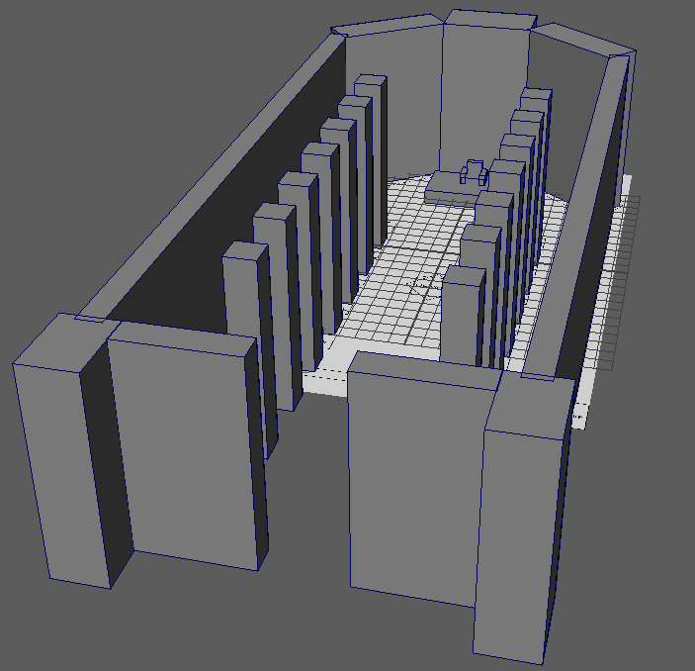

Post-production/Future Development

As of the time of writing, the animation of this project has not yet been completed, meaning my audio and visual editing cannot be documented. However, my predictions say that my final artifact will still be complete by the deadline, as the only processes left for me to complete are as follows:
- The character animation, which I am very efficient at producing.
- Addition of the fire lightning and cloth effects once animation is complete.
- The rendering of the scenes, where I will use the on-campus computers, as that will be faster.
- Creating the impact frame in Page 6 Frame 4, where I only need to draw 3-4 frames of.
- Placing the renders and frames into Adobe After effects, so I can splice them together with the music track.
- Exporting the footage and uploading to Moodle.
My completed artifact will be available for viewing on the day of my Final Viva.

Evaluation

This year long project has taught me much, from new techniques, to truths about myself and the industry I wish to work in. I have come to notice that when I first generate ideas for projects, it is usually beyond my means to produce within the time frame, and I have to rework it once I realise that fact. This has led to some of my works being much smaller in scope than originally planned, or even having features removed to make the workload more viable. This project was no exception, as my initial plan involved more characters, environments and effects than I had the time to create, which lead to the removal and retooling of almost all of these elements. This has taught me that I still have some learning to do when it comes to working within my means. I will practice this within my personal work in the future, so that I do not repeat this in a professional setting.
This does not mean I will forsake high concept ideas, but rather plan more carefully how I allocate my time and resources to create them. For example, I should have researched a method to create low-poly characters that would still achieve my stylistic goals, allowing me more time to work on other aspects of the production, rather than trying to adapt tutorials meant for high poly and detailed characters to my more simplistic ones.
However, I also think that a lot of my time conserving techniques were effective for this project, such as my 2D facial expressions, which were used instead of sculpting out each character’s facial features, which would have required much more time in exchange for a gamble on visual quality, due to my lack of experience in modelling body parts. Another example is my use of coloured Lamberts in lieu of full textures, which was once again chosen due to my lack of experience and time to master it. Of course I will improve these skills after this project, as they are essential skills for many positions in the animation industry and many projects I wish to create for myself, so I must be diligent in their practice.

References
[1] T. Cahill, Director: Clash of Silence, No Date.
[2] M. Oum, Director, RWBY, Austin: Rooster Teeth Productions, 2013
[3] Honkai Impact 3rd, “Honkai Impact 3rd Animation - Final Lesson,” YouTube, Feb. 20, 2019. [Online]. Available: https://www.youtube.com/watch?v=8dmvNGxYPCU&t.
[4] Academic Phoenix Plus, “Quickly Create Realistic Curtains using nCloth in Maya 2020,” Youtube, Dec. 2, 2020. [Online]. Available: Quickly Create Realistic Curtains using nCloth in Maya 2020 - YouTube.
[5] REDproductions, “Fight Slapping Intense Strong Adventure Determine Music,” pixabay. [Online]. Available: Fight Slapping Intense Strong Adventure Determine Music | Royalty-free Music - Pixabay
[6] lemonmusicstudio, “Phantom,” pixabay. [Online]. Available: Phantom | Royalty-free Music - Pixabay
[7] Top-Flow, “Speed Thrill Beat,” pixabay. [Online]. Available: Speed Thrill Beat | Royalty-free Music - Pixabay
[8] Maya Help, “Create a Fire effect,” Autodesk Maya 2022. [Online]. Available: Maya Help | Create a Fire effect | Autodesk
[9] A. Cheparev, “Easy 3D Character Modeling in Maya - Part 1 - Body,” Youtube, Dec. 7, 2022. [Online]. Available: Easy 3D Character Modeling in Maya - Part 1 - Body - YouTube
[10] Interactive Media High Tech High School, “Creating 2D Animated Textures in Maya,” Youtube, Feb. 2, 2021. [Online]. Available: Creating 2D Animated Textures in Maya (youtube.com)
[11] Academic Phoenix Plus, “Quickly Rig a Character in accuRig and Maya 2023 HumanIK,” Youtube, May. 3, 2023. [Online]. Available: Quickly Rig a Character in accuRig and Maya 2023 HumanIK (youtube.com)

Additional Reading List

P. J. Naas. How to Cheat in Maya 2017 : Tools and Techniques for Character Animation 2017.
https://incompetech.com/music/royalty-free/music.html

