

OBAIDAH SBEITAN

An Investigation into the relevance events can have on visitor numbers at Welsh Castles- Case Study- Oystermouth Castle

BA (Hons) Business Management
UWTSD Swansea 2020

An Investigation into the relevance events can have on visitor numbers at Welsh Castles- Case Study- Oystermouth Castle

UNDERGRADUATE DISSERTATION
Supervised by Kathryn Flynn

OBAIDAH SBEITAN BA (Hons) BUSINESS MANAGEMENT 2020

DECLARATION
This work has not previously been accepted in substance for any degree and is not being concurrently submitted in candidature for any degree.

Signed……………………………………………

Date………………………………………………

STATEMENT 1

This dissertation is being submitted in partial fulfillment of the requirements for the degree of BA.

Signed…………………………………………….

Date………………………………………………

STATEMENT 2

This dissertation is the result of my own independent work/investigation, except where otherwise stated.

Other sources are acknowledged by footnotes giving explicit references. A bibliography is appended.

Signed……………………………………………

Date………………………………………………

STATEMENT 3

I hereby give consent for my dissertation, if accepted, to be available for photocopying and for interlibrary loan, and for the title and summary to be made available to outside organisations.

Signed………………………………………………

Date…………………………………………………

STATEMENT 4

I hereby give consent for my dissertation, if accepted, to be available on the university’s IT system to those who have consent to use the system.

Signed………………………………………………

Date…………………………………………………

Acknowledgments

I would like to thank my family, especially my mother who has always believed in me and supported me, not only throughout the completion of this dissertation, but throughout my entire time at university. My four boys who have been patient and have supported me to complete my degree.
My friends, Sam, Caitlin and Becky, who I’m grateful to have met and call my friends. They have been very supportive and motivated me to do my best. We have spent three years together in university and have become very close. We shared laughs and tears and built memories that we will look back at.
Finally, I have to express my gratitude towards my dissertation lecturer, Dr Caroline Jawad, for her support and constant encouragement; and my dissertation supervisor Kathryn Flynn, without whom, I would not have been able to get this dissertation right. I extremely appreciate her detailed feedback, which made things clearer for me.

Abstract
The purpose of this dissertation, which is part of the requirements for the researchers’ degree course, is to investigate whether events can increase visitor figures at heritage sites, in particular castles, focusing on a case study of Oystermouth Castle. The researcher conducted secondary research and collected the available literature that revolved around the topics of this dissertation, events, tourism, heritage and culture. With regards to the case study, there was no previous research conducted that would allow the researcher to build an assumption. Despite the castle having visitor figures from previous years, the figures could not be used by the researcher as they were general figures that did not separate the daily visitors from the visitors who are attending events. Therefore, the study was built without the assumption of knowing visitor figures when there was an event on.
The findings of the secondary research assisted the researcher with constructing the primary research, which was in the form of an online questionnaire. The design of the questionnaire allowed the researcher to collect quantitative and qualitative data, which enabled the researcher to gain a better understanding of the topic. The researcher used SmartSurvey platform to distribute the questionnaire and was able to collect 404 responses. Chapter 3 explains in further detail, the methods which the researcher considered most appropriate for this research. The researcher used the Research Onion Source for the methodology.
The data collected was analyzed, displayed and presented in chapter 4, in the form of percentages and opinions of the participants. The findings of the research suggested that events which are hosted in castles are considered as a motive that attracts people to visit the castle and encourages them to visit different castles. The findings are explained in further detail in chapter 5. These findings allowed the researcher to form a conclusion, regarding hosting events in castles. Based on these findings, recommendations were made, in order to aid Oysetrmouth castle with its performance and assist it with attracting more visitors.

Table Of Content
Declaration ………………………………………………………………………………III
Acknowledgments ………………………………………………………………………IV
Abstract …………………………………………………………………………………..V
Table of content.…………………………………………………………………………VI
Coronavirus ...……………………………………………………………………………IX
- Chapter 1: Introduction..…………………………………………………………….1
1.1 Aims and Objectives……………………………………………..………………..1
1.2 Background…………………………………………………..…………………….1
1.3 Research…………………………………………………..……………………….2
1.4 Introduction to the Case study …………………………..………………………2
2. Chapter 2: Literature Review ……………………………..………………………4
2.0 Macro section ……………………………………………..……………………..4
2.1 Introduction …………………………………………………..…………………….4
2.1.1 Events ……………………………………………………..…………………..4
2.1.2 Heritage and Culture ……………………………………….………………..5
2.1.3 Motivation and Drive..………………………………………..……………….5
2.2 Events and Tourism ………………………………………………..……………..6
2.2.1 Cultural Events ……………………………………………….………………7
2.2.2 Heritage and Cultural Tourism ………………………………..…………….7
2.3 Tourism in Wales ………..……………………………………….……………….8
2.3.1 Castles in Wales ……………………………………………………….…….9
2.4 Management ……………………………………………………………….……..10
2.4.1 Cultural Heritage Management …………………………………….………10
2.4.2 Event Management ………………………………………………………….10
2.4.3 Managing Volunteers…………………………………………………………11
2.5 Funding …………………………………………………………………………….11
2.6 Case study- Micro section ……………………………………………….……….12
2.6.1 Oystermouth Castle …………………………………………………………….12
2.6.2 Events at Oystermouth Castle ………………..…………………………….12
2.7 Conclusion………………………………………………………………………… 13
3. Chapter 3: Research Methodology ………………………………………...….….14
3.1 Research Onion ………………………………………………………………….14
3.1.1 Philosophy…………………………………………………………………… 15
3.1.2 Approach …………………………………………………………………..…15
3.1.3 Strategy and Choice …………………………………………………………16
3.1.3.1 Primary Research ……………………………………………..……....16
3.1.3.2 Questionnaire Design …………………………………………..……..17
3.1.3.3 Pilot Study ………………………………………………………..……..17
3.1.3.4 Sampling ……………………………………………………….……….18
3.1.3.5 Collection and Analysis ………………………………………….…….18
3.2 Time Horizons ………………………………………………………………..……18
3.3 Reliability and validity ……………………………………………………………..19
3.4 Limitations ……………………………………………………………….………….19
3.5 Ethical Consideration ………………………………………………………………20
3.6 Future Studies ………………………………………………………………………20
4. Chapter 4: Data Analysis ………………………………………………………..……21
4.1 Introduction ………………………………………………………………………….21
4.2 Section One-Tourism Preferences………………………………………………..22
4.2.1 Castles VS museums-Qualitative Data …………………………….……….24
4.3 Section Two-visiting Welsh Castles ………………………………………………25
4.4 Section Three- Events and Castles ………………………………………...…….26
4.4.1 Qualitative Data ………………………………………………………………..27
4.4.2 Benefits of Hosting Events in Castles ……………………………………….28
4.5 Section Four-Oystermouth Castle ………………………………………………..29
4.6 Section Five-Admission Fee …………………………………………………….30
4.7 Section Six- Demographics ……………………………………………………….31
4.8 Main Findings……… ……………………………………………………………….31
5. Chapter Five- Findings and Recommendations. …………………………………..34
5.1 Introduction ……………………………………………,……………………………34
5.2 Conclusion …………………………………………….…………………………….34
5.3 Recommendations ………………………………………………………………….35
5.3 Future Research… …………………………………………………….………….35
Bibliography ………………………………………………….………………...………..36
Appendices ……………………………………………………………………...….…...40
Appendix 1-Application for Ethical Approval …………………………………….…...40
Appendix 2- Questionnaire ………………………………………………………….….59
Appendix 3-GANTT Chart ………………………………………………………...…....64

List of Figures
Figure 1: Maslow's Hierarchy of Needs ………………………………………….….6
Figure 2: Marketing Strategy for Oystermouth Castle ………………………..…….13
Figure 3: Onion Research ………………………………………………………….….14
Figure 4: Graph depicting the respondents' preference of who to travel with….…22
Figure 5: Graph depicting the respondents' holiday type preference ………….…22
Figure 6: Graph depicting if respondents would consider visiting a historical attraction as a main reason to travel ………………………………………………………………...23
Figure 7: Graph depicting the types of historical attractions the respondent chose………………………………………………………………………………….….23
Figure 8: Word cloud representing most used words from the responses from question 7 ……………………………………………………………………………………….…24
Figure 9: Graph depicting the percentage of respondents who agreed with hosting events in castles …………………………………………………………………….…26
Figure 10: Word cloud representing most used words from the responses from question 13 …………………………………………………………………………………….….27
Figure 11: Graph depicting the types of events the respondents considered appropriate…………………………………………………………….…………….….29
Figure 12: Graph depicting the percentage of respondents who knew Oystermouth Castle …………………………………………………………………………………...29
Figure 13: Graph displaying the participants ages ………………………………...31

Coronavirus
After the UK implemented a 24 hour curfew in March 2020, UWTSD took steps to support the research students and research, during the curfew and University building closures.
Formal supervision meetings continued as much as possible and were arranged via suitable meeting software with documents shared electronically.
Some research was at greater risk to delays; for example, projects requiring physical presence to undertake interviews and fieldwork or data collection. Supervisors and research students urgently revised their research plans. UWTSD understands that some students’ projects and dissertations were planned to require in-person research and data collection that is not possible in this period of remote learning. Digital research activities that advance the studies were prioritized; if it was no longer possible to continue with the existing plan, then consideration to changes to the project plan should be considered to offset, wherever possible, undue future delays to the project/dissertation submission. All fieldwork conducted by students occurred remotely using electronic means wherever possible.

Chapter 1: Introduction
The purpose of this chapter is to introduce the dissertation's aims and objectives; give a background of the topic of the research, outline the methods of the research and provide an introduction to the case study.

1.1 Aims and Objectives
The aim of this research is to investigate and analyse the impact that events have on heritage sites, mainly Oystermouth Castle, Swansea. A number of objectives have been set to aid with achieving this aim.
Objectives:
- To research and evaluate the current available literature in the field of events, tourism and heritage sites.
- To research, choose and utilize the most appropriate research methods in order to collect quantitative and qualitative data.
- To analyze the data collected and present the findings in order to establish whether events have a beneficial impact on heritage sites, in terms of visitor figures.
- To establish a link between hosting events and attracting more visitors to Oystermouth Castle, which will be used to put forward recommendations.

1.2 Background
The purpose of this dissertation is to investigate the impact that events have on heritage sites, in particular Welsh Castles with particular focus on Oystermouth Castle. There is limited academic literature available on the link between events and heritage sites; however, there is a clear link between events and tourism, as it was argued that events encourage tourism. Getz and Page (2016) suggest that, events are unique, produced from a blend of people, management, setting and program. In addition, events are seen to include the culture element as seen in the UNESCO definition when stating that; events are also modes of life, and are seen as a necessity to human's values, traditions and beliefs.
Culture is also a form of tourism and it has been agreed that cultural tourism is what moves people towards cultural attractions, in order to obtain knowledge and information for their own cultural demands (Jovicic, 2016). On the other hand, tourism can provide financial support for heritage world, making the destinations more desirable to visitors while adding to the local tourism business,( UNESCO, 2019). Therefore, highlighting the relation between events and cultural tourism is beneficial for this research, in addition to the impacts that events have on castles.
As part of the castle’s marketing plan, provided by the marketing department in Swansea Council, the aim is to raise the profile of the castle by driving an increase in visitors and revenue. The researcher intended to conduct an interview with the marketing department in order to understand and know the methods they will be using and applying to enable them achieve this aim. However, due to the COVID-19 pandemic and the lockdown situation the interview did not take place..

1.3 Research
A questionnaire was conducted by the researcher, using online software SmartSurvey. SmartSurvey “is a digital survey solution that helps anyone create surveys, build questionnaires and analyse the results", (SmartSurvey, 2020). The Questionnaire was distributed to a wide range of people in Wales, aged from 18 years to 65 and over. This data collection method was considered the most appropriate to the research, as it has the advantage of collecting large amounts of data. The design of the questionnaire allowed the researcher to collect quantitative and qualitative data. (Saunders, et al., 2009) This will be explained in further detail in Chapter three. Using the questionnaire enabled the researcher to receive a high number of respondents, which will aid with the findings and conclusion.
1.4 Introduction to the Case study
Oystermouth Castle was founded in the 12th century by William de Londres, and is located in the Gower Peninsula. The Castle is owned by Swansea Council, since it was given to Swansea Corporation in 1927, by the Dukes of Beaufort who had continued to hold it until then. During the period, before Swansea Council took over the castle, it was restored from being ruins by George Grant Francis. The restoration included a careful reconstruction of the tracery in the chapel window. It was reported that the National Assembly for Wales announced in 2009 that they were to invest £1.9 million in Welsh heritage sites in order to boost tourism in Wales. In 2010, Oystermouth Castle closed its doors, as part of the refurbishment programme. The Castle underwent refurbishments worth £1 million and reopened its door to the public mid-2011. The refurbishment included an educational space with a canopy covering it, a new visitors' centre within the castle walls, a glass platform and a bridge which connects to Alina’s Chapel. The chapel which is located on the second floor, was built under the direction of Aline de Mowbary; however, this was not the reason for naming the chapel Alina. Remnants of a medieval painting, which dates back to the 14th century, forms a high importance and testimony to the original painting of the chapel, which is attributed to Alina de Broes, (oysetermouthcastle, 2019).
The Castle was given to Swansea Corporation by the Duke of Beaufort and remains up until this time the responsibility of Swansea Council. However, it is supervised by the Friends of Oystermouth Castle, which is a group of volunteers that look after the castle as a way of giving back to their community. Despite the castle being owned and managed by the Council, the Friends are the people who have the responsibility for running the castle on a day to day basis, (swansea.gov, 2019). Furthermore, Oystermouth Castle is on Cadw’s protected list of heritage sites and is listed as a grade one building and is considered as the main historic attraction in the Mumbles area, which attracts visitors. Cadw is a welsh organisation that looks after historic buildings and sites, historic parks and ancient monuments. Cadw is made up of 250 people that work across a range of disciplines with 100 people working on taking care of monuments, (Cadw, 2019). Therefore, any changes made to the castle, have to be approved and supervised by Cadw.
During the castle’s opening months, which are from April until September, events are held inside the castle walls. The events are mainly to attract families with children, except for the Halloween event, which is held in October; this event attracts over 13 year olds. All of the events are funded by Swansea Council; however, the Friends of the Castle are in charge and have control over the spending of the funds, (oystermouthcastle, 2019).
The following chapter will present the previous available academic research regarding events, tourism and heritage sites. This will used to support the study and analysis carried out by the researcher.

- Chapter 2: Literature review
The purpose of this chapter is to address the first objective:
- To research and evaluate the current available literature in the field of events, tourism and heritage sites.
Macro section
2.1 Introduction
This chapter aims at conducting a review of what available literature there is, with reference to heritage and historical attractions, focusing on castles and how using events would increase their visitor figures. The researcher used a variety of resources in order to construct this chapter. In this chapter definitions of events, heritage and culture are provided; an explanation of what motivates people to travel and an explanation of the link between events and tourism, cultural events and tourism events. As this research focuses on castles in Wales, research on tourism and castles in Wales was conducted. The management aspect has been looked into, in addition to the funding. Finally, the available information about Oystermouth Castle was presented.
2.1.1 Events
Events is defined in the Oxford English Dictionary (2010, pg. 606) as
‘A thing that happens or takes place, especially one of importance; a planned or public social occasion; each of several particular contests making up a sports competition’.
Allen, et al (2002) suggests that the event industry is a dynamic and fast-growing sector with obvious synergies with tourism. When an event is appropriately hosted, it can have the potential to positively impact the economy and expand the visitor footprint, by, providing media exposure, promoting development, and stimulating infrastructure upgrades, which include the emergence of new partnerships. Supporting this, Getz (2007) explains that hosting a significant event in a city, region or nation, provides it with the opportunity to present and rethink the destination. It is for this reason that many countries view the successful hosting of events, as a vehicle for growth and that tourism bodies are devoting resources to attracting and supporting major events as part of a broader strategy.

2.1.2 Heritage and Culture
Many events may also include the element of culture, as the UNESCO defines it: ‘not only the arts and letters, but also modes of life; the fundamental rights to the human being's value systems, traditions and beliefs’, (Shah, 2010, pg.1 ).
On the other hand, the Oxford English Dictionary suggests that culture is either something appreciated as an art, or a collection of beliefs and behaviour that leads to connecting a particular group. However, these definitions seem to suggest elective participation and not an intrinsic element of the human experience. Whereas, Hofstede (1994, pg.5) defines culture as ‘collective programming of the mind which distinguishes the members of one group or category of people from another’. Hofstede believes that culture is a fundamental part of the uniqueness of human mental programming.

2.1.3 Motivation and Drive
Crompton (1979), states that motivation is a critical factor and force behind tourism behaviour. With regards to decision making Mazanec et al (2001) suggest that it is crucial to understand what drives and attracts the consumer to visit attractions or attend events. The tourist behaviour is influenced by a number of demographic factors, which include gender, age and ethnicity, in addition to cultural backgrounds, social influences and education, ( Mason, 2016). However, Crompton and McKay (1997) suggest that motive has an impact on the decision making process. These motives can be characterized as the Push and Pull factor, and as Gnoth (1997) suggests, the push and pull factors are important to understand, in order to attract the consumer. He explains that the push factors are considered motivations and forces that lead a tourist to seek activities that will reduce their needs , while the pull factor are forces generated from destinations and what the tourist knows about this destination. Furthermore, Chan and Baum (2007) suggest that the pull factor is what drives people away from their homes and the push factor is what attracts them to go to the chosen attraction. Hence, this will enable organisations to know what is in demand by the consumer. It was argued that the demand theory aims at answering the question of what people want and how much they want it, believing that this will lead the businesses and organisations to better decision making; therefore, offering what is in demand and growing in a competitive market.


Figure 1 Maslow’s Hierarchy of needs, (googleimages, 2020).
Maslow’s Hierarchy of needs (as shown above) displays the needs that people require. It shows that needs such as shelter, food and drink, are the most important and form the bottom section of the triangle. Once the physiological needs are met, a person requires safety and security-safety needs. Together, these two form the base of the triangle – the basic needs. After these needs are fulfilled, the need for love and belonging, being accepted by people and loved ones becomes important to have and when having, will lead to the next level, which is Self Esteem. Here, people require the respect of other people instead of love. When these needs are satisfied and fulfilled, a person reaches self-actualization. Maslow also explains that in order to reach this level, a person must conquer the steps in the lower levels. However, the need does not have to be fulfilled 100% in order for the next level of need to emerge, (Torkildsen, 2005). Hence, the consumer needs and demands are important factors that need to be understood and addressed by any organisation, in order to provide an output that will meet these needs and fulfil the demands.

2.2 Events and Tourism
Events are known to be high value tourism attractions. There is a clear link between major events and tourism, which is why many cities have identified event tourism as a priority in their tourism strategies, (Torkildsen, 2005). Therefore, governments support the need for events to exist in order to benefit the tourism sector.

2.2.1 Cultural Events
Whatever the reason for the development of cultural events, new demands are being laid on managers working in the cultural and tourism industries. Professional handling, strategic thinking, development of and adherence to policies, net-working abilities, social impacts, artistic creativity, flair for marketing, and under-standing of economic tools to measure the return-on-investment of their efforts, are all but a few of the traits to be possessed by these individuals. It was suggested that they use several buildings that create the atmosphere and set the scene where the activities take place. History and cultural heritage are the central themes and the main attractions. A historical period is recreated and a historical setting is staged. The most common historical period represented in these fairs is the medieval period (51%). Far from this, it was recorded as 14% set in the ancient Roman period, 15% in the Modern era, and 15% in the contemporary period. Only one fair is dedicated to Pre-history, (Lyck et al, 2012). Furthermore, there are several reasons which can be given for the increase in these fairs, including tourism-related factors, availability of new types of promotion, and the inherent desire to preserve cultural heritage, Prentice (1993).
In Ireland, a great example of a cultural event is the St. Patrick’s Festival in Dublin where thousands of overseas visitors descend on the city. 'The Gathering Ireland' is an example of the power of the Irish tourism product that combines people and place; the event has over 5,000 community or family gatherings which collectively attract an estimated 275,000 people. And it doesn’t stop there, the Irish 2015 strategy, People, Place and Policy: Growing Tourism to 2025, identifies events as one of four areas to focus on, to create international desire to travel and meet in Ireland, (itv, 2016). Hence, it shows the impact of events on the hosting city, in terms of visitor figures.

2.2.2 Heritage & Cultural Tourism
According to Poria et al (2001, p1048) ‘Heritage tourism is a phenomenon based on tourists motivations and perceptions rather than on a specific site attributes. It is a subgroup of tourism, in which the main motivation for visiting a site is based on the place’s heritage characteristics according to the tourist’s perception of their own heritage’. On the other hand, Sigala and Leslie (2005, p 5) explain that the term Heritage and Cultural tourism refers to ‘the segment of the tourism industry that places special emphasis on heritage and cultural attractions’. They continue to cite Masberg and Silverman (1996, p. 20 ) explaining the problems these terms face ‘despite the growing interest in heritage tourism, here is a surprising lack of understanding of how visitors define a heritage site and what activity of visiting a heritage site means to them’. Whereas Richards (1997), defines cultural tourism as ‘the movement of persons to cultural attractions away from their normal place of residence, with the intention to gather new information and experiences to satisfy their cultural needs’, (Richards, 1997, p24). However, according to Silberberg (1995,p 361) cultural tourism is defined as ‘visits by persons from outside the host community motivated wholly or in part by interests in the historical, artistic, scientific or lifestyle/ heritage offerings of a community, region, group or institution. These theories indicate that there is no one agreed definition for cultural tourism, however, highlights the importance of it. Furthermore, Sigala and Leslie ( 2005) suggest that the growth the cultural tourism has undergone since 1980, was a direct result of the rising interest in arts, culture and history.
It has been suggested that the interest of visitors in cultural experiences provides opportunities, while nonetheless, also raises challenges for tourism. Cultural tourism is a type of tourism activity, where the visitor’s main motivation is to learn, discover and experience the tangible and intangible cultural attractions in a tourism destination. These attractions relate to a set of material, spiritual and emotional features of a society that encompass historical and cultural heritage. Therefore, cities are increasingly using cultural events to improve their image, stimulate urban development and attract visitors and investment. As part of its event-led regeneration strategy, Rotterdam staged the 'Cultural Capital of Europe' event in 2001. The aims were to attract visitors and to stimulate cultural consumption among residents, while positioning Rotterdam as a cultural destination, Sigala and Leslie (2005).Despite Swansea missing out on being crowned UK City of Culture 2021, being short listed for the title meant that the city was showcased across the UK and beyond, as said by Rob Stewart Swansea council leader, (BBC, 2017). This indicates that the majority aspire for city recognition; this is a need that leads cities to put forward strategies which include ways to enhance their cultural aspects in order to showcase them to the word.

2.3 Tourism in Wales
It has been argued that tourism is considered an important part of the Welsh economy, as it was recorded that tourists spent over £1.853 million between the months of January and December 2018, which was generated from over 10 million trips to Wales. It was also recorded that over one million tourists visit Wales every year, which makes Wales a tourism destination. The 12 months ending in March 2019, saw 10.1 million visitors to Wales, resulting in a tourist expenditure of £1.848 million, (gov, 2019). Moreover, it was reported that about 100,000 people in Wales are employed in the tourism industry. This accounts for nearly ten per cent of the workforce, which only stresses on the importance of tourism for Wales. Surveys revealed that one of the main things tourists do when visiting, is to visit historical attractions such as castles and museums. One of the advantages of tourism in an area is obvious, tourists spend, which leads to providing jobs. As mentioned previously, tourists spend £1.848 million a year, which is a boost to the economy of the country. However, tourism can have its disadvantages, such as over- crowding, clash of culture and language barriers which lead to misunderstandings. Nevertheless, the advantages can overcome the disadvantages, (geographyinthenews.org, 2020).
In terms of heritage sites visits, the Welsh Government published in 2016, records of visitor figures to Welsh heritage sites, which showed that more than 135,000 families visited Cadw protected sites in the season between July and September. This was listed as a record breaker for the Welsh heritage sites. The increase in visitor figures was believed to be a result of the Dragon campaign, as it was thought to have encouraged families to visit the Cadw sites. This campaign was a new approach to promote an initiative which aims to bring visitors to a 'never seen before' event and experience, (Itv, 2016).
2.3.1 Castles in Wales
It is reported in Wales (2020), that there are over 600 castles in Wales, with more per square mile than anywhere else in the world. However, Cadw (2019) stated that Wales is known to be the ‘land of castles’ having 427 of them, with 44 of them protected by Cadw. Some of these castles have been lived in continuously for thousands of years; however, others are only romantic ruins. A number of the Welsh castles are being used up to this time, for a variety of different purposes. Some are used as museums and as venues to host different types of events, such as Cardiff Castle, which was built In the 11th century, (Wales, 2020). Caerphilly Castle, the second biggest castle in the UK after Windsor Castle was built in the 13th century. The Castle hosts a variety of different events, such as weddings and family events, (Cadw, 2019). However, for this research Oystermouth Castle has been chosen as a case study, as it will be seen later in section 2.6. As mentioned earlier in this research, Oystermouth Castle is protected by Cadw, however, managed by Swansea Council and supervised on a day to day basis by the Friends of the Castle. This has its impact on the management of the castle. The next point will look further into the managing aspect of the attraction, events and volunteers.

2.4 Management
Swarbrooke (2002) argued that management aids with achieving goals, by arranging the factors of the production, organising resources and integrating them in an effective manner in order to achieve the set goals.

2.4.1 Cultural Heritage Management
It is widely acknowledged that cultural heritage attractions play an important part and role in the world's tourism industry. Fyall, et al (2003) explain that these attractions are instruments of economic regeneration in some countries' industry. However, attracting all these visitors has an impact on the site itself, as these attractions were built for specific purposes. Therefore, it is vital to thoughtfully manage intangible cultural heritage sites and attractions. Moreover, Swarbrooke (2002), explains that there should be an agreed method of managing attractions in order for these attraction to run correctly and smoothly to achieve their aim and attract more visitors.
With regards to the Oystermouth Castle, it is protected by Cadw, which is a historic environment service of the Welsh Government and is considered part of the Tourism and Cultural Group. They work to protect the historic, heritage sites, structures and buildings of Wales in order for the public to visit, enjoy and understand their significance, (Cadw, 2019). Despite Oystermouth Castle being listed as one of Cadw’s protected sites, the castle is managed by Swansea City Council and run by the Friends of the Castle, (Swansea.gov, 2020). This has an impact on the management of the castle, which results in delays with approvals. The castle has an allocated supervisor from Swansea Council that looks into the management of the castle and works alongside the Friends of the Castle. However, this is an added pressure as it means the Friends of the Castle have to get approval for the decisions they make, from the council supervisor, despite it being their responsibility to run the daily activities at the castle.

2.4.2 Event Management
Managing events falls under the umbrella of management. Therefore, managing events at the heritage sites are as important as managing the site itself. Getz (2007), describes event management as planning and organising an event, taking into consideration all elements such as workers, volunteered or paid, the venue, the set - up, third party companies that are involved, stakeholders, budgets and everything that is involved in making and creating the event.
Since Oystermouth Castles hosts events during opening months, it is important to consider managing events. However, these events are planned and organised by the castle supervisor and on the day of the event run by Friends of the Castle, who are volunteers. Managing volunteers can be considered as a challenge at certain times.

2.4.3 Managing Volunteers
Holmes and Smith (2009) describe volunteers as non - paid ‘workers’ and volunteer as ‘work’. Volunteering, according to them, is seen as ' an indicator of civic engagement and social capital and an activity that should be encouraged ‘, (Holmes and Smith, 2009, p7). Volunteers that are involved in human made attractions, which are explained by Swarbrooke (2002) who is cited by Holmes and Smith (2009) as ‘sites that were not originally designed for tourists but have become attractions; these include heritage attractions such as monuments, castles and palaces, temples and archaeological sites’ , (Holmes and Smith, 2009,p26). Oystermouth Castle extensively relies on volunteers to run the day to day activities and to take part in the events that are put on in the castle. As mentioned in 2.4.2, the events are planned and organised by the castle supervisor but run by the Friends of the Castle on the day of the event. As stated earlier in the research, the Friends are a group of volunteers that are dedicated to the castle. However, despite their dedication, their personal circumstances could intervene in their duties at the castle. And since they are only volunteers, they are not paid to run the events, which could result in them not attending. This therefore, adds to the supervisors’ responsibilities to arrange alternatives between the volunteers. If the Friends were paid employees, they would be obliged to do their job. Not having paid employees, other than the supervisor, is due to the lack of the Castle funding from the Council.

2.5 Funding
Since 1994, the Heritage Fund has awarded over £410 million to heritage projects in Wales. This funding looks after monuments, historic buildings, historic sites and archaeological sites, in order to safeguard them for future generations, (heritagefund, 2020). In 2009, the National Assembly for Wales, which since 06 May 2020 became the Welsh Parliament, invested £1.9 million in heritage sites; this was done in order to boost the tourism industry, (welshparliament, 2020). As for Oystermouth Castle, Swansea Council allocates a budget for the restoration, events and anything that goes on in the Castle in order to maintain the Castle and attract more visitors. But, it does not include payment for employees, as they fully rely on volunteers. The castle charges an entry admission fee for visitors, and the events are included in these fees, (Swanseacouncil, 2020). This therefore, suggests that the castle does now make any extra profit from the events they host.

2.6 Case study- Micro Section

2.6.1 Oystermouth Castle
Situated in Mumbles, Oystermouth Castle was built in 1231 by William de Londres. It is stated that in the post medieval period, Oystermouth Castle was held as part of the Lords of Gower, by the Earls of Worcester. Evidence could not be found to suggest that it saw military action and there is no clear evidence to show building work of post-medieval date. The Castle was acquired by Swansea Borough Council in 1927, before which time, it was held by the Dukes of Beaufort. The council undertook further consolidation and restoration work, which had been undertaken previously in the 1840s and 1870s by the antiquary George Grant Francis, including a careful restoration of the tracery in the chapel window. The Castle is currently the responsibility of Swansea Council and run by a group of volunteers, the Friends of Oystermouth Castle, (oystermouthcastle, 2019).
The Castle underwent conservation work between 2010 and 2011, in order to improve accessibility and ensure the structure remained safe for visitors. The Castle reopened its door to the public on the 16th of July 2011. Since then, it has been open for the public during tourist seasons, for a small entry fee, (swanseacouncil, 2020).

2.6.2 Events at Oystermouth Castle
Each year, the Castle puts on a series of events in order to attract visitors; the majority of the events are held during school holidays. The Castle is not only used for events, it is also used as an educational resource, attracting schools to visit during the year. The Castle’s main aim, according to the Marketing department of Swansea Council, is to raise the profile of the Castle, which will drive the visitors and revenue. Their objective is to increase visitor numbers by 5%. Their latest reports show an increase in the number of visitors from 2017 to 2018, as they recorded 12,482 paying visitors and 17,000 including events, school trips, coaches and group bookings. However, the reason for the increase in visitor numbers could not be determined if it was an impact of the events or not. The system used in the castle does not separate visitor figures recorded for the event or for usual days. As for the events, they are held during opening season, which runs from April to September, and re-opens for the biggest and final event at the end of October, which is the Halloween event. Every year, one big event is organized for each month during the castle's open season. However, due to the COVID-19 pandemic, the castle has been unable to host any events so far for 2020. All events, except the Halloween event, are included in the admission fee, (Swanseacouncil, 2020).
2018: 12,482 paying visitors / ticket sales | 17,000 including events inside the castle, school groups, coach trips, group bookings)

2017: 10,893 paying visitors / ticket sales | 16,300 including events inside the castle, school groups, coach trips, group bookings)

Figure 2 Marketing Strategy for Oystermouth Castle (swanseacouncil.gov, 2019).

2.7 Conclusion
As it can be seen in this chapter, there is limited academic literature available about impacts of events on heritage sites. However, the researcher has provided literature about events, cultural events and their link to tourism, cultural tourism and heritage. Little research has been conducted on the events that take place in Oystermouth Castle.
The following chapter will provide the methodology and identify the methods that were undertaken whilst this research was being conducted, in order to gather more data with regards to the aim of this dissertation. The techniques will be outlined and justified as to why they were considered the most appropriate approach for collecting the data.

- Chapter 3: Research Methodology
The purpose of this chapter is to address the second objective:
- To research, choose and utilize the most appropriate research methods in order to collect quantitative and qualitative data.
In this chapter, secondary and primary research methods, which the researcher chose, will be identified and justified whilst using the research onion from ‘ Saunders et al, 2016’, from the philosophy, all the way through to the technique and procedures used.
‘Saunders et al, (2016, p5) explains research as “something that people undertake in order to find out things in a systematic way, thereby increasing their knowledge” .

3.1 Research Onion
It is imperative for the researcher to fully understand the methods available, in order to choose the most appropriate method for data collection. This will also aid with determining good practice for better implementation of the methods chosen, (Bryman & Bell, 2007). The extent of research method options which were available to the researcher are illustrated in Saunders et al (2016), Research Onion, shown in figure 3.1 below.
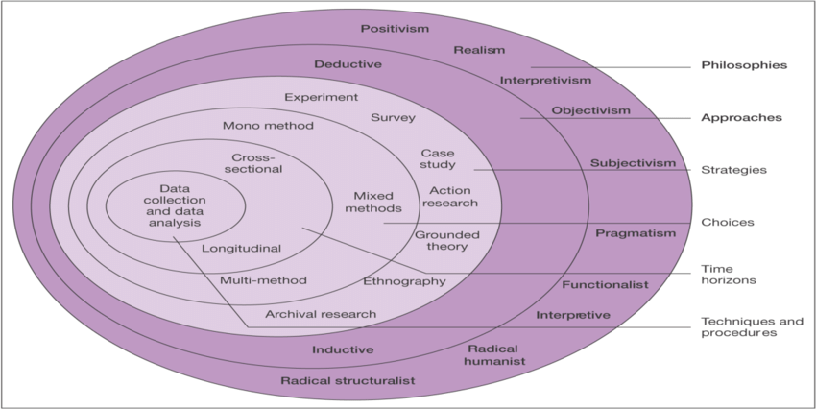
Figure 3. Research Onion Source ( Saunders, et al, 2016).
The researcher followed the above diagram from the outer layer inwards. For this dissertation, the research was undertaken based on the philosophical angle, the positivism with elements of interpretivism by using a deductive approach. The strategies used were a case study and survey. As for the survey, mixed methods were used to form an online questionnaire, which was designed to collect qualitative and quantitative data. The time horizon was cross-sectional and the data collected was addressed and analyzed by the researcher, which is the core of the Onion Research.

3.1.1 Philosophy
This research holds, with regards to the general topic of the study, epistemological underpinning, which indicates that the research is concerned with “assumptions about knowledge, what constitutes acceptable, valid and legitimate knowledge “, (Saunders et al, 2016, p.716). However, as for the case study, Oystermouth Castle, the researcher has no assumptions due to unavailable previous research conducted.
This research adopted the positivism approach as it is a primary approach, including some elements of interpretivism in some areas. Positivism approach requires the use of a quantitative methodology, which is based on numbers and measurements, in order to collect and analyse. On the other hand, the interpretivism is based on words and images which use qualitative data, (Saunders et al, 2016). As the basis of this dissertation held the foundations of quantitative data, positivism is the most appropriate paradigm. However, there are also aspects of qualitative analysis, meaning that elements of the interpretivism paradigm also needed to be acknowledged, (Collis & Hussey, 2014). The purpose of this approach was to discover the opinions and thoughts of key personnel in the sector, which led to enhancement of the numerical findings.

3.1.2 Approach
Deductive approach, as described by Loseke (2017), involves ‘using what is already known in order to determine what data to collect’. There is available literature regarding the topic of Events in Heritage Sites and the Increase of Visitors. Hence, using the deductive approach is the most appropriate approach for this research.
The purpose of this dissertation was exploratory, as it did not aim or intend to offer final solutions to the problem in question; instead, it intended to explore the research question and establish correlation in order to provide a foundation for any further study which will be made into a similar area, (Dudovskiy, 2018).
The researcher initially chose a mixed methods approach for this research, in order to collect qualitative and quantitative data, via online questionnaires and interviews. However, after reconsideration the researcher chose to primarily focus on collecting quantitative data via questionnaires and not conduct interviews, due to the unavailability of the intended people for the interviews.

3.1.3 Strategy and Choice
O’Gorman and Maclntosh (2015) state that the collection of data is considered as the backbone of every research project; therefore, the researcher should be able to identify what data is worth analysing. As for this dissertation, it focuses on a case study of Oystermouth Castle, Swansea and collecting data via surveys. The survey strategy which Zikmund et al (2013, p185) define as ‘a method of collecting primary data through ‘communication’ with individuals’, is considered the suitable method of collecting data for this research.
The secondary research, which is considered as the data already available for the researcher to collect and analyse, was explained by Baxter et al (2001), as data which occurs in the format of public reports, books, articles, newspapers and websites. However, the researcher was limited to the findings of this data, as there were not many researches previously conducted on this topic, or Oystermouth Castle; this will be explained further, later in this chapter.

3.1.3.1 Primary Research
As for the primary data, which is data generated for the specific reason of the research project, this included questionnaires from a survey (Bryman and Bell, 2007), which was chosen as a primary method for collecting data to form the primary data for this research. Blaxter et al, 2001 suggest that a researcher may use a combination of more than one type of data collecting. Therefore, the researcher chose to collect data through online questionnaires and intended to conduct an interview with a key person with knowledge of the case study, who would benefit this research due to her practical, immediate involvement. However, the researcher was unable to complete the interview. This was due to the key person not responding and the researcher being unable to meet with the key person due to the quarantine impact of COVID-19, which was considered as a limitation to this dissertation.
As mentioned previously, the researcher collected quantitative and qualitative data. The reason for this decision is that the researcher was pursuing a Triangulation method, in order to compare the findings between the three research methods, case study, qualitative and quantitative, (Hair, 2011). However, as mentioned earlier, one element of the Triangulation method was not completed - the interview. The use of triangulation would have increased the confidence in the data collected by the researcher, which would also mean the validity is higher. Hair (2011), suggested that the results from using the triangulation provide the researcher with a fuller picture and a unified conclusion on the research question. O’Gorman and Maclnotsh (2015) explain that the mixed method research design is commonly used.

3.1.3.2 Questionnaire Design
The questionnaire consisted of twenty four questions, ranging from tourism preferences, visiting Welsh Castles, events and castles, admissions fees to demographics. The questions were a mix of closed-ended multiple choice and open ended questions. The closed ended type of questions is considered most useful in order to obtain comparative data, statistical data, (Cameron & Price, 2009). As for the open ended questions, they provide the qualitative data that presents the respondents opinions and preferential data, (Thomas, 2003). See appendix 2 for the full questionnaire.
Hence, the design of the questionnaire features both Likert scale questions and free text answers, which will provide the researcher with both the data required and aid with putting forward recommendations. Moreover, the advantage of an online questionnaire is that it can reach a wider range of people and as mentioned, it can collect both quantitative and qualitative data.

3.1.3.3 Pilot Study
Saunders et al, (2007) suggest that prior to the questionnaire being launched, it should be pilot tested by an expert, in order to refine the questionnaire to ensure that the respondents answer the questions, which therefore, will result in no issues when recording the data.
An organisational professional looked at the questions for the questionnaire and discussed them with the researcher. Some alterations were made, with regards to the wording and the position of the question. For example, the researcher was advised to move the questions about the participants’ demographics to the end of the questionnaire instead of having them in the beginning and to include more questions that linked directly to the case study, Oystermouth Castle.

3.1.3.4 Sampling
For this study, the researcher used two types of sampling; probability sampling and non-probability sampling. Walter (2013, p160) explains that probability sampling is “a way of achieving samples that are representative of the whole population of interest and involve random selection”, whereas non-probability sampling involves a specifically chosen sample based on particular characteristics or similar differentiating features relevant to the study. Therefore, it cannot be determined whether the results of the study are representative of the whole population, (Walter, 2013). In relation to the questionnaire, which was launched on SmartSurvey platform, the demographics were chosen by the researcher. It targeted 18 -65 and over years old people, from all genders, who live in Wales. The participants were diverse, as this will give the researcher a better understanding of a wider population.

3.1.3.5 Collection and Analysis
Fin, el at (2000), explain that the context of any data collection is important for the analysis. This ensures that the results are not isolated, which could lead to unexpected variation within the data. As for this study, the element of quantitative data was included in the questionnaire in the form of open ended questions, which allowed the participants to express their opinions in their own words. The survey was launched on Smart Survey platform, a UK based company that specializes in surveys and is used by the government and private sectors, (smartsurvey, 2020). After a period of four days, there were 404 responses collected. The results were in the form of percentages, and open ended answers. The numerical results were analyzed by using SPSS and displayed as graphs and discussed according to percentages and respondent numbers. This gave the researcher a better understanding of the results. As for the qualitative data, the researcher used NVIVO which highlighted the words most used by the respondents and present them in a word cloud. The results were analyzed and presented in chapter 4.

3.2 Time Horizons
Saunders and Philips (2012) suggest that, the time horizon of any research project can be either cross-sectional or longitudinal. They continue to explain that cross-sectional research means to collect data in a singular time period which often allows a single set of data collection. On the other hand, the longitudinal research takes place over a more prolonged period of time, therefore, allowing multiple stages of data collection. The researcher, acknowledges that this research lends itself to a cross-sectional investigation.

3.3 Reliability and Validity
Saunders et al (2016, p156) explain that ‘reliability refers to the extent to which the data collection techniques or analysis procedures will yield consistent findings’. Since this study is primarily a positivists, the results tend to have high reliability with low validity, according to Collis and Hussey (2009). However, this study has a slight element of interpretivisim from the open ended questions in the questionnaire, which Saunders et al (2016) suggest that they are considered low reliability as there are many variables that could have an effect on the outcome of the interview. Despite interpretivisim being considered low reliability, it has a high level of validity, which reflects the ‘accuracy and trustworthiness’ of the data and it’s findings, (Bernard, 2006 p53). Therefore, the use of interpretivisim produced a reverse effect and having the combination of the two, theoretically should result in producing a study that is both reliable and valid, (Collis, and Hussey, 2009).
As mentioned earlier in this study, Oystermouth Castle is owned by Swansea Council, however, run by ‘The Friends of the Castle’. The Friends of the Castle is a group of volunteers who run the day to day management of the castle. The majority of the volunteers are retired people, who joined for the love of the castle and the need to give back to their community. Therefore, with regards to the reliability of visitor numbers during normal days and event days, it could be slightly questioned. This is due to the fact that the events are included in the admission fee. Visitors do not buy a ticket specifically for the event, hence making it difficult to separate event visitors and castle visitors.

3.4 Limitations
The primary limitation to any study is time constraints, and applies to all undergraduate dissertations, (Saunders, et al, 2007). However, the researcher attempted to mitigate the limitations by first creating a Gantt Chart, which can be seen in appendix 3, to ensure that the researcher completed the tasks of this study in a logical beneficial order. However, the researcher was unable to finish tasks in the intended time frame.
The researcher was faced with another limitation when collecting the data. The initial plan was to conduct both quantitative data in the form of an online questionnaire and qualitative data in the form of interviews. However, due to some participants not responding for the interviews, the researcher therefore, focused on collecting more quantitative data. Qualitative data was collected within the design of the questionnaire, as was explained in section 3.1.3.2 The Friends of the Castle were not chosen for the interviews, this was due to them being unavailable.
A further limitation was the lack of reliable records of visitor figures during events. This was due to not having a separate system in the castle. The events were included in the admission fee, hence, making it difficult to determine whether the visitors were visiting the castle for the event or for a tour of the castle.

3.5 Ethical Consideration
When a research includes members of the public, ethical considerations are vital and should be taken into consideration, (O’Gorman & Maclntosh, 2015). As for this research, all data collected is confidential and has been stored on servers with a secured password and has not been shared with any person other than the researcher and the supporting facility, which for this study is the University Of Wales Trinity Saint David.

3.6 Future Studies
There is limited literature available with regards to the topic of events hosted in historical attractions. Therefore, this study could aid any future research as it collected sufficient responses to build an understanding of the topic.
The following chapter goes on to analyse all the data which has been collected via methods discussed in this chapter.

Chapter 4: Data Analysis
The purpose of this chapter is to address the third objective:
- To analyze the data collected and present the findings in order to establish whether events have a beneficial impact on heritage sites, in terms of visitor figures.
In chapter 3, the researcher stated the use of SPSS to analyse the quantitative data. This has been completed, however, is not shown in this chapter. This was due to the researcher using SPSS on UWTSD library computers and not having access to them as a result of lockdown.

4.1 Introduction
This chapter addresses and analyzes the data gathered and collected via the primary method of a questionnaire, as explained in chapter 3. There were 404 respondents who were specifically targeted by SmartSurvey. The data collected will be analyzed in this chapter and interpreted by the researcher and presented in the form of graphs and percentages; in addition to presenting qualitative data to show the respondents opinions. The questionnaire can be organised into sections, in order to achieve different purposes; questions 1, 2, 3 and 4 were to establish the tourism preferences by the respondents. Question 7 was for the researcher to have a better understanding as to why the respondent preferred museums over castles or castles over museums. Questions 8, 9, 10 and 11 focused on gathering information regarding visiting Welsh Castles by the respondents, which castle, if it was well maintained and if they would visit it again. However, question 12 asked about their opinion, whether they thought that the government markets the Welsh Culture enough to attract visitors.
Questions 5, 6, 13,14 and 15 revolve around events and castles. This data was to acknowledge what the respondents thoughts about hosting events in castles, by presenting quantitative and qualitative data. Moving onto the case study, Oystermouth Castle, questions 16, 17 and 18 asked the participants if they had heard of, or visited the castle. If not, would an event attract them to visit. In terms of admission fees, question 19 asked if they thought historical attractions should have an entry admission and question 20 asked about the price they would consider suitable. The participants’ demographics were asked in questions 21, 22, 23 and 24. The full questionnaire can be seen in appendix (2).

4.2 Section one- Tourism Preferences
The first and second questions asked the participants about their holiday preferences, to establish an understanding of why people travel. The first question asked them who would they prefer to travel with, 72.52% of the respondents said they prefer to travel with family, 18.56% prefer to travel with friends, 5.95% prefer to travel alone and the rest had mixed responses.
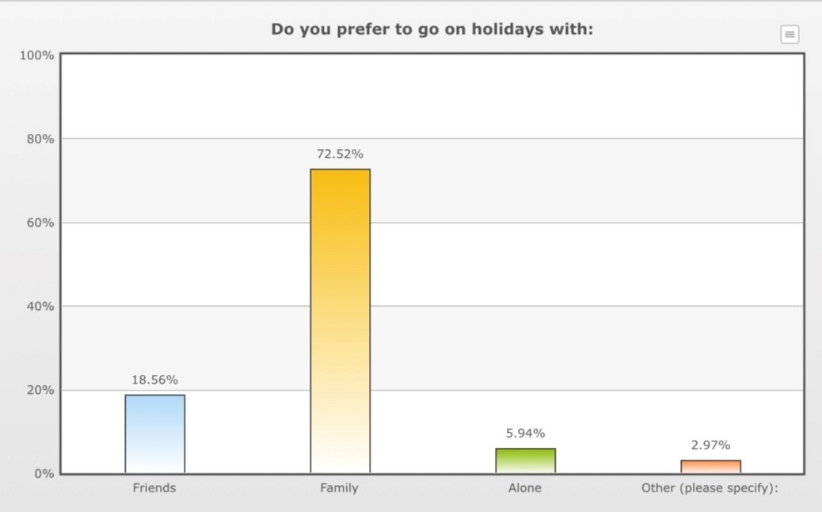
Figure 4: Graph depicting the respondents’ preference of who to travel with.
As for the second question, it asked about the type of holiday that they preferred. 48.76% of them preferred to go on beach holidays and 20.79% preferred city breaks 13.86% preferred cultural holiday and 10.15% chose adventure holidays.
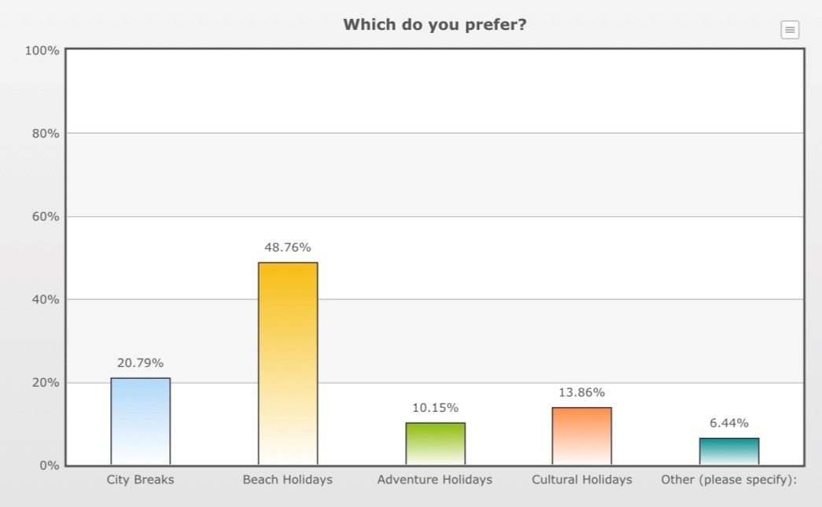
Figure 5. Graph depicting respondents’ holiday type preference.
While people go on holiday, their activities and interests vary from one to another. As mentioned in chapter two, 2.2.2 Heritage and Cultural Tourism, traveling for cultural purposes has been increasing since 1980, (Sigala and Leslie , 2005). Question 3 asked the respondents if they would consider visiting a historic attraction as a main reason to travel, and 80.97% responded with yes and 19.06% said no.
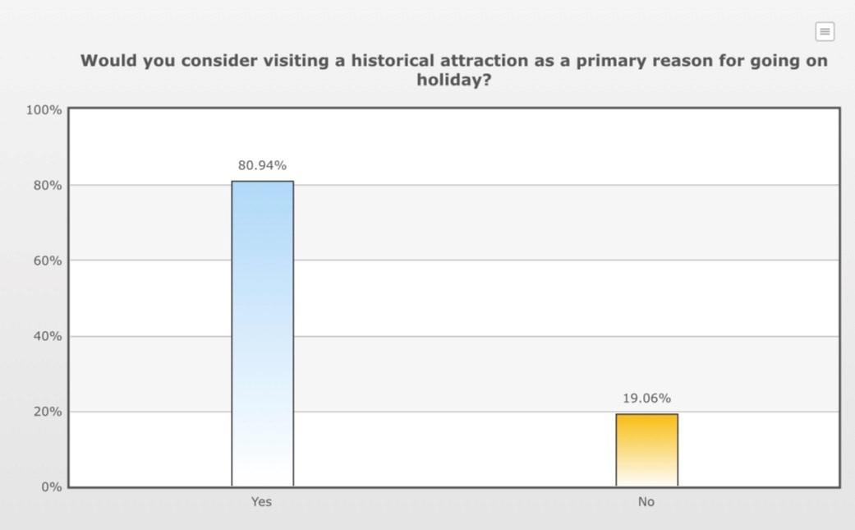 Figure 6 . Graph depicting if respondents would consider visiting a historical attraction as a main reason to travel.
In question 4 respondents were asked about the type of historic attraction that they would consider visiting. 84.10% chose castles, 64.83% chose museums, 54.74% chose churches and cathedral and 47.09% chose stately homes.
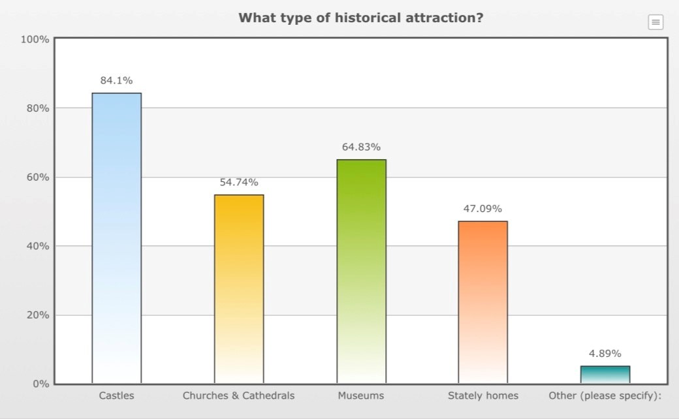
Figure 7. Graph depicting the types of historical attractions the respondents chose.

4.2.1 Castles vs museums - Qualitative Data
60.89% of the respondents chose visiting castles over museums, as question 7 asked them which they preferred to visit more, castles or museums. They were then asked to express their opinion using their own words without any character limit. Some of their responses for choosing castles were:
‘Debatable. I would generally prefer a museum to see if any art shows were on. Castles can be quite adventurous, but only at certain times of the year’
‘Castle’s tell a story, each castle is a fundamental piece of history still standing within our day and age and I think that’s astounding.’
‘You can really imagine yourself in the past and how great the castle would have been’
‘I find them really impressive in their construction’

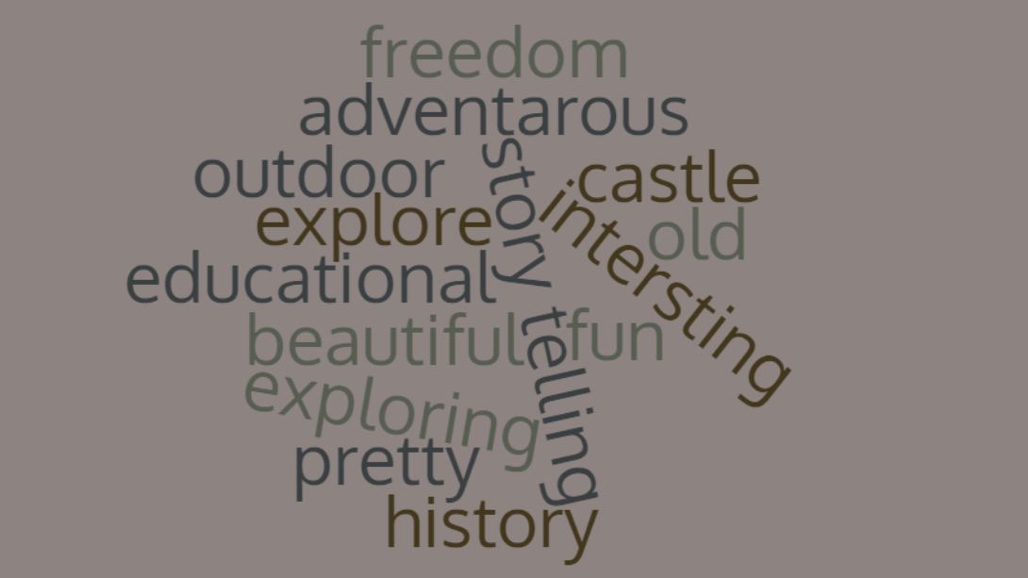
‘Figure 8: Word cloud representing most used words from the responses from question 7
The word cloud presents the most frequently used words in the participants’ responses. In their opinions, they thought that visiting castles is considered more interesting, and has more of a story telling side as it allows them to walk the paths of history.
As for museums 39.11% preferred to visit them, and some of their opinions were:
‘Museums are a way of discovering the history of the place you are visiting to learn about the culture’
‘Castles are history you can see and feel.Museums are just for looking and reading about’
‘I find the museum more adventurous.’
‘They are educational and children and adults love to learn about history’
‘There is far more to learn from a museum, though the perfect visit for me would be a castle with a museum’

4.3 Section Two- Visiting Welsh Castles
80.94% of the participants said that they have visited a castle in Wales and 19.06% have not, according to question 8. As mentioned in point 2.3.1 in chapter two, Wales has over 600 castles; however, when the respondents were asked to state which one, Cardiff Castle and Caerphilly Castle were the two most visited castles. 93.31% of them said that they would visit the castle again, and 6.69% said they would not. Question 9 asked the participants if they thought the castle they visited was well maintained or not. A high percentage of 96.67% thought the castle was well maintained and only 3.33% didn’t.
Question 10 asked about the reason of the visit, whether it was a planned or unplanned visit, for an event or any other reason. They were then asked if they would visit again in question 11, and 93.31% said that they would; a high figure which suggests satisfaction of the participants visit to the castle.
Furthermore, question 12 gave them the opportunity to express their opinion, with regards to advertising the Welsh Culture. The majority felt that the Welsh Government does not market the Welsh Culture enough and some of the responses were:
‘I've never seen any advertisements for it, but I think it's the sort of thing you'd know about anyway if you were interested in that sort of thing’
‘No, they never advertise the small village events which is where people will find Welsh culture’
‘No. I think they should advertise them more’
‘No I feel they could make more effort to get places recognised by visitors’
‘No they focus on the country side and food not our historical attractions’
However, some of the respondents thought that there is enough advertising, however, it should not encourage attracting more visitors due to the impacts it may cause. As an example of an opinion:
‘Yes they do, perhaps too effectively - I am a Welsh resident and can see the destruction the increase in mass tourism has caused here in the last 20 years or so - particularly in some of the AONB areas. I feel this element is greatly overlooked in favour of short-term profit and commercial gain’

4.4 Section Three- Events and Castles
As for question 5, it asked the respondents if they would travel for an event, and 89.60% said that they would. This figure is relatively high which indicates the importance of attending events to the participants. However, only 10.42% said that they would not travel for an event. Moreover, question 6 asked how far they would travel for an event. This question was for the researcher to acquire a better understanding as to what extent the participants would go for an event.
The respondents were asked in question 13 if they agreed with hosting events in castles. The response was high with a percentage of 90.59% who have agreed.
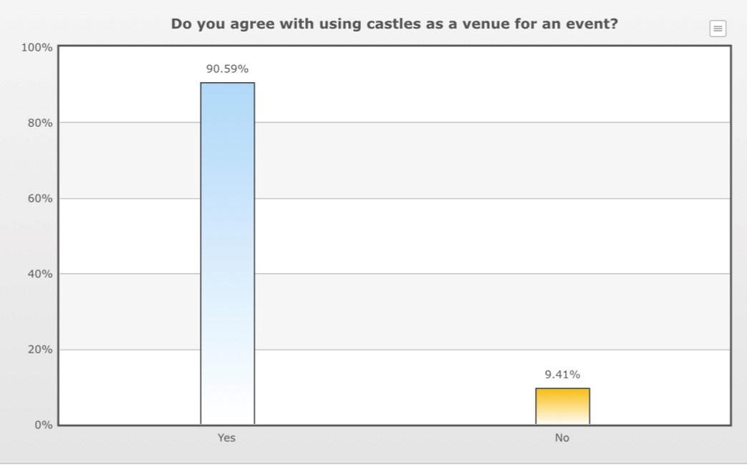
Figure 9. Graph depicting the percentage of respondents who agreed with hosting events in castles

4.4.1 Qualitative data
Question 13, which was in two sections, the yes and no, which resulted in percentages as shown in 4.4, and the second section, which gave them the opportunity to express their opinion in their own words to form the qualitative data. Some of the responses for agreeing with using castles as venues for events were:
‘Culture is appreciated and nice use of space’
‘Because having an event in a castle is different than anywhere else’
‘Make use of it and raise money for any restoration’
‘I have been to an event at a castle. I think it's a great modern day use for them. And it brings people to historical places they may not normally go to’ .
‘I feel it would enhance the atmosphere and promote the history’
‘It can draw more people in, and actually pay for the upkeep of the castle’.
‘Venues are more attractive in castles’
‘Castles are a fun place to hold an event, and people who would not normally visit a castle may become interested in seeing other castles’.
‘I agree, Welsh Castles are a magnificent way of bringing modern life, socialism and Welsh culture together’.
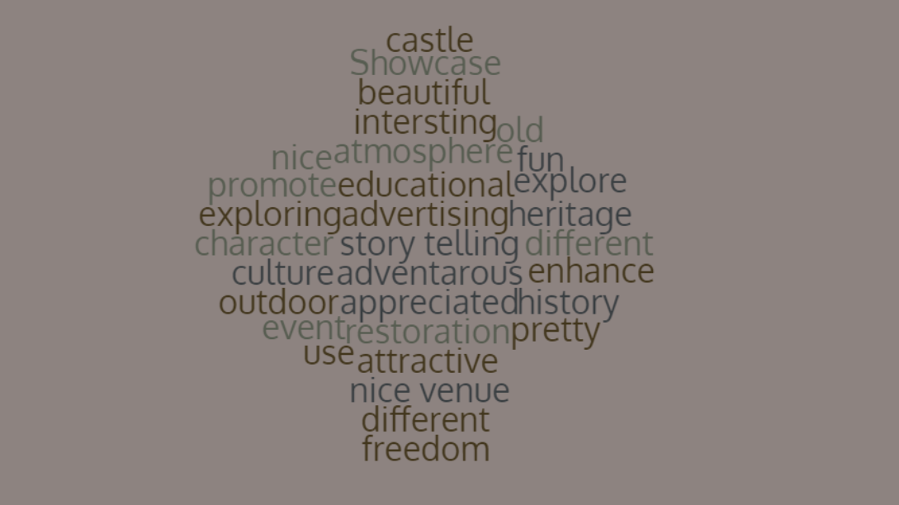
Figure 10. Word cloud representing most used words from the responses from question 13
This word cloud presents the frequently used words by the participants. 90.95% believed that it is a good idea to host events in castles, as they are different and beautiful (according to the word used in the responses). However, 9.41% disagreed with considering castles as a venue for events, and some of their opinions were:
‘They are history, there is no way to guarantee everyone in said event would respect the area and then it could be trashed due to alcohol, intolerance or simply ignorance which would be utterly pointless’
‘Rhuddlan Rocks was good but allowing 1000 drunk people inside a castle in one go to a rock concert. No that’s not good.’
‘Castles should be visited by respectful people who specifically want to visit a castle, not just used as a venue for anybody without a care in the world’

4.4.2 Benefits of hosting events in castles
In section 2.2 in chapter two, it suggests that there is a known link between events and tourism. Some of the responses for question 13 suggested that hosting events in castles would increase visitors and encourage tourism. Some of the responses were:
‘Brings tourists to the town’
‘It encourages visitors to visit a castle who may otherwise not have visited as they are not interested in visiting historical and cultural places. It also will generate an income to help maintain the castle for future generations which is very important’
‘I think it would bring in people from other countries, more money to put into the keeping up the maintenance and having more visitors from wedding party to go back and have a good visit at a different time’
The responses also displayed opinions of the participant; some believed that hosting events in castles will showcase heritage and would be an opportunity to advertise the venue. It could also be a way to bring the Welsh culture together and one venue could lead to an interest in visiting the other Welsh castles.
Question 14 asked the participants what type of events they would consider suitable to host in a castle. The results are displayed in the graph below:
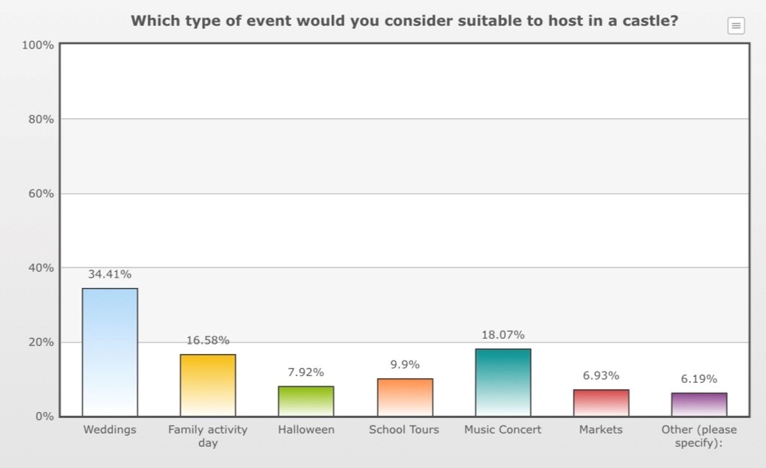
Figure 11. Graph depicting the types of events the respondents considered appropriate
As can be seen in figure 9, weddings were the type of event most considered suitable by the respondents. Followed by music concerts and family activity days.
As for question 15, it asked the participants if they thought hosting events in Castles would attract visitors. The responses were 92.82% that thought it would attract more visitors and 7.18% thought it would not.

4.5 Section Four- Oystermouth Castle
The questionnaire targeted Wales, and despite Oystermouth being in Wales 233 respondent from the 404 did not know the Castle as question 16 asked them if they had heard of Oystermouth Castle; and question 17 asked those who had heard of it, if they had visited the castle.
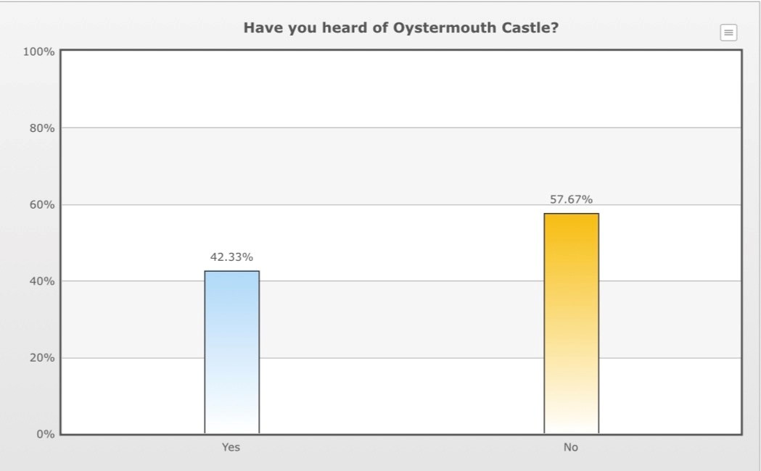
Figure 12. Graph depicting the percentage of respondents who knew Oystermouth Castle
42.33% which was 171 of the respondents, knew Oystermouth Castle, however, only 98 of them had visited the castle.
On the other hand, question 18 asked the participants if an event would attract them to visit the castle, if they had not been yet. 81.63% of them said they would visit the castle if there was an event.

4.6 Section Five- Admission Fees
Question 19 asked the participants if they agreed with an entry admission fee for historical attractions. 77.48% agreed with having admission fees and 22.52% disagreed to paying any fees to enter historical attractions. The participants were given the option to express their opinion about paying entry fees; some of these opinions were:
‘Payment helps to maintain the building’.
‘Need to pay for renovations and up keep’
‘It helps pay for the maintenance and therefore you are paying to stop the attraction disappearing from our country’
‘I do not agree with paying fees to enter a castle unless there’s a specific event going on. However I understand the fees will contribute to restoration and paying staff’
The general opinion was that the entry fee is to go towards the maintenance and renovation of the castle. Some disagreed, stating that paying a fee would be considered unaffordable for some families, which would lead to them not visiting historical sites.

4.7 Section Six- Demographics
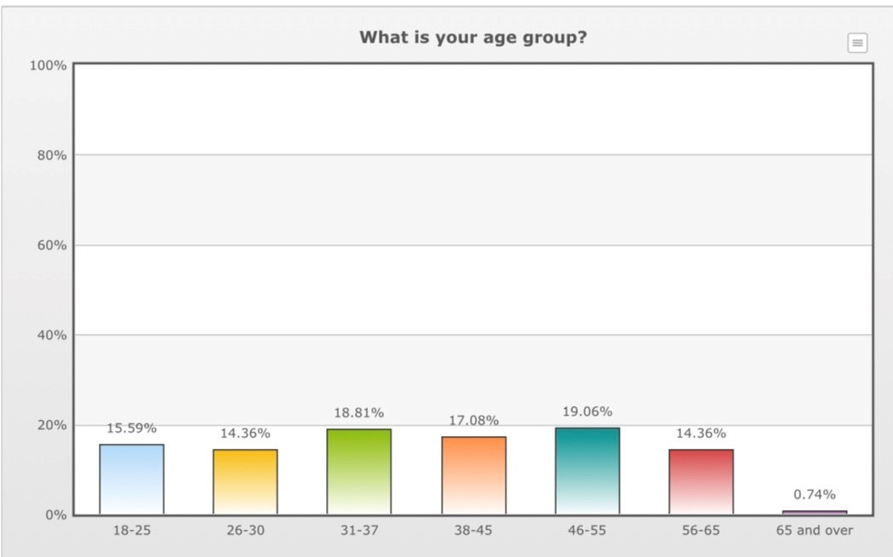
Figure 13. Graph displaying the participants ages
The graph above illustrates the ages of the participants (question 21). As it can be seen in figure 11, 19.06% are aged between 46-55 years and 18.81% between 31-37years, 17.08% aged between 38-45 years, 15.59% are aged between 18-25 years and two age groups were equal with 14.36%, 26-30 years and 56-65 years. Only 0.74% of over 65 years and over, took part in the questionnaire. The percentages of the age groups of the respondents were relatively equal, leading to a diversity in the responses.
As for the gender of the participants, question 22 asked about, the best gender description that they would describe themselves as. 65.10% described themselves as females and 33.66% as males. Only one participant described him/herself as other and four preferred not to say. Furthermore, question 23 asked the participants about their location. 67.99% were from South Wales, 24.07% from North Wales and 7.94% were from Mid Wales. As for the final question, question 24, it asked about the participants’ occupation.

4.8 Main Findings
More than 50% of tourists travel for leisure and recreational purposes; whether it was for a beach holiday, adventure, cultural or city breaks, (unwto, 2019). Leisure includes visiting historical attractions, which includes castles; events are also considered as traveling for leisure, (Torkildsen, 2005). The analysis of the questionnaire questions, regarding the participants’ tourism preferences highlighted that a high number of the participants preferred to go on beach holidays with family. However, only 56 of the respondents preferred cultural holidays, as some said they enjoy learning about different cultures and the history of other countries. This proves the point 2.2.2 in chapter 2 when Sigala and Leslie (2005, p 5) explained that the term Heritage and Cultural tourism refers to ‘the segment of the tourism industry that places special emphasis on heritage and cultural attractions’. These findings support the annual international tourism highlights of 2019.
Moreover, 404 responded to the questionnaire, and 327 of them stated that they would consider visiting an historical attraction with 275 of them preferring castles to the other historical attractions. Chapter 4 presented some of the reasons as to why the respondents preferred to visit castles. On the other hand, point 2.3.1 explaines that there are 600 castles in Wales, and only 107 of the respondents have visited a castle in Wales. The two castles that were most visited were Cardiff Castle and Caerphilly Castle, and when the respondents were asked for the reason of visiting, they stated that it was a planned visit and some went specifically for an event at the castle. Referring back to point 2.3.1, these two castles host a variety of different types of events, from weddings to family events. As mentioned in chapter 2, there is a clear link between events and tourism; which indicates that events work as a motive for traveling and visiting a certain attraction. In point 2.1.3, the push and pull factors are explained as; the push factor is what pushes the tourist to go a certain attraction and the pull factor is what the attraction does to pull the tourist to visit. With regards to the respondents’ responses, the events were considered as the pull factor that attracted the respondents to visit the castle.
As for the main point of this dissertation, hosting events in castles, the majority of the respondents considered the castle an appropriate venue to host an event. The main finding regarding this topic from the questionnaire was that events attract people to castles and encourage them to visit other castles. 375 of the respondents believed that hosting events in castles will increase and attract more visitors, but, as they explained, the Welsh government does not advertise the Welsh heritage culture enough to attract more visitors. They feel that there is not enough marketing and advertising of the Welsh historical attractions and by hosting events in these attractions, the marketing will increase, which will therefore, lead to attracting visitors. Hence, the attractions will be advertised more and will become known. More visitors will increase the ticket sales, which could then be used, according to the respondents, to maintain and renovate the attraction.
In terms of the case study, Oystermouth Castle, a high number of the respondents have not heard about the castle before. However, they would consider visiting the castle if there was an event hosted there. Again, showing that events act as a motive to visit castles. These findings were based on an almost equal percentage of different genders and ages groups.
The following chapter will address the final objective and establishing a link between events in heritage sites and the increase of visitor figures.

Chapter 5: Conclusion & Recommendations

5.1 Introduction
In this chapter the final objective:
- To establish a link between hosting events and attracting more visitors to Oystermouth Castle, which will be used to put forward recommendations.
is addressed, as the researcher forms a conclusion and puts forward recommendations. .

5.2 Conclusion
To conclude, the collected secondary research, which was presented in chapter 2, covered topics that are related to the main topic of this dissertation. However, the literature available, regarding impacts of hosting events in heritage sites with regards to visitor figures, was limited. In terms of the case study, Oystermouth Castle, there was no previous research conducted. Hence, this study could be used for future studies about the castle. As for the primary research, it allowed the researcher to have a better understanding of the addressed topic, and collected a good number of responses that allowed the researcher to build a conclusion.
As can be seen from the main findings of the questionnaire in chapter 4, based on the responses of the online questionnaire, the participants believed that events play a main reason to encourage people to visit castles. In the participants’ opinion, they believed that these castles are not advertised enough for people to know about. The Welsh culture heritage is not marketed enough to reach everyone in order to attract them to visit. Castles are considered more interesting to the majority of the participants, as they allow the visitor to see history and allow them to imagine what it was like in the past.
With regards to Oystermouth Castle, more than half of the participants had not heard of the castle, despite them living in Wales. This shows that the castle is not advertised enough to attract visitors. The castle hosts events during the opening months which are from April to September, but it was difficult for the researcher to determine if the visitors came to the castle for the event or just to visit the castle. This was due to the lack of available reports and valid records from the castle. However, it could be concluded from the findings that with the correct advertising and hosting the correct events in Oystermouth Castel, more visitors will be attracted to visit.
The main conclusion and the answer to this investigation is, hosting events in castles, will attract more people to visit, which shows the importance of events and the impact they could have on increasing visitor figures to castles

5.3 Recommendations
The findings of the questionnaire enabled the researcher to put forward recommendations that could aid Oystermouth Castle with performance, with regards to increasing visitor figures.
- Oystermouth Castle supervisor should explore the event options, and conduct a research to build a better understanding of what events attract people to visit the castle.
- The Swansea Council marketing department should increase the advertising of the castle, in order to reach a wider audience.
- The castle should have a system that differentiates the visitors who are visiting for the event or for a tour in the castle.
- The castle should have more paid employees who work at the castle on a regular basis, during operating seasons. These employees could assist the Friends of the Castle with the daily responsibilities.
- Work more closely with schools and invite them to events, which will encourage the children to come back with their families on different days.
5.4 Future Research
The researcher feels that the collected data could be used for future studies with regards to hosting events in castles and potentially taken into consideration by Swansea Council and Oystermouth Castle. Completing this dissertation was a challenge for the researcher firstly, the limited resources and research available that revolves around the chosen topic. The case study, Oystermouth Castle,has not been included in any research prior to this one. Hence, the research had no assumptions of the outcome of the questionnaire. But if this research was to be conducted again, the researcher would conduct interviews with locals and members from Swansea Council. The overall conclusion of this dissertation is that, Oystermouth Castle should host more events that are in demand, to increase its visitor figures.

Bibliography
Ahmed, Z.U. (1991) The influence of the components of a state's tourism image on product positioning strategy, Tourism Management , 12, pp.331-340.
Allen, J. , O'Toole, W. , Mcdonnell, I. and Harris, R. (2002) Festival and Special Event Management. London: Wiley.
Baloglu, S. and Brinberg, D. (1997) Affective images of tourism destinations, Journal of Travel Research, 35(4), pp. 11-15.
BBC. (2017) UK City Culture 2021: Swansea disappointed to lose the bid [online] Available at: https://www.bbc.co.uk/news/uk-wales-south-west-wales-42271740 ( Accesssed on: 16/01/2020).
Beard, C and Russ, W. (2017) Event Evaluation and Design: Human Experience Mapping. Event Management Journal, 21 (3), pp, 365-375.
Bowdin,G., McDonnell, I., Allen, J., and O’Toole, W. (2001) Events Management. Oxford: Butterworth- Heinemann.
Bryman, A and Bryman, P. S. R.A (2003) Quantity and Quality in Social Research. New York: Routledge.
Bryman, A. & Bell, E., (2007) . Business Research Methods. (2nd ed) . Oxford: Oxford University Press.
Business Wales (2019) The Heritage Fund [online] Available at: https://businesswales.gov.wales/news-and-blogs/news/heritage-fund (Accessed on: 25/05/2020).
Cadw. (2019) Oystermouth Castle [online] Available at: https://cadw.gov.w).
ales/visit/places-to-visit/find-a-place-to-visit?location=51.575906%2C-3.999879%3C%3D3000m&search_query=mumbles&current_location= (Accessed on: 12/11/2019).
Cadw. (2019) Inspiring passion from our past. [online] Available at : https://cadw.gov.wales/ (Accessed on: 20/02/2020).
Cohen, L., Manion, L. & Morrison, K., (2017). Research Methods in Education. 8th ed. Abingdon: Routledge.
Collis, J. & Hussey, R., (2009). Business Research: A Practical Guide for Undergraduate & Postgraduate Students. (3rd ed.) Basingstoke: Macmillan Publishers Limited.
Cooper, D. C. & Schindler, P. S., (2001). Business Research Methods.( 7th ed). New York: McGraw-Hill.
Daniel, P. S. & Sam, A. G., (2011). Research Methodology. New Dehli: Gyan Publishing House.
Denney, A.S. and Tweksbury, R. (2013) How to Write a Literature Review. Journal of Criminal Justice Education 24 (2), 218-234.
Fyall, A,. Garrod, B., Leask, A (2003) Managing Visitor Attraction, New Directions. Oxford: Butterworth- Heinemann
Geography in the news (2020) Tourism in Wales [online] Available at : https://www.geographyinthenews.org.uk/issues/issue-4/tourism-in-wales/ks3/
(Accessed on: 19/01/2020)
Getz, D. (2007) Event Studies, Theory, research and policy for planned events . Oxford: Butterworth- Heinemann
Ghauri, P. & Gronhaug, K., (2005). Research Methods in Business Studies: A Practical Guide. 3rd ed. Harlow: Financial Times Prentice Hall.
GGAT. (2010) Oystermouth Castle [online] Available at: http://www.ggat.org.uk/oystermouth_excav/oystermouth_history.html (Accessed on: 05/02/2020).
Gov (2019) Statistical first release [online] Available at: https://gov.wales/sites/default/files/statistics-and-research/2019-06/wales-tourism-performance-report-january-to-december-2018.pdf ( Accessed on: 01/05/2020)
Hair, J (2007) Research Methods for Business (2nd ed). Chichester: Wiley and sons
Hair, J (2011) Essentials of Business Research Methods (2nd ed) Oxford: Routledge.
Harrison, R. (1994) Manual of Heritage Management. Oxford: Butterworth- Heinemann
Hart, C (1988). Doing a literature review. Releasing the social science research imagination. London: Sage.
Heritage Fund (2020) Areas Buildings and Monuments [online] Available at: https://www.heritagefund.org.uk/our-work/buildings-and-monuments (Accessed on: 25/05/2020).
Holmes, K and Smith,K. (2009) Managing Volunteers in Tourism Attractions, destinations and events. Oxford: Butterworth- Heinemann
Johnson, P. & Clark, M.,( 2006). Business and Management Research. London: Sage.
ITV. (2016) Record-breaking visitor figure for Welsh heritage sites [online] Available at: https://www.itv.com/news/wales/2016-10-28/record-breaking-visitor-figures-for-welsh-heritage-sites/ ( Accessed on: 19/01/2020).
Jeffries, D. (2001) Governments and Tourism. Oxford: Butterworth- Heinemann.
Kelle, U. (2006). Combining qualitative and quantitative methods in research practice. Qualitative Research in Psychology, 3(1), 293-311.
KPI (2020) What is a key performance indicator? [online] Available at: https://kpi.org/KPI-Basics (Accessed on: 13/03/2020).
Loseke, Donileen, R ( 2017) Methodological Thinking: Basic Principals of Social Research Design. (2nd ed) Thousand Oaks: Sage
Lyck, L., Long, P., and Graig, A. (2012) Tourism, Festivals and Cultural events in times of crisis. [online] Available at:
https://www.encatc.org/media/287-tourism_festivals_and_cultural_events_in_times_of_crisis.pdf (Accessed on: 17/01/2020)
Mazanec, J. A., Crouch, G I,. Brent Ritchie, J R,. and Woodside, A G. (2001) Consumer Psychology of tourism, hospitality and leisure. ( 2nd edn) . Oxon: CABI.
Misiura, S. (2006) Heritage Marketing. Burlington: Butterworth- Heinemann

Neal B, and McElroy, T. (2004) Bussiness Finance. A Value-Based Approach Essex: Pearson Education Limited.
Novelli, M. (2005) Niche tourism, contemporary issues, trends and cases. Oxford: Butterworth-Heinemann
Orbsali, A. (2000) Tourists in Historic Towns, Urban Conservation and Heritage Management. London: E & FN Spon.
Paulus, T. M., Lester, J. N. and Dempster, P.G (2014) Digital Tools for Qualitative Research. London: Sage.
Pettinger, R. (1994) Introduction to Management. London: The Macmillan Press LTD.
Prentice. R. (1993) Tourism and Heritage Attractions. London: Routledge
Richards, G and Munsters, W. (2010) Cultural Tourism Research Methods. Oxfordshire: CBA International
Samuels, J.M., Wiles, F.M,. and Brayshaw, R.E. (1999) Financial Management and Decision Making . London: International Thomson Business Press.
Saunders, M., Lewis, P. & Thornhill, A., (2009) . Research Methods for Business Students. (5th ed). Essex: Pearson Education Limited.
Saunders, M. & Phillip, L., (2012). Doing Research in Business and Management. (1st ed). Harlow: Pearson Educated Limited.
Saunders, M, Lewis, P & Thornhill,A. (2016) Research Methods for Business Students. (7th ed) Harlow: Pearson Education Limited.
Shaw, E. (1999). A guide to the qualitative research process: evidence from a small firm study. Qualitative Market Research, 2(2), 59-70.
Shone, A and Parry, B. (2010) Successful Event Management (3rd edn). Hampshire: Cengage.
Sigala, M and Leslie, D. (2005) International cultural tourism, management, implications and cases. Oxford: Elsevier Butterworth- Heinemann
Silverman, D. (2015). Interpreting Qualitative Data (5th ed.). London: Sage.
Smith, H. (1975). Strategies of Social Research: methodological imagination (1st ed.). London: Prentice Hall.
Swansea Council. (2019) Oystermouth Castle [online] Available at: https://www.swansea.gov.uk/oystermouthcastle (Accessed at: 12/11/2019).
Swarbrooke, J. (2002) The Development and Management of Visitor Attractions, (2nd edn). Oxford: Butterworth- Heinemann
Tashakkori, A and Teddlie, C. (2003). Handbook of Mixes Methods in Social and Behavioral research. Thousand Oaks: Sage.
Torkildsen, G. (2005) Leisure and Recreation Management ( 5th edn). Oxon: Routledge.
UNESCO. (2019) Socio- Economic Impacts of World Heritage Lists [online] Available at: https://whc.unesco.org/en/socio-economic-impacts (Accessed on: 16/11/2019)
Wales. (2020) Castle Country [online] Available at : https://www.wales.com/about/culture/castles (Accessed on: 02/02/2020).
Welsh Parliament (2020) Boosting the Tourism [online] Available at: https://senedd.wales/en/Pages/Home.aspx (Accessed on: 20/05/2020).
Yin, R. (1984). Case Study Research: Design and Methods. Beverly Hills:Sage
Zorn, T. and Campbell, N (2006) Improving the writing of literature reviews through a literature integration exercise. Business Communication Quarterly 69 (2): 172-183

Appendices
Appendix 1
APPLICATION FOR ETHICAL APPROVAL

In order for research to result in benefit and minimise risk of harm, it must be conducted ethically. A researcher may not be covered by the University’s insurance if ethical approval has not been obtained prior to commencement.

The University follows the OECD Frascati manual definition of research activity: “creative work undertaken on a systematic basis in order to increase the stock of knowledge, including knowledge of man, culture and society, and the use of this stock of knowledge to devise new applications”. As such this covers activities undertaken by members of staff, postgraduate research students, and both taught postgraduate and undergraduate students working on dissertations/projects.
The individual undertaking the research activity is known as the “principal researcher”.
Ethical approval is not required for routine audits, performance reviews, quality assurance studies, testing within normal educational requirements, and literary or artistic criticism.

Please read the notes for guidance before completing ALL sections of the form.

This form must be completed and approved prior to undertaking any research activity. Please see Checklist for details of process for different categories of application.

SECTION A: About You (Principal Researcher)

Full Name: |  |  | Obaidah Sbeitan
Tick all boxes which apply:
Member of staff: | ☐ | Student: |  | X☐ | Honorary research fellow: | ☐

Faculty/School/Centre: | Business
Campus: | Swansea Business Campus
E-mail address: | 1701881@student.uwtsd.ac.uk
Contact Telephone Number: | 07532078021
For students:
Student Number: | 1701881 | Undergraduate | X☐
Programme of Study: | Events Management | Taught Postgraduate | ☐
Director of Studies/Supervisor: | Caroline Jawad/ Kathryn Flynn | Research | ☐

SECTION B: Approval for Research Activity

Has the research activity received approval in principle?  (please check the Guidance Notes as to the appropriate approval process for different levels of research by different categories of individual) |  | YES | X ☐ | NO | ☐
 |  |  |  | Date
If Yes, please indicate source of approval (and date where known): | Research Degrees Committee |  | ☐
 | Faculty Research Committee |  | ☐
 | Other (write in) |  | ☐
Approval in principle must be obtained from the relevant source prior to seeking ethical approval.

SECTION C: External Ethical Guidance Materials

Please list the core ethical guidance documents that have been referred to during the completion of this form (including any discipline-specific codes of research ethics, and also any specific ethical guidance relating to the proposed methodology). Please tick to confirm that your research proposal adheres to these codes and guidelines.
☐
☐
☐

SECTION D: External Collaborative Research Activity

Does the research activity involve collaborators outside of the University? |  | YES | ☐ | NO | X☐
If Yes, please provide the name of the external organisation and name and contact details for the main contact person:
Institution
Contact person name
Contact person e-mail address

Where research activity is carried out in collaboration with an external organisation
Does this organisation have its own ethics approval system? | YES | ☐ | NO | x☐
If Yes, please attach a copy of any final approval (or interim approval) from the organisation

SECTION E: Details of Research Activity

Indicative title: | A critical analysis of events at heritage cultural sites. Case study of Oystermouth Castle
Proposed start date: | 02/11/2019 | Proposed end date: | 30/04/2020
Purpose of research activity (including aims and objectives)
Outline the purpose, aims and objectives of the research activity, including key research questions. Show briefly how existing research has informed the proposed activity and explain what the research activity will add and how it addresses an area of importance. (Maximum 300 words)
The purpose of this research is to find out the socio economic impacts of events held in Oystermouth Castle.
the aim of this study is to evaluate and critically analyse events that are held in heritage cultural sites, focusing on Oystermouth Castle. A number of objectives have been set in order to achieve this and are as follow:

1. To determine the social role that events play within the Oystermouth Castle.. This will be identified after conducting interviews and questionnaires.

2. Appraise the economic beneficial of the events that are held at Oystermouth castle, which will be done through collecting data from Swansea Council. After analysing the data, the researcher will be able to come to a conclusion whether the events generate an economic impact.

3. To provide Oystermouth Castle with recommendations with regards to using events for their benefit, based on a comparison with other castles which host events

(this box should expand as you type)
Proposed methods
Provide a brief summary of all the methods that may be used in the research activity, making it clear what specific techniques may be used. If methods other than those listed in this section are deemed appropriate later, additional ethical approval for those methods will be needed. (Maximum 600 words)
Interviews will be conducting as to questionnaires. Looking at statistics that will be provided by Erika the Oystermouth Castle supervisor.

(this box should expand as you type)

Location of research activity
Identify all locations where research activity will take place.
UWTSD library, mumbles and the guildhall.

(this box should expand as you type)
Research activity outside of the UK
If research activity will take place overseas, you are responsible for ensuring that local ethical considerations are complied with and that the relevant permissions are sought. Specify any local guidelines (e.g. from local professional associations/learned societies/universities) that exist and whether these involve any ethical stipulations beyond those usual in the UK (provide details of any licenses or permissions required). Also specify whether there are any specific ethical issues raised by the local context in which the research activity is taking place, for example, particular cultural sensitivities or vulnerabilities of participants.
(this box should expand as you type)

SECTION F: Scope of Research Activity

Will the research activity include: | YES | NO
Use of a questionnaire or similar research instrument? | X☐ | ☐
Use of interviews? | X☐ | ☐
Use of diaries? | ☐ | X☐
Participant observation with their knowledge? | X☐ | ☐
Participant observation without their knowledge? | ☐ | X☐
Use of video or audio recording? | ☐ | X☐
Access to personal or confidential information without the participants’ specific consent? | ☐ | X☐
Administration of any questions, test stimuli, presentation that may be experienced as physically, mentally or emotionally harmful / offensive? | ☐ | X☐
Performance of any acts which may cause embarrassment or affect self-esteem? | ☐ | X☐
Investigation of participants involved in illegal activities? | ☐ | X☐
Use of procedures that involve deception? | ☐ | X☐
Administration of any substance, agent or placebo? | ☐ | X☐
Working with live vertebrate animals? | ☐ | X☐
Other primary data collection methods, please explain in this box | ☐ | ☐

If NO to every question, then the research activity is (ethically) low risk and may be exempt from some of the following sections (please refer to Guidance Notes).

If YES to any question, then no research activity should be undertaken until full ethical approval has been obtained.

SECTION G: Intended Participants

Who are the intended participants: | YES | NO
Students or staff at the University? | ☐ | X☐
Adults (over the age of 18 and competent to give consent)? | X☐ | ☐
Vulnerable adults? | ☐ | X
Children under 18? | ☐ | X☐
Prisoners? | ☐ | X☐
Young offenders? | ☐ | X☐
Those who could be considered to have a particularly dependent relationship with the investigator or a gatekeeper? | ☐ | X☐
People engaged in illegal activities? | ☐ | X☐
Others (please identify): | ☐ | ☐

Participant numbers and source
Provide an estimate of the expected number of participants. How will you identify participants and how will they be recruited?
this box should expand as you type)

Information for participants: | YES | NO | N/A
Will you describe the main research procedures to participants in advance, so that they are informed about what to expect? | X☐ | ☐ | ☐
Will you tell participants that their participation is voluntary? | X☐ | ☐ | ☐
Will you obtain written consent for participation? | ☐ | X☐ | ☐
Will you explain to participants that refusal to participate in the research will not affect their treatment or education (if relevant)? | X☐ | ☐ | ☐
If the research is observational, will you ask participants for their consent to being observed? | X☐ | ☐ | ☐
Will you tell participants that they may withdraw from the research at any time and for any reason? | X☐ | ☐ | ☐
With questionnaires, will you give participants the option of omitting questions they do not want to answer? | X☐ | ☐ | ☐
Will you tell participants that their data will be treated with full confidentiality and that, if published, it will not be identifiable as theirs? | X☐ | ☐ | ☐
Will you debrief participants at the end of their participation, in a way appropriate to the type of research undertaken? | X☐ | ☐ | ☐
If NO to any of above questions, please give an explanation
(this box should expand as you type)

Information for participants: | YES | NO | N/A
Will participants be paid? | ☐ | X☐ | ☐
Is specialist electrical or other equipment to be used with participants? | ☐ | X☐ | ☐
Are there any financial or other interests to the investigator or University arising from this study? | ☐ | X☐ | ☐
Will the research activity involve deliberately misleading participants in any way, or the partial or full concealment of the specific study aims? | ☐ | X☐ | ☐
If YES to any question, please provide full details
(this box should expand as you type)

SECTION H: Anticipated Risks

Outline any anticipated risks that may adversely affect any of the participants, the researchers and/or the University, and the steps that will be taken to address them.
If you have completed a full risk assessment (for example as required by a laboratory, or external research collaborator) you may append that to this form.

Full risk assessment completed and appended?

Yes ☐
No ☐

Risks to participants
For example: emotional distress, financial disclosure, physical harm, transfer of personal data, sensitive organisational information
(this box should expand as you type)
If research activity may include sensitive, embarrassing or upsetting topics (e.g. sexual activity, drug use) or issues likely to disclose information requiring further action (e.g. criminal activity), give details of the procedures to deal with these issues, including any support/advice (e.g. helpline numbers) to be offered to participants. Note that where applicable, consent procedures should make it clear that if something potentially or actually illegal is discovered in the course of a project, it may need to be disclosed to the proper authorities
(this box should expand as you type)
Risks to investigator
For example: personal safety, physical harm, emotional distress, risk of accusation of harm/impropriety, conflict of interest
(this box should expand as you type)
University/institutional risks
For example: adverse publicity, financial loss, data protection
(this box should expand as you type)
Adverse outcomes
List measures put in place to limit any adverse effects or outcomes of research activity where appropriate. Include any emergency protocols.
(this box should expand as you type)

Disclosure and Barring Service
If the research activity involves children or vulnerable adults, a Disclosure and Barring Service (DBS) certificate must be obtained before any contact with such participants. | YES | NO | N/A
Has a DBS certificate been obtained? | ☐ | ☐ | ☐

SECTION I: Feedback, Consent and Confidentiality

Feedback
What feedback will be provided to participants, how will this be done and when?
(this box should expand as you type)
Informed consent
Describe the arrangements to inform potential participants, before providing consent, of what is involved in participating. Describe the arrangements for participants to provide full consent before data collection begins. If gaining consent in this way is inappropriate, explain how consent will be obtained and recorded.
(this box should expand as you type)
Confidentiality / Anonymity
Set out how anonymity of participants and confidentiality will be ensured in any outputs. If anonymity is not being offered, explain why this is the case.
(this box should expand as you type)

SECTION J: Data Protection and Storage

In completing this section refer to the University’s Research Data Management Policy and the extensive resources on the University’s Research Data Management web pages (http://uwtsd.ac.uk/library/research-data-management/).
 | YES | NO
Does the research activity involve personal data (as defined by the Data Protection Act)?  “personal data” means data which relate to a living individual who can be identified—  (a) from those data, or  (b) from those data and other information which is in the possession of, or is likely to come into the possession of, the data controller, and includes any expression of opinion about the individual and any indication of the intentions of the data controller or any other person in respect of the individual. | ☐ | X
If YES, provide a description of the data and explain why this data needs to be collected:
(this box should expand as you type)
Does it involve sensitive personal data (as defined by the Data Protection Act)?  “Sensitive personal data” means personal data consisting of information as to –  (a) the racial or ethnic origin of the data subject,  (b) his political opinions,  (c ) his religious beliefs or other beliefs of a similar nature,  (d) whether he is a member of a trade union (within the meaning of the Trade Union and Labour Relations (Consolidation) Act 1992),  (e) his physical or mental health or condition,  (f) his sexual life,  (g) the commission or alleged commission by him of any offence, or  (h) any proceedings for any offence committed or alleged to have been committed by him, the disposal of such proceedings or the sentence of any court in such proceedings. | ☐ | X☐
If YES, provide a description of the data and explain why this data needs to be collected:
(this box should expand as you type)

Will the research activity involve storing personal data on one of the following: | YES | NO
Manual files (i.e. in paper form)? | ☐ | ☐
University computers? | ☐ | ☐
Private company computers? | ☐ | ☐
Home or other personal computers? | ☐ | ☐
Laptop computers/ CDs/ Portable disk-drives/ memory sticks? | ☐ | ☐
“Cloud” storage or websites? | ☐ | ☐
Other – specify: | ☐ | ☐
For all stored data, explain the measures in place to ensure data confidentiality, including details of password protection, encryption and anonymisation:
(this box should expand as you type)

Will the research activity involve any of the following activities: | YES | NO
Electronic transfer of data in any form? | ☐ | ☐
Sharing of data with others at the University? | ☐ | ☐
Sharing of data with other organisations? | ☐ | ☐
Export of data outside the European Union or importing of data from outside the UK? | ☐ | ☐
Use of personal addresses, postcodes, faxes, emails or telephone numbers? | ☐ | ☐
Publication of data that might allow identification of individuals? | ☐ | ☐
Use of data management system? | ☐ | ☐
Data archiving? | ☐ | ☐
If YES to any question, please provide full details, explaining how this will be conducted in accordance with the Data Protection Act (and/or any international equivalent):
(this box should expand as you type)

List all who will have access to the data generated by the research activity:
(this box should expand as you type)
List who will have control of, and act as custodian(s) for, data generated by the research activity:
(this box should expand as you type)
Give details of data storage arrangements, including where data will be stored, how long for, and in what form. Will data be archived – if so how and if not why not.
(this box should expand as you type)

SECTION K: Declaration

The information which I have provided is correct and complete to the best of my knowledge. I have attempted to identify any risks and issues related to the research activity and acknowledge my obligations and the rights of the participants.

In submitting this application I hereby confirm that I undertake to ensure that the above named research activity will meet the University’s Research Ethics and Integrity Code of Practice
Signature of applicant: | O.sbeitan | Date: | 11/11/2019

For students:
Director of Studies/Supervisor: | Kathryn Flynn
Signature: | O.sbeitan
Date: | 11/11/2019

For staff:
Head of School/Assistant Dean:
Signature:
Date:

Checklist: Please complete the checklist below to ensure that you have completed the form according to the guidelines and attached any required documentation:
☐ | I have read the guidance notes supplied before completing the form.
☐ | I have completed ALL RELEVANT sections of the form in full.
☐ | I confirm that the research activity has received approval in principle
☐ | I have attached a copy of final/interim approval from external organisation (where appropriate)
☐ | I have attached a full risk assessment (and have NOT completed Section H of this form) (where appropriate)
☐ | I understand that it is my responsibility to ensure that the above named research activity will meet the University’s Research Ethics and Integrity Code of Practice.
☐ | I understand that before commencing data collection all documents aimed at respondents (including information sheets, consent forms, questionnaires, interview schedules etc.) must be confirmed by the DoS/Supervisor, module tutor or Head of School.

RESEARCH STUDENTS AND STAFF ONLY
All communications relating to this application during its processing must be in writing and emailed to pgresearch@uwtsd.ac.uk , with the title ‘Ethical Approval’ followed by your name.
You will be informed of the outcome of your claim by email; therefore it is important that you check your University and personal email accounts regularly.

STUDENTS ON UNDERGRADUATE OR TAUGHT MASTERS PROGRAMMES should submit this form (and receive the outcome) via systems explained to you by the supervisor/module leader.

This form is available electronically from the Academic Office web pages: http://www.uwtsd.ac.uk/academic-office/

Appendix 2

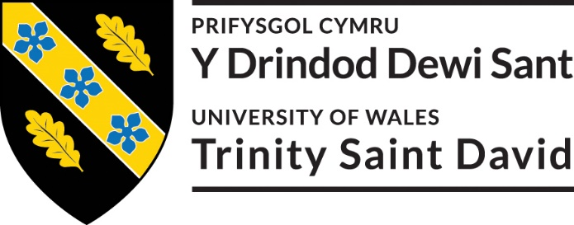

This research is part of an undergraduate final year research project. The purpose of it is to critically investigate the impacts of events on cultural facilities, focusing on Oystermouth Castle in Swansea.

I hereby acknowledge that the data collected by this survey will be anonymous and confidential and will be used by the University of Wales Trinity Saint David for academic and educational purposes only.
- Yes
- No

- Do you prefer to go on holidays with:
- Friends
- Family
- Alone
- Other (please specify)

2. Which do you prefer?
- City Breaks
- Beach Holidays
- Adventure Holidays
- Cultural Holidays
- Other (please specify):

Please state why:

3. Would you consider visiting a historical attraction as a primary reason for going on holiday?
- Yes
- No

4. What type of historical attraction?
- Castles
- Churches & Cathedrals
- Museums
- Stately homes
- Other (please specify):

5. Would you travel for an event?
- Yes
- No

6. How far would you travel for an event?
- Same city
- Different city
- Different country

7. Do you prefer visiting a museum or a castle?
- Museum
- Castle
Please state why:

8. Have you visited a castle in Wales?
- Yes
- No
- If yes, which castle?

9. Do you think the castle was well maintained?
- Yes
- No

10. Why did you visit the castle?
- A planned day visit
- Unplanned day visit
- For an event
- Other (please specify):

11. Would you visit again?
- Yes
- No

- In your opinion, does the Welsh government market the Welsh Culture enough to attract visitors? Can you give recommendations?

13. Do you agree with using castles as a venue for an event?
- Yes
- No
Why do you agree/ disagree with using castles as a venue?

14. Which type of event would you consider suitable to host in a castle?
- Weddings
- Family activity day
- Halloween
- School Tours
- Music Concert
- Markets
- Other (please specify):

15. Do you think that hosting events in Castles will attract more visitors?
- Yes
- No

16. Have you heard of Oystermouth Castle?
- Yes
- No

17. Have you visited Oystermouth Castle?
- Yes
- No
If yes, why did you visit Oystermouth Castle?

18. If you haven't been to Oystermouth Castle, would an event attract you to visit ?
- Yes
- No

19. Do you agree with paying a fee to enter historic attractions?
- Yes
- No
Explain why you agree / disagree:

20. How much would you consider reasonable?
- £1- £5
- £5- £10
- £10- £15
- £15+

- What is your age group?
- 18-25
- 26-30
- 31-37
- 38-45
- 46-55
- 56-65
- 65 and over

22. What gender best describes you?
- Male
- Female
- Other
- Prefer not to say

23. Where do you live ?
- North Wales
- Mid Wales
- South Wales
Which City?

24. What is your occupation?

Appendix 3



