DS 1 Assessment

Screenshot/Photo 1
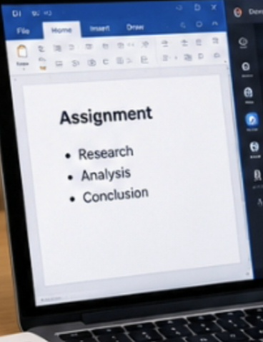
I use Microsoft word to prepare my coursework for study and other things.

Screenshot/Photo 2

I use the internet for internet surfing and browsing for various information. Also, I use internet for online shopping sometimes.

Screenshot/Photo 3
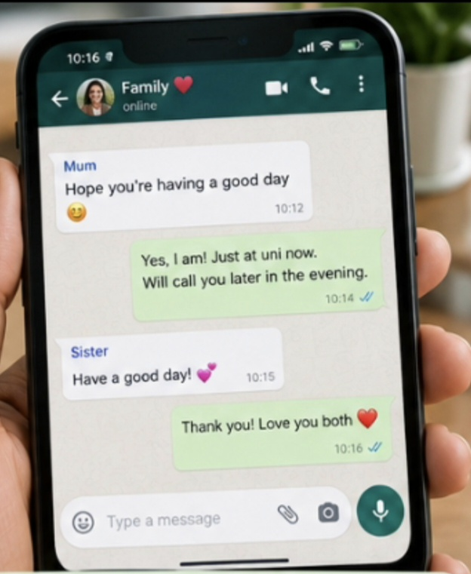
I use WhatsApp to communicate and send messages to friends and family. Also, with other apps like snapchat, Instagram and emails.

Screenshot/Photo 4
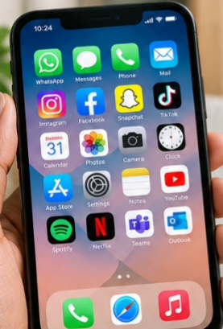
I use the apps on my smart phone to stay organised in different areas of my life, by saving things in different folders for easy access.

Screenshot/Photo 5
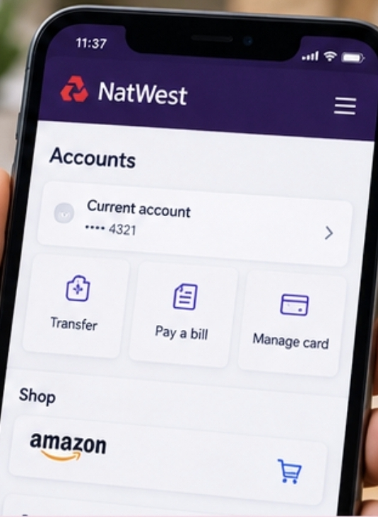
I do internet banking through my phone to check my account balances and to pay for shopping.

Screenshot/Photo 6
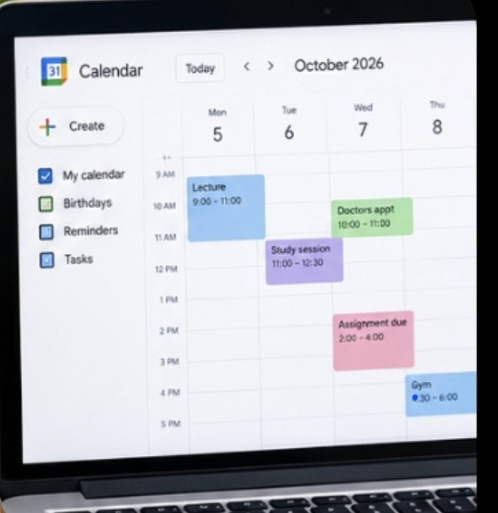
I use the calendar to remind myself and keep track of my appointments and important tasks.

My Short Reflection

- I use digital tools every day for different things such as communication, banking, research, calendar, alarms and shopping.
- I feel confident because it helps me manage and prioritise my time, gives me access to trusted information to make informed decisions in my daily life.
- I would want to improve on being able to be more secure and safe online
- I often use these tools because it makes everyday life easier and more convenient.
- I hope this module will help me be more confident in analysing and making informed decisions.
- Digital skills are important for me because it helps me communicate better, access information, organise my appointments and also save time.

