DS 1 Template

My Screenshots/Photos
- Please add 4–6 screenshots or photos of your digital life.
- You can use your phone or laptop.
- For each screenshot, write one or two sentences explaining what it shows.

Screenshot/Photo 1

Social media
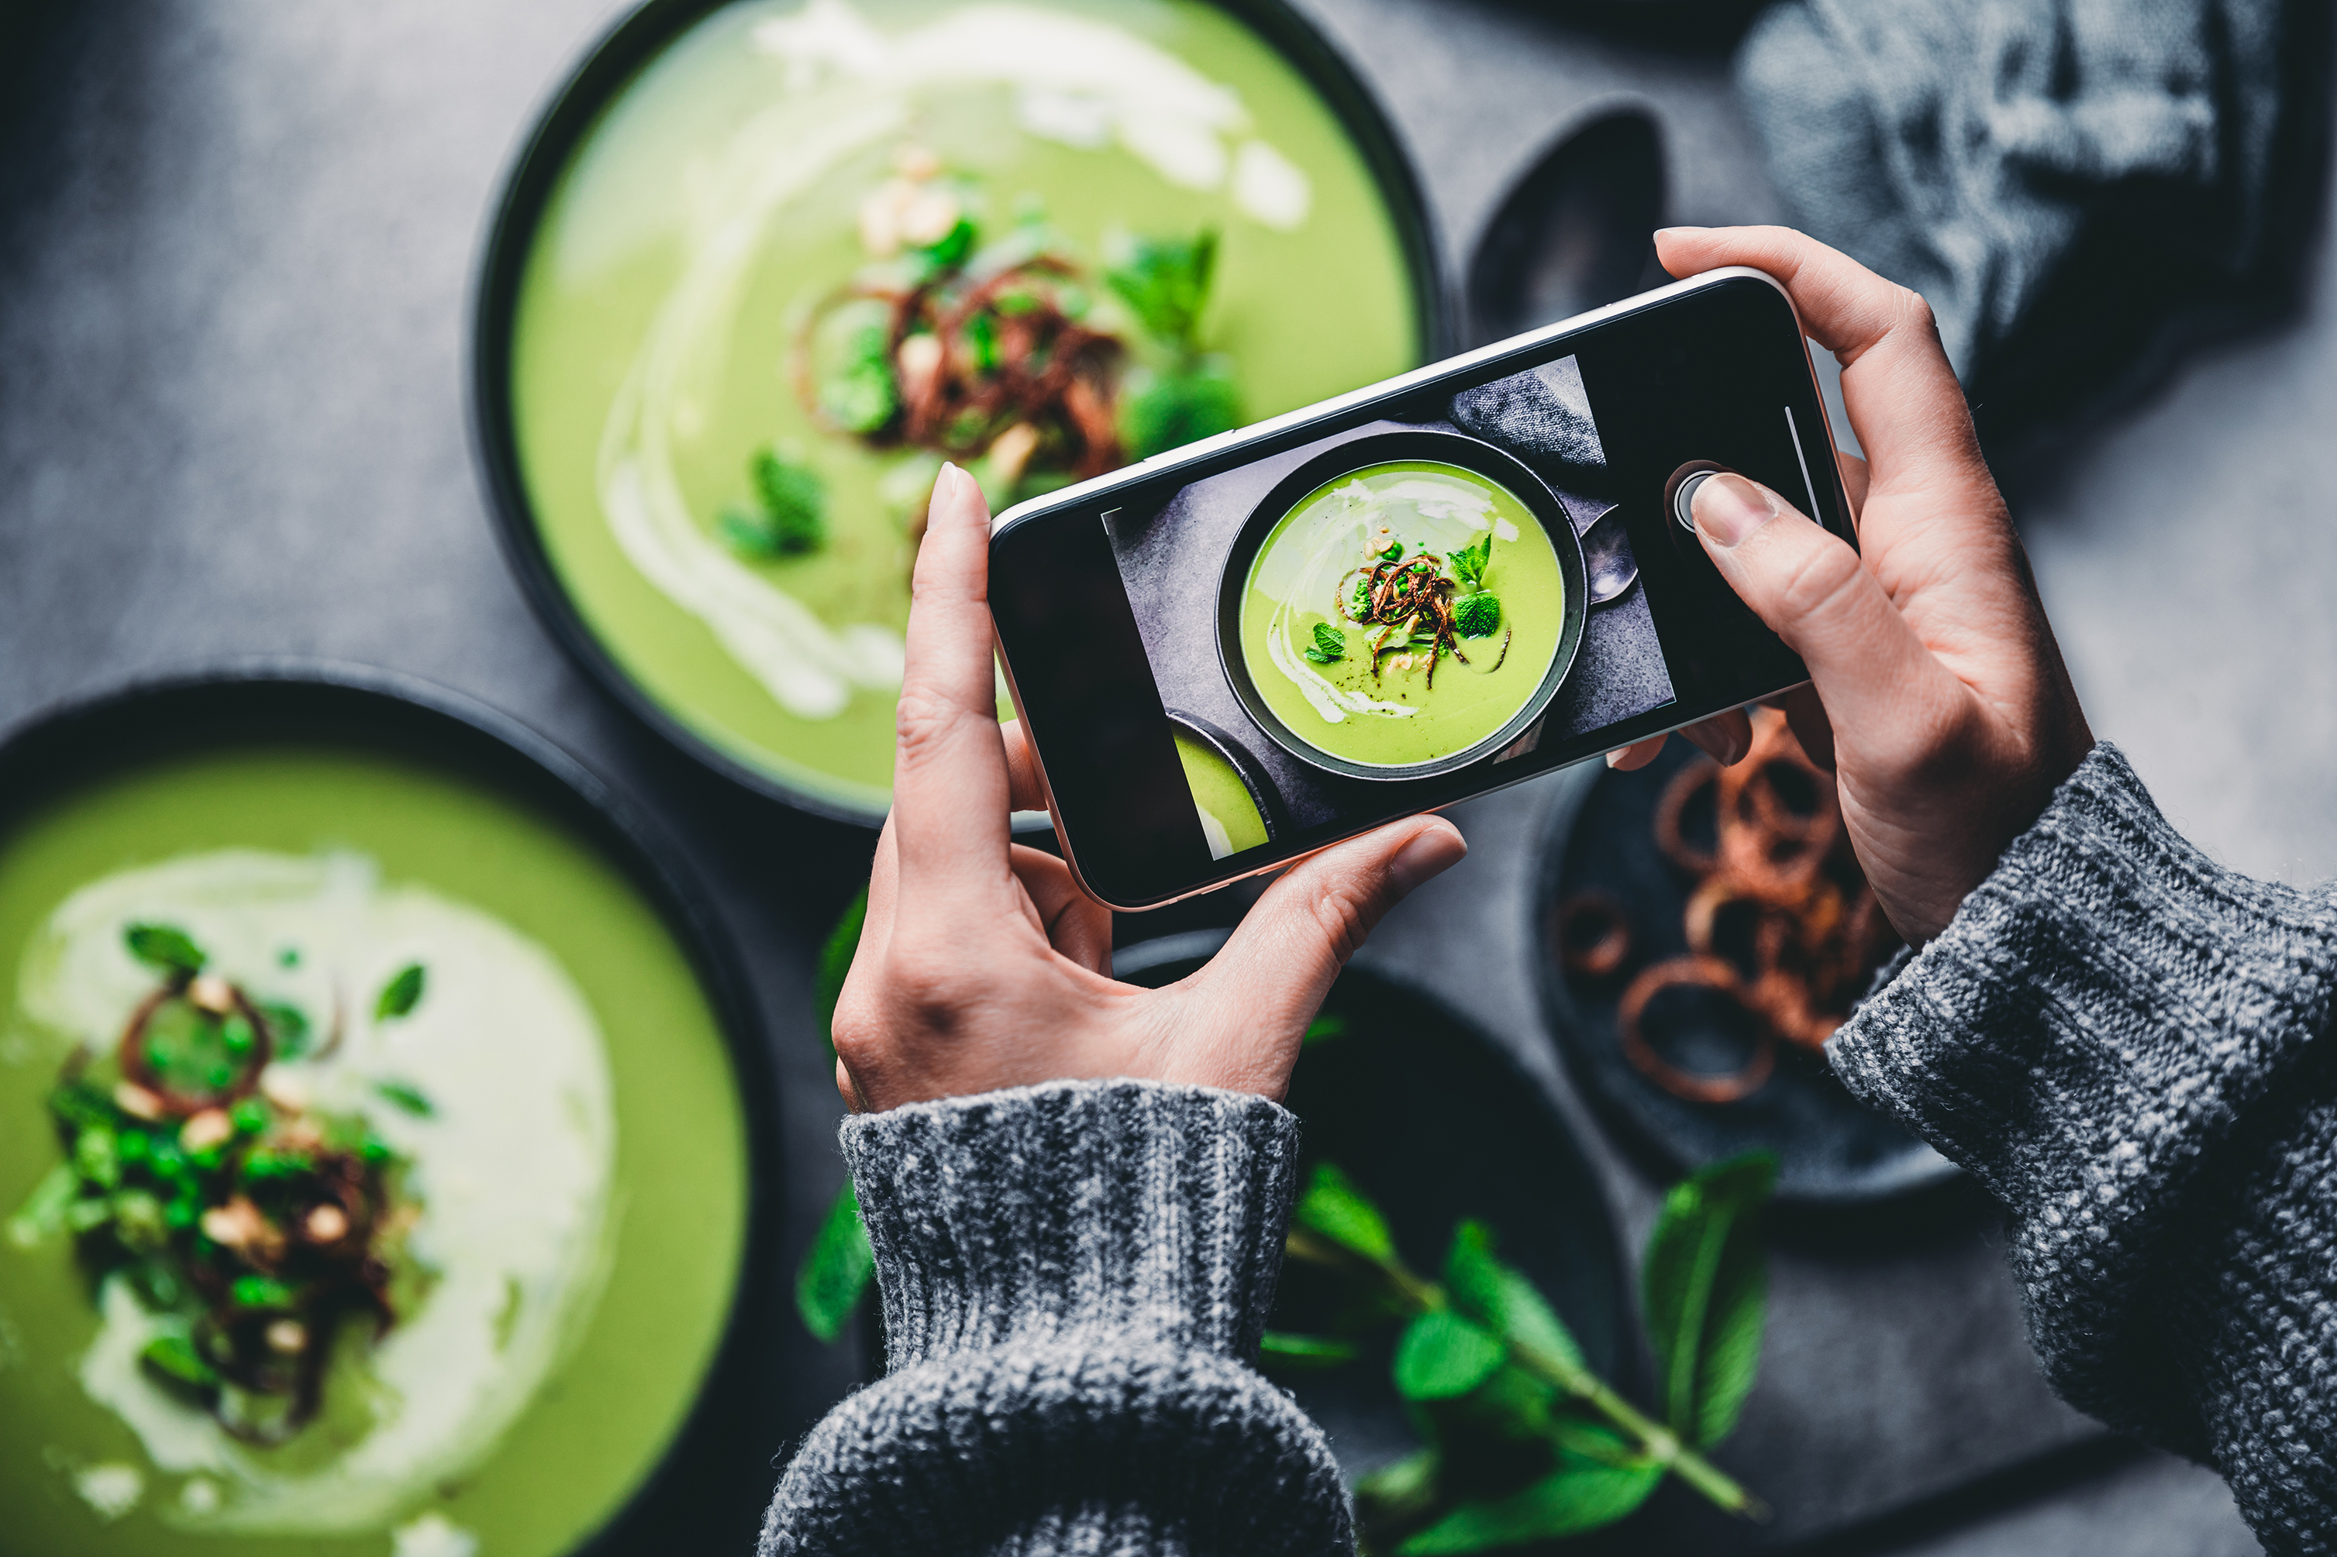
This is social media where we meet new people make new friends and also communicate with friends and family.

Screenshot/Photo 2
CRAAP
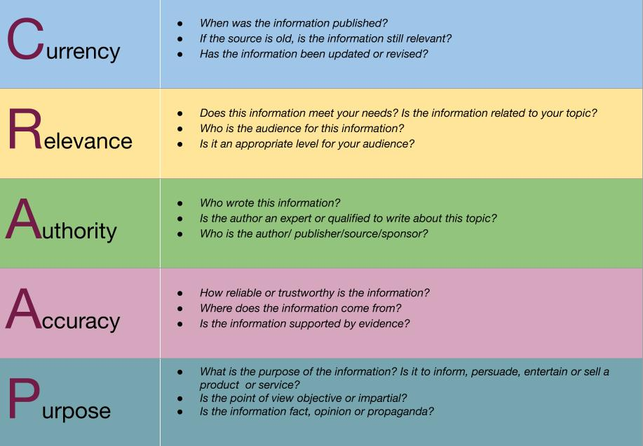
CRAAP is a checklist where you can get the information you want and need like when it was dated and what it is about.

Screenshot/Photo 3
The news
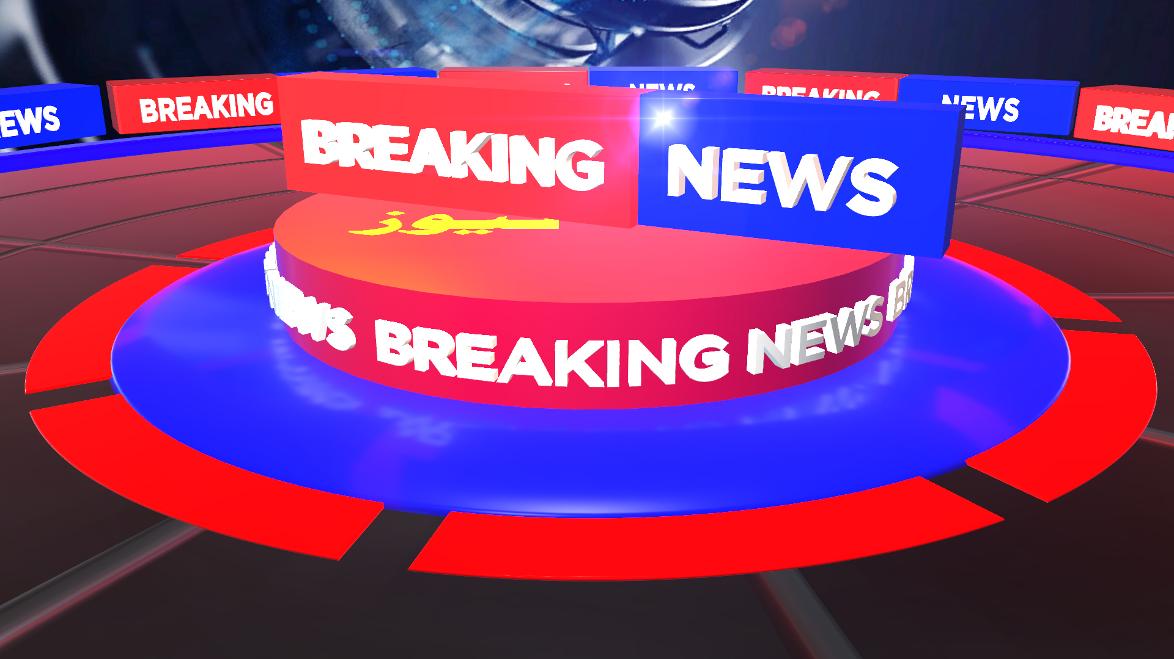
News keeps us informed of what going on around the world like the weather about people and about bat people like the criminals .

Screenshot/Photo 4
The internet

This is the internet where we get information about the future and the past it shows picture videos and also writing about any search you looking for.

Screenshot/Photo 5
car
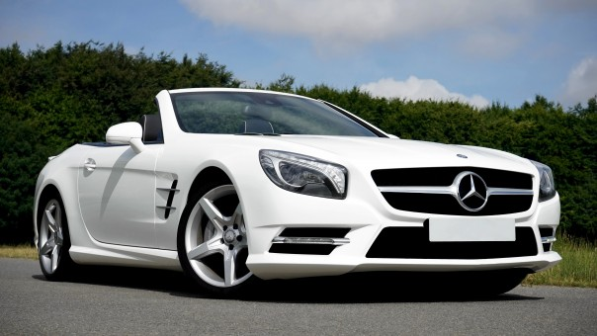
A car can get you anywhere you want but the GPS tracks it down to the destination with out a map or a GPS you would not know where you are

Screenshot/Photo 6
graduation

Graduation is a important day of anyone’s life because that means you succeeded and you worked really hard to graduate

My Short Reflection
- Write 5–8 simple sentences about your digital life.
- You can use the sentence starters below if helpful.
I use digital tools to check for homework and class work
I feel confident when I understand the assignment and help others
I want to improve to take more notes in class
I use the tools in class and at home when I to do homework
I sometimes feel nervous when I do not understand at all and we have to write about the work
I hope this module helps me complete all my tasks and not be behind
Digital skills are important for me because I can see all the work the teacher presented in class and we could take the important notes

Sentence starters
- I use digital tools to …
- I feel confident when I …
- I want to improve …
- I often use these tools: …
- I sometimes feel nervous about …
- I hope this module will help me …
- Digital skills are important for me because …
You can write more if you want.

Submission Checklist
Before you submit, please check:
​​​ ☐ I added 4–6 screenshots
☐ I wrote short sentences for each screenshot
☐ I wrote my short reflection
☐ My work is my own
☐ My file opens correctly
​​☐ My file opens correctly

