

Master of Business Administration

Module Name: Marketing Management
Module code: LCMB7024

Assessment Component 1

Lecturer:
Laila Maazouz
Dian Mayasari

Student Name: Kaushal Ashokbhai Prajapati
Student ID: 2531730

Word Count : 2460

Table of Contents
1. Introduction 3
2. Task 1: Critical Analysis of the Macro Marketing Environment 3
2.1 Macro Marketing Environment 3
2.2 Analysis of Macro Factor 1: Technological Environment 4
2.2.1 Impact on The Pioneer Organisation 4
2.2.2 Impact on The Follower Organisation 5
2.3 Analysis Of Macro Factor 2: Legal Environment 6
2.3.1 Impact On the Pioneer Organisation 6
2.3.2 Impact On the Follower Organisation 8
3. Task 2: Strategic Responses of Pioneering and Follower Organisations 8
3.1 Pioneering Organisation’s Strategic Responses 8
3.2 Follower Organisation’s Strategic Responses 10
4. Conclusion 12
5. References 14

1. Introduction
This report is a critical analysis of strategic marketing management in the global smartphone industry with Apple Inc, as the pioneering organisation and Samsung Electronics as the follower. The high competition, swift cycles of innovation, and a strong consumer expectation are the features of the industry, where companies are competing not only with the features of their products, but also with the integration of the ecosystem and the brand positioning, and the technological leadership. The emerging technologies in the market (artificial intelligence, 5G, and smart ecosystems) and the growth of emerging markets continue to fuel the expansion of the market.
Here, strategic choices can be studied through the macro marketing environment where the external environment impacts the competitive edge and positioning through technological innovations and legal interventions. The PESTEL framework allows organisations to foresee opportunities and threats so that they can not be proactive but reactive. In this report, two major tasks are arranged. Task 1 analyses how both organisations have been affected by the choice of macro-environmental factors through the PESTEL analysis. Task 2 builds upon such insights and compares the strategic responses of Apple and Samsung in terms of the relevant frameworks, including the Growth Matrix by Ansoff and the Generic Strategies by Porter.

2. Task 1: Critical Analysis of the Macro Marketing Environment

2.1 Macro Marketing Environment
The macro marketing environment is examined in PEST framework which considers the political, economic, social, technological, legal and environmental forces in the strategic environment. Technological and Legal factors have been chosen in the smartphone industry because they directly influence the process of innovation, ecosystem regulation, and regulatory adherence. Competitive differentiation is promoted by rapid technological change, whereas platform dominance is transformed by heightened legal oversight. The above factors are strategically relevant because they dictate the ability of companies such as Apple Inc. and Samsung Electronics to be competitive.

2.2 Analysis of Macro Factor 1: Technological Environment

2.2.1 Impact on the Pioneer Organisation
In the case of Apple, the opportunity of technological growth is immense and is seen in its vertical integrated ecosystem and strategy of proprietary innovation. Jayant et al. (2024) note that product differentiation is enhanced by the development of its own silicon chips (e.g. A-series and M-series) and AI-powered features like on-device machine learning.
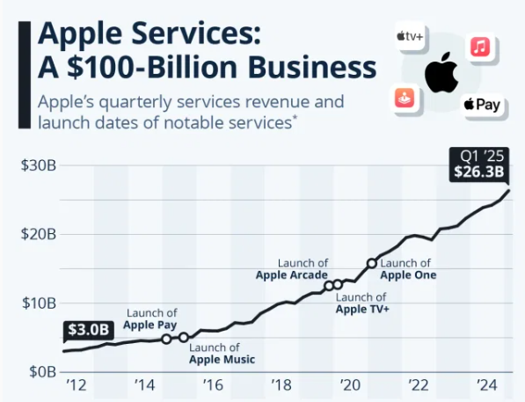
Figure 1: Apple services revenue
(Source: Voronoiapp, 2025)
As seen in Figure 1, Voronoiapp (2025) confirms that Apple generated over 26.3 billion in services revenue in Q5 due to the lock-in of the ecosystem and integration of devices. This is the way in which technological control would increase retention of customers in the long term and diversification of revenues. Additionally, the feature of AI-powered capabilities introduced by Apple in iOS (e.g., on-device processing of AI) remains in line with consumer demands that grow regarding data security.
In comparison to the competitors such as Samsung that are overly dependent on cloud-based AI, Sharon (2020) found that the strategy that Apple has designed generates an edge of privacy. Nonetheless, technological leadership is a threat to this in its turn with high cost of R&D and slower open innovation uptake potentially constraining flexibility. As an example, although Apple is concerned with controlled innovation cycles, it may find it difficult to keep up with the pace of AI implementation based on companies such as Dmitrienko et al. (2023) illustrate that Huawei Technologies that actively invest in AI hardware.

2.2.2 Impact on the Follower Organisation
Samsung has an opportunity and a competitive pressure in the same technological environment. Compared to Apple, Kornelakis and Petrakaki (2024) found that Samsung has a more open and adaptive model of innovation and strives to collaborate with many platforms, including Android, incorporating a variety of technologies in a short period of time.
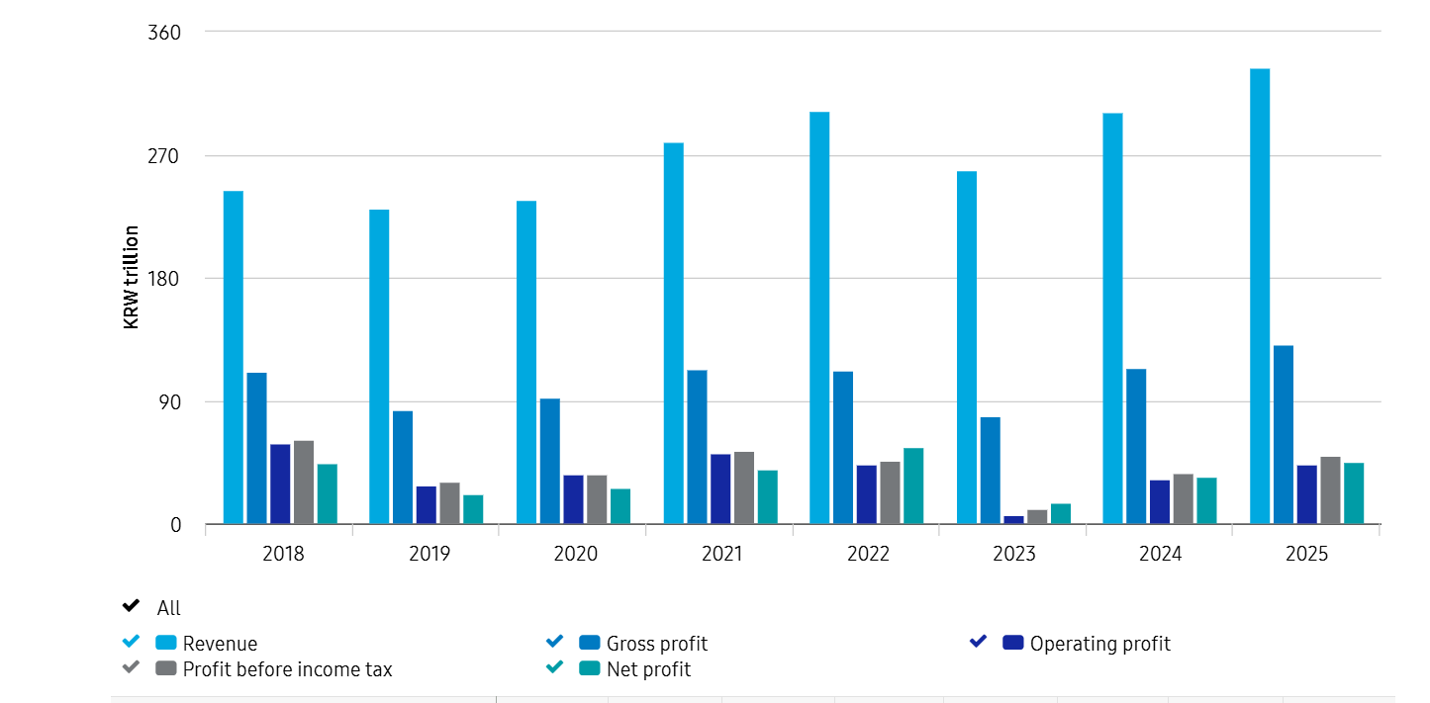
Figure 2: Samsung revenue
(Source: Samsung, 2022)
As seen in Figure 2, Samsung indicated that its cell phone segment recorded about 333.6 billion dollars revenue in 2025 with display and semiconductor technologies innovation (Samsung, 2022). Samsung can provide its competitors such as Apple and other firms developing OLED displays and memory chips due to its leadership in these products. Nevertheless, Kornelakis and Petrakaki (2024) argue that the technological transparency also poses a threat, because Samsung does not have such a closely synchronized ecosystem as Apple does.
Reliance on third-party software platforms (e.g. Android) decreases differentiation and exposes itself to ecosystem change led by companies. Shin and Cho (2020) note that Samsung is more flexible, with less ecosystem control, as compared. It can quickly be innovative (e.g., it adopted foldables before Apple), but it has difficulty matching the customer lock-in rate. This puts Samsung in a powerful yet weaker market with the benefit of scale and speed instead of exclusivity. However, Lenox (2023) argue that Apple deploys technology to create closed-system competitive advantage, Innovation agility, and market responsiveness, as opposed to Samsung.

2.3 Analysis of Macro Factor 2: Legal Environment

2.3.1 Impact on the Pioneer Organisation
In the case of Apple, tightening of the legal environment is a threat and a limited opportunity. The closed ecosystem of Apple, especially the App Store policies, has come under intense antitrust investigation. Ingemarsson and Bichet (2024) highlight that the introduction of the Digital Markets Act (DMA) within the EU compelled Apple to open up to third-party apps stores and other payment systems, a direct threat to its command and control of the distribution of iOS.
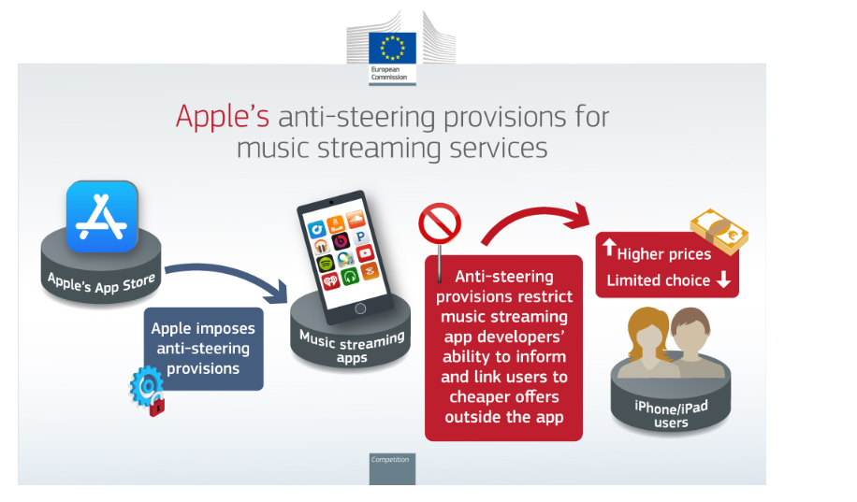
Figure 3: European Commission fined Apple
(Source: European Commission, 2025)
Also, in 2024, the European Commission fined Apple 1.8 billion due to the distribution of music streaming in an anti-competitive manner (European Commission, 2025). Apple Inc. was fined to limit music streaming application encouraging users to use alternatives, which are not in the App Store, as this blocks competition and consumer choice as seen in Figure 3. This is an indication that its traditionally powerful ecosystem control is wearing away under the pressure of the laws.
Nevertheless, Apple is also enjoying the advantages of policies on data privacy like GDPR that are consistent with its positioning as a company focused on user privacy. Cheyre et al. (2025) illustrate that the implementation of features such as App Tracking Transparency (ATT) has increased the credibility of consumers and undermined competitors who have integrity in derived advertising, such as Meta Platforms. In such a way, though the antitrust laws decrease the exclusivity of the Apple platforms on the platform, the regulations based on privacy support the premium differentiation of the Apple company and the basis of competitive advantage rooted in trust.

2.3.2 Impact on the Follower Organisation
In the case of Samsung, there is a relatively lower direct exposure and opportunity in the legal environment. In comparison with Apple, Kotapati et al. (2020) argue that Samsung lacks a highly controlled system of distributing apps, which makes it less susceptible to antitrust interventions concerning platform monopolisation. This makes Samsung more regulator amiable and flexible in the markets where stringent laws on competition are enforced. However, the global regulatory fragmentation acts as an indirect threat to Samsung. Indicatively, Lim and Oh (2025) illustrate that the Personal Information Protection Act (PIPA) in South Korea has increased the demands on data management, which impacts the device manufacturers such as Samsung.
Simultaneously, Samsung is enjoying the legal issues faced by Google. With Google LLC under attack by antitrust courts in Android dominance suits, Samsung becomes freer to customise user interface and services, which makes it less dependent. Similarly, Choo (2025) found that Samsung is more adaptable in the legal sense along with poorer strategic leverage. Conversely, Apple is a less regulated product line due to its close-knit ecosystem but can use privacy laws to differentiate its products. Being in a more open ecosystem, Durosaro (2023) highlights that Samsung is not that threatened by legal actions, but it cannot transform regulation into a powerful competitive advantage.

3. Task 2: Strategic Responses of Pioneering and Follower Organisations

3.1 Pioneering Organisation’s Strategic Responses
The strategic reactions of the Apple Inc. to the macro-environment forces, especially, legal restrictions and changing consumer demands illustrate a planned growth strategy based on the Growth Matrix created by Ansoff. Instead of being confined to the traditional iPhone dominance, Apple has been diversified and has extended its ecosystem to maintain a competitive advantage.
Market Penetration: Apple is still increasing its market strength in the already established markets based on the customer retention strategy built on the ecosystem. The combination of hardware, software and services promotes the repetitive buy and lasting loyalty. An example of this is the installed-base which in the case of Apple reached more than 2.2 billion active devices around the world in 2024, which means that it is a penetrated market (Apple Newsroom, 2024). Similarly, Kotapati et al. (2020) found that as a reaction to regulatory pressures against the dominance of the App Store, Apple has added value to its ecosystem (e.g., bundled services such as Apple One) strengthening switching costs. The approach made by Apple builds a stickier customer base compared to Samsung Electronics that depends more on the rate of sales of its hardware, making it less susceptible to price-based competitive pressures.
Product Development: The response which is the most important in the case of Apple is constant product innovation in the current customers. The attempt to redefine consumer technology categories through the introduction of products like Vision Pro mixed-reality headset in 2024 is one of the ways through which Apple is trying to use its ecosystem (Blackman and Harley, 2024). This is in line with product development strategy formulated by Ansoff in which innovation maintains differentiation. Besides, Köhler et al. (2024) illustrate that Apple has grown to sophisticated chipsets and health-related functionality (e.g. Apple Watch health tracking), which reinforces its value proposition. This capability to expand product lines in the current markets is supported by Statista (2024) that indicates that Apple had more than 20 percent of the worldwide market share of wearable devices. On the contrary, Bungaran (2024) argues that Samsung develops fast (e.g. foldables) whereas Apple develops slower, but more integrated products, which guarantee premium positioning and long-term adoption, as opposed to experiments.
Market Development: Apple has penetrated the emerging markets well like India which has continued to give new markets due to its smartphone penetration and the growth of middle classes. Business Standard (2023) reported that in 2023, Apple registered more than 50% annual increment in revenues in India. Localized manufacturing and retailing helps to support this expansion and decrease reliance on Western markets, which are already overcrowded. In its geographic diversification strategy, Hai (2023) found that Apple focuses on the high-end market in the emerging economies compared to Samsung that is already well represented in the price sensitive markets, thereby sustaining brand exclusive and widening its target market.
Diversification: Apple also has exited into financial services (Apple Pay, Apple Card) and digital content (Apple TV +) and is also a related diversification strategy. CNBC (2026) reported that by 2024, with its successful growth past hardware, services revenue exceeded 16% due to iPhone demand. This differentiation decreases dependency on the iPhone sales and the risk occasioned by the alteration in regulations on the core products. One of the ecosystem-based case diversification that Apple performs more actively than Samsung, which spreads its activities across the electronics production, increases user experience and strengthens brand loyalty (Hai, 2023).
The strategic response of Apple as expounded in the framework of Ansoff points to the balanced form of growth with high levels of focus on products development and diversification. In contrast to Samsung which has been expanding sharply with a heavy emphasis on volume in addition to fast innovation, Bryła and Abdusattarov (2025) argue that Apple has been focusing on the more limited expansion of its ecosystem and high differentiation. However, Apple has a brilliant strategy of turning the macro-environmental challenges into opportunities hence it continues to be the leader in the smartphone industry around the world.

3.2 Follower Organisation’s Strategic Responses
The macro-environmental pressures of Samsung Electronics, especially the legal regulation, and changing technological expectations are met in a strategy that is a hybrid of the Porters Generic Strategies. In contrast to Apple Inc. which focuses on managing its ecosystem to ensure control, Samsung pursues a flexible cost leadership and differentiation combination as the means of remaining competitive in various markets worldwide.
Cost Leadership Strategy: Samsung enjoys the benefits of its large scale manufacturing and vertical integration in semiconductors and displays to enjoy cost efficiencies and price its products competitively in various product levels. This is especially in the domination of its smartphone division in mid-range and low-end markets.
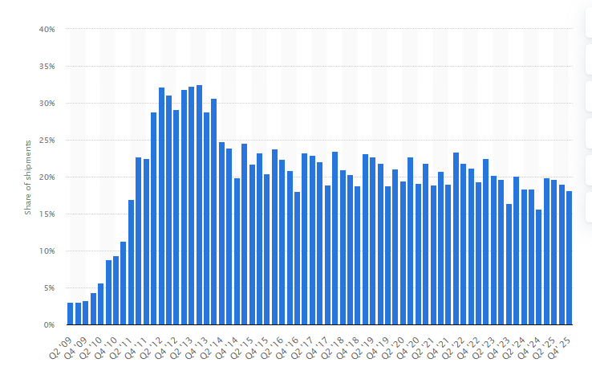
Figure 4: Samsung's share of smartphone shipments worldwide
(Source: Statista, 2025)
Statista (2025) notes that Samsung had a 19% market share in the worldwide smartphone, which is leading over most other rivals in terms of volume sales as seen in Figure 4. It is also a plan that enables Samsung to be resistant to disruptions in the regulatory environment, unlike Apple, which heavily relies on high-margin service revenues. Rather, it subsidises legal strains with growth and efficiency in operations. However, Apple has suffered at premium prices whereas Hai (2023) argues that Samsung has tapped into a wider range of demand because its prices are accessible to a wider range of markets.
Differentiation Strategy: At the same time, Samsung also aims at differentiation due to fast technological development and product diversification. It is ahead of its time in the use of foldable smartphones (Galaxy Z series) and this shows an indication of responsiveness to changing consumer demands. Moreover, Samsung combines innovative display and camera features, which attract the technological-oriented consumers with high technical solutions. Haizar et al. (2020) compare that Samsung has a faster and more experimental innovation cycle than Apple, thus it is able to adjust to market trends faster.
Focused Differentiation (Selective Segmentation): Samsung has also implemented a focused differentiation approach in such areas as high-end Android users and business customers. Samsung aims at high-end clients who want to switch Apple ecosystem with its Galaxy S and Note products, now being included in Ultra models. Also, the Samsung Knox security system can be used to improve its competitiveness in business environments, as the growing regulatory focus on data security (Cherednichenko et al., 2024). Such strategic orientation allows Samsung to develop credibility in the areas that Apple has always dominated. Comparatively, Apple has a more consistent premium approach, whilst Samsung segmentation covers more of the market but with less exclusivity.
The strategic flexibility and responsiveness of Samsung is manifested in its hybridization of the strategies offered by Porter. Bryła and Abdusattarov (2025) argue that whereas Apple applies differentiation strategy by ecosystem exclusiveness, Samsung applies cost leadership coupled with innovation strategy to secure both mass and premium market. This gives flexibility in responding to macro-environmental changes, especially the changes in regulations. Nonetheless, the lack of a highly regulated ecosystem prevents Samsung to produce a customer lock-in that is sustained.

4. Conclusion
This analysis indicates that macro environmental factors, especially technological developments and regulatory laws are essential in determining the intensity of competition in the smartphone market. Apple Inc. is still using technological innovation and privacy-centered positioning to maintain an ecosystem-based premium competitive advantage, despite growing regulatory limitations. Conversely, Samsung Electronics is more flexible and adaptive making use of cost leadership and quick innovation as a method of competing in different market segments. Based on Task 2, we can see that the strategy of Apple focuses on the controlled growth via ecosystem expansion and diversification whereas Samsung uses a hybrid approach to the strategy of scale efficiency and differentiation. This comparative analysis reveals that, although Apple has better customer lock-in and long-term defensibility, Samsung has a superior agility and a wider market coverage.

5. References
Apple Newsroom (2024). Apple reports first quarter results. [online] Apple Newsroom (India). Available at: https://www.apple.com/in/newsroom/2024/02/apple-reports-first-quarter-results/ [Accessed 27 Mar. 2026].
Blackman, T. and Harley, D., (2024). Interpreting Apple’s visions: Examining the spatiality of the Apple Vision Pro. Platforms & Society, 1, p.29768624241283913. https://journals.sagepub.com/doi/abs/10.1177/29768624241283913
Bryła, P. and Abdusattarov, S. (2025). Apple’s Strategy Success Factors and Challenges in Europe: A Case Study of Apple’s Business Model and International Marketing. Annales Universitatis Mariae Curie-Skłodowska, sectio H – Oeconomia, [online] 59(5), pp.7–30. doi:https://doi.org/10.17951/h.2025.59.5.7-30.
Bryła, P. and Abdusattarov, S., (2025). Apple’s Strategy Success Factors and Challenges in Europe: A Case Study of Apple’s Business Model and International Marketing. Annales Universitatis Mariae Curie-Skłodowska, sectio H–Oeconomia, 59(5), pp.7-30. https://journals.umcs.pl/h/article/view/19001
Bungaran, H. (2024). Strategy Studies Tiered Value Chain By Samsung In The Era of Global Competition. Deleted Journal, [online] 3(2), pp.19–27. doi:https://doi.org/10.32734/jba.v3i2.17789.
Business Standard (2023). Apple’s India revenue up 50% but still only 1.5% of its global returns. [online] @bsindia. Available at: https://www.business-standard.com/companies/news/india-s-50-revenue-surge-still-just-1-5-of-global-earnings-for-apple-123083001195_1.html [Accessed 27 Mar. 2026].
Cherednichenko, O., Kyrychenko, I., Nechvolod, K., Smelyakov, K. and Dolhanenko, O., (2024), April. Data Security Analysis in EMM Systems. In Modeling, Optimization, and Controlling in Information and Technology Systems Workshop at CoLInS 2024. CoLInS. https://hal.science/hal-04818594/
Cheyre, C., Leyden, B.T., Baviskar, S. and Acquisti, A., (2023). Did Apple’s App Tracking Transparency Framework Harm the App Ecosystem. https://papers.ssrn.com/sol3/papers.cfm?abstract_id=4467977
Choo, H.J., (2025). An Analysis of Samsung Electronics’ success myths from the perspective of dynamic capabilities. In Strategic Management and Innovation Strategies: From the perspective of revisiting dynamic capabilities (pp. 51-78). Singapore: Springer Nature Singapore. https://link.springer.com/chapter/10.1007/978-981-96-8437-3_3
CNBC (2026). Apple sales surge 16% on ‘staggering’ iPhone demand. [online] CNBC. Available at: https://www.cnbc.com/2026/01/29/apple-aapl-earnings-report-q1-2026.html [Accessed 27 Mar. 2026].
Dmitrienko, A., Lipovenko, M., Gostilovich, A., Kolosov, A. and Ming, L. (2023). Development strategies of high-tech companies in China: Huawei and Tencent. Nexo Revista Científica, [online] 36(02), pp.176–187. doi:https://doi.org/10.5377/nexo.v36i02.16058.
Durosaro, M., (2023). The Impact of Cooperation and Competition on Firms' Response to Grand Challenges. https://www.academia.edu/download/129129590/The_Impact_of_Cooperation_and_Competition_on_Firms_Response_to_Grand_Challenges.pdf
European Commission (2025). Commission fines Apple over €1.8 billion over abusive App store rules for music streaming providers. [online] European Commission - European Commission. Available at: https://ec.europa.eu/commission/presscorner/detail/it/ip_24_1161 [Accessed 27 Mar. 2026].
Hai, D.H., (2023). Comparative analysis of market and product development potential of Apple and Samsung. International Journal of Advanced Multidisciplinary Research and Studies, 3(1), pp.723-734. https://www.researchgate.net/profile/Chin-Tan-23/publication/368308285_Comparative_Analysis_of_Market_and_Product_Development_Potential_of_Apple_and_Samsung/links/63e21453f8cf684fe9748e43/Comparative-Analysis-of-Market-and-Product-Development-Potential-of-Apple-and-Samsung.pdf
Haizar, N.F.B.M., Kee, D.M.H., Chong, L.M. and Chong, J.H., (2020). The impact of innovation strategy on organizational success: A study of Samsung. Asia Pacific Journal of Management and Education, 3(2), pp.93-104. https://www.researchgate.net/profile/Nor-Fitrah-Mohd-Haizar/publication/343138536_The_Impact_of_Innovation_Strategy_on_Organizational_Success_A_Study_of_Samsung/links/6220a6d7c4c4fa27cd2500e0/The-Impact-of-Innovation-Strategy-on-Organizational-Success-A-Study-of-Samsung.pdf
Ingemarsson, R. and Bichet, P., (2024). Survey on the digital markets act and digital policy: a year into the application of one of the most innovative regulatory tools (2023–2024). Journal of European Competition Law & Practice, 15(5), pp.264-272. https://academic.oup.com/jeclap/article-pdf/15/5/264/59275388/lpae034.pdf
Jayant, A., Sheldon, M., Kim, S. and Shrivastava, S., (2024). The state of edge ai. Peri-Labs Report. https://peri-labs.github.io/docs/assets/files/The_State_of_Edge_AI.pdf
Köhler, C., Bartschke, A., Fürstenau, D., Schaaf, T. and Salgado-Baez, E. (2024). The value of smartwatches in the healthcare sector: Monitoring, nudging, and predicting (Preprint). Journal of Medical Internet Research, [online] 26(39356287). doi:https://doi.org/10.2196/58936.
Kornelakis, A. and Petrakaki, D. (2024). Technological innovation, industry platforms or financialization? A comparative institutional perspective on Nokia, Apple, and Samsung. Business history, 67(8), pp.1–26. doi:https://www.tandfonline.com/doi/abs/10.1080/00076791.2024.2377688.
Kotapati, B., Mutungi, S., Newham, M., Schroeder, J., Shao, S. and Wang, M., (2020). The antitrust case against Apple. Available at SSRN 3606073. https://papers.ssrn.com/sol3/papers.cfm?abstract_id=3606073
Lenox, M., (2023). Strategy in the digital age: mastering digital transformation. Stanford University Press. https://books.google.com/books?hl=en&lr=&id=lBK3EAAAQBAJ&oi=fnd&pg=PT7&dq=Apple+deploys+technology+to+create+closed-system+competitive+advantage,+Innovation+agility,+and+market+responsiveness,+as+opposed+to+Samsung.&ots=8f1R2n9Dz6&sig=pZ_hlkrc2aSMyON5v87JEZFWbco
Lim, S. and Oh, J. (2025). Navigating Privacy: A Global Comparative Analysis of Data Protection Laws. IET Information Security, 10(1). doi:https://doi.org/10.1049/ise2/5536763.
Samsung (2022). Financial / Valuation Sanpshot │Financial Information │ Investor Relations │ Samsung Global. [online] Samsung global. Available at: https://www.samsung.com/global/ir/financial-information/financial-valuation-snapshot/ [Accessed 27 Mar. 2026].
Sharon, T. (2020). Blind-sided by privacy? Digital Contact tracing, the Apple/Google API and Big Tech’s Newfound Role as Global Health Policy Makers. Ethics and Information Technology, 23(1), pp.45–57. doi:https://doi.org/10.1007/s10676-020-09547-x.
Shin, B.Y. and Cho, K.T. (2020). The Evolutionary Model of Corporate Entrepreneurship: A Case Study of Samsung Creative-Lab. Sustainability, [online] 12(21), p.9042. doi:https://doi.org/10.3390/su12219042.
Statista (2024). Wearables - statistics & facts. [online] Statista. Available at: https://www.statista.com/topics/1556/wearable-technology/#topicOverview [Accessed 27 Mar. 2026].
Statista (2025). Samsung’s share of smartphone shipments worldwide from 2nd quarter 2009 to 4th quarter 2025. [online] Statista. Available at: https://www.statista.com/statistics/276477/global-market-share-held-by-samsung-smartphones/?srsltid=AfmBOop_188Bms0iNIY5aJ_UhdDxFnI_9T900DN9AmWp_0SnzemuwNyC [Accessed 27 Mar. 2026].
Voronoiapp (2025). Apple Services: A $100-Billion Business. [online] Voronoiapp.com. Available at: https://www.voronoiapp.com/business/Apple-Services-A-100-Billion-Business-3901 [Accessed 27 Mar. 2026].

