
Evaluating the Effectiveness of Chosen Maintenance Strategies for Dedicated Equipment

HARLEY OULTON

Abstract

This report presents a critical evaluation of the current maintenance practices for the KMT Streamline SL-V100s intensifier pumps employed in the Abrasive Waterjet Cutting (AWJC) systems at TIMET Swansea, a key site in the titanium manufacturing process. The investigation centres on the High Pressure Seal Assembly, a core component in the intensifier pump, currently maintained under a Breakdown Maintenance (Run-to-Failure) strategy. The report outlines the operational framework of the AWJC systems, assesses the rationale behind the existing maintenance philosophy, and identifies key failure modes primarily resulting from improper installation practices rather than component ageing, infant mortality.
Utilising data extracted from the site's Computerised Maintenance Management System (CMMS), including recorded downtimes and causes of failure, trends were analysed to establish correlations between failure rates and shifts in maintenance personnel structure and training levels. The analysis demonstrates that a significant proportion of failures stem from standard operating procedures not being adhered to and insufficient familiarity with the equipment among newly assigned staff.
Key Performance Indicators (KPIs) such as Mean Time Between Failures (MTBF), Mean Time to Repair (MTTR), and failure rates were employed to evaluate system reliability and maintainability.
Recommendations include the implementation of targeted OEM-led training programmes, reinforcement of procedural compliance, and acquisition of an additional intensifier pump to improve system redundancy for WJC 2 and 3. A comparative cost-benefit analysis supports these proposals, balancing the capital investment against revenue losses caused by unplanned downtime. The study concludes that while the current breakdown maintenance strategy remains appropriate for this application, enhancements in training and redundancy infrastructure will significantly reduce failure frequency and improve overall operational uptime.

Contents
Abstract 1
Contents 2
List of Figures 2
1.0 Introduction 3
1.1 Abrasive Waterjet Cutting Process Overview 3
2. Critical review of current maintenance practices 4
2.1 KMT Intensifier Pumping System – High Pressure Seal Assembly 4
2.2 High Pressure Seal Assembly – Current Maintenance Strategy Critical Analysis 5
3. Full Evaluation of How the Current Maintenance Approaches Could Be Improved 8
3.1 Establishing Maintenance Key Performance Indicators 8
3.2 Computerised Maintenance Management System (CMMS) 10
3.3 Improving Dynamic Redundancy 12
4. Consideration of Costs and Resources for Maintenance Improvements 13
5. Conclusion/Recommendations 14
6. References 15

List of Figures
Figure 1: KMT Streamline SV-L100 (KMT- WaterjetSystems, 2025) 4
Figure 2: KMT Streamline SL-V100 High Pressure Cylinder Assembly (KMT-WaterjetSystems, 2006). 5
Figure 3: High Pressure Seal Assembly (KMT-WaterjetSystems, 2006). 5
Figure 4: Six Patterns of Failure (Regan, 2012) 6
Figure 5: Reintroduction of Infant Mortality (Regan, 2012) 7
Figure 6: Maintenance History Sample for WJC (Timet, 2025) 10
Figure 7: WJC Downtime Causes 2024 11
Figure 8: Trend of HP Seal Failures 2024 11

Equation 1: MTBF 8
Equation 2: MTTR 8
Equation 3: Failure Rate 9
Equation 4: Reliability 9

Table 1: Training Cost for Mechanical Staff 13
Table 2: Additional KMT Streamline SV-L100 13

1.0 Introduction

This report outlines the evaluation of the current maintenance practises for a piece of equipment used in Timet Swansea process route. The equipment is situated in the Waterjet Cutting Bay at Timet Swansea, which is a manufacturing plant of Titanium Metals Corporation, otherwise known as TIMET. The company have been in operation from 1950s and supplies almost one fifth of the world’s titanium. Due to titanium’s unique combination of metallurgic properties, corrosion resistance and strength to weight ratio, it is a sort after material in the aerospace industry, among other industries. The titanium produced by the company is used within many sectors, the largest volume sold to the aerospace and energy sector. Smaller shares go to military and medical uses. TIMET Swansea produces milled products such as sheet, plate and bars, as well as specialist products for customers such as Rolls-Royce (Timet.com 2025).
Within this report, a single maintenance strategy has been critically examined, and a structured approach has been adopted to identify potential enhancements to future maintenance programmes. The associated costs and resources required for these improvements have been evaluated, and recommendations for future actions are provided in the conclusion.

Abrasive Waterjet Cutting Process Overview

Abrasive Waterjet Machining (AWJM) is a non-traditional subtractive manufacturing process that employs a high-pressure jet of water mixed with abrasive garnet particles to erode and cut through materials with high precision. This method is particularly effective for cutting hard-to-machine materials and is valued for its versatility. As illustrated in Figure 1, TIMET utilises AWJM to cut blanks from hot-rolled titanium plate. The process offers significant advantages, including minimal material waste (Alsoufi, 2017), no thermal distortion, and the absence of a heat-affected zone (Waterjetmachines.org, 2019).
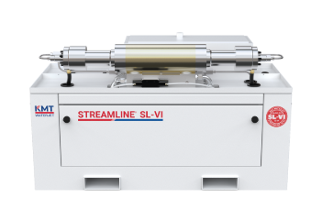
Figure 1: KMT Streamline SV-L100 (KMT- WaterjetSystems, 2025)
At TIMET, the abrasive waterjet systems from Waterjet Sweden (WJS) are driven by a KMT Streamline SL-V100s intensifier pumpa. WJC 1 has three pumps running in parallel, dividing the work and pressure over the three, while WJC 2 and 3 each have 2 pumps running in parallel with a shared backup unit. This system incorporates an electrically powered hydraulic pump that delivers oil at 2750 psi to the high-pressure intensifier. The intensifier then amplifies the factories standard mains water pressure (typically 50–60 psi) to a cutting pressure of 55,000 psi. This is achieved through differential piston areas within the hydraulic intensifier—by applying pressure to a larger surface area on the oil side, the system generates a much higher pressure on the water side, effectively multiplying the pressure ratio by a factor of 20 (Nambiath, 2016).

2. Critical review of current maintenance practices

2.1 KMT Intensifier Pumping System – High Pressure Seal Assembly

Figure 2 displays an exploded view of the KMT Streamline SL-V100s High Pressure Cylinder Assembly. This assembly contains a number of components, but this report will evaluate the maintenance approach relating to the High Pressure Seal Assembly. Figure 3 is an additional exploded view of the High Pressure Seal Assembly, which displays the correct arrangement the seal must be fit on the Hydraulic Piston in relation to the Sealing Head.
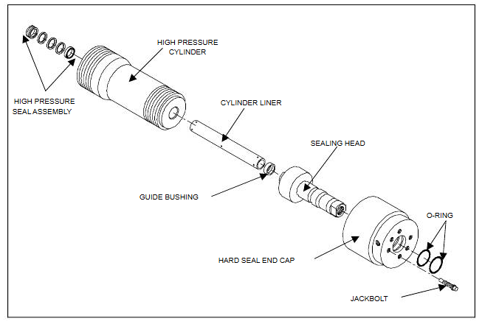
Figure 2: KMT Streamline SL-V100 High Pressure Cylinder Assembly (KMT-WaterjetSystems, 2006).
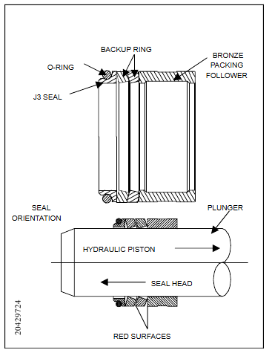
Figure 3: High Pressure Seal Assembly (KMT-WaterjetSystems, 2006).

2.2 High Pressure Seal Assembly – Current Maintenance Strategy Critical Analysis

The KMT Streamline SL-V100s intensifier pump is engineered with a fail-safe design, where failures occur progressively rather than abruptly. Internal components such as seals and fittings are designed to leak gradually through designated weep holes, serving as an early indication of wear. The appearance of water at a weep hole typically signals the onset of internal seal or valve degradation, allowing maintenance teams to respond before a complete failure occurs.
A programmable logic controller (PLC) is integrated into the system to manage fault detection and diagnostics. The PLC continuously monitors key operating parameters such as pressure, temperature, and fluid levels. If any of these values exceed safe thresholds, the system initiates an automatic shutdown to prevent damage to critical components.
Due to the gradual nature of these failures, TIMET employs a Breakdown Maintenance or Run-To-Failure strategy for the High Pressure Seal Assembly. Under this maintenance philosophy, components are intentionally operated until failure, with no preventive interventions performed beforehand. However, two contingencies are in place to mitigate disruption. For WJC 1 if an intensifier pump fails, the unit is isolated from the system and the two functional units maintain operation, while the isolated unit is repaired. While this does allow for reduced downtime, it increases the pressure and workload requirements for the two functional units, leading to increased wear, and possible breakdowns (Regan, 2012; KMT-WaterjetSystems, 2006). For WJC 2 and 3, when a failure occurs, the unit is isolated for repair and the backup is selected to maintain production, providing dynamic redundancy to the system (Trivedi, K.S. 2017).
One of the primary advantages of employing a breakdown maintenance strategy is the minimal effort and planning required for its implementation. This approach also reduces the likelihood of failures linked to infant mortality—a term used to describe the premature failure of components shortly after installation, Failure Pattern F shown in Figure.4. Such failures often result from installation errors or defects in new parts, significantly compromising system reliability (Regan, 2012; Limble CMMS, 2023).​
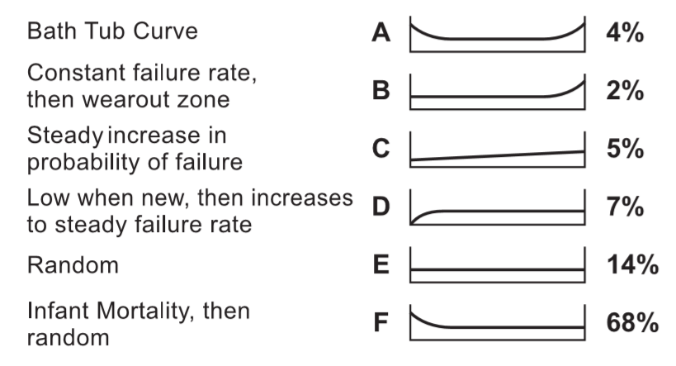
Figure 4: Six Patterns of Failure (Regan, 2012)
Studies indicate that a substantial proportion of equipment failures follow the infant mortality pattern. For instance, research by Nowlan and Heap revealed that approximately 68% of components exhibit this failure pattern, characterised by a high initial failure rate that decreases over time (Nowlan et al., 1974). This underscores the potential risks associated with frequent scheduled maintenance, which can inadvertently reintroduce early-life failures into an otherwise stable system (F7I.ai, 2023). This
By contrast, a breakdown maintenance approach limits interventions to instances of actual failure, thereby reducing the frequency of disruptions caused by infant mortality failures. This strategy aligns with findings that most equipment failures are not age-related, suggesting that time-based preventive maintenance may be inefficient and sometimes counterproductive (F7I.ai, 2023). Proactive maintenance risks reintroducing infant mortality back into a stable system, due to incorrect installation, or poor component quality replaced, and this is shown in Figure 5.
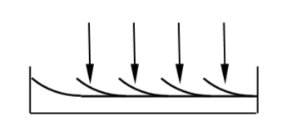
Figure 5: Reintroduction of Infant Mortality (Regan, 2012)
​While breakdown maintenance offers certain advantages, it is accompanied by significant drawbacks that can impact operational efficiency and financial performance. The inherent unpredictability of equipment failures under this approach can strain labour resources, especially if multiple assets fail simultaneously. This scenario necessitates urgent deployment of maintenance personnel, potentially leading to increased labour costs due to overtime and emergency response efforts (Howell, 2022). Additionally, this maintenance strategy requires maintaining a substantial inventory of spare or replacement parts to address unexpected failures promptly, thereby increasing inventory holding costs (Howell, 2022).
This approach is generally considered when the cost of repair post-failure is lower than that of implementing a comprehensive preventive maintenance plan, and where asset failure does not pose significant safety risks or the potential for further equipment damage. However, it necessitates a thorough understanding of potential failures and their associated consequences to mitigate risks effectively (Regan, 2012).

3. Full Evaluation of How the Current Maintenance Approaches Could Be Improved

3.1 Establishing Maintenance Key Performance Indicators

To ensure maintenance efforts align with organisational objectives and operational strategies, it is essential to implement maintenance Key Performance Indicators (KPIs). These KPIs create a connection between business goals and the maintenance activities required to fulfil them. By defining clear KPIs, the baseline or existing reliability level can be assessed, enabling evaluation of changes in maintenance strategies for improvements relative to this benchmark (Lifetime-reliability.com, 2020b).
The maintenance KPIs employed at TIMET include:
- Mean Time Between Failure (MTBF): MTBF calculates the average time a system operates before experiencing failure. It measures only the active operational time between failures, excluding repair time. MTBF is commonly utilised to predict the likelihood of individual unit failure within a specified timeframe (Epsilonengineer.com, 2020; Lifetime-reliability.com, 2020b).
$$MFBF= \frac{Total Uptime}{Number of Failures}$$
Equation 1: MTBF
- Mean Time to Repair (MTTR): MTTR evaluates the maintainability of repairable equipment or components. It represents the average time required to restore a defective item to operational status, including notification, fault finding, and the repair time. This metric aids in understanding repair efficiency (Epsilonengineer.com, 2020; Lifetime-reliability.com, 2020b).
$$MTTR= \frac{Total Downtime}{Number of Failures}$$
Equation 2: MTTR
- Failure Rate: The failure rate is calculated by taking the inverse of MTBF and serves as an essential tool in the design and planning of systems. Failure rate is a projection of a component or systems performance, often expressed in terms of the number of failures per hour (Epsilonengineer.com, 2020; Lifetime-reliability.com, 2020b).
$$λ= \frac{1}{MTBF}$$
Equation 3: Failure Rate
- Reliability: Reliability refers to the probability of a component or system performing without failure and can be calculated using distinct approaches based on the operational timeframe, whether it is relatively short or long (Epsilonengineer.com, 2020; Lifetime-reliability.com, 2020b).
$$R=1-λ^{t}$$
$$R= e^{-λt}$$
Equation 4: Reliability

3.2 Computerised Maintenance Management System (CMMS)

A Computerised Maintenance Management System (CMMS) is a software application designed to centralise, streamline, and automate maintenance operations within an organisation. Its primary purpose is to improve the management of assets, resources, and maintenance schedules, resulting in increased reliability, reduced downtime, and cost savings (Lopes et al, 2016).
Maintenance records for all engineering work conducted by Timet engineering craft is fed back into SAP following completion of any work performed. Craft personnel are responsible for feeding back faults/breakdown, time taken for the repair, required resources (personnel and parts), and details of the actions taken.
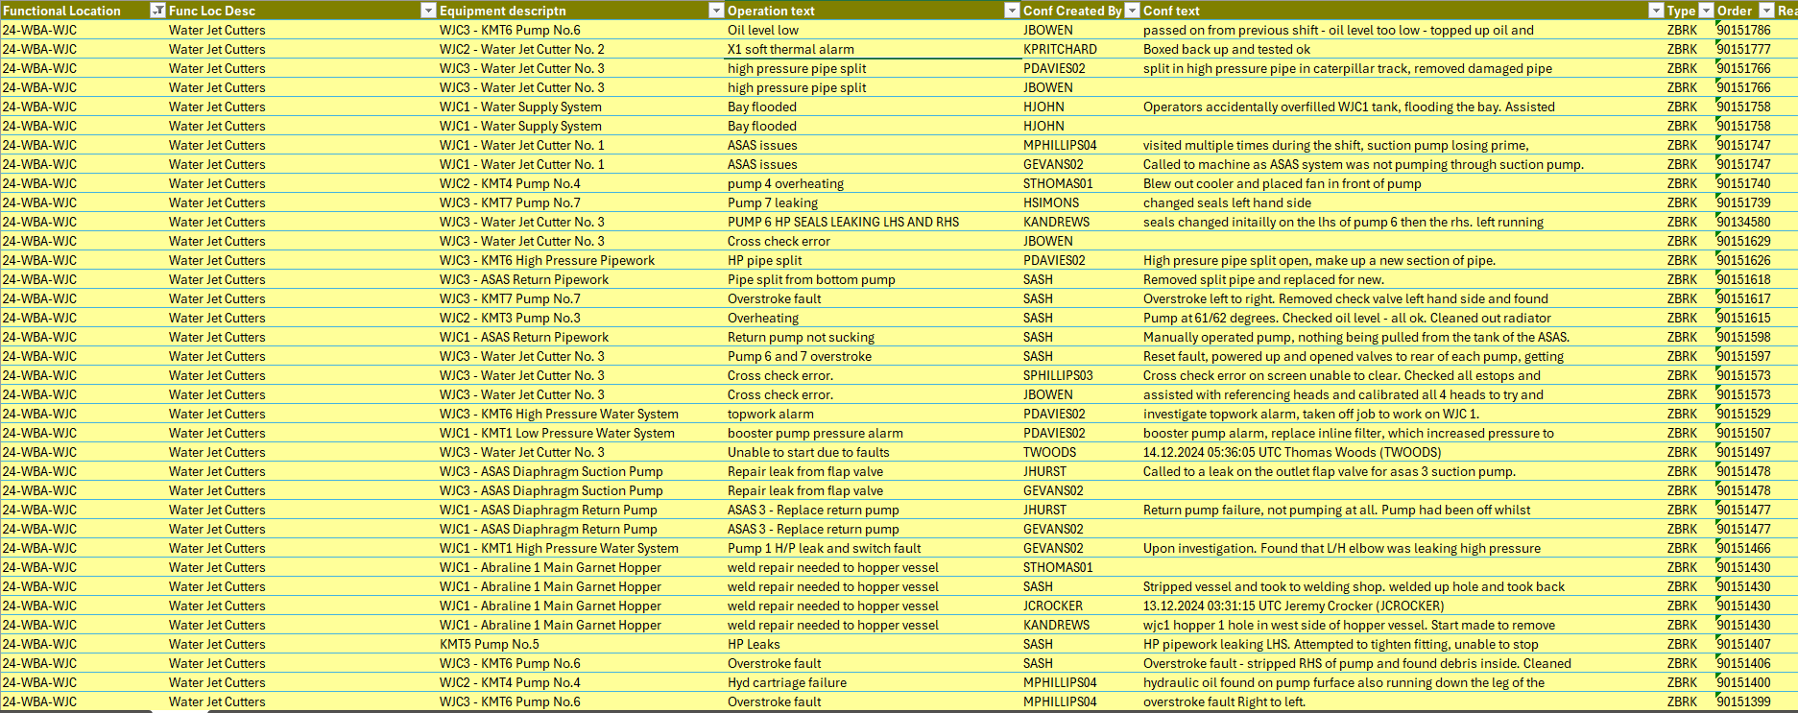
Figure 6: Maintenance History Sample for WJC (Timet, 2025)
By utilising the data and reports stored in this CMMS, engineering management can evaluate the causes of breakdowns and allow for data-driven decisions to be made on future maintenance strategies.
Using the data gather from the CMMS, the number of events and total downtime caused by HP Seal Failures was calculated, and a trend of failure per months graphed.

Figure 7: WJC Downtime Causes 2024

Figure 8: Trend of HP Seal Failures 2024
Analysing the reports fed back into the CMMS, a high number of the causes of failure of HP Seals were attributed to craft incorrectly fitting the HP Seal or not following standard operating procedures on the removal of damaged seals and fitting of replacement.
Figure 8 shows a decreasing trend on failures from the beginning of 2024 to August. At the start of 2024 a change for all personnel to full continental shift patterns and the removal of a dedicated day craft personnel working on the WJC was completed. Craft unfamiliar with SOPs and not trained for repairs on the WJC, began working in the area, leading to increased failures.
Developing skills and upskilling additional craft across all shifts will improve the success rate of repairs and components installed, while ensuring adherence to SOP will allow equipment to be maintained properly.

3.3 Improving Dynamic Redundancy

As previously mentioned in this report, WJC 2 and 3 have a dynamic redundancy built into the system, as a backup unit is available. This unit is shared between the two, and if a fault occurs on both machine at the same time, one will have to remain offline.
By purchasing an additional KMT SL-V100 and bringing WJC 2 and 3 in line with WJC 1, the downtime for both machines will be decreased. An additional unit will also allow flexibility for a single unit for be taken offline for preventative maintenance to be completed on other components. While the advantages of this do not combat the main cause of HP seals failures, it will reduce failures caused by failures of other components that benefit from preventative maintenance.

4. Consideration of Costs and Resources for Maintenance Improvements

Table 1 outlines the cost and resource requirements necessary to implement the proposed additional training for engineering craft. This expenditure should be evaluated against the revenue losses incurred due to breakdowns related to this failure, enabling an assessment of the cost-effectiveness and overall benefit of the recommendation. Additionally, if the potential benefits justify the investment in this training, it will be essential to monitor the relevant KPIs to measure improvements and determine the initiative's success.
Table 1: Training Cost for Mechanical Staff
Table 2 details the cost and resource requirements associated with the acquisition and installation of an additional KMT Intensifier pump to enhance system redundancy. This investment must be assessed against the revenue losses resulting from breakdowns linked to this failure, enabling a comparison of whether the recommendation is both cost-effective and advantageous. Again, if the projected benefits justify the expenditure on this redundancy measure, it will be essential to monitor the relevant KPIs to evaluate improvements and verify the success of the initiative.
Table 2: Additional KMT Streamline SV-L100

5. Conclusion/Recommendations

The evaluation and analysis conducted on failures involving the High Pressure Seals revealed that many of these issues were not due to age-related wear but were instead the result of errors introduced during repairs to other components within the intensifier. Reports in the Maintenance History Shift indicated that standard operating procedures for this asset were not consistently followed by engineering personnel.
These issues are attributed to the lack of training on the KMT intensifier pumping system, caused by removal of a dedicated personnel for the area and lack of training during the covid period. As a corrective measure, it is recommended to provide training directly from the OEM on the maintenance and repair of the KMT system to all engineering staff, with periodic refresher sessions at an interval of every three years.
A further recommendation is to maintain the current breakdown maintenance strategy for this component, given the unpredictable nature of the failures, the challenges in implementing a predictive maintenance approach, and the absence of safety risks associated with system failures. However, the existing WJC system comprises eight KMT intensifier pumps, with seven required for normal operation and one functioning as a standby pump for WJC 2 and 3. It was observed that the MTTR for certain breakdowns was significantly extended when the system was already reliant on the standby pump. This is due to the lack of sufficient redundancy to rapidly transfer operations to another pump when multiple failures occur. To address this, a supplementary recommendation is to acquire an additional KMT intensifier pump to enhance system redundancy, thereby improving reliability and reducing MTTR (White, 2020).
TIMET would benefit from adopting a static redundancy approach, whereby the manual change of three to two pump running could be automated. By automating this process, disruptions to production caused by pump failures could be further minimised by eliminating the need for manual intervention from engineering personnel (Trivedi, 2017).

6. References

Epsilonengineer.com. (2020), ‘MTBF, MTTR and Reliability’, [Online]. Available: https://www.epsilonengineer.com/mtbf-mttr-and-reliability.html, (Accessed: 27 March 2025).
F7I.ai (2023) 'Understanding Equipment Failure Patterns and the Predictive Maintenance Advantage'. Available at: https://www.f7i.ai/blog/understanding-equipment-failure-patterns-and-the-predictive-maintenance-advantage (Accessed: 6 April 2025).
Garg, A., & Deshmukh, S. G. (2006). Maintenance management: literature review and directions. Journal of Quality in Maintenance Engineering, 12(3), 205–238. https://doi.org/10.1108/13552510610685075 (Accessed: 6 April 2025).
Howell, J (2022) '11 Disadvantages of a Reactive Maintenance Program'. Available at: https://www.prometheusgroup.com/resources/posts/11-disadvantages-of-a-reactive-maintenance-program (Accessed: 1 April 2025).
KMT-WaterjetSystems. (2006), ‘Streamline High Pressure Waterjet Pump: Operation Manual’, Germany, MA: Author.

Lifetime-reliability.com. (2020a), ‘Correct Equipment Maintenance Management Strategy Selection makes All the Difference’, [Online]. Available: https: //www.lifetime-reliability.com/cms/free-articles/maintenance-management/maintenance-strategy-101/, (Accessed: 1 April 2025).
Lifetime-reliability.com. (2020b), ‘Useful Key Performance Indicators for Maintenance’, [Online]. Available: https://www.lifetime-reliability.com/free-articles/maintenance-management/Useful_Key_Performance_Indicators_for_Maintenance.pdf, (Accessed: 26 March 2025).
Lopes, Isabel & Senra, Patrícia & Vilarinho, Sandrina & Sá, Vera & Teixeira, Catarina & Lopes, João & Alves, Anabela & Oliveira, José & Figueiredo, Manuel. (2016). Requirements Specification of a Computerized Maintenance Management System – A Case Study. Procedia CIRP. 52. 268-273. 10.1016/j.procir.2016.07.047.
Limble CMMS (2023) 'An Introduction to Equipment Failure Patterns'. Available at: https://limblecmms.com/blog/equipment-failure-patterns/ (Accessed: 6 April 2025).
Nowlan, F.P., Heap, H.B., & Matteson, T. (1974). Reliability-centered maintenance. [Source: United Airlines]
Regan, T. (2012) Maintenance Engineering Handbook. 7th edn. New York: McGraw-Hill.
The Maintainers (2023) 'Understanding Six Failure Patterns for Increased Reliability'. Available at: https://themaintainers.com/blog/understanding-reliability-through-failure-patterns (Accessed: 4 April 2025).
Timet.com. (2020), ‘Timet’, [Online]. Available: https: //www.timet.com/, (Accessed: 27 March 2025).
Trivedi, K.S. and Bobbio, A. (2017). Reliability and Availability Engineering. Cambridge University Press; 2017:286-302.
WorkTrek (2023) '10 Disadvantages of Reactive Maintenance'. Available at: https://worktrek.com/blog/reactive-maintenance-disadvantages/ (Accessed: 7 April 2025).
Waterjetmachines.org. (2019), ‘How Water Jet Cutting Machines Work’. [Online]. Available: http://www.waterjetmachines.org/how-water-jet-cutting-machine-works.html, (Accessed: 26 March 2025).
White, T. (2020), ‘How to Apply the Correct Maintenance Strategy to Your Assets’, [Online]. Available: https: https://www.reliableplant.com/Read/20854/maintenance-strategy-assets, (Accessed: 30 March 2025).

