Chloe Wilson
Airbnb’s Business Model, Strategies and Information Systems

Contents
1.0.Introduction 2

2.0.Airbnb’s Landscape 2

3.0.Business Model Canvas (BMC) 3

4.0.Airbnb’s Business Model Canvas (BMC) 4
4.1.Main Value Propositions 4

5.0.Strategic Formulation Framework (SFF) 5

6.0.Grand Strategy Matrix (GSM) 6
6.1.Market penetration 7
6.2.Market development 8
6.3.Product Development 8
6.4.Horizontal Integration 8

7.0.Information Systems 9
7.1.Platforms 9
7.2.Enterprise Resource Planning (ERP) 10
7.3.Supply Chain Management System (SCM) 11
7.4.Customer Relationship Management System (CRM) 12

8.0.Future development for Airbnb 13

9.0.Conclusion 14

10.0.Bibliography 15

11.0.Appendices 22
11.1.Appendix 1 22
1.0.Introduction

This report will critically evaluate Airbnb by analysing their current financial landscape, business model, existing strategies and strengths as well as identifying limitations and challenges. Recommendations will be proffered for future development and growth. This will be achieved by utilising the Business Model Canvas (BMC) tool and the Grand Strategy Matrix (GSM) from the Strategic Formulation Framework (SFF). Airbnb’s information systems will be evaluated through their platform, Enterprise Resource Planning System (ERP), Supply Chain Management System (SCM) and Customer Relationship Management System (CRM).

2.0.Airbnb’s Landscape

Airbnb provide accommodation services by operating a multi-sided digital platform which enables hosts to list their available accommodation for short-term rental and allows guests to book accommodation globally (MarketLine,2020). The development of a diversified online platform presents the concepts of the sharing economy and collaborative consumption (Krouk, et al 2020). The sharing economy is an economic model that is associated with the sharing, exchanging, and renting of goods (IBID) and is concerned with the access to goods over ownership. The model allows individuals to capitalise on underused assets and generate an income (Wirtz,2019).
Airbnb has disrupted and revolutionised traditional accommodation models leading to the development of new peer-to-peer (P2P) marketplaces (Tsourgiannis, et al 2019). The growth of P2P short-term rental services within the sharing economy signify an innovative industry (Guttentag, et al 2018) which has grown quicker than virtually anyone had anticipated (Guttentag,2015).
Since Airbnb’s establishment in 2008 they have expanded into 190 countries and allowed 4 million hosts to provide space to 800 million guests (Airbnb,2020). However, as Airbnb has grown in popularity their hosts have become a problem to neighbouring property owners, with complaints from hotels and residents resulting in stricter rules for short-term rentals (Marketline,2019). Governments have started to introduce legislation, which has led to lawsuits being filed and the creation of uncertainty for all parties involved, whilst disputes between hosts and renters are resolved. This in turn has created adverse publicity for Airbnb (IBID).
Covid-19 has significantly affected the tourism sector and the restrictions imposed have challenged Airbnb’s business model. In 2020 Airbnb’s third-quarter revenue dropped to $1.34 billion which was 18% lower compared to the 2019 (Levy,2020). Chesky the CEO of Airbnb believes that, ‘the coronavirus pandemic will change how people travel for years to come’ (Abril,2021).

3.0.Business Model Canvas (BMC)

A business model is the blueprint of business strategy and the basis of business processes and information systems. Osterwalder, et al (2010) highlight that the BMC is not the strategy of an organisation, but a description of how an organisation operates to generate value for stakeholders.
Mechanisms are available to support the development of a business model and according to Plenter, et al (2017) the BMC created by Osterwalder is the most effective. The BMC contains nine fundamental building blocks from key partners to revenue streams (see fig 2) (Osterwalder, et al 2010) which are essential elements that highlight vital opportunities for innovation and product development (Bradford,2016).
The BMC is a practical tool that allows organisations to create and modify their business model to increase value and reflect changes in customer behaviour. The BMC links to Kim and Mauborgne’s (1997) Value Curve framework which encourages a company to assess what can be reduced, created, raised or eliminated in an industry to create value and provide a competitive advantage (see fig 1) (Kim, et al Mauborgne 2004).

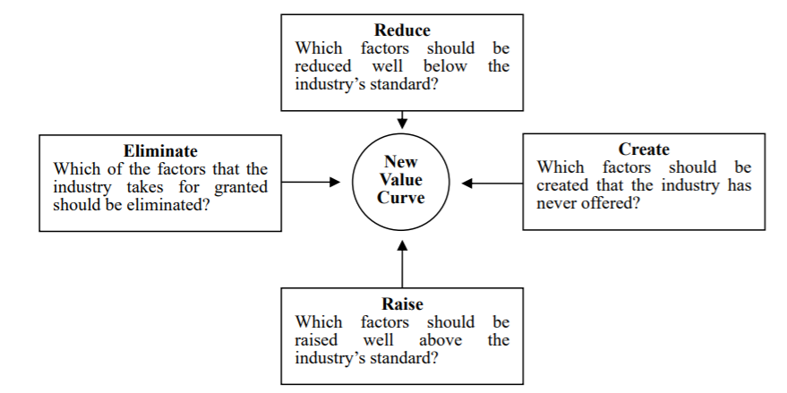

Fig 1 (Kim, et al Mauborgne 2004)

The BMC is an essential tool for existing businesses allowing them to refine and identify opportunities to add new products or services (Chaffey, et al 2018). However, the BMC does not directly consider the impact of competitors and does not specify key performance indicators for the evaluation of the business model (IBID).

4.0.Airbnb’s Business Model Canvas (BMC)

Figure 2 identifies Airbnb’s BMC. According to Chaffey, et al (2018) the value proposition of a business model is the crucial component because it identifies what the business offers. Airbnb has value propositions for guests and hosts as well as supplementary service providers (Dolnicar,2018).

4.1.Main Value Propositions

Review system

Mair and Reischauer (2017) state that digital platforms providing ratings build trust between hosts and guests which is essential in virtual environments. Airbnb have a review system to enhance communication between hosts and guests (Zervas, et al 2016), however, Wu, et al (2012) states that a barrier to Airbnb’s services is establishing customer trust (Wu, et al 2012). On Trustpilot Airbnb have an overall rating of 1.5 out of 5 stars based on 7,054 reviews (Trustpilot,2021). This rating is detrimental to Airbnb, decreases value and decreases retention.

Price

Sthapit et al (2018) revealed that price was a key motivator for consumers when booking accommodation with 46% of travellers selecting low-cost accommodation and frequently choosing Airbnb (Nguyen,2014). Renting a room from Airbnb’s platform will regularly be cheaper than a hotel and with an average cost saving of 49% (Luqi,2019).

Airbnb provide a diverse range of affordable accommodation alternatives and encourage small-scale entrepreneurship by allowing hosts to generate an additional income (Gyimothy, et al 2017).
Refer to appendix 1 for a full evaluation of Airbnb’s BMC.

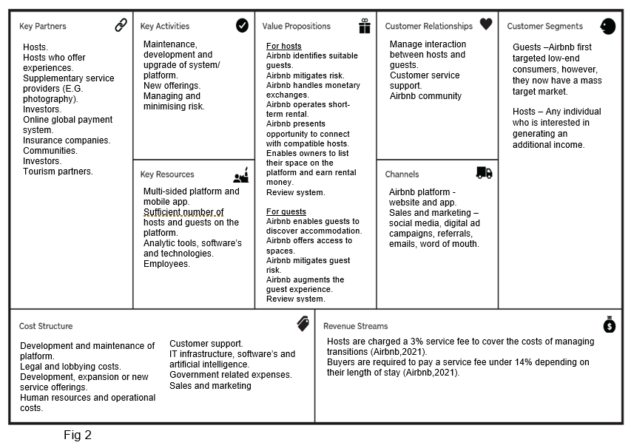

5.0.Strategic Formulation Framework (SFF)

The SFF assists organisations in identifying and evaluating alternative strategies (David, 2007). Strategies can be recognised, chosen and assessed through the SFF by completing three stages, including input, matching and decision. Stage one highlights the data required to form strategies by assessing external, internal and competitive factors, with stage two concentrating on identifying alternative strategies by aligning important external and internal aspects (see fig 3) (Torlak, et al 2007).
Stage three is the quantitative Strategic Planning Matrix (QSPM) which uses data from stage one to assess strategies shown in stage two. This provides senior managers with alternative strategies giving them a basis for choosing one preferred strategy. Strategies can be based on the company’s strengths and weaknesses and external threats and opportunities (David,2007).
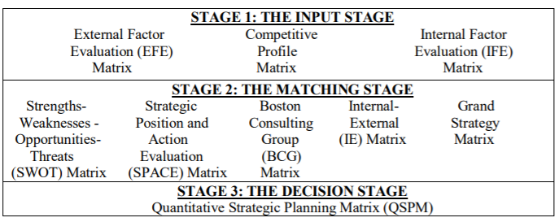

Fig 3 (Torlak, et al 2007)
The SFF allows Airbnb to identify factors that will aid strategic decision making. Previous frameworks were not comprehensive and did not provide the detail required for strategic planning. For example, the Balanced Score Card provides quantitative information in relation to an organisations performance, however, it does not link it to strategy and is without the logic of the business model behind it (Lueg,2015).
The SFF is an extremely structured and complex tool and can be time consuming to complete. However, it could be argued that the SFF is essential for large organisations, such as Airbnb, as it requires a structured methodology. The SFF is agile and can be updated frequently to ensure it aligns with strategy (PHD Essay, 2020).

6.0.Grand Strategy Matrix (GSM)

The GSM tool contained within the SFF will be used to evaluate Airbnb. The GSM is used by organisations to formulate strategies based on two evaluation dimensions, competitive position and market growth (Lu,2017).
Airbnb are categorised in quadrant one of the GSM as they exhibit most of these characteristics and strategies (see fig 4). Companies in quadrant one achieve rapid market growth and a strong competitive position by exploiting market penetration, market development and product development strategies (IBID). If a quadrant one company has too many resources then vertical or horizontal integration could be successful strategies. If a quadrant one company is too consigned to a product then concentric diversification can reduce the risks linked to limited product range (Torlak, et al 2007).

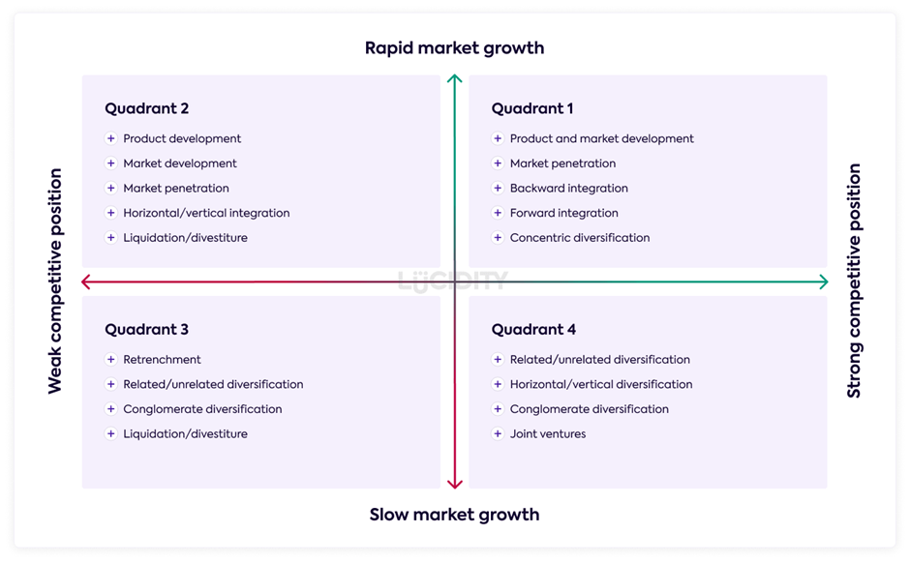
Fig 4

6.1.Market penetration

According to Bigley (2019) penetration strategies are vital for growth opportunities in existing markets and can include educational and community-based approaches. Airbnb introduced the Community Centre in 2015 allowing hosts to connect, share stories, seek advice and create a world ‘where anyone can belong’ (Airbnb,2021). This concept links to Airbnb’s slogan ‘belong anywhere’ and suggests that building a community is the focus of the brand (Gallagher,2016). Airbnb introduced the Host Endowment in 2020 which delivers support to the host community. A $1 billion fund provides support for education and finances (Airbnb,2020). In 2021, Airbnb announced the launch of its Neighbour Support Line in the UK and a partnership with Crimestoppers (Airbnb,2021). Although, these activities do not generate revenue, they do create a strong market image and publicity.

6.2.Market development

Market development is the process of entering new markets with existing products (Mukherjee,2014). In 2017 the number of rooms and apartments listed on Airbnb’s platform in China reached 20,000. Additionally, 8.6 million Chinese tourists use Airbnb when travelling (Marinova, 2017). However, Dolnicar (2018) highlights that the Chinese market has not embraced Airbnb’s platform as traditional Chinese culture highlights that homes are not permitted to be shared with strangers (Li,2016). China already have alternative accommodation platforms including Tujia and Xiaozhu that are perceived as more flexible (Dolnicar,2018). According to Yimin (2015) Airbnb need to operate with local regulatory authorities in China in order to access the Chinese market.

6.3.Product Development

Product development is essential for businesses allowing them to expand and remain competitive (Bresciani, et al 2016). In 2016 Airbnb extended their value proposition with experiences (Gallagher,2017) which added additional experience hosts to its business model. This allowed Airbnb to achieve a strong competitive position creating pressure on other accommodation providers to offer more than just a room (Bearne,2018). However, when experiences were first introduced, they had a slow uptake (Bensinger,2018). As Santoro, et al (2017) state new product development and innovation requires investment which can create risks. The experience option required reorganisation which is now considered a vital part of the business model and has changed Airbnb’s entire product strategy (Joffrion,2018).

6.4.Horizontal Integration

Horizontal integration strategies occur when a company purchase their competitors which allows them to expand into additional markets, diversify products and service offerings and reduce competition (Tarver,2021). Airbnb launched a global hotel technology partnership with SiteMinder to allow boutique hotels and B&B’s to list rooms on the platform (Olivia,2018). It could be argued that Airbnb have not fully utilised the horizontal integration strategy as boutique hotels and B&B’s were not acquired. However, it has allowed small accommodation providers to reach, engage and communicate via the Airbnb platform. This has also allowed Airbnb to expand the number and type of products offered which attracts additional guests (Airbnb,2018).

7.0.Information Systems

7.1.Platforms

Multi-sided platform
Airbnb use a multi-sided digital platform that promotes P2P activity and connects several parties, including hosts, guests and supplementary service providers (Dolnicar,2018). The platform allows C2C interaction, engagement and exchange between suppliers and customers which is made possible through collaborative e-commerce (Trabucchi, et al 2019). The platform is the underlying tool that supports Airbnb’s other information systems and business activities.

Amazon Web Services (AWS)
Airbnb decided to outsource their IT infrastructure after demand through Airbnb’s website increased and required additional services, tools and storage capacity. Airbnb recognised that Amazon Web Services (AWS) were a flexible and cost-effective solution (Evangelos,2016).
Amazon have a powerful IT infrastructure allowing them to diversify and offer value by providing organisations, such as Airbnb, with various webservices (AWS,2021). Figure 5 identifies a variety of AWS’s that Airbnb has adopted.
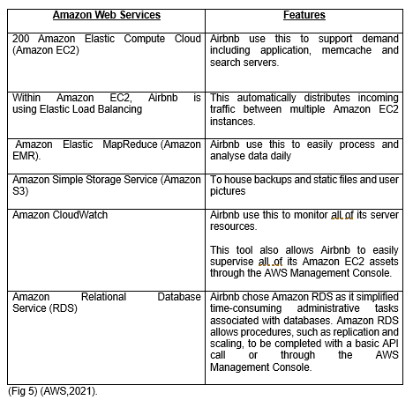

7.2.Enterprise Resource Planning (ERP)

Information systems that include ERP are designed to deliver valuable data that support strategies, operations, management analysis and decision-making functions (see fig 6) (Laudon, et al 2007). ERP systems are a vital component of an organisations processes and the majority of enterprises could not function without them (Matende, et al 2013).
The ERP system gives Airbnb two significant benefits. Firstly, it provides Airbnb with a unified understanding of the organisation that includes all functions and departments and secondly, it provides a database where all transactions are recorded, processed, analysed and reported (Nawaz,2013).
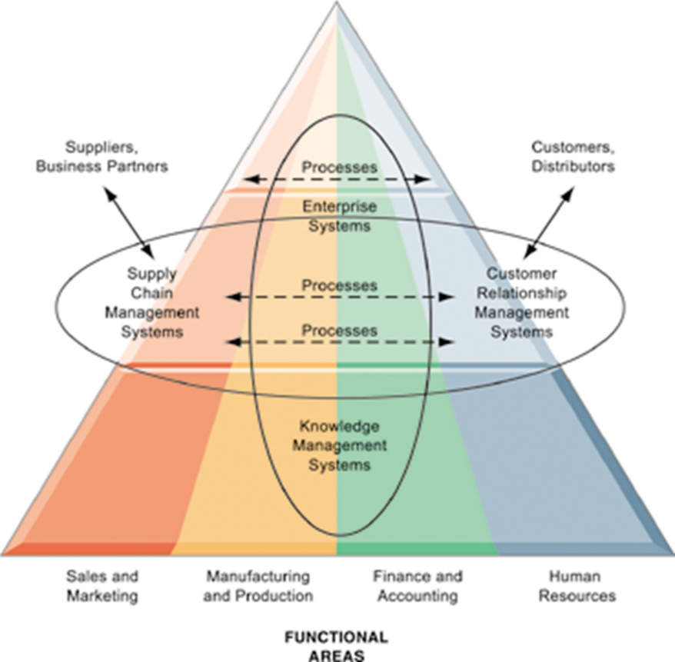

Fig 6 (Laudon, et al 2007).
An ERP system is a high-cost to install and maintain, however, it is essential for Airbnb as it supports the real time integration of data that all functional parts of the organisation have access to (Rom, et al 2006). Previously, organisations would have separate systems meaning that information was captured in one system and would need to be transferred to other relevant departments creating a time lag.

Business Intelligence and Analytics (BIA)
BIA are vital modules for Airbnb’s ERP system and can be defined as, ‘the technologies, systems, practices, and applications that analyse critical business data to help an enterprise better understand its business and market’ (Lim, et al 2013). Airbnb use Apache Superset which is an enterprise BIA web application (Beauchemin, et al 2021). Apache Superset provides Airbnb with a variety of options to analyse and visualise data in graphs (Apache Software, 2021).

7.3.Supply Chain Management System (SCM)

SCM is a system to improve business processes, creating resilience, agility competitiveness. The main purpose of the SCM is to enhance the product or service competitiveness (Machowiak,2012). The SCM system consists of upstream supply chain, downstream supply chain and internal supply chain (see fig 7) (Chaffey,2018).
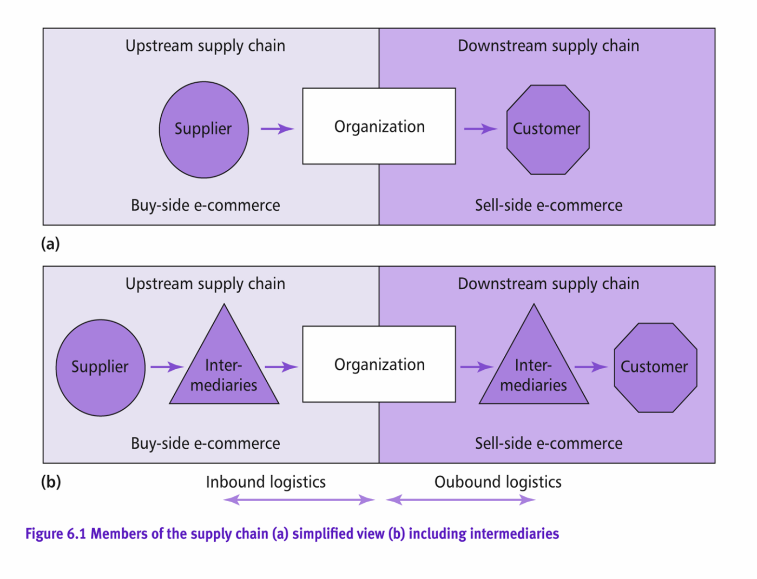
Fig 7 (Chaffey,2018)
Airbnb are in the centre of the diagram and their suppliers or hosts are in the upstream supply chain which is known as the buy-side e-commerce. Long-term relationships with suppliers are identified as critical aspects of SCM systems (Min, et al 2004). It is essential for Airbnb to build and manage relationships with suppliers to avoid them connecting with alternative platforms. The key requirements to achieve long-term relationships are trust and communication (Parkhi,2015) and to achieve this Airbnb will store supplier information within the CRM system.
Airbnb also connect to customers which is known as C2C business and is categorised under the downstream supply chain, known as sell side e-commerce. The downstream supply chain allows communication and collaboration between Airbnb, the customers and hosts (Chaffey,2018). The information that is captured here about the customers is also fed into the CRM system.
The internal supply chain allows information such as processing, purchasing decisions, planning, regulations and photographer agreements to be stored. This information is then linked to the ERP system and shared across the functional business areas (IBID).

7.4.Customer Relationship Management System (CRM)
CRM systems help build and sustain long-term business with customers (Soliman,2011) providing Airbnb with the opportunity to capture information about customers and build long-term relationships and trust. This can be achieved through personalisation, targeted services and tailored experiences which will help achieve a competitive advantage (Solis,2019). However, according to Stone, et al (2014), several organisations encounter challenges dealing with high volumes of data and fail to exploit the insight provided. This results in customer needs and preferences being unrecognised which decreases value.

To ensure Airbnb capture data to increase value they use various technologies and techniques which will be activated using different marketing approaches (see fig 8) (Chaffey,2018). For example, the Search Engine Optimisation (SEO) technique involves achieving the highest positioning on the search engine’s results page which is determined through algorithms (Fahy, et al 2015). Airbnb utilise SEO to ensure they are ranked first when a customer searches for accommodation providers. However, the data from each tool is captured in different formats and provides unstructured data (Sirisha, et al 2017). This information is captured by the CRM and then transferred to the ERP to gain a deeper analysis.
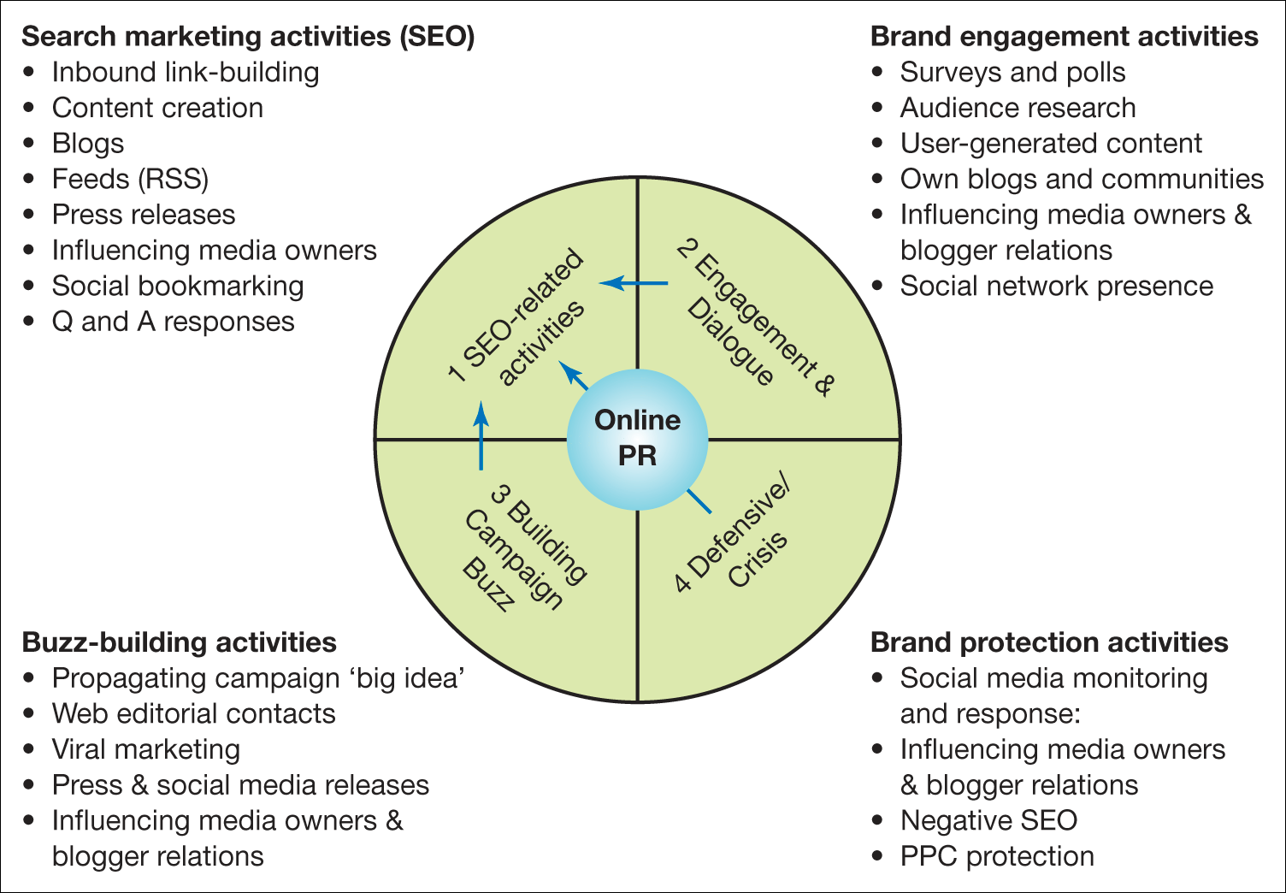

Fig 8 (Chaffey,2018).

8.0.Future development for Airbnb

From an evaluation of Airbnb’s business model, there are potential opportunities for future development. Airbnb could utilise the product development strategy to ensure they remain competitive. For example, Airbnb could transform into a one-stop-shop for travel by providing guests with the option to book flights, accommodation and car rental through the Airbnb platform (Fania,2018). Figure 9 highlights the proposed business model canvas for this development.
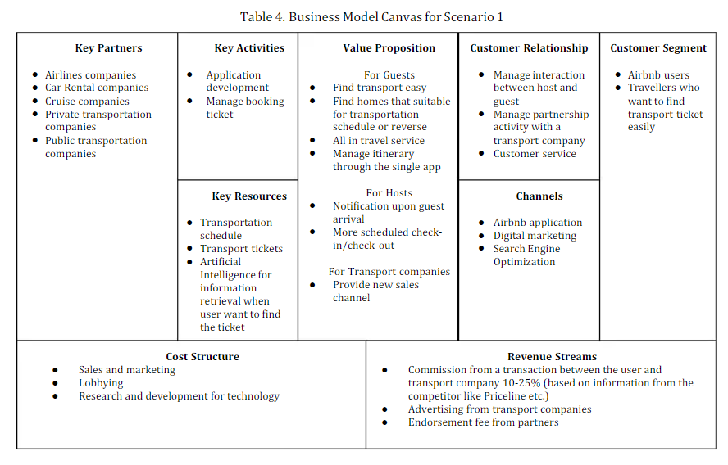
Fig 9 (Fania,2018)
A news article identifies that Airbnb plans to transform into a one-stop-shop for travel (World News, 2018) and this notion can be supported with Airbnb’s appearance on the stock market indicating that they are raising capital in order to expand (Feiner,2020) (refer to appendix 1 revenue streams).
The biggest challenge associated with P2P accommodation marketplaces is that there are low barriers for entry. For example, Airbnb’s competitors can replicate the business model which is why it is essential for Airbnb to constantly identify strategies for future growth (Wu, et al 2012).

9.0.Conclusion

This report has critically evaluated Airbnb’s BMC by establishing how they deliver value to stakeholders by utilising market penetration, market development, product development and horiztiontal strategies. The ERP, SCM and CRM systems provide valuable data that support strategies, create competitiveness and help build and sustain long-term relationships. Regulations, Coronavirus and low barriers for entry have been identified as challenges for which recommendations have been proffered. Airbnb have sought stakeholder investment which will allow them to develop strategies including transforming into a one-stop-shop for travel.

10.0.Bibliography

Abril , D. (2021, January 14). Airbnb’s CEO on how COVID has changed travel forever. Retrieved from Fortune: https://fortune.com/2021/01/14/airbnb-brian-cheskys-future-of-travel-predictions-coronavirus-pandemic/
Airbnb. (2018, February 07). Airbnb Launches Global Hotel Technology Partnership to Support Boutique Hotels, Bed and Breakfasts. Retrieved from Airbnb: https://news.airbnb.com/airbnb-launches-global-hotel-technology-partnership-to-support-boutique-hotels-bed-and-breakfasts/
Airbnb. (2020, October 30). An Important Announcement from Airbnb. Retrieved from Airbnb: https://news.airbnb.com/an-important-announcement-from-airbnb/
Airbnb. (2021, February 11). Airbnb launches Neighbour Support Line and joins forces with Crimestoppers. Retrieved from Airbnb: https://news.airbnb.com/en-uk/
Airbnb. (2021). Superhost: Recognising the best in hospitality. Retrieved from Airbnb: https://www.airbnb.co.uk/d/superhost
Airbnb. (2021). What is the Airbnb Community Centre? Retrieved from Airbnb: https://www.airbnb.co.uk/help/article/1183/what-is-the-airbnb-community-centre
Alves, H., Fernandes, C., & Raposo, M. (2016). Social Media Marketing: A Literature Review and Implications: IMPLICATIONS OF SOCIAL MEDIA MARKETING. Psychology and Marketing, 1029-1038.
Amazon Web Services. (2021). Airbnb Case Study. Retrieved from https://aws.amazon.com/solutions/case-studies/airbnb-case-study/
Apache Software. (2021). Apache Superset is a modern data exploration and visualization platform. Retrieved from The Apache Software Fountation: https://superset.apache.org/
Bearne, S. (2018, April 11). 'Airbnb is forcing everyone to up their game': how hotels are changing tack. Retrieved from The Guardian: https://www.theguardian.com/business-to-business/2018/apr/11/airbnb-is-forcing-everyone-to-up-their-game-how-hotels-are-changing-tack
Beauchemin, M., Scott, A., Liu, V., Kyryliuk, B., & Grace, G. (2021). Superset. Retrieved from Airbnb: https://airbnb.io/projects/superset/
Bensinger, G. (2018, February 21). Airbnb Wants You to Do More Than Just Book a Home. Customers Aren’t Buying It. Retrieved from The Wall Street Journal: https://www.wsj.com/articles/airbnbs-push-into-experiences-has-been-a-slog-1519209000
Bigley, J. (2019). A Tactical Framework for Market Penetration with a Multidimensional Organization. Research in Economics and Management, 2470-4393.
BMI. (2021). How Airbnb's exponential business model works. Retrieved from Business Models Inc: https://www.businessmodelsinc.com/exponential-business-model/airbnb/
Bradford. (2016). Five strategies provide a model for innovation: Clear picture begins with large "canvas". Strategic Direction, 19-21.
Bresciani, S., & Ferraris, A. (2016). Innovation-receiving subsidiaries and dual embeddedness: impact on business performance. Baltic Journal of Management, 108-130.
Camilleri, M. (2018). Market Segmentation, Targeting and Positioning. In Travel Marketing, Tourism Economics and the Airline Product: An Introduction to Theory and Practice (pp. 69-83). Switzerland: Springer.
Chaffey, D., Hemphill, T., & Edmundson-Bird, D. (2018). Digital Business and E-Commerce Management. London: Pearson Education, Limited.
David, F. (2007). Strategic Management: Concepts. London: Pearson.
Dolnicar , S. (2018). PEER-TO-PEER ACCOMODATION NETWORKS. Oxford: Goodfellow Publishers Ltd.
Evangelos, K. (2016, May). CSP - Client Relationship Management in Iaas cloud deployment model - The outsourcing case of Airbnb & AWS. Retrieved from ResearchGate: https://www.researchgate.net/publication/303034351_CSP_-_Client_Relationship_Management_in_Iaas_cloud_deployment_model_-_The_outsourcing_case_of_Airbnb_AWS
Fahy, J., & Jobber, D. (2015). Foundations of Marketing. Great Britain: McGraw-Hill Education .
Fania, R. (2018). Business Model Innovation for Airbnb. Business, Information Technologies, Economics and Startups, 1-10.
Feiner, L. (2020, December 10). Airbnb skyrockets 112% in public market debut, giving it a market cap of $86.5 billion. Retrieved from CNBC: https://www.cnbc.com/2020/12/10/airbnb-ipo-abnb-starts-trading-on-the-nasdaq.html
Gallagher, L. (2016, December 22). How Airbnb Found a Mission—and a Brand. Retrieved from Fortune: https://fortune.com/longform/airbnb-travel-mission-brand/
Gallagher, L. (2017). The Airbnb Story: How Three Ordinary Guys Disrupted an Industry, Made Billions... And Created Plenty of Controversy. New York: Hughton Mifflin Hartcourt Publishing Company.
Guttentag, D. (2015). Airbnb: disruptive innovation and the rise of an informal tourism. Current Issues in Tourism, 1192-1217.
Guttentag, D., Smith, S., Potwarka, L., & Havitz, M. (2018). Why Tourists Choose Airbnb: A Motivation-Based Segmentation Study. Journal of Travel Research, 342-359.
Gyimóthy, S., & Dredge, D. (2017). Collaborative Economy and Tourism: Perspectives, Politics, Policies and Prospects. Germany : Springer.
Innovation Tactics . (2020, September 15). Airbnb Business Model Canvas. Retrieved from Innovation Tactics : https://innovationtactics.com/business-model-canvas-airbnb/
Joffrion, E. (2018, July 09). The Designer Who Changed Airbnb's Entire Strategy. Retrieved from Forbes: https://www.forbes.com/sites/emilyjoffrion/2018/07/09/the-designer-who-changed-airbnbs-entire-strategy/?sh=6e6873ef2c36
Kim, W., & Mauborgne, R. (2004, July ). Value Innovation: The Strategic Logic of High Growth. Retrieved from Harvard Business Review: https://hbr.org/2004/07/value-innovation-the-strategic-logic-of-high-growth
Kotler, P., & Armstrong, G. (2009). Principles of Marketing. London: Pearson Education.
Krouk, R., & Almeida , F. (2020). EXPLORING THE IMPACT OF COVID-19 IN THE SUSTAINABILITY OF AIRBNB BUSINESS MODEL. JOURNAL OF SMART ECONOMIC GROWTH, 89 – 107.
Laudon, J., & Laudon, K. (2007). Management Information Systems : Managing the Digital Firm. Indiana: Lebanon.
Levy, A. (2020, November 17). Airbnb’s IPO filing shows it’s navigating the pandemic better than travel industry peers. Retrieved from CNBC: https://www.cnbc.com/2020/11/16/airbnb-navigating-covid-better-than-rest-of-industry-ipo-filing-shows.html
Li, Y. (2016). The crisis of Airbnb model in China. Business Culture, 40-43.
Lim, E.-P., Chen, H., & Chen, G. (2013). Business Intelligence and Analytics: Research Directions. ACM transactions on management information systems, 1-10.
Lu, L.-T. (2017). Strategic Planning for Xiaomi: Smart Phones, Crisis, Turning Point. International Business Research, 149-160.
Lueg, R. (2015). Strategy maps: the essential link between the Balanced Scorecard and action. Journal of Business Strategy, 34-40.
Luqi, T. (2019). Impact of Airbnb on customers' behaviour in the UK hotel industry. Tourism Analysis, 13-26.
Machowiak, W. (2012). Risk management-unappreciated instrument of supply chain management strategy. LogForum, 277-285.
Mair, J., & Reischauer, G. (2017). Capturing the dynamics of the sharing economy: Institutional research on the plural forms and practices of sharing economy organizations. Technological Forecasting and Social Change, 11.
Mangles , C. (2021, February 22). Need to create a winning marketing campaign? Plan your strategy across the RACE Framework. Retrieved from Smart Insights: https://www.smartinsights.com/digital-marketing-strategy/organize-campaign-plan-race-framework/#:~:text=The%20RACE%20planning%20framework%20is%20designed%20to%20help,that%20helps%20integrate%20all%20marketing%20communications%20into
Marinova, P. (2017, December 05). Why China is Crucial for Airbnb’s Global Ambitions. Retrieved from Fortune: https://fortune.com/2017/12/05/airbnb-china-growth/
Marketline. (2019, February 22). AIRBNB: UNCERTAIN FUTURE OF SHORT-TERM RENTAL PLATFORMS. Retrieved from Marketline: https://www.marketline.com/blog/22mk-airbnb-uncertain-future-of-short-term-rental-platforms/
MarketLine. (2020, April). Airbnb Inc – Strategy, SWOT and Corporate Finance Report. Retrieved from MarketLine: https://store.marketline.com/report/ml1122876sa--airbnb-inc-strategy-swot-and-corporate-finance-report/
Matende, S., & Ogao, P. (2013). Enterprise Resource Planning (ERP) System Implementation: A Case for User Participation. Procedia Technology, 518-526.
Min, S., & Mentzer, J. (2004). Developing and Measuring Supply Chain Concepts. Journal of Business Logistics, 63–99.
Mukherjee, J. (2014). Market Development by Multinational Brands: Empirical Evidence from Indian Fast Food Retailing Business. The Journal of Business Perspective , 1-7.
Nawaz, N. (2013). The Impact of Enterprise Resource Planning (ERP) Systems Implementation on Business Performance. SSRN Electronic Journal, 30-47.
Nguyen, Q. (2014). Retrieved from Core: https://core.ac.uk/download/pdf/62889552.pdf
Olivia , S. (2018, February 22). The Guardian. Retrieved from Not just homes any more: Airbnb expands into hotels and luxury spots: https://www.theguardian.com/technology/2018/feb/22/airbnb-hotels-expansion-travel
Osterwalder, A., & Pigneur, Y. (2010). Business Model Generation: A Handbook for Visionaries, Game Changers, and Challengers (The Strategyzer Series). New York: Wiley.
Parkhi, S. (2015, May). A Study of Evolution and Future of Supply Chain Management. Retrieved from ResearchGate: https://www.researchgate.net/publication/278029600_A_Study_of_Evolution_and_Future_of_Supply_Chain_Management
PHD Essay. (2020, March 24). David’s Framework Mission Vision. Retrieved from PHD Essay: https://phdessay.com/an-application-of-davids-strategy-formulation-framework-to-the-turkish-airlines-on-domestic-air-transportation-operations/#:~:text=Strategy-Formulation%20Framework%20(David,%202007)%20Fred%20David%20stated%20the,(IFE)%20Matrix,%20and%
Plenter, F., Fielt, E., Hoffen, M., Chasin, F., & Rosemann, M. (2017). REPAINTING THE BUSINESS MODEL CANVAS FOR PEER-TO-PEER SHARING AND COLLABORATIVE CONSUMPTION. Retrieved from Vais Library: https://aisel.aisnet.org/ecis2017_rp/142/
Rom, A., & Rohde, C. (2006). Enterprise resource planning systems, strategic enterprise management systems and management accounting: A Danish study. Journal of Enterprise Information Management, 50-66.
Santoro, G., Vrontis , D., & Pastore, A. (2017). External knowledge sourcing and new product development. British Food Journal, 2373-2387.
Shukla, L. (2013). A Case Study on Customer Acquisiton and Retention on the Airline Service Industry. IOSR Journal of Business and Management, 15-33.
Sirisha, J., & Reddy, M. (2017). Unstructured Data: Various approaches for Storage, Extraction and Analysis. International Journal of Computer Science and Information Security, 101-106.
Soliman, H. (2011). Customer Relationship Management and Its Relationship to the Marketing Performance. nternational Journal of Business and Social Science, 166-182.
Solis, B. (2019, December 16). How Can We Build Trust In Digital Business? Retrieved from Forbes: https://www.forbes.com/sites/briansolis/2019/12/16/how-can-we-build-trust-in-digital-business/?sh=3a3fd7b06ec2
Sthapit, E., & Jiménez-Barreto, J. (2018). You never know what you will get in an Airbnb: poor communication destroys value for guests. Current Issues in Tourism, 1-4.
Stone, D., & Woodcock, D. (2014). Interactive, direct and digital marketing: A future that depends on better use of business intelligence. Journal of Research in Interactive Marketing, 4-17.
Tarver, E. (2021, January 18). Horizontal vs. Vertical Integration: What's the Difference? Retrieved from Investopedia: https://www.investopedia.com/ask/answers/051315/what-difference-between-horizontal-integration-and-vertical-integration.asp
Torlak, N., & Sanal, M. (2007, September). David's Strategy Formulation Framework in Action: The Example of Turkish Airlines on Domestic Air Transportation. Retrieved from ResearchGate: https://www.researchgate.net/publication/260186648_David's_Strategy_Formulation_Framework_in_Action_The_Example_of_Turkish_Airlines_on_Domestic_Air_Transportation
Trabucchi, D., & Buganza, T. (2019). Fostering digital platform innovation: From two to multi‐sided platforms. Creativity and Innovation Management, 1-14.
Trustpilot. (2021, March 05). Airbnb. Retrieved from Trustpilot: https://uk.trustpilot.com/review/www.airbnb.com?b=MTYxNDQxNTUxNzAwMHw2MDNhMDY5ZGY4NWQ3NTBiOThhMjM3NDA
Tsourgiannis, L., & Valsamidis, S. (2019). Digital marketing in tourism: why Greek tourists use digital marketing applications like Airbnb. International Journal of Culture, Tourism and Hospitality Research, 473-486.
Vinerean , S. (2017). Importance of Strategic Social Media Marketing. Expert Journal of Marketing, 28-35.
Wirtz, J. (2019). Platforms in the peer-to-peer sharing economy. Journal of Service Management , 1-32.
World News. (2018, February 25). Airbnb reveals secret plan to launch an airline to help company become ‘one-stop shop for travel’. Retrieved from World News: https://theworldnews.net/gb-news/airbnb-reveals-secret-plan-to-launch-an-airline-to-help-company-become-one-stop-shop-for-travel
Wu, S., Lee, F., & Raynard, J. (2012). Airbnb. Retrieved from http://www.econ.ucla.edu/sboard/teaching/tech/Airbnb.pdf
Xie, K., & Mao, Z. (2017). The Impacts of Quality and Quantity Attributes of Airbnb Hosts on Listing Performance. International Journal of Contemporary Hospitality Management, 1-37.
Yimin, H. (2015, August 29). Three challenges facing Airbnb in China. Retrieved from Business Insider: https://www.businessinsider.com/three-challenges-facing-airbnb-in-china-2015-8?r=US&IR=T
Zervas, G., & Proserpio, D. (2016, November 18). The Rise of the Sharing Economy: Estimating the Impact of Airbnb on the Hotel Industry. Retrieved from http://people.bu.edu/zg/publications/airbnb.pdf

11.0.Appendices

11.1.Appendix 1

Customer Segments
Initially, Airbnb targeted low-value consumers, however, they extended the target market by providing accommodation at various prices allowing them to attain a mass market (BMI, 2021). Achieving a mass market allows Airbnb to establish a suitable number of hosts and guests on the platform. This is vital as numerous P2P accommodation networks have been unsuccessful in creating critical mass (Dolnicar,2018).

Revenue Streams
Main revenue stream
Revenue streams include the methods an organisation uses to derive income which can include sales of goods and services, subscription fees and affiliate-based commission arrangements (Chaffey,2018). Airbnb’s main revenue stream is charging the parties involved in the rental. For example, Airbnb captures value from the hosts by charging a 3% fee to cover the costs of transactions and buyers are required to pay a fee which is dependent on the length of stay (Airbnb,2021). Airbnb also provide hosts with an additional revenue stream by allowing them to generate a new source of income by listing their space on the platform.
Stock market
At the end of 2020, Airbnb appeared on the stock market at $146 per share which was an increase of $78 compared to their initial public offering (IPO) (Feiner,2020). This provided Airbnb with a market capitalisation of $86.5 billion which was more than its main competitors, for example, Booking ($86b), Expedia ($18b), Marriott Hotel ($42b) and Hilton ($29b). This is the first time Airbnb has gone public due to reduced travel trends from Coronavirus. It is indicated Airbnb have appeared on the Nasdak in order to gain investments from shareholders and grow the business.

Customer Relationships
It is essential for Airbnb to build customer relationships and this can be achieved through customer acquisition and customer retention. According to Kolter, et al (2009) identifying a suitable target market ensures that returns are profitable. It has already been identified that Airbnb has a mass market which allows them to generate high revenues. Additionally, customer retention is concerned with satisfying consumer needs to ensure they return to the organisation in order to increase profits. This can be achieved through loyalty programmes and review systems (Shukla,2013). It can be identified that Airbnb have a Superhost Programme that rewards the top-rated and most experienced hosts. The programme allows Superhosts to earn additional revenues and attract more guests (Airbnb,20210).

Channels
Communication channels are an essential part of Airbnb’s business model. Airbnb’s main communication channel is through the platform and mobile application as well as social media channels. Web 2.0 technologies have allowed interaction and collaboration between organisations and customers (Alves, et al 2016). Airbnb use these technologies in order to ‘Reach, Act, Convert and Engage’ customers in accordance with the RACE Framework (Mangles,2021). Social media channels allow Airbnb to provide support, deal with queries, increase brand awareness and retain customers by ensuring information is relevant, updated frequently and involves a two-way discussion (Vinerean,2017).

Key Partners
Airbnb’s key partners are hosts and guests as Airbnb would not be able to operate the business and generate revenues without them. Additionally, supplementary service providers are a key partner of Airbnb’s business model and can include professional photographers. Photography services are essential for hosts to ensure the digital appearance of accommodation is attractive to increase revenues (Dolnicar,2018).

Key activities
One of the main activities within Airbnb’s business model is minimising risk as building trust and long-term relationships are essential (Xie, et al 2017). It can be identified that Airbnb offer guests refunds if the hosts specification and pictures do not match the accommodation (IBID). As previously stated, Airbnb attempt to mitigate this risk by offering photography services.

Key Resources
Advancements in technology have allowed organisations to reach their target market through digital and mobile applications (Camilleri, 2018). These applications and the P2P platform are essential resources for Airbnb as they communicate with their audience in a virtual environment.

Cost Structure
Airbnb will be required to utilise advertising and promotion techniques in order to acquire and retain customers. Additionally, Airbnb will require research and development costs for product development and design as well as improvement and maintenance of the platform (Innovation Tactics , 2020).

