Bryn Sutton
Pembrokeshire College [88924]
Project Initiation Document

Project Initiation Document
This document covers the project idea and marks out the objectives and scope of the project using the BOSCO method.
The project RPD or Resource Priority Database, is designed as a mobile data gathering project, which can be transported to various disaster areas as required.
RPD can be deployed to a variety of terrain types due to the use of ex-military trucks, which are designed for off road travel.
Each of the 30 vehicles will disperse to inhabited areas of any disaster zone and will be accompanied by volunteers from the red cross or other aid organisations in the area.
Equipped with a computer, database program and a satellite Wi-Fi connection each team can collect data on the size and requirements of multiple areas in a disaster zone.
The database collates the information gathered and suggests a relevant aid package for the prescribed area. All this information is sent back to a HQ vehicle that will be near the Red Cross HQ, to provide a print out of what each location requires.
In this way the red cross/aid organisations will be able to organise and transport the resources faster and with less waist.

BOSCARD [1]
https://www.projectsmart.co.uk/boscard.php

Objectives
- Create a database that is easy to use and can return a specific response
- Find a suitable solution for a mobile implementation
- Quick response system in the case of an emergency
- Give specific information on which materials/ resources are required in various locations of a disaster area.

Scope
- The Resource Priority Database (RPD) will be an easy to use database that can quickly gather information about what resources are required in a disaster area and should be able to be used by someone unfamiliar with the database.
- RPD will be able to work efficiently in areas that have lost both electricity and internet capacity due to the satellite Wi-Fi systems put in place
- The RPD will be capable of traversing rough terrain in order to get to isolated spots due to the use of 30 ex-military trucks.
- The service can quickly determine what resources are required in which locations in a disaster area.

Constraints
- The availability of fuel in the disaster area could restrict the area in which the database can be distributed.
- The availability of relief resources may hinder the effectiveness of the database, if there are not enough resources then the database’s information will need to be modified after the fact.
- A lack of volunteers would slow down the pace at which data can be gathered.
- Initially having 30 vehicles could put a constraint on how quickly RPD can collect data over a large disaster area.
Assumptions
- It is assumed that the RPD will be ready to go within two hours of arriving at a disaster location, once a HQ has been established and volunteer groups have been assigned to each RPD team.
- The RPD will be able to collate and calculate the amount of resources required for each disaster area.
- The RPD will be able to reach almost any location in a disaster zone
Risks
- Being backed by the red cross, there is a risk that their funding may not be able to cover the project costs.

Deliverables
- RPD will deliver a mobile networked database
- RPD will be simple to use
- RPD will gather data and provide the required resources across a disaster area
- Aid teams such as the red cross will have a complete list of resources required across a disaster zone.

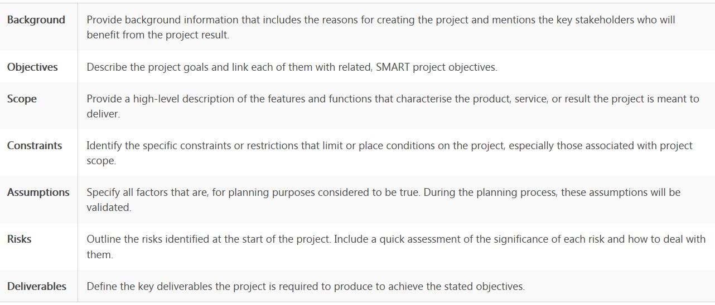

Pre-Project Project plan
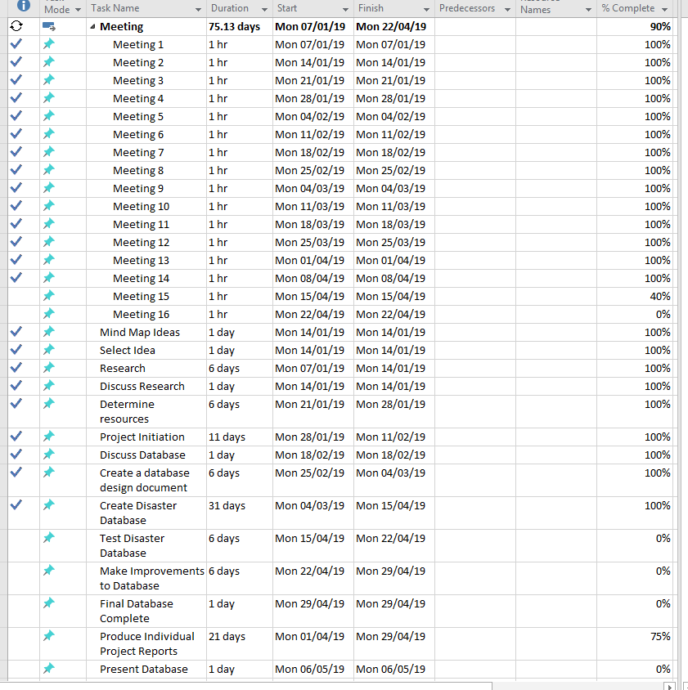

References
[1]
Author:  Article title: | Unknown  BOSCARD (Terms of Reference)
Website title: | Project Smart
URL: | https://www.projectsmart.co.uk/boscard.php

