

Programme: Master of Business Administration
Module: Marketing Management
Module code: LCMB7024
Assignment Title: Marketing Environment Analysis

Marketing Environmental Analysis and Strategic Comparison

Netflix (Pioneer) And Disney+ (Follower)

Lecturer: Dian Mayasari (Birmingham)
Student name: Akashkumar Dharmendrakumar Prajapati
Student ID number: 2438331
Word count: 2608
Submission date: Friday 24th October 2025 by 2pm

Table of Contents

Introduction 2
Task 1 – Macro Marketing Environmental Analysis 3
1.1 Political and Legal Factors 3
1.3 Social and Cultural Factors 4
1.4 Technological Factors 4
1.5 Environmental Factors 5
1.6 Legal Factors (Expanded) 5
1.7 SWOT Analysis Summary 5
1.8 Synthesis: Implications for Marketing Management 6
Task 2: Strategic Evaluation 7
2.1 Introduction to Strategic Comparison 7
2.2 The 4Ps Analysis 8
2.3 The 7Ps: Extending the Service Marketing Mix 10
2.4 Segmentation, Targeting, and Positioning (STP) 11
2.5 Branding and Relationship Marketing 11
2.6 Comparative Evaluation: Pioneer vs Follower Dynamics 14
Conclusion 15
Harvard Reference List (with links) 16

Introduction

Digital streaming has become one of the fastest-growing entertainment sectors, reshaping how consumers access and experience media. The emergence of subscription video-on-demand (SVOD) platforms illustrates the strategic significance of marketing management in turbulent, technology-driven environments (Kotler & Keller, 2016). Within this sector, Netflix is widely recognised as the pioneer that redefined home entertainment through its subscription-based, algorithm-driven, and globally scalable model. Disney+, by contrast, represents a follower strategy: it entered later but leveraged the heritage, brand equity, and intellectual-property portfolio of The Walt Disney Company to capture share in an already mature streaming market (Lotz, 2021).
This report explores how these two organisations respond to and shape their marketing environments. Using PESTEL and SWOT frameworks, the first task analyses the macro-environmental influences that frame competition in the SVOD industry. The second task then applies marketing-management concepts — notably the 4Ps, 7Ps, STP, and relationship marketing — to evaluate how each company’s strategy sustains competitive advantage. The aim is to demonstrate the managerial importance of environmental analysis and marketing adaptation in maintaining brand leadership and customer engagement in digital service industries.

Task 1 – Macro Marketing Environmental Analysis

1.1 Political and Legal Factors

Political regulation has become a decisive element of streaming competition. Governments now enforce local-content quotas, taxation on digital revenues, and rules on data privacy that affect market access (European Commission, 2022). Netflix operates in more than 190 countries and must therefore tailor its compliance strategy to diverse regimes, from the EU’s Audiovisual Media Services Directive to censorship laws in India and the Middle East. This complexity increases operating costs but also encourages localisation — a political constraint turned into a marketing asset through investment in local productions such as Lupin (France) and Money Heist (Spain). Disney+, as part of a multinational conglomerate with decades of regulatory experience, benefits from established government relationships and self-regulatory mechanisms ensuring brand safety and child-friendly standards (Disney, 2023). By aligning its compliance with its family-oriented brand image, Disney+ converts regulation into a positioning advantage.

1.2 Economic Environment
Macroeconomic shifts strongly influence consumer spending on non-essential entertainment. The COVID-19 pandemic temporarily accelerated subscription growth, but post-pandemic inflation and cost-of-living pressures have heightened price sensitivity (PwC, 2023). Netflix has adopted a dynamic pricing model, introducing lower-cost ad-supported tiers to retain value-conscious customers (Statista, 2024). Its focus on scalability and predictable recurring revenue demonstrates the link between economic conditions and pricing strategy. Disney+, conversely, leverages bundled offers with Hulu and ESPN+ to create perceived value through cross-platform integration, mitigating churn during economic downturns (Disney Annual Report, 2023). Currency fluctuations and production-cost inflation also affect profitability, compelling both firms to pursue economies of scale and in-house content creation to reduce licensing costs.

1.3 Social and Cultural Factors

Cultural shifts toward individualised consumption, multi-device viewing, and global content discovery underpin the SVOD model (Jenkins, 2020). Netflix successfully anticipated these changes by investing in advanced recommendation algorithms and encouraging binge-watching behaviour — a social phenomenon that deepened engagement and brand habit. Its diverse catalogue supports cultural inclusivity, aligning with global social trends around representation. Disney+, however, relies on nostalgia and family co-viewing as emotional triggers, consistent with its traditional positioning as a curator of safe, high-quality storytelling (Johnson, 2021). Social advocacy and corporate reputation also affect marketing: both firms promote sustainability and inclusion messaging to strengthen brand trust among socially conscious audiences.

1.4 Technological Factors

Technology constitutes the principal driver of competitive advantage in streaming. Netflix pioneered adaptive streaming, personalised interfaces, and data-driven content commissioning based on predictive analytics (Gomez-Uribe & Hunt, 2015). These innovations embody market orientation by converting consumer data into actionable insights that inform both production and promotion. Disney+, as a later entrant, leveraged cloud partnerships with Amazon Web Services and its proprietary BAMTech platform to achieve comparable performance (Bloomberg, 2023). Emerging technologies such as artificial intelligence, spatial computing, and interactive storytelling will further reshape engagement. Both companies invest in AI-based recommendation engines, but Netflix’s first-mover advantage has created strong brand associations with algorithmic personalisation.

1.5 Environmental Factors

Sustainability expectations influence brand perception even in digital sectors. Data-centre energy use, carbon emissions from production, and device lifecycles all contribute to environmental scrutiny (IEA, 2023). Netflix has pledged to achieve net-zero emissions by 2030 through renewable-energy sourcing and sustainable filming practices. Disney+ aligns with The Walt Disney Company’s wider environmental commitments, integrating eco-themed content and green production protocols. These initiatives not only address stakeholder expectations but also operate as differentiation tools within corporate social responsibility (CSR) marketing frameworks (Peattie & Crane, 2018).

1.6 Legal Factors (Expanded)

Beyond political policy, the legal environment affects intellectual-property rights and data protection. Streaming firms face increasing litigation risk over content licensing and copyright disputes. Netflix’s investment in original programming reduces dependency on external licences, providing both creative autonomy and risk mitigation (Thompson, 2022). Disney+ benefits from owning vast IP assets — Marvel, Star Wars, Pixar — granting it unique legal leverage. The General Data Protection Regulation (GDPR) and similar laws require transparent data practices; both firms frame privacy compliance as a trust-building marketing message.

1.7 SWOT Analysis Summary

Factor | Netflix (Pioneer) | Disney+ (Follower)
Strengths | Global first-mover; strong brand equity; advanced analytics; diversified content; agile innovation. | Iconic IP portfolio; cross-media integration; family-oriented brand reputation; bundled pricing.
Weaknesses | Rising content costs; dependence on subscription revenues; limited ancillary businesses. | Late market entry; narrower demographic appeal; technology initially less sophisticated.
Opportunities | Emerging markets; ad-supported tiers; gaming and interactive formats. | Leveraging heritage franchises globally; co-branding synergies; regional partnerships.
Threats | Market saturation; regulatory restrictions; economic downturns; new entrants. | Competitive imitation; piracy; high fixed costs; subscription fatigue.

The SWOT comparison highlights contrasting strategic logics: Netflix’s success derives from innovation and data agility, while Disney+ capitalises on differentiation through heritage and ecosystem integration. From a marketing-management perspective, both approaches demonstrate adaptive fit with their respective environments — Netflix’s dynamic capability model aligns with contingency theory, whereas Disney+ exemplifies resource-based marketing advantage (Grant, 2021).

1.8 Synthesis: Implications for Marketing Management

The macro-environmental analysis reveals how marketing decisions are embedded in broader institutional, economic, and technological contexts. Political and legal factors compel both firms to localise offerings, illustrating how compliance becomes a component of the marketing mix. Economic volatility influences pricing and bundling, while social trends determine brand storytelling and segmentation logic. Technology acts as both catalyst and constraint: continuous innovation is required to sustain customer engagement, yet the speed of change increases strategic risk. Environmental and CSR commitments reinforce brand authenticity, an increasingly vital component of service marketing credibility.
For marketing managers, the Netflix-Disney+ comparison underscores the need to integrate environmental scanning into strategic planning. Successful firms treat external change not as threat but as opportunity for repositioning, product innovation, and relationship reinforcement. Netflix’s agility in algorithmic marketing exemplifies proactive orientation, whereas Disney+ demonstrates strategic imitation — a follower tactic that leverages established assets within new distribution channels. Both paths confirm that effective marketing management in digital contexts requires dynamic capabilities, global market insight, and continuous alignment between environmental forces and internal resources.

Task 2: Strategic Evaluation

2.1 Introduction to Strategic Comparison

Having evaluated the macro-environmental factors shaping the streaming video industry, this section applies key marketing management frameworks to assess how Netflix and Disney+ have structured and executed their marketing strategies. The analysis adopts a comparative perspective through the 4Ps (Product, Price, Place, Promotion), the 7Ps (including People, Process, Physical Evidence), and Segmentation, Targeting and Positioning (STP) models. Additionally, relationship marketing and branding theories are incorporated to explain how each company sustains loyalty and differentiation in an increasingly saturated marketplace.
Netflix, as the pioneer, exemplifies innovator marketing behaviour — prioritising continuous product and process reinvention to maintain leadership (Rogers, 2003). Disney+, as the follower, demonstrates a fast-second strategy (Lieberman & Montgomery, 1998): entering aftermarket validation, then leveraging brand capital and complementary assets to challenge incumbents. Both firms illustrate how marketing management integrates environmental awareness with internal resource orchestration to achieve sustainable competitive advantage.

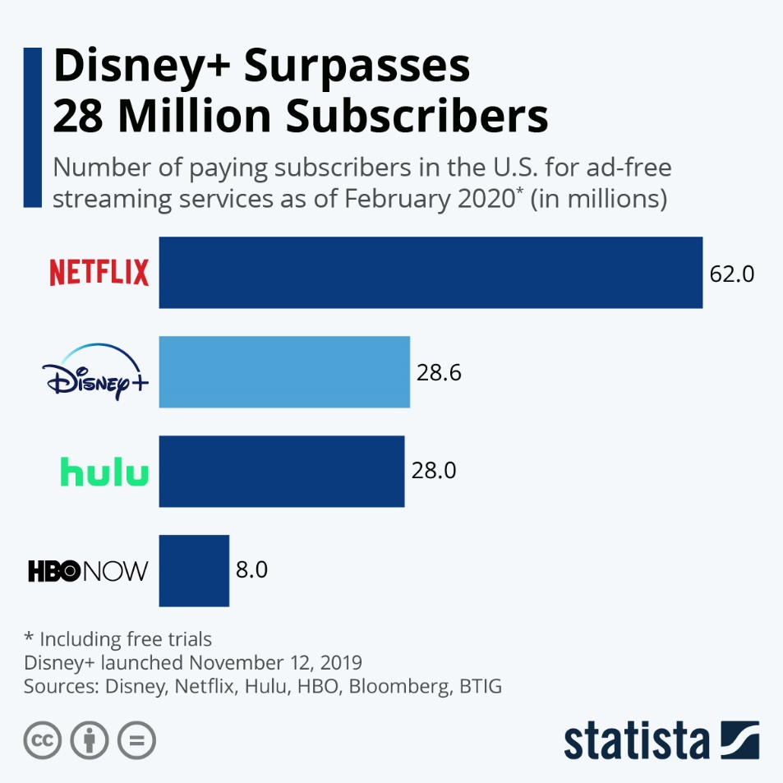

Figure 1 – Here is strategic comparison of Netflix vs. Disney+, especially useful when you apply the 4Ps, 7Ps and STP frameworks (and tie in branding/relationship marketing).

2.2 The 4Ps Analysis

- Product Strategy
Netflix has transformed the meaning of “product” in digital services by shifting focus from tangible goods to experiential and personalised content ecosystems (Kotler et al., 2019). Its use of data analytics for customising viewing recommendations converts user behaviour into continuous service innovation. This aligns with service-dominant logic, in which value is co-created between provider and customer (Vargo & Lusch, 2004). Netflix Originals such as Stranger Things and The Crown function as both entertainment and brand assets — strengthening its market identity as an innovator in storytelling.
Disney+, in contrast, differentiates through brand heritage and portfolio marketing. Its product strategy capitalises on owned franchises — Marvel, Star Wars, Pixar — which serve as emotional anchors for multigenerational audiences (Johnson, 2021). Rather than compete head-to-head on volume, Disney+ emphasises content exclusivity and quality assurance, linking its offering to trust, nostalgia, and family values. This approach applies brand extension theory by transferring parent-brand associations to digital products (Aaker, 2010).
- Price Strategy
Pricing models in the SVOD market reflect value perception, elasticity, and cost structures. Netflix employs market-based pricing that varies regionally according to purchasing power and competition intensity. The recent introduction of an ad-supported tier represents value segmentation, targeting price-sensitive consumers without diluting premium brand positioning (PwC, 2023). Disney+ similarly utilises differentiated pricing, but with an added emphasis on bundling — combining Disney+, Hulu, and ESPN+ to encourage cross-platform consumption (Disney, 2023). Bundling embodies the product line pricing principle (Kotler & Keller, 2016), strengthening perceived value through complementary access.
- Place (Distribution) Strategy
Distribution in digital markets equates to platform accessibility and device integration. Netflix’s early investment in app ubiquity — across smart TVs, mobile devices, and game consoles — established a global standard for seamless accessibility (Gomez-Uribe & Hunt, 2015). Its decentralised cloud-based infrastructure enables fast international rollout. Disney+, benefiting from hindsight, adopted an accelerated global expansion strategy, launching in 60+ countries within three years (Statista, 2024). It utilises vertical integration within the Disney media ecosystem, connecting theme parks, merchandise, and cinematic releases with streaming distribution. This demonstrates channel synergy — a key element of integrated marketing systems (Jobber & Ellis-Chadwick, 2020).

- Promotion Strategy
Netflix relies heavily on digital and data-driven promotion. Algorithmic recommendation acts as implicit marketing communication, supported by social media virality and influencer amplification. Campaigns for Wednesday (2022) and Squid Game (2021) leveraged meme culture and user-generated content, illustrating the transition from push to pull marketing (Kannan & Li, 2017). Disney+, by contrast, exploits its cross-media promotional capabilities: theatrical releases, merchandise, and theme-park experiences serve as synergistic touchpoints. This reflects integrated marketing communication (IMC), aligning multiple channels for consistent brand storytelling (Fill & Turnbull, 2019).

2.3 The 7Ps: Extending the Service Marketing Mix

While the 4Ps explain product-market strategy, the 7Ps illuminate how service delivery supports long-term customer satisfaction.
- People:
Netflix’s workforce culture emphasises autonomy and innovation, documented in its “Freedom and Responsibility” policy (Hastings, 2020). Employees are treated as brand ambassadors for creativity and agility. Disney+, conversely, relies on its legacy service ethos — scripted professionalism, storytelling expertise, and customer care inherited from its entertainment divisions (Disney, 2023).
- Process:
Netflix’s subscription model prioritises frictionless user experience: one-click sign-up, personalised interface, and adaptive streaming. These reflect process excellence as part of service quality (Zeithaml et al., 2018). Disney+ uses a similar digital infrastructure but adds cross-platform continuity — integration with Disney ID accounts linking consumer data across business units.
- Physical Evidence:
In digital services, physical cues translate into interface design and perceived reliability. Netflix’s minimalist user interface and iconic “ta-dum” intro act as sensory brand symbols. Disney+ leverages its cinematic visuals and family-friendly colour palette to evoke reassurance and legacy appeal. Both reinforce brand tangibility in intangible services (Bitner, 1992).

2.4 Segmentation, Targeting, and Positioning (STP)

Netflix’s segmentation strategy is psychographic and behavioural. It targets global consumers seeking convenience, diversity, and personalised entertainment (Smith, 2020). It’s positioning statement — “See what’s next” — encapsulates innovation and discovery, appealing to novelty-seekers. The brand’s differentiation stems from mass customisation, made possible through algorithmic learning.
Disney+ applies demographic and value-based segmentation, focusing on families and nostalgic adults. Its positioning as “The home of Disney magic” emphasises emotional security and brand heritage (Disney, 2023). Unlike Netflix’s individualised approach, Disney+ markets itself as a shared experience — aligning with collective consumption values. Through targeting by identity rather than data patterns, it creates emotional attachment rooted in brand trust.
From a theoretical lens, both strategies represent the value discipline model: Netflix pursues operational excellence and customer intimacy, while Disney+ prioritises product leadership through brand experience (Treacy & Wiersema, 1993).

2.5 Branding and Relationship Marketing

Branding remains central to sustaining customer loyalty in saturated digital markets. Netflix exemplifies a dynamic brand, continuously updated through content and interface innovation. Its investment in original programming reinforces brand authenticity and distinctiveness — essential for maintaining perceived leadership (Keller, 2013). Brand equity is measured through engagement metrics and churn rates rather than traditional awareness.
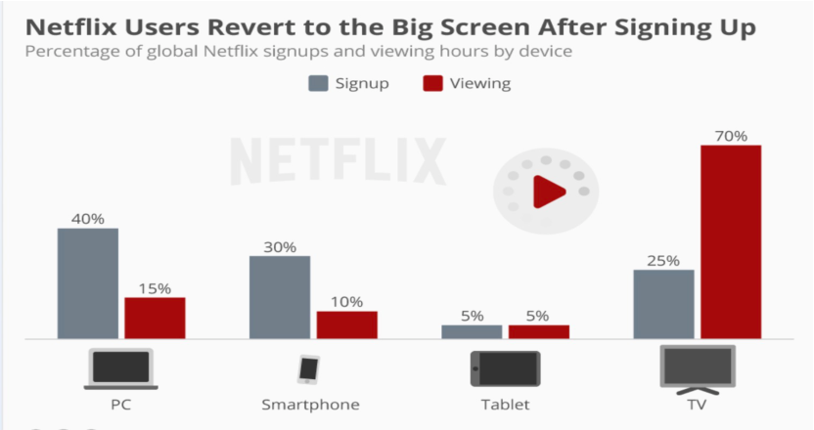
Disney+, on the other hand, inherits immense symbolic brand equity from its parent company. The platform leverages brand architecture by consolidating sub-brands (Marvel, Pixar, and National Geographic) under a single master identity. This approach aligns with corporate brand unification strategy (Hatch & Schultz, 2001). The emotional dimension of Disney+’s branding — built around nostalgia and family bonding — fosters strong affective commitment, a key variable in relationship marketing (Morgan & Hunt, 1994).In relationship-marketing terms, Netflix prioritises technological intimacy — using data to personalise offerings and sustain habit loops (Reinartz et al., 2004). Disney+ focuses on community and cultural connection through shared experiences, fan events, and cross-promotional storytelling. Both utilise CRM analytics, yet their relational philosophies diverge: Netflix is algorithmically empathic, Disney+ emotionally resonant.
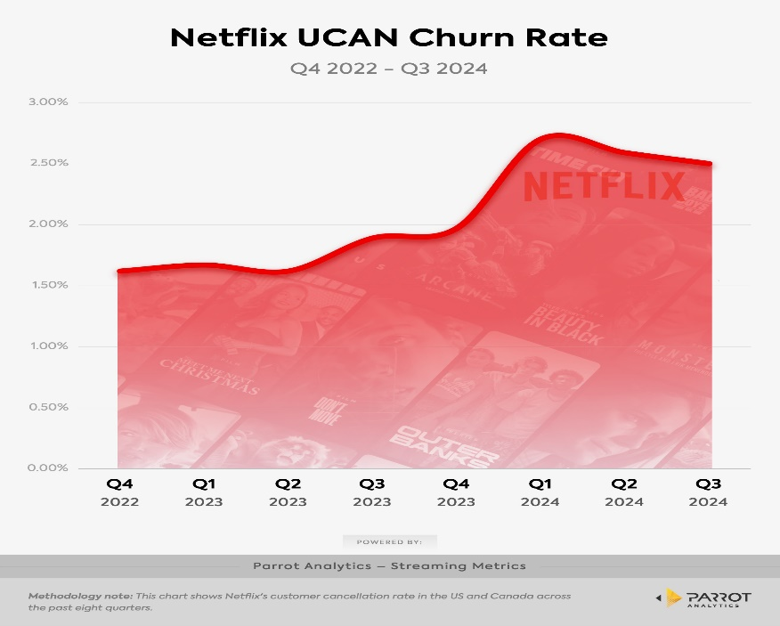

Figure 2 - Netflix – Technological Intimacy, Low Churn
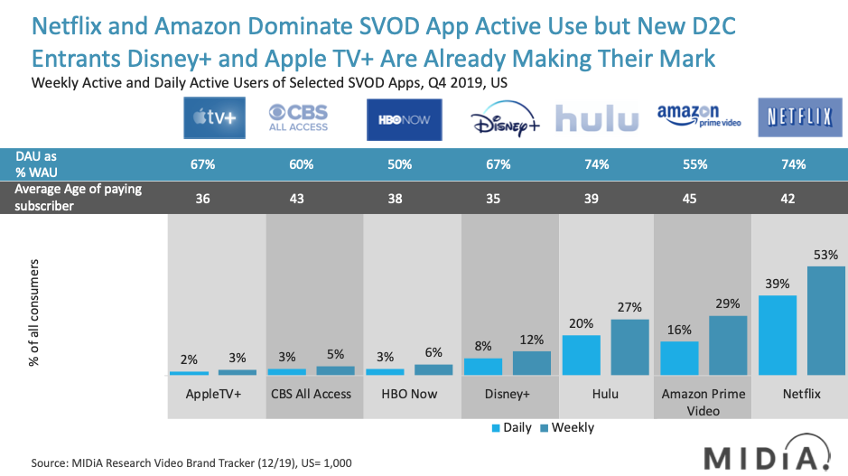
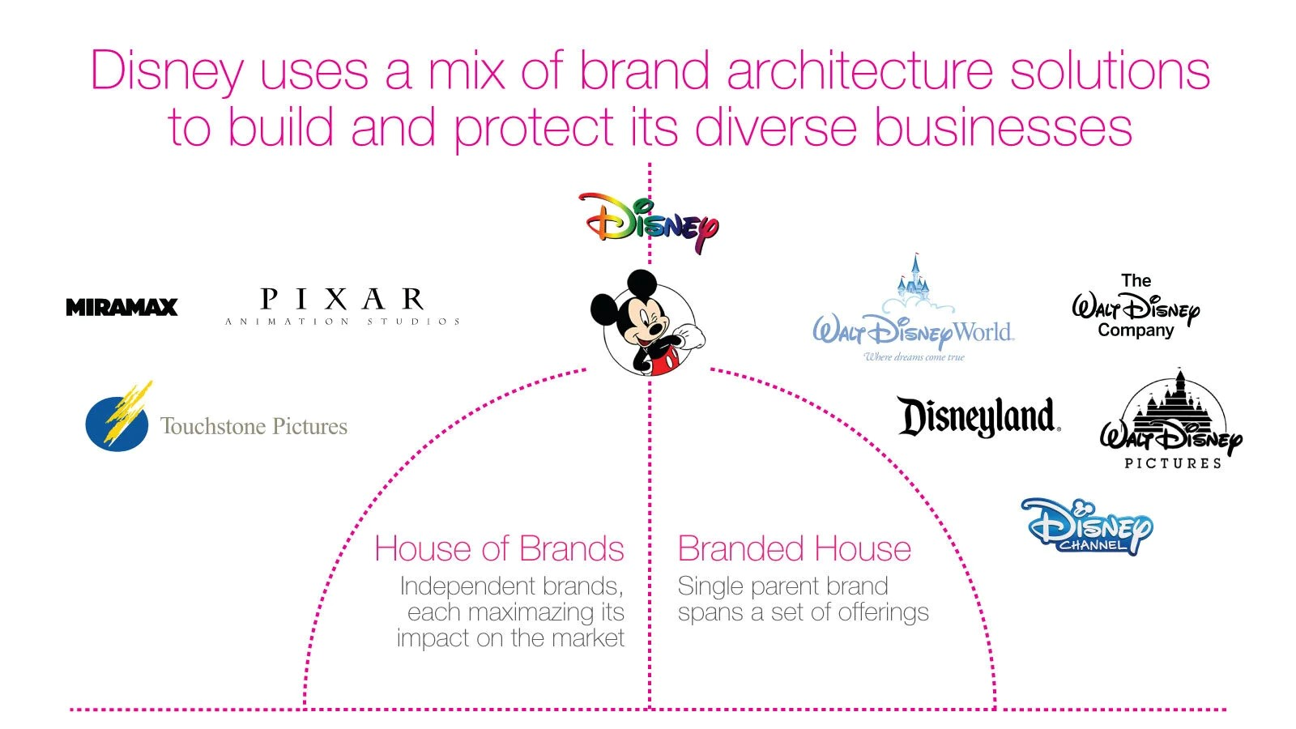

Figure 3 - Disney+ – Brand Equity & Emotional Connection

2.6 Comparative Evaluation: Pioneer vs. Follower Dynamics

The pioneer–follower dichotomy shapes how marketing management strategies evolve. Netflix, as first mover, has reaped advantages in brand awareness, network effects, and learning curves. It set the market’s consumption logic and continues to benefit from economies of experience. However, first-mover status also incurs high R&D costs and exposure to imitation.
Disney+, as a late entrant, adopted a fast-follower adaptation model, drawing on established brand strength and diversified revenue sources. Its marketing success demonstrates strategic timing: waiting for market maturity before leveraging synergistic resources (Lieberman & Montgomery, 1998). In diffusion-of-innovation terms, Netflix corresponds to innovators and early adopters, while Disney+ targets the early majority (Rogers, 2003). Both models co-exist productively — Netflix driving innovation; Disney+ stabilising and mainstreaming it.
From a managerial perspective, the case highlights the importance of strategic ambidexterity — balancing exploration (innovation) with exploitation (brand leverage). Netflix’s data-driven agility sustains novelty, whereas Disney+’s integrated marketing ecosystem sustains trust. Both illustrate that marketing management in the digital era depends on continuous adaptation and brand co-creation with consumers.

Conclusion

The comparative marketing analysis of Netflix and Disney+ demonstrates how pioneers and followers navigate dynamic global markets through distinct yet equally effective approaches to environmental and strategic alignment. The PESTEL and SWOT frameworks revealed that macro-level drivers — technological innovation, regulation, and social trends — compel adaptive marketing behaviour. Netflix converted first-mover challenges into learning advantages through agile innovation, while Disney+ capitalised on brand heritage to achieve rapid scale.
Through the 4Ps, 7Ps, and STP analyses, the report showed that Netflix focuses on personalisation and technological differentiation, whereas Disney+ emphasises brand legacy and cross-media integration. Relationship marketing principles explained how each sustains loyalty — one through algorithmic intimacy, the other through emotional resonance.
Ultimately, both cases affirm that marketing management is not static but iterative: success depends on continuous environmental scanning, dynamic capability development, and authentic value creation. In hypercompetitive digital markets, pioneers innovate to stay relevant, and followers innovate to catch up — yet both rely on coherent marketing strategies aligned with evolving consumer expectations.

Harvard Reference List (with links)

Aaker, D.A. (2010) Building Strong Brands. New York: Free Press.Available-at: https://books.google.co.uk/books?hl=en&lr=&id=OLa_9LePJlYC&oi=fnd&pg=PT14&dq=Aaker,+D.A.+(2010)+Building+Strong+Brands.+New+York:+Free+Press.&ots=sEP7SSdG78&sig=H5loigkmM5WMd0pcoDv_bVtpiCY&redir_esc=y#v=onepage&q&f=false
Bitner, M.J. (1992) ‘Servicescapes: The impact of physical surroundings on customers and employees’, Journal of Marketing, 56(2), pp. 57–71.Available at: https://journals.sagepub.com/doi/10.1177/002224299205600205
Bloomberg (2023) Disney+ Expands Cloud Streaming Infrastructure with AWS Partnership. Available at: https://www.bloomberg.com/uk
Brennen, B.S. (2021) Censorship and Streaming Media: Global Challenges for Netflix. London: Routledge. Available at: https://www.taylorfrancis.com/books/mono/10.4324/9781003122388/qualitative-research-methods-media-studies-bonnie-brennen
Disney (2023) the Walt Disney Company Annual Report 2023.Available at: https://thewaltdisneycompany.com/investor-relations/
European Commission (2022) Audiovisual Media Services Directive (AVMSD) Implementation Report. Available at: https://digital-strategy.ec.europa.eu/en/policies/audiovisual-and-media-services
Gomez-Uribe, C.A. and Hunt, N. (2015) ‘The Netflix recommender system: Algorithms, business value, and innovation’, ACM Transactions on Management Information Systems, 6(4), pp. 1–19.Available at: https://dl.acm.org/doi/10.1145/2843948
Grant, R.M. (2021) Contemporary Strategy Analysis. 11th edn. Hoboken: Wiley. Available-at: https://books.google.co.uk/books?hl=en&lr=&id=TadJEAAAQBAJ&oi=fnd&pg=PR5&dq=Grant,+R.M.+(2021)+Contemporary+Strategy+Analysis.+11th+edn.+Hoboken:+Wiley.&ots=oSY3VKijRb&sig=z6SSfRNywRU1n_4v3DhfzsHhzI0&redir_esc=y#v=onepage&q&f=false
Hastings, R. (2020) No Rules Rules: Netflix and the Culture of Reinvention. London: Virgin Books. Available at: https://books.google.co.uk/books?hl=en&lr=&id=M1XADwAAQBAJ&oi=fnd&pg=PT26&dq=Hastings,+R.+(2020)+No+Rules+Rules:+Netflix+and+the+Culture+of+Reinvention.+London:+Virgin+Books&ots=_0E7egvNBq&sig=3G2vjO3OHSp9sGCDZSmwhXPL6UU&redir_esc=y#v=onepage&q&f=false
Hatch, M.J. and Schultz, M. (2001) ‘Are the strategic stars aligned for your corporate brand?’, Harvard Business Review, 79(2), pp. 128–134.Available at: https://hbr.org/2001/02/are-the-strategic-stars-aligned-for-your-corporate-brand
International Energy Agency (IEA) (2023) Data Centres and Energy Use Report 2023.Available at: https://www.iea.org/reports/data-centres-and-energy
Jenkins, H. (2020) Convergence Culture: Where Old and New Media Collide. 2nd edn. New York: NYU Press. Available at: https://nyupress.org/9780814743072/convergence-culture/
Jobber, D. and Ellis-Chadwick, F. (2020) Principles and Practice of Marketing. 9th edn. Maidenhead: McGraw-Hill Education. Available at: https://books.google.co.uk/books?id=7w6ozQEACAAJ&redir_esc=y
Johnson, D. (2021) Disney, Streaming, and the Future of Media. Oxford: Wiley-Blackwell. Available at: https://www.taylorfrancis.com/books/mono/10.4324/9781315857992/sports-tv-victoria-johnson
Kannan, P.K. and Li, H. (2017) ‘Digital marketing: A framework, review and research agenda’, International Journal of Research in Marketing, 34(1), pp. 22–45.Available at:https://www.sciencedirect.com/science/article/abs/pii/S0167811616301550?via%3Dihub
Keller, K.L. (2013) Strategic Brand Management: Building, Measuring, and Managing Brand Equity. 4th edn. Harlow: Pearson Education. Available at: https://thuvienso.thanglong.edu.vn/handle/TLU/27
Kotler, P. and Keller, K.L. (2016) Marketing Management. 15th edn. Harlow: Pearson Education. Available at: https://www.researchgate.net/profile/Cosmas-Nwankwo/publication/358736828_THE_EVOLUTION_FROM_PRE-ACADEMIC_MARKETING_THOUGHT_TO_THE_NEW_PARADIGM_OF_ENTREPRENEURIAL_MARKETING/links/62125e5deb735c508ae50b1a/THE-EVOLUTION-FROM-PRE-ACADEMIC-MARKETING-THOUGHT-TO-THE-NEW-PARADIGM-OF-ENTREPRENEURIAL-MARKETING.pdf
Lieberman, M.B. and Montgomery, D.B. (1998) ‘First-mover advantages’, Strategic Management Journal, 19(12), pp. 1111–1125.Available at: https://sms.onlinelibrary.wiley.com/doi/10.1002/(SICI)1097-0266(1998120)19:12%3C1111::AID-SMJ21%3E3.0.CO;2-W
Lotz, A. (2021) Media Disrupted: Surviving Pirates, Cannibals, and Streaming Wars. Cambridge, MA: MIT Press.Available at: https://mitpress.mit.edu/9780262046563/media-disrupted/
Morgan, R.M. and Hunt, S.D. (1994) ‘The commitment-trust theory of relationship marketing’, Journal of Marketing, 58(3), pp. 20–38.Available at: https://journals.sagepub.com/doi/10.1177/002224299405800302
Peattie, K. and Crane, A. (2018) ‘Green marketing: Legend, myth, farce or prophesy?’, Qualitative Market Research, 21(2), pp. 216–232.Available at: https://www.emerald.com/qmr/article-abstract/8/4/357/359333/Green-marketing-legend-myth-farce-or-prophesy?redirectedFrom=fulltext
PwC (2023) Global Entertainment & Media Outlook 2023–2027.Available at: https://www.pwc.com/gx/en/industries/tmt/media/outlook.html
Rogers, E.M. (2003) Diffusion of Innovations. 5th edn. New York: Free Press.Available at: https://books.google.co.uk/books?id=9U1K5LjUOwEC&redir_esc=y

