The mechanisms and complexities of the dynamic handling of the competition motorcycle

Ross Hanna P143100

School of Engineering
Motorcycle Dynamics M6X00412
Motorcycle Engineering BEng
10/01/2018

Abstract

The research conducted in this paper concerns the methods of intervention used on a MotoGP motorcycle. Three different interventions have been studied, including, Ignition cut, fuel cut and throttle valve control. Data from a real motorcycle has been analysed using Datron’s 2D WinARace software, and MathWorks Matlab software for data processing. Through this analysis it was possible to gain an insight into how different parameters affect the traction control system and its sub-systems. It has been found that ignition cut is used under acceleration where the front wheel is close to leaving the ground. Fuel cut is predominantly used under braking or in a situation where stability is of high priority. It was not possible to discern if there was a sensor dedicated to throttle valve position, but analysis was able to be carried out on the Idle Control System (ICS) based channels. It was found that ICS is dependent directly on slip value, affected by rear suspension position and clutch pressure. ICS also directly linked to the fuel intervention. Further work on this subject includes dynamical and parametric modelling to discern the full control strategies. Through researching into this subject, similar work of analysis on real race data, has not been found.

Introduction

Before the introduction of control ECU’s by the FIM, (2016), MotoGP bikes had evolved into extremely complex, electronically controlled machines with a hoard of sensors and control system which governed the bikes behaviour. In the current 2018 season, a unified ECU control system is used. This has been implemented by Magneti Marelli but has been, in part, developed by the competing factories, such as Yamaha, Honda and Ducati. In the current rules, a “spec” ECU with pre-developed software has been supplied. The factories inputted towards this development through supplying their own software for controlling certain aspects of the bikes behaviour.
Before the unified software, the MotoGP control systems and algorithms were fully developed by the factories. The systems developed were complicated, but specialised, to control their own bikes. Systems such as traction control (TCS), launch control (LC), Idle Control System (ICS), also known as Engine Brake Control (EBC), and anti -wheelie control (AWS) were all developed by the factory, using their own software and sensors.

Research

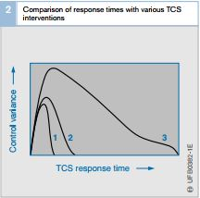
Since the introduction of TCS, there has been ongoing development. Even filtering into MotoGP, developing into a complex electronic system, with many sub-systems, controlling many aspects of the bikes behaviour.
Figure 1 - Comparison of throttle valve and ABS intervention (1), Throttle and ignition intervention (2) and throttle valve only (3) (Bosch, 2007, pp. 103)

Tyre Slip

Tyre slip is a phenomenon that is observed when transmitting torque through a tyre, causing the distance it travels to be less than that of free rolling (Wong, 2001). This is defined by Massaro, Sartori and Lot (2011, pp. 421) in the following equation:

$$К= \frac{ω∙R-V}{V}$$

Equation 1 - (Massaro, Lot and Cossalter, 2011, pp. 18)

Massaro, Lot and Cossalter (2011, pp. 18) derive a formula for the “practical slip” defined in equation 1 which is the slip that is observed, and based on models of a non-compliant tyre. “Instantaneous slip” is the slip which generates the longitudinal force;

$$К_{i}= \frac{\left(ω+ \dot{ξ} \right)R-V}{V}$$
Equation 2 - (Massaro, Lot and Cossalter, 2011, pp.19)
Both formulas have important implications but for this paper, only practical slip will be considered. To evaluate tyre slip, a model must be designed. Multiple tyre models have been put forward as shown in Massaro, Sartori and Lot (2011) & Tanelli, Sartori and Savaresi (2007).

Graphs can be produced using the “magic formula”. This formula is “a single expression that can be used to represent the longitudinal driving or braking force, the lateral force or the moment about the z axis” (Cossalter, 2006, pp. 39). The formulae as stated by are as follows in equations 3, 4 & 5;

$$Y\left(x\right)=y\left(x\right)+ S_{v}$$
Equation 3
$$y\left(x\right)=D∙\sin\left\{∙arctan\left[Bx-E\left(Bx-arctanBx\right)\right]\right\}$$

Equation 4

$$X=x+ S_{h}$$
Equation 5
Nomenclature and equations of other parameters can be found in the appendices section 1. This formula “might be an accurate model for off line simulation”(Li et al., 2015, pp. 714) However, according to Schramm, Hiller and Bardini, (2014) to obtain the values for slip, the wheel velocities must be considered.

There is substantial research based around tyres and their contribution to full vehicle models. For example, Massaro, Lot and Cossalters (2011) work on TCS modelling a compliant tyre and transmission. However, this is outside the scope of this reports research aims.

Traction Control

TCS is used on a MotoGP bike due to the high power of the engines. “This extra power is a source for a new set of problems, because higher acceleration and maximum velocities can compromise motorcycles manoeuvrability and stability” (Biral, Garbin and Lot, 2018, pp. 382). It is recognised that a motorcycle has a relatively high centre of mass causing high load transfer. According to Cossalter (2006) this leads to the normalised load reducing to zero. “TC aims at regulating the slip of the rear tyre using the throttle opening, and/ or the engine spark advance” (Massaro, Lot and Cossalter, 2011, pp.15) .

TCS uses a host of sensors to measure and calculate various parameters that are then used in the associated control systems. Strategies include control of the throttle valves, fuel injectors and ignition system. These can be used independently or in conjunction with each other.

Out of the three control strategies, throttle control is seen as slow reacting, compared to fuel and ignition cut which are much faster. This can be seen in figure 1 where compared is the use of only the throttle valve closing and simultaneous use of throttle vale and ignition adjustment.

It can be concluded from this diagram that the combination of throttle and ignition adjustment is much faster than throttle valve intervention alone.

Fuel delivery changes have a direct effect on the torque delivery. In a TCS, fuel delivery can be either reduced, modulated or cut completely. This will produce different reductions in torque over different time periods and engine speeds.

Anti – Wheelie System (AWS)

The anti-wheelie system is a subsystem of the TCS. Due to the high power of a MotoGP bike a phenomenon known as a “wheelie” is observed. This is when the engines power produces a large enough torque around the rear contact patch that the resultant force vector of the vehicle weight and the acceleration force falls on the outside of the rear contact point;

$$α_{0 wheelie}=Mf_{s}×\frac{L}{H}$$

Equation 6 - (Akitsu, 2012, pp.3)

Launch Control (LC)

Launch control focuses on the initial acceleration at the start of a race. When the clutch is released to accelerate from the start/ finish line in first gear, the torque of the engine, combined with the high transmission ratio of the gearbox, is enough to lift the front wheel from contact with the ground. The acceleration value at which this will happen can be calculated to reasonable accuracy using the following formula:

$$\ddot{x}=g\frac{b}{h}- \frac{F_{D}}{m^{*}}$$
Equation 7
Where;
$$\ddot{x}=Linear Acceleration \left(m/{s^{2}}\right)$$
$$g=Gravitational Acceleration \left(m/{s^{2}}\right)$$
$$b=Horizontal Length From Rear Wheel$$
$Spindle to C.O.G$ (m)
$$h=Vertical Height of C.O.G to Ground (m) \\ F_{D}=Drag Force \left(kg∙m/{s^{2}}\right) \\ m^{* }=Reduced Mass (kg)$$

This formula by Cossalter (2006) uses the geometric properties of the motorcycle (b, h & p) to determine the acceleration limit. Before rule changes in MotoGP, the launch control systems allowed the rider to hold the throttle at 100% and release the clutch as fast as possible, ignoring what effect that it should have on the bike. This was because the launch control had its own inbuilt rev limiter to stop over revving and controlled the power delivered to the rear wheel. This is due to the LC system using the AWS. Due to new rules and software, the rider must modulate the power themselves as the new system from Magneti Marelli does not allow the sophistication of previous, factory-built systems.

Engine Brake Control (EBC)

Following downshifts and during sudden deceleration, inertia in the drivetrain and engine causes a braking force. Bosch (2007) explains when this force, and the subsequent reactive torque, rise beyond a certain level, the tyres will not be able to transfer the resulting loads to the road. To reduce the amount of slip caused by this negative torque, the engine is gently accelerated by opening the throttle valves. This is controlled on a MotoGP system by using the ICS. This system controls one of the two pairs of throttle valves, keeping them slightly open to reduce the negative pressure in the engine. This results in less braking torque, less slip and a greater stability.

Methodology

To fully understand the systems on a MotoGP motorcycle, sensor data was analysed from the Motegi racetrack.
The course was divided into eleven sections, corresponding to each corner. Honda Racing Corporation (2016) recognises Motegi as having fourteen corners, however, eleven corners were used in concurrence with the data. (Figure 2)
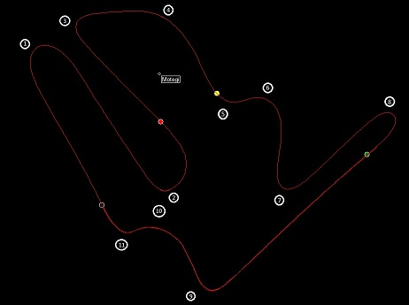
Figure 2- Motegi Twin Ring Corner Sections

The sections were defined as being the area between two points of minimum velocity, with single significant peak between them (Appendices figure 1).
Four sections were chosen from the data of the fastest lap at 1:50.710s. These were corners six, seven, nine and eleven. This gave two open corners and two 90-degree corners. Table 1 illustrates the intervention methods activated.

Corner | Ignition Cut | Fuel Cut | ICS
6 | Yes | No | No
7 | Yes | Yes | Yes
9 | Yes | No | Yes
11 | Yes | Yes | Yes
Table 1
The focus is to determine what parameters trigger the interventions, how the parameter value effects the magnitude of the intervention, what parameters are affected by the interventions and to what degree. To accomplish this, the data analysis programs Matlab and 2D WinARace will be utilised. 2D will measure the data and help with ease of visualisation. Matlab will then be used for any computation required.

Analysis

Section Six
Section six illustrates the use of only ignition cut. Ignition cut was measured up to 13%. Based on the data from the histogram and table in Figure 3 and figure 4, 13% is the highest significant cut, at 0.533%, whereas 21% and 41% cuts account for less than 0.2% of total ignition cuts.
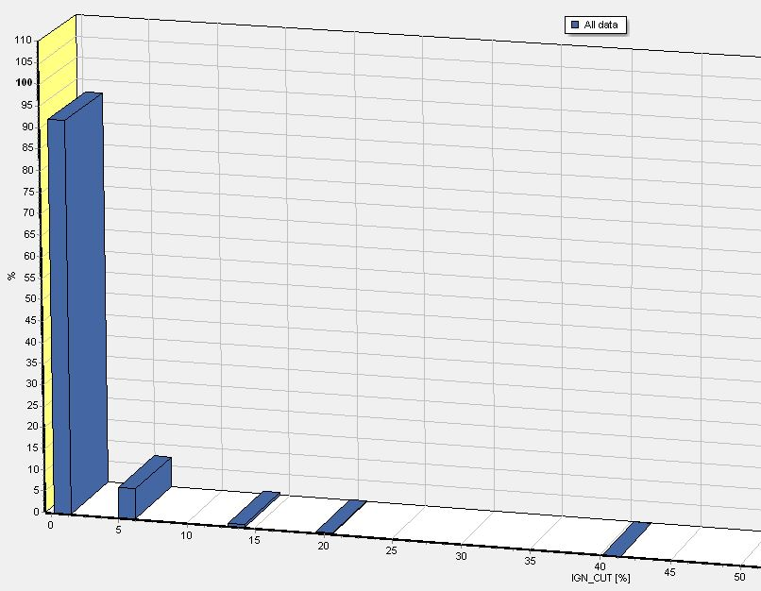
Figure 3 – Histogram of Ignition Cuts Frequency

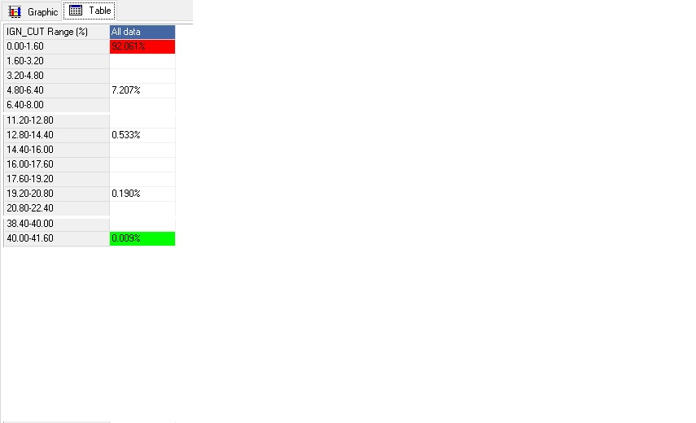
Figure 4 - Table of Ignition Cut Percentages by Time

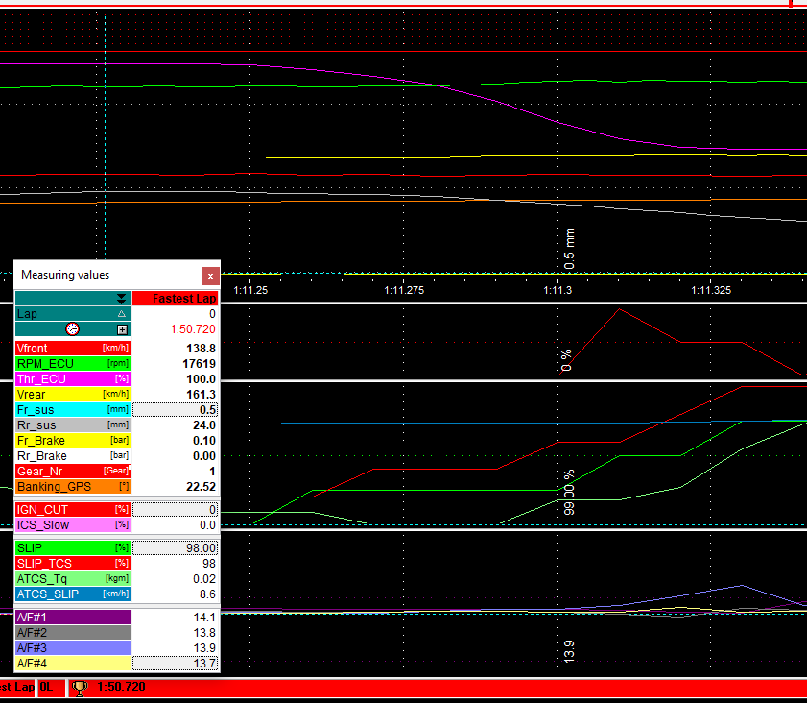
The ignition cut in this instance can be seen when accelerating out of the corner. Figure 2 in the appendices shows the full section data as well as the other chosen sections. It has been observed that when ATCS_Tq increased, slip also increased. There is no direct correlation between the value of slip and ignition cut. However, the peaks of TCS_Torque correspond to initiation of the ignition cut protocol, though only when slip is over 100%.
Figure 5 - 99% Slip and 0% Ignition Cut

Section Seven
The attitude of the motorcycle in section seven is controlled by all three intervention methods.
Ignition cut only occurs on the exit of the corner. The peaks still coincide with ATCS_Torque if slip is over 100%. The spark reduction is more aggressive, with a maximum of 40% reduction at 1:11.31s. This reduction was at 100% slip, with a difference of 19.8 km/h in wheel velocities, and 60% throttle. This data shows that anti-wheelie control is being implemented.
The 40% cut was initiated 0.5s after the previous cut, which started at low fork travel (2.8mm) and a high difference in wheel velocities and slip (23.3 km/h and 110% respectively). The difference in wheel velocities dropped to 18.6 km/h and slip was down to 103%.
V_Sat and V_GPS were considered as methods of validating the velocity of the overall bike, rather than wheel speeds. At the point of interest there was a 4 km/h difference in the two sensors, this was deemed as unreliable.
Fuel delivery was reduced to stabilise the bike for good corner exit. It took 0.68s from beginning to end of the wheelie. Ignition cut took 0.426s to intervene, and 0.558s for fuel cut. Before the ignition cut started, slip was below 100%. When slip reaches 100% ignition cut takes effect. Figures 5 and 6 show adjacent measurements showing a change from 0% ignition cut to 40%, and slip from 99% to 100%.
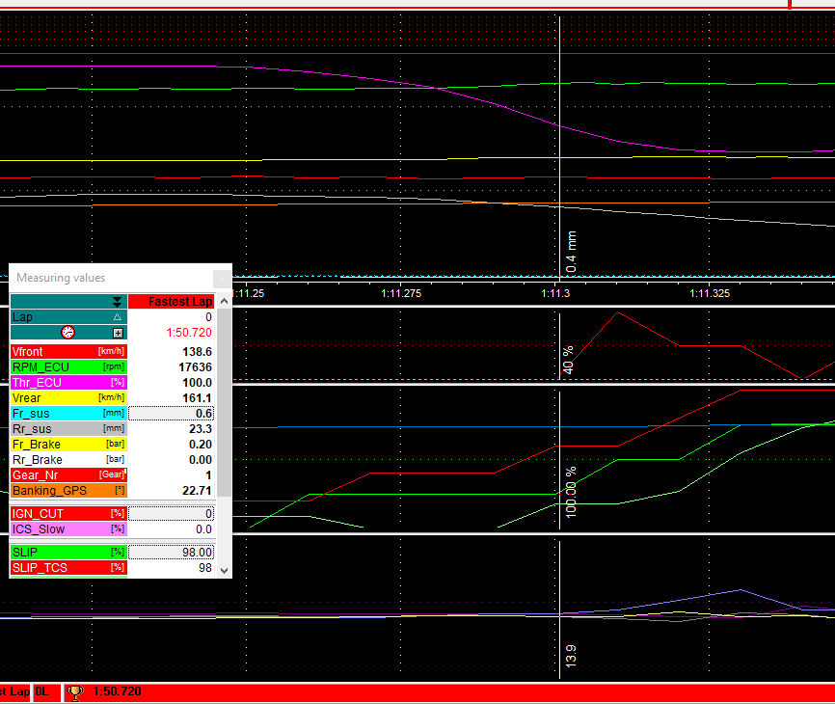
The last intervention seen is ICS. When the throttle reaches 0%, the engine braking causes slip to decrease from 98% to 92%. This causes rear wheel velocity to drop below that of the front wheel. The effective drop in rear wheel velocity is from +28.1 km/h to +12km/h relative to the front wheel. when the front brake is used, slip reduces further to 88%.
Figure 6 - 100% Slip and 40% Ignition Cut
Once the slip has dropped, the ICS opens the throttle valves to reduce the engine braking. When the gear changes from third to second, the ICS increases. At 1:04.50s the ICS_Slow percentage is 7.0%. By 1:04.83s the ICS_Slow value has increased to 14.9%. However, the ICS channel has stayed constant at 12.9%. Looking at the clutch pressure it can be seen that as Clt_Prs decreases, ICS_Slow increases to control the drop in slip (91% to 81%). This is caused by the drop in clutch pressure, and re-engagement of the transmission. This also causes a drop in the rear wheel velocity of 15km/h, giving a difference in wheel velocities of -10.8 km/h. (negative indicative of slower rear velocity). This further decreases to 0.1km/h 0.44s later. Due to this, the ICS_Slow percentage reduces to 6.7% and continues to decrease, producing a slip value of 92%. The ICS_Slow percentage fluctuates around zero for another 0.96s until slip is at 99%, the ICS finally reducing to 0%. This is until triggered by the decrease in slip caused by the release of front brake.
Section Nine
This section is a 90-degree right hand corner. On releasing the throttle, ignition cut is observed, with four peaks of 20%. When the throttle reaches zero, and the slip decreases to 96%, ICS_Slow increases, but only to 1% until the clutch pressure increases. When the clutch is released, ICS_Slow increases to 15.8%. At the same time, slip decreases from 100% to 78%. ICS_Slow stays active until slip reaches 100%. This suggests ICS is directly related to slip values of less than 100%, with the rear suspension travel playing a key role.
Ignition cut is observed, but only briefly and at 6%. Large changes (greater than 16.7) in air to fuel ratio (A/F) are observed, starting at 1:34.44s, where ICS_Slow is still over 0. All four cylinders A/F ratio exceeds 16.7, lasting for 0.20s, then reducing to below 12.7, and then rising to over 16.7 again. This repeats in a consistent waveform for 6 oscillations lasting 2.21 seconds. Over the same period, slip increases to over 100%. However, the slip at the start of the fuel cut sequence was at 96%, rather than the expected 100%. This suggests that the TCS has a degree of predictive qualities.
During acceleration out of the corner, only ignition cut is observed, lasting 0.21s as the throttle reaches 100%.
Section Eleven
The final section is another 90-degree right hand corner. The radius of this corner is 30m compared to 25m of corner nine. It could be expected that the corner speed would be higher, however the mid corner speed is similar.
The ICS is active from the apex of corner ten, as the throttle is closed throughout, excluding a short “blip” up to 18.6%. The magnitude of the intervention from the ICS is lower, compared to the 15.8% of section nine, reaching only 5.0%. The main difference between this section and section nine is that both ICS and fuel cut are active simultaneously, shown in figure 2.4 in the appendices. The peaks in A/F ratio coincide with the drops in ICS control. This shows the control system is modulating both the fuel and ICS to get the best torque reduction to not interfere with the bikes behaviour mid corner.
Both systems are used together as ICS is considered slow acting and fuel cut considered fast acting. The ICS drops before the largest peak in A/F, at the same time the clutch pressure increases as second gear is selected. When the clutch is released, slip drops to 93%, then rises to 97% as ICS and fuel cut occur. Fuel cut continues until the throttle opens to accelerate out of the corner. Ignition cut is utilised when the slip exceeds 110% and the rear wheel is spinning 23.2 km/h faster than the front. Ignition cut reaches 6% on three occasions. This coincides almost perfectly with increases in slip and “velocity difference” channels, while front suspension extends to almost full length.

Discussion
Through analysis of the data, it is possible to gain an insight into the control systems and methods used. For example, ICS is only activated if the slip value is less than 100% and if the rear suspension is close to full extension. It is thought that there is a link between ICS and the difference in wheel velocities, either directly or indirectly. ICS only allows the throttle valves to close if the slip is larger than 100%.
Ignition cut is mainly seen to be used in corner exit. This coincides with the peaks in ATCS_Torque, and is almost perfectly synchronised with increases in slip and the difference in wheel velocities channel. Ignition cut seems to be used to control an impending wheelie, being when the front suspension is approaching zero. Future research could be conducted through dynamic modelling, to
identify links between pitch rate and any interventions, to determine if there is a predictive nature in the systems.
The fuel cut intervention is used on a MotoGP bike to control the bikes attitude. It is not possible to determine exactly how long each injector delivers fuel, and therefore, energy for combustion. A/F ratio sensors give an approximation and show if fuel has been cut to the cylinder. A limit of 2 units of air over stoichiometric is used to see if fuel has been reduced to the cylinder as the A/F ratio varies naturally. Fuel cut is used in a waveform as shown in figure 7.
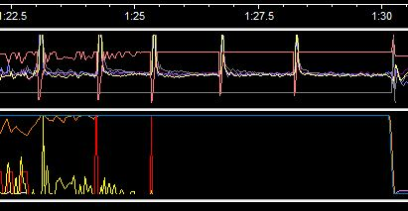
Figure 7 - A/F Ratio Oscillations
If cut for a large time period, this would cause a pitching motion as the load is transferred forwards.

Conclusion
All three of the interventions researched were used on the lap which was analysed. Four sections were selected as they best demonstrated the use of the interventions used on their own and in combination. If all interventions were used together and more aggressively, the reaction time could possibly be faster, using methods similar to the steepest descent algorithm (Weisstein, n.d.) or other methods such as those described by (Li et al., 2015) but could cause instability. A substantial amount of work has gone into developing these systems, whilst being able to retain the bikes controllability. Further work to be undertaken includes using the dynamical equations and multi degree of freedom models such as (Biral, Garbin and Lot, 2002) and (Massaro, Sartori and Lot, 2011) to calculate the theoretical slip and dynamics of the motorcycle. This method allows results to be compared, and refinements made to the input parameters to determine the actual values of data other than those in the spec sheet like below (Figure 8);
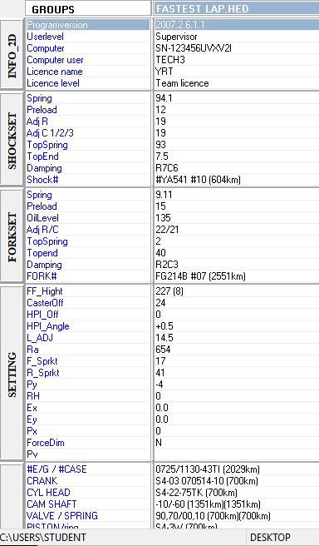
Figure 8 - Spec Sheet Associated with Data Analysed.

And validate the final values before further analysis can be undertaken, such as more research into the algorithms used.

(Bosch, 2007)
(Akitsu, 2012)

References
Akitsu, Y., 2012. Research on Engine Torque Control with Acceleration Performance for MotoGP Class Racing Motorcycles. SAE Technical Papers, [online] 4. Available at: <http://www.scopus.com/inward/record.url?eid=2-s2.0-84881215012&partnerID=tZOtx3y1>.
Biral, F., Garbin, S. and Lot, R., 2002. Enhancing the Performance of High Powered Motorcycles by a Proper Definition of. (724).
Bosch, R., 2007. Safety, Comfort and Convenience Systems. In: Safety, comfort and convenience systems, 3rd ed. Chichester: John Wiley & Sons Ltd, p.404.
Cossalter, V., 2006. Motorcycle Dynamics. Second ed. Morrisville: Lulu.
FIM, 2016. FIM WORLD CHAMPIONSHIP.
Honda Racing Corporation, 2016. Grand Prix of Japan - MotoGP. [online] Available at: <https://motogp.hondaracingcorporation.com/event/grand-prix-of-japan/> [Accessed 13 Jan. 2018].
Li, L., Ran, X., Wu, K., Song, J. and Han, Z., 2015. A novel fuzzy logic correctional algorithm for traction control systems on uneven low-friction road conditions. Vehicle System Dynamics, [online] 53(6), pp.711–733. Available at: <https://doi.org/10.1080/00423114.2015.1012212>.
Massaro, M., Lot, R. and Cossalter, V., 2011. On engine-to-slip modelling for motorcycle traction control design. Proceedings of the Institution of Mechanical Engineers, Part D: Journal of Automobile Engineering, 225(1), pp.15–27.
Massaro, M., Sartori, R. and Lot, R., 2011. Numerical investigation of engine-to-slip dynamics for motorcycle traction control applications. Vehicle System Dynamics, 49(3), pp.419–432.
Schramm, D., Hiller, M. and Bardini, R., 2014. Vehicle dynamics: Modeling and simulation. Vehicle Dynamics: Modeling and Simulation, 9783540360, pp.1–405.
Tanelli, M., Sartori, R. and Savaresi, S.M., 2007. Sliding mode slip-deceleration control for brake-by-wire control systems. IFAC Proceedings Volumes (IFAC-PapersOnline), 5(PART 1), pp.135–142.
Weisstein, E.W., n.d. Method of Steepest Descent. [online] Available at: <http://mathworld.wolfram.com/MethodofSteepestDescent.html> [Accessed 17 Jan. 2018].
Wong, J.Y., 2001. Chapter 1 MECHANICS OF PNEUMATIC TIRES. In: Theory of Ground Vehicles, 4th ed. [online] Wiley. Available at: <http://media.wiley.com/product_data/excerpt/19/04713546/0471354619.pdf>.

Appendices

Section One

Parameter D – represents the peak value and depends on the vertical load
Parameter C – Controls the asymptotic value assumed by the curve as the slip tends towards infinity, and determines the form of the slip curve.
Parameter B – determines the slope of the curve from the origin
Parameter E – characterises the curvature near the peak, and determines the position of the peak itself

Section Two

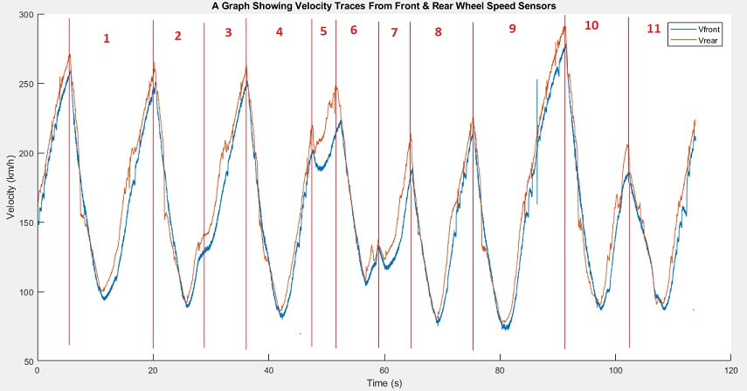
Figure 1.1 – Vfront and Vrear trace for fastest lap. Broken into sections to define corners.

Section Three
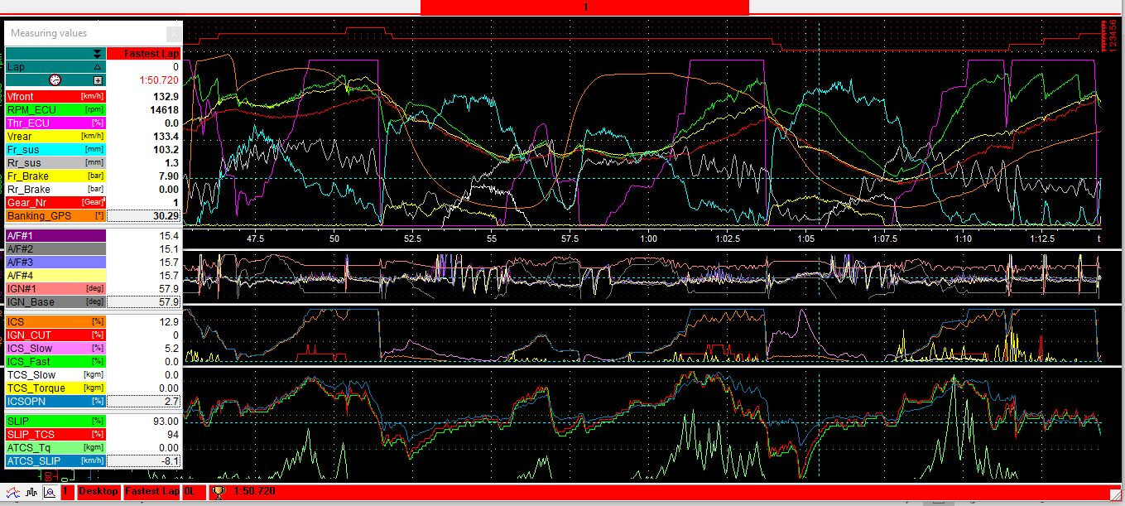
Figure 2.1 – Section Six Data with Key for Colours of Each Channel.

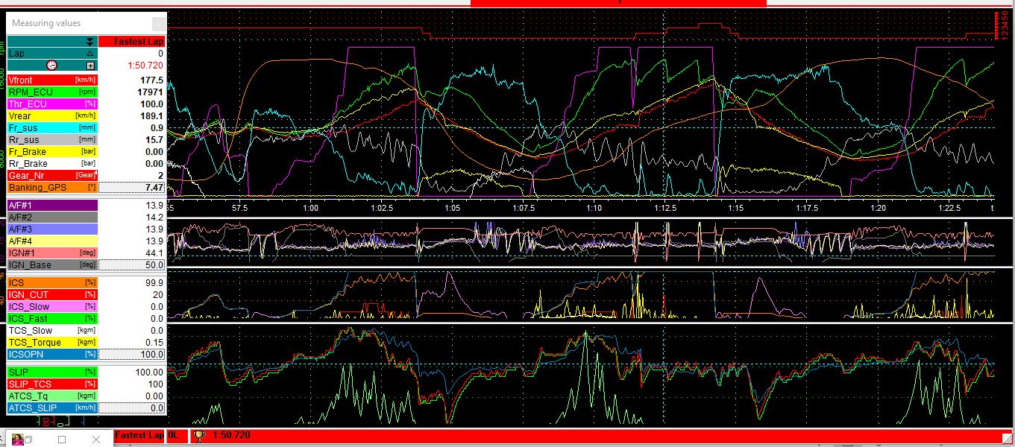
Figure 2.2 – Section Seven Data with Key for Colours of Each Channel.

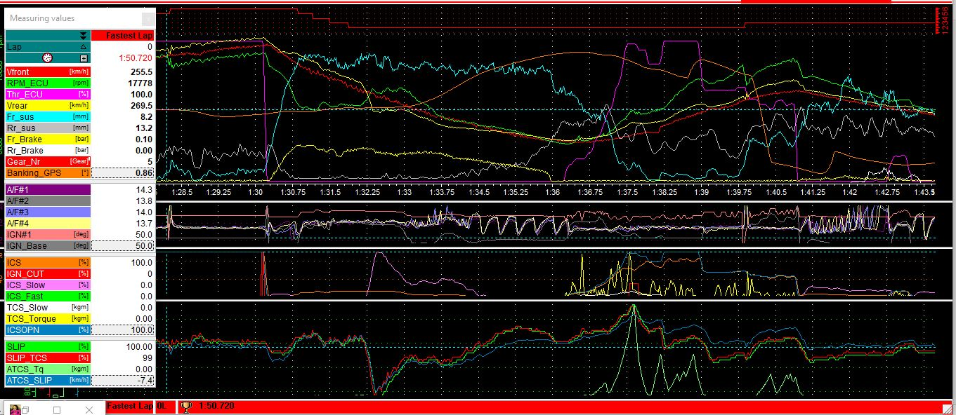
Figure 2.3 – Section Nine Data with Key for Colours of Each Channel.
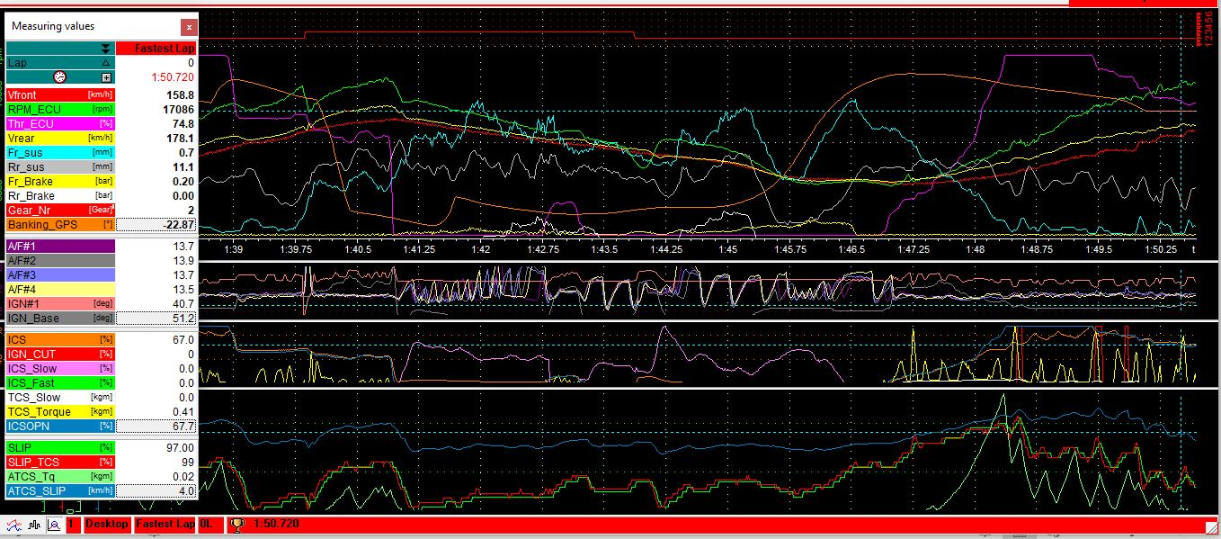
Figure 2.4 – Section Eleven Data with Key for Colours of Each Channel.

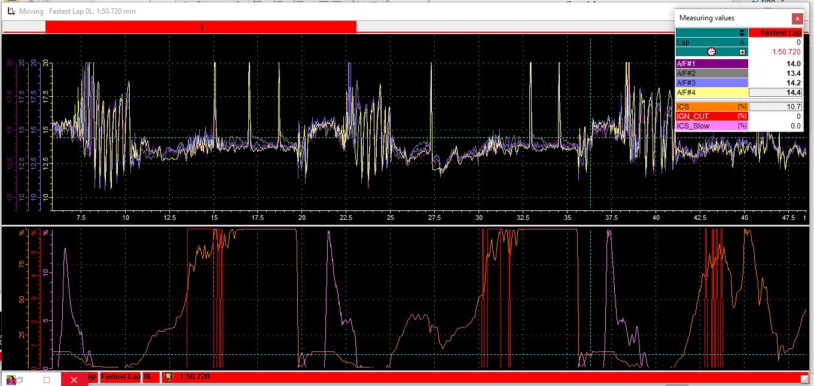
Figure 2 – A/F Ratio for Cylinders 1 – 4, with ignition cut and ICS_Slow Shown in the Lower Section.

