

Student name: | Abdullah Al Toha | Student ID number: | 2513613
Programme: | Applied Computing (Foundation)
Module: | Analysing & Solving Problems
Module code: | ACCA4019
Lecturer: |  | Internal Verifier: | Suresh Shanmugasundaram
Assignment Title: | Component 2: Written assessment: Problem Analysis and Solution Development | Word count: | 2000
Submission deadline: | 11/08/2026

Table of Contents

Deconstruct the Problem 3
Propose a Solution 5
Reflect and Justify 11
References 13

Deconstruct the Problem
The basic use case is college computing students who have recurring meetings for a group project, which are continually disrupted by asynchronous constraints. Service demands for some students who work part-time, combined with differing class schedules and personal commitments, cause delays in submissions and an imbalanced workload. To tackle this systematically, the problem is broken down into interconnected parts, in a systems-thinking way, considering the group of individuals as a social-technical system, instead of several individuals in isolation [1].
These are essentially as follows: (1) Personal availability profiles, (2) collective availability overlap of free slots, (3) Time closeness to weekly deliverables, and (4) Equity in participation. Feedback loops exist with these components, and as meetings are missed, the residual became higher, leading to further unavailability, hence further schedule conflicts.
Key requirements and constraints are prioritised with the MoSCoW technique [2].
Must have: At least once per week, all members need to attend a common free interval before the interval of the corresponding weekly project; must work on actual, heterogeneous schedules provided by students.
Should-have: Residual conflicts minimised (might include letting a member rearrange paid work/travel due to a meeting); clear who is in attendance and contributing, and be aware early if workload imbalance.
Could have: Times prioritised based on preference; reminders can be automated; simple visualisation of cumulative participation.
Won't-have: With external employment systems, full calendar synchronization, task allocation by using AI, integration of real-time video conference.
The priorities guarantee that the solution will remain as on-point as possible with the 3 stated objectives without going beyond the typical student project timeframe [3].
The following variables are relevant and have to be recorded and/or worked with:
– Ai,t A_{i,t} Ai,t – Binary or graded availability matrix, each student i i i of discrete time slots t t t.
Each week's target should be given a hard deadline date, which should be located right after the period w w w.
Associates make up a n n n group with a minimum quorum of n.
Soft preference weights that represent the between soft versus academic flexibility rigidities.
There are cumulative participation counters which are used as equity indicators.
These constraints form a constrained set-covering / allocation-optimisation problem (Nemhauser & Wolsey, 1988) whose feasible region is the intersection of individual free intervals, which also have to be followed by Dw D_w Dw. The next design phase can use well-known combinatorial techniques without any scope creep and without being under-specified due to the specific components that were enumerated, decision variables, and MoSCoW priorities.

Propose a Solution
A proposal for a structured, constraint-based process for group meeting scheduling is presented, which is a blend of systems thinking and constraint-based practice about how to squeeze a resource. A constrained set-intersection is seen in the scheduling problem. The process can be completed manually (with the use of a shared digital calendar and a simple decision template) or semi-automatically (using a lightweight spreadsheet or a free web form). The logical flow can be summarized with the following flowchart description, which can be drawn as a traditional process diagram using diamond decision diamonds, rectangle process boxes, and arrows for flow [4].
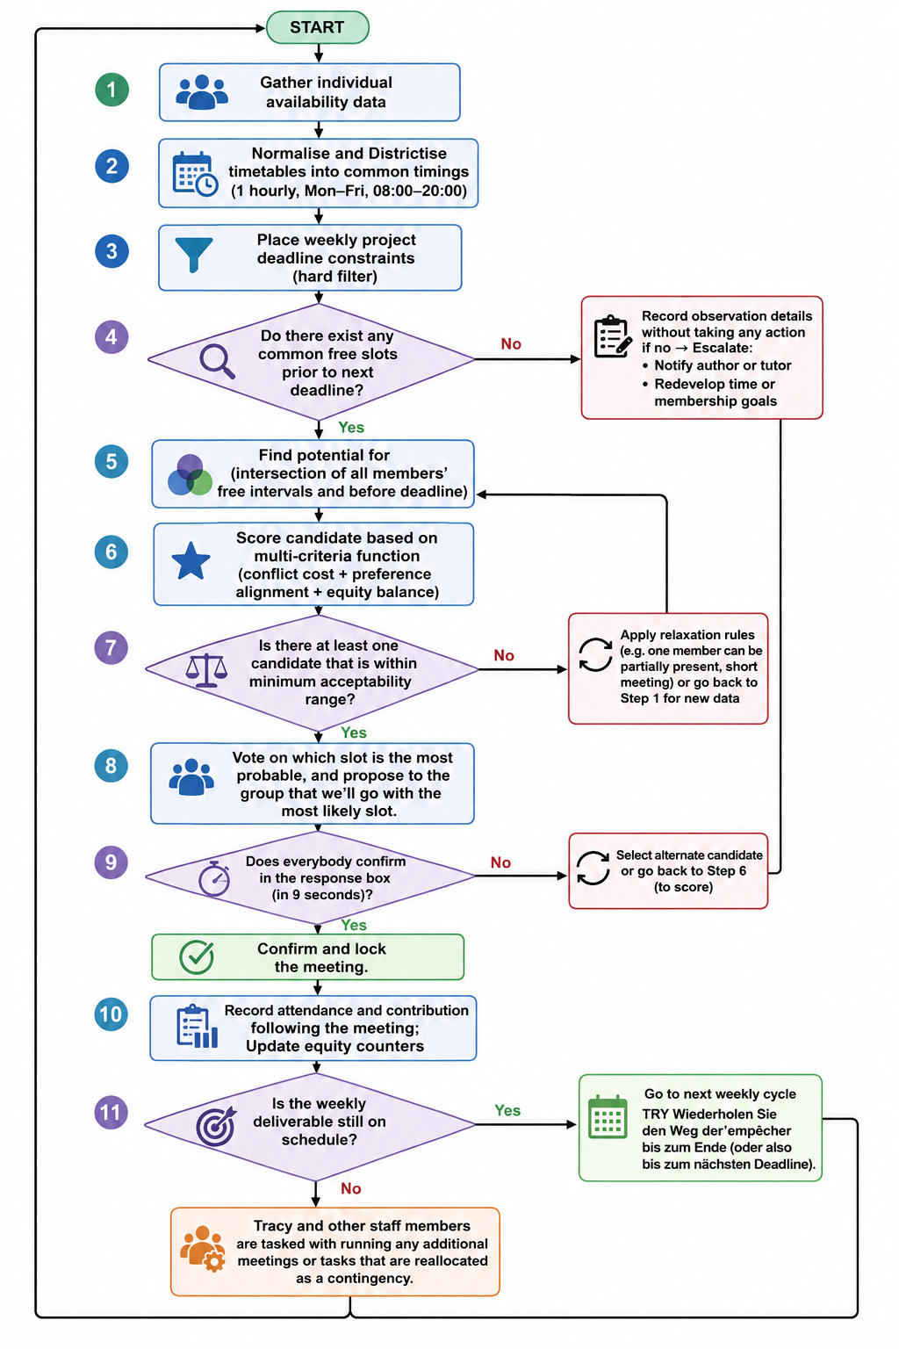Figure: flowchart outline
The diagram in the Practice will be viewed as a flowchart outline (Logical Steps).
1. Starts from the beginning and gathers individual availability data
2. Process: Normalise and Districtise timetables into common timings (such as 1 hourly, Mon-Fri from 08:00 to 20:00)
3. Process: Place weekly project deadline constraints (hard filter)
4. Decision: Do there exist any common free slots prior to next deadline?
Record observation details without taking any action if no → Escalate: notify author or tutor / redevelop time or membership goals
o Yes → Proceed
5. Find potential for 5th step (intersection of all members' free intervals and before deadline)
6. Process: score candidate based on simple multi-criteria function (conflict cost + preference alignment + equity balance)
7. Decision: Is there at least one candidate that is within minimum acceptability range?
o No → Apply relaxation rules (eg. one member can be partially present, short meeting) or go back to step 1 for new data
o Yes → Proceed
8. Process: vote on which slot is the most probable, and propose to the group that you'll go with the most likely slot.
9. Does everybody confirm in the response box (in 9 seconds)?
o No → Select alternate candidate or go back to score
o Yes → Confirm and lock the meeting.
10. Process: Record attendance and contribution following the meeting; Update equity counters
Decision: 11 - Is the weekly deliverable still on schedule?
Tracy and other staff members are tasked with running any additional meetings or tasks that are reallocated as a contingency.
o Yes -> Go to next weekly cycle
TRY Wiederholen Sie den Weg der’empêcher bis zum Ende (oder also bis zum nächsten Deadline).
This flowchart is representative of a closed loop control structure, which is typical of systems thinking [5]. The availability model is continually updated with feedback derived from attendance and progress data and does not allow hidden workload imbalances to build up.

A detailed explanation of the solution is given below:
The first step in the solution is to concisely organize the data. Members of the group will provide a weekly availability matrix for the following 7-14 days indicating their availability, constrained (such as a part-time job which can be moved with notice) and blocked times [5]. This also creates a common temporal grid by discretising these inputs at uniform time instances. As temporal upper bounds, hard constraints (weekly project deadlines) are applied; any slot whose start time is later than the project's current deadline is removed. This step meets the third project objective – meet deadlines before – by construction [5].

The main and key calculation is the intersection of free intervals for all members. Mathematically, this is the set.
S=⋂i=1nFi∩{t∣t<Dw}S = \bigcap_{i=1}^{n} F_i \cap \{ t \mid t < D_w \}S=i=1⋂n​Fi​∩{t∣t<Dw​}
Free Set For i in the member: Fi F_i Fi and the deadline for week w: Dw D_w Dw. If S is non-empty, then there is a feasible region. It never forces an inappropriate meeting for the sake of protecting the integrity of the school schedule or the well-being of the student, and the process escalates if there is no S S S.
A lightweight multi-attribute utility function is used to evaluate a candidate's station map, operationalising the second objective (minimise timetable conflicts), within S S S. Common criteria for scoring are:
Conflicts: increased fee for situations where a member has to move away or do paid work to maintain slots.
• Preference alignment: bonuses are given to the slot engaged in preference alignment.
Equity balance: (is to encourage times that are not continually excluding the same member.
The scoring method is inspired by the classical allocation-optimisation ideas [6] and is easily understood and computed by the student. The slot with the highest score that is above an acceptability threshold is proposed. Confirmation moves through time; if it doesn't happen or if it happens explicitly, the next person is confirmed, or there has been a controlled relaxation, for example where one person is confirmed for the first 30 minutes, then released after that. If confirmed, the meeting is added to a shared calendar.
Attendance and notes on the brief contribution are recorded after each meeting. These data are used to input into an equity counter, which will bring imbalances to the surface early enough, giving the group the chance to redistribute work before resentment starts to set in or "free riding" goes on. All these steps continue to be repeated each week on the schedule – a pattern that makes it seemingly predictable, rhythmic, and lowers the mental drain of constantly having to negotiate ad hoc.
Key Decision Points
The flow has 4 dominating decision nodes. The first (common slots before deadline) could be a hard feasibility gate. The second (acceptability threshold): This is controlled flexibility and doesn't give up on the feasibility requirement. The third (group confirmation) protects autonomy, and informally asserted limitations of the availability information are brought to light. The fourth (progress check) connects scheduling to project outcome - focusing the process on the project itself rather than on scheduling.
Assumptions
There are a number of assumptions underlying the design. First, members will provide availability data that are reasonably accurate and up to date, not optimisation problems because of systematic underreporting. Second, the group size is small (ranging from 3 to 6), and it is still feasible to list the intersections. Third, students have the basic digital-literacy skills needed to share a calendar or spreadsheet. Thirdly, the weekly deadline is assumed to be fixed and known in advance, as in most of the designs for computing-course projects.
The Approach reflects the three objectives
The explicit intersection step and the hard deadline filter ensure that there are suitable meeting times for all members, without proposing a meeting time that one of the members is not free to attend and before the deliverable. The multi-criteria scoring function clearly favours slots that cause the least amount of disruption, and the equity counters discouraged repeatedly loading the same individuals, are both reducing the likelihood of timetable problems. The closed loop structure drives towards efficient project deadlines meetings have to meet relatively early enough to ensure remaining working time, attendance has to be monitored, and contingencies have to be activated when there is too little progress.
Those MoSCoW priorities that have been identified in the problem-deconstruction process (must-have common slots before deadlines, should-have conflict minimisation) are embedded into the process, which leads to a tight scope. Systems thinking requires that all local scheduling decisions be continuously assessed against the big picture goal of equitable and timely completion of the project. This leads to a systematic, reusable, and educationally validated procedure for structuring an unstructured social problem into a well-formulated constraint satisfaction problem.

Reflect and Justify
Several complementary problem-solving techniques were deliberately used in the solution development process. The trick is to get beyond the superficial symptoms of missed meetings and late submissions and to restate the problem as a constrained multi-agent scheduling problem, and to abstract the underlying structure of the problem, in such a way that the structure does not depend on the personalities or contents of any specific group of agents or course. This abstraction allowed subsequent use of formal concepts like intersection of sets and multi-criteria scoring, without being bothered by idiosyncratic details.
Decomposition (subdivision) next isolated the complete social situation into smaller pieces – individual availability matrices, hard deadline filters, candidate generation, scoring, confirmation and feedback – and these were designed and analysed independently, before being re-assembled. The MoSCoW prioritisation technique helped to maintain focus on the design and meant that the design was not so focused on the secondary features as it was on the three that were mandatory. The overarching perspective provided was from systems thinking; that the group is a dynamic socio-technological system, with feedback loops among attendance, workload equity and future availability [7]. Finally, part of the allocation optimisation was used as input for the candidate-scoring step, using classical concepts of feasible-region search and multi-attribute utility.
These techniques can be used for a number of reasons. The challenge is a dual problem of both combinatorics, as these free slots have to be found in common, and social issues, as they have to be handled with equity and commitment. Technical optimisation alone would not take into account the human element that results in data about schedules being incomplete or outdated; facilitative approaches alone would not provide the rigor to ensure that sessions take place before deadlines. A hybrid approach is therefore introduced as being congruent with the hybrid nature of the problem. Decomposition and MoSCoW make the solution manageable for students not specializing in operations research, and systems thinking and abstract modelling allow it to be scaled to a variety of group sizes and timetables typical of computing courses.
However, there are a number of assumptions and definite limitations in the approach. It assumes that students will provide reasonably accurate data and availability that are timely and in good faith (which can't be dealt with algorithmically and should be dealt with socially). It also assumes that the group size is small (usually 3 to 6 members), and that an exhaustive search of the intersection can thus still be performed; larger groups necessitate heuristic search methods that are not discussed here [8]. There is implicit, but not explicit, a willingness of the institutions to accept some deviation from the exact time if they cannot be met at all. The scoring function, though completely understandable and made simple for the purpose, is, however, a function that cannot take into account nuanced differences in preference and the cultural consideration for the timeliness of a meeting. Lastly, the solution only tackles the scheduling layer, and other bonding issues related to the problem, such as free-riding, unequal skills distribution and/or interpersonal conflicts, are not part of the current solution, but would need to be complemented with pedagogical intervention.
To sum up, they offer a plausible and coherent answer to the aims set out in the statement, but sacrifice completeness to make them understandable and manageable in a student-project dimension.

References List

[1] P. M. Senge, The Fifth Discipline: The Art and Practice of the Learning Organization, rev. ed. New York, NY, USA: Doubleday, 2006.
[2] International Institute of Business Analysis, A Guide to the Business Analysis Body of Knowledge (BABOK Guide), 3rd ed. Toronto, ON, Canada: International Institute of Business Analysis, 2015.
[3] G. L. Nemhauser and L. A. Wolsey, Integer and Combinatorial Optimization. New York, NY, USA: John Wiley & Sons, 1988.
[4] P. B. Checkland, Systems Thinking, Systems Practice. Chichester, U.K.: John Wiley & Sons, 1981.
[5] G. L. Nemhauser and L. A. Wolsey, Integer and Combinatorial Optimization. New York, NY, USA: John Wiley & Sons, 1988.
[6] R. L. Keeney and H. Raiffa, Decisions with Multiple Objectives: Preferences and Value Tradeoffs. New York, NY, USA: John Wiley & Sons, 1976.
[7] H. A. Taha, Operations Research: An Introduction, 10th ed. Upper Saddle River, NJ, USA: Pearson, 2017.
[8] Project Management Institute, A Guide to the Project Management Body of Knowledge (PMBOK Guide), 7th ed. Newtown Square, PA, USA: Project Management Institute, 2021.

