Professional Career Development in Health and Social Care (LCHS 4009)

ASSIGNMENT 2

Name of Student: MARIE SIDIME

I.D. Number: 2441955

Name of Tutor: ODETTE JACK

Acknowledgement of AI use: I confirm that I have not used AI to complete my work. (IF YES, ALSO WRITE I USED THIS SOURCE……. GIVE REFERENCE SUCH AS GRAMMARLY FOR EXAMPLE……TO………PROOFREAD FOR EXAMPLE).

Table of Contents

Introduction ………………………………………………….3

What is a portfolio…………………………………………….3
- Finding a job in Health and Social Care………….…………….3
- Curriculum Vitae (CV)……………………..………………..4, 5
- Personal Statement ……………………………………...……...6
- SWOT analysis………………………………………………7, 8
- Personal Development Plan (PDP)……………………………..9
- Gibbs Reflective Cycle……………………………………10, 11
- References……………………………………………………..12

Practical Portfolio
Introduction: A portfolio is an organized collection of documents that demonstrates an individual's achievements, skills, experiences, and personal development, which helps educators and employers to identify whether a person is suitable to practice or qualify to work collaboratively through the review of a Curriculum Vitae, personal statement, and reflective accounts that support competence development and professional growth in practice-based disciplines(Oermann, De Gagne and Philips,2022). In this portfolio, I will demonstrate my suitability for an adult nurse position by including my Curriculum Vitae (CV), a personal statement tailored to the role, and a SWOT analysis with a personal development plan. I will also analyse a reflection cycle using Gibbs’s reflective model (GIBBS, 1988). This reflection analyses a class presentation I delivered during week six of the Professional Career Development module.

Task 1 of 4
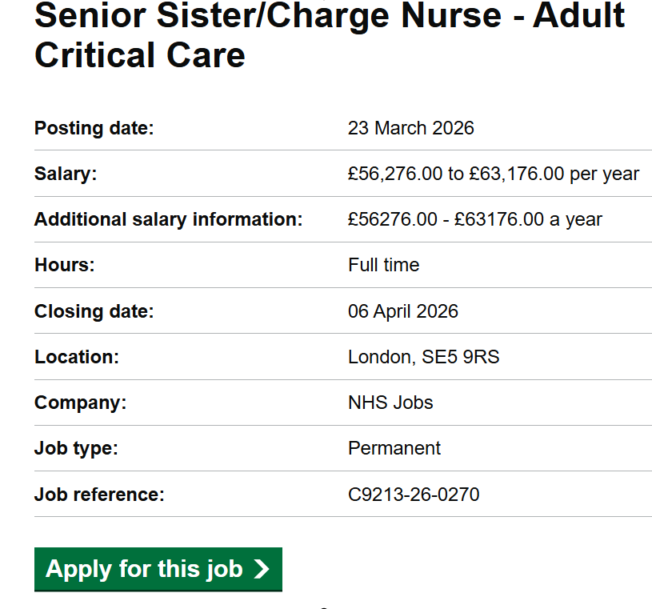

Curriculum Vitae
Name: MARIE SIDIME
Phone: 07474002827
Email: sidimemarie@hotmail.fr

Personal Profile
I am a self-motivated and compassionate individual currently studying Health and Social Care at the University of Wales Trinity Saint David. I have a strong interest in supporting vulnerable people in maintaining their well-being, dignity, and treatment. I have experience working as part of a team as a healthcare assistant, collaborating with colleagues and professionals, and building trusting relationships with patients through my effective communication skills and desire to create a safe environment where patients are valued, respected, listened to, and supported, which is required in my future career as an adult nurse.

Education and Qualifications
University of Wales Trinity Saint David (UWTSD)
BSc (Hons) Health and Social Care
June 2025 - Present

London Academy of Management and Sciences (LAMS)
BSc (Hons) Business Administration
February 2011 - June 2016

English Language Degree for Teaching at the University of General Lansana Conte,
Teaching/ Education
Conakry, Guinea
October 2005 – September 2009

College of Social Science
Baccalaureate 2
Saint George, Conakry -Guinea
October 2003 - June 2005

Work Experience
July 2023 – Present: Crew Member, McDonald’s Restaurant Ltd.
Duties & Responsibilities:
- Welcome customers and create a friendly environment
- Accurately takes customers' orders
- Prepare and serve the food according to McDonald's food handling procedures
- Work effectively with colleagues to ensure efficient customer service

September 2023 – Present: Support Care Worker, J.C. Michael Groups Ltd, Care Agency
Duties & Responsibilities:
- Providing personal care such as washing, dressing, and oral hygiene
- Supporting service users with their daily activities, such as mobility and social interaction
- Administering medication
- Meal preparation and feeding

September 2018 – May 2023: Support Care Worker, Calculated Care Agency
Duties & Responsibilities:

- Provide personal care to patients, including washing, dressing, and dental care
- Assisting them in interacting with the community and friends
- Monitoring their health and documenting any abnormal changes to their routines
- Build positive relationships with patients and provide emotional support to them
and families if needed.
- Support patients with meals and hydration

Training and Certificates
Care Certificate Standard (2023)
Moving and Handling Training (2023)
First Aids Training (2024)
Customer Care Workshop Programme (2024)

Key Skills
- Effective Communication and Listening Skills
- Empathy and Compassion
- Problem-solving ability and decision -making
- Teamwork and cooperation
- Multitasking
- Understanding of safeguarding and confidentiality
- Ability to remain calm in challenging situations
- IT skills (Microsoft Word, Email, PowerPoint)

Interest and Hobbies
I enjoy volunteering in the community during the festival season and providing companionship to elderly people and veterans. I also enjoy reading science and medical books. I enjoy going out with friends and family, travelling to different countries, meeting a variety of people, and developing my communication skills and knowledge.

References
Available upon request

Task 2 of 4
Personal Statement
I am currently studying for a BSc in Health and Social Care, and I am passionate about working in a role that allows me to support individuals and communities in making a meaningful difference in their lives. This motivation has inspired me to pursue a career in the health and social care sector, with the long-term aim of becoming an Adult Nurse. I am particularly drawn to this field because it plays a vital role in supporting individuals who may be vulnerable, unwell, or in need of assistance with their daily lives. My goal is to work in a role where I can provide compassionate care, emotional support, and encouragement while promoting dignity, independence, and well-being.
Studying Health and Social Care has provided me with a strong foundation in the principles, values, and responsibilities required in healthcare settings. Through my coursework, I have gained knowledge of safeguarding, person-centred care, communication strategies, equality and diversity, and the importance of maintaining professional boundaries. These topics are essential in ensuring that individuals receive safe, respectful, and appropriate care regardless of their background or personal circumstances. My studies have also enhanced my understanding of the challenges people face due to illness, disability, ageing, or social factors, strengthening my commitment to supporting individuals compassionately and respectfully.

One of my key strengths is my ability to communicate effectively with others. Communication is essential in health and social care, as professionals need to understand the needs and work closely with colleagues, families, and other professionals. I can listen attentively, respond sensitively, and adapt my communication style to meet the needs of different individuals. This skill will be invaluable in adult nursing, where effective communication supports safe practice, builds trust, and improves the quality of care.
I also see empathy and patience among my strongest qualities. I know that individuals needing care can sometimes feel vulnerable, anxious, or frustrated. Being patient and understanding helps me provide emotional support and fosters a caring environment. I am also confident working within a multidisciplinary team. Health and social care professionals must collaborate effectively to ensure that individuals receive the best possible support and treatments, and I am a dependable, responsible person, always willing to learn from others.

Throughout my studies, I have developed strong organizational skills that enable me to manage tasks effectively and maintain high standards of care. Adult Nursing presents significant challenges, and the ability to prioritize tasks is essential to ensure safety and consistency. I believe my academic knowledge and commitment to supporting others would enable me to make a positive contribution to the growth of a healthcare organization. Adult Nursing is a challenging responsibility, but I am determined to keep learning, practicing, and developing my professional skills to build the knowledge and experience needed to pursue a successful career as an adult nurse and contribute to patient safety and well-being.

Task 3 of 4
SWOT Analysis
A SWOT analysis is a strategic planning tool used to identify and analyse internal capabilities (Strengths and Weaknesses) and external factors (Opportunities and Threats) that influence professional development and enable an organisation to achieve its objectives and make decisions (Helms and Nixon, 2010). The following SWOT analysis is based on my current experience in health and social care and my aspiration to become an Adult Nurse.

STRENGHTS | WEAKNESSES
- Strong communication and interpersonal skills developed through care work and customer-facing roles.  - Extensive experience providing personal care, supporting daily living, and promoting dignity.  - Empathy, compassion, and a person-centred approach gained from supporting vulnerable adults.  - Ability to remain calm in challenging situations and work effectively within a team.  - Training in safeguarding, moving and handling, first aid, and medication support. | - Limited clinical experience in acute hospital settings.  - Still developing confidence in delivering complex or sensitive clinical information.  - Need to strengthen academic writing and critical analysis at the degree level.  - Balancing work, study, and personal commitments may affect time management.
OPPORTUNITIES | THREATS
- A nursing degree will provide clinical placements to develop advanced clinical skills.  - Opportunities to specialise in areas such as acute care, community nursing, or long-term conditions.  - High demand for adult nurses across the NHS and social care sector.  - Access to simulation labs, workshops, and professional development resources. | - High-pressure clinical environments may increase stress and risk of burnout.  - Patients may present with complex physical, emotional, or social needs.  - Staff shortages and workload pressures within the NHS.  - Policy changes or funding challenges may impact training and service delivery.

In the Strengths section of my SWOT analysis, I identified the skills and qualities that I can bring to the nursing profession. My experience as a Support Care Worker has enabled me to develop strong communication skills, empathy, and the ability to build trusting relationships with patients. These experiences have taught me how to understand individual needs, provide emotional and physical support, and maintain a person-centred approach. My background in customer service has further strengthened my ability to remain calm, professional, and patient when interacting with people from diverse backgrounds. Additionally, my training in safeguarding, moving and handling, and first aid demonstrates my commitment to safe and effective care, which is essential in nursing practice.

In the Weaknesses section, I acknowledged areas that need further development. Although I have extensive experience in social care, I have limited exposure to clinical procedures commonly used in hospital settings. I also recognise the need to continue improving my academic writing and critical thinking skills to meet the demands of degree-level study. Furthermore, I am still developing confidence in delivering sensitive or complex information, which is an important aspect of nursing communication. Balancing work, study, and personal responsibilities can be challenging; therefore, refining my time-management strategies will be crucial for success.

The Opportunities section highlights external factors that can support my growth as a future Adult Nurse. My nursing degree will provide structured clinical placements, simulation training, and opportunities to learn from experienced nurses. These experiences will enable me to develop advanced clinical skills, including patient assessment, wound care, and medication administration. There are also many pathways for specialisation within adult nursing, including acute care, community nursing, and long-term conditions, which can support long-term career progression. The increasing demand for nurses across the NHS further enhances my employment prospects.

Finally, the Threats section considers potential challenges I may face. Nursing can be emotionally and physically demanding, and patients may present with complex needs that require resilience and adaptability. High workloads, staffing pressures, and policy changes within the NHS may also impact the working environment. However, by developing strong coping strategies, seeking support when needed, and maintaining a reflective approach, I can manage these challenges effectively and continue to grow professionally.

Personal Development Plan
A Professional Development Plan (PDP) is a structured approach that enables individuals to assess their current skills, identify development needs, and set targeted goals to enhance their professional competence. It promotes continuous learning and reflective practice, which are essential components of effective nursing and health and social care practice (Jasper, 2013).

GOAL | SMART  DESCRIPTION | IMPORTANCE | DEVELOPMENT&  EVALUATION
Strengthen clinical knowledge and skills | By June 2027, complete at least three clinical skills workshops and practise skills during placements. | Essential for safe, evidence-based nursing practice. | Attend workshops, practise in simulation labs, and seek mentor feedback. Evaluate through reflective logs and assessments.
Improve academic writing and critical analysis | By November 2027, attend two academic writing workshops and improve assignment grades. | Supports evidence-based practice and academic success. | Attend writing sessions, review feedback, and read  nursing literature. Evaluate through improved grades
Develop confidence in sensitive communication | By March 2028, participate in communication simulations and shadow nurses during complex conversations. | Vital for patient safety, dignity, and trust. | Attend simulations, shadow staff, and keep a reflective journal. Evaluate through mentor feedback.
Build emotional resilience and self-care strategies | By June 2028, attend four wellbeing workshops and create a personal resilience plan. | Supports long-term wellbeing in a demanding profession. | Attend wellbeing sessions, practise mindfulness, and reflect regularly. Evaluate through reduced stress and improved coping.

PERSONAL DEVELOPMENT PLAN SUMMARY
My PDP focuses on developing the core skills required for my future role as an Adult Nurse. Strengthening my clinical knowledge will help me deliver safe and effective care, while improving my academic writing will support my ability to engage with evidence-based practice. Developing confidence in sensitive communication is essential for building trust with patients and working effectively within multidisciplinary teams. Finally, building emotional resilience will help me manage the demands of nursing and maintain my well-being. By setting SMART goals and outlining clear development strategies, I can monitor my progress and ensure I am fully prepared for the responsibilities of adult nursing.
Task 4 of 4

Gibbs Reflective Cycle
In this reflective account, I have applied Gibbs’ Reflective Cycle (1988), which structures reflection through six stages: description, feelings, evaluation, analysis, conclusion, and action plan.

Description
For my LCHS4009 Component 1 assessment, I delivered a presentation on communication skills in health and social care. The aim was to demonstrate my understanding of effective communication, including verbal, non-verbal, and active listening techniques. During the presentation, I discussed the key principles of effective communication and how it supports employability and my future career as an adult nurse. After presenting, I received verbal feedback from my lecturer, who highlighted both strengths and areas for improvement.

Feelings
Before I began my presentation, I felt nervous about speaking in front of the class and being recorded. I was particularly worried about delivering all the required information, including a practical example, within the five-minute time limit. Although I had practised thoroughly, I was still concerned that I might forget key points or speak too quickly due to anxiety. However, as I progressed through the presentation, I gradually felt more confident narrating my practical example, which helped me engage with the audience. However, I also felt slightly self-conscious about my body language and maintaining appropriate eye contact. According to Mehrabian (2009), non-verbal cues such as eye contact and facial expressions are essential components of effective communication, which made me more aware of my presentation style. After finishing, I felt relieved but also reflective, as I realised that certain areas, such as pronunciation, still needed improvement.

Evaluation
Reflecting on my presentation experience, several aspects went well, but there was both positive and negative feedback. My lecturer commented that my explanation of communication models needed to be more clearly structured and noted that I demonstrated a good understanding of how effective communication supports patient dignity and safety. I also used practical examples from my care experience, which helped link theory to real practice and made the presentation relevant to healthcare settings. However, the feedback also highlighted areas for improvement. My lecturer explained that my voice was slightly quiet in some parts of the presentation, which made it difficult for the audience to hear certain points. I was also advised to structure my key ideas more clearly before speaking and to slow down my pace to improve clarity. Additionally, maintaining consistent eye contact with the audience could have been stronger, as my feelings of anxiety affected my non-verbal communication. Overall, the feedback helped me recognise both my strengths and the areas I need to develop further.

Analysis
Reflecting on the verbal feedback from my lecturer, I recognise that anxiety influenced my thinking and contributed to the nervousness during the presentation and affected key communication skills required to ensure that my points were clearly understood and that the audience remained engaged, which is essential for effective communication in professional practice (NMC, 2018). Research shows that anxiety can interfere with clarity, vocal projection, and confidence, reducing the overall effectiveness of communication in health and social care settings (Arnold & Underman Boggs, 2020). This helps explain why I struggled to maintain consistent eye contact, as highlighted in my lecturer’s feedback, and why some aspects of my delivery were less clear than intended.

Conclusion
Overall, the presentation was a valuable learning experience that helped me to recognize that public speaking requires practice and self-confidence, which are essential when communicating with an audience and sharing key points with explicit information. This reflective experience will help me improve my presentation abilities and contribute to my professional development.

Action Plan
To improve my presentation skills, I will rehearse more before future presentations, focusing on timing and clear speech. I will practice speaking clearly in front of peers or tutors to seek verbal or written feedback. Collecting feedback from others often reveals areas I may not notice myself (Brookfield, 2017), and joining a friendly community speaking group to develop public speaking confidence. In addition, I will use Google Speech Recognition to develop my pronunciation. These steps will help me develop my confidence, communication, and overall presentation skills for future assessments and professional practice.

References
Arnold, E., and Underman Boggs, K. (2020). Interpersonal Relationships: Professional Communication Skills for Nurses. 8th edn. St. Louis: Elsevier.
Brookfield, S.D. (2017). Becoming a Critically Reflective Teacher. 2nd edn. San Francisco: Jossey-Bass.
Gibbs, G. (1988) Learning by Doing: A Guide to Teaching and Learning Methods. Oxford: Oxford Polytechnic.
Helms, M.M. and Nixon, J. (2010) ‘Exploring SWOT analysis – where are we now?, Journal of Strategy and Management, 3(3), pp. 215–251.
Jasper, M. (2013). Beginning Reflective Practice. 2nd edn. Andover: Cengage Learning.
Mehrabian, A. (2009). Nonverbal Communication. New Brunswick: Aldine Transaction.
Nursing and Midwifery Council (2018). The Code: Professional Standards of Practice and Behaviour for Nurses, Midwives and Nursing Associates. London: NMC. Available at https://www.nmc.org.uk/standards/code/. (Accessed 13 April)
Oermann, M.H., De Gagne, J.C., and Phillips, B.C. (2022). Teaching in Nursing and the Role of the Educator: The Complete Guide to Best Practice in Teaching, Evaluation, and Curriculum Development. 3rd edn. New York: Springer Publishing Company.

.

