
communication Skills in the work place
Nazrin Karim - 1710333

July 13, 2018
University of Wales Trinity Saint David

Executive Summary

The purpose of this report is to analyse the case study and identify the communication issues within the organisation and look at how these have had an impact on effective team work within the organisation.

The researcher has suggested and spoken about various communication models. The models discussed are The Shannon and Weaver Model, Berlos model of communication, and the Argyle model of communication. The researcher has also discussed the tuckmans team building theory and Belbins team roles.

Table of Contents
Executive Summary 1
Terms of Reference 3
Procedure 4
Introduction 5
Findings 6
Conclusion 11
Recommendations 12
Bibliography 13
Acknowledgements 15

Terms of Reference

This report was requested by Melanie Squire on the 12th of June 2018 from Nazrin karim. The report is to be submitted on the 13th July. This report is based on the case study of a social services organisation and looks at the communication issues the staff have and how it impacts the organisation.

The researcher came across many barriers while putting this report together like understanding the communication models and working around family commitments.

Procedure

To complete this report the researcher has used several online websites and articles.

Introduction

Having good communication in an organisation is extremely important as it is one of the key things which can lead to success. The case study shows many communication issues between the social workers themselves and between the mangers and staff.
Using communication models can help resolve these issues. According to Businesstopia, 2018, the Shannon Weaver model can help as it is two way and has the concept of noise which can help by removing the noise or problem causing the noise. In the same way the Argyle communication Model is also two way and allows feedback, so the receiver can reply to the sender and let them know whether the message has been received and clearly understood.
The researcher found there was a lack of trust between social workers and to reduce trust issues and help build an effective team, managers can apply the Bruce Tuckman theory along side Belbins team roles (The Team Building Company, 2018). This will help staff slowly get to know each other and build trust between them and each member roles will be clearer.

Findings

Communication errors

After reading the case study the researcher has found that there are many communication errors in this social service department. The researcher found that there is a lot of barriers to communication as staff were in two different buildings. Even though staff are happy being separate from the main building as traveling for them was easier, they still felt left out as things like new procedure came to them as a surprise. The researcher found that being in separate buildings also meant less face to face communication and no proper mechanisms to communicate ideas. Using the Lasswell model of communication or the Shannon Weaver mathematical model (Communication Theory, 2010), could help improve these issues as these models was designed to improve communication. However, the Shannon Weaver model is more graphical as it includes two extra elements which the Lasswell model does not and therefore the Shannon Weaver model would be more effective in this case. There are six elements to the model, they are sender, encoder, channel, decoder, receiver and noise (Businesstopia, 2018).

According to A Dictionary of Media and Communication, as cited by the Oxford reference,2018, this is the most influential model of communication. Even though it does not have a feedback element it is still useful as it can help get information through to the staff and for any reason if there is problem in the receiver, receiving the correct information the noise element will let the sender know that the correct information has not gone through or only half gone through. For example, if this was a verbal message the transmitter would be the mouth, the signal would be the sound waves and the ear would be the receiver but if the receiver gets distracted that would be the noise and therefor the receiver would not receive the correct message. However, as seen in the image above the newer model the feedback element was later added to the Shannon Weaver model which now makes it more effective and useful.
So, if staff regularly receive messages then they would be more aware of any new procedures or any other changes which will make them feel more part of the team.

Another issue recognised by the researcher was that there was a high number of absence and more members of the team were leaving due to poor performance. And all this was down to poor management as absences were not being dealt with which meant shortage on staff, which led to more pressure and more work on staff members which was causing low performance. Managers were not speaking to staff about why they are performing badly or even what reasons they are leaving for. This is a great lack of communication but can be improved using the Berlos model of communication.
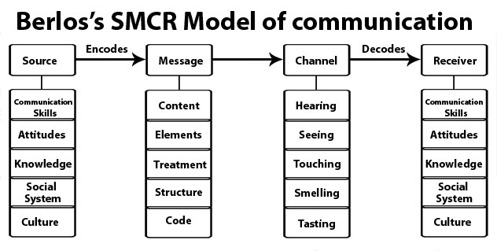(Mass Communication Theory, 2015).

The Berlo model of communication also known as the SMCR, has four components (Juneja, 2018), source, which is the message that needs to be communicated, message, which is the content that needs to be communicated, channel, is the five senses which clearly says that a message is not just about the words we can hear, and receiver, this is the person group or company who is the recipient of the message. Even though this model does not have a feedback element, but it can still help the communication between the managers and staff as it allows the receiver and the source to swap places so that the receiver can replay the message back in the opposite direction, so they can confirm understanding (Praxis, 2015). In that way the managers can have a clear understanding of what issues the staff are having and they can both work together to resolve the problems.

Problems in the relationships between social workers were also poor. Most of them worked with families so when they were in the office they would come back to new faces and for these reasons the social workers would just put their head down and do their work alone. Due to this communication problem between the staff it made it difficult for them to make close bonds with each other and therefore they were unable to build trust in one another.

This was also influencing reports and cases as they were poorly written and stayed open longer then they needed to be. To achieve success, it is important to have good communication. As stated in The Nest, there is nothing more important to an organisation then effective and clear among team members. Poor communication can lead to unmotivated staff who may question their own confidence and ability (Page,2018), which is exactly what is happening in this organisation where more staff are leaving as already mentioned. A good way to improve and build a good team would be to apply Bruce Tuckmans team development model. According to Tuckman the five stages in the model can help build an effective team. The stages are forming, storming, norming, performing and adjourning.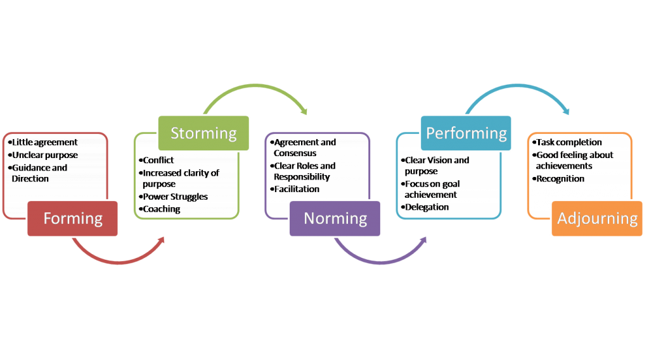
(Verozen, 2016)

The forming stage is where the team members get to know each other. This is the first stage, so members do not know each other well enough to be able to trust each other.
The second stage is the storming stage were the members put ideas together. There maybe disagreements which can lead to conflict between members. At this stage it is important that they have a team leader.
The next stage is the Norming stage. After the fist two stages the team move on to the norming stage where members start to agree on things. They start to trust each other and accept each their contributions.
Not all team make it to the next stage which is the performing stage. If they reach this stage it means high performance. At this stage there will be high levels of respect in the communication between the team members. At this stage the team put their ideas to action and perform.
And the final stage is adjourning. Some may call this the mourning phase as this is where the team comes to an end as their may have been achieved or a member maybe leaving. In a successful team new members will join every time a member leaves so the team will need to revert back to the forming stage.
If the managers apply these stages, it will help staff build a relationship with each other as they get to know one another at the forming stage and eventually will build trust between them through the stages which will then lead to high performance and positive results, however to benefit from these stages managers will need to change their approach at each stage (Mindtools, 2018), and schedule regular reviews of where their team is and adjust leadership approach appropriately.
For more effectiveness in the team it would be a good idea to use the Belbin nine team roles alongside the Tuckmans Theory as each team member will have their own strengths and weaknesses, (Belbin, 2018), and each will have equal importance but may not be needed at the same time.

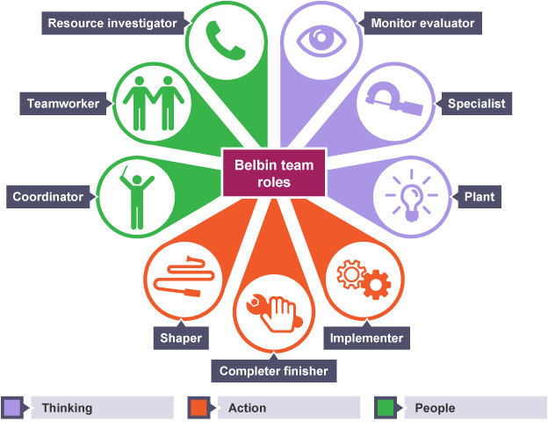
(Nguyen, 2017)

So, if the managers apply the Tuckman theory alongside Belbins team roles, when in the office the social workers will be clearer in their own roles and may results in less or no conflict and of course a strong team who can work together and be happy in what they are doing and hopefully no one would want to leave the job.

Another issue social workers were coming across was decision making. The social workers had different opinions. This resulted in decisions made by one social worker, override by another. This could be very bad for any organisation as it can result in misunderstanding and conflict, (Mindtools, 2018). However, these problems can be resolved when managed well by the managers. One of the major reasons for these decision-making problems is again communication errors. Another good communication model that can be used to help resolve these problems is the Argyle Model of Communication. Argyle argued, (Health and social care, 2015), that skilled interpersonal interaction involved a cycle where a message is sent and the receiver decodes what the other is communicating and constantly adapts their behaviour and communicates effectively.
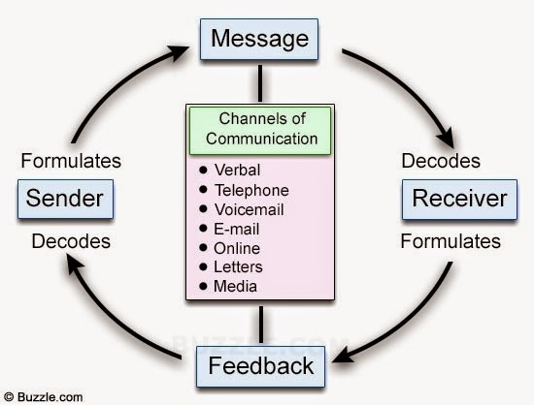

The argyle communication cycle can help the social workers build their communication skills as it is very similar to the other communication models already mentioned. The message is sent, the receiver decodes the message and then can send feedback (Middleton, 2013). By using this cycle, the social workers can build on their communication skills through which they can implement improved interpersonal interaction with each other. This can help them work together and come to mutual agreements on decisions made rather than overriding each other’s decisions and can help resolve any conflicts or misunderstandings.

Conclusion

After thorough reading of the case study, the researcher found that there are a lot of communication barriers in the social service department which need to be resolved in order to improve the performances of staff individually as well as in a team. A major reason for the low performance is due to the lack of understanding and trust in each other. To improve the team performance the mangers, need to apply the communication models mentioned. These models help send messages, the receiver decodes the message and sends feedback to show clear understanding (Bussinesstopia, 2018). Using the Tuckman theory alongside Belbins team roles can help build and maintain an effective Team (The Team Building Company, 2018).

Absences and the number of staff leaving is high which effects the organisation resulting in poor performances. This was due to bad management as managers were not communicating with staff to find out reasons for why staff were not coming in or why they chose to leave. Again, these issues can be solved using the Berlow communication model (Juneja, 2018).

So, at the end of the report the researcher found the main cause of the issues is the lack of communication which can have a great negative impact on any organisation if not resolved.

Recommendations

To build and maintain an effective team and resolve any issues between the social workers the researcher has recommended the following: -

- Manager should introduce Bruce Tuckmans theory to the team as it will help the staff to get to know each other and help build trust between them which will have a positive impact on the team as the staff will be able to share ideas, work together and be happy in what they do (The Team Building Company, 2018).
- Managers should regularly reward or even praise staff as this will let employees know that their hard work and high levels of performance is noticed and will increase their motivation to perform higher (Chron, 2018). Managers can choose to reward the staff in different ways. These can be an extra bonus, store vouchers, drinks or even just an appraisal can be motivating. This can benefit the organisation with high achievements. An employee who is rewarded is often more motivated to stay with the organisation, so it is important to do this as social workers are choosing to leave so it can help motivate to stay.
- Managers need to improve their communication methods by using the Shannon weaver communication model as this is a two-way model and can help in getting messages through to staff and staff are able to send feedback to confirm that messages have been received and understood which can avoid any misunderstanding (Businesstopia,2018).

Bibliography

Brenner, L. (2018), ‘What is the Importance of Team Communication, [Online]. Available: https://women.thenest.com. [Accessed: 2018, July 2].

Businesstopia. (2018), ‘Shannon and Weaver Model of Communication’, [Online]. Available: www.businesstopia.net/communication/shannon-and-weaver-model-communication. [Accessed: 2018, July 2].

Chandler, D & Munday, R. (2011), ‘A Dictionary of Media and Communication’, (1st Edition), Oxford: Oxford University Press.

Chron. (2018), ‘The Role of Reward in Employee Motivation’, [Online]. Available: http://smallbusiness.chron.com/role-reward-employee-motivation-18814.html. [Accessed: 2018, July 10].

Communication Theory. (2010), ‘Shannon and Weaver Model of Communications’, [Online]. Available: www.communicationtheory.org/shannon-and-weaver-model-of-communication/. [Accessed: 2018, June 30].

Health and Social Care. (2015), ‘Argyle Theory’, [Online]. Available: http://btechealthandsocialcare.blogspot.com/2015/12/argyles-theory.html. [Accessed: 2018, July 6].

Juneja, P. (2018), ‘Berlo’s Model of Communication’, [Online]. Available: www.managmentstudy.com. [Accessed: 2018, July 1].

Mass Communication Theory. (2015), ‘Berlo’s SMCR Model of Communication’, [Online]. Available: https://rahmanjmc.wordpress.com. [Accessed: 2018, July 1].

Mindtools. (2018), ‘Forming, Storming, Norming, and Performing’, [Online]. Available: www.mindtools.com. [Accessed: 2018, July 4].
Mindtools. (2018), ‘Managing Mutual Acceptance in Your Team’, [Online]. Available: www.mindtools.com. [Accessed: July 5].

Nguyen, M. (2017), ‘Belbins Team Roles in Practice’, [Online]. Available: www.linkedin.com. [Accessed: 2018, July 5].

Oxford Reference. (2018), ‘Shannon and Weaver’s Model’, [Online]. Available: www.oxfordreference.com. [Accessed: 2018, June 30].

Page, M. (2018), ‘the Importance of Good Communication’, [Online]. Available: www.michaelpage.co.uk. [Accessed: 2018, July 4].

Praxis. (2015), ‘Berlo’, [Online]. Available: www.praxisframework.org. [Accessed: 2018, July 1].

The Team Building Company. (2018), ‘Forming – Storming – Norming – performing’, [Online]. Available: www.teambuilding.co.uk/theory/Forming-Storming-Norming-Performing.html. [Accessed: 2018, July 4].

Verozen. (2016), ‘Building a Team’, [Online]. Available: www.verozen.co.uk. [Accessed: July 5].

Acknowledgements

The researcher would like to show appreciation to those individuals who made it possible for her to prepare and put this report together. This includes their lecturer, Melanie Squire who guided them through the report. The researcher would also like to thank their friends who helped when the researcher failed to understand something. And lastly a mention to family who supported the researcher all the way and made it possible to work around them to complete this report.

