Samina Sultana
Student Number: 1912524
Change makers:
Creativity and Value Creation
BMHP5014_BIRM
Dr Azora Hurd
E-Portfolio Evidence of Learning
Task 1 and 2

Project Idea
The Face Mask Bin

Task 1 - Mind-map

- Plastic pollution
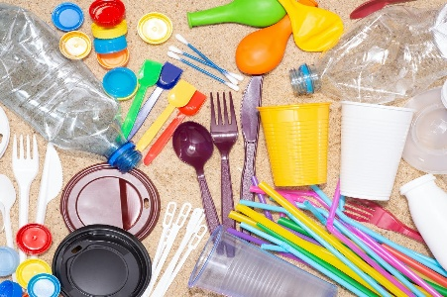
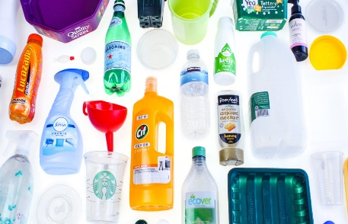

Cheap production and easy availability can make plastic very useful but it has numerous shortfalls, with its harmful effects causing great concern for our planet.

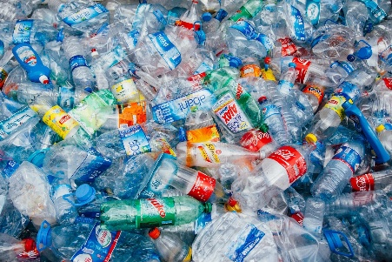
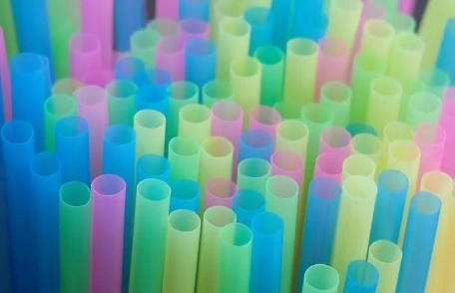

- Ocean life endangered
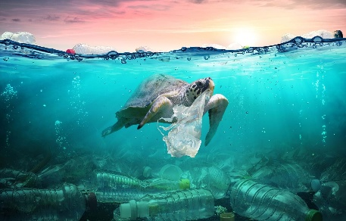
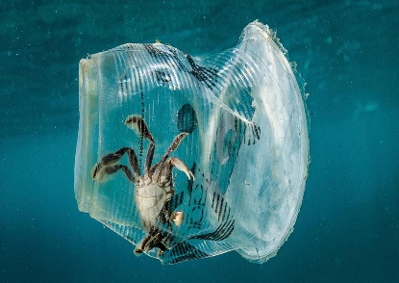
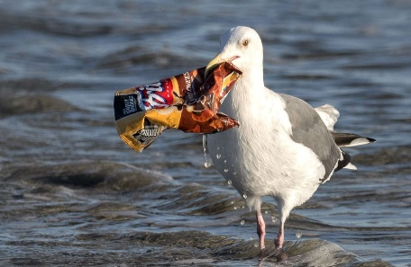
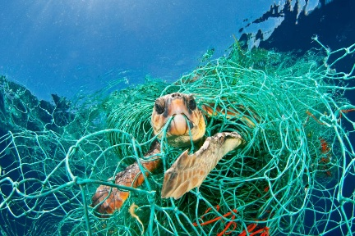
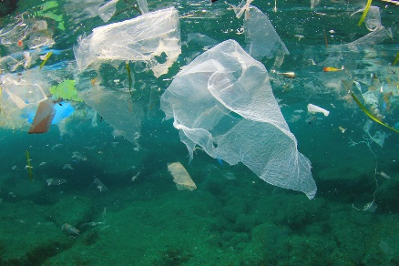

Plastic products clog oceans, seas, lakes and waterways. 1 in 3 marine animals have been found tangled in marine litter. Over 90% of all seabirds have plastic pieces in their stomachs (Thevenon,2014).
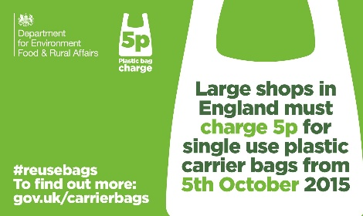
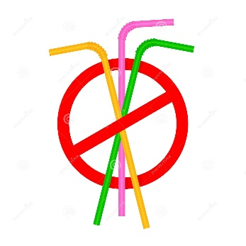
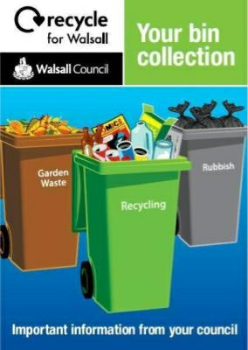
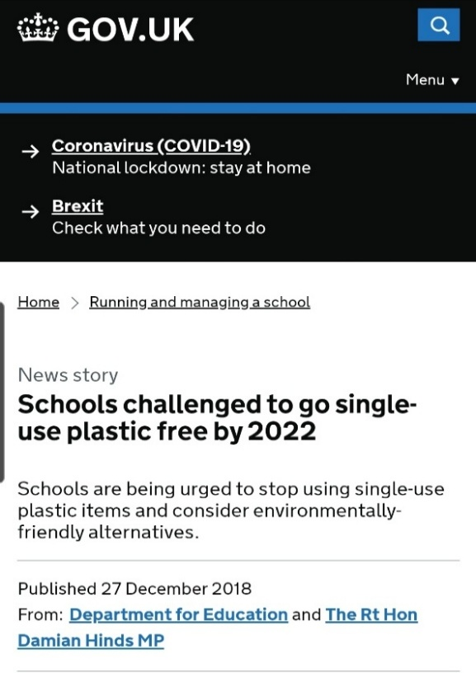
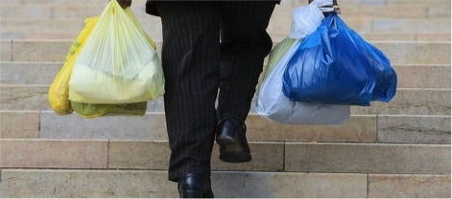
- The fight against Plastic Pollution
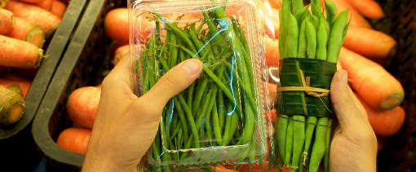
Countries, governments and wildlife enthusiasts are continuously trying to battle the fight against plastic pollution, by introducing bans on plastic packaging, straws and bags.
- Covid-19 – The rise of a Global Pandemic.
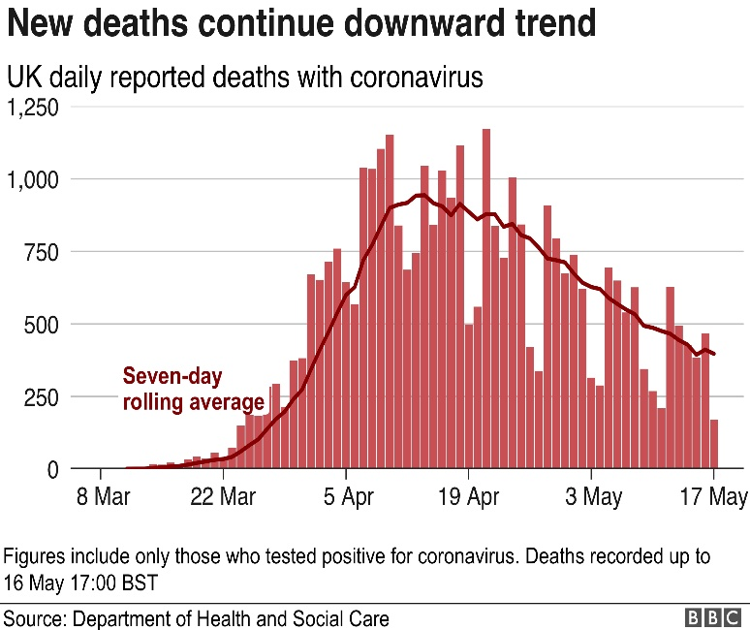
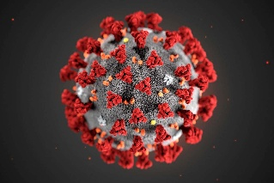
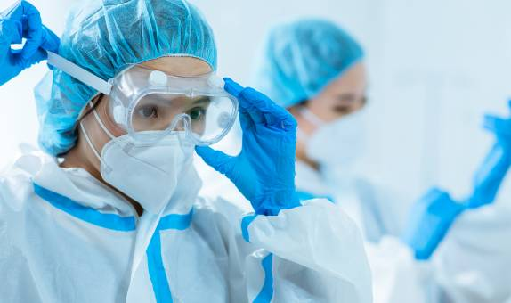

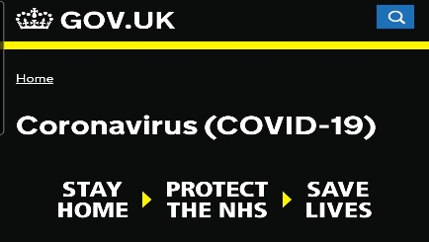

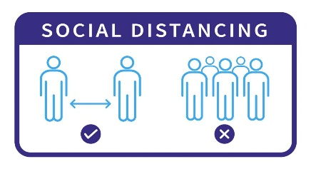

Cases of a mysterious illness was first reported in Wuhan, China and later confirmed as a new kind of Coronavirus. Since then, the infection has dramatically spread and was declared a global pandemic (NewScientist,2014).

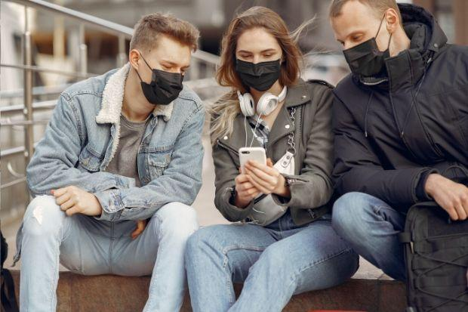
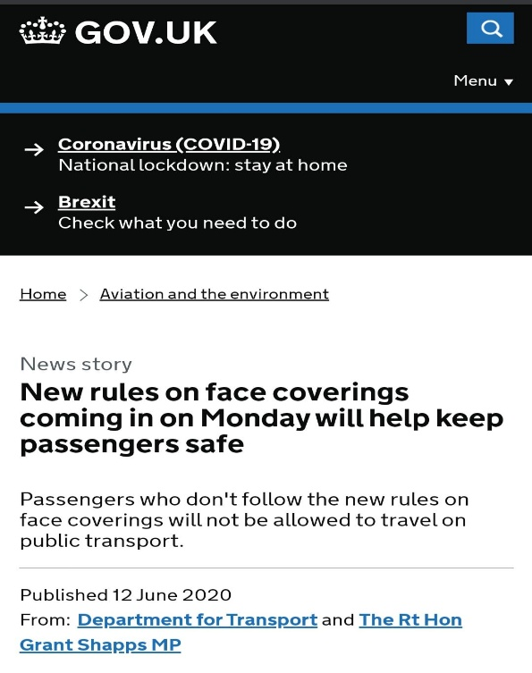
- Face masks become mandatory
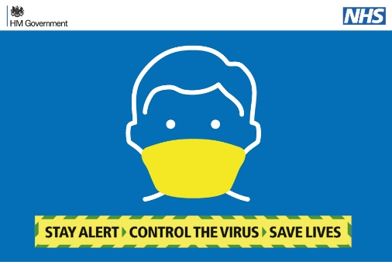
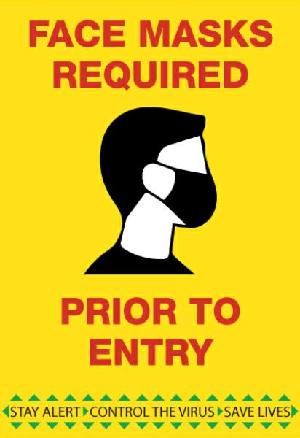

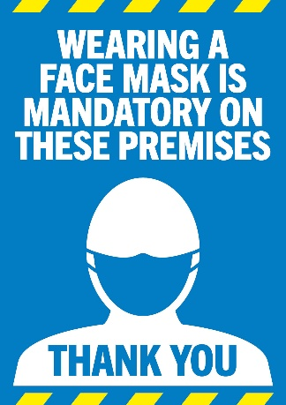
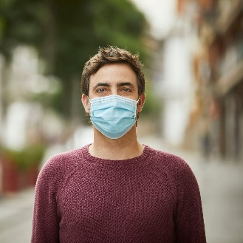

Due to the rapid spread of the disease, face masks must be worn in public by law. The new law gives way to increased plastic littering.
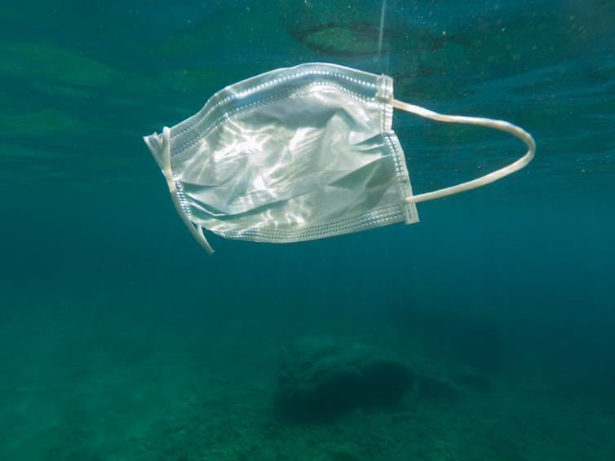
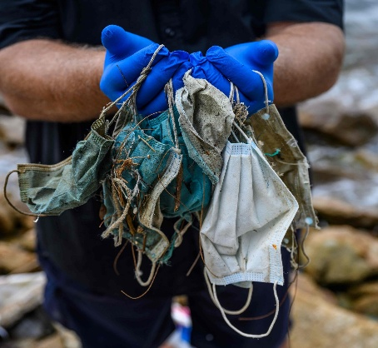
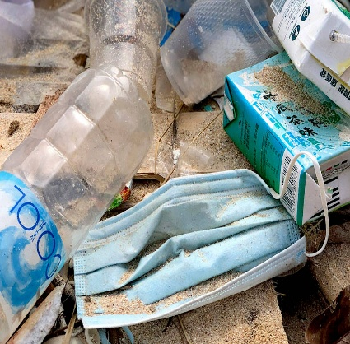

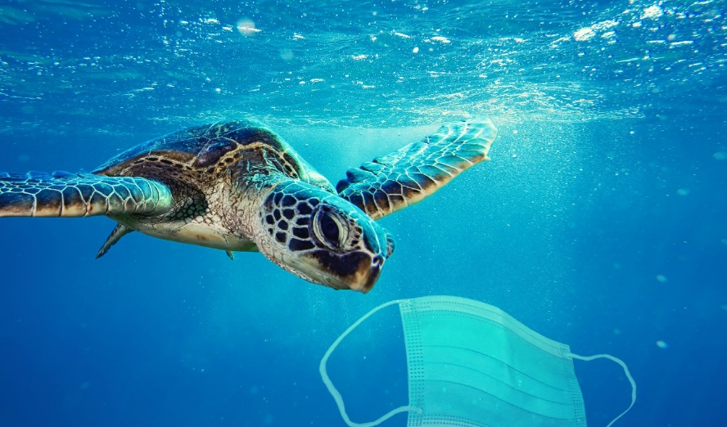

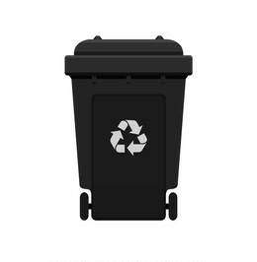
- ‘The Face Mask Bin'
My idea proposes that public streets and each household should receive a bin specific for discarding single-use face masks in order to prevent them being littered and filtering the oceans.

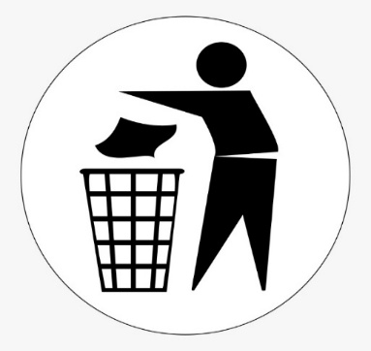
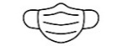
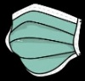

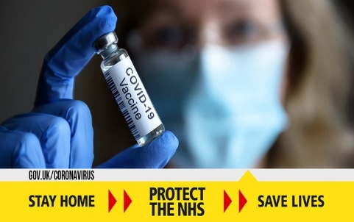

- The End of the Pandemic
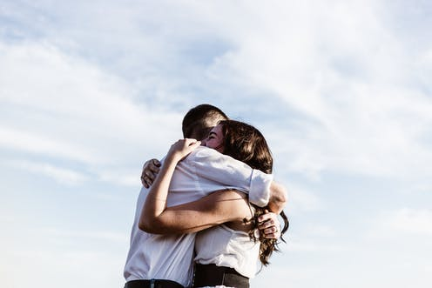
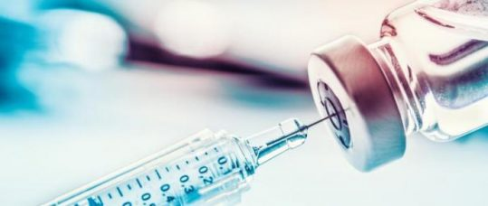

The Covid-19 vaccinations have paved way for an end to this ongoing pandemic and it is hoped that in the near future, social distancing and the necessity of face masks will be lifted.

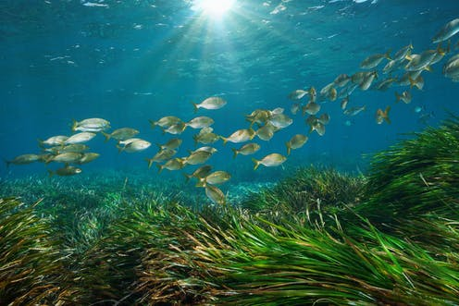
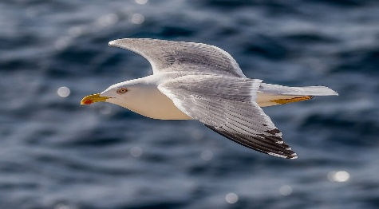
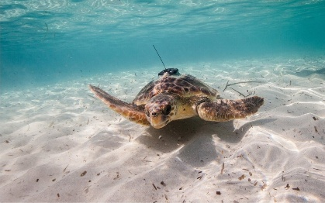
- The pandemic’s effect on the ocean.
By discarding of single-use PPE needed in this pandemic appropriately, we have helped saved the habitats of sea animals from being damaged by another mass use of plastic – face masks.

Task 2 - Blog

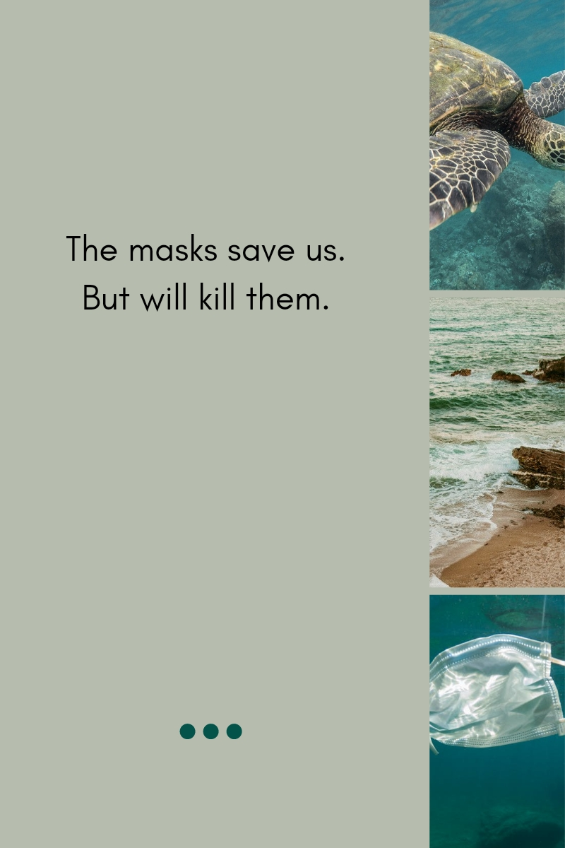
Innovation, Creativity and Values –
Change making; the act of creating value and Seeking Solutions
Email: 1912524@student.uwtsd.ac.uk
Username: Samina Sultana
https:www.thisismyblog.com/ref861533402085017/myblog-save-the-sea-animals-from-masks-the-face-mask-bin.org
The Face Mask Bin
In order to combat the ever-growing damage of plastic pollution and its environmental effects, I am introducing my project idea - The Face Mask Bin – as a tool of remedying this developing problem. Every individual amasses different levels of plastic due to its numerous involvements in daily life. Plastic usage has increased now more than ever, due to the present pandemic necessitating the law of wearing face masks in public. These PPE face masks are made from single-use plastic, meaning they are non-recyclable and non-biodegradable. My idea will help to reduce the amount of face mask littering, decreasing its harmful effect on oceanic pollution and habitat damage.
I propose every household should receive a bin specific for discarding these single-use masks to ensure they are not inappropriately littered. I also suggest these bins are utilised in public streets and parks to promote appropriate discarding.

Marine conservation organisation, OceanAsia (2020), released a report estimating that 1.56 billion face masks will flood the oceans in the year 2020. This will result in an estimate of up to 6000 metric tonnes of increased plastic pollution. These masks will take as long as 450 years to break down (Ho,2020), all while disturbing and endangering marine wildlife and ecosystems.
In this constantly changing world, it is up to us to ensure that all life, including marine life, are living with equal chances of survival. By incorrectly disposing of our face masks, we are in turn decreasing the value of these ocean creatures who are battling a constant war with plastic we litter. Change is now vital more than ever, with the current pandemic necessitating the need for protective clothing. As the coronavirus lingers, it is up to us to be the change makers that prevent the negative environmental impacts of masks.
These masks, like other forms of plastic pollution, can be mistaken for food by marine mammals. Dolphins, porpoises and turtles can mistake them for food and through consumption these plastics endanger their digestive tracts (Cooke, 2020). One study documented traces of plastic in the organs and bodies of 100% of marine turtles, 59% of whales and 40% of seabirds sampled (Lavender, 2016). Even if they do not choke, animals can become malnourished as the materials fill up their stomachs but provide no nutrients. Smaller animals may also become entangled in the elastic within the masks as they begin to break apart (Roberts, 2020).
These animals are calling out for help. Change is needed. Their life is valued too.
Whilst the masks save us, it is killing them.

Links -
OceanAsia - https://oceansasia.org/covid-19-facemasks/
GreenQueen - https://www.greenqueen.com.hk/amp/plastic-pollution-oceansasia-founder-says-public-should-phase-out-single-use-masks-where-possible-2/
Sea Education Association - https://www.annualreviews.org/doi/abs/10.1146/annurev-marine-010816-060409?journalCode=marine
The Conversation - https://theconversation.com/amp/coronavirus-face-masks-an-environmental-disaster-that-might-last-generations-144328

References/Task 1
- NewScientist. (2014). https://www.newscientist.com/term/covid-19/ [Accessed:14/02/2021]
- Thevenon, F. (2014). Plastic Debris in the Ocean: The Characterization of Marine Plastics and their Environmental Impacts, Situation Analysis Report. Gland, Switzerland: IUCN.

Appendice/Task 1
- The Conversation. (2020). Available: https://theconversation.com/amp/avoiding-single-use-plastic-was-becoming-normal-until-coronavirus-heres-how-we-can-return-to-good-habits-140555. [Accessed:12/02/21]
- First Mile. Available: https://thefirstmile.co.uk/service/single-use-plastics-recycling. [Accessed:12/02/21]
- RCI. (2020). Available: https://www.rcinet.ca/en/2020/02/04/canada-still-wants-to-ban-single-use-plastics-in-2021/ [Accessed:12/02/21].
- WWF. Available: https://www.wwf.org.uk/get-involved/schools/oceans-and-plastics. [Accessed:12/02/21]
- Friends of the Earth. Available: https://friendsoftheearth.uk/plastics [Accessed:12/02/21]
- Green Element. Available: https://www.greenelement.co.uk/blog/plastic-pollution/ [Accessed:12/02/21]
- The National. Available: https://amp.thenationalnews.com/opinion/comment/the-ocean-is-nature-s-number-one-influencer-but-thanks-to-plastic-its-health-is-in-freefall-1.838896 [Accessed:12/02/21]
- Condor Ferries: https://www.condorferries.co.uk/plastic-in-the-ocean-statistics [Accessed:12/02/21]
- RRecycligbins.co.uk. Available: https://www.recyclingbins.co.uk/blog/recycling-bin-colours-in-the-uk/. [Accessed:12/02/21]
- BBC News. (2019). Available: https://www.bbc.co.uk/news/amp/uk-northern-ireland-49441769 [Accessed:13/02/21]
- The Best of Walsall. Available: https://www.thebestof.co.uk/local/walsall/community-hub/blog/view/bin-collection-dates-in-walsall/ [Accessed:13/02/21]
- Good Shopping Guide. Available: https://thegoodshoppingguide.com/success-a-look-at-englands-new-plastic-bag-tax/. [Accessed:13/02/21]
- Gov.uk. (2018). Available: https://www.gov.uk/government/news/schools-challenged-to-go-single-use-plastic-free-by-2022 [Accessed:13/02/21]
- Kingston. Available: https://www.kingston.ac.uk/research/coronavirus/ [Accessed:13/02/21]
- New Scientist. (2020). Available: https://www.newscientist.com/term/covid-19/ [Accessed:13/02/21]
- Apollo Medical. (2020). Available: https://www.apollomedical.co.uk/social-distancing-in-healthcare-centres/ [Accessed:13/02/21]
- BBC News. (2020). Available: https://www.bbc.co.uk/news/amp/uk-52699483 [Accessed:13/02/21]
- Derby Telegraph. (2020). Available: https://www.derbytelegraph.co.uk/burton/you-not-wear-face-mask-4587563.amp [Accessed:13/02/21]
- Dreams Time. Available: https://www.dreamstime.com/signs-stop-straw-tube-plastic-refusal-disposable-drinking-favor-straws-ban-sign-white-background-image145702740 [Accessed:13/02/21]
- Gov.uk. (2020. Available: https://www.gov.uk/government/news/new-rules-on-face-coverings-coming-in-on-monday-will-help-keep-passengers-safe [Accessed:14/02/21]
- Footprint South. Available: https://footprintsouth.co.uk/product/covid-19-wear-mask-information-poster/ [Accessed:14/02/21]
- The Northern Echo. (2020). Available: https://www.thenorthernecho.co.uk/news/national/uk-today/18585033.full-list-doesnt-need-wear-face-mask-law-changes-july-24/ [Accessed:14/02/21]
- Display Signs. Available: https://www.displaysigns.net/product/sd084-face-masks-required-sign/ [Accessed:14/02/21]
- Green Queen. (2020). Available: https://www.greenqueen.com.hk/amp/plastic-pollution-oceansasia-founder-says-public-should-phase-out-single-use-masks-where-possible-2/ [Accessed: 14/02/21]
- GreenaBiz. (2020). https://www.greenbiz.com/article/how-face-masks-gloves-and-other-coronavirus-waste-are-polluting-ocean [Accessed:14/02/21]
- New York Times. (2020). Available: https://www.nytimes.com/2020/07/25/climate/covid-masks-discarded.html [Accessed:14/02/21]
- Clip Art. Available: https://clipart.me/free-vector/surgical-mask [Accessed:14/02/21]
- Clip Art Key. Available: https://www.clipartkey.com/view/hhimTh_put-rubbish-in-bin-cartoon-put-your-trash/ [Accessed:14/02/21]
- Shutterstock. Available: https://www.shutterstock.com/search/wheelie+bin+cartoon [Accessed:14/02/21]
- Nursing in Practise. (2020). Available: https://www.nursinginpractice.com/latest-news/vaccinations-and-immunisations-to-become-essential-contractual-service-in-general-practice/ [Accessed:13/02/21]
- The Conversation. (2020). Available: https://news.exeter.gov.uk/st-thomas-health-centre-latest-surgery-to-offer-covid-vaccinations/?amp=true [Accessed:14/02/21]
- Taking Care of your Diabetes. (2018). https://tcoyd.org/2018/09/top-10-tips-on-how-to-make-your-doctors-appointment-a-success/ [Accessed:13/02/21]
- The Conversation. (2019). Available: https://theconversation.com/amp/revealed-how-underwater-plants-and-corals-can-help-animals-survive-marine-heatwaves-123839 [Accessed:14/02/21]
- Save coastal wildlife. (2020). Available: https://www.savecoastalwildlife.org/save-coastal-wildlife-blog/2020/2/17/have-we-all-missed-the-point-about-seagulls?format=amp [Accessed:14/02/21]

References/Task 2
- Cooke, S. (2020). Masks on the Beach. The impact of Covid-19 on Marine Plastic Pollution. OceansAsia
- Ho, S. (2020). Plastic Pollution: OceansAsia Founder Says Public Should Phase-Out Single-Use Masks Where Possible. https://www.greenqueen.com.hk/amp/plastic-pollution-oceansasia-founder-says-public-should-phase-out-single-use-masks-where-possible-2/
- Lavender, K. (2017). Plastic in the Marine environment. Annual Review of Marine Science 2017. 9:1, 205-229.
- OceanAsia. (2020). https://oceansasia.org/covid-19-facemasks/ [Accessed:13/02/21]
- Roberts, K., Bowyer, C., Fletcher, S. (2020). Coronavirus face masks: an environmental disaster that might last generations. The Conversation.

Appendice/Task 2
- The Conversation. (2020). Available: https://theconversation.com/amp/coronavirus-face-masks-an-environmental-disaster-that-might-last-generations-144328 [Accessed:16/02/21]
- WWF. Available: https://www.worldwildlife.org/species/sea-turtle [Accessed:16/02/21]

