

INTERNATIONAL BUSINESS COMMUNICATIONS

BUSINESS EXPANSION OF TESCO

ASSESSMENT 1
MODULE: PROJECT MANAGEMENT
MODULE CODE: LCBB6001

STUDENT NAME: ELENA ALINA GRIGORAS
STUDENT ID: 2112864

LECTURER NAME: DR CHARLES NWAOGWUGWU
TABLE OF CONTENTS

INTRODUCTION 2
BUSINESS EXPANSION AND CHALLENGES 3
OVERVIEW OF TESCO 3
EVALUATION OF THE DESTINATION – COUNTRY FACTS 4
COMMUNICATION BARRIERS IN THE CHOSEN COUNTRIES 7
CHOICE OF THE MARKET 9
TRAINING AND DEVELOPMENT OF EMPLOYEES 9
CONCLUSION 11
REFERENCES 12

INTRODUCTION
Business communication has been an essential ingredient in the success of modern business organisations. There is a definite structure in the type of business communication that is observed in various parts of the world. The British way of business communication is also unique and follows the epitome of the British legacy. English is the preferred language in British business communication and the British people prefer professional attire in business meetings and the work environment. Strong handshakes are common and are signs of greeting in a meeting. The communication is courteous in nature and business persons and employees maintain a sense of courteousness in communicating with others. There is a tendency to avoid harsh language and confrontation in business communication and everything is done formally (Malyuga, Ivanova, and Feigina, 2020).
Therefore, a business operating in the UK may find it difficult to operate in countries with different communication styles. The present study will try to analyse the market expansion strategies related to Tesco – one of the leading retailers in the UK industry and how it can take care of communication problems while entering a new country.

BUSINESS EXPANSION AND CHALLENGES

OVERVIEW OF TESCO
Tesco is one of the biggest retailers in the world and is based in the UK. The company has expanded to various countries and operates around 7000 stores worldwide. Most of its expansion has been based in the European countries of the UK, Hungary, Ireland, Poland, Czech Republic, and Slovakia (Tesco Worldwide, 2024). The company has been well-known for its ability to deliver cheap and affordable products to its customers. The retail stores of Tesco are all-inclusive and consist of product categories like groceries, books, electronic items, food, dresses, etc. The management of the company has also developed products under its own brand to deliver cheap products to the customers and this has been the reason why Tesco has become so successful. The online sales of the company have also developed and special care has been given to customer care aspects as well – especially, after Covid (Core purpose and values, 2024).
However, in recent times, the performance of Tesco has not been up to the mark, and on closer analysis it can be seen that the net profit of the company has decreased to £1,000m in 2023 from £2.033m in 2022. The earnings per share and dividends have also decreased as a result. This is interesting as the turnover of the company has increased on a year-to-year basis. This underlines the fact that the management had to incur high expenses related to the operations and maintenance of the company (Key facts, 2024). The UK retail industry has also contracted given the deterioration of the economic conditions of the country after BREXIT. The growth rate has been flat in the UK economy in 2023 and the GDP has contracted by 0.1% in the 3rd quarter. Industry experts have claimed that the condition of the economy will persist in the coming years and there may be chances of recession (The Economic Times, 22nd December, 2023). Tesco has faced competition in the UK retail industry from low-cost German players like Aldi and Lidl which has also played a role in reducing its profits. Based on these conditions, the management is contemplating to move to an international destination. It would be viable for the company if the chosen market is in the EU region which will make it easier for Tesco to control its operations there. The management has chosen two tentative markets in the process – Italy and Belgium. The final destination will be chosen in the following parts of the study.

EVALUATION OF THE DESTINATION – COUNTRY FACTS
The evaluation of the chosen markets that have been specified can be done with the help of CAGE analysis which denotes the cultural, administrative, geographical, and economic distance. This can be stated with the help of the following chart:
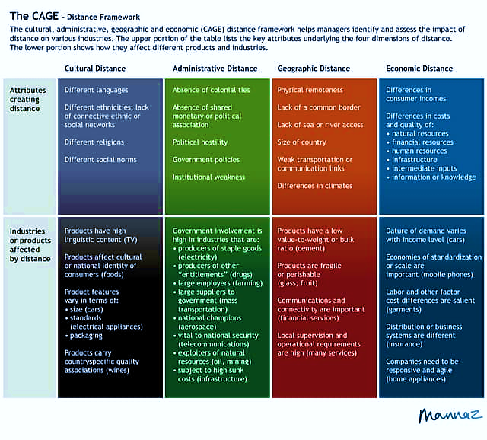
Source: Clark, Li and Shepherd, 2018
Cultural distance: It is apparent that there are differences in cultures between the UK and the chosen countries. The best way to understand the differences in cultures is via Hofstede’s cultural dimensions. Geert Hofstede defined various dimensions upon which countries have been ranked (Dingil et al, 2019). The ranking of the countries can be stated with the help of the following figure:
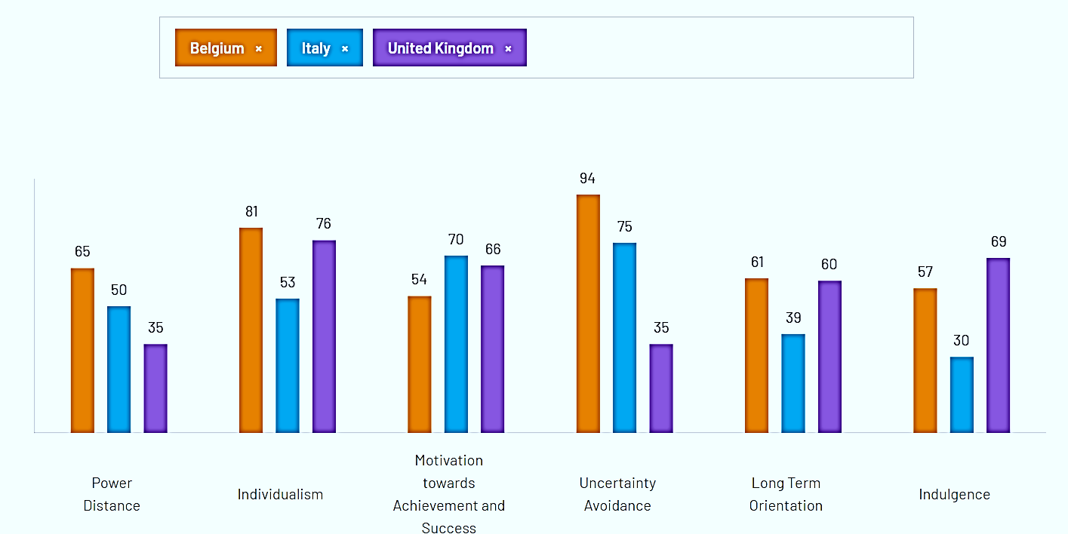
Source: The Culture Factor Group, 2024
It can be seen that the culture of Belgium is similar to that of the UK in the context of individualism, indulgence, and long-term orientation. This means that business organisations in Belgium and Italy are not comfortable operating in ambiguous situations. The consumers in Italy are more price-sensitive than in the UK. In the case of Italy, there are huge differences between the countries in the context of power distance, long-term orientation, individualism, and indulgence. The culture in Italy is family-oriented and the consumers look to save money for their future. They are more conservative in spending money and thus, can be termed as the most price-sensitive people among the three countries (Beugelsdijk, and Welzel, 2018).
The languages of communication in both these countries have been different from that of the UK. The people in Belgium and Italy are proud of their heritage and thus, look to speak in their native language. This can be a problem for the employees of Tesco coming to operate in these countries. However, of late, more and more people have learnt and understood English as countries have become more globalised. More and more international companies have come to these countries and thus, the society has become more vibrant (Paul, 2020). As Belgium and Italy have both been important contributors to the EU economy, the culture of the people has become more dynamic and people have not been protective about the same as they had done earlier. In addition to the ethnic communities living here, there are people from other regions of the world as well. This can be an advantage for Tesco as the employee pool will increase and the products will also be available to a more vibrant and dynamic market.
Administrative distance: Belgium and Italy have both been parts of the EU and thus, are part of the common market policy of the organisation. There is free movement of goods and services within the EU region and thus, companies coming from this region would have significant advantages operating here. The UK was also a part of the EU and thus, was also a part of the common market. However, after BREXIT, the UK came out of the Union and thus, the UK companies lost their advantages in the EU countries. Therefore, a company looking to operate in any of the EU countries will have to pay a substantial amount of taxes and duties in order to make the products available there (Bloom et al, 2019).
However, the relationship between the countries spanned many decades during the World Wars. Italy and the UK enjoyed friendly relations before the World War but they chose different sides due to their political ideologies (Pollard, 2020). Belgium, on the other hand, has friendly ties with the UK Government and has trading relations. There have been business and trade relations between the countries after they became parts of the EU and the same has continued up to now.
Geographical distance: All these countries are situated in Europe and are connected by sea links as well as air links. Rail links have also been established from the UK to mainland Europe which makes it easier to commute between the countries. Italy and Belgium are closer to the existing markets of Tesco like Hungary, the Czech Republic, Poland, and Slovakia which can allow the company to take advantage of the existing supply chain. (Paul and Benito, 2018).
Economic distance: As has been stated earlier, the UK economy has been shrinking after the country came out of the EU. On the other hand, Belgium is growing as a country within the EU with the development of a service-based and export-driven economy and per capita real GDP has been $53,300. The growth rate of the country has been 3.01% according to the 2022 figures. The country has an enormous supply of skilled workers who are well-versed in the modern-day technological landscape. Society has become cosmopolitan with the development of various cities and industrial belts all over the country (The World Factbook, 2024). Italy has also been a major exporter in the EU but the country was highly disrupted due to the Pandemic. However, the country has been looking to recover and has showcased an impressive 6.74% growth rate in 2021. However, the experts have underlined that the figures have often been skewed due to a lack of governance and corruption in the country. There is also high regional discrimination with the northern part of the country being more prosperous than the south. The real GDP per capita of the country has been $41,900 according to the 2021 figures which showcases that the country is not too far away from the stronger states in the continent (The World Factbook, 2024).
The analysis has provided some key facts related to the countries of choice for Tesco which can be enhanced by the analysis of the communication barriers that the company can face in these countries.

COMMUNICATION BARRIERS IN THE CHOSEN COUNTRIES
The communication style in the UK business landscape has been discussed in the introductory segment of the study. It will be interesting to understand the communication landscape in Belgium and Italy that may provide the mode of action for Tesco in the coming years.
Belgium: People in Belgium are influenced by the individual cultural traits of their backgrounds. The Belgian society is fragmented and thus, their communication styles are highly influenced by the same. In general, the population is comfortable in English. They may appear as reserved because of their communication style which is direct and honest. The Belgians expect the other party to the communication to “break the ice” and they also expect the other party to be direct in their communication. They value relationships and avoid being too intimate in the business context. However, they like the other party to be honest and they can open up if they develop good relationship with them (Passport to trade, 2024)
Italy: The Italians are more open than Belgians and thus, they are not as reserved. However, they also love their language and are more comfortable conversing in the same. They communicate openly about their emotions and they also expect the same from the other person. Therefore, it is better to converse with them directly and with honesty. They love humour and thus, they can converse with a person freely if they are able to mix humour in their conversations. Any business conversation may include back stories and incidents and they also expect the other person to speak about the same things. They are very expressive when they communicate and thus, can use non-verbal communication in an expressive manner as well. It is not uncommon for people in Italy to hug and kiss each other (Evason, 2017).
It has to be stated that the communication style in the UK is not as open as in Italy and is more congruent to the style followed in Belgium. Therefore, a company like Tesco will face problems communicating in Italy and will be at ease in Belgium. However, communication is formal and people in the UK would like to maintain a standard nomenclature in communication.

CHOICE OF THE MARKET
The choice of the market can be arrived at with the help of scores of two countries in the context of the analysis. This can be stated with the help of the following table:
 | Cultural distance | Administrative distance | Geographical distance | Economic distance | Communication | Total
Belgium | 9 | 8 | 8 | 9 | 9 | 43
Italy | 7 | 8 | 8 | 8 | 8 | 39
It can be seen that Belgium ranks higher than Italy on the basis of analysis that has been done in the study up to now. Thus, Tesco should look to enter the Belgian market in this regard.

TRAINING AND DEVELOPMENT OF EMPLOYEES
It is quite apparent that proper training and development activities have to be pursued in order to make the UK employees ready to work in Belgium. It will be a good idea to make them aware of important Belgian words and also to learn about popular idioms and statements. The employees should be trained to be disciplined, honest, and polite in their conversations and to avoid ambiguity (Wallace, 2021). They should be direct and should have the tendency to research before they come for meetings. They should also have the ability to use jokes that are easily understood. They should know about the behaviours of their Belgian counterparts and they should be prepared to expect silence from them. They should also have an idea of their culture and the areas that are close to them. For example, they have a good long-term orientation like that of the UK people, and thus, more emphasis should be given to their history and heritage.
The development of the training program will require the support of the leadership of Tesco. The leadership should be able to intrinsically motivate the expatriates who are going to Belgium and thus, they should be communicated about the experiences and opportunities they can receive. Leaders from various positions in the organisation may come and talk to them about the need for Tesco to go to Belgium. This can be instrumental in the success of the program.

CONCLUSION
The present study has dealt with international business communications and the problems that are faced when expatriates move to other countries. The study has taken the example of Tesco which is looking to move to either Belgium or Italy. A careful analysis has been made on various aspects and it has been decided that Belgium will be the most preferred destination given the opportunities in the market and the similarities of the country with that of the UK on various fronts. Communication has been important in this case and like the UK, Belgian communication is formal and disciplined as well.
However, there is a need to develop proper training and development activities in order to prepare the expatriates to perform their jobs in the new country. The employees should be aware of the culture of the country, and should also learn important aspects of communication. The leadership of the company will have a huge role to play as they have to motivate the employees to move to Belgium.

REFERENCES
1. Beugelsdijk, S. and Welzel, C., (2018). Dimensions and dynamics of national culture: Synthesizing Hofstede with Inglehart. Journal of cross-cultural psychology, 49(10), pp.1469-1505.
2. Bloom, N., Bunn, P., Chen, S., Mizen, P., Smietanka, P. and Thwaites, G., (2019). The impact of Brexit on UK firms (No. w26218). National Bureau of Economic Research.
3. Clark, D.R., Li, D. and Shepherd, D.A., (2018). Country familiarity in the initial stage of foreign market selection. Journal of international business studies, 49, pp.442-472.
4. Core purpose and values. (2024). Tesco Plc. Available at: https://www.tescoplc.com/about-us/core-purpose-and-values/ (Accessed on March, 2024)
5. Dingil, A.E., Rupi, F., Schweizer, J., Stasiskiene, Z. and Aalipour, K., (2019). The role of culture in urban travel patterns: Quantitative analyses of urban areas based on Hofstede’s culture dimensions. Social sciences, 8(8), p.227.
6. Key facts. (2024). Tesco. Available at: Key Facts (tescoplc.com) (Accessed on March, 2024)
7. Malyuga, E.N., Ivanova, M. and Feigina, R., (2020). British and Australian Corporate Communication: A Socio-Linguistic Perspective. International Journal of English Linguistics, 10(5).
8. Passport to trade. (2024). Business culture: Belgian communication. Available at: Business communication in Belgium & Business etiquette (businessculture.org) (Accessed on March, 2024)
9. Paul, J. and Benito, G.R., (2018). A review of research on outward foreign direct investment from emerging countries, including China: what do we know, how do we know and where should we be heading? Asia Pacific Business Review, 24(1), pp.90-115.
10. Paul, J., (2020). Marketing in emerging markets: A review, theoretical synthesis and extension. International Journal of Emerging Markets, 15(3), pp.446-468.
11. Pollard, N., (2020). Refuges for movable cultural property in wartime: lessons for contemporary practice from Second World War Italy. International Journal of Heritage Studies, 26(7), pp.667-683.
12. Tesco Worldwide. (2024). Tesco. Available at: https://corporate.tesco.hu/en/about/our-businesses/ (Accessed on March, 2024)
13. The Culture Factor Group. (2024). Country comparison tool. Available at: Country comparison tool (hofstede-insights.com) (Accessed on March, 2024)
14. The Economic Times. (22nd December, 2023). UK economy shrinks in Q3, suggesting recession might have begun. Available at: UK economy: UK economy shrinks in Q3, suggesting recession might have begun - The Economic Times (indiatimes.com) (Accessed on March, 2024)
15. The World Factbook. (2024). Belgium. Available at: Belgium - The World Factbook (cia.gov) (Accessed on March, 2024)
16. The World Factbook. (2024). Italy. Available at: Italy - The World Factbook (cia.gov) (Accessed on March, 2024)
17. Wallace, C.D., (2021). The multinational enterprise and legal control: host state sovereignty in an era of economic globalization. BRILL.

