Llanllyr Landscape Characterization
Llanllyr has been the subject of archaeological excavations for the past few years due to its rich history. In the present day there stands farm buildings and land, rivers and lakes, and in the not so distant past, a Cistercian nunnery. Recent archaeological discoveries also show evidence of Roman, Medieval and Mesolithic activity with burnt patches indicating the presence of firepits, pottery sherds, human and animal bones and large numbers of non-native flint flakes. Its landscape, however, does not initially seem as intriguing to the everyday person. Llanllyr, situated in west Wales, is for the most part full of ordinary looking farmland, but the areas close to where the old abbey was located, and where evidence of much earlier human activity has been found, is at present marshy fields that will hold much of their water in areas that are of lower elevation, but have areas that are slightly more raised, with dry ground that people can easily walk across to get around. It is also fairly close to the west coast of Wales, an easy enough distance for ancient people to travel if they so needed to, as well as the nearby towns of Tal-sarn and Llanerchaeron. Most crucially to the site and to the groups who were active there, however, are the many freshwater rivers that surround it, as fresh water is of course vital to life and necessary for farming and keeping livestock.
Located in and a few meters above the floodplain of the River Aeron, Llanllyr’s landscape is full of gentle slopes and reeds, denoting current and former wetland activity, supported by the topographical survey and notation of a silted pond seen in figure 1. We do not know how much of this area used to be marshland or even fully submerged under water, nor how long flooding occurred in the area. What we can see is which areas are currently covered with reeds and which are drier and more elevated, which has impacted where the trenches have been placed for the April-May 2024 portion of the excavation. Students were offered the opportunity to suggest locations for trenches 13 and 14, all of which were chosen in locations that had some areas of dry ground at one end of the proposed trench location and some potentially wetter, reedier areas at the other. Both trenches 13 and 14 had few archaeological finds, barring one piece of flint recovered from the south end of trench 13, suggesting that either these locations were previously waterlogged at the times where there was known human activity in Llanllyr, or that the context corresponding to mesolithic soil is at a much lower elevation than that of trench 10 and its extensions. This too would prompt some thought into how exactly the soil had built up so unevenly across the landscape, but we have no confirmation yet as to how deep down the mesolithic and neolithic soil is without carbon dating results from the site.

The southern extension of trench ten (T10(S)) showed evidence of both flooding and drought in the area. As seen in Figure 2, Deposits of ash and evidence of a fire pit was found, following the same discovery from within the original borders of trench 10. However, the ash and burnt earth appears displaced from its expected position and pushed downhill, very likely by water due to flooding activity. Trench 10 is located in one of the drier and more elevated areas of the field, and given that the flints found in trench 10 and it’s north extension (T10(N)) follow a consistent diagonal line across the sites and don’t appear to have been displaced, this may mean that the ashes seen in T10(S) were washed downhill by deliberate human activity, or that the flints were left by an entirely different group of people. Looking at figure 3 also suggests drought in the same 2x8m stretch of ground, very close to the deposits of burnt material. The large cracks seen across the bottom of the trench indicate significant, prolonged drought due to their size and depth. Once again, the proximity of these two events of flooding and drought can only be speculated until the samples from the site have been radiocarbon dated, however the evidence of a prolonged period of drought in what otherwise appears to be a very wet and marshy area of west Wales is an important discovery that suggests that some significant natural events must have influenced the landscape since the mesolithic era. Trenches 10(S), 13 and 14 have all been excavated deep enough into the ground to reveal multiple different contexts, and appear to follow similar patterns. Namely, as seen in Figure 4, there are thick lines along the trench wall making it very easy to determine where each context layer starts and ends, and both displayed alternating layers of soil and clay, some layers more chalky than others, and both trenches had reached a layer of gravel just as they had dug down to groundwater.

The Llanllyr estate’s first documented use was as a nunnery and a cell of the Cistercian abbey of Strata Florida, and is an important discovery as one of two currently known medieval nunneries in Wales. Many parts of the original estate are unlikely to ever be recovered, as Llanllyr has very acidic soil that will erode most fragments of wood, cloth, bone and many other materials, however archaeologists and historians can still speculate about the lives of the medieval nuns at the Llanllyr estate, and the activities of mesolithic and bronze age peoples at the site. "We know the nuns farmed sheep and cattle successfully and they would have tended mills, orchards and fishponds.” The location of the nunnery can also tell historians a bit about the lives of those who built, farmed and lived there, such as their connection to the nearby Strata Florida Abbey, and proximity to other known historical sites and villages, namely Llanerchaeron and Tal-sarn. Of course there is also the west coast town of Aberaeron, which is likely where the flints found throughout excavations have originated from, as flint is not naturally found inland in Wales, therefore it was likely brought East from Aberaeron or another coastal area to be made into tools. Access to the coast may have also been beneficial to people throughout the ages for trade, fishing, and collecting resources, such as flint, that could not be found in Llanllyr or other areas of Wales.

The landscape of Llanllyr may not be the best suited to preserving history due to its acidic soil and marshy fields, yet it was an important place for people of the past to settle, from the mesolithic period to the medieval to the farm seen at the site today, archaeological evidence from each period being equally important in telling the story of the landscape, particularly some of the recent student-led trenches in April-May of 2024, two of which were partially dug down to groundwater, exposing context layers and the makeup of the ground below sight at Llanllyr which had not been previously explored in as much detail at the site. Llanllyr’s location, marshy, acidic ground and it’s good access to rivers defined how humans have settled on the site for millennia, and both limited and uplifted their livelihoods.

Sources:
BBC, 'Incredibly important' medieval find at Llanllyr, Ceredigion, 2014
Murphy, F. & Wilson, H. Llanllyr, Ceredigion, Archaeological Fieldwork 2015: Interim Report, Dyfed Archaeological Trust, 2015. https://www.dyfedarchaeology.org.uk/wp/wp-content/uploads/llanllyrinterim2015.pdf
Murphy, Frances, SURVEY AND EXCAVATION AT LLANLLYR MEDIEVAL NUNNERY
AND POST-MEDIEVAL MANSION, CEREDIGION, 2014-2015, Dyfed Archaeological Trust, 2017. https://www.dyfedarchaeology.org.uk/wp/wp-content/uploads/llanllyrreport2017.pdf

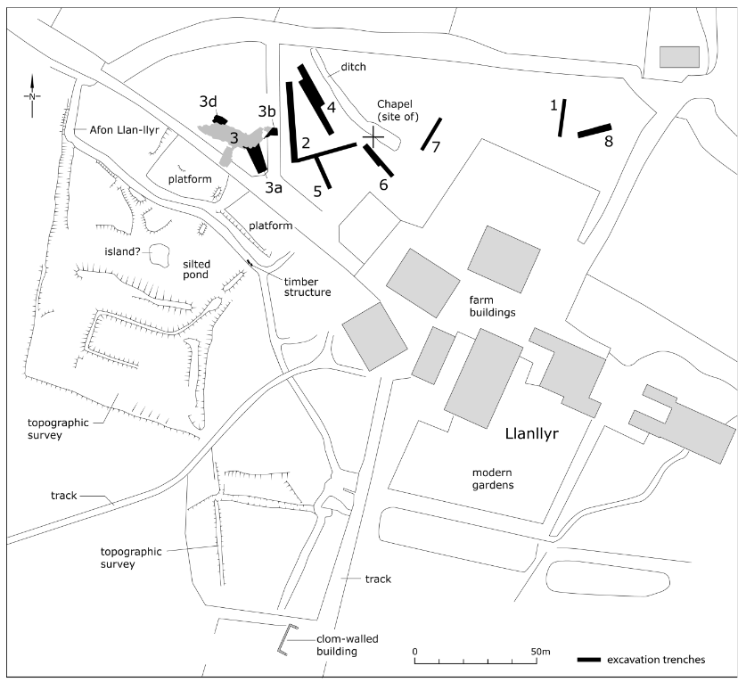
Figure 1: Figure_Llanllyr_4_Plan of the excavation trenches, the topographic survey and the
modern landscape. SURVEY AND EXCAVATION AT LLANLLYR MEDIEVAL NUNNERY AND POST-MEDIEVAL MANSION, CEREDIGION, 2014-2015, Dyfed Archaeological Trust, 2017

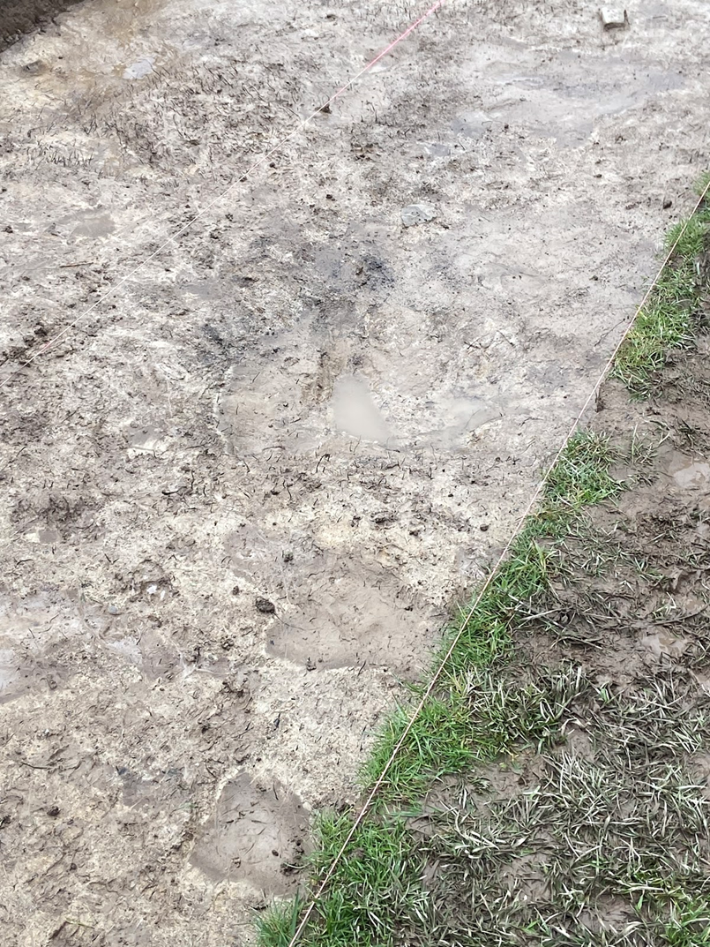

Figure 2: Llanllyr_Trench10S_1 Overhead view of T10(S), showing areas of soil darkened by materials previously being burned there. Apollo Caddy, 2024.
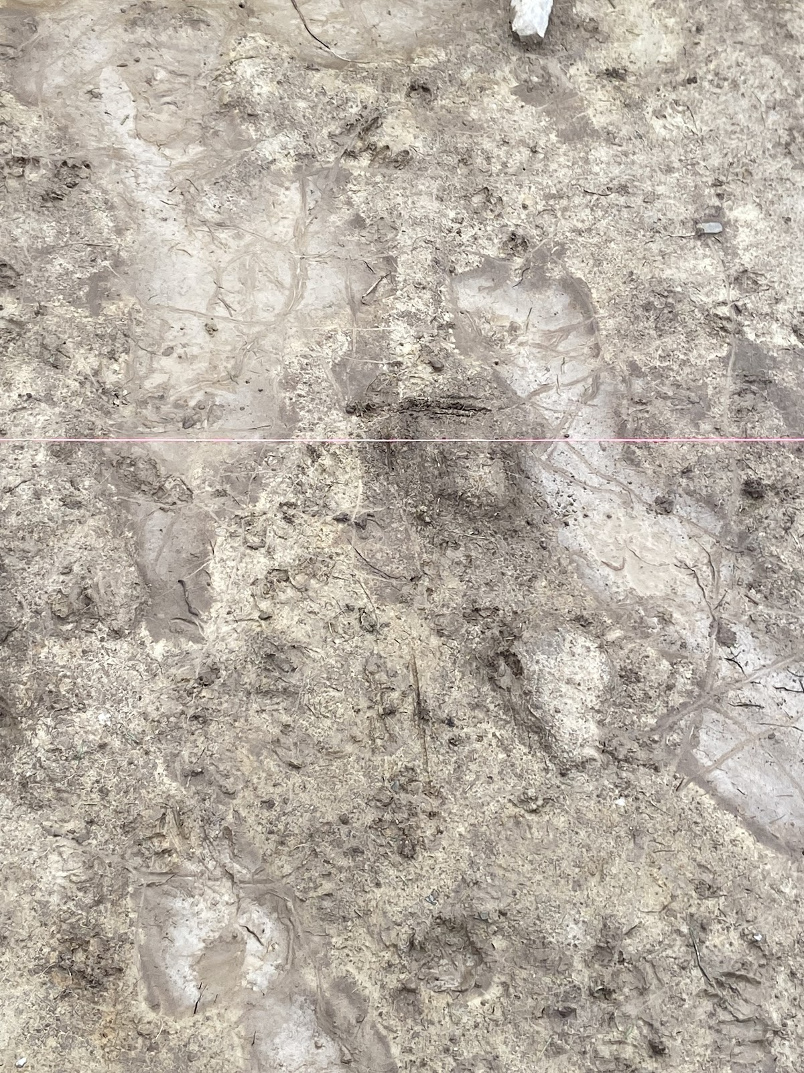
Figure 3: Llanllyr_Trench10S_2 Top down view of the rough midpoint of T10(S), showing large cracks in the surface of the uncovered soil, caused by drought. Apollo Caddy, 2024.
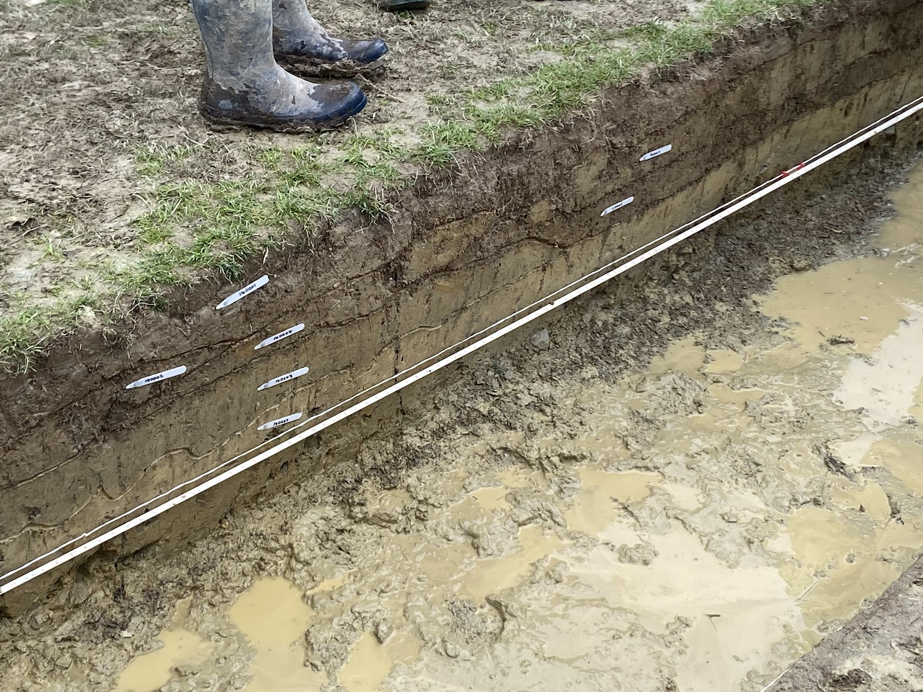
Figure 4: Llanllyr_Trench14_1 Cross section of trench 14, displaying the clear lines between different context layers. Apollo Caddy, 2024.

Murphy, 2015, p.1.
Murphy & Wilson, 2017, p.4.
Murphy & Wilson, 2017, p.4
BBC, 2014.
BBC, 2014.

