Mahmud Akbar
SN - 1711691
Programme: BA (Hons) Leadership and Management - Skills for the Workplace
Module: Developing Innovation and Creativity for Business Advantage
Module Code: BMSW6102
Lecturer: Md. Nazmul Hasan

Task 1

Innovative Product Plan

Easy use digital hair clipper
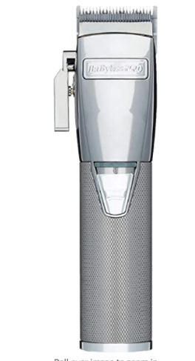

Many problems have arisen during the Corona virus pandemic, which has thrust people to becoming innovative and creative to cope with the challenges. Many people are pulling out their hair to solve the dilemmas, I mean literally because during lockdown the barber shops were closed. For many people their hair was growing very long, and it was a headache for them to get a haircut. I experienced the same hair-raising problem. Plato said, necessity is the mother of all inventions. With this in mind, I decided to use my head productively to ease this shortcoming and created an easy to use digital hair cutter, which even the novices could use.
During the national lockdown period, when the barber shops were closed, from my own experience it had a detrimental impact on many people. I tried to buy a hair clipper online and instore at Boots and at Lloyds, but to no avail, everywhere the product was sold out. This prompted me to create an easy to use hair clipper. It was the prime time to introduce the commodity, as there was an immediate and huge demand for it. In their venture to expand their organisations, incumbent businesses were overlooking this need, which provided an opportunity for small enterprises like mine, to take advantage and make their mark. The big companies like Argos, Boots and Curry’s were pre-occupied with other products and services. My little venture could never compete with them, but their lack of focus on my interest, allowed me to enter the market.

Akbar Enterprise
The name of my venture is Akbar Enterprise, trading as Easy Living Limited. It is based in an industrial estate in Birmingham. Trading away from the prime locations, makes financial sense as the rent and rates are cheaper.
Being a new business with limited resources, I have decided to collaborate with a nearby metal merchant. This Co-opetition strategy will provide a mutual business advantage (Brandenburger and Nalebuf 2020). Our co-opetition will give a leverage to increase the company’s presence in the market, provide better products and services.
I accessed Companies House online, went through the set -up process, paid the required fee, after a few checks I became the director of the company. Trading as a limited company has many benefits, it minimises personal liability, which means should the business struggle, my personal assets will be protected. Operating as limited company creates a professional image for the business, which brings a sense of credibility and trust. On the tax front, limited companies in the UK pay 19% Corporation tax on profits, compared to sole- traders who pay between 20 to 45% income tax on their profits (Rapid Formations 2015).

Akbar’s Digital Hair Clipper 2020 (ADHC 2020)
The Akbar’s Digital Hair Clipper 2020 provides the user with exceptional precision, better rotation and control with the Digital Swiping Technology, motorised combs and memory function. Moreover, the clipper generates a 4-detent taper control for comfort, speed and precision. Taper levers are placed on the side of hair clippers, which can easily be moved, using one’s thumb. This function allows the user to change the length of cut without applying graders (Hair Clippers 2018). All these features makes it very easy for the nervous, first time hair cutters or experienced users to achieve an excellent hairstyle. The clipper is designed with top quality metal and an easy grip. The clipper includes two replacement blades. Easily swipe, select and lock one of the 40 length settings from 1 to 40mm. The advanced self-sharpening titanium blades, and easy glide technology, allows you to cut hair twice as fast and give long-lasting performance.
The digital hair clipper is a universal product and useful for all types of people. It will be greatly beneficial to the male population, especially to young men who prefer to have a haircut once a month. As this clipper has functions to smoothly reduce hair from all parts of the body, it is essentially suitable for all genders and ages.

Product Design

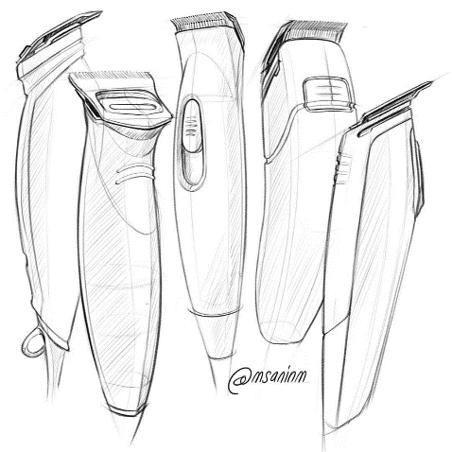
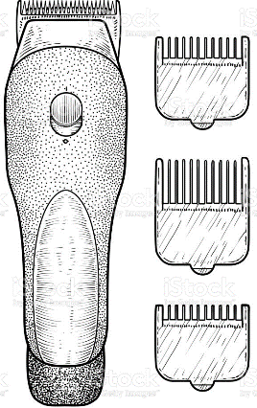

As my hair clipper is not a new invention, but which has been modified with the user-perspective in mind, to provide a solution to the immediate demand for the product. In a time of a crisis, where there is a scarcity for certain products, it is an excellent time to introduce a new or modified version to satisfy the customers demand and enhance the retention of their custom. A fundamental design objective is to keep it simple, by standardising the product and using common components, as this will make it easier to produce the commodity (Bruce and Bessant 2002).

Special Features
The digital swipe and smooth glide allows you to move through the 40 length settings by as small as 0.1mm steps. It has an innovative smart memory system, which remembers your last cutting length, so you know if that measurement was suitable or not.
Performance: this hair clipper comes with 4 adjustable combs; from 1 to 9mm, 10 to 19mm and 20 to29 mm and 30 to 40 mm. The motorised powered length setting system, automatically moves the chosen comb into the desired length, securely fastening this setting in, making things simpler and thus providing confidence to the amateur user when selecting the hair style.
Auto Turbo: The Turbo feature automatically increases the speed when approaching thick hair, allowing you to get the ideal and effortless haircut.

- Worldwide voltage for easy use around the globe.
- Rechargeable Lithium battery & mains powered.
- 2 pin- plug (wherever required).
- Titanium blades.
- Corded or cordless.
- Self- sharpening blades that sharpen themselves during use.
- Manufacturer's 2 years guarantee.
This fabulous and user-friendly digital hair clipper is available for only £29.95. As an introductory offer you can purchase our HD mirror for half price, £9.95. By using the hair clipper, in conjunction with the mirror, it will provide excellent clarity to get the perfect haircut.

Business Sustainability
Once a business starts operating, the primary concern is to be self-sufficient before profits. The first step to sustainability is to set up a budget, which will determine your financial outgoings and the capacity to publicise your business effectively. The team leader should allocate appropriate roles to the team members, as to who is responsible for what. Identify the best sources to promote your commodities. In the current climate, our strategy is to embrace the social media platforms to inform about our product.
The 21st century is the era of knowledge and 2020 can be classed as knowledge plus wisdom to tackle the challenges of COVID-19. The manager must ensure the staff are trained to be polite and offer customers the help they need, be firm on providing excellent customer services as this builds trust. The employees must be familiar with the technology, as this leads to efficient performances. The leader needs to analyse what is working well, display appreciation for it, as this creates positivity and instils confidence to all the team members. Identify the flaws, remove what is not working and focus on improvements. One must reinvest some of the profits to reinforce the business and stay ahead of its competitors.

Distribution
We need to install a reliable logistics system to provide the efficient movement of raw materials and the finished product to the right destinations. We must deploy a reliable transportation system to deliver our products safely to the customers. If the deliveries are within the Birmingham area, it makes financial sense for a member of staff to carry this out. Otherwise it is better to outsource the delivery service to companies like Royal Mail, Hermes or DPD. Our aim is to provide a fast, secure and flexible delivery service to match the quality of our product. The chart below gives an indication of the top delivery service providers in the UK.
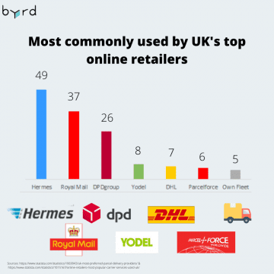

(Statista 2020).

Identifying online marketplaces
The strategy is to identify the target market and conclusively relay to them you are providing great value and a superior product to them (Kotler 1999).
With the intended customers in mind, it will be easier to customise the product or service to the right audience and promote it effectively.
I must be wise to gain the maximum effect for my money, by streamlining my marketing strategy. This whereby I create content which will be of interest to the prospective customers. I disregard what I think will be of no benefit to them. This creates better connection with the customers and makes it easier for them to make a purchase decision. According to a research by CEB, businesses who streamlined their marketing strategies were 86% more likely to make a sale (Olenski 2015).
Having analysed the data from the surveys, there are some options available to advertise the newly enhanced hair clipper:
Marketplace platforms, like Amazon, eBay, Shopify and Wix.
Social media sites such as Facebook, Instagram, Pinterest, Twitter and YouTube.
The first aim when launching a new product is to gain online visibility. One method is pay-per-click (PPC) advertising, which helps to create a promotional campaign in Adwords and Facebook Ads to reach the intended audience.

Promoting a Product
The purpose of promoting a new merchandise is to inform the prospective users, a better product is being launched for their comfort. It is best to include all the information by creating a single source, which the potential customers can refer to before making a transaction (Lynn 2020). It must include:
- The product name and photo of the model.
- A product description, explaining what it does.
- A paragraph briefly and simply defining key or new features and functions.
- One or two lines outlining the benefits of the new product.
- Details of the costs and how to purchase the merchandise.
- Provide a link to the new product and details of release dates.

Promoting a New Product Using Email Marketing
I have considered utilising email, as an effective digital marketing tool. One thing that puzzles me is that many people say we will email customers, it is not like one has a magic list of potential customers. Initially you need to procure some relevant details and one method is to pay companies who specialise in holding people’s email addresses. The best thing about this is the list has been accumulated with people’s consent, which makes it totally legitimate to utilise it. Along the away as the business communicates with the new customers, they should build up their own email profiles, by law they must gain their consent before sending future emails. This will prove more profitable, as you have may have made successful transactions with them.
The email should inform the recipient about the forthcoming launch. It should emphasize how good this product will be and briefly tell them how it will “beat the market heat” and offer a solution to their problem. It should create a sense of anticipation and make the reader want to buy the item as soon as possible.

Conventional Promotion Methods
We can advertise by using the conventional methods, local radio stations, in newspapers, posters and leaflets (Abernethy and Laband 2004). It will highlight the beauty of your product and how to purchase it. As a person who has issues with digital platforms, this will greatly appeal to people aged over fifty. Announce you will be giving away ten hair clippers to the best respondents, so they write down their names, phone numbers and addresses and send it to your company address.
Another way to attract attention in this COVID 19 related moment is to donate maybe twenty products to key workers. By giving away the products to some Birmingham Hospital staff, may attract the attention of the Birmingham Mail or the Midlands news channel. They may give coverage to the noble gesture and show the Akbar organisation in a positive manner.

Company’s own website
Creating a company website is a must for all businesses in this digital era. Having an online presence, gives the company an exclusive identity and the opportunity to be more credible and establish the business prominently. As the websites are available twenty- four hours a day, the customers and the searchers can access the site for information about current and new products and services at their convenience. Being a small enterprise, it is even more evident to have the optimum online presence, to gain the benefits of capturing the audience attention, which may lead to some sales. With this in mind I have had my company’s website created. The name of my website is www.akbarseasyliving.co.uk. It provides all the essential and latest information about my company. For my initial message, I will try to capture the customer’s interest by sending an introductory discount offer of 20%, valid for the first two months.

Shopify
Shopify is a commerce platform, that has been designed to allow budding entrepreneurs to set up an online store and sell their products. The beauty of implementing Shopify, is its speed and easy-to-use drag-and-drop store builder. This enables a person to upload their wares quickly and set up their shop and start selling.
Shopify's user interface simplifies the selling process. Start by uploading a product, adding the product's title and description and inputting the images. Once you are satisfied, click the save product button.

Shopify provides the essential features that every eCommerce website needs, such as a built-in shopping cart app that supports many secure payment methods and allows third-party integrations. The system allows you to set up discount codes and email them to the customers. Another effective sales recovery ploy is, it can allow a person to send abandoned cart emails, to remind customers of their efforts to access the site. In many cases, it creates positive responses and prompts customers to make orders from your store.

This platform’s charges are reasonable for a company that provides an all-in-one-service. Their payment methods are safe and meets all the security standards. The merchant can view the transaction in Shopify’s dashboard and know the money will be transferred into their business account within three days (Merchant Machine 2020). I will subscribe to their services, as I think it will provide excellent value.

Data Security
In 2018 data protection law was introduced to safeguard all the data of people in your information system. The companies are accountable for the security and confidentiality of its employee and customer data. It is crucial for the firms to implement data security systems to ward off any threats, to protect the information and the business’s reputation.
Antivirus, data backup like Cloud and Firewalls are examples of data protection methods. Internally, companies can apply Role-based access control (RBAC), this limits the access of data within the organisation, according to the status of the subordinates or managers (Insights for Professionals 2020). An unwritten golden rule I endorse, is never disclose any information than what is required.

After Sales Service
Providing a good after sales service is a very important factor in attracting customers into purchasing your product. It creates a sense of trust, that if anything goes wrong, they can rely on the company to fix the problem. Conducting business in the social media era, improper after sales service can lead to negative online reviews, which can be damaging for the organisation. Although, we are a small company people can contact us online or by telephone regarding any problems or advise. I strongly believe communicating by telephone is good, as talking to someone in the company is reassuring and it leads to enhancing the brand loyalty.
I firmly believe to build a brand one needs to create a meaningful social media engagement. During these difficult times, it is vital to stay connected with the customers, provide them with their needs and give them the best service and value possible.

References
Abernethy, A. And Laband, D. (2004) "The Impact of Trademarks and Advertisement Size on Yellow Page Call Rates". Journal of Advertising Research 44 (1), 119-125
Brandenburger, A. and Nalebuf, B. (2020) Coopetition Strategy | An Approach to Compete and Cooperate﻿ | Business Strategy Hub [online] available from <https://bstrategyhub.com/coopetition-strategy-an-approach-to-compete-and-cooperate%EF%BB%BF/> [20 October 2020]
Bruce, M. and Bessant, J. (2002) Design in Business. Harlow: Prentice Hall
Hair Clippers (2018) Hair Clipper Terms Explained [online] available from <http://www.hairclippers.co.uk/information/hair-clipper-terms-explained/#:~:text=The%20taper%20lever%20effectively%20allows,result%20in%20a%20shorter%20cut/> [20 October 2020]
Insights for Professionals. (2020) Learn to Love Office 365 Role-Based Access Control [online] available from <https://www.insightsforprofessionals.com/it/software/learn-to-love-office-365-role-based-access-control/> [20 October 2020]
Kotler, P. (1999) Marketing Management: Analysis, Planning, Implementation, And Control. Prentice Hall
Lynn, V. (2020) Promoting Product [online] available from <https://openviewpartners.com/author/vickilynn-brunskill/page/3/#.X5guDYj7Q2w/> [20 October 2020]
Merchant Machine. (2020) 21 Top Ecommerce Platforms for UK Businesses: 2020 Comparison [online] available from <https://merchantmachine.co.uk/ecommerce-platforms/> [20 October 2020]
Olenski, S. (2015) 4 Ways to Streamline Your Marketing Strategy [online] available from <https://www.forbes.com/sites/steveolenski/2015/09/02/4-ways-to-streamline-your-marketing-strategy/> [20 October 2020]
Rapid Formations (2015) What Is A Limited Company? [online] available from <https://www.rapidformations.co.uk/blog/what-is-a-limited-company/> [27 October 2020]
Statista (2020) Which parcel delivery provider do you prefer? [online] available from <https://www.statista.com/statistics/1069943/uk-most-preferred-parcel-delivery-providers/#:~:text=According%20to%20a%202019%20survey,was%20publicly%20owned%20until%202015/> [27 October 2020]

