Ryan Thomas
1704067
5/9/2019
BA Photojournalism and Documentary Photography

Over the course of 4 years, I have developed not just my photo skills, but the style and technique I have overall evolved into what it is now. I believe a lot of hard work to boost my skills has led me to becoming much more comfortable with the way I shoot and therefore achieve my current niche of creativity. By distancing myself away from basic landscape shots that I first began shooting, to eventually becoming more comfortable shooting people and the way they express themselves as well as their cultural or conceptual significance in the world they live in. To document these people or the environments they live in, I believe that my own unique style is significant in the story I would like to tell. In the future, I would like to tie together all these common themes consistently to create work that is particularly distinctive to myself.

To prepare my dissertation research, we were told to choose 3 specific keywords that lay the framework for our future conceptions. Following my common themes that have led my techniques and style to where they are now, I decided to start with the word or phrase “Cogito” or in full “Cogito ergo sum”, in Latin which means, “I think, therefore I am” conceived by French philosopher René Descartes in 1637. He originally believed that to think of himself as a conscientious being, he couldn't just trust his senses because as an example, even your eyes can deceive you when you see things distorted or warped by water, heat or distance, and even sound can play tricks on you. As well as this, while asleep he had dreamt that he had awoken whilst asleep, so how could he be positive he wasn't dreaming then? As a mathematician, he understood that 2+3 must equal 5 even in a dream that would be true. But he realized that even if some sort of simulation was taking control of his life, that no matter how unreliable his math may be, every thought proved that he existed as a thinking thing, and therefore contained the capacity to thinking the ways of Pathos, Logos, and Ethos. In essence, the philosophical principle that one's existence is demonstrated by the fact that one thinks, therefore gives us the act of emotional expression, rational decisions based on logic, and that allows us to conduct our behaviour in an ethical manner. The fact that Pathos, Logos, and Ethos can all be connected to this philosophical idea, demonstrates the human nature that René Descartes described in his context, “Discourse on Method”. His thesis was composed to challenge the theological faith that by ushering in scientific reason that could be based upon physical human acts (Pathos, Logos, and Ethos). Furthermore, in his argument to critics, the statement “I am” expresses an immediate intuition of oneself. Such Ideas that would be critical for my work going forward, were the ideologies that yes, we exist in life because we are capable of not just emotional expression, but also logical and ethical thought, word and deed. Tied together, the human conditions ability to express characterful expression and ideas, is one of the main premises of the work I consistently produce and will be the main framework surrounding next years work. As an example of how human existence allows us for self expression and ideas, many artists have used these human conditions to create imaginative pieces of art. Painters such as Charles Le Brun, Edvard Munch, Vermeer, and August Macke. All contain portraits or paintings of people, proving that we exist as our actions of expressions developed from the idea of René Descartes. Not only that, but photographic evidence also proves that we think (and then act in the form of expression, whether in physical or conceptual), such photographers as Ralph Waldo Emerson, Voleti Ravi Kumar, Daido Moriyama, and Erik Kim to name a few. In their work you can see that self expression isn't just through facial expressions, but the way present themselves, act, attitude, and even innocence. This is perhaps the most important follow up to this keyword because it ties up all the notions that yes, we think and act therefore we exist in a world with emotion, logic, and ethics, and therefore we can use these conceptual beliefs to create art that is as effective as it demonstrates the human condition in the world we live in.

To add to this important keyword, I have also consistently dedicated the majority of my work into the same frequently familiar theme, Optimism. Defined by the Cambridge Dictionary, optimism is the quality of being full of hope and emphasizing the good parts of a situation. Many artists choose to depict their subjects in a sorrowful, almost depressing state such as war photographers, renaissance painters, etc, whereas I have decided to consistently stick with optimistic perspectives when shooting. The reason behind this is due to the fact I enjoy showing moments that include both optimism and and people's expressions when tied in together with “Cogito Ergo Sum”. Together this produces work that has given me my particular niche. I consistently photograph moments of raw expression of happiness, love, excitement, and laughter. Such optimistic expressions are vital to the story I want to tell in my work, and will be one of three of the main themes in next years dissertation framework. As an example, this key idea of documenting subjects and environments with a positive outlook are evident when you view all my nightclub, street, and portrait photos. According to research conducted by Hannes Zacher, “optimism was shown to have a correlation with creativity or the production of new and original work“, which points out the importance that optimism plays in the role of my photos. Key painters that make use of this are painters such as Jan Steen, Judith Leyster, Franz Hall, and Jean Groberg. These painters work covers the workers in a positive way, something similar to what I have done previously and will be conducting into next year. As you can see in Jean Grobergs painting here depicting a farmer smiling is exactly what my usual objective is while going about my unique artistic style. As well as this example, you can also see from photographers such as Brian Doben and Robert Capa. Both of which are known for their amazing work but 2 particular projects that they've done, are what intrigued me due to its similarity to my work. Brian Dobens work really grabbed my attention due to the fact that covers yet more people at work, but in such a creatively positive and optimistic way in every single shot. Not only will this be a massive stepping stone for ideas going into next year but it is, precisely the line of photojournalism that my ideas surround. In each photo you can see that the subjects of the photos’ optimism gives such a creative aspect to the pieces. Not only this but just having optimism isn't diverse enough in itself, but when tying together all three main themes you can see that as a whole the images work well. A prime example of how optimism can be used diversely in such a way that photography makes a positive impact, is in Robert Cappa’s work I found that ranged from 1936 - 1944. In his photos he photographs the positive expressions of those of during the war (including the Spanish Civil War in the mid to late 1930’s). In his photographs he allowed for such positivity and optimism even in a time of hardships and troubles, whereas many other photographers may have tried to capture the dark, downtrodden, and gloomy spirits and expressions of those involved. This proves resilience that also provides unique creativity in particular situations. Such resilience is something that can be seen in his work below. One photo in particular that grabbed my attention was the one of the American soldiers celebrating the french liberation in 1944. This proves just like the previous key word, that it can be beneficial when creating art that also demonstrates how optimism can be used as a creative tool that helps create the positive outlook on the world that the artists desire for.

The last keyword can't be found to be as important in philosophical terms but in more of a contemporary sense when discussing art. This is because aesthetic, in definition is, “giving or designed to give pleasure through beauty” and part of a philosophy that tries to decipher the nature of art. Therefore, the term refers to the decorative sense and not to the intellectual. Due to the fact our perception of art primarily comes from the human nature, it makes sense that art is philosophical, and therefore, so is the form of the aesthetic. This is important to me just as much as the other two key words because it describes exactly what the photos design and composition intakes as well as the content material within the work. The correlation between design and the what the image or painting tells as a story has been critical to all art since the beginning of time. In any form of art, the piece is primarily composed into two different components, creativity and contextual ideas. So despite the fact that to produce a piece of effect art, both parts are dependent on each other, when an artist contains the contextual notion but lacks the creativity, he will only develop similar looking art time and time again without continually working on aesthetic skill. I in particular, take the aesthetic of my photography incredibly serious when planning my shots and the way I edit them afterwards. This has played a large role in the success of developing my photography niche. Prime examples of how this has developed in my work is overall vibrance, contrast and crop of all my images that set it apart by giving the sense of epic and inspiring. In not so modern times before the use of digital editing, aesthetic was based solely on the use of shadows/highlights and composition. Whereas today, aesthetic can based on both composition as well as the design and a high digital editing process. Photographers that are responsible for such intellectual ideas as well are such as Sam Kolder, Emmett Sparling, Ansel Adams, Brasai, and Chris Burkard. All these have techniques have significantly set them apart in their field of both modern and even dated photography. Through time, photo manipulation was an important part of making photos looking to their full potential in the past, that still holds today whereas it has advanced to allow us to manipulate and color our photos for our unique purposes to allow us to stand out differently. This manipulation has even become an acquired skill that if mastered, allows you to therefore become a master of your own aesthetic, something I will be basing my whole framework around. These techniques of using remarkable compositions with the utilization of both highlights and shadows in a fashion that gives the images the best aesthetic look that work even better with their contextual use. Past photographers such as Ansel Adams and Brassai are great examples of how without the use of vibrant colors they can use rule of thirds, leading lines, triangles, the use of shadows and highlights, and natural beauty (specifically Ansel Adams’ beautiful landscapes) in an effective and elegant way. More modern photographers that I mostly associate myself with such as Sam Kolder, Emmett Sparling and Chris Burkard on the other hand, also use these essential techniques but with the use of color, executing powerfully unique aesthetics that cause the photos to tell a story in a captivating and awe-inspiring way. Such examples of work below prove just how digital editing has developed the way my photographs aesthetic has become important in the way my work is presented and will therefore be decisive in the way I present my final dissertation in my final year of university. The importance of the use of unique aesthetic is something that many photographers and other artists have attached to themselves for hundreds of years to set themself appart. This is so important to me now because of how my work has developed since I first started shooting and is still continuing to evolve. As a historical significance, aesthetic in photography continues to prove that composition is unfailingly resilient amongst all art but nonetheless is forever changing and adapting in the world we live in and the issues that are presented, this will lay one of the three basis for the groundwork on my entire work next year and will provide the guidance for the design needed on all work produced.

After compiling all 3 keywords, various artists, and multiple pieces of artwork, I would have to put together a conceptual question that would overall define my entire 3rd year dissertation. While bringing together Cogito; the fact we are capable of thought and therefore emotional, logical, and ethical expression, optimism; the ability to document subjects and environments that contain vast amounts of happiness, excitement and laughter, and lastly aesthetic; the use of ornamental design and composition that is an effective tool, I have resulted in what will be my plan for the coming years in development in my work. The fundamental characteristic of this question is that it needed to be able to set myself up for not just the proposal next year but as a foundational base for the coming years as a conceptual artist in an ever changing social environment. The question, “As human beings, it is evident that we are capable to sustain the illelectual ability to think, therefore giving us the conscience to act upon our thoughts by turning them into emotional, logical and ethical ideas that we can therefore use to create an optimistic and uniquely diverse world but what exactly bounds us from constantly evolving these ideas and how do we as artists adapt to these changes while using our photographic skill set to document human existence for the future?“

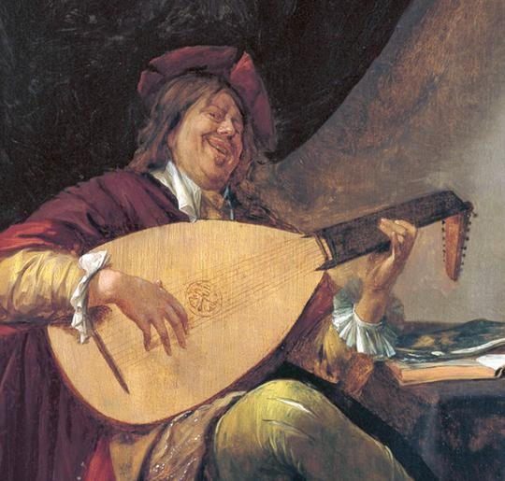 Jan Steen (1600?)

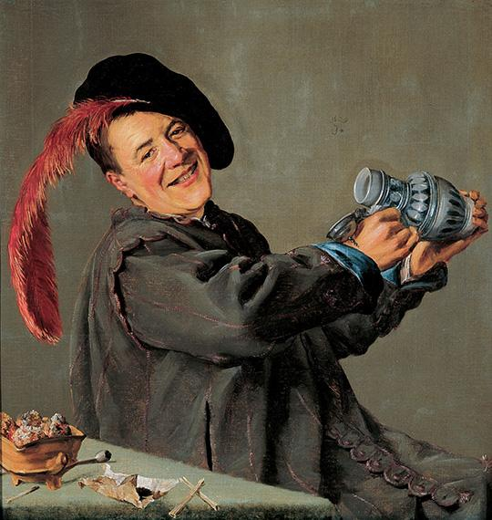 Judith Leyster (1629)

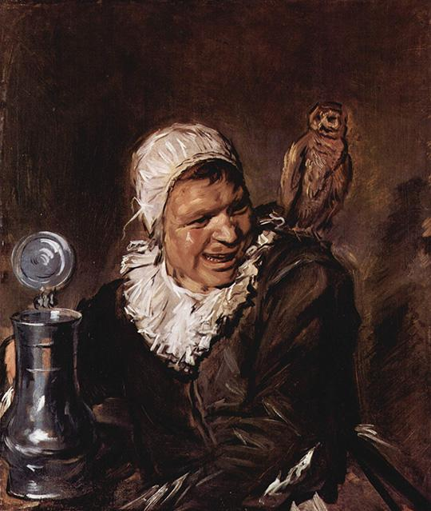 Franz Hal (1633- 35)

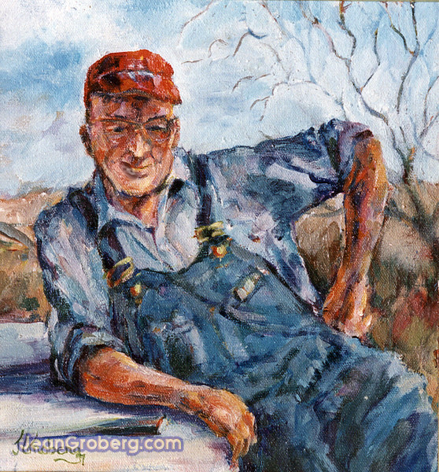 Jean Grober (1963)

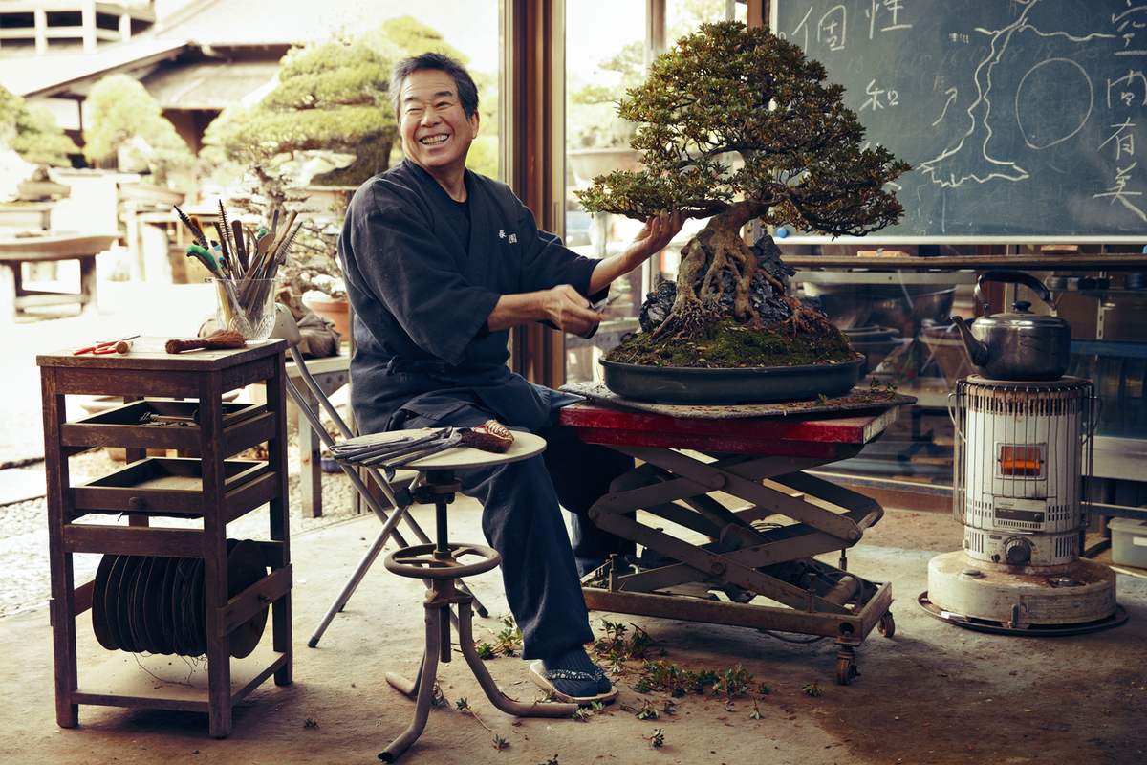 Brian Doben (2015)

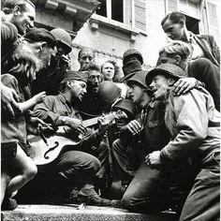 Robert Cappa (1944)

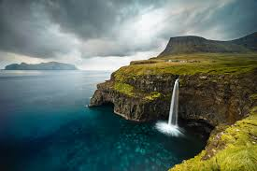 Chris Burkard (2017)
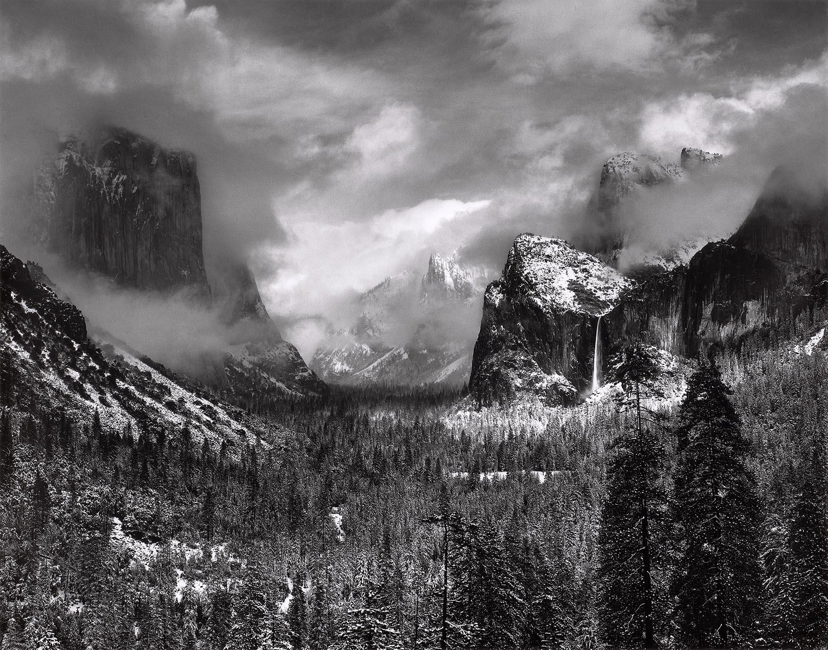 Ansel Adams (1942)

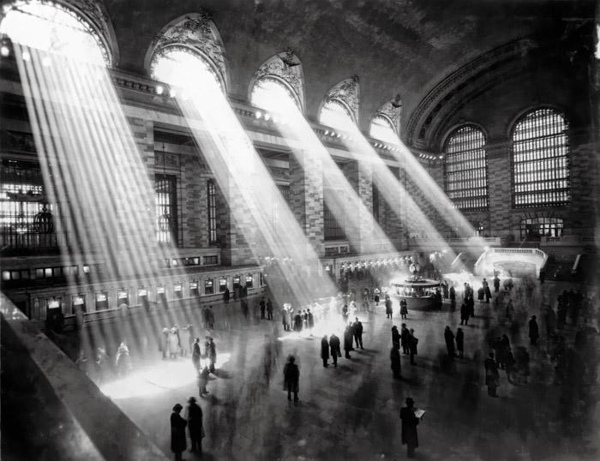 Brassai (1953)

References

Anon, (2019). [online] Available at: https://www.quora.com/How-do-people-express-themselves [Accessed 9 May 2019].
Artnaudas Blog. (2019). IMPORTANCE OF AESTHETICS IN ART. [online] Available at: http://artnaudas.com/blog/importance-of-aesthetics-in-art/ [Accessed 9 May 2019].
BETA, A. and HERE, S. (2019). How to Express Yourself Through Photography. [online] ERIC KIM. Available at: http://erickimphotography.com/blog/2018/01/19/how-to-express-yourself-through-photography/ [Accessed 9 May 2019].
British Journal of Photography. (2019). self-expression. [online] Available at: https://www.bjp-online.com/tag/self-expression/ [Accessed 9 May 2019].
Chrisburkard.com. (2019). Chris Burkard. [online] Available at: https://www.chrisburkard.com/ [Accessed 9 May 2019].
Citeseerx.ist.psu.edu. (2019). [online] Available at: http://citeseerx.ist.psu.edu/viewdoc/download?doi=10.1.1.81.5178&rep=rep1&type=pdf [Accessed 9 May 2019].
CULTURAL STUDIES 101. (2019). Turtles all the way down. [online] Available at: https://culturalstudies101.wordpress.com/2011/11/30/turtles-all-the-way-down/ [Accessed 9 May 2019].
Davidepetilli.com. (2019). [online] Available at: http://davidepetilli.com/blog/photography-means-expression/ [Accessed 9 May 2019].

Dictionary.cambridge.org. (2019). OPTIMISM | meaning in the Cambridge English Dictionary. [online] Available at: https://dictionary.cambridge.org/dictionary/english/optimism [Accessed 9 May 2019].
Dubovoy, M., Dubovoy, M., Dubovoy, M., Dubovoy, M., Dubovoy, M., Dubovoy, M., Dubovoy, M., Dubovoy, M., Nachoum, A., Dubovoy, M., Dubovoy, M., Taskett, J., Nachoum, A., Martin, J., Cramer, C., Witherill, H., Dubovoy, M., Dubovoy, M., Nachoum, A., Dubovoy, M., Cramer, C., Witherill, H., Dubovoy, M., Dubovoy, M., Dubovoy, M., Cramer, C., Nachoum, A., Witherill, H., Dubovoy, M., Dubovoy, M. and Taskett, J. (2019). Photo Aesthetics - The Best of Photography: Images, Articles, Opinion, Reviews and Techniques. [online] Photo Aesthetics. Available at: https://photoaesthetics.com/ [Accessed 9 May 2019].
From the Grapevine. (2019). 7 dazzling drone photographers to follow on Instagram. [online] Available at: https://www.fromthegrapevine.com/nature/best-drone-photographers-follow-instagram [Accessed 9 May 2019].
Huffingtonpost.co.uk. (2019). HuffPost is now part of Oath. [online] Available at: https://www.huffingtonpost.co.uk/2015/05/28/brian-doben-at-work_n_7374334.html?guccounter=1&guce_referrer=aHR0cHM6Ly9jb25zZW50LnlhaG9vLmNvbS8&guce_referrer_sig=AQAAAJgnmGL04x65QeIz_KnAdK6bT1GYUhJrsIT8I3GkVespQ3gzRx629SoNA4k0nBcxJdtAYk_-K6oCqouOD6q_1uHk75dfCJs444jd6N35OZDOmpN-rutTrnTkMNAS2-E9UA_RLQD8h8c778g83j66X6yaRplSQw0t5TM1YdBvDfFk [Accessed 9 May 2019].
Huffpost.com. (2019). HuffPost is now a part of Oath. [online] Available at: https://www.huffpost.com/entry/express-yourself-why-expr_b_7166602 [Accessed 9 May 2019].
Hull, C. and >, M. (2019). 27 Most Famous Photographers You Need To Know. [online] ExpertPhotography. Available at: https://expertphotography.com/most-famous-photographers/ [Accessed 9 May 2019].
Instagram.com. (2019). EMMETT SPARLING (@emmett_sparling) • Instagram photos and videos. [online] Available at: https://www.instagram.com/emmett_sparling/?hl=en [Accessed 9 May 2019].
Instagram.com. (2019). Sam kølder (@samkolder) • Instagram photos and videos. [online] Available at: https://www.instagram.com/samkolder/?hl=en [Accessed 9 May 2019].
Jeangroberg.com. (2019). People Denim. [online] Available at: http://www.jeangroberg.com/pages/2bd/People-Denim.html [Accessed 9 May 2019].
Macke, A. (2019). August Macke. [online] Ranker. Available at: https://www.ranker.com/review/august-macke/512532?ref=node_name&pos=14&a=0&ltype=n&l=301720&g=1 [Accessed 9 May 2019].
Metmuseum.org. (2019). [online] Available at: https://www.metmuseum.org/press/exhibitions/2015/about-face [Accessed 9 May 2019].
Oxford Dictionaries | English. (2019). aesthesic | Definition of aesthesic in English by Oxford Dictionaries. [online] Available at: https://en.oxforddictionaries.com/definition/aesthesic [Accessed 9 May 2019].
Oxfordbibliographies.com. (2019). History of Aesthetics - Philosophy - Oxford Bibliographies - obo. [online] Available at: http://www.oxfordbibliographies.com/view/document/obo-9780195396577/obo-9780195396577-0002.xml [Accessed 9 May 2019].
Pankajsharmaphotography.blogspot.com. (2019). "Abhivyakti" : Expression Through Photography. [online] Available at: https://pankajsharmaphotography.blogspot.com/ [Accessed 9 May 2019].
PetaPixel. (2019). Understanding Basic Aesthetics in Photography. [online] Available at: https://petapixel.com/2016/08/08/understanding-basic-aesthetics-photography/ [Accessed 9 May 2019].
Philosophy & Philosophers. (2019). 20 philosophical words you need to know. [online] Available at: https://www.the-philosophy.com/20-philosophical-words-you-need-to-know#Empiricism [Accessed 9 May 2019].

The Public Domain Review. (2019). The Serious and the Smirk: The Smile in Portraiture. [online] Available at: https://publicdomainreview.org/2013/09/18/the-serious-and-the-smirk-the-smile-in-portraiture/ [Accessed 9 May 2019].
Staff, A. (2019). How Artists Use Facial Expressions to Lure Us into Their Worlds - Artists Network. [online] Artists Network. Available at: https://www.artistsnetwork.com/art-mediums/oil-painting/how-artists-use-facial-expressions-to-lure-us-into-their-worlds/ [Accessed 9 May 2019].
YourDictionary. (2019). Examples of Ethos, Logos, and Pathos. [online] Available at: https://examples.yourdictionary.com/examples-of-ethos-logos-and-pathos.html [Accessed 9 May 2019].
YouTube. (2019). Rene Descartes - “I think, therefore I am”. [online] Available at: https://www.youtube.com/watch?v=0A6UKoMcE10 [Accessed 9 May 2019].

