Student name: Mary Bath

Student Number: 1802660

Programme of Study: Illustration (BA)

Module: ADAD5004 Research in Practice

Word count: 2708

Tutors Name: Delyth Lloyd-Evans

Three Keywords: Fairy tales, Sexism and reimagined

This proposal will explore the three words; fairy tales, sexism and re-imagined, focusing on the problematic themes and stereotypes of women within fairy tales. I will examine the origin of these tales and how they have changed with examples of modern adaptations. This proposal will also explore how these words are represented in illustration. Through researching these three keywords I hope to compile a question for my independent project.

Fairy tales

Many have become accustomed to stereotypical children’s fairy tales, in which a princess is rescued from evil by a heroic man, to marry and live happily ever after. However, research reveals many of the original tales are much darker than modern adaptations present them. Derived from folklore, they often contain themes of murder, cannibalism, mutilation and incest (Tatar, 2019). For instance, The Little Mermaid makes a deal with the sea witch who silences her by cutting off her tongue in exchange for legs, only after losing her prince to a human. Cinderella’s evil stepmother hands a knife to the stepsister to cut off their toes and heel to fit into the glass slipper which ended with their eyes being pecked out by doves. These tales sound like modern horror films, but these tales were not originally made for children. The Brothers Grimm published their first edition of Hausmärchen or the English translation Nursery and Household Tales in 1812-15, predominantly aimed at adults but after disappointing sales, the Brothers Grimm made the material suitable for younger audiences by decreasing the themes of sex but keeping many of the violent scenes (Kiger, 2021). Although the themes are distressing and horrific, they are typically laced with moral lessons, characters that display virtue prevails over evil, and villains are punished (Evans, 2014). These stories are powerful in presenting cultural motives and ideals to children (Baker-Sperry & Grauerholz, 2003).

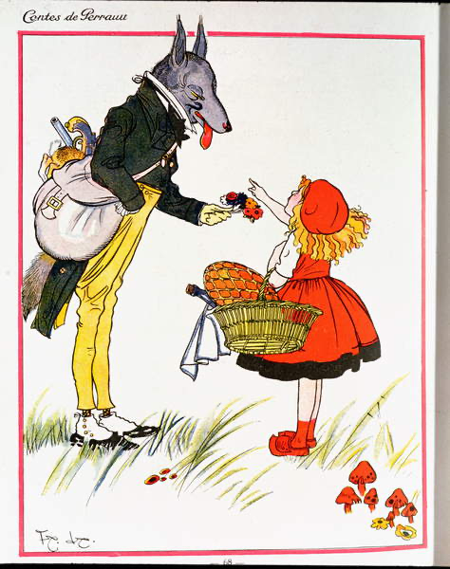
Fig. 1, Little Red Riding Hood meeting the Wolf, Felix Lorioux, 1919

Le petit chaperon rouge, also known as Little Red Riding Hood by Charles Perrault (1697) exemplifies how horror and distressing themes can be used as a lesson for children. The tale is about a young girl taking a journey through the woods to deliver food for her sick grandmother. She comes across a sly and cunning wolf asking her where she is going, which she naïvely tells him. He tells her to take another route to see who would arrive first. Red Riding Hood went the long way, the wolf reaches the grandmother first. He eats the grandmother whole and disguises himself as her and awaits Little Red Riding Hood. On arrival, Red Riding Hood is unaware her grandmother had been replaced. The wolf asks her to get into bed with him, so she undresses and gets into bed. Upon closer inspection she says “Grand-mamma, what great arms you have”, to which he replies, “all the better to hug thee, my dear”. She makes more observations until she says “Grand-mamma, what great teeth you have got!” which leads the wolf to say, “That is to eat thee up”. There follows a uniquely horrible ending of Little Red Riding hood being eaten by the wicked wolf (Perrault, 2012, pp. 23-25).

Unlike other versions of this story where Little Red Riding-hood manages to escape or when the huntsman cuts open the wolf to save the grandmother and Red Riding Hood, she does not survive. Perrault wanted to use this tale as a warning for children, especially pretty, well-bred girls to never approach wolves, especially those who appear charming and good-natured, as they might be the “most dangerous of all” (Bacchilega, 1997, pp. 53-54). Felix Lorioux’s illustration Little Red Riding Hood meeting the Wolf (1919) as seen in fig 1, is a perfect interpretation of the message Perrault is trying to present. The illustration presents a well-dressed wolf, gentleman-like, handing flowers to Little Red Riding Hood. The wolf seems kind towards Red Riding Hood, wearing 1500s style clothing, a bag on his shoulder which carries some hunting guns and concealed dead rabbits, his true nature juxtaposing with his disguise. Unlike Perrault’s tale where her mother gifts her a red riding hood, the illustration displays her wearing a red dress. She is seen as a very young girl with blonde hair. The red hue of the hood could be a representation of coming of age (Silva, 2016).

Sexism

Children are accustomed to fairy tales where a brave knight embarks on a quest to save a beautiful princess, but this begs the question why do princesses need to be saved? While the boys have strong and heroic characters to look up to, girls usually have victims who devote themselves to marrying their saviour instead of independent and intelligent role models. This narrative structure influences how gender is perceived by children.

There are often sexist stereotypes in the fairy tales we know today. These tropes include the evil witch and evil stepmother, as seen in Sleeping Beauty, Cinderella and Snow White and many more. These stereotypes indicate women are unsupportive and a threat to each other. Due to these stereotypes, female heroines frequently lack female role models and must rely on males for a healthy relationship (Orenstein, Baker-Sperry, & Kaufman, 2021).

Women's suffering is displayed in many fairy tales, the word ‘tears’ is in correlated with women more than men as well as the words ‘bitter tears’ (Jorgensen, 2019). A disturbing sexist stereotype within fairy tales is the romanticized sexual violence and assault. In the original tale of sleeping beauty titled Sun, Moon, and Talia by Giambattista Basile 1634, the king impregnates the sleeping princess. She awakens after giving birth to twins which sucked the splinter out of her finger. In the end, the princess and the king get married after killing his recent wife (Basile, Perrault, & Lawrence, 2014). To desensitize the story the Grimm’s brother’s adaptation Briar Rose, introduced a true love's kiss to wake up the princess, which is also problematic as it is still not consensual but has been used widely and romanticised in fairy tales including Disney’s Snow White and Sleeping beauty.

Women protagonists in fairy tales are often described as passive, domestic fair and pretty, whereas antagonist is described as ugly, wicked and vicious (Jorgensen, 2019). The feminine beauty ideal is presented often in fairy tales, they portray physical appearance as one of women’s most valuable attributes, that all women should strive to acquire (Baker-Sperry & Grauerholz, 2003). This implies that unless you are the feminine beauty ideal, you are undeserving of a happy ending. They display outdated societal perspectives, female characters are frequently suppressed; a happy ending necessitates patriarchal and heterosexual households (Kelly, 2021). The celebration of marriage also suggests that unmarried women are worthless (Orenstein, Baker-Sperry, & Kaufman, 2021)

A study conducted by Baker-Sperry and Grauerholz titled The Pervasiveness and Persistence of the Feminine Beauty Ideal in Children's Fairy Tales highlighted that 94 percent of tales mentioned physical appearance, and women's beauty was mentioned five times more than mentions of men’s handsomeness. Beauty and attractiveness were a dominant trait in female characters compared to male (Baker-Sperry & Grauerholz, 2003).

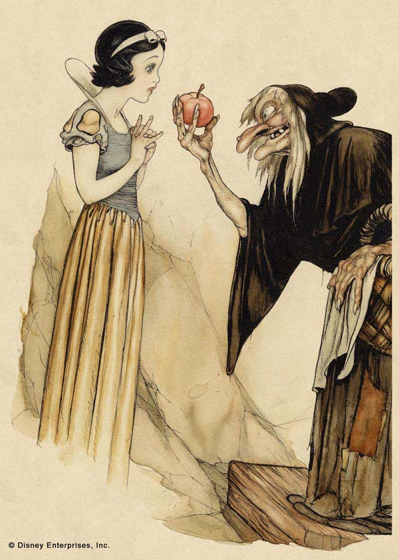
Fig. 2, Snow White and Witch with Poisoned Apple, Gustaf Tengrren, 1937

Although beauty is rewarded in many Grimm’s tales it can also attract danger and harm (Baker-Sperry & Grauerholz, 2003). Snow White is a perfect example of how beauty is valued within fairy tales. Grimm’s Sneewittchen or the English translation Little Snow-White (1812) is about a princess, Snow White who is endangered when her evil stepmother (the Queen) orders a huntsman to kill her to maintain the title of ‘the fairest of us all’. Snow White escapes and finds refuge in a cottage homed by seven dwarves. The Queen disguises herself to murder Snow white herself, this consisting of a bodice that she pulls so tight, Snow White faints before being rescued by the dwarfs. Unsuccessful the queen returns with a poisoned comb. After another failed attempt she offers her a poisoned apple that would put her into a deep sleep. The dwarves return, convinced she is dead they place her in a glass casket. Later a prince finds her while hunting; entranced by her beauty he asks the dwarfs for permission to take her. His attendants tripped while carrying her on their shoulders dislodging the piece of poisoned apple, resulting in her waking and marrying the prince. The Queen asks once more to the mirror ‘who is the fairest of us all’, it answers ‘prince’s bride’, curious to see who this was she goes to the wedding shocked to see it is Snow White. The couple tortures her by forcing her to dance with red hot iron slippers until she dies, and they live happily ever after (Grimm, 1985).

The basis of Snow White’s is beauty and jealousy. The evil Queen valued it so much she would have murdered her stepdaughter to preserve her prominence. Praise for beauty is promoted in the narrative, especially with the magic mirror. The Queen seeks reassurance that she is the most beautiful but when Snow White takes the title she feels threatened as beauty is her symbol of her worth. Disney’s adaptation gave the mirror a masculine voice and appearance, this could be interpreted as male validation.

Although the Disney adaptation Snow White and the seven dwarfs (1937) was a similar story, the king was not present, pulling the focus towards the evil stepmother. Again, the Queen gave her the poisoned apple, but in this version, she was awoken by a true love's kiss. The Queen still dies but from her own actions, not from the red-hot iron shoes by Snow White and the prince, thus maintaining their image of ‘good characters’.

The protagonist, Snow White is described “as white as snow, as red as blood, and as black as ebony wood” (Grimm, 1985, p. 251), which are all colours that symbolize coming of age. White symbolises purity and innocence, red the colour of passion and life while black represents death. Disney’s character design of Snow White illustrated by Gustaf Tengreen fig 2, resembles the description closely of Grimm’s original text. Her skin is smooth and pale, small button nose and small physique, are all elements of society's perfect feminine beauty. Her hair follows 1930s beauty standards, decorated with a white ribbon, later changed to red, to make her forehead appear smaller thus making her features ‘cute, slender and dainty’ (Pallant & Holiday, 2021). She wears a perfect delicate gown with a blue corset, yellow skirt, slashed puffed sleeves and a white collar, very much inspired by medieval fashion (Pallant & Holiday, 2021). It is hinted that Disney’s adaptation of snow white is aged fourteen unlike the Grimm’s fairy tale which is only seven years old (Zipes, 2002), yet she appears to be a fully matured woman with hints of naivety like her rounded cheeks. While the film avoids saying her exact age the artists were told to make her look “old enough to marry” ( Norman Rockwell Museum , 2022). The illustration displays the stepmother camouflaged as a crone, handing Snow White a poisoned red apple. The stepmother portrays the opposite of the feminine ideal, her skin is wrinkled with a large nose, grey thin hair and missing teeth. This further suggests how youth plays an important part in attractiveness and beauty. Her posture is hunched unlike Snow White and displays a menacing grin. The Queen wears a black cloak closely resembling the grim reaper, the black foreshadowing death. The red apple plays a biblical reference to the forbidden fruit and danger.

Reimagined

Feminist ideas have contributed to the critique of fairy tales, not just for their portrayal of women as helpless and their portrayal of males as heroes, but also for reinforcing patriarchal ideologies (Dallacqua, 2018). Disney’s animated films played a huge part in shaping fairy tales in today’s culture. In several Disney movies such as sleeping beauty and snow white, women are painted as defenceless requiring saving and are absent from the action (Dallacqua, 2018). However, recent movies have taken the opposite approach. For example, Disney’s movie Frozen (2011) was praised for its absence of a male saviour and instead of ending the story with marriage to a prince, the sister is saved through platonic sisterly love (Streiff & Dundes, 2017). Other examples include Brave (2012) which is about a princess who would do anything to avoid getting married and focuses on the trials and tribulations of a mother-daughter relationship, and Moana (2016) an independent, brave princess who sails the sea to save her island. Media has reinvented and fractured fairy tales to be more inclusive with female empowerment, including children’s picture books.

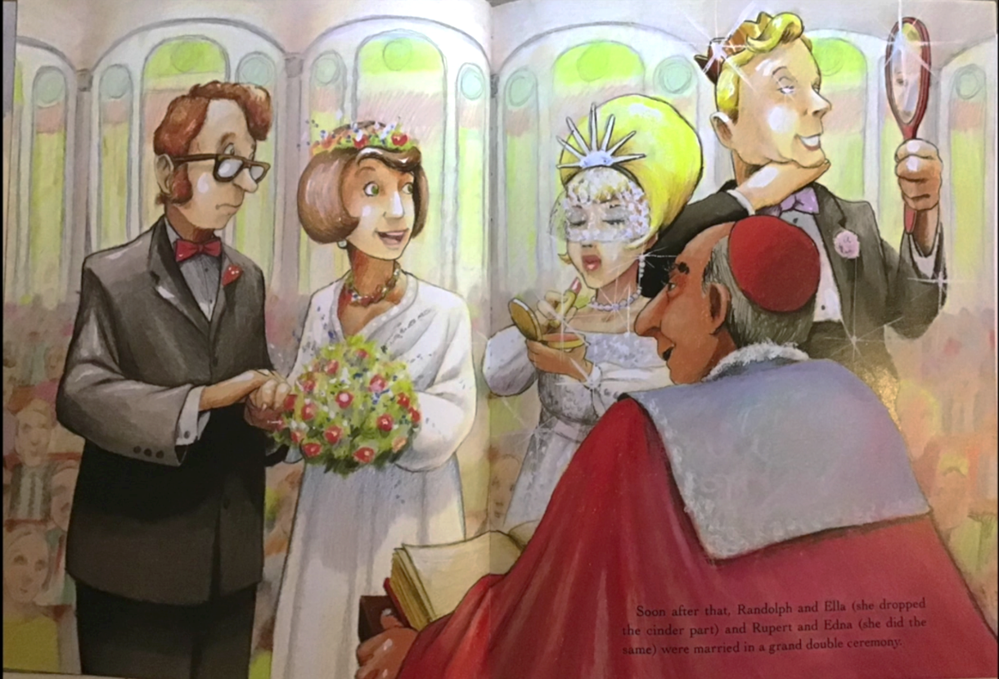
Fig. 3, Cinder Edna, Ellen Jackson, 1998

Cinder Edna by Ellen Jackson 1994 has a feminist twist on the classic tale of Cinderella. This consists of a woman who lives next door to Cinderella, both have evil stepmothers and stepsisters. Cinderella thinks about her troubles when she’s done with her chores, and Edna learns skills like making tuna casserole in sixteen different ways and earning from doing jobs for neighbours. When Cinderella wanted to go to the ball she wished for a fairy godmother, Edna used the savings to buy a gown to attend the ball herself. Cinderella falls in love with Prince Randolph at the ball, and Edna falls for his earth-friendly and kind younger brother Rupert. Like the classic tale, Cinderella and Edna must leave at the stroke of midnight. While Randolph looks for someone to fit in the glass slipper, Rupert finds Edna by asking her to recite the sixteen different ways she can make a tuna casserole that she told him that evening. They all get married, and Cinderella ends up in a castle having to listen to boring speeches from the Grand Archduke while Edna and her prince make casseroles and play duets in their cottage. The final page asks the reader “Guess who lived happily ever after?” (Jackson, 1998). This 90s fractured fairy tale represents that you do not need to be the prom queen to have a happy life but by pursuing one’s efforts you can achieve one’s desires and people would appreciate your inner qualities (Schaaff, 2014).

Cinder Edna is described as “not much to look at” while Cinderella was described as beautiful. There’s a constant comparison of the two characters throughout almost as if they are competing. Towards the end of the book fig. 3 shows their wedding. Cinderella is attired following society's ideal feminine with blonde hair and delicate features. While Edna has a humbled appearance, short brunette hair and more pronounced features. A study conducted by Clare Bartholomeus indicated that some children found it difficult to identify with Edna and would rather identify with Cinderella. Many girls prefer stories which include princess heroes as the protagonist (Batholomaeus, 2016). Arguably, switching stereotype of beauty is not enough to disrupt the course of the feminine beauty ideal in fairy tales.

Researching the three keywords has led me to conceptualise the direction of my writing for next year’s project. Looking into fairy tales, sexism and reimagined, and the interrelationship between the three words, has opened many paths and potential to investigate further. Through research, I found that fairy tales used to be quite graphic and disturbing, but many of the unsavoury aspects have been sanitized. Beauty is frequently rewarded whereas its absence is punished. Changing the narrative of beauty may not be the best approach to making feminist tales for younger audiences. I want my practice-based project to be a representation of a progressive feminist version of what is lacking in many of the original fairy tales.

The key question I have come to is; What makes a feminist fairy tale? I will further my research with sub-questions such as why have fairy tales become so desensitized? Why are women put in peril? What motifs are behind the stereotyping of women? Is beauty displayed as a negative trope?

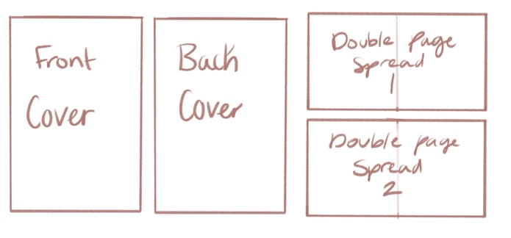
Fig, 4

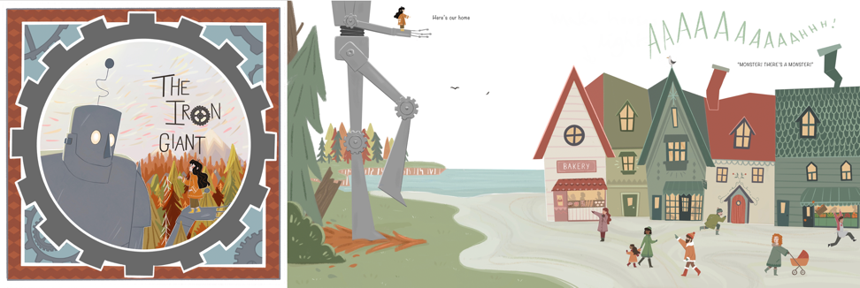
Fig, 5

My proposed practice-based project would consist of a front and back cover, as well as 2-3 double-page spreads of a children’s picture book. A tale from Forgotten Fairy Tales of Brave and Brilliant Girls by Kate Pankhurst. Using an example of my past work fig, 5 will consist of illustrations and text in a square format.

Bibliography

Bacchilega, C. (1997). Postmodern Fairy Tales: Gender and Narrative Strategies. Philadelphia, Pennsylvania : University of Pennsylvania Press .

Baker-Sperry, L., & Grauerholz, L. (2003). The Pervasiveness and Persistence of the Feminine Beauty Ideal in Children's Fairy Tales. Gender and Society, 17(5), 711-726. DOI: 10.1177/0891243203255605

Basile, G., Perrault, C., & Lawrence, R. L. (2014). Talia, The Sleeping Beauty A European Fairytale. Blackdown Publications .

Batholomaeus, C. (2016). 'Girls can like boy toys': junior primary school children's understandings of feminist picture books. Gender and education, 28(7), 935-950. DOI: 10.1080/09540253.2015.1106443

Dallacqua, A. K. (2018). Wondering About Rapunzel: Reading and Responding to Feminist Fairy Tales with Seventh Graders. Children's literature in education, 50(3), 261-277. DOI: 10.1007/s10583-018-9352-z

Evans, S. (2014). Are Grimm’s Fairy Tales too twisted for children?, from BBC : https://www.bbc.com/culture/article/20130801-too-grimm-for-children [Accessed: 24th April 2022]

Grimm, T. B. (1985). The Complete Illustrated Stories Of The Brothers Grimm. London: Chancellor Press.

Jackson, E. (1998). Cinder Edna. United Kingdom : HarperCollins.

Jorgensen, J. (2019). The Most Beautiful of All: A Quantitative Approach to Fairy-Tale Femininity. The Journal of American folklore, 132 (523), 36-60. DOI: 10.5406/jamerfolk.132.523.0036

Kelly, C. (2021). Feminist Fractured Fairy Tales: Angela Carter, Emma Donoghue, and Heroines Who Embrace Their Desires. Southern New Hampshire University

Kiger, P. J. (2021). 10 Fairy Tales That Are Way Darker Than You Realized as a Kid. from howstuffworks: https://people.howstuffworks.com/10-dark-fairy-tales.htm [Accessed: 24th April 2022]

Kowalski, J. M. (2020, Sebtember 23). Enchanted: Illustrated Fairy Tales . from Illustration History An educational resource and archive : https://www.illustrationhistory.org/essays/illustration-in-fairy-tales [Accessed: 24th April 2022]

Norman Rockwell Museum . (2022). SNOW WHITE and the SEVEN DWARFS the creation of a classic. from NORMAN ROCKWELL MUSEUM: https://www.nrm.org/snowwhite/selected_works.html [Accessed: 26th April 2022]

Orenstein, P., Baker-Sperry, L., & Kaufman, A. S. (2021). Traditional fairy tales prepetuate sexist ideas , from Parila: https://www.parlia.com/a/fairy-tales-perpetuate-sexism-patriarchy [Accessed: 26th April 2022]

Pallant, C., & Holiday, C. (2021). Snow White and the seven dwarfs: New Perspective on Production, Reception, Legacy. New York: Bloomsbury Acedemic.

Perrault, C. (2012). Little red riding hood by Charles Perrault. United Kingdom: Dover Publications Incorporated .

Schaaff, S. M. (2014). What We're Reading: Cinder Edna: Edna is the anti-Disney princess, with a lot of wit, charm and moxie . Washington Post – Blogs. Washington: WP Company LLC d/b/a The Washington Post. [Accessed: 4th May 2022]

Silva, F. V. (2016, October 1). Charles Perrault and the Evolution of "Little Red Riding Hood". Marvels & tales, 30(2), 167-190. DOI: 10.13110/marvelstales.30.2.0167

Streiff, M., & Dundes, L. (2017, March 26). Frozen in Time: How Disney Gender-Stereotypes Its Most Powerful Princess. Social sciences (Basel), 6(2), 38. DOI: 10.3390/socsci6020038

Tatar, M. (2019). The Hard Facts of the Grimms' fairy tales (Vol. Expanded edition). Princeton, NJ: Princeton University Press.

Zipes, J. (2002). Snow White and the Seven Dwarfs. The Oxford Companion to Fairy Tales.

List of Figures

Fig. 1, Lorioux, F. (1919) Little Red Riding Hood meeting the Wolf (colour engraving) Available at: https://www-bridgemaneducation-com.ezproxy.uwtsd.ac.uk/en/asset/200551/summary [Accessed at: 23rd April 2022]

Fig. 2, Tengrren, G. (1937) Snow White and Witch with Poisoned Apple, (Book illustration; watercolour and ink on paper) Available at: https://www.nrm.org/2013/06/snow-white-in-the-press/snow-white-and-witch-with-poisoned-apple-gustaf-tenggren/ [Accessed at: 24th April 2022]

Fig. 3, Jackson, E. (1998) Cinder Edna. HarperCollins

Fig. 4, Bath, M. (2022) Picture book diagram

Fig. 5, Bath, M. (2021) Iron man picture book

