International Marketing Strategy of BMW

module TITLE: INTERNATIONAL marketing

student NAME: OLAWUNMI oshodi

student id: 1706254

TUTOR: DR RICHARD small

TABLE OF CONTENTS
LIST OF TABLES 2
LIST OF FIGURES 2
1. INTRODUCTION 3
2. ORGANIZATIONAL AND PRODUCT OVERVIEW 4
2.1 COMPANY BACKGROUND 4
2.2 PRODUCT AND OFFERING 4
2.3 SWOT ANALYSIS FOR BMW GROUP 4
3. MARKET ANALYSIS 5
3.1 COUNTRY 1: UNITED KINGDOM 6
3.2 COUNTRY 2: UNITED STATES 6
4. COMPARISON OF THE MARKETING STRATEGY USED IN EACH COUNTRY 7
4.1 COMPARING AND CONTRASTING THE STP 8
4.1.1 SEGMENTATION STRATEGY OF THE BMW 8
4.1.2 TARGETING STRATEGY OF THE BMW 8
4.1.3 POSITIONING STRATEGY OF THE BMW 9
4.2 COMPARING & CONTRASTING THE MARKETING MIX 11
4.2.1 PRODUCT STRATEGY 11
4.2.2 PLACE AND DISTRIBUTION MIX OF BMW 12
4.2.3 PRICING STRATEGY 13
4.2.4 PROMOTIONS MIX 13
4.3 COMPARING & CONTRASTING DIRECTIONAL DEVELOPMENT STRATEGY OF THE BMW 14
5. STANDARDIZATION AND SOCIAL FACTORS, CULTURE AND LANGUAGE 16
5.1 DIFFERENTIAL ANALYSIS 16
5.1.1 PRODUCT TYPE/ PRODUCT STRATEGY 16
5.1.2 SOCIAL, CULTURAL AND LANGUAGE FACTORS 16
5.2 GLOBAL MARKETING, STRATEGIC ADOPTION & ECONOMIES OF SCALE 16
5.2.1 GLOBAL MARKETING STRATEGY OF BMW 16
5.2.2 STRATEGIC ADOPTION AND ECONOMIES OF SCALE 18
5.3 APPLICATION OF THE 4C’S MODEL 19
6. SIMILARITIES AND DIFFERENCES BETWEEN THE ORGANIZATIONAL STRATEGIES & APPROACHES 20
7. APPRAISING THE CURRENT STRATEGIES USED 21
7.1 COUNTRY 1: UNITED KINGDOM 21
7.2 COUNTRY 2: UNITED STATES OF AMERICA 22
8. CONCLUSION 24
LIST OF REFERENCES 25

LIST OF TABLES
Table 1- SWOT Analysis of the BMW Group 4
Table 2- Porter's Diamond Analysis for the UK Market 6
Table 3- Porter's Diamond Analysis for the US Market 7
Table 4- Promotions Mix of the BMW UK and the USA 14
Table 5- Socio-cultural differences between the two countries 16

LIST OF FIGURES
Figure 1- BMW Positioning Strategy: BCG Matrix 10
Figure 2- BMW Positioning Strategy: Definition-Volume Matrix 10
Figure 3- BMW Positioning Strategy: Bowman's Strategic Clock Analysis 11
Figure 4- BMW Product Mix Strategy: Product Onion 12
Figure 5- Sales Variations for BMW-UK 21
Figure 6- BMW Group Revenue Analysis by regions in 2016 22
Figure 7- US Luxury Car Sales in 2017 and BMW's Position 23

1. INTRODUCTION
The report is a critical analysis of the marketing strategy and organizational approaches of the BMW the leading German luxury automobile producer evaluated on the similarities and differences between the approaches used in two different markets that is UK which is in the European region and the USA in the American Region. In the first section of the report a comprehensive overview of the product, organization along with a SWOT analysis undertaken for the group company is presented for a better understanding of the current organizational marketing strategy. The two markets are appraised separately using models such as Porter’s Diamond and industry-market evaluation techniques in understanding the differences of the segments facilitating the analysis.
In the next section of the report the segmentation, targeting and positioning strategies used in the two countries are evaluated and the similarities and the differences between the strategies are identified. In appraising the positioning strategy of the BMW in the two operational markets theories and models such as BCG Matric, Bowman’s strategic Clock Analysis, and Definition- Volume Matrix are used. The marketing mix is then evaluated and the differences and the similarities are identified. BMW uses a global branding strategy and a localized marketing strategy based on the regions which is slightly different based on the socio-cultural factors of the two economies that needs attention in understanding such differences. The directional strategy used by the company in the two different segments are also evaluated.
In the next section of the report, the global marketing strategy and the localized strategies used by the organization in the two countries are separately appraised for better understanding purposes. The organizational other approaches and procedures are also evaluated to identify the differences and similarities in such. Finally the overall marketing strategy used in each country is evaluated based on the findings of the report as explained throughout the report where possible improvements re also highlighted.

2. ORGANIZATIONAL AND PRODUCT OVERVIEW

2.1 COMPANY BACKGROUND
Bavarian Motor Works widely known as the BMW, is a German multinational motor car manufacturing catering the demands of premium and high end customers founded in the 1916 (BMW-website, 2018). The production of the BMW is carried out across the world in 30 production facilities in 14 countries especially in large scale in Germany, Brazil, China, India, South Africa, UK and the US (BMW-website, 2018). The headquarters is located at Munich, Germany and caters the entire world through unique high end products (BMW-website, 2018). According to the latest reports BMW has produced over 2.5 million vehicles by the end of the year 2016 earning a net income over 7 billion euros (BMW-website, 2018). The organization employs a workforce over 120,000 and use more labour intensive and traditional strategies in manufacturing compared to the other car manufacturing companies engaged in heavy use of capital intensive production techniques (BMW-website, 2018).

2.2 PRODUCT AND OFFERING
The BMW Group makes provisions for three main lines of products that is the BMW, MINI and the Rolls-Royce (BMW-website, 2018). The organization also produces motorcycles apart from the premium automobiles along with provisions for financial and mobility services (BMW-website, 2018). The products are innovative and BMW is recognized as the innovations leader with an intelligent material mix along with a technological shift towards digitalization and resource efficient production promoting sustainability aspects contributing positively to the economy (BMW-website, 2018). The report is focused on the BMW automobiles that has many models targeted at many segments and target groups (BMW-website, 2018). Some of the most famous models include; the BMW X series, BMW 5 series, BMW I series, BMW 7 series, BMW 3 series, BMW Z4, BMW M series, BMW 6 series, BMW 1 series, BMW 2 series etc. (BMW-website, 2018)

2.3 SWOT ANALYSIS FOR BMW GROUP
Table 1- SWOT Analysis of the BMW Group
Factor | Descriptions/ Findings
Strengths | Strong marketing strategy, higher brand value, established market and brand equity levels, effective and skilled management and workforce, consistency in product innovations, research and development function, clearly defined organizational culture and structure, use of advanced technology and greener production and operational environments.
Weaknesses | Higher operational costs, lower profit margins, higher customization needs and increasing costs pushing the selling prices further up, use of labor intensive and traditional techniques in quality management which are fairly outdated and costly to the company, use of traditional marketing channels to reach the target segments which may not be very effective compared with the available marketing channels especially with the advancements in the social media and digital marketing communications.
Opportunities | The opportunity for collaboration with the suppliers and the large scale similar manufacturers for mutual benefits and reducing the operational costs that has been a major issue to the company, streamlining the production and operational environments with least cost approaches, use of digital and technology based e-commercial marketing and promotional campaigns that are cost effective and could derive benefits out of a higher reach, opportunity for niche strategy where highly customized prototypes are produced at a very high price with higher margins delivering the customer expected value.
Threats | Increased competition within the operational markets, economic recession and financial crisis in the key operational markets such as European market and American markets, changes in technology and automobile techniques, rapid changes in customer preferences, effects to the income levels from increasing tax rates and inflation rates in economies, trade protectionists policies and exchange rate fluctuations affecting the Group revenues of the BMW.
Source; Author Generated, 2018

3. MARKET ANALYSIS

3.1 COUNTRY 1: UNITED KINGDOM
The first market chosen for the Analysis is the United Kingdom where BMW has wide spread outlets catering the demand. The country demographics are in support in the demand creation process of the BMW where the disposable income levels and the average income levels are relatively high (Hommes, 2013). Moreover, the competition levels are relatively lower when compared to that of the other country considered US (Campbell, et al., 2012). The market is growing and the industry is attractive for developments (Klein & Welfens, 2012). The European market is showing high growth signs especially in the luxury innovative and inspiring automobile sector that is in advantage of the UK’s BMW strategy (Wójtowicz & Rachwał, 2014).
Table 2- Porter's Diamond Analysis for the UK Market
Factor | Justification
Demand Conditions | Effective where the industry is growing, the substitutability is low, bargaining power of the customer is lower and rivalry is relatively lower.
Factor Conditions | Industry is available with the required equipment, technology, capital and raw materials needs for the effective implementation of the BMW’s strategy
Firm’s Strategy | Clearly stated organizational strategy, effective organizational culture and the organizational structure supporting growth and development objectives and an effective marketing strategy
Support services | The support services such as infrastructure systems, distributional networks, road networks, raw material concentration, supplier availability, manufacturing facilities are effective for a smooth marketing and operations strategy adaptation.
Source; Author Generated, 2018

3.2 COUNTRY 2: UNITED STATES
The second market used for the Analysis is the United States which is a capitalistic economy that is in support in terms of the demographic, economic and social aspects for a premium product as such as BMW (Rawlinson & Wells, 2016). However, the competition levels are relatively higher when compared with the UK market where few large established key superior and premium car manufacturers can be seen within the industry (Schmidt, et al., 2010). The market is growing even though the growth rate is slightly lower than that of the UK which is in favour of the BMW (Avery & Bergsteiner, 2011).
Table 3- Porter's Diamond Analysis for the US Market
Factor | Justification
Demand Conditions | The market is growing, high number of competitors could be seen and therefore the substitutability and the bargaining power of the customers are relatively higher compared with that of the UK.
Factor Conditions | The raw material availability, supplier availability, infrastructure availability is effective to implement an effective strategy for BMW.
Firm’s Strategy | Clearly defined organizational goals and objectives, clear organizational culture and organizational structure, clear organizational vision, mission and core objectives set at the core of the organizational operations that are consistent across all operating counties.
Support services | Delivery networks, port authorities, distribution channels, retail services, advertising agencies, media, and supplier networks are strong within the US that is in favour of the BMW.
Source; Author Generated, 2018

4. COMPARISON OF THE MARKETING STRATEGY USED IN EACH COUNTRY

4.1 COMPARING AND CONTRASTING THE STP

4.1.1 SEGMENTATION STRATEGY OF THE BMW
The segmentation process of the BMW in its global marketing strategy is carried out on the bases of demographics, behavioral and psychographic factors of target market segmentation where similar characteristics of the general market are identified and then decided to cater (Law, 2017). The age and income factors are considered under the demographic basis of segmentation where an age range of between 35 years to 50 years and Higher Income Range have been selected to cater (Hassan & Craft, 2012). Moreover, behavioral and psychographic factors such as the taste for innovative and aspirational products, the social status and the prestige, pride, income levels and portions willing to sacrifice on luxury by the customers, the willingness for superiority and esteem, the preference for reliability, advanced technology, unique product, and higher quality are considered in the segmentation process of the BMW (Bickhoff, et al., 2014). Within the UK market the average income of a BMW customer has been identified to be at 45 years where the UK reports an average income of 40 years (Vignali, et al., 2010). The reasons in the difference being the average salary and earnings with regard to age and capacity differing within the two countries as per studies further reveal. It is also evident that the BMW products are being valued more in the UK than compared with the USA that suggest more superiority is seen within the UK market than the US which is formed based on social perceptions, personal attitudes, availability of substitutes etc. (Lovelock, 2011)Overall the segmentation process of the BMW is identical in both the countries where the organization follows global strategies maintaining consistency across all operational destinations (Narla, 2013).

4.1.2 TARGETING STRATEGY OF THE BMW
The Target Market in both countries could be identified as the higher income groups with superior status over others belonging to the age range between 35 years to 50 years who prefer higher status, high quality luxury comfort and reliable innovative and aspiring products (Kapferer & Bastien, 2012). The average income of a BMW customer within the UK has been identified as a person with an income over 25,000 pounds (Johansson, 2010). The company believes that this particular segment will appreciate the masterpiece product and it will be more relevant to market the high quality premium product to this identified segments (Lovelock, 2011). In positioning the product to the target segments as identified many marketing channels are used and selected on a comprehensive evaluation that does not tarnish the superiority of the product. Moreover, exclusive and customized marketing strategies carried out on small portions of the target market could be seen within both UK and the US. Even though the target market is identical the size and the scale of the target markets in the two countries differ significantly based on population, demographic distribution, geographical factors, age-population distributions, age-income distribution etc.

4.1.3 POSITIONING STRATEGY OF THE BMW
The BMW has positioned them in the customer minds on a general note as a symbol of higher quality, advanced technology, high performance, and exclusive and unique status driving automobile brand. Few minor differences could be identified in the positioning strategy between the two countries where few social and cultural differences are identified and needs attention in the positioning strategy. The tag line used in both the countries is “The Ultimate Driving Machine” which is consistent over the global strategy of the BMW (BMW, 2018). Moreover positioning the mission of the company, which is the promotion of individual mobility through premium products and premium services is considered by the BMW in both the destinations through similar positioning strategies through marketing and promotional mix as presented in the next section of the report. The product is positioned as a star product according to the Boston Consultancy Group Model/ Matrix considering the overall product lines as a whole as shown below where the market growth rate and the industry attractiveness is high and high profitability is seen within the both markets of UK and the USA. Moreover, the relative market share is very high within the UK compared with other major rivals of the BMW. Comparatively the competitive position is less strong within the US, however, the relative market share is relatively high generating cash within the dynamic and competitive industry.
Figure 1- BMW Positioning Strategy: BCG Matrix

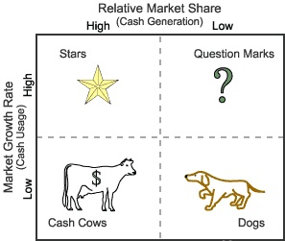
Source; Author Generated, 2018
Moreover, the product is produced in smaller scale and is highly defined as shown below. The product is customized and aimed at a smaller segment where lower volumes are clear in both the countries. Further, the product is highly defined based on the customer requirements addressing every aspect as much as possible.
Figure 2- BMW Positioning Strategy: Definition-Volume Matrix
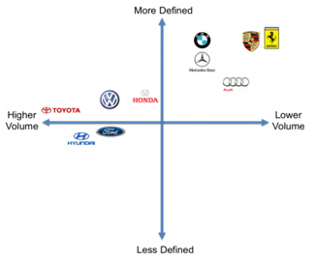
Source; Author Generated, 2018
The Bowman’s strategic clock model could be also used in evaluating the positioning strategy of the BMW with each of the two countries. On the evaluation it was clear that both the countries position the BMW products as Focused differentiation in average. More weight towards a risky high margins strategy were seen within the UK while a focus differentiation strategy was clear with the US market for the BMW as shown below.

Figure 3- BMW Positioning Strategy: Bowman's Strategic Clock Analysis
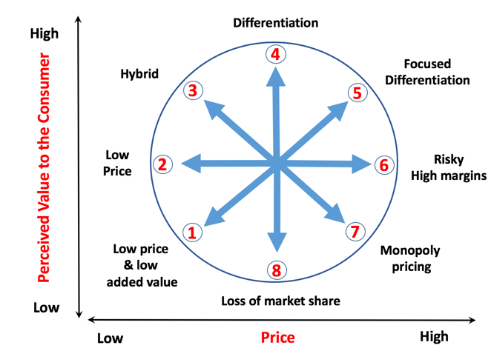
Source; Author Generated, 2018
The success of the BMW’s strategy within both the operational countries lies with the brand value that has gained by the organization over time. BMW is considered to be one of the most prestigious and leading luxury state of the art brands and producers of automobiles. Therefore the management strategies taken to improve the brand loyalty, brand recognition, brand value and corporate image also positions the products in the customer minds accordingly. The company has been affected negatively in both operational countries following a recall of failure products in the year 2010 that company managed to overcome over time slowly through latest developments especially with the energy efficient battery powered designs and the convertible designs. However, the loss in competitiveness and strategic advantage resulted from the negative action is notable.

4.2 COMPARING & CONTRASTING THE MARKETING MIX

4.2.1 PRODUCT STRATEGY
More customized products can be seen within the market of UK when compared with the USA in the BMW product strategy. Overall the products are identical and are produced in small batches. The customer needs are heavily focused in designing the products where research and development is a continued process at the BMW. Within the product strategy of the BMW, the concept of WANT product is been highlighted where the organization tries to make the product a want for everyone especially the Upper income class (BMW, 2018). The Lower income groups are motivated from the product as product mix strategy explained by the BMW Group. The product comes in different series that caters different needs of the customers (Schmidt, et al., 2010). Luxury, comfort and safety has been the core product considerations of the BMW. The handling speed and the braking systems are of higher quality and uses unique technology and is unmatchable to any of the major rivals within the industry. Along with the product quality services are also offered in enhancing the customer value that can be further explained with the adoption of the product onion model as follows.
Figure 4- BMW Product Mix Strategy: Product Onion
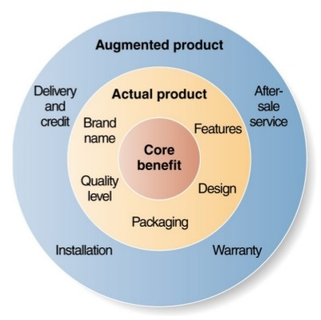
Core product that includes the most basic values of the product includes a vehicle to fulfill transportation needs, safety and reliable product. The actual product elements of the BMW product includes the higher and the superior brand value, higher quality levels, superior comfort levels, unique and innovative designs, advanced technology, unmatchable speed, vehicle handling systems and safety systems etc. These two levels are seen in both the UK and the USA where the augmented product features are different to some extent. Within the UK more credit and easy payment and loan facilities are attached to the BMW sales where minimum can be seen within the US. Both countries make provisions for after sales services where customer experience is one of the critical success factor defined by the company. thus it is clear that he core And the actual product characteristics of the BMW are identical in both destinations UK and USA where some differences are seen and identified within the augmented product level.

4.2.2 PLACE AND DISTRIBUTION MIX OF BMW
BMW uses flagship stores and authorized dealers in the distribution strategy in both the locations. The core objective of such strategy being delivering a higher value to the customer providing a pleasant environment. The Company invest huge sums of money in establishment of flagship stores across all operational countries. The BMW has more than 156 authorized dealers across the UK and around 120 dealers within the US (BMW, 2018). The number of dealers solely depend on the demand conditions and the nature of competition within the country.

4.2.3 PRICING STRATEGY
Premium pricing strategy is followed by the company where high income levels are targeted. The premium price is also a reflection of the superiority and the quality of the products. The higher price is also expected to give a status to the customer deriving a snob value effect which is against the traditional demand theory. The demand is high where the prices are high where the customer perceive that the higher price is because of the higher status received on the purchase. Where the price is reduced the demand will drop considerably where the customer will not see the product prestigious over the others. Highly esteem characteristics are also seen within the pricing strategy of the BMW where the price derives esteem to the customer. The strategy is consistent over all operational destinations as well as in both the UK and the US where the product is a luxury product aimed at a niche segment of people as highlighted in earlier sections of the report.
Moreover, the pricing strategy is based on a differentiating strategy where the BMW could easily adopt a premium strategy resulting from the uniqueness of the design, high quality, superiority and the higher brand value it possess (BMW, 2018). The people are willing to pay the extra amount for these benefits they receive along with the product that makes the current pricing strategy successful. As evident the pricing strategy is identical in both countries where differences are seen at times of promotional campaigns that are limited to the country.

4.2.4 PROMOTIONS MIX
The promotional mix of the BMW is carefully designed and decided based on the nature of the target segments in line with the product features. BMW can be considered a smart marketer and most of the promotional and marketing campaigns of the BMW are based on the positioning of the superiority of the product, to highlight the advanced technology used, to communicate the advantages of the products and differentiation strategy, to express and highlight the unmatchable designs and the innovative technology. Since the products are aimed at the the high income earners, premium customers and professional class, mass marketing strategies that are traditional are not used. Exclusive and customized strategies are highly used by the BMW where the channels to be used to reach the particular segments are carefully decided. BMW uses slogans to communicate a unique message to its customers and this slogan is consistent across the BMW Group. Some of such slogans include; “The Ultimate Driving Machine”, “Sheer Driving Pleasure” (BMW, 2018). Most of the marketing and promotional works of the BMW are outsourced and WCRS has been the advertising agency of the organization since 1970’s (BMW, 2018). Local level marketing and promotional campaigns are also carried out by the outsourced partner where Flagship stores and dealers also perform promotional campaigns in driving sales at a very small scale covering the geographical area in which they cater. BMW invest heavily in film production as a promotions strategy especially within the UK and the US where advertisements are also seen quite often. Celebrity endorsements are used along with product endorsements both and local and global levels. Moreover the differences and similarities within the marketing and promotions mix of the BMW in the two different countries could be presented as below.
Table 4- Promotions Mix of the BMW UK and the USA
Basis | UK Market | US Market
Television Advertisements | Can be seen | Can be seen
Print Media Usage | Relatively low | Relatively high
Social media presence | Relatively low | Relatively low
Celebrity endorsements | High | Relatively low
Webinars & Vial Marketing strategies | No/ Low | No/ Low
Email marketing | Very Low | Moderate
Web Subscriptions | No | Make provisions
SMS Marketing | No | No
Sponsoring activities | Very high | Very high
Use of direct marketing | At moderate levels | At moderate levels
Marketing strategy implementation | By the BMW Group, Dealers and the Flagship store management | By the BMW Group, Dealers and the Flagship store management
Source; Author Generated, 2018

4.3 COMPARING & CONTRASTING DIRECTIONAL DEVELOPMENT STRATEGY OF THE BMW
A directional growth strategy could be referred to a strategy where the company focuses on business growth and development through the increase in the sales, demand and profitability while decreasing the costs and operational issues identified in a SWOT analysis accomplishing organizational goals and objectives as intended. A directional strategy is set to achieve growth and these directional strategies could vary according to the operating markets and the countries depending on the industry and the economic conditions. As per the SWOT analysis it is clear that one of the major strengths of the BMW is being effective in its marketing and branding strategy where there is a strong brand name, brand image. Moreover the company introduces new innovations on a continued basis that has been able to drive sales in its directional development strategy. One of the major weakness of the BMW in all operational markets being the higher costs associated with the production and the operations the company is looking for ways of reducing the costs on a continued basis that has also formed the basis of the directional development strategy. However, cost reductions are only fairly possible where the variation in production is high, scale is low and the cost of raw materials and production is considerably high. BMW in its directional strategy especially within the UK looked into ways of reducing the costs by identifying an opportunity to collaborate with the manufacturers and the raw material suppliers. Further, in both the UK and USA the spending on the research and development function were increased to identify and develop ways in which the company could decrease the operational costs for improved profitability. The major threats such as the recession within the UK and the European market, the financial and international trade crisis in the US with the election of the new president are also considered in the directional development strategy of the BMW in the UK and the USA.

5. STANDARDIZATION AND SOCIAL FACTORS, CULTURE AND LANGUAGE

5.1 DIFFERENTIAL ANALYSIS

5.1.1 PRODUCT TYPE/ PRODUCT STRATEGY
The product strategy is identical in both the countries where the same products slightly customized with slight differences in augmented product could be seen. The branding strategy is implemented at a global level and the marketing strategies are localized to match the requirements of the identified customer groups that will be explained in more detailed in the later sections of the report.

5.1.2 SOCIAL, CULTURAL AND LANGUAGE FACTORS
The socio-cultural factors within the two economies differ where the language used being The English across both the UK and the USA. The socio-cultural differences that can be identified within the two countries could be presented as below.
Table 5- Socio-cultural differences between the two countries
The United Kingdom | The USA
The early adaptation rates considering a new innovation is relatively low bound to the cultural and traditional attitude related factors. The customers are bound by the traditional and cultural values and any harm in such would lead in negative perception creation and negative attitude formation. | The customers are risk taking and they have masculine attitudes towards new innovative products. Moreover, the status related factors are highly seen within the economy where esteem drives the economy when compared with that of the UK.
Source; Author Generated, 2018

5.2 GLOBAL MARKETING, STRATEGIC ADOPTION & ECONOMIES OF SCALE

5.2.1 GLOBAL MARKETING STRATEGY OF BMW
The global marketing strategy of the BMW could be appraised based on two perspectives that is global product strategy and the Global promotions strategy. The Products are standardized where customization could be also seen in minor scale by the BMW in its operational regions. Overall identical products are introduced to the markets by the BMW in the product or manufacturing strategy based on the identified customer needs and requirements in delivering higher customer experience and value. However the marketing and promotions strategy could be different from one country to another from one region to another based on the socio-cultural factors that dives the marketing and promotions strategy. Since the brand value and the brand equity has been a major concern for the BMW within the industry in maintaining competitive advantage, more emphasize is given when deciding the right marketing and promotions campaigns in the global strategy. However, the positioning is consistent throughout all operational countries driving corporate reputation where brand equity has been a major focus in the global marketing strategy of the BMW.
BMW uses a centralized and a unified approach in the globalized marketing strategy to be carried out by different countries. The strategy is also called as global branding and local marketing. However the localized strategies are not designed for each country instead they have been used for three key regions in which the BMW operate the European, Asian and the American Region. Therefore where the study is conducted for the differences in the marketing strategy used in the UK and the USA it is worthwhile evaluating the localized strategy designed by the BMW group for American and European regions.

5.2.1.1 Localized marketing strategy for the European region: UK
European market is the key market for the BMW where the target groups are identified as those with higher educational and knowledge levels, more professional background, high income earners. These target segments ae mostly found in industrialized economies were there are many agricultural based economies within the European region that needs consideration within the BMW European marketing strategy. Higher disparity in income could be identified within this segments compared to the American regions where a gap between more than 5 times could be identified between the rich and poor based on the GDP per capita. Moreover the purchasing power is low within the European region where the 80:20 rule is seen clearly within the economy in the aspects of income distribution. Based on the above considerations it is clear that the market size within the European regions are relatively small but targeting them in the marketing strategy is complex where they are distributed within the mass market. The customer preferences, lifestyles and socio-cultural perceptions are also different which is considered in the localized marketing strategy communicating the brand at a global level by the BMW.

5.2.1.2 Localized marketing strategy for American region: UK
The American market was entered by the BMW in the year 1974 and the BMW uses own established sales channels and networks in distributing the products within the American regions. Compared to the European localized strategy the American Localized Strategy considers different aspects that are attached to their market conditions, economic conditions and socio-cultural factors. The US economy is relatively strong and wealth and income drives sales and demand of the products within the US. The income levels are relatively high along with the disposable income and the per capita GDP where the marketing strategy is to be targeted at these identified segments of the market. 80% of the population within the US belongs to the higher and the middle income groups unlike in the European region where the marketing strategy can be relatively mass scale when compared with the strategy that should be used within the UK. In the American Localized strategy the BMW positions the products as a high quality superior product that highlights the product features where the competition levels are relatively higher than that of the UK. Further, the Product aspects considered more over the customer features where within the UK the customer features where focused more than the products accordingly in the Localized strategy. Developments in the products, re-engineering of the existing products, innovations, research and higher quality realizing the self-actualization needs of the customers are considered here by the American Localized Strategy of the BMW when compared with that of the European strategy applicable for the UK.

5.2.2 STRATEGIC ADOPTION AND ECONOMIES OF SCALE
The production of the BMWs are in small batches where mass scale production are not taken place which is evident in both the US and the UK. Quality being a key success factor, human interaction is high with a mix of both capital and labor intensive strategies where economies of scale have been derived through reduction in product failures, cost savings out of using most effective and efficient strategies, using greener technology, cost controlling and total quality techniques and management etc. Further, the production plants are mostly located within highly concentrated areas where high access to raw materials could be seen thus deriving advantages from external economies of scale to the BMW which is evident in both operational countries UK and the US. The average costs of production is considerably nigh which is also a weakness as identified by the BMW Group where manufacturer and supplier collaboration is considered at times. On an overall comment, the economies of scope is lower where the economies of scale is also lower where the variations are high, customization can be seen and batch production techniques are used by the BMW. This is also one reason for the higher prices of the BMW products. However, the branding strategy of the BMW is instituted at the global level that drives marketing economies of scale to the organization. Moreover, the marketing strategies are also localized into key three regions that covers a considerable market that can drive further marketing related economies of scale. The production plants are located in different locations and the overheads are spread across locations and products reducing the risks which can be also an advantage rising from the economies of scale.

5.3 APPLICATION OF THE 4C’S MODEL
- Customer needs and wants (Armstrong, et al., 2014): the customer needs and requirements are accurately identified by the BMW in both the operational markets through customer surveying, customer analysis, observation, data collection methods, secondary data gatherings to design products accordingly delivering a higher value to the end customer.
- Convenience (Armstrong, et al., 2014): the flagship stores and authorized dealers are located across the countries in both the US and UK and delivery options are also provided on request to the customers increasing the convenience. Spare parts, services and after sales offers are provided by the BMW maintaining superior service standards.
- Cost (Armstrong, et al., 2014): the operational costs are considerably high that is also an identified weakness where the company is looking for strategies to reduce such costs. On the point of view of the customer the prices are high but considering the target market the portion of the income sacrificed on the product may be marginal.
- Communications (Armstrong, et al., 2014): effective promotions strategies that are localized to suit the market conditions are evident as per the study as also highlighted under the marketing mix.

6. SIMILARITIES AND DIFFERENCES BETWEEN THE ORGANIZATIONAL STRATEGIES & APPROACHES
As presented above many similarities between the two countries in the marketing approach related to the segmentation, targeting and positioning process, the marketing mix as identified. The brand strategy is implemented at a global level which is consistent over both countries UK and the USA. Further explaining the similarities as evident within the two approaches used in catering the two segments by the BMW, it is clear that continued process improvement and technological advancement trough innovations and increased expenditure on research and development is considered at the heart of the organizational operations. The increasing concerns towards sustainable environment has also forced BMW and other car manufacturers to use energy efficient production and manufacturing techniques that are used consistently in production plants in both the UK and the US. Ensuring quality, superiority and reliability of the products has been a core value of the organization that is ensured by adopting a total quality management environment within the manufacturing plants as well as service outlets of the BMW. One of the key success factor has been identified as superior customer service that drives sales, demand and brand value to the BMW which is also effectively managed in both the operational countries. However the management and administrative of these similar end strategies are different depending on the cultural outset of the organization based on the employees, the nature of the industry setting, the market conditions, social perceptions, leadership styles etc. The end results may be also affected by these differences in the management and administrative styles even though the targets are identical. Overall high similarity can be seen in the approach of administration and management between the both countries UK and the US by the BMW.
Considering the aspects of human capital, recruitments and hiring processes, most of the employees are sources from the operating markets giving job opportunities to the economy. The impact to the environment and the community is minimized as much as possible by following ethical and environmentally friendly processes that can be seen within both UK and the USA. Moreover, more focus on the CSR activities within the UK economy can be also seen when compared to the USA.

7. APPRAISING THE CURRENT STRATEGIES USED
In appraising the current strategy used in the two countries by the BMW different metrics and the findings as explained throughout the report could be used as below (Armstrong, et al., 2014).

7.1 COUNTRY 1: UNITED KINGDOM
The sales increase or variations could be used as an indicator of marketing strategy and according to the statistics as presented below major variations could be seen within the UK market for the BMW which is considerable.
Figure 5- Sales Variations for BMW-UK
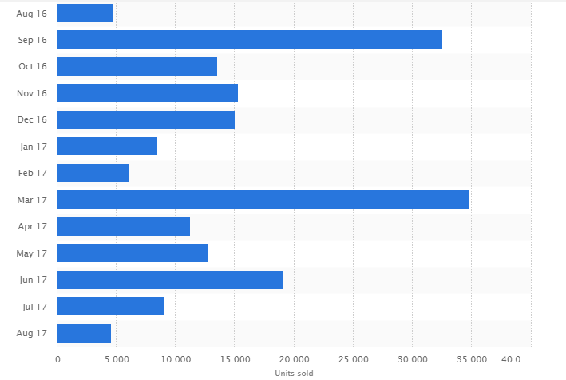
Source; MorningStar Financials, 2018
The targeting, positioning and the segmentation processes used by the UK are fairly effective where trending and emerging bases of segmentation with the latest developments in technology should be also considered within the marketing strategy. Moreover, the local levels promotions campaigns are considerably low where marketing activities are only visible at a global level. Thus improvements in the localized marketing strategy with the support of authorized dealers and collaboration with the flagship stores could be considered. Further, more concerns on social media and digital marketing platforms and channels should be considered by the BMW. Digital and social media channels are considered less costly and more effective that will improve the marketing strategy of the BMW UK thereby benefiting the BMW Group. Overall the marketing strategy of the BMW-UK is effective even though improvements are possible as explained above.

7.2 COUNTRY 2: UNITED STATES OF AMERICA
The second most sales within the group is recorded by the United States by the BMW and the contribution to overall group revenue is over 14% (MorningStar Financials, 2018). This has slightly increased compared to the previous years which shows signs of a successful marketing strategy implemented within the US.
Figure 6- BMW Group Revenue Analysis by regions in 2016
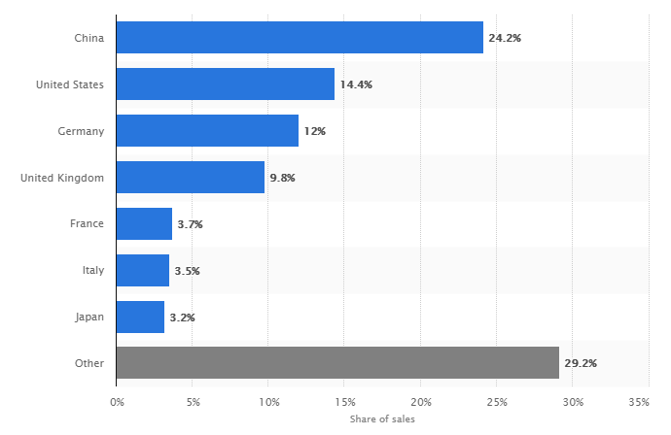
Source; MorningStar Financials, 2018
The car sales when compared with the major rivals of the BMW within the market of USA can be presented as below and needs considerable attention were the market share is relatively low where the industry is flooded with substitute products. Thus marketing and promotional activities plays a major role within the USA compared to that of UK.
Figure 7- US Luxury Car Sales in 2017 and BMW's Position
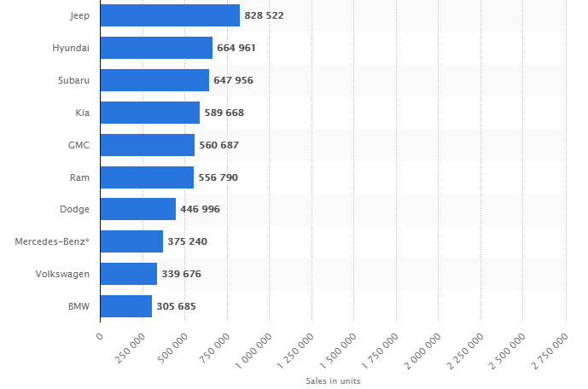
Source; MorningStar Financials, 2018
As explained throughout the report the marketing strategy of the BMW-US is also similar to the UK where minor differences are evident. Overall the strategy is effective where improvements are possible in decreasing the costs associated with the marketing and promotions, improvements in designs and productive aspects etc.

8. CONCLUSION
As presented in this report, both the countries. UK and USA where BMW cars are being marketed and sold shows positive signs of an effective marketing strategy which BMW Group deploy, is well managed, and well defined appraised with the use of many theoretical models learnt in the class as shown above. Moreover, improvements are also possible in securing the competitive and strategic advantage within the dynamic and growing industry that should be addressed by the BMW in achieving growth and development targets.

LIST OF REFERENCES
Armstrong, G., Adam, S., Denize, S. and Kotler, P., 2014. Principles of marketing. Pearson Australia.
Avery, G.C. and Bergsteiner, H., 2011. How BMW successfully practices sustainable leadership principles. Strategy & Leadership, 39(6), pp.11-18.
Bickhoff, N., Hollensen, S. and Opresnik, M., 2014. Step 2: Strategic and Operative Marketing Planning—Segmenting, Targeting, Positioning. In The Quintessence of Marketing (pp. 47-110). Springer, Berlin, Heidelberg.
BMW-website, 2018 accessed at www.bmw.group.co on 25th March 2018
Campbell, A.R., Ryley, T. and Thring, R., 2012. Identifying the early adopters of alternative fuel vehicles: A case study of Birmingham, United Kingdom. Transportation Research Part A: Policy and Practice, 46(8), pp.1318-1327.
Hassan, S.S. and Craft, S., 2012. Examining world market segmentation and brand positioning strategies. Journal of Consumer marketing, 29(5), pp.344-356.
Hommes, C., 2013. Behavioral rationality and heterogeneous expectations in complex economic systems. Cambridge University Press.
Johansson, J.K., 2010. Global Marketing Strategy. Wiley International Encyclopedia of Marketing.
Kapferer, J.N. and Bastien, V., 2012. The luxury strategy: Break the rules of marketing to build luxury brands. Kogan page publishers.
Klein, M.W. and Welfens, P.J. eds., 2012. Multinationals in the New Europe and Global Trade. Springer Science & Business Media.
Law, C.M., 2017. Restructuring the global automobile industry(Vol. 4). Taylor & Francis.
Lovelock, C., 2011. Services marketing: People, technology, strategy. Pearson Education India.
MorningStar Financials, 2018; BMW Sales and Revenue Analysis
Narla, S.R., 2013. The evolution of connected vehicle technology: From smart drivers to smart cars to... self-driving cars. Institute of Transportation Engineers. ITE Journal, 83(7), p.22.
Rawlinson, M. and Wells, P., 2016. The new European automobile industry. Springer.
Schmidt, A., Dey, A.K., Kun, A.L. and Spiessl, W., 2010, April. Automotive user interfaces: human computer interaction in the car. In CHI'10 Extended Abstracts on Human Factors in Computing Systems (pp. 3177-3180). ACM.
Vignali, G., Vignali, C. and Ryding, D., 2010. Segmentation/Targeting/Observation/Positioning (Stop). The Strategy Process, 85(112), p.28.
Wójtowicz, M. and Rachwał, T., 2014. Globalization and new centers of automotive manufacturing–the case of Brazil, Mexico, and Central Europe. Prace Komisji Geografii Przemysłu Polskiego Towarzystwa Geograficznego, (25), pp.81-107.

