

Assessment 1 – Reading Task Template
Upload your photo of your A3 in-class notes here:
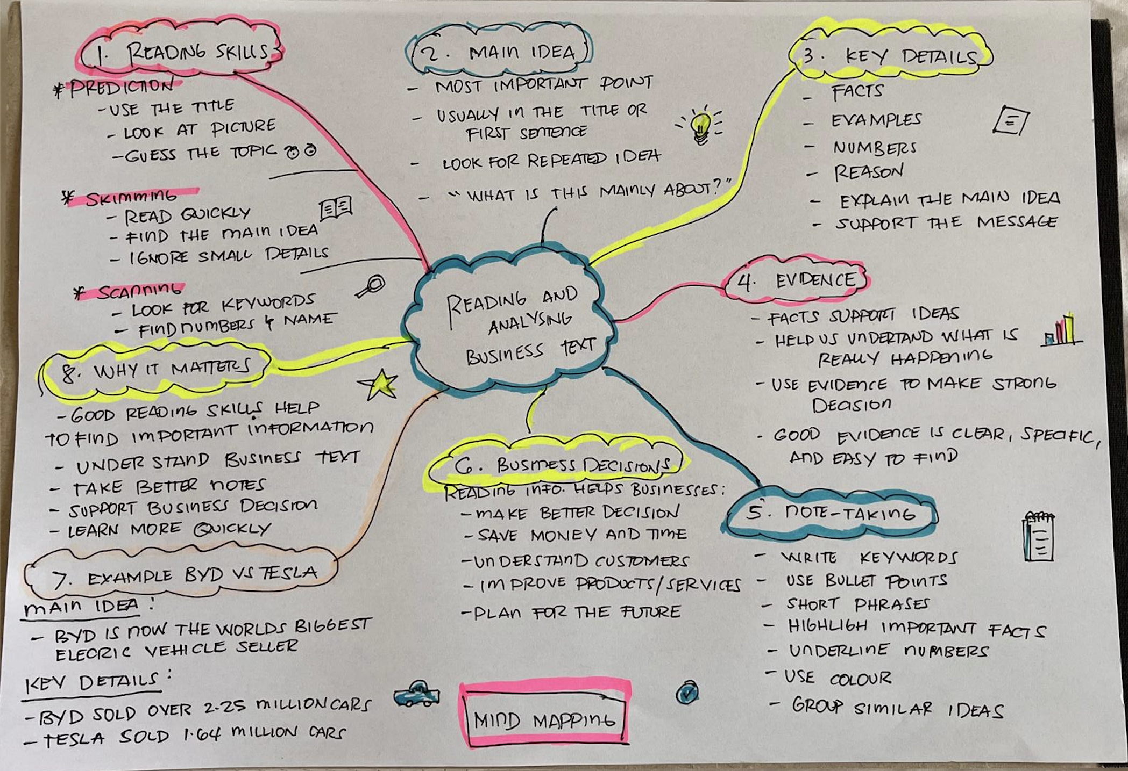

1. Answer these questions using the sentence starters below
a. What is the main idea of the text?
The main idea is that the social media helps the business become popular and get more customers.
b. What are two key points?
One key point is that Honywood Sandwich Shop became popular after customers shares videos on TikTok.
Another key point is that many small business use TikTok, Instagram and Facebook to grow their business and increase sales.
c. What part of the text did you find most important? Why?
The most important part is that social media can help small business rach more customers. I think this is important because it can help a business to grow and become successful.
d. Was anything unclear or difficult to understand?
I was not sure about how some videos become viral and why they get so many views.
e. How did your group help you understand the text better?
My group helped me by discussing the article, explaining difficult words and sharing different ideas.
2. One sentence reflection
Question: What did you find challenging about this task?
The hardest part was finding the main idea because the article gave many different business examples.

