KNOWLEDGE AND INFORMATION MANAGEMENT REPORT

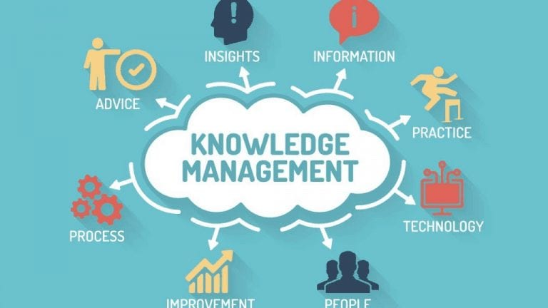

STUDENT: Luboia Barros 2017955
MODULE: Knowledge and Information Management Skills for the Workplace
MODULE CODE: BMSW5106
LECTURER: Dr Oluwaseun Adegbite
ASSIGNMENT TITTLE: Knowledge and Information Management Report in selected organizations.

INTRODUCTION



Here, we will be learning about SHEIN and Etsy as e-commerce and how they act in the market
An examination will be carried out to understand how specific Knowledge Management Systems is adopted in both organizations, with a view to creating a competitive advantage for organizations that are concerned with implementing, Knowledge Management with the purpose of facing the model shifts and meeting the needs and expectations of its customers.
The concept will be explained in depth and the types of applications available for the entrepreneur who wants to put this technique in favor of the development of their business will be presented.

MAIN ORGANISATION ACTIVITIES.

E-commerce breaks geographic limitations, allowing products and services to be marketed to a specific target audience in any region the company wants.
With e-commerce, shopping can happen anywhere, from any electronic device, and without having to face traffic, crowded parking lots and gigantic queues. A few clicks are enough for the consumer to have what he wants quickly, safely and with little bureaucracy.

Examples:

Figure 1
SHEIN
Shein is an e-commerce platform, provides services consisting of offering SHEIN products on a website through which customers can purchase these SHEIN products.
The company is believed to have been founded by three men in 2008 in the eastern Chinese city of Nanjing, which originally mainly sold wedding dresses. Among the founders was Xu Yangtian, an expert in search engine optimization. In 2012, until then without his former colleagues, he began distributing women's fashion under the domain name sheinside.com.

The business took off in 2015 and currently makes its products available in more than 220 countries. Here in England, Shein grew a lot during 2020 and conquered a large number of consumers very quickly by offering products of different styles at a very attractive price.

The brand has a very strong presence on social networks such as Tik Tok and Instagram, SHEIN has more than 4.7 million posts and, as a result, is able to offer a wide variety of pieces that are on the rise, especially with the younger audience. Another factor that contributes to the good acceptance is the availability of different sizes of women's, men's, children's and plus size clothing.
The Chinese store also stands out for having a wide variety of bags, accessories, beauty items, makeup, decoration and even pet products.
The SHEIN affiliate program works as a partnership, where you register on the company's website and if approved, you can advertise your products on social networks, blogs and other platforms, having a cookie that identifies you if any purchase is made, being able to receive from 10% to 20% for each sale.

Unlike competitors, however, Shein does not need to be present in a physical space to gain relevance among an audience that is starting to have purchasing power. Like her target audience, she is a digital native. It is thanks to the virality of videos with people wearing Shein pieces that she is successful.
Linking to Google Trends, you can see that searches for the brand name skyrocketed in mid-2020, when the pandemic was at its height and everyone started shopping online. In June, Shein's app for iOS and Android surpassed Amazon's in number of downloads, becoming the leader there and in more than 50 countries.


Figure 2

ETSY
ETSY is an online platform dedicated to the sale of handmade products. Focusing on selling handmade or vintage items, it covers a wide range of items from art, photography, clothing and jewelry to beauty products, quilts and toys.

The site was launched on June 18, 2005 by a small company called Iospace. Based in Brooklyn (New York), it consists of Robert Kalin, Chris Maguire and Haim Schoppik.
Selling products on ETSY is simple you just need to create a username and then you can name the store. Creation is free, but you pay for each item added, plus a percentage of 3.5% of product sales to Etsy.
Etsy is an easy way for independent artists and small businesses to achieve global visibility. It is an international platform for unique and creative products to buy and sell.
Reselling is not allowed in Handmade.

SWOT ANALYSIS

Table 1

Table 2

KNOWLEDGE MANAGEMENT SYSTEMS FOR BOTH ORGANIZATIONS

Within the administrative environment, Knowledge Management comprises a series of actions that a company can, and must, develop to ensure the continuity and quality of its production.
Also known as KM, the concept is broad and serves as a guide to classify and organize the individual knowledge of each employee, systematizing it so that everyone has access. This management technique allows the entrepreneur to gather the knowledge necessary for the organization to achieve its production and growth objectives. the KM encourages creativity and research in daily production, with a focus on innovation.

According to Peter Drucker, the world we live the amount of knowledge has become virtually infinite.
Whether due to globalization, which increases the dissemination and access to information, or due to the accelerated technological development, the fact is that so much knowledge has never been produced on the planet as it is today.

For Wiig (1997) KM is to understand, focus and manage the construction of knowledge.
systematically, explicitly and deliberately, managing effective knowledge processes. O
The author also adds that the general objective of knowledge management is to maximize the effectiveness and the return of its knowledge assets related to the organization, seeking the renewal
permanent (WIIG, 1997). According to Uriarte (2008) it was Wiig who created the term “management of the
knowledge".

This means that the wealth of knowledge is not automatically passed from parent to child, either by law or genetic material, nor is it shared naturally within a company, for example.
And it is precisely on top of this wealth that Knowledge Management works.
The concept involves actions on several fronts within the administrative environment that seek to manipulate information, expanding its access to people who may need it.

Knowledge Management encourages the capture, multiplication and distribution of knowledge in a democratic way, so that significant gains in efficiency and productivity can be observed.
With this approach, the intention is to observe which are the skills, present or not among the staff, which, if brought into the company, can represent gains in quality and productivity.
In practice, this means creating an action plan for the company, establishing a budget and dates for carrying out internal training and workshops to share knowledge among employees.

Based on these concepts, Nonaka and Takeuchi (1995) conclude by stating that the
Organizational knowledge is knowledge that must be disseminated throughout the organization as a whole, incorporating it into products, services and systems. For Nonaka and Takeuchi (1995), the creation of the organizational knowledge is the key to continuous innovation in the company and, for that, it is necessary that there is study, of the theoretical approaches that involves it through the

Transforming Data into Information, DIKW.
SHEIN
Table 3
Data | Information | Knowledge
Audience is 33.93% male and 66.07% female. The largest age group of visitors are 25 to 34 year old. | The business took off in 2015 and currently makes its products available in more than 220 countries. | Offer a wide variety of pieces that are on the rise.

ETSY
Table 4
Data | Information | Knowledge
Etsy charges 6.5% transaction fee to the final price (after any discounts), including shipping, product customizations and gift wrapping. | Etsy is an easy way for independent artists and small businesses to achieve global visibility. | Starting a side hustle on Etsy is a great idea because it connects you with customers who want to buy your product.

It describes how Tacit Knowledge (non-formalized) and Explicit Knowledge (formalized) are converted into organizational knowledge.

Types of knowledge:
Table 5
Tacit knowledge (subjective) | Explicit Knowledge (Objective)
Coins become a discount at the end of the purchase, and can be combined with other coupons. The discount is insane, there are those who can buy pants for less than 10£.  . | On website, you can see photos, videos and opinions of those who bought it. The comment box of each piece is a bomb because the site follows a gamification logic: the more a customer comments and opines, the more virtual coins from the store she can earn, and if the comment has many likes, the balance increases.

There are two types of knowledge: “Explicit” knowledge, which can be expressed in words and numbers, and easily communicated and shared, and “tacit” knowledge that makes it difficult to transmit and share with others, as it is deeply rooted in your emotions, values or ideas.
The main purpose of Knowledge Management is connected as generation sources with knowledge application needs.
It must be easy to transfer knowledge from the generators' minds to the people who use it in executing the company's strategy.

In this sense, understanding what is tacit and explicit knowledge is fundamental to implement KM, since identifying all the knowledge that the company has is one of the first steps to evaluate how it can be better used in marketing strategies and even to innovate and bring competitive advantages to the business.
Nonaka & Takeuchi (1997) state that knowledge tacit knowledge and explicit knowledge are not separate entities, but mutually complementary. They also claim that they interact with each other.
others and make exchanges in the activities of human beings.

KNOWLEDGE MANAGEMENT LIFE CYCLE

Knowledge Acquisition (KA) | This concept aims at the acquisition of inputs and products for sale or item. However, the focus is on continuous improvement of activities, increasing performance and reducing cost.
Knowledge Retention (KR) | Knowledge management includes all knowledge management activities that conserve knowledge. Also including activities that maintain the viability of the knowledge being within the system.
Knowledge Transfer (KT) | This process is known for the dynamics, opportunities and cycles of mutual appreciation that we all need for new solutions with a direct impact on society.

SHEIN

KNOWLEDGE ACQUISITION:
Shein uses technology to engage the consumer and is present in all phases of the business, in design, production, operation and logistics.

KNOWLEDGE RETENTION:
The company invests deeply in technology to provide a smooth and seamless experience for users, satisfying customer needs continuously.

KNOWLEDGE TRANSFER
The company's app was designed to allow complete integration with the supply chain, enhancing the scope and speed of execution of the marketplace

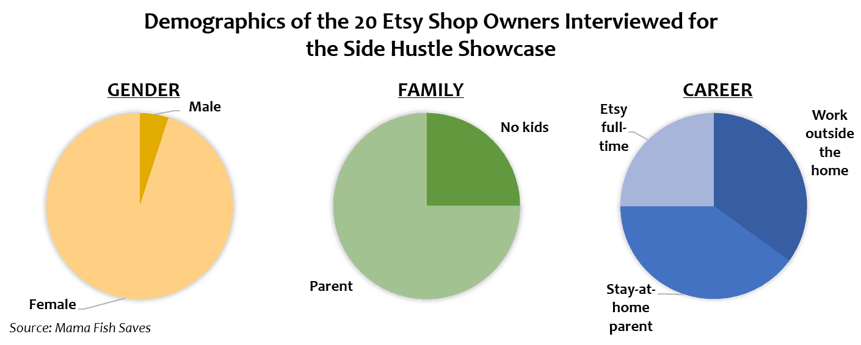
Figure 3

ETSY
KNOWLEDGE ACQUISITION:
Etsy knew that its users come to explore, discover and buy new and exclusive things. To facilitate this, Etsy knew it needed to introduce viewers to interesting products.

KNOWLEDGE RETENTION:
According to Senior Vice President of Product Mike Grishaver, the team has been hard at work on functionality that can recommend products based on factors that go beyond what people have analyzed. The result is an experience that surprises shoppers with unique new items and engages them to find more.

KNOWLEDGE TRANSFER
For Etsy, web and mobile feed engagement increased immediately after the company instituted enhanced data analytics. People have discovered new products that strangely reflect their personalities and interests.

KNOWLEDGE MANAGEMENT CONTRIBUTION TO VALUE CHAIN?

Organizations can increase the value of their deliveries and increase competitive advantage at the cost of contracting and reducing investments in production. However, organizations can achieve the result in another way, which is through gaining quality on top of their product being the same, for example. Therefore, it creates more value.

In the first case, this logic works by reducing internal procedural costs. In the second, the opposite happens, because the higher quality allows a higher price to be demanded. Both methods lead to an increase in profit margin.
This model aims to achieve the maximum quality of service and/or product, until reaching the final consumer.

The value chain enables the company to understand how the organization works and the practice of its productive and strategic processes.
It is a tool that directly reflects the functioning and addresses all the nuances of the business.
This comprehensive view, which shows primary, support and management processes, serves as a field of analysis for managers. Thus, it is possible to work on improvements that strengthen the delivery of value to customers.
One of the main advantages of the value chain is that any company can adhere to the model for better results. After all, it is a concept that aims to unravel the processes within a business. In other words, it is a corporate tool at its core. Not least, it can be applied by organizations of all sizes and from all market segmen

INCLUDE PORTER'S ANALYSIS IN YOUR STRATEGIC PLANNING (PORTER’S FIVE FORCES)
Porter's 5 forces are related to determining a company's position within its market. They analyze the internal and external environments in order to determine the most efficient strategies in front of their competitors. These are: rivalry between competitors, bargaining power of suppliers, bargaining power of customers, threat of substitute products or services, and barrier to entry of competitors.
A main strategy for gathering comprehensive information is a broad survey of the entire market or what it will be doing. It is important to try to get as many referrals from customers and suppliers as possible.

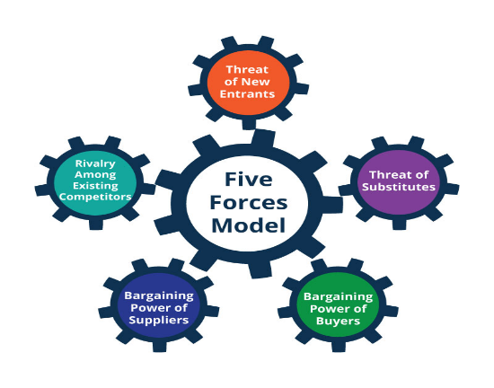
Figure 4

For this to be done successfully, it is necessary to carry out research via the internet, calls or even places so that we can even make comparisons with the competition. Paying attention to the positive points that can be implemented is fundamental.

Regarding information about consumers, applying them with pertinent questions about what they want to know is a very valid option. In this part, it is important to make a selection of what is really relevant so that nothing is forgotten.

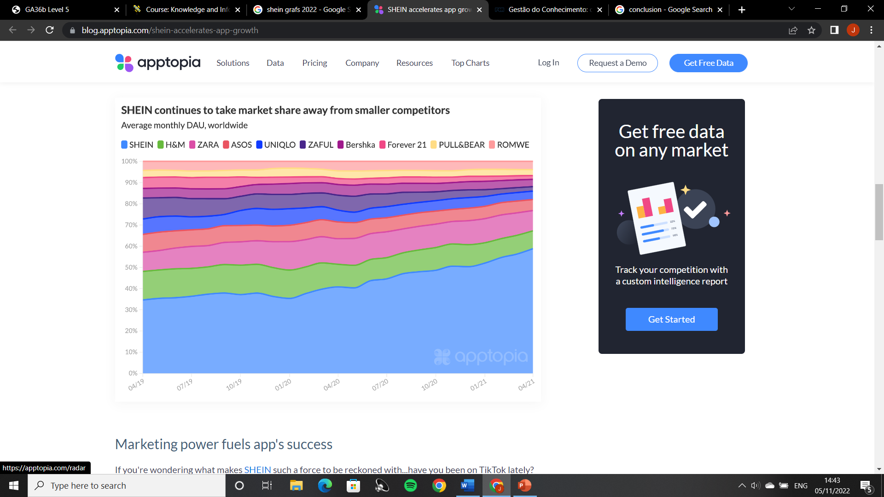

Figure 5
- Threat of substitute products
The focus of this force is to detect the emergence of new trends in order not to make the products or services offered obsolete. For this to be possible, the enterprise must be able to make changes in its operational lines. These new products are not necessarily the same as those already offered, but they can replace them, meeting the same need.

- Threat of entry of new competitors
It presents the difficulty of entering new companies in the market. Therefore, it is necessary to study the existing impediments for this to happen and the reaction power of the already constituted organizations. Factors related to this topic are the amount required for the initial investment, existing bureaucracy in the area and whether there are tax or governmental incentives for starting a business..

- Customer bargaining power
It studies the importance of consumers for the company's brand in the market. In addition, it checks the influence of customers for revenue. The greater the availability of products, the more power customers have in negotiation. In the opposite situation, the demand for price and quality tends to be stronger.

- Negotiating power of suppliers
Check the best vendor options on the market, but in such a way that there is never just one option. If there are a large number of suppliers available, the requirements related to price and delivery time would be in favor of the company. In the opposite situation, the enterprise is more vulnerable to the conditions of its suppliers.

- Rivalry between competitors
It is related to market research. It consists of locating your direct competitors – they offer the same types of products, for the same target audience and in the same price range – and indirect ones – they offer products that can replace what is being offered. Once this is done, an analysis is carried out of how strong these brands are in the market and the positive points adopted by each of them.

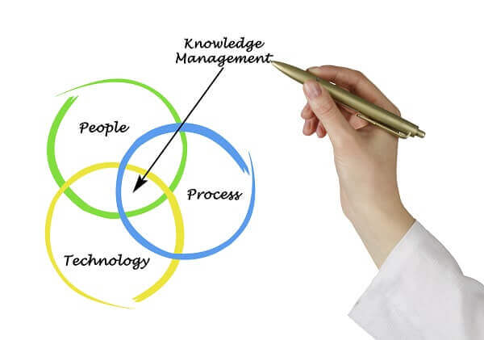
Figure 6

In addition to practical issues, there may be professionals who, both in production and in any other area, are disconnected from the company's culture. In this way, Knowledge Management for the industry can help not only in the use of information in the production order, but also in other adjustments, procedural or not, but necessary to increase productivity and work quality.

In general, these adjustments involve the following initiatives:

- Adequate recording of all processes so that information is not concentrated in just one person;
- Conducting training to maintain a quality standard in manufacturing practices;
- Elaboration of informative and motivational content to ensure the intensification of the corporate culture;
- Better internal and external communication.

1 – Qualifies the workforce
A company in constant modernization needs to keep its employees at the same pace. Therefore, it is essential that there is a constant corporate training program. And it is from knowledge management that this can be done much more efficiently. Among the available options, e-learning is a methodology with many advantages that can be used to update the knowledge of your workforce.

2 – Strengthens commercial work
The success of commercial work depends on privileged information for the sale to take place, which involves access to customer data, the product to be sold, the production process, a validated institutional discourse, in addition to knowledge about stock, logistics dynamics and even financial, so that you can negotiate properly. All this has to be organized in predefined locations and also, in part, already known to the seller. But this, of course, requires constant training.

3 – Decreases exposure to controllable risks
When a company is concerned with sharing knowledge among its employees and between sectors, control strategies and good business practices are more rigorously followed, avoiding unnecessary exposure to controllable risks. Among the possible risks to be avoided with information are default,
financial losses with delays or errors in production and accidents or incidents caused by maintenance failure.

4 – Increases brand equity
It is important that companies do not have any irreplaceable employees. Knowledge management for industries, in this case, allows all employees in a sector to be able to perform their functions. Nothing stays in one person's head. Likewise, all sectors are aware of the steps performed by other areas. This gives an idea of ​​the whole, improves the process and results, increasing quality, which positively impacts the value of the product. It is what allows you to differentiate yourself from the competition.

5 – Assists in after-sales
After-sales is a fundamental step in maintaining the relationship with the customer. We have already talked here on the blog about how it is cheaper to cultivate an existing contact than to acquire a new one. However, for this to be possible and for the after-sales to be qualified and effective, the employees responsible for this task need to have customer, sales and product information. That is, this data needs to be organized, updated, accessible and understandable.

CONCLUSION



E-commerce is a strategy by which companies can commercially communicate with their suppliers, customers and consumers on larger scales than traditional ones.
The accelerated evolution that the Internet generates every day is causing changes in people's customs. Today, commercial transactions via the Internet are already a reality. Many businesses are being conducted electronically and this phenomenon is already being called the Digital Revolution or Information Revolution, a fact that is causing an impact comparable to that of the Industrial Revolution in the 19th century, CHESTER (1998). Management help in the development of sharing, integration, creativity, teamwork, gains in trade. It is a set of activities whose main functions are the creation, storage and use of knowledge within organizations.

REFERENCES
- “Knowledge and information management report”
- Kuryło, Piotr, Adam Wysoczański, and Piotr Bonarski. "Knowledge and information management." System Safety: Human-Technical Facility-Environment 3.1 (2021): 1-10.
- Li, J., Saide, S., Ismail, M.N. and Indrajit, R.E., 2021. Exploring IT/IS proactive and knowledge transfer on enterprise digital business transformation (EDBT): a technology-knowledge perspective. Journal of Enterprise Information Management.
- Nakash, M. and Bouhnik, D., 2021. Can return on investment in knowledge management initiatives in organizations be measured? Aslib Journal of Information Management.
‘Knowledge management system’
- Mora, M., Wang, F., Gómez, J.M. and Phillips‐Wren, G., 2022. Development methodologies for ontology‐based knowledge management systems: A review. Expert Systems, 39(2), p.e12851.
- Riva, A. and Pilotti, L., 2022. How to Develop an Effective Knowledge Management Strategy? Economia Aziendale Online-, 13(1), pp.1-17.
- Deepu, T.S. and Ravi, V., 2021. A conceptual framework for supply chain digitalization using integrated systems model approach and DIKW hierarchy. Intelligent Systems with Applications, 10, p.200048.
“Swot analysis”
- Van, L.T.H., Guzikova, L. and Nguyen, A.T., 2022. Evaluation of E-commerce Impact on Sustainable Economic Growth: The Case of Vietnam. In International Scientific Conference on Innovations in Digital Economy (pp. 101-111). Springer, Cham.
“Porter’s five forces”
- Martinez-Contreras, R.M., Hernandez-Mora, N.C., Vargas-Leguizamon, Y.R. and Borja-Barrera, S.M., 2022. Pestel Analysis and the Porter's Five Forces: An Integrated Model of Strategic Sectors. In Handbook of Research on Organizational Sustainability in Turbulent Economies (pp. 292-314). IGI Global.
- Martinez-Contreras, R.M., Hernandez-Mora, N.C., Vargas-Leguizamon, Y.R. and Borja-Barrera, S.M., 2022. Pestel Analysis and the Porter's Five Forces: An Integrated Model of Strategic Sectors. In Handbook of Research on Organizational Sustainability in Turbulent Economies (pp. 292-314). IGI Global.

