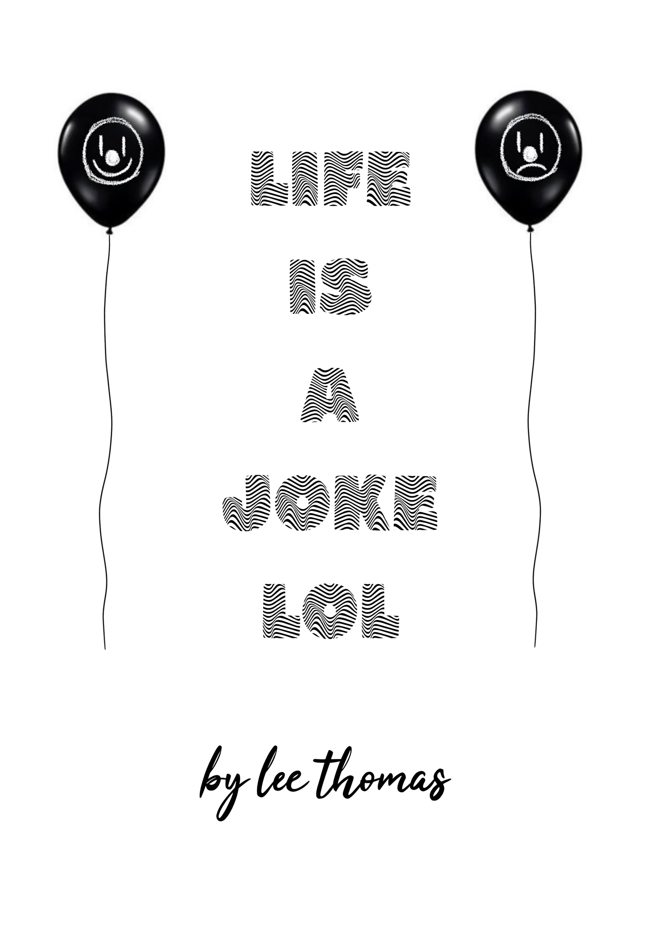

Name: Lee Thomas

Student ID: 1804249

Pathway: Illustration

Word count : 4634

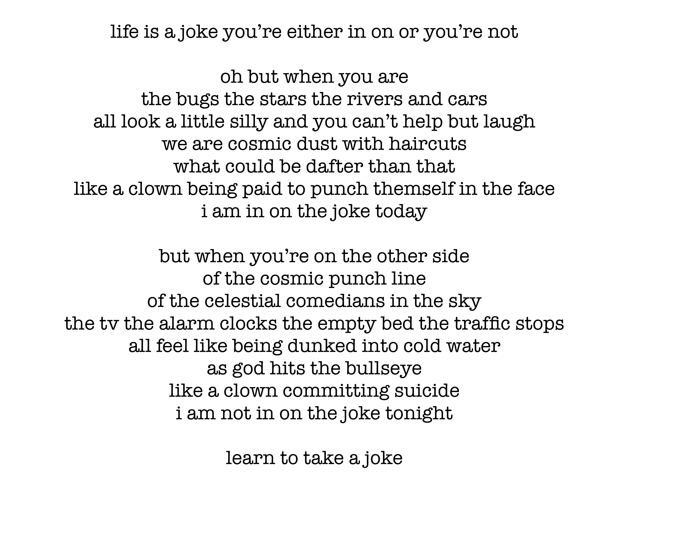
Sometimes it feels like life is a joke that you’re either in on, or you’re not. This project began with a poem I had written for a previous MA project, which ended up as part of a collection of poems that had accompanying illustrations. I approach writing in a different way to my artwork, where writing is more cathartic and introspective. The writer Anne Marie Duff once described writing as ‘getting rid of demons’ – “There’s a catharsis in telling a miserable old tale, you get rid of demons”, and I find it therapeutic to write and free myself of some often heavy and intrusive demons. I approach illustration in a different way, my approach is more surreal, playful and often an escape from emotion, a way to turn the demons into colourful and strange characters. I enjoyed creating this illustrated book of poetry but it lacked cohesion and my style running through it so for my final project I wanted to reconsider how to approach this idea. I came back to the poem ‘life is a joke lol’ and thought about how I could focus on this theme and take it further, using the poem to help navigate my art into a more personal and emotional space, with the goal being to try a new approach yet keeping the style and subject matter in line with my surreal and cartoon like style. The poem references the duality I experience with bipolar disorder, which is categorised by two extremes, mania and depression. This duality is not always experienced separately but can be a confusing mix of the two, two extremes fighting to become one –
“The patterns are not always the same and some people may experience:
- rapid cycling – where a person with bipolar disorder repeatedly swings from a high to a low phase quickly
- mixed state – where a person with bipolar disorder experiences symptoms of depression and mania together; for example, overactivity with a depressed mood” nhs.co.uk (2023).
With this poem I split the writing into two separate parts, one detailing the manic side and the second part relating to the depressive side, with each line mirrored with its opposing side in the other paragraph. The sentiment ‘life is a joke’ is also a duality in itself. The first meaning is more positive, when you’re in on the joke, when life isn’t something to take too seriously and you’re able to laugh at your own expense. Conversely, the other side of this meaning; when it feels like you’re not in on the joke, where everything is going wrong to the point that it feels like someone or something whether it be fate or God is making fun of you, you are the butt of the joke. For this project I wanted to explore this duality, but also look at the unity between the two extremes, two extremes that often blend together to create who I am as an individual. After all, I am not either of these states independently, I am the struggle within the meeting ground. During my initial research period for this project, I came across this quote from the author Deepak Chopra “the direction of life is from duality to unity” (Deepak Chopra, goodreads.com). This struck a chord with me as my life has been defined by the two extreme of bipolar disorder, the mania and the depression, but throughout my life these states have formed who I am as a unified being, and I wanted to create a project that reflected this personal struggle.
Further adding to this idea of the two sides of the joke, is the character of the clown. Early on in developing this project I knew I wanted to create a clown character to act as a symbol for the poem, the artwork and the themes of bipolar disorder and duality. The concept of a clown dates back to Ancient Greece (Britannica.com) and came to the UK derived from medieval mystery plays – ‘Among the first professional stage clowns were the famous William Kempe and Robert Armin, both of whom were connected with Shakespeare’s company.’ (Amy Tikkanen, Britannica.com). The character of the clown would often act as part of the audience, undermining the villainous characters of the play and pelting them with food. Beginning as a one dimensional character, the classic circus clown character later began around 1805 (Britannica.com). I particularly related the idea of my experience with bipolar disorder with this extract I read detailing the early days of these circus clown.
‘The earliest of the true circus clowns was Joseph Grimaldi, who first appeared in England in 1805. Grimaldi’s clown, affectionately called “Joey,” specialised in the classic physical tricks, pratfalls, and slapstick beatings. In the 1860s a low-comedy buffoon appeared under the name of Auguste, who had a big nose, baggy clothes, large shoes, and untidy manners. He worked with a whiteface clown and always spoiled the latter’s trick by appearing at an inappropriate time to foul things up.’ (Amy Tikkanen, Britannica.com)
Experiencing bipolar disorder almost feels like a manic clown, coming onto the stage of my life to mess things up with its hyper and silly antics, trying to make a fool of the characters on stage trying to make it through the play. The humour of clowns seem to be derived from mischief, annoyance, and undermining the central characters, and this is how I often view manic episodes. To begin this project i then began to create my manic clown character, starting off with the design of the makeup. I wanted it to be colourful and clashing, using colour to reflect mania, as well as messy and chaotic application of the colours. I wanted to think about what the colours represented, so I chose green for the lips and drawn on smile, green can often represent a calming influence, reflecting nature, but this colour also represents a duality in itself. I chose green as a colour for the significant part of the manic clowns make up design as green can also represent toxicity – ‘Green in particular is also linked to toxic and radioactive substances, especially after the discovery of radium by Marie and Pierre Curie in 1898, which was found to emit a green ‘glow’. This association has passed into popular culture, with films and video games adopting these colours to represent poisons and the artificial.’ (Alisa Harvey, Howitworksdaily.com).
I moved on to the design of the rest of the body of the clown, keeping the outfit white so the outfit could be splashed with clashing colours to emphasise the chaotic and mischievous element of the manic clown. The chaos symbol is something that often appears in my work, I’m interested in the link between creativity and chaos. ‘Without chaos, our lives would be doomed to predictability. There would be no such thing as creative thinking’ (Peter Lloyd, ideaconnection.com) Sometimes creating art feels like dipping into a stream of ideas, rushing by and wrestling with what comes out, the unpredictability and the blind fishing of creative thinking adds to the excitement, and the revelations of processing and understanding the ideas when the effort of creation begins. Bipolar disorder is similar in this chaotic sense. It’s unpredictable, it can have a chaotic influence on my life and like with creativity it involves me wrestling with the ideas that are pulled from the stream of my subconscious and then trying to understand it in real time, so I felt the chaos symbol should feature within the design of my characters.
Now I had my manic clown, I wanted to create an inversion of this character to represent the depressive episodes, working from the manic clown and like the paragraphs of the poem using those ideas and showing the opposite sides. My inspiration for this character came from the infamous Pierrot the clown. Pierrot the clown has become an infamous cultural figure as he was the first clown to represent sadness and introspection, a play on the so far traditional roles of the clown. Pierrot started out as a traditional clown in the sixteenth century, mischievous and the comic relief, but by the 19th century his image and character was softened and sentimentalised (jutsposhmasks.com). The character began to be portrayed through mime to exaggerate the emotional range of his emotions, not using words but silent expressions through body movements.
‘Paul Legrand, a highly regarded and influential French mime and a member of the Cercle Funambulesque, a theatrical society that promoted work, especially pantomime, inspired by the Commedia dell’Arte, transformed Pierrot into the tearful, sentimental character that is most familiar to post-19th-century admirers of the figure.’ (Author unknown, Justposhmasks.com)
I wanted this character to be represented with a monochrome colour palette, with a lot of black in the outfit and make up, referencing the gothic ideals what are often associated with sadness, and to be in contrast with my manic clown character. I drew this character with a sad mouth painted on, to represent the weight of the depressive episodes, with sharp angular make up added to represent the danger of these emotions.
Now I had my two characters representing the duality of bipolar disorder I started to think about the concepts behind the illustrations and how I would feature them in the Sysygy exhibition. I wanted to continue the theme of duality through how the artwork would be displayed and represented, and began thinking about the idea of displaying the artwork across a concertina. With a double sided concertina, the artwork could be split between the two sides, with the artwork featuring the manic clown on one side and the depressive clown on the other side. Because each of the clowns are inversions of each other, I knew that some of the artwork would also be paired to display two sides of an emotion. On the concertina each piece could have the mirror image on the other side, creating one unified page with two sides. Although I was happy with presenting the artwork through a double sided concertina, I wanted to add some extra elements to make the display stand out more. I came up with a concept of attaching balloons to add to the concertina, alluding to the classic circus clown character and the playful and mischievous nature of the manic clown, and adding an element of irony and juxtaposition to the depressive clown character. I would divide the balloons into two, bright colourful balloons to represent the manic clown and black balloons for the depressive clown. This idea went through a few changes. Initially, the balloons would be attached to the artwork, with a balloon weight attached to the bottom, holding the design in place and floating it mid air. After a few trials, this didn’t seem to work as the print of each artwork was too heavy to be held up by the balloon and create the initial effect that I wanted. After I had seen my space for the exhibition, I modified this design, but I believe in a way that benefited the overall theme of duality. I had two shelves that would fit a concertina on each, so I split the designs into their respective characters and had each shelf represent the two sides of bipolar disorder. I added some confetti to the displays which, like the balloons added an extra manic element and an extra juxtaposition for the depressive clown, who is not in on the joke. After a few weeks of the exhibition being installed the concept, accidentally, evolved further. I visited the space to see if the helium balloons were still floating, and found that the bright colourful balloons attached to the manic clown sketches were still strong and up in the air, but the other side, with the darker themed art for the depressive clown had all become limp and some were on the ground. It became another reminder that this clown was not in the joke. It fit the theme perfectly and added an extra juxtaposition to the display that I wish I had done from the beginning.
Now I had an idea of how to exhibit my work and had the characters created, it came time to create the artwork. I wanted to incorporate text into my work, and the ‘life is a joke’ title led me to an idea of the theme of the text that featured in the work. I wanted to think of sayings or expressions that had double meanings, that could be read in a few ways, keeping in theme with the intent to express duality in my work. The saying in one of the pieces ‘I hope you’re happy’ exemplifies this approach. In one expression, ‘I hope you’re happy’ can be a sincere expression of hope towards another, wishing them the best and letting them know you’re thinking of them. In contrast, another well known expression of ‘I hope you’re happy’ is cynical, bitter and usually expressed after someone has done something wrong, either intentionally or out of ignorance. I also used the popularised expression ‘live laugh love’ usually found on more simple and inoffensive décor for homes and used it for a one of the pieces. With the depressive clown the saying adds a layer of irony and desperation, and the manic clown has its zest for life heightened.
Before moving on to create the concepts for my artwork, I looked for inspiration from other artists who have expressed bipolar disorder and duality through their chosen mediums. One of the artists I first came across was Missy Douglas. Originally from the Uk, she relocated to Brussels and began a somewhat controversial project, creating a painting a day for a year, without taking her medication prescribed for her bipolar diagnosis (David Keller, bbc.co.uk). Her work uses expression and colour to portray her mental state, with a cathartic energy in the brushstrokes on her paintings. In the painting ‘day 359’ you can feel and see the fear she felt in this depressive episode by the frantic brushstrokes and the box of white colour bleeding out into the black and red. Douglas said of her work "I wanted it to be as pure a view of the disorder as possible," (Missy Douglas, bbc.co.uk) – I admired this attitude and dedication to an unedited representation of her experience, and the element of unknowing, each day would be a new painting dictated by a mood she would encounter that same day. Douglas has said that she previously was secretive about her diagnosis but wanted to use this project to allow people maybe unfamiliar with the condition to see an authentic window into the daily life of the experience, and this was in part a reason why I chose to go down this route with this project. Instead of using my work as an escape, a distraction I would confront the subject and allow myself to feel it and be open with it. "This is something you don't always appreciate, as you are constantly living in the eye of the bipolar storm," like Douglas, putting the feelings into my art gave me a chance to stop and reflect on how my internal landscape looks, something that often causes me some fear, something I rush through without stopping, in front of me for myself and everyone else to see. There was a moment setting up my exhibition when I thought to myself – ‘this looks rather crazy’ – the clowns, balloons and confetti became a physical representation of an energy I often keep secret and being confronted with it was quite powerful.
Another influence on this project was the artist Bo Burnham, a comedian, poet, and musician. His work reminds me very much of the evolution of the classic clown, to the Pierrot the clown figure. Funny, mischievous, taking aim at those above him, his jokes often descend into self deprecation, self awareness and using his mental health issues as material in a way that feels quite bitter – in his special ‘Make Happy’ (2016) Burnham has a song called ‘can’t handle this’ – what begins as a comic expression of privilege, complaining that he can’t fit his hand inside a Pringles can, eventually evolves into a genuine confession, with the lyrics
“I can sit here and pretend
Like my biggest problems are
Pringle cans
And burritos
The truth is, my biggest problems you
I want to please you
I don’t think I can handle this right now
Look at them they’re just staring at me
Like come and watch the skinny kid
With a steadily declining mental health
And laugh as he attempts to give you
What he cannot give himself” (Bo Burnham, Make Happy)
This change of tone in Burnham performance turns the lens of the viewer, the audience, and imparts a sense of guilt on our part. We came to see a clown perform on stage for our entertainment but he humanises himself and reveals his struggles to play that part for us and for me this shares traits with the Pierrot the clown figure and perhaps why they have become a strong symbol for sensitive emotion. A sad clown forces the viewer to humanise someone they perhaps hadn’t before and only seen as a one dimensional being here for entertainment, and this is often how it can feel to have a hidden mental illness. You perform and act a certain way to maintain your perception of normality but it is always important to recognise we are more than who we are around others and that it is essential to feel vulnerable sometimes. It was this feeling that also made me consider tackling my experience for this project. Perhaps using the figure of the clown in my artwork and exhibition space would involve the audience and spectators to consider the person behind the art, to see beyond a drawing and see vulnerability. I also think I wanted to see that myself. I too have safely hidden within the audience to my own mental health struggles, out of fear of acceptance and taken it for entertainment, something I make self deprecating jokes about and use anecdotally, but subconsciously throughout this project I have been inviting myself to humanise the clown on the stage.
Creating a project that explored my experiences with bipolar disorder was sometimes uncomfortable and their were times when I wasn’t sure I was prepared to show this work to the public. But eventually I realised this comfort came from being authentic and grew to feel an acceptance around the work that began coming out. I’ve always found art therapeutic, mainly due to the almost hypnotic state I get lost in while creating, hyper focusing on lines, shading and textures to the point where hours have suddenly passed. But this is usually contained to the creation of the work, and not necessarily the content. Pushing my work into a more reflective place was a conscious choice to further explore the therapeutic nature of creating. In ‘The Art Therapy Sourcebook’ writer Cathy Malchiodi emphasises the importance of ‘drawing from within’ “art therapy asks you to explore your inner experience – your feelings, perceptions, and imagination.” (Cathy Malchiodi, p4) I’ve always been interested in art therapy and decided to ‘ draw from within’. Since the early twentieth century psychiatrists have been interested in the link between imagery and the unconscious. In ‘The Art Therapy Sourcebook’, it is noted that European psychiatrists Marcel Reja and Emil Kraeplin began to use drawings by their patients to better understand their ailments. Famously Freud then went on to further define the link between the unconscious mind and artistic expression, noting that “patients frequently said they could draw their dreams but were unable to describe them in words” (Cathy Malchiodi, p26). I find creating art expresses my internal world view, feelings and understanding of the universe and the human condition far more than speaking about it does. In ‘The Doors of Perception’ (1954) by Aldous Huxley, Huxley touches on these ideas by saying “we are forever attempting to convert things into signs for the more intelligible abstractions of our own invention. But in doing so we rob these things of a great deal of their native thinghood” (Aldous Huxley, p58) It seems that words are too rigid, too restrictive to fully explain the vast nature of our emotions, but artistic expression can be interpreted and relies on the perception of the viewer, creating a broader more universal language to be analysed within. It is this aspect of art theory that interested me in taking this project forward and analysing my own mental health difficulties.
“ In essence, both art theory and psychoanalysis are the study of images – real and imagined – for the sake of rooting out a deeper meaning. Until Freud’s theories of the unconscious mind, however, the study of art history and the discussion of images was almost exclusively in reference to the finished product of the image. It was not until 1910 that Freud wrote the first account of psychological art theory, and with the bridging of the gap between art criticism and psychoanalysis, scholars began the discussion of art as a process of revealing unconscious motivations and hidden meanings.” (Laura Thipphawong, artshelp.com).
It is interesting to note how late into our history this link between the subconscious mind and creative output was realised, and often times with my work I implore this theory backwards – creating work and then observing what I have created and trying to understand its significance. For this project, I looked inward first and wanted to illicit specific imagery in my work, all originating from the trigger of the poem ‘life is a joke lol ‘. Because of this approach, I feel like I was able to maintain my usual contextual style, surreal and cartoon like creations, as I was pulling from the psyche and unconscious mind. Because of my bipolar diagnosis and the anxiety around this, from a young age I developed a nightmare disorder. This is a disorder where as a response to anxiety you have more nightmares than average, often four or five times a week in my case. In one of these dreams, I grew emotional from a scary interaction and while walking around in public, put on a clown mask to hide my face. This imagery stuck with me and became the catalyst, mixed with the poem to create this project. The surrealist movement had a similar approach, after Freud had popularised the theory that our dreams and subconscious were symbols to help us better understand ourselves in his text The Interpretation of Dreams, they began importing techniques to access the subconscious to use in their artwork.
“The notion that dreams held keys to revealing inner consciousness through symbolism of hidden desires, sexual personae, forgotten events, and even the truest nature of the dreamer, was particularly enticing to the Surrealist artists. The movement came to adapt psychoanalytic tools like free association and stream of consciousness as methods for creating art that unveiled things hidden in the unconscious mind. These practices involved automatic drawing, the process of creating marks and images without conscious intention.” (Laura Thipphawong, artshelp.com).
Taking inspiration from this dream, I had the clown characters and the theory behind them decided, as well as the exhibition presentation, and began to create the artwork. I thought about how I could continue the theme of duality through the chosen medium and decided to mix a combination of photography and digital illustration. Mixing the ‘real’ with the digital, the conscious with the subconscious, but also as a way to bring the characters into my world, not confining them to their own, as a reminder to myself and the audience that although they are drawn in a digital, cartoon like style, the emotions and ramifications of those emotions are very much real. I chose to create some digital graffiti for one set of sketches, using photographs I had taken at a disused slate mine in Wales. Graffiti is an expressive and performative art form, sometimes messy and chaotic but meant to be seen, with a message and/or emotion the artist wants the world to see and consider. I think subconsciously this choice was made in my case due to the anxiety of showing my work to the public, I wanted to recreate that for myself with these graffiti pieces, as a way to remind myself these emotions and experiences will soon become exposed, and that there is no hiding from them. In another attempt of mixing photography with digital art, I staged a scene of myself in the bath, my head slightly underneath the water, adding an extra narrative duality – am I coming up or taking myself under? I recreated the clown make up of each of the clowns and let the, bleed into each other, the duality of the two mood states that create my singular identity coming together.
One of the sets I created was a digital drawing that acted as a title card for the project, featuring each of the clowns with the title of the project, life is a joke, written into the composition and some of the key symbology drawn in – the chaos symbol and the hands. I was happy with these pieces but they also felt too contained and constrained for a project about mania and depression. I began to play around with each of the layers, adding distortions and effects without considering how clean it would all look, just trying to create a representation of the two mood states of bipolar disorder. These became the two pieces titled mania and depression. Once the depression piece was printed, I went on to physically scratch the eyes. Depression to me, is blinding, the opposite of clarity, and this extra touch helped that particular piece feel complete. I took the layers from the sketch of the manic clown and used the outline to create a digitally painted piece, using the colour palette from the initial sketch and quickly making marks without too much consideration, aiming to create a more chaotic and manic version of the earlier version of the sketch. I then warped the black outline layer to create a wavy, distorted effect that added to this feeling of chaotic energy.
One of my favourite set of sketches for this project involves a scene with each of the clown characters coming down a set of stairs, entering through a portal in space. In this sketch the portal represent an access point of the subconscious, the imagery of the clowns coming out into the physical world. The manic clown descends the stairs confident and cocky, with a mischievous grin, whilst the depressive clown has already given up and sits with its head in its hands on the staircase. This is often how it feels to experience each of these mood states, feeling like a clown has come from my subconscious into my life, bringing its influence and like the early iterations of clowns, arriving to undermine the main characters of the show.
Throughout this project I tried to take my style that I have developed in my art and attempt some new approaches to gain a more personal and satisfying result. Taking inspiration from art therapy and the surrealists approach to deciphering the symbols held in the subconscious mind I feel like the work I have achieved has been fulfilling if not a little nerve wracking coming from a vulnerable place. My medium is digital art but I attempted several approaches to this to bring a more personalised, authentic and cathartic approach to my experience of creating and hopefully the results. Stepping back to look at the finished exhibition display held a mix of emotion and realisations about myself, but I feel like I achieved my goal of displaying how it feels to be in on the joke, and how it feels to not be.

References

Author unknown (2022) History of Pierrot the Clown. Available at https://www.justposhmasks.com/blog/history-of-pierrot/
Author unknown (2023 review) Symptoms – bipolar disorder. Available at https://www.nhs.uk/mental-health/conditions/bipolar-disorder/symptoms/
Harvey, A (2020) why do we associate purple and green with poison? Available at https://www.howitworksdaily.com/why-do-we-associate-purple-and-green-with-poison/
Tikkanen, A (2020) clown. Available at https://www.britannica.com/art/clown Accessed 11 January 2023.
Chopra, D (2023 review) Good reads. Available at https://www.goodreads.com/quotes/264086-the-direction-of-life-is-from-duality-to-unity
Thipphawong, L (2021) Art Theory: Freudian Psychoanalysis, available at https://www.artshelp.com/art-theory-freudian-psychoanalysis/
Lloyd, P (date unknown) No Creativity Without Chaos. Available at https://www.ideaconnection.com/right-brain-workouts/00197-no-creativity-without-chaos.html#:~:text=Without%20chaos%2C%20our%20lives%20would,just%20as%20busy%20unraveling%20it.

Burnham, Bo (2016) Make Happy. Netflix

Huxley, A (1954) The Doors of Perception p.58. Penguin
Malchiodi, C (2007) The Art Therapy Sourcebook p.4, p.26. Mcgraw Hill books

