
Applied Computing
Wales Institute of Science and Art (WISA)

Enterprise Network Security
(ACCA7032)

Activity 2

Topology
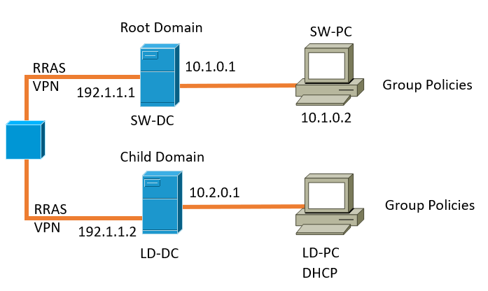
You need to complete the following tasks:
- Build a virtual network configuration
- Install and Configure
  - Critical network services
  - Routing

Critical Details
Login: -: Username: Administrator, Password: Pa55w0rD!
System Configuration: -: Language: English US, Time Format: London UK
- In SW Network,
  - Install Routing and Remote access Service and modify firewall rules to allow ICMP Traffic.
  - Configure Site-to-Site VPN to LD Network. Set the connection type to “persistent connection”.
  - Create a forest named WSSIT.NSA
  - Create all appropriate A records for all servers on 10.1.0.0/24 and 10.2.0.1/24.
  - Create a reverse lookup zone creating PTR records for all servers.
- In LD Network,
  - Install Routing and Remote access Service and modify firewall rules to allow ICMP Traffic.
  - Configure Site-to-Site VPN to Swansea Network. Set the connection type to “persistent connection”.
  - Create a child domain named LD.WSSIT.NSA in WSSIT.NSA tree
  - Create user accounts for LD.WSSIT.NSA domain with all the parameters defined in the users_list.xlsx document.
  - Mount second disk drive to C:\LondonFiles.
  - Configure DHCP Services. The range is 10.2.0.10 – 10.2.0.20. Determine other DHCP options as per the infrastructure.
- Sharing Disk Drive:
  - To the earlier created C:\LondonFiles, set access permissions to allow users in the users_list.xlsx has full control permissions and other network users have only read access.
  - Share the drive to both LD and SW network.
- Configure IIS Server
  - Create https://web.ld.wssit.nsa website and enable windows internal authentication. All the LD users can be authenticated.
  - All authenticated users should be presented a text “Welcome to LD Website”.
- Remote Desktop Services:
  - Configure remote access for LD-DC from any other machines in the network.
  - Make sure that the Remote Desktop Services login page should be accessed via https://rds.ld.wssit.nsa and necessary certificates are signed.

