Student Name: Hristo Tsvetanov Hristozov
Student ID : 2030334
Introducing the Modern Workplace (LCBB4003)

REPORT ON ORGANISATIONAL STRUCTURE AND CULTURE OF H&M

Table of Contents
Introduction 3
Organisational Structure of H&M 4
Leadership in H&M 5
Organisational Culture 6
Effective management of H&M 7
Organizational behaviour in H&M based on behavioural approaches 7
Conclusion 10
References 10

Introduction
H&M is the company which deals with fashion and cosmetics and operates in 37 countries around the world. It was first established in Vasteras, Sweden. H&M has its branch in U.K. as well. This is a highly successful multinational company. The success of the company is highly dependent on the business model of the company that is constructed by considering the internal and the external environment of the company. Organisational management is one aspect that helps the company in achieving its objectives. H&M is seen to be having a good organisational management as there is a constant growth of the company over the years. The organisational structure enables the company to improve the global reputation. The organisational culture helps the employees of the company to perform better by motivating them. The organisational behavioural approach is also seen to be influencing the organisational performance. This is a report constructed based on the organisational structure and organisational behaviour approach of H&M so that the organisational performance of the company can be understood.
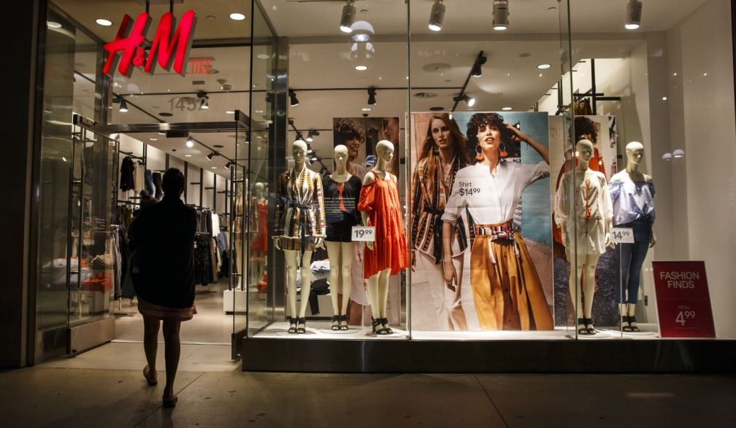
H&M
Source: (Fallon, 2016)

Organisational Structure of H&M
The organisational structure of any company impacts the innovation capability. The innovation capability is directly linked to the organisational performance (Iranmanesh et al. 2020). The organisational structure is of two types – organic and mechanistic. The type of organisational structure that is followed in H&M is of organic type. This type of structure is found to be flexible, and the authority of the organisation is distributed among different people in the organisation. H&M is seen to be having a matrix organisation which means that the people working in particular department are responsible for the best practice in that department (Hmgroup.com, 2015). This organisational structure allows the employees to express their own feelings independently. The top management of H&M is seen to be involved in motivating and empowering the employees so that they can try innovative processes to manufacture new products. There is a hierarchy in leadership that is present in leadership but there is absence of more authority in the top management (Hmgroup.com, 2019). The CEO of the company is in charge of managing the operations of the company. The organisational structure of the company helps the employees to perform in a flexible way and try new techniques so that the organisational performance can be improved. These are the factors that show that the organisational structure is helping to improve the operations and performances in H&M.
The organisational structure of H&M allows working in the organisation with commitment. The management of the company always emphasizes that the growth of the company is possible when there is individual growth of the people working in the company. The organisation is seen to be promoting the cross-functional developmental opportunities that will allow overall development of the employees. The overall development of employees will lead to the improvement of the performance of the company.
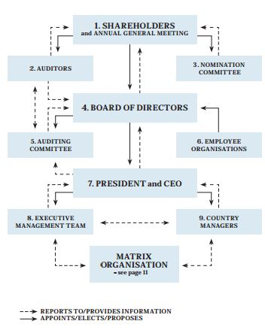
Organisational Structure of H&M
Source: (Hmgroup.com, 2015)

Leadership in H&M
The organisational success depends entirely on the leadership style chosen by the company (Jian and Fairhurst, 2017). The type of relationship that exists between the top management of a company and its employees determine the organisational performance of the company. The CEO of H&M has a high leadership quality, and this helps in promoting quality performance by the employees. The CEO is responsible for the day-to-day management of H&M (H&M Group, 2021). The leader of H&M is seen to be leading by example and is the role model for most of the employees. This leadership has imbibed organisational values in the company which advocates teamwork and thus helps the employees to perform at their best. This proper management of H&M enables the proper operation internationally. The organisational performance is improved when there is empowerment of the employees to work independently.

Organisational Culture
The culture of an organisation refers to the values and principles that are helping the employees to perform in a way that will bring achievement to the company. The organisational culture is including the mission of the organisation and also the techniques to be followed that will define the procedure involved in achieving the goal or mission, H&M is seen to be having a very strong organisational culture and this has been existing in the organisation from the days of its foundation. The strong culture is valuable and contributes to the success of H&M over the years. The spirit of H&M is the corporate culture of the organisation. The organisational culture of H&M is based on several values that describe the ways of working in simple terms. H&M is one of the organisations that provide the employees to work independently and take decisions and responsibilities based on their knowledge. The good working environment in any organisation automatically enhances the quality of the performance of the employees and the job satisfaction of the employees increase. H&M believes in job rotation, and this helps the employees to grow beyond their own genre. The employees are able to learn more skills and thus their performance improves in the organisation. The organisation is constantly organising programmes that will help in developing skills in the employees, and this helps the company to retain more employees over the years. This is one of the important factors that improve the organisational performance of the company, and it achieves success.
It is usually misjudged that an employee cannot move forward in H&M. But in reality, H&M is growing quite fast and is thus providing opportunities to all the employees. The employees are motivated in the company as they are provided new challenges. The culture of H&M lies in encouraging the employees to try many different roles in the organisation. There are also different benefits that are provided by the organisation to the employees, and this motivates the employees to perform better in the organisation. H&M is also having a culture of fulfilling all the aspirations of the employees and this leads to the improvement of the organisational performance.

Effective management of H&M
Effective management is one of the factors that play an important role in bringing success to the company. H&M is the company that believes in the decentralized decision-making process which means that this company believes in the proper communication among the employees and the management. The company feels that this will help it to know the opinions of the employees regarding the management practices of the organisation. Teamwork is one of the attributes that have improved the management approach of H&M. This organisation is employee owned. The management of the organisation is involving the heads of the departments that form teams for projects. These teams will be formed of the individuals who will be having the most qualities and skills. It is also noticed that H&M is gaining success over the years which made it be ready to form partnership with the other clothing brands situated at any place in the world.

Organizational behaviour in H&M based on behavioural approaches
The behavioural approaches in the management are based on the well being of the employees. The behavioural approaches in any organisation are designed in a way that provides motivation and satisfaction to the workers. The behavioural approaches in the company can provide a better work environment in the company so that the productivity of the employees enhance. H&M operates in 37 countries and recruits’ employees from all the 37 countries where the company is operational. There is a strong work ethics maintained in H&M. There are different types of people who are involved in the working structure of H&M. The employee-suggestion box is one of the behavioural approaches that are used in the company (Johnston, 2018). The workplace of H&M is an inclusive workplace. The management treats all the employees equally. As H&M is located throughout the world, equality and diversity is promoted in the company. There is no kind of discrimination that resides in the managerial structure of the company. The employee-suggestion box approach is used when the employees are working in teams. The management and the leaders give importance to the choices of the employees. It is seen that the leaders are being role models of the company. The company uses an open-door policy which promotes that the employees must be straightforward. They must be open about all the suggestions that they would like to provide to the different sections of management. The next behavioural approach that is implemented in the organisational behaviour of H&M is Flex-time scheduling. This is mainly the approach in which the employees are allowed to work flexibly, and this is an approach that works its best to respect individual needs. Usually, companies follow this approach in the organisational behaviour as this improves the satisfaction of the employees. This happens because the employees are given a comfortable and accommodating workplace to work. H&M management believes in maintaining good employee relation and therefore tries to keep the employees comfortable while working in the company.
The company respects all the suggestions of the employees. It also plays a major role in maintaining the good partnership with the employees. H&M respects all the rights of the employees as well. It is seen that H&M management believes in providing flexible work schedules to the people who are working in the company (about.hm.com, 2021). The company always encourages the employees to work according to their comfort zone. The only focus of H&M is that the employees must be committed to the work and must be prepared to take challenges. This taking up of challenges in turn will help the employees explore new opportunities. The next behavioural approach that is imbibed in the structure of H&M is positive reinforcement. This is the approach that is directly linked with the productivity of companies. The leadership quality of the managers follows this behavioural approach. The employees are given the best working environment so that they can grow together. H&M also focuses on the work that is produced in the company. The performances of the workers are checked at times by the managers. If any employee is seen to be not working according to their capability, the managers try to approach them to know the reasons. It is seen that there are different people who are working in the company and there is diversity in the work culture of the company. The managers also try to organise the workforce of the company into self-organised teams so that the workers are capable of giving their best production. This type of organisational behaviour will lead to the growth of the entire organisation. The most important organisational behaviour that is visualised in the management of H&M is respecting the information of the company. H&M believes that the most important asset of the company is the information. The management therefore makes sure that there is privacy maintained in the organisation. There is safeguarding of the confidential information about the company. The employees are also given rewards based on the performances in the organisation. This is one of the factors that are responsible for the enhancement of the organisational performance. The positive organisational behaviour thus can help in the organisation to grow and sustain in the competitive market.

Conclusion
To put it in a nutshell, it is seen that H&M allows growth of the employees and provides them with the opportunities to explore their talents. The employees of the organisation are also given independence to select their own work schedules. Usually, the employees of the organisation are free to provide their own suggestions. H&M uses these suggestions to innovate new ideas for their products. The employees are not allowed to experience any closed environment. The management always prefers the employees to be straight-forward. It is also seen that the company prefers teamwork, and this shows that the employees and the leaders have collective responsibility towards the success of the environment. The leaders of the company are considered to be role models by the employees. The success of H&M clearly indicates that the organic and flexible organisational structure should be maintained in most of the companies. The employees must be given rewards for their excellent performance which will motivate them to perform better. This will enhance the organisational performance.

References
About.hm.com. 2021. The H&M Way. [online] Available at: <https://about.hm.com/content/dam/hmgroup/groupsite/documents/en/hm-way/HM%20Way_en.pdf> [Accessed 24 August 2021].
Fallon, P., 2016. H & M Hennes & Mauritz. [online] Fortune. Available at: <https://fortune.com/global500/2017/h-m-hennes-mauritz/> [Accessed 24 August 2021].
Hmgroup.com. 2015. [online] Available at: <https://hmgroup.com/wp-content/uploads/2020/10/Corporate-Governance-Report-2014_en.pdf> [Accessed 24 August 2021].
Hmgroup.com. 2019. Corporate governance report 2019 H&M. [online] Available at: <https://hmgroup.com/wp-content/uploads/2020/10/HM-Corporate-governance-report-2019.pdf> [Accessed 24 August 2021].
H&M Group. 2021. Company management - H&M Group. [online] Available at: <https://hmgroup.com/about-us/corporate-governance/company-management/> [Accessed 24 August 2021].
Iranmanesh, M., Kumar, K.M., Foroughi, B., Mavi, R.K. and Min, N.H., 2020. The impacts of organizational structure on operational performance through innovation capability: innovative culture as moderator. Review of Managerial Science, pp.1-27. https://www.researchgate.net/profile/Mohammad-Iranmanesh-2/publication/343081870_The_impacts_of_organizational_structure_on_operational_performance_through_innovation_capability_innovative_culture_as_moderator/links/5f169c104585151299ad5d3b/The-impacts-of-organizational-structure-on-operational-performance-through-innovation-capability-innovative-culture-as-moderator.pdf
Jian, G. and Fairhurst, G.T., 2017. Leadership in organizations. The international encyclopedia of organizational communication, pp.1-20. https://onlinelibrary.wiley.com/doi/pdf/10.1002/9781118955567.wbieoc124
Johnston, K., 2018. Examples of Behavioural Approaches in Business Management. [online] Yourbusiness.azcentral.com. Available at: <https://yourbusiness.azcentral.com/examples-behavioral-approaches-business-management-23852.html> [Accessed 24 August 2021].

