University of Wales Trinity Saint David
School of Engineering

Application of Automation in Wastewater Treatment

Control and Automation
ACMA5001

Shanjidah Ahmed
2309702
23/04/26
Contents
1 Introduction 1
2 History of Instrument, Control and Automation 2
3 Automation within Wastewater Treatment 4
4 Discussion and Case Study 5
4.1 Sensors 5
4.2 Process Controllers and Actuators 8
4.3 Supervisory Control 10
5 Regulations and Standards 11
6 Future Technologies and Developments 12
7 Conclusions 14
8 References 15

Table 1 - Emissions Limit Dow Silicones Barry (Betteridge, 2026) 11

Figure 1 - Centrifugal Governor (Han and Zhang, 2022) 2
Figure 2 - Turbidity Flow - Labelled Diagram (OPTEX, no date) 5
Figure 3 - Diagram of Turbidity Sensor (Endress+Hauser, 2018) 6
Figure 4 - Turbidity Probe (Endress+Hauser, 2018) 6
Figure 5 - Electromagnetic Flow Meter Diagram (Endress and Hauser, 2024) 7
Figure 6 - Loop Diagram (PID) (Iratni and Chang, 2019) 8
Figure 7 – General PID Response to Setpoint (Ianni and Rossi, 2021) 8
Figure 8 - Control Blocks Dow's Methanol System (Dow Silicones, 1998) 9
Figure 9 - Pneumatic Actuator with Controller and Positioner(Inst Tools, 2019) 9
Figure 10 - History of Industrial Automation (Berg, 2021) 12

Glossary of Terms
Term | Definition
SCADA | Supervisory Control and Data Acquisition
DCS | Distributed Control System
PLC | Programmable Logic Controller
ICA | Instrumentation Controls and Automation
IoT | Internet of Things
IIoT | Industrial Internet of Things
PID | Proportional-Integral-Derivative
WWT | Wastewater Treatment
AI | Artificial Intelligence
I/P Converter | Current- to-Pneumatic converter

Introduction
Instrument Controls and Automation covers the notion of sensor technology and its journey to and from a readable interface. This report looks to identify key historical automation inventions, and its adaption into modern usage. Particular attention will be taken to highlight the operational flow of the automation from sensor to response. With relevant insight from wastewater treatment plants located at Dow Silicone. As well as the importance of regulations and technology development to meet standards of compliance, ensuring stability and efficiency is maintained. Future technologies and development in this sector include the involvement of Industry 4.0 and artificial intelligence. Driving towards automation response and predictability and moving away from manual approaches.

History of Instrument, Control and Automation
Instrumentation often dates to the First Industrial Revolution with the implementation of various manual mechanisms to aid with distinct process parameters (Amos, 2017). A key development during 18th century saw the invention of the steam engine governor, a defining invention by James Watt considered as the first known closed loop system (Amos, 2017). This mechanism used the concept of centrifugal force to rotate two equal masses, (generally spheres) on an axis, in order to control engine speed when connected with a valve (Amos, 2017) as seen in figure 1. This paved the way for advancements in both temperature and pressure gauges, for more precise applications (Process Instrument Solutions, 2025).
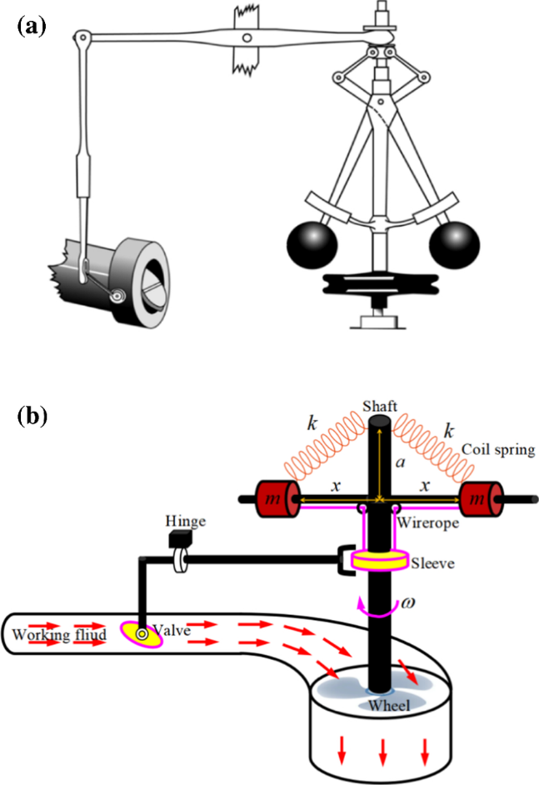

Figure 1 - Centrifugal Governor (Han and Zhang, 2022)
The 19th century changed the course of instrumentation due to prevalence within the electronic field, particularly Siemens (recognised for its industrial application and control technology) (Forbes Marshell, no date). Further to this automation developed further through the 20th century, with the introduction of radar and an increase in reliability of both current flow and voltage (Forbes Marshell, no date). Marking the beginning of the standardised electronic output of sensors between 4-20mA (Amos, 2017) and the change from mechanical to analogue configurations (Berg, 2021).
From this the emergence of Supervisory Control and Data Acquisition (SCADA) (Berg, 2021) was introduced, a key element to drive automation through integrated circuits and PLC’s (Programmable Logic Controllers), (Forbes Marshell, no date) and giving rise to the first Distributed Control System (DCS) founded in 1975 (Berg, 2021).
Modern day application sees the use of digital processes within instrumentation providing real time data with the use of sensors, monitoring applications and DCS, allowing live feedback and automated response (Process Instrument Solutions, 2025).

Automation within Wastewater Treatment
Instrumentation, Controls and Automation (ICA) has advanced rapidly over the past 40 years particularly within the wastewater industry (Olsson et al., 2014). The purpose of such movements looks to improve both efficiency and cost margins, with previous methods having little control authority and insufficient processing capability for high-level use in Wastewater Treatment (WWT) facilities (Olsson and Ingildsen, 2003).
The objective of wastewater systems generally works on the notion to regain a level of sanitary, pH and temperature of water to coincide with environmental parameters. It has been determined that with current technologies in ICA, efficiency can increase by 10-30%, thus real time measurements and automation is key to productivity (Olsson, 2006).

Discussion and Case Study
Dow currently processes its own waste derived from by-products of silicone manufacturing; this requires three defining cells and functions within the WWT plant to ensure regulations are met. Once parameters are adhered to, the processed/decontaminated effluent is released back into the Cadoxton river.

Sensors
Due to the impact of non-regulatory wastewater stream entering the environment, sensors are considered paramount in order to adhere to environmental policy (Weerasinghe, Jayathilaka and Vithanage, 2025). Sensors allow users to react to live measurements due to its high level of sensitivity, thus calculated response can take place to ensure product satisfaction before discharging (Weerasinghe, Jayathilaka and Vithanage, 2025).
Sensors typically found within the wastewater industry include the use of chemical and optical variants, these both have advantages and disadvantages for particular usage, however chemical sensors are often used in conjunction with monitorisation of heavy metals within effluent (Weerasinghe, Jayathilaka and Vithanage, 2025). Optical have advantages in spectroscopic measurements, detecting organic matter, often referred to as Turbidity Sensors. This is achieved by a light dispersion, if this is reflected it is deduced that a large quantity of contaminants remain thus a reading can be calculated for such operation, seen in figure 2.
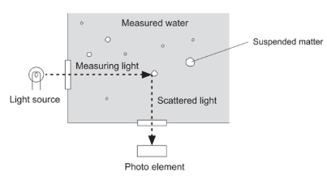

Figure 2 - Turbidity Flow - Labelled Diagram (OPTEX, no date)

Figure 3 and 4 below indicates the flow of infra-red light directed through the effluent which in turn is read by the sensor (at 90º or 135º) in FNU (Formazin Nephelometric Unit) (Endress+Hauser, 2018), these however can be denoted by a range of units’ dependant on its application. ISO 7027 is generally used when infrared detection is required, enabling a more universal method when determining turbidity (Endress+Hauser, 2018). The detector converts electrical signal into a turbidity value (Endress+Hauser, no date b).
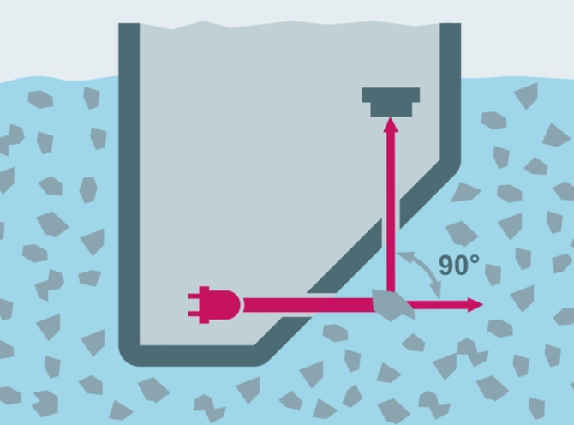

Figure 3 - Diagram of Turbidity Sensor (Endress+Hauser, 2018)
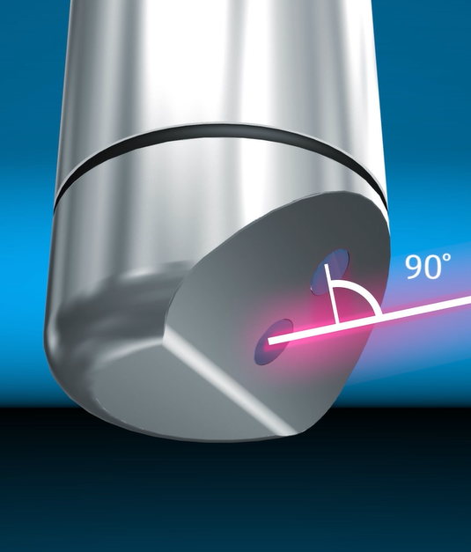

Figure 4 - Turbidity Probe (Endress+Hauser, 2018)

Through Dow’s WWT plants, effluent is initially stored within clarifiers (first cell), which generally has a pH rating of around 0.3-1, thus neutralising and removal of large, suspended particles is required. Liquid levels within clarifiers also require constant monitoring, due to the prevalence and demanding fluctuating nature of the sites effluent waste.
pH sensors use potentiometric measurements to gain values which can then be related to effluent levels. These often use electrodes encased in a glass sheath to produce electrochemical potential between a reference solution and the effluent (Endress+Hauser, no date a). A higher value will be determined with a more acidic solution due to the hydrogen cation present in the acidic solution.
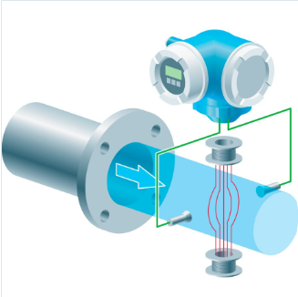
Secondary WWT looks to add methanol to the system, however prior to this flow rate needs to be monitored. This is typically achieved using a flow meter commonly described as variable flow technology, converting mechanical movement read on the field devices to an electrical impulse, (requiring additional attachments) (KROHNE, 2020). Other methods of flow measurement (for conductive fluids) can include electromagnetic concepts such as faradays law to induce a current. A higher flow rate producing a stronger current between electrodes as seen in figure 5 (Endress and Hauser, 2024).

Figure 5 - Electromagnetic Flow Meter Diagram (Endress and Hauser, 2024)

From the input received from sensors, analysis can take place though PLC’s, DCS, SCADA and IoT (Internet of Things) (Berg, 2021).

Process Controllers and Actuators
A signal of 4-20mA is sent out by sensors which is then received by a DCS, in some case PLC’s will also be prevalent between these stages, in which automated processes and proactive action will take place (Berg, 2021), advancing both control algorithms and process transmitter inputs (Viry, no date). PLC’s offer a number of inputs and outputs (I/O) which can be connected to SCADA systems, playing a role in the development of Industrial Internet of Things (IIoT) (Berg, 2021).
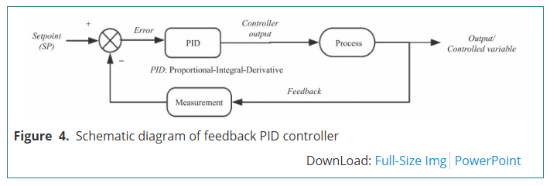
A PID (Proportional-Integral-Derivative) control is often used as a method to mitigate change within a system/waveform, this is referenced to a setpoint in which error between variables can be corrected (Iratni and Chang, 2019). To ensure stability within a PID system a feedback loop is necessary(Viry, no date), as seen in figure 6. Figure 7 shows the variation of inputs applied to the output signal in order to adjust values, these relations use proportional, integral and derivative measures. Integral operations distinguish past values, whereas derivative measures look towards predicting future values, thus with this system working in unison PID optimises output to DCS (Emerson, 2025).
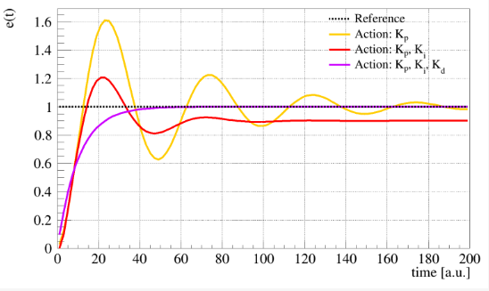
Figure 6 - Loop Diagram (PID) (Iratni and Chang, 2019)
Figure 7 – General PID Response to Setpoint (Ianni and Rossi, 2021)
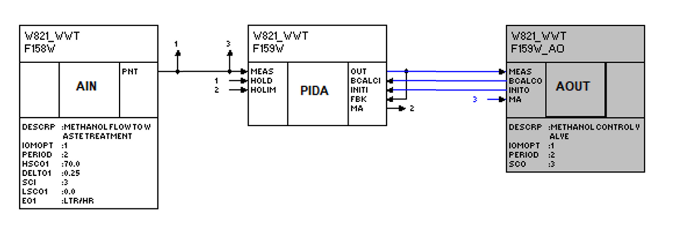
Figure 8 below shows the stages in which the DCS provides PID calibration to the initial signal. This includes an analogue input block, PID and analogue output to the corresponding valve. Once the analogue output block has been sent it is converted through an I/P converter to deliver a pressure between 3-15psi (0-100%). As the Dow system is dated this would typically be seen as 0.2-1bar pressure in modern configurations.
Figure 8 - Control Blocks Dow's Methanol System (Dow Silicones, 1998)
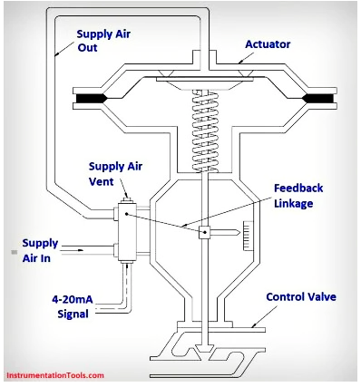
This impulse of pressure regulates an actuator to open and close a valve based on these proportions, thus the pneumatic control of the actuator works in tandem with PID controllers in order to keep processes within specified parameters (Viry, no date). The solenoid in conjunction with the actuator is energised to provide these outputs, however if an issue where to arise and electrical impulse was interrupted the actuator would fail on a closed position, due to the spring mechanism of its design, ensuring flow does not surpass regulatory limit (as seen in figure 9).
Figure 9 - Pneumatic Actuator with Controller and Positioner(Inst Tools, 2019)

Supervisory Control
Supervisory Control and Data Acquisition (SCADA) and PLCs involve micro-processing abilities thus having a larger range to enable a more controlled and stable monitoring system compared to that of previous methods (Viry, no date). Supervisory control introduced the elements of monitoring and coordination with regards to signal conditioning, as opposed to previous technology which limited the ability to control multiple actuators in unison (Berg, 2021). SCADA systems with regards to WWT allows both chemical dosing and effective management of flow and sludge properties whilst simultaneously driving to improve energy efficiency. This is prominent with errors found in turbidity, pH balance in which SCADA systems can automatically adjust parameters in order to meet expectation (ionexchange, 2025). Pre-processed data conducted through SCADA is used to further detect and identify sensor error in future process monitoring of plant (Wade, A and M.R, 2005).
SCADA systems have developed over the years from local network capabilities to cloud computing involving Internet of Things (IoT), using ethernet connectivity for remote access, easier maintenance and an improved level of communication between wider geographical locations (Berg, 2021). With its ability to send alarm signals to interface, as well as track, log and trend issues, IoT are key to handling industrial data, such as process valves, which in turn stores and processes information via cloud and filters data in accordance with the set parameters needed to ensure correct response (Berg, 2021). Automation error has moved from 1.15% with manual processing to around 0.00001%, (Berg, 2021) thus the implementation of modern control systems adds a greater level of certainty.
Issues pertaining to the use of Bluetooth/automatic instruments can lead to higher risk of cyberattacks, this is due to its initial drive to make automation a product of efficiency rather than security, thus standards and guidelines are not universally enforced, impairing its use in modern day systems (Knowles et al., 2015). However issues include the involvement of remote access and availability to large volumes of people within organisations, this subsequently added to another level of ease for attackers, as primarily automation was local and isolated, however the use of internet to advance connectivity also bares additional issues with protection and safeguarding of instruments and process (Knowles et al., 2015).

Regulations and Standards
With WWT operations being load driven (Olsson, 2006) there is a high importance to ensure capacity for environmental issues and to redistribute water back to natural environments at a preestablished demand rate, thus avoiding over spill and legal action (Olsson, 2006).
Companies are required to submit permits to adhere to local limits and UK governmental regulations. Table 1 below indicates the limits Dow currently hold, and their frequency of occurrence, which need to be complied to.
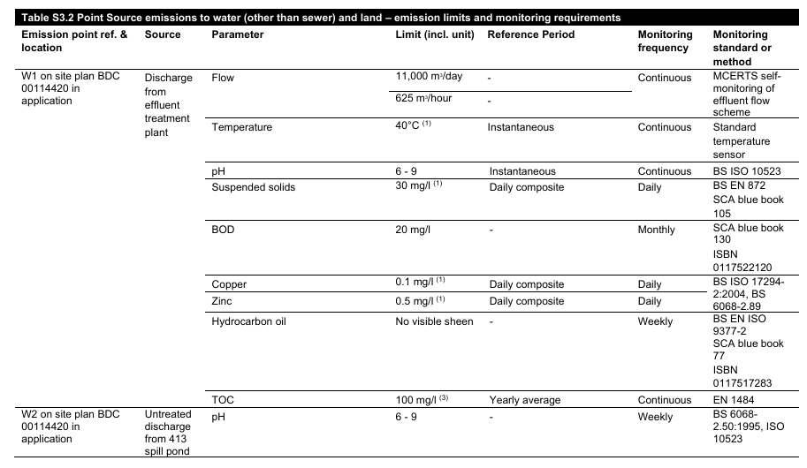
Table 1 - Emissions Limit Dow Silicones Barry (Betteridge, 2026)

It is stated that in the event of limit breach the company would be required to disclose information, and preventative actions should be taken to avoid further implication. However, some instances with numerous breaches would recognise the need to fine Dow, and put further measures in place to avoid reoccurrence, thus making it harder to reapply for permits due to the lack of environmental adherence.
In general, WWT is highly regulated for specific purposes, as many instances sees processed sediment/effluent released into natural environments. Thus, widespread issues can arise with fluctuations in levels and parameters such as pH, acidity and flow, harming both aquatic organisms, livestock and humans if not controlled correctly. Control of WWT is crucial for environmental protection, as well as resource management (Iratni and Chang, 2019).

Future Technologies and Developments
Current issues pertaining to the use of sensors looks at the interference due to the properties within the WWT stream (Weerasinghe, Jayathilaka and Vithanage, 2025)(Iratni and Chang, 2019). Digital Twin looks to mitigate this occurrence with its ability to optimise performance, predict maintenance needs and simulate parameter fluctuations (Soares, 2020). Working in conjunction with SCADA technology due to its foundation in the control system framework (Berg, 2021). However, it is noted that challenges may become apparent when used in smaller scale corporations due to the need to train, invest and develop current sensor infrastructure (Soares, 2020). With regards to sensors, manufacturer and technology advancements are continuously developing to produce more sensitivity within reading parameters and thus advancing wastewater practice (Weerasinghe, Jayathilaka and Vithanage, 2025). For example, an introduction of microfluid technology within sensors would improve its capabilities to detect organic compounds and metal particulates, thus again improving stability and automation of treatment plant (Weerasinghe, Jayathilaka and Vithanage, 2025).
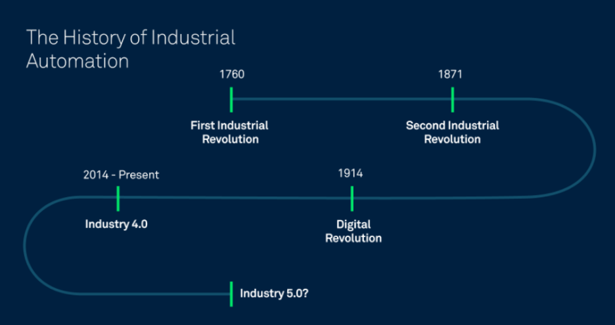
The use of AI (Artificial Intelligence) within the automation industry suggests an up turn in efficiency and response due to its capabilities and responsiveness (Forbes Marshell, no date). This aligns with industry 4.0 approach, with adoption of AI technology and internet grounded communication, such as IoT (Berg, 2021). IoT is a key component to industry 4.0 allowing filtering of large data secs whilst also acquiring data from the cloud to provide real time data to AI interface (Berg, 2021). Figure 10 below highlights the key changes in industrial automation.
Figure 10 - History of Industrial Automation (Berg, 2021)
Other developments could see the introduction of e-nose into the wastewater sector, with its ability to detect and monitor gases such as methane and hydrogen sulphide (Ijaz et al., 2025). This would perform well with the use of AI, however researcher suggest development would need undertaking to ensure pattern recognition, and complex datasets in order to achieve stability and a reliable output (Ijaz et al., 2025).

Conclusions
The development seen with the ICA industry suggests the industrial need to consistently improve both stability and accuracy in the field. Control technology has moved away from linear control to non-linear with AI being a more prominent driver towards improvement in efficiency and stability within systems ​(Iratni and Chang, 2019)​. This corresponds to local legislation as well as requirements determined by region to ensure a safe environment for all organisms (Iratni and Chang, 2019).
The advantages seen within the SCADA systems look to monitor outputs of a live feed, thus interpreting data such as pressure and flow, which in turn can adapt and automate valves through actuators to enable rapid response in sequence​ (ionexchange, 2025)​. With these in mind regulations and standards can be met with adherence to governmental compliance ​(ionexchange, 2025)​. Further to this leak detection and alarm response aids with the notion to produce more efficient workflow, in a cost-effective and timely manner.
Sensor application provides a range of varying detection methods through radar, optical and chemical variants (Weerasinghe, Jayathilaka and Vithanage, 2025). Each operation producing specific parameters. These can then relay electrical signal to DCS, PLC through a 4-20mA current (Berg, 2021). Which in turn will generate an appropriate response often based on a preestablished set-point. Once determined the output will change from digital to analogue to the specific instruments (actuator), energising a coil to open a valve.
It has been noted that a typical manual process would have an error rate of around 1.15% whereas an automated process would suggest a region of around 0.00001% (Berg, 2021). Thus, the movement to improve automation in the WWT sector is crucial for both stability and efficiency with its advantages seen in both labour and time costs.

Word count: 2506

References
Amos, S. (2017) A Brief History and Future of Instrumentation. Available at: chrome-extension://efaidnbmnnnibpcajpcglclefindmkaj/https://www.gambica.org.uk/static/uploaded/012dfcac-a890-47e8-954fd7feb61b2c92.pdf (Accessed: 3 April 2026).
Berg, C. (2021) The Complete Guide to Industrial Automation, Clarify. Available at: https://www.clarify.io/learn/industrial-automation (Accessed: 3 April 2026).
Betteridge, C. (2026) EPR-BR9685IX V011 - Consolidated Permit. Available at: file:///C:/Users/UB08982/Downloads/EPR-BR9685IX%20V011%20-%20Consolidated%20Permit.pdf (Accessed: 8 April 2026).
Dow Silicones (1998) ‘W821 Wastewater Treatment - Block Drawing’, Dow [Preprint]. Dow.
Emerson (2025) The PID Controller & Theory Explained, NATIONAL INSTRUMENTS CORP. Available at: https://www.ni.com/en/shop/labview/pid-theory-explained.html?srsltid=AfmBOooqpmfHkG5_mdvdAIsWAUfrRO_yjJDQl0c7gt7WnYUT0BG2uYt7 (Accessed: 23 April 2026).
Endress+Hauser (2018) Turbidity measurement. YouTube. Available at: https://www.youtube.com/watch?v=qz8xHQJw6qY (Accessed: 7 April 2026).
Endress+Hauser (no date a) pH sensors and transmitters. Available at: https://www.endress.com/en/field-instruments-overview/liquid-analysis-product-overview/pH-sensors-transmitters (Accessed: 8 April 2026).
Endress+Hauser (no date b) Turbidity Sensors and Transmitters. Available at: https://www.uk.endress.com/en/field-instruments-overview/liquid-analysis-product-overview/turbidity-sensors-transmitters?locale=en (Accessed: 7 April 2026).
Endress and Hauser (2024) ‘Electromagnetic Flow Measuring Principle’, 12 March.
Forbes Marshell (no date) History of Instrumentation Engineering. Available at: https://www.forbesmarshall.com/instrupedia/history-of-instrumentation-engineering/ (Accessed: 3 April 2026).
Han, Y. and Zhang, Z. (2022) ‘Bifurcation and chaos for a novel model of trigonal centrifugal governor with non-smooth control’, Nonlinear Dynamics, 111, pp. 1–20. Available at: https://doi.org/10.1007/s11071-022-08115-w.
Ianni, A. and Rossi, N. (2021) ‘SIR-PID: A Proportional–Integral–Derivative Controller for COVID-19 Outbreak Containment’, Physics, 3(3), pp. 459–472. Available at: https://doi.org/10.3390/physics3030031.
Ijaz, U. et al. (2025) ‘A comprehensive review of electronic nose systems: design, sensors, and future directions’, Chemical Engineering Journal, 524, p. 169482. Available at: https://doi.org/https://doi.org/10.1016/j.cej.2025.169482.
Inst Tools (2019) What is a Pneumatic Actuator?, Inst Tools. Available at: https://instrumentationtools.com/what-is-a-pneumatic-actuator/ (Accessed: 23 April 2026).
ionexchange (2025) SCADA Water Treatment Revolutionizes Plant Monitoring, Ion Exchange. Available at: https://us.ionexchangeglobal.com/scada-water-treatment-plant-monitoring/#:~:text=In%20wastewater%20treatment%2C%20SCADA%20enables,efficiency%20while%20reducing%20energy%20consumption (Accessed: 18 April 2026).
Iratni, A. and Chang, N.-B. (2019) ‘Advances in Control Technologies for Wastewater Treatment Processes: Status, Challenges, and Perspectives’, IEEE/CAA Journal of Automatica Sinica, 6(2), pp. 337–363. Available at: https://doi.org/10.1109/JAS.2019.1911372.
Knowles, W. et al. (2015) ‘A survey of cyber security management in industrial control systems’, International Journal of Critical Infrastructure Protection, 9, pp. 52–80. Available at: https://doi.org/https://doi.org/10.1016/j.ijcip.2015.02.002.
KROHNE (2020) ‘Variable Area Flowmeter’. KROHNE.
Olsson, G. (2006) ‘Instrumentation, Control and Automation in the Water Industry – State-of-the-Art and New Challenges’, Water science and technology : a journal of the International Association on Water Pollution Research, 53, pp. 1–16. Available at: https://doi.org/10.2166/wst.2006.097.
Olsson, G. et al. (2014) ‘Instrumentation, control and automation in wastewater - from London 1973 to Narbonne 2013’, Water Science and Technology, 69(7), pp. 1373–1385. Available at: https://doi.org/https://doi.org/10.2166/wst.2014.057.
Olsson, G. and Ingildsen, P. (2003) ‘AUTOMATION IN WASTEWATER TREATMENT PLANTS’, Proceedings of the Water Environment Federation, 2003(9), pp. 238–254. Available at: https://doi.org/10.2175/193864703784639570.
OPTEX (no date) High-Sensitivity Turbidity Sensor Protects Beverage Quality and Reduces Purification Equipment Maintenance Loads. Available at: https://www.optex.co.jp/e/solutions/well-water.html (Accessed: 8 April 2026).
Process Instrument Solutions (2025) Exploring the History of Process Instrumentation, Process Instrument Solutions Ltd. Available at: https://www.processinstrumentsolutions.co.uk/2025/04/01/exploring-the-history-of-process-instrumentation/ (Accessed: 3 April 2026).
Soares, A. (2020) ‘Wastewater treatment in 2050: Challenges ahead and future vision in a European context’, Environmental Science and Ecotechnology, 2, p. 100030. Available at: https://doi.org/https://doi.org/10.1016/j.ese.2020.100030.
Viry, L. (no date) ‘Instrumentation and control engineering: unveiling modern automation systems’, Fuji Electric. Available at: https://www.fujielectric.fr/en/blog/instrumentation-and-control-engineering-unveiling-modern-automation-systems/?srsltid=AfmBOorD-7o4r2CH4iUU0_wx-PCL4xo9bJzUfFrAAsRZLDwDIXHH-33t (Accessed: 12 April 2026).
Wade, M., A, S. and M.R, K. (2005) ‘On real-time control and process monitoring of wastewater treatment plants: Real-time process monitoring’, Transactions of the Institute of Measurement and Control, 27, pp. 173–193. Available at: https://doi.org/10.1191/0142331205tm140oa.
Weerasinghe, M., Jayathilaka, K. and Vithanage, M. (2025) ‘Sensors for detection and monitoring of contaminants in wastewater’, Current Opinion in Environmental Science and Health. Elsevier B.V. Available at: https://doi.org/10.1016/j.coesh.2025.100609.

