Programme: BSc (Hons) Health and Social Care
Module: Introduction to Independent Research Skills
Module code: BMHP5019
Assignment Title: Component 2: Written Assignment (Research report)
Topic: How safe is the treatment used to treat bipolar disorder in pregnancy and the postnatal period in Uk?
Student ID:2336477
Student Name: Esther Nankya
Lecturers Name: Eleni koutsogeorgou

Table of Contents
Introduction 1
Main concept of the research 1
Rationale of the project 1
Scope of the research 2
Research aim, objectives and questions 2
Background 2
Context of the research 2
Policies 3
Legislation 3
Guidance 3
Services 4
Practice 4
Methods of data collection 4
Results 6
Thematic analysis table 6
Sub-theme 1: Understanding bipolar disorder in pregnancy 7
Sub-theme 2: Clinical management of bipolar 8
Sub-theme 3: Safety of bipolar medications during pregnancy 9
Sub-theme 4: Effects of bipolar medications in the postnatal period 10
Sub-theme 5: Risk–benefit decision making in treatment 10
Sub-theme 6: Strategies for reducing harm to mother and baby 11
Discussion 11
Conclusion and recommendations 13
Reference list 14

Introduction
The research report will highlight information about treatment and medicines used for treating bipolar disorder during the time of pregnancy and postnatal period. It will be based on secondary information, and highlight information from various sources like books, journals and websites. The report will contain the background of the research and method that is used to collect data and analyse the aim and objectives of the research and demonstrate results. After the methodology section, the research results will be given based on the thematic analysis.

Main concept of the research
Bipolar disorder is a severe and persistent condition characterised by extreme fluctuations in mood, energy, and activity level, people with bipolar disorder experience panic attacks, mood swings. In this stage, they feel energetic, restless and excited, depressive episodes that leave them feeling sad, tired and hopeless (West, 2021). Pregnancy and the postnatal period are extremely sensitive, physical and emotional changes occur in a woman’s body during pregnancy, postnatal period following birth brings significant hormonal, emotional, social changes, these stages can be tricky and risk of mood episodes can rise up when left untreated, the illness can negatively affect the mother’s mental health ,family life and baby care. Certain medications for bipolar disorder can pose risks during pregnancy or while nursing, and this makes treatment decisions complicated (Thomson and Sharma, 2023).

Rationale of the project
The justification behind this project is necessity mediate two significant problems, and part of it is protecting the mother against relapse, severe depression, mania. The second one is the need to mitigate harm the unborn baby or newborn child, some drugs have been associated with birth defects, poor pregnancy outcomes or side effects to infants. Stopping medication its risky, and untreated bipolar disorder can cause significant mental health issues often accompanied by poor self-care, substance misuse and suicide risk (Rusner, Berg and Begley, 2022).

Scope of the research
Safety of antipsychotic medications used for the treatment of bipolar disorder in pregnancy and the postnatal period, assessing the risk associated with commonly prescribed drugs and their potential for harm in both mothers and babies. It can cause dangers of one kind of untreated bipolar disorder and the challenge of treatment decisions during those times, as well as strategies to mitigate these dangers, including close attention to drug selection: re-evaluation of dose, constant monitoring and shared decision-making with the patient’s providers (Rasheed, 2024).

Research aim, objectives and questions
Aim: The aim of this research is to evaluate the safety of pharmacological treatments used for and during pregnancy and the postnatal period.
Objectives:
- Analyse bipolar disorder and its management during pregnancy.
- Examine the impact and safety of drugs used to manage bipolar disorder during pregnancy and the postnatal period.
- Evaluate strategies that can help to decrease the risks associated with bipolar disorder medications during pregnancy and the postnatal period.
Questions:
- What is bipolar disorder, and how is it managed during pregnancy?
- What are the impacts and safety of drugs used to manage bipolar disorder during pregnancy and the postnatal period?
- What are the strategies that can help to decrease the risks associated with bipolar disorder medication during pregnancy and the postnatal period?

Background
Bipolar disorder is a mental health condition, it has drastic effects on mood, energy and behaviour, and a person can have times of mania and times of depression. Special care needs to be taken about this ailment during pregnancy and the postnatal period. NICE states that its antenatal and postnatal mental health guideline includes women planning a baby, pregnant women or those who have had a baby in the past year (Perry et al., 2021). It adds that the guideline encompasses severe mental illness, including bipolar disorder, and makes the subject sensitive, as treatment must safeguard the mother’s .

Policies
Perinatal mental health is a major area of health policy in the UK, and NHS states that specialist perinatal mental health services are part of service improvement in the NHS for a Long-Term Plan. The service provides care and treatment for women with complex mental health needs, support the parent and baby relationship, as well as providing advice where a woman is contemplating pregnancy. NICE quality standards also demonstrate that good care is not just about the medicine, it is about the organisation of services, early identification, diagnosis, treatment and access to specialist teams (Pandya-Wood, Barron and Elliott, 2022). This policy background is relevant to this project because safe treatment depends not only on the medicine but also on the healthcare system.

Legislation
There are rules of law that direct practice, and the Human Medicines Regulations 2012 consolidate UK legislation on medicinal products for human use. It is important because drugs that used for bipolar disorder need to be prescribed and monitored under the law, and the Mental Health Act 1983 provides the primary legal framework for assessing and treating people with mental disorders in particular circumstances (Oussedik, Anderson and Feldman, 2023). The Mental Capacity Act 2005 is also particularly important it establishes the legal principles that applies when a person may lack mental capacity, that define the act well, Cases of severe bipolar relapse, condition which, as you can imagine, sees its fair share of psychiatric pregnancies and teratogenicity, these laws might impact consent and treatment decisions.

Guidance
Well-thought-out clinical guidance does exist around this topic, and NICE has one guideline on bipolar disorder and another on antenatal and postnatal mental health. NICE also has a Clinical Knowledge Summary that includes women of childbearing age with bipolar disorder, including pregnancy, unintended pregnancy, acute episodes in pregnancy and breastfeeding (NICE, 2017). The strongest advice is valproate, and NICE quality standards do not permit the prescription of valproate given a mental health diagnosis for women and girls of childbearing age. The UK govt has a page that also states that valproate presents reproductive harm, and precautions are taken to minimise it, and guidance on lithium is less straightforward. Decisions to use lithium during pregnancy and breastfeeding need careful benefit discussion not to cause risk, explains the Royal College of Psychiatrists (Moonie, 2022).

Services
There several health services involved, women may be supported by a GP and midwife or obstetric team, community mental health team, psychiatrist, pharmacist or health visitor. NHS England says specialist perinatal mental health services help women with complex mental health needs during pregnancy, and after birth, and NICE quality standards service availability should also include specialist multidisciplinary perinatal community services and inpatient mother and baby units (Lews, 2025). Mother and baby units are essential as they enable a mother to access psychiatric inpatient care while not being separated from her baby, and this model of service is particularly crucial for women with bipolar disorder, as some may develop a severe illness after birth and need immediate specialist support.

Practice
Care in practice should be planned, joined up with person-centred, and NICE states that treatment decisions for pregnancy and the postnatal period should be made according to both the perinatal mental health guideline and the guideline for the mental health problem. NICE states that professionals should seek more specialist advice from secondary care, for a perinatal mental health service where appropriate (Kumar, 2023).

Methods of data collection
Researchers can find data sources for their research, especially when this research adopted secondary data collection method, it does not seek new data from patients, doctors or hospitals. It used previously published information from academic books, journal articles, clinical guidelines, government reports and reputable health websites. The objective of the research was relevant as the focus of this study was to lay on these medications prescribed for bipolar disorder in pregnant patients and in postpartum (Harlan, 2021). Researchers were able to draw up a clear picture of the topic, without directly approaching vulnerable women or babies, by analysing pre-existing evidence.
The data were obtained by performing a secondary data analysis, and online academic databases and trusted health sources were searched for relevant materials. These sources were primary articles and peer-reviewed journal articles, as well as mental health guidelines or public health documents related to bipolar disorder, pregnancy, postpartum period of up to 1 year following childbirth and drug safety. Relevant search terms included the concrete words bipolar disorder, pregnancy, postnatal period, mood stabilisers, antipsychotics, drug safety and maternal mental health breastfeeding (Gentile, 2022). Sources that had direct relevance to the research topic were filtered out from this search and included were articles about the effects of medicines on pregnant women, unborn babies and newborn infants. Sources unrelated to bipolar disorder or not addressing the safety of medicine in pregnancy were excluded from the analysis.

Results.
The study was largely qualitative, secondary data-driven, about ideas, findings, recommendations and explanations rather than a collection of numbers from experiments or surveys helpful, statistics from prior research were also reviewed, including relapse rates and risk for birth defects or complications from medication, this provided a wider perspective on the issues allowed us to weigh treatment risks against those of untreated bipolar disorder (Dodd and Berk, 2022).
Data was analysed through a thematic analysis approach, first was identified as a source of reading multiple times. Following the identification of key points, which was grouped into main themes focused on management of bipolar disorder during pregnancy and safety of medications, risks to mother and baby, post-natal considerations, as well as harm reduction. The data from different sources were then cross-referenced, with the researcher categorising similar insights but highlighting differing opinions (Dawson et al., 2023). Using this method helped structure the discussion and allowed us to directly address the research aim and objectives.
The ethical account took into considerations in this research; the study did not involve human participants as it used only secondary data. The vital factors means that physical violence, psychological trauma ethical accountability was still needed, and any information used in the research must be obtained from reliable and trustworthy sources (Clarke, 2022). This research also had to be conducted with proper citation of others' work to avoid being accused of plagiarism, and they had to fairly represent the ideas and findings of other researchers. There should be no misinformation, cherry-picking, bias in reporting or anything similar. Another ethical sensitivity point was the researchers talked about pregnant women, mental illness and medicine use. The writing would have to always be respectful and careful (Butler, 2022).

Thematic analysis table
Themes | Sub themes | Sources | Description
Bipolar disorder and its management during pregnancy | Understanding bipolar disorder in pregnancy | (Kumar, 2023) | This sub-theme will discuss what bipolar disorder is, the symptoms, and why pregnancy can make management more difficult.
Bipolar disorder and its management during pregnancy | Clinical management of bipolar disorder during pregnancy | (Thomson and Sharma, 2023) | This sub-theme will focus on how bipolar disorder is managed, monitored, treated planned the continuity care, during pregnancy
Impact and safety of drugs/ treatment used during pregnancy | Safety of bipolar medications during pregnancy | (Dodd and Berk, 2022) | This sub-theme will examine the safety of drugs such as mood stabilisers, antipsychotics, and antidepressants during pregnancy.
Impact and safety of drugs/ treatment used during pregnancy | Effects of bipolar medications in the postnatal period | (Bilszta, Meyer and Buist, 2022) | This sub-theme will look at medication safety after childbirth, breastfeeding, maternal recovery, and neonatal effects.
Strategies to reduce medication-related risks | Risk–benefit decision making in treatment | (Oussedik, Anderson and Feldman, 2023) | This sub-theme will explore how healthcare professionals and mothers balance the risks of medication against untreated bipolar disorder.
Strategies to reduce medication-related risks | Strategies for reducing harm to mother and baby | (West, 2021) | The sub-theme will discuss practical ways to reduce risks, such as careful drug choice, dose adjustment, monitoring, and multidisciplinary support.

Sub-theme 1: Understanding bipolar disorder in pregnancy
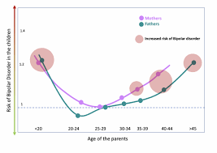
Figure: The U-curve in bipolar disorder.
Source: (Kumar, 2023).
Kumar (2023) also cautions that both mothers' and fathers' ages can impact the likelihood of bipolar disorder occurring in their children, with lower parental age posing a more significant risk to the child's potential health problems, particularly if the parent is under 20. It falls off in the mid-age categories of 25-34 years, and from there on, the risk begins rising again, especially in older moms and dads, typically beyond age 40 or 45. So parental age can be an important to consider in pregnancy. The graph gives insight that bipolar disorder probably has multiple associated risks and adequate health support can reduce these effects for families (Brett et al., 2022).

Sub-theme 2: Clinical management of bipolar
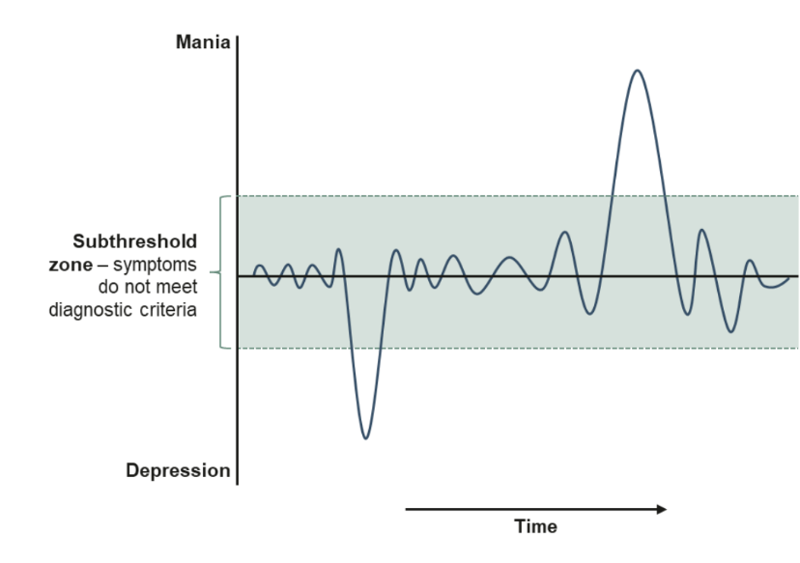
Figure 02: Clinical issues in bipolar disorder.
Source: (Thomson and Sharma, 2023).
Bipolar disorder is a numbers game, and Thomson and Sharma (2023) show that some symptoms transition, are temporally aligned in the sub-threshold states or indeterminate middle period and do not touch full diagnostic criteria. But sometimes the mood dips low into depression, and at other times ascends high into mania, which means bipolar disorder is not always stable. This is important in pregnancy; such minor complaints can turn serious if not addressed appropriately on time. This process requires routine assessments, monitoring of mood and quick intervention if symptoms fluctuate indicating that treatment needs to be managed thoughtfully to provide the best outcomes for mother and baby (Bilszta Meyer & Buist 2022).

Sub-theme 3: Safety of bipolar medications during pregnancy
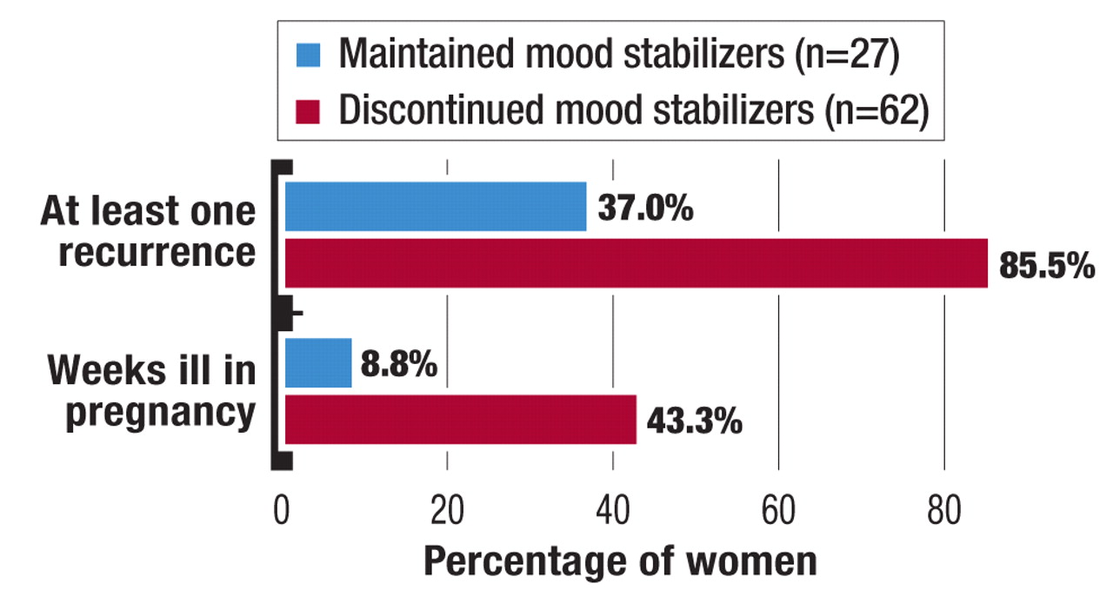
Figure 3: Bipolar treatment during pregnancy.
Source: (Dodd and Berk, 2022).
The image from Dodd and Berk (2022) shows that bipolar does not stand still, and certain symptoms remain in this indeterminate middle period do not fulfil full diagnostic buy-in sometimes the mood sinks far down into depression, and other times goes high up into mania. That means bipolar disorder is not uniform. During this period small complaints can become complicated if not managed in a timely manner, and good clinical management entails regular check-ups, close monitoring of mood and immediate intervention when symptoms change (Avakumovic, 2025). It also suggests that treatment must be planned with care to protect both mother and baby.

Sub-theme 4: Effects of bipolar medications in the postnatal period
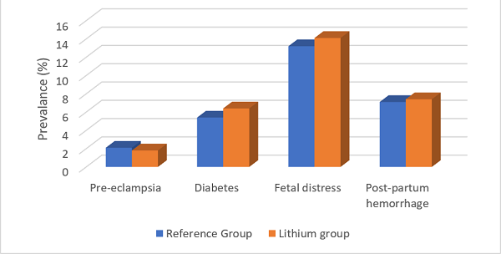
Figure 4: Effects of bipolar medication.
Source: (Bilszta, Meyer and Buist, 2022).
Bilszta, Meyer and Buist (2022) compares a reference group vs. a lithium group, and it indicates that any problem associated with pregnancy and birth is a bit more common among women who take lithium. The incidence of diabetes is higher in the lithium group, 7%, than in the reference group, at around 6%, and fatal distress is also higher, 15% versus 14%. Post-partum haemorrhage is a bit higher as well, around 8% compared with 7–8%. Additionally, the rates of pre-eclampsia are not clearly increased and appear a little lower in the lithium group (Oussedik, Anderson and Feldman, 2023). The chart provides an overall indication that lithium use may be associated with some increased risks, so monitoring during and after birth is necessary.

Sub-theme 5: Risk–benefit decision making in treatment
The research of Oussedik, Anderson and Feldman (2023) concerns deciding how to weigh the risks and benefits of treatment, this means that both doctors and mothers need to think carefully before starting or stopping a medicine. The process begins by evaluating the mother’s current symptoms, mental health history and previous relapses. Potential risks of the medication to the baby are weighed against those of untreated bipolar disorder, doctor also factors in the stage of pregnancy, dose and side effects, along with breastfeeding plans (Oussedik, Anderson and Feldman, 2023). At that point, the mother is brought into the conversation so she can make an informed decision, to formulates a safe treatment plan for mother and baby.

Sub-theme 6: Strategies for reducing harm to mother and baby
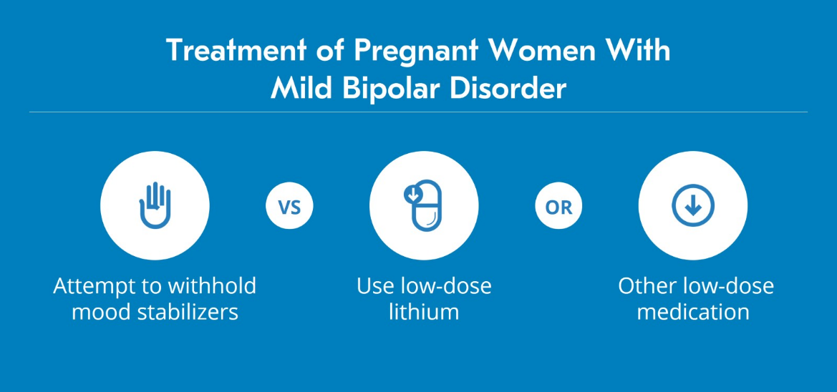
Figure 5: Strategies to reduce harm from bipolar disorder.
Source: (West, 2021).
West (2021) describes an algorithm for harm reduction in mild bipolar disorder in pregnancy, so the first thing the doctor does is to check how severe the patient's illness is. If the symptoms are mild and stable, they might try withholding mood stabilisers or go for a treatment that can reduce medicine-related complications to the baby. If further treatment is required, low-dose lithium or another low-dose medicine might be next, with the aim of at least incrementally identifying the safest agent and lowest effective dose. Regular monitoring of the mother’s mental state, physical health, and baby’s condition throughout this process helps mitigate risk to both. (Rusner, Berg and Begley, 2022).

Discussion
This scoping review revealed three major themes, and were intimately associated with the three research objectives, results showed that bipolar disorder in pregnancy and during the postnatal period is a complex issue, there are issues not just around mental illness, it is about pharmacotherapy safety, relapse risk and the importance of close attention to mother and baby in health care settings.

The major theme focused on bipolar disorder, how to manage it during pregnancy and aligned with the first objective, which was to describe bipolar disorder and its management during pregnancy (West, 2021). There were two sub-themes addressing this theme, Understanding Bipolar Disorder in Pregnancy, indicated that parental age or even the state of pregnancy overall could have mediate risk and experience. The second sub-theme, clinical management of bipolar disorder in pregnancy, showed a dynamic condition. While symptoms may be mild for a period, and can abruptly ratchet up severe depression or mania, and this finding is important because pregnant women with bipolar disorder must be closely monitored (Avakumovic, 2025). It also recommends that management during pregnancy not be proactive, and routine review, early intervention and diligent follow-up are vital aspects of care.
The second main topic was the effect and safety of drugs in the management of pregnant women with bipolar disorder, as well as those who are postnatal, and this theme corresponded with the second objective. In the first sub-area under this topic, safety of bipolar medications in pregnancy, it was found that discontinuation of mood stabilisers was associated with a substantially greater relapse rate (Brett et al., 2022). Women who discontinued treatment had more relapses and remained ill for a larger portion of their pregnancy to protect the mother, The second sub-theme, effects of bipolar medicines postnatally, revealed that certain medications like lithium might be associated with a slightly increased risk of some birth complications and post-birth complications (Clarke, 2022). This conclusion indicated that medication administration is beneficial but poses risks, these two sub-themes together addressed the second objective, depicting that treatment decisions cannot be made solely based on risk from medicine must include the danger of untreated bipolar disorder.
The third core theme was to mitigate the hazards associated with bipolar disorder medications taken during pregnancy and in the postnatal period, and the third theme corresponded to the third objective (Dodd and Berk, 2022). The first sub-theme, risk–benefit decision making in treatment, insight into the treatment selection should be done by considering many factors, that include a history of mental health, past relapse, stage of pregnancy, dose of medicine and plans for breastfeeding. The second sub-theme, strategies to minimise harm to mother and baby, indicated that in some mild cases, doctors might withhold mood stabilisers or use low-dose lithium or another low-dose medicine if treatment required. This indicated the aim is not merely to cease or persist in medicine, but rather to select the safest course for every female (Harlan, 2021).
The synthesis of themes, sub-themes and excerpts addressed the research objectives, and the first theme described the condition and need for management. The second theme investigated the safety and impact of drug management.

Conclusion and recommendations
This study demonstrates that the treatment of bipolar disorder during pregnancy and the postnatal period is a complex matter, and the results suggest that both the disease and the medications are risky. Without effective treatment, the mother may relapse and experience severe depression or mania. It can also impact the baby and family life, problems during pregnancy, birth and breast feeding. As a result, treatment must be meticulously planned and carefully monitored.
The study also emphasises that there is no one ‘best treatment’ for every woman. They must figure out what risks need to be considered based on the woman’s mental health history, stage of pregnancy, type of medicine, level of risk. It is critical for the woman and health professionals to make decisions together (Moonie, 2022).
Policy and UK practice need much more robust support to come from specialist perinatal mental health services. Simple guidance, early assessment of risk and reg­ularity of follow-up have the potential to improve care and reduce harm for both mother and baby as a result; better working together between mental health and maternity services would surely also help (Oussedik, Anderson and Feldman, 2023).

Reference list
Avakumovic, V.R. (2025). Bipolar disorder and pregnancy: Therapeutic dilemmas. Engrami, 37(3), pp.41–56.
Bilszta, J.L.C., Meyer, D. and Buist, A.E. (2022). Bipolar affective disorder in the postnatal period: investigating the role of sleep. Bipolar Disorders, 12(5), pp.568–578.
Brett, J., Staniszewska, S., Mockford, C., Marx, S.H., Hughes, J., Tysall, C. and Suleman, R. (2022). Mapping the Impact of Patient and Public Involvement on Health and Social Care research: a Systematic Review. Health Expectations, 17(5), p.q.
Butler, I. (2022). A Code of Ethics for Social Work and Social Care Research. British Journal of Social Work, 32(2), pp.239–248.
Clarke, L. (2022). Health and social care. Cheltenham: Nelson Thornes.
Dawson, S., Campbell, S.M., Giles, S.J., Morris, R.L. and Cheraghi-Sohi, S. (2023). Black and minority ethnic group involvement in health and social care research: A systematic review. Health Expectations, 21(1), pp.3–22.
Dodd, S. and Berk, M. (2022). The Safety of Medications for the Treatment of Bipolar Disorder During Pregnancy and the Puerperium. Current Drug Safety, 1(1), pp.25–33.
Gentile, S. (2022). Bipolar disorder in pregnancy: to treat or not to treat? BMJ, 345(nov09 1).
Harlan, N. (2021). Health and social care: intermediate. Harlow: Prentice Hall.
Kumar, D.K. (2023). Bipolar Disorder, Pregnancy and Childbirth - Living with Uncertainty. Bipolar Disorders, 18, pp.25–25.
Lews, J. (2025). Bipolar Disorder, Pregnancy and Childbirth - Living with Uncertainty. Bipolar Disorders, 18, pp.25–25.
Moonie, N. (2022). Advanced health and social care. Oxford: Heinemann Educational.
NICE (2017). Antenatal and postnatal mental health: clinical management and service guidance | Search results | NICE. [online] NICE website: The National Institute for Health and Care Excellence. Available at: https://www.nice.org.uk/search?q=Antenatal+and+postnatal+mental+health%3A+clinical+management+and+service+guidance&ndt=Research+recommendations [Accessed 11 Mar. 2026].
Oussedik, E., Anderson, M.S. and Feldman, S.R. (2023). Risk versus benefit or risk versus risk: Risk aversion in the medical decision making process. Journal of Dermatological Treatment, 28(1), pp.1–2.
Pandya-Wood, R., Barron, D.S. and Elliott, J. (2022). A framework for public involvement at the design stage of NHS health and social care research: time to develop ethically conscious standards. Research Involvement and Engagement, 3(1).
Perry, A., Smith, K.G., Florio, A.D., Craddock, N., Jones, L. and Jones, I. (2021). Mood episodes in pregnancy and risk of postpartum recurrence in bipolar disorder: The Bipolar Disorder Research Network Pregnancy Study. Journal of Affective Disorders, 294, pp.714–722.
Rasheed, E. (2024). Health and social care. London: Hodder Education.
Rusner, M., Berg, M. and Begley, C. (2022). Bipolar disorder in pregnancy and childbirth: a systematic review of outcomes. BMC Pregnancy and Childbirth, [online] 16(1). Available at: https://www.ncbi.nlm.nih.gov/pmc/articles/PMC5084442/ [Accessed 25 Jun. 2019].
Thomson, M. and Sharma, V. (2023). Weighing the Risks: the Management of Bipolar Disorder During Pregnancy. Current Psychiatry Reports, 20(3).
West, A. (2021). Mandatory second opinion reduced the rate of intrapartum cesarean delivery without harm to mother or baby. Evidence-based Obstetrics & Gynecology, 7(2), pp.68–69.

