DECLARATION, I David Talbalt declare that this assignment is all my own work and that I have acknowledged all materials used from the published or unpublished works of other people. All references have been duly cited.
Assignment

The evaluation of the cost of current levels of service

How these current levels of service may be improved through supplier benchmarking (comparison of two or more suppliers)

The establishment of the Key Performance Indicators necessary to ensure good performance.

Introduction
Competitiveness in today’s market environment has driven business organisations to look for effective logistics and supply chain management that can secure competitive advantage. In order to concentrate on their core businesses, companies outsource their logistics activities to a third party logistics providers (3PL). This can successfully lower the cost of logistics, reduce assets, extra burden of services and overcome the risk of delay in delivery.
“A third Party Logistics is an independent enterprise who does not own the products or services but participates in the supply chain and provides logistics services under a contract to the manufacturer, retailer and or consumers of a product or service” (Giri & Sarker, 2017).
A Third Party Logistics (3PL) is therefore defined as a “provider of outsourced logistics services. Logistic services encompass anything that involves management of the way resources are moved to the areas where they are required” (techtarget.com, 2010). These services varies depending on what the 3PL provider offers, while others have an integrated bundle that offer complete logistics solution. They range from transportation, warehousing/ distribution, financial services, forwarding and shipping and including information technology.
This essay will evaluate the cost of current levels of service and how these levels may be improved through supplier benchmarking. The essay will then use UPS, FedEx Express and DHL, the three most competitive logistics company to make a comparison. Finally, the Key Performance Indicators necessary to ensure good performance will be discussed.
Current Level of Service
The rise of 3PL companies started as early as 1980’s when business organisations are in search of new ways to reduce or eliminate their logistics functions through outsourcing, to enable them concentrate on their core business. FedEx is known as one of the early companies that revolutionised the way 3PL companies offer their services. The company is instrumental in changing the way business to business and business to customer transactions are operated by using just-in-time techniques, saving businesses warehousing space and lowering overall cost in return.
Further to this, is the introduction of efficient-customer-response (ECR) techniques, resulting to cost effective shipment sizes, which became an economic advantage to businesses.
When the benefits of outsourcing logistics functions became very evident, the number of Third Party Logistics increasingly multiplied, offering numerous number of services. The increase in the supply of these services brought about sudden competition among the 3PL companies, attracting more savings to the companies that employ them.
According to Martin Murray, (2016), “The last decade has seen the 3PL provider transitioning from a local or regional business to one that offers national or global coverage. In the US, the 3PL market has been growing at a compound annual rate of 14.2 percent since 1996 and in 2006; 3PL’s in the United States reported $89.4 billion in gross revenue”.
Logistics outsourcing has been transformational to business organisations as they focus on core competencies to meet their corporate objectives. The current level of service needed by companies is ever increasing as 3PL companies evolve. Most 3PL providers have a long term relationship with their employers and are closely integrated. According to Adam Robinson (2014), there are three levels of outsourcing in 3PL services, namely: Transactional Outsourcing: This level is purely transactional without long term contracts and no bonding between the 3PL provider and the outsourcing companies. The second level is called, Tactical Outsourcing, involving a long term relationship with a negotiated contract and an integrated IT system to facilitate the flow of information and enable visibility in the supply chain for both parties. The final level is the Strategic Outsourcing, at this level, the 3PL companies become a partner in supply chain management, and creates a transactional transparency based on a successful long term relationship.
According to Mindy Long (2016), the survey polled in 2016 on Third Party Logistics outsourcing indicates that 43% of the companies polled consider themselves as a strategic buyer, 37% as tactical buyers while 20% is a combination of both.
Third Party Logistics (3PL) is part of a Supply Chain (SC), which is defined by Dr. Ir. Jack G.A.J. van der Vorst (2004), “as a sequence of (decision making and execution) processes and (material, information and money) flows that aim to meet final customer requirements and take place within and between different supply chain stages”. The supply chain is not limited to Manufacturer and its suppliers, but also include the transporters, warehouses, retailers and end consumers of the product/s.
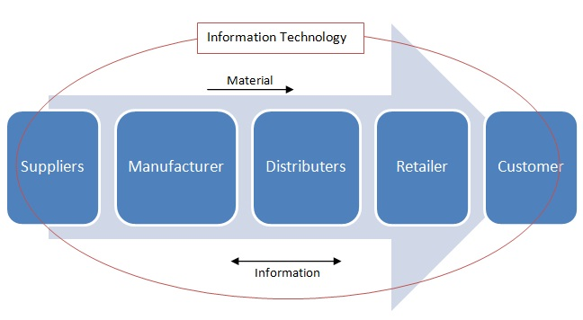
Figure 1: Simplified “diagram of a supply chain within the total supply chain network”.
According to this cycle, a typical retail shop that displays many products to consumers, replenish inventory from the distribution centre (which involves warehousing and transportation), this will mean different manufacturers replenishing the distribution centres and these manufacturers are ordering their raw materials from their suppliers (Blogspot, 2014). The flow and processes can be push based model, also referred to as build-to-stock or pull based model, also known as build-to-order. The push based is a model whereby the processes is based on a forecast starting from the supplier to the retailer which leaves the consumer to buy what is available. The pull based is in the other hand, the process whereby supply and manufacturing is based on order, the distribution centres and the retailers are automatically replenished and customer order is realised. Most supply chain is designed to function with the combination of both pull and push strategies at a point in the chain (Lander S, 2017).
The need for collaboration among sequential players in the supply chain from the initial supplier to the final consumer in order to achieve overall lower cost, is understood as Supply Chain Management (SCM). SCM as defined by Jack G.A.J. van der Vorst (2004), “is the integrated planning, co-ordination and control of all business processes and activities in the supply chain to deliver superior consumer value at less cost to the supply chain as a whole whilst satisfying requirements of other stakeholders in the supply chain (e.g. government and NGO’s)”.
The Corporation’s Enterprise Resource Planning (ERP) system is a very important catalyst to collaboration within the supply chain. It allows accurate distribution of information at a relative short period within the supply chain. A system defined as “a process by which a company (often a manufacturer) manages and integrates the important parts of its business. An ERP management information system integrates areas such as planning, purchasing, inventory, sales, marketing, finance and human resources (Investopedia, 2017). Most car makers deploy the use of ERP software throughout the entire supply chain, BMW, for instance, uses SAP to integrate the activities of the 3PL providers to maintain efficiency and conformity to the BMW standard of business (Glick, 2001). Nissan car maker uses EnterpriseIQ ERP system, from the California based vendor IQMS, offering automotive specific capabilities, such as EDI and AIAG labelling, which eliminated shipping errors, increased information speed and accuracy and reduced the cost of sending EDI significantly (Ludwig, 2010).
Supplier Benchmarking
Definition – “A measurement of the quality of an organization's policies, products, programs, strategies, etc., and their comparison with standard measurements, or similar measurements of its peers”. (Business Dictionary, 2017).
The reason why business organisations employ benchmarking process is to search for the best practice within their industry and or outside, to scrutinise how the performance levels of others are achieved and to understand the processes involved. The data generated are analysed and compared with own operations against the competitor’s, the positive outcomes, are then used to improve internal process, approaches, existing technologies and practices to lower cost, advance customer service and royalty and generate more profits (tutor2u.com, 2015).
The most common types of benchmarking include; strategic, competitive, process, internal, external, functional and international benchmarking. Strategic benchmarking is normally long-term, and focuses on overhauling and re-aligning the overall business strategies that have become inappropriate. Performance or competitive benchmarking is used by business to consider their position in relation to performance mostly with others in the same sector and through a third party to protect confidentiality. Internal benchmarking is the process of comparing similar operations in different divisions of business within a business organisation. It encourages sharing of ideas, mainly the best practices developed within each sector of the organisation (Bauld S & McGuinness K, 2006). External benchmarking implies analysing the practice of outside organisations which are adopted to be the best practise. International or global benchmarking is the process of identifying and analysing the best practitioners somewhere in the world. The quest to achieve a global standard is the drive for international benchmarking, while advances in information technology and business globalisation has enabled such international projects.
Supplier benchmarking is an important part of the manufacturer’s procurement strategy. The aim is to advance the supplier’s existing performance and to avoid any suspected future risk. The most common tool used by Manufacturers is the Intelligent Supplier Management Tool (ISMT), the system enables the input of different numbers of supplier’s history that include: delivery efficiency, quality (how reliable), product price (competitiveness), customer service (culture) and financial status (stability). Each segment is assigned to a score, ranging from 0 (poor) to 5 (excellent). The results are used to determine the performance of the suppliers and the end assessments obtained are then compared with the best established practice in the database, to benchmark the suppliers (Choy, Lee, & Lo, 2002).
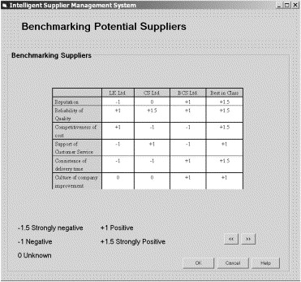
Fig. 2. The benchmark results by the system.
Benchmarking is an important tool, meant to drive performance and value by using the best in practice as a comparable standard. Benchmarking, is commonly used in outsourcing industry before awarding large supplier contracts. Business competitiveness has driven companies to increasingly employ benchmarking as a means to tighten the margins of failure and waste and reap the benefits of continuous improvement.
The three most ranked 3PL provider in the world are UPS, DHL and FedEx Company. They are the main competitors in this type of business and are responsible for the delivery of millions of packets all over the world every day (Godinari, 2014).
In comparing the three, (UPS) is known to have a good grip on delivering packages and documents in a worldwide scale via ground and air. They operate freight and ground shipping, including heavy and bulky packages that are not time sensitive. UPS business is in three dimensions, namely, Domestic package operations in the US, International package operations and Supply Chain with Freight operations.
FedEx Corporation in the other hand, is an American courier delivery service, operating highly recommended over-night delivery services to businesses. They also provide next day air delivery services within America, and time sensitive international services. FedEx is known for their aircraft fleets capabilities, as one of the largest in the world and carries more freight than any other airline. The Corporation is organised into operating units.
While, DHL express is a part of German logistics company, Deutsche Post DHL operating international express mail services. DHL has the largest market share and is the largest operating logistics company in the world. They have the best international shipping standard, reliable and on time.
Conclusively, these three though big and efficient, still have their differences, like UPS is very good in the land delivery, FedEx is a giant in the air delivery while DHL is a combination of both.

Key Performance Indicators
As a result of today’s competitive environment, there is a persistent need to control the costs and performance of 3PL providers, which has proven to be a successful tool in accomplishing business objectives. Keeping the track of Key Performance Indicators (KPIs) is dynamic in achieving consistent and absolute performance measurements. The factors involved can be monitored daily, weekly, monthly or yearly, depending on the business objectives. KPI is therefore defined as “a set of quantifiable measures that a company uses to gauge its performance over time. These metrics are used to determine a company's progress in achieving its strategic and operational goals, and also to compare a company's finances and performance against other businesses within its industry” (Investopedia.com, 2017). In order to manage an efficient and a cost effective logistics operation that takes into consideration all points of contact in the manufacture of a product or provision of a service, monitoring vital KPIs to uphold a dependable and well-functioning supply chain is needed. Below are the common KPIs that help to scrutinise and manage the progress of a business strategic objectives:
- Track Scorecard KPIs – this involves monitoring factors like, on-time pickup, on-time delivery, the percentage of damaged products while on transit, the percentage of damage free shipments. Data are collected through online feedback from customers for accuracy purposes as carriers may apply some exceptions (Rio, 2017).
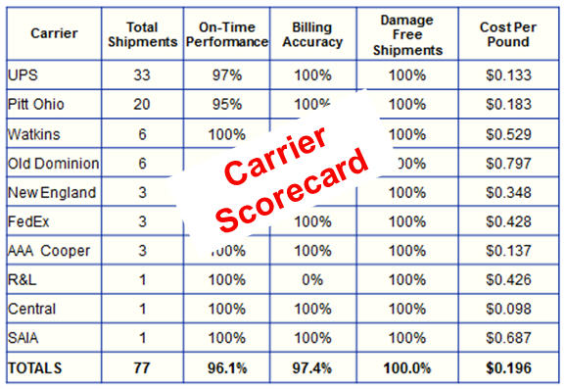
Fig. 3 Populated Scorecard Matrix (Lynch, 2013)
The credible advantages of using carrier scorecard is that the carriers are measured objectively, the data collected are actionable and identification of areas of continuous improvement are easily and quickly determined.
- Load Optimisation and Least cost provider – To be very cost effective, tracking load optimisation is vital through possible consolidation of shipments when required. Ensuring the cheapest provider with the correct carrier is used for each shipment based on service requirement.
- Invoice Accuracy – Track billing KPI, against improper billing from carriers. KPI tracking will help companies mitigate the loss of time and cost, associated with incorrect bills.
- Inventory turnover rate (Logistics and supply chain) – used to measure the rate at which a product is sold or the period of time it took to sale it. Low turnover will mean overstocking or product deficiency, while high turnover will signal the danger of out of stock that may cause production downtime along the supply chain.
- Percentage of Out of Stock Items ( Distribution channels/ Centres) – this KPI tracks the current number of items that are out of stock in percentage, allowing the distribution centre to establish which item needed to be restocked. This metric can also be used to measure the products that are mostly on demand (fwwarehousing.com, 2011).
Having KPIs within the supply chain improves collaboration and provides an opportunity to learn and understand each other’s business aims, focus and mission. This will enable the embedment of inter business culture within the supply chain, making it possible for the entire supply chain to work as a team as each segment offers their expertise efficiently to suit.
Conclusion
Third Part Logistics (3PL) is an integral and vital part of any given supply chain. A parcel ordered in the Amazon website, must be delivered by a 3PL Logistics Company within the margin of cost and standard practise agreed with the Amazon. The efficiency and accuracy of this service are measured and tracked through KPIs for continuous improvement of their service. Benchmarking the carriers, will enable Amazon to select the most reliable and cost effective, to become part of the supply chain. 3PL companies are the linkage from the manufacturer to the distribution centre, to the retailer and to the final consumer.
However, the use of 3PL providers have an implication of sharing confidential information with the provider due to closer collaboration within the supply chain. Using a 3PL provider, can also lead to the extinction of in-house logistics operations which can be used by the manufacturer as a contingency or back-up plan in the case of a failure.

Reference:
Bauld S & McGuinness K, (2006) “Benchmarking suppliers” summitconnects.com March 20 2006 Accessed at: http://www.summitconnects.com/Articles_Columns/PDF_Documents/200603_08.pdf on 25/11/17 at 16:04

Blogspot.co.uk (2014) “Supply Chain Management” cmuscm.blogspot.co.uk September 18 Accessed at: http://cmuscm.blogspot.co.uk/2014/09/technology-in-supply-chain-examples.html on 17/11/17 at 23:13

Businessdictionary .com (2017) “Benchmarking” Accessed at: http://www.businessdictionary.com/definition/benchmarking.html on 18/11/17 at 12:11

Choy K L & at el (2002) “An intelligent supplier management tool for benchmarking suppliers in outsource manufacturing” Expert Systems with Applications
Volume 22, Issue 3, April 2002, Pages 213-224 Accessed at: https://www-sciencedirect-com.ezproxy.uwtsd.ac.uk/science/article/pii/S0957417401000550 on 25/11/17 at 17:08

Fwwarehousing.com (2011) “KPIs to Monitor Supply Chain and 3PL Logistics Performance” Accessed at: http://www.fwwarehousing.com/kpis-to-monitor-supply-chain-and-3pl-logistics-performance/ on 26/11/17 at 22:59

Giri B. C & Sarker B. C (2017) “Improving performance by coordinating a supply chain with third party logistics outsourcing under production disruption” Computers & Industrial Engineering Volume 103, January 2017, Pages 168-177 Accessed at: http://www.sciencedirect.com.ezproxy.uwtsd.ac.uk/science/article/pii/S0360835216304387 on 08/11/17 at 21:35

Glick B, (2001) “SAP software drives BMW's success” computing.co.uk March 08 2001 Accessed at: https://www.computing.co.uk/ctg/news/1832763/sap-software-drives-bmws-success on 25/11/17 at 11:31

Godinari D (2014) “Comparison between UPS, DHL and FedEx” wordpress.com June 05 2014 Accessed at: https://logisticsmgepsupv.wordpress.com/2014/06/05/comparsion-between-ups-dhl-and-fedex/ on 27/11/17 at 21:55

Ivestopedia.com (2017) “Enterprise Resource Planning – ERP” Accessed at:
https://www.investopedia.com/terms/e/erp.asp on 25/11/2017 at 11:18

Investopedia.com (2017) “Key Performance Indicators – KPI” Accessed at: https://www.investopedia.com/terms/k/kpi.asp on 25/11/17 at 19:31

Lander .S (2017) “Push vs. Pull Supply Chain Strategy” chron.com {no date} Accessed at: http://smallbusiness.chron.com/push-vs-pull-supply-chain-strategy-77452.html on 17/11/17 at 23:45

Long M (2016) “2016 Third-Party Logistics Study. The State of Logistics Outsourcing” 2016 20TH ANNUAL THIRD-PARTY LOGISTICS STUDY Accessed at: https://www.kornferry.com/media/sidebar_downloads/2016_3PL_Study.pdf p.6 on 13/11/17 at: 21:51

Ludwig C (2010) “Can ERP play a greater in the auto supply chain?” automotivelogistics.media April 01 2010 Accessed at:
https://automotivelogistics.media/intelligence/can-erp-play-a-greater-in-the-auto-supply-chain on 25/11/17 at 11:22
Lynch J (2013) “LTL Carrier Scorecard with Key Process Indicators (KPIs)” rvcf.com March 2013 Accessed at: https://www.rvcf.com/mpage/RVCF_LINK_13_03_6 on 26/11/17 at: 21:26

Murray M (2016) “Small Business - Selecting A Third Party Logistics Provider, 3PLs Are an Important Part of Today's Supply Chain” thebalance.com November 18, 2016 Accessed at: https://www.thebalance.com/selecting-a-third-party-logistics-3pl-provider-2221230 on 11/11/2017 at 21:03

Rio P (2017) “Key Performance Indicators That Every Logistics & Warehouse Manager Should Know” translogisticsinc.com April 13 2017 Accessed at: http://blog.translogisticsinc.com/kpis-every-logistics-warehouse-manager-should-know on 25/11/17 at 20:32

Robinson .A (2014) “Third Party Logistics Services Explained, The Different Types of 3PLs, and The Various Levels of Outsourcing” cerasis.com February 7 2017 Accessed at: http://cerasis.com/2014/02/07/third-party-logistics-services/ on 13/11/17 at 21:46

Techtarget.com (2010) “3PL (third-party logistics)” Searcherp.techtarget.com February 2010 Accessed at: http://searcherp.techtarget.com/definition/3PL-third-party-logistics on 08/11/17 at 21:53

Tutor2u.com (2015) “The Benchmarking Process” Accessed at:
https://www.tutor2u.net/business/reference/what-is-benchmarking on 18/11/17 at 12:48

Van der Vorst .J (2004) “Supply Chain Management: theory and practices” Accessed at: https://www.researchgate.net/publication/40122004_Supply_Chain_Management_theory_and_practices on 18/11/17 at 00:49

