

ACADEMIC AND EMPLOYABILITY SKILLS
ASSESSMENT GROUP 12

Student Name: | ANAMARIA FERMESANU
Student Number: | 1907760
Module No: | BMSW4001
Module Title: | ACADEMIC AND EMPLOYABILITY SKILLS
Lecturer: | LLOYD BEHARRY

CONTENTS

INTRODUCTIONS

SKILL DEFINITION

EMPLOYABILITY SKILLS

SOFT SKILLS

HARD SKILLS

OWN SKILLS ANALYSIS

SWOT ANALYSIS

PERSONAL DEVELOPMENT PLAN (PDP)

ACADEMIC SKILLS

CONCLUSION

REFERENCES

1.INTRODUCTION
The purpose of this report is to detect the academic skills that are needed to succeed in a University and how this is correlated with employability skills and how my own skills are reflected.

2.SKILL DEFINITION
A skill is defined as “the ability and capacity acquired through deliberate, systematic and sustained effort to smoothly and adaptively carryout complex activities or job functions involving ideas (cognitive skills), things (technical skills), and/or people (interpersonal skills)”. BusinessDictionary.com 2019
In other word someone's ability or skill represents the total of his knowledge of any measure. Used in the plural, the notion designates a set of knowledge of any kind with which the person he has can operate in society.

3.EMPLOYABILITY SKILLS

3.1 Employability skills or soft skills are the skills that allow someone to work, for example reliability and honesty.
The Skills for Business Network (UK Skills) state “ Employability defines the knowledge, skills, attitudes and behaviours required by individuals to seek, obtain and sustain employment at all levels in the labour market” ( www.employment-studies.co.uk/ )
Dr Peter Hawkins (1991, p9) defined four groups of skills: people skills, self -reliance skills, generalist skills and specialist skills. Developing skills like this will help you become more employable and hopefully gain job security.
Below is a list of the most important soft skills that most of the employers are looking for:
Communications skills.
In almost every career communication skills are important. You definitely need to interact on the job with others, whether they are clients, customers, friends, employers or vendors. You will also need to talk to people for person, by telephone or by writing.
- Good listener. Employers want workers who not only express their own opinions but also listen to others emphatheticaly.
- Negotiation. Negotiation in a context of work is described as the process of creating a mutually acceptable agreement between two or more parties.
- Nonverbal communication. Nonverbal communication relates to gestures, facial expressions, tone of voice, expression of the eye (or lack thereof), language of the body, attitude, and other ways of communicating without using words.
- Persuasion. Workplace persuasion (or other environments) involves persuading others to take action, agree to a contract, or obtain a product or service.
- Presentation
- Public speaking.
- Reading body language.
- Storytelling.
- Verbal communication. This requires more than just talking, strong verbal communication skills. Verbal communication involves both how messages are sent and how messages are received. Employers highly appreciate staff who can communicate information clearly and effectively.
- Visual communication.
- Writing reports.
- Writing skills.
Critical thinking.
You need to be able to understand problems, think critically and come up with ideas objectively.
- Adaptability. Workplace adaptability means being able to adjust to be successful. Employees in a leadership role often have to deal with unusual circumstances where explicit instructions are not available. They need to learn how to rely on their own judgement and trust in making difficult decisions.
- Creativity. Creative thinking means looking in a new way at something. It's the very "thinking outside the box" concept.
- Critical observation.
- Critical thinking. Critical thinking refers to the ability to objectively evaluate information and make a rational decision. It includes the evaluation of sources such as records, information, measurable anomalies and findings from research.
- Desire to learn.
- Flexibility. The willingness and ability to adapt readily to changing circumstances and demands provide flexibility on the job. The word "flexibility" refers by nature to the ability to bend or adapt to changing forces. It is worth a lot to be flexible when it comes to jobs. Employees with a versatile attitude handling their work are usually more highly valued by employers.
- Innovation.
- Logical thinking. Employers highly appreciate staff who can communicate information clearly and effectively.
- Problem solving.
- Troubleshooting.
- Value education.
- Willingness to learn.

Leadership
"Leaders are coaches with a passion for developing people, not players," said Randy Stocklin, co-founder and CEO of One Click Ventures. "They get satisfaction from achieving objects through others. Leaders inspire people through a shared vision and create an environment where people feel valued and fulfilled."
Coaching. Whatever the work, it is an important part of being a good leader to embrace a coaching mentality. A coach is supporting and helping. A coach is part cheerleader, part teacher, and should be confident in this role as a leader in a business environment. A leader knows how to mentor people on their own right to become leaders.
- Decision making. Whether you determine which employee to recruit, which consultant to use, or which business plan to implement, it is important for your company to be able to make the best decision. Together, organizational culture and leadership style define the decision-making process in any company.
- Dispute resolution.
- Facilitation.
- Giving clear feedback.
- Inspiring people.
- Leadership.
- Management. Management skills are extended to a wide range of roles in fields such as manufacturing, banking, accounting, marketing and human resources. Common management components in various fields include: selection, supervision, staff motivation and assessment, scheduling and workflow preparation, development of policies and procedures, analysis and reporting of performance for a group or department, problem solving, budget and spending development and tracking, staying up-to-date with developments in the sector, working with other staff and departments.
- Mentoring.
Motivating. Employees can use motivation skills to increase their chances of achieving positive results when interacting with customers, subordinates, upper management, suppliers, donors, team members, sources of funding and supervisors.
- Project management.
- Resolving issues.
- Successful coaching.
- Supervising.
- Talent management.

Positive attitude
Employers also look for candidates who carry the workplace with them a good attitude. They want workers who are polite to others, friendly, who are generally happy.
- Confidence
- Cooperation.
- Courtesy.
- Energy.
- Friendliness
- Honesty
- Humorous.
- Patience
- Respectability.
- Respectfulness.
Teamwork
Teamwork is defined as “The process of working collaboratively with a group of people in order to achieve a goal.” (www.businessdictionary.com/definition/teamwork.html). Whether you are going to do a lot of team projects or just attend a few departmental meetings, you need to be able to work with the people around you efficiently. Even though you may not always see eye to eye, you need to be able to work with others.
- Accepting feedback.
- Collaboration. The term ' collaboration ' meaning refers to collaborating with someone else to create or generate something. Successful collaboration requires a spirit of cooperation and respect towards each other. Employers typically look for employees who work together as part of a team and are able to align their personal achievement with company goals.
- Customer service. Whether you're dealing with customers in person, on the phone, or via email or online chat, it's important to be able to connect to others on a human level and feel like they're connecting with someone who really cares and wants to solve their issue.
- Dealing with difficult situations.
- Emotional intelligence. The capacity of a person to understand his / her own feelings and the emotions of others is emotional intelligence (EI).
- Empathy. Empathy is an ability of great importance. You need to be able to understand how they feel in order to interact well with others. Empathy is particularly critical when dealing with clients with issues or problems that come to you. You need to be genuinely concerned about their issues and help to fix them.
- Establishing interpersonal relationships.
- Dealing with difficult personalities.
- Interpersonal skills. The way you connect and interact with others is related to your interpersonal skills. When managers are recruiting, interpersonal skills are one of the top requirements used to assess applicants. It is important to be able to get along well with colleagues, bosses, clients and vendors regardless of the type of job you have.
- Persuasion.
- Self-awareness.
- Social skills.
- Team building. Team building understands how to help people function as a cohesive group where all members feel involved in the team's success and achievements. All members contribute to the development and definition of goals and steps to achieve those goals. Everyone can work together for the group's goals.
- Teamwork. Regardless of your position, you need to work together well and transfer on your team skills to hiring managers, recruiters and future employers. Those with teamwork skills such as communication and a good attitude will lead to a more successful team.
Work ethic
“Work ethic is the ability to maintain proper moral values within the workplace. It is an attitude that shapes the way an individual performs its job duties with high moral standards.” (https://www.myaccountingcourse.com/accounting-dictionary/work-ethic). Employers are looking for a strong work ethic for job candidates. These people are working on time, completing tasks efficiently, staying focused and being coordinated. You can spend your time and complete your work thoroughly. Those who have a strong working ethic can also follow guidelines when working independently.
- Attentiveness.
- Business ethics.
- Competitiveness.
- Dedication.
- Following direction.
- Meeting deadlines.
- Motivation.
- Multitasking.
- Organization.
- Planning.
- Punctuality.
- Reliability.
- Self- direction.
- Self -monitoring.
- Staying on task.
- Strategic planning.
- Time management.
- Working well under pressure.
3.2 Employment skills or hard skills are the abilities required to effectively perform a job, such as expertise and experience in the field of work, along with literacy, numeracy and computer skills.
Formal education and training programs including college, apprenticeships, short-term training, online courses and on-the-job training would require hard skills.
Examples of hard skills include computer programming, web design, typing, accounting, finance, writing, mathematics, legal or other quantifiable skills that are included in the requirements for a job.
These types of skills are learned and can be defined, evaluated and measured. In some industries, employers may even test candidates’ hard skills, to make sure that they can really do what their resume claims they can do.
Here you can find some examples of the hard skills required for different occupations:
- Accounting.
- Administrative.
- Analytics.
- Banking.
- Computer.
- Construction.
- Data.
- Design.
- Editing.
- Electrical.
- Financial.
- Hardware.
- Information Technology.
- Languages.
- Legal.
- Manufacturing.
- Math.
- Medical.
- Project Management.
- Programming.
- Research.
- Science.
- Software.
- Teaching.
- Technology.
- Writing.
According to Dr Peter Hawkins (1999, p9) “to be employed is to be at risk, to be employable is to be secure”
4. OWN SKILLS ANALYSIS
Competency is often used interchangeably. Identifying job skills, however, is only the first step of a skills examination. Usually it is the first step in developing a map of skills. Assessment of abilities is often presented as a two-dimensional graph. The graph describes a job's major responsibilities and splits any major responsibility into their job skills or activities. A detailed skills diagram or competency map also identifies the sub-skills, supporting knowledge and skills, attitudes and behaviour, and the tools needed to do the job. It can also define the performance level for the successful application of each skill.
4.1 Personal SWOT Analysis.
“SWOT analysis is the examination of your (or your organisation) situation by looking at Strengths, Weaknesses, Opportunities and Threats. It has been used by businesses for many years as a strategic planning tool, because it helps to give you an all-round view of the organisation” ( https://www.skillsyouneed.com/ps/personal-swot-analysis.html)
SWOT analysis is the most important management technique for understanding the strategic position of an organization. SWOT analysis aims to recommend the strategies that provide the one better alignment between internal and external environment: choosing the right strategy, to adapt the strengths to opportunities, minimize risks and eliminate weaknesses.

STRENGTHS:  - Hardworking  - Good communication skills  - Love to learn  - Organization skill  - Creativity  - Reliability  - Ability to work well under pressure | WEAKNESSES:  - Bored with the routine work  - High standards  - Very critique with myself  - Very organized  - Diligent
OPPORTUNITIES:  - Continuing studies  - New challenges  - Experience in a different environment  - Better earnings  - More autonomy | THREATS:  - No specific training qualifications  - Unused to working in a variety of environments  - Competition
Personal SWOT Analysis

4.2 Personal Development Plan

A Personal Development Plan (PDP) is a method of portfolio assessment embedded in a wider process of development. The PDP is also known as planning personal education (Evans et al., 2002), planning personal learning (Walker et al., 2003) and planning personal action (Challis, 2000). It is developed through the recognition of learning needs, often in partnership with a mentor, assessor or colleagues. In order to address the learning needs, learning and professional development opportunities are selected and later reflected by the learner and evaluator.

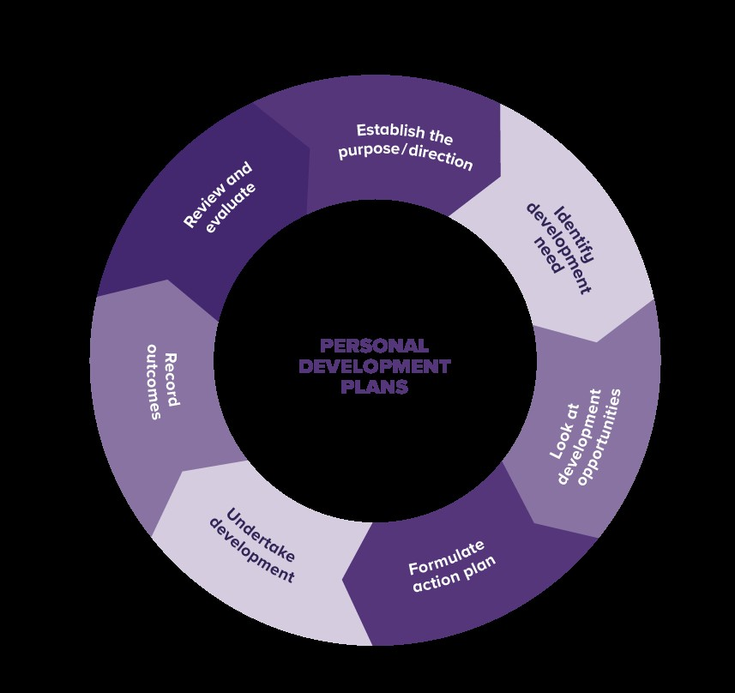
( https://www.kbmanage.com/concept/personal-development-plans)
5. ACADEMIC SKILLS
Academic skills are all about helping you become a more successful university-level learner and improving the learning and study skills that will assist you now and in the future.
These are some of the most important academic skills:
- Written English
- Essay writing
- Reading
- Note-taking
- Independent learning
- Research
- Presentation skills
- Exam technique
- Conversational skills
- Self -motivation
- Time management
It is also important to be competent in these basic academic skills to find and retain jobs that provide steady income, benefits and advancement opportunities.
Academic achievement is significant because it prepares for future careers for students. It also encourages students to participate in competitive fields. Academic achievement is often a symbol of a skilled intelligence that can help students throughout their lives.

6. CONCLUSION
The youth unemployment rate has been growing over time due to a lack of job fit and the skills that the workers (young graduates) have. That is because most of the classes that students take at the university do not have a clear roadmap to the job they will do when they complete or graduate. In fact, those who graduated from four years of college still lacked the skills needed to fit into the job market.
These opportunities for work are not filled because skills are not matched. That is, workers do not have the skills needed by employers (Hind & Moss, 2011). Such abilities may include the ability to manage the team, solve various problems, the ability to write and verbally interact with other parties and stakeholders, and the ability to express innovative and critical thinking when dealing with different circumstances. Since these skills are basically to be mastered, most young people still lack them, so they can not integrate entirely in most organizations even though there are many holes to be bridged (Wyman, 2015)

7. REFERENCES
- Business dictionary.com 2019
- Anna Gravells Delivering employability skills in the lifelong learning sector, 2010, University of Wales Saint David, Electronic Books. 2010
- Peter Hawkins The art of building windmills-career tactics for the 21st century 1991
- Peter Morgan The business student’s guide to study and employability 2017
- David W.G. Hind, Stuart Moss Employability skills 2005
- www. thebalancecareers.com
- www.businessnewdaily.com
- www.myaccountingcourse.com
- www.skillsyouneed.com
- www.kbmanage.com



