James Ball
1809296
Software development
Part C

Contents
1 Description 3
2 Identify problem 4
3 Pseudocode 5
3.1 Seed the RNG with CPU time 5
3.2 Print explanation of the rules of the game 5
3.3 While (user doesn’t choose exit) 5
3.3.1 Randomise card array 5
3.3.2 Clear grids of old data 5
3.3.3 Get grid size from user (checking if grid is < 52 and even number of cards) 5
3.3.4 Fill grid with randomised cards 5
3.3.5 Fill shown grid with “x-x” 5
3.3.6 Print shown grid to screen 5
3.3.7 While (not all pairs are matched (score < number of pairs in grid)) 5
3.3.8 End While 5
3.3.9 Print final loop number with the minimum number of moves the user could have won in (final score) 5
3.4 End While 5
4 Implementation 5
5 Testing 12
5.1 Defining the grid size 12
5.1.1 Normal values 12
5.1.2 Grid too large 12
5.1.3 Grid gives an odd number 13
5.2 Picking grid coordinates 13
5.2.1 Valid coordinates but incorrect guess 13
5.2.2 Valid coordinates and correct guess 14
5.2.3 Coordinates of card already flipped over 14
5.2.4 Coordinates outside grid 14
5.2.5 Invalid coordinates 15
5.2.6 Coordinates entered with wrong type 15
5.3 Completing the game 15
5.3.1 Scoring 15
5.3.2 User answers “No” 16
5.3.3 User answers “no” 16
5.3.4 User answers “yes” 16
5.3.5 User answers “Yes” 17

Description
Develop a C program to allow the user to play a version of a popular card matching game, such as that shown below:

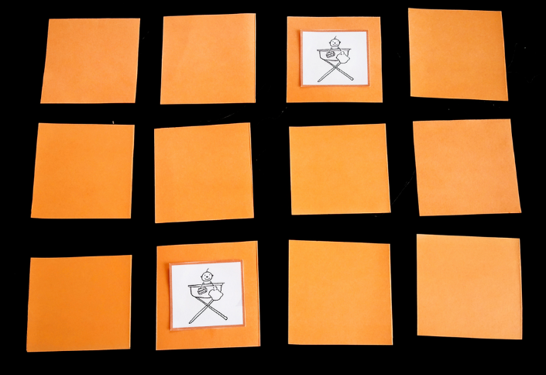

(Note: the game need not be visually complex, and can be implemented with numbers or single letters rather than pictures)

- Identify specific problems in completing the exercise.
  - You may also constrain a problem (simplify it) to produce a simpler solution that may act as a stepping stone to solving the real problem
- Write a clear analysis of the solutions (the thought process behind them) – what logical stages are required. You could use a flowchart or pseudocode
- Show a code listing with annotations
- Show testing (screenshots) that clearly demonstrate that the solutions work under all circumstances

The matching game has various rules which you must identify. For example the player may turn over two “cards” at a time and see their content. Then they must turn the cards back to the blank side before their next turn. The player must attempt to identify matching cards. The goal of the game is to turn over the largest number of matching pairs in the lowest number of moves.

You may implement the rules simply or in a more complex way. You should use at least one function other than the main function. (It is OK to make any arrays used global, to simplify the program. Any variables should be passed as a parameter to a function with a return value if required) Extra credit will be given for more complex implementations.

Note: Remember, there are many marks available for design etc. It is better to have a version of the game that is partially functional, even if it does not incorporate the more complex requirements.

Identify problem
The steps identified in this problem are:
- Create a grid of cards, the size of which is chosen by the user
- Fill the grid with random cards from a deck of cards
- Randomise the locations of the cards in the grid
- Display grid on the screen with cards ‘flipped’ so you can’t see the face
- Ask the user for two picks and store the coordinates
- Be able to ‘flip’ chosen cards on the grid
- Be able to check if the chosen card is a valid choice (in the grid, not already chosen)
- Be able to check if the picked cards match and:
  - If the cards match, keep those flipped over
  - If they don’t, obscure them again
- Know when all the pairs have been found and end the game
- Keep a running score to display when the game ends
- Loop the game until the user wants to exit

Pseudocode

Seed the RNG with CPU time

Print explanation of the rules of the game

While (user doesn’t choose exit)

Randomise card array

Clear grids of old data

Get grid size from user (checking if grid is < 52 and even number of cards)

Fill grid with randomised cards

Fill shown grid with “x-x”

Print shown grid to screen

While (not all pairs are matched (score < number of pairs in grid))

Iterate loop number

Get user coordinates for first card (checking if the card picked has already been flipped and the coordinates given are valid)

Print shown grid to screen, with the first pick

Get user coordinates for second card (checking if the card picked has already been flipped and the coordinates given are valid)

Print shown grid to screen, with the first and second picks

If (two cards match)

Score += 1

Print congratulations message

Else

Print not match message

Clear the incorrect picks from shown grid

Print shown grid with previous picks cleared

End If

End While

Print final loop number with the minimum number of moves the user could have won in (final score)

End While

Implementation
// Name: Software Development Assignment - Part C
// Author: James Ball 1809296
// Date: 01/04/19
// Version: 2.6

#pragma region Import needed libraries
#include <stdio.h>
#include <time.h>
#include <stdlib.h>
#include <ctype.h>
#include <string.h>
#include <Windows.h>
#pragma endregion

#pragma region Define structures and grids
struct coord { // using a structure allows x and y coordinates to be passed to functions and returned
int x;
int y;
};

char shown_grid[53][53][5];

char grid[53][53][5];

// define the packOfCards with a full set of cards
char packOfCards[52][9] = { "2-S", "3-S", "4-S", "5-S", "6-S", "7-S", "8-S", "9-S", "10-S", "J-S", "Q-S", "K-S", "A-S",
"2-C", "3-C", "4-C", "5-C", "6-C", "7-C", "8-C", "9-C", "10-C", "J-C", "Q-C", "K-C", "A-C",
"2-H", "3-H", "4-H", "5-H", "6-H", "7-H", "8-H", "9-H", "10-H", "J-H", "Q-H", "K-H", "A-H",
"2-D", "3-D", "4-D", "5-D", "6-D", "7-D", "8-D", "9-D", "10-D", "J-D", "Q-D", "K-D", "A-D",
};
#pragma endregion

#pragma region Prototypes
/*Prototypes*/
int is_pair(coord, coord);
int is_alreadyPaired(coord, coord);
void clear_grids();
void fill_grids(coord, int);
void display_ShownGrid(coord);
void display_Grid(coord);
struct coord get_MaxDimentions(void);
struct coord get_Pick1(coord);
struct coord get_Pick2(coord);
void randomiseCardArray();
/*----------*/
#pragma endregion

// check if the two selected coordinates have the same value
int is_pair(coord pick1, coord pick2)
{
if ((strcmp(grid[pick2.y][pick2.x], grid[pick1.y][pick1.x])) == 0) //strcmp() takes two strings and returns 0 if they are the same, so if the values of pick1 and pick2 are the same then they are a pair
{
return 1;
}
else
{
return 0;
}
}

// checks if picked coordinates have already been paired, to stop users picking flipped cards
int is_alreadyPaired(coord pick)
{
if ((strcmp(grid[pick.y][pick.x], shown_grid[pick.y][pick.x])) == 0) //strcmp() takes two strings and returns 0 if they are the same, so if the values in grid and shown grid are the same then it has already been turned over
{
return 1;
}
else
{
return 0;
}
}

// clear hidden grid, fill shown grid with "x-x"
void clear_grids()
{
int count_x = 0, count_y = 0;

for (count_y = 0; count_y < 52; count_y += 1) // clear grid
{
for (count_x = 0; count_x < 52; count_x += 1)
{
strcpy(grid[count_x][count_y], "");
}
}

for (count_y = 0; count_y < 52; count_y += 1) // fill shown grid with "x-x"
{
for (count_x = 0; count_x < 52; count_x += 1)
{
strcpy(shown_grid[count_x][count_y], "x-x");
}
}

return;
}

// fill hidden grid with 'cards' from 'packOfCards' array
void fill_grids(coord max, int NoOfPairs)
{
int count_inner = 0, count_outer = 0;
coord point;
point.x = 0;
point.y = 0;

for (count_inner = 0; count_inner < NoOfPairs; count_inner += 1) // loops for number of pairs, putting 1 card in two different places in the grid
{

while (grid[point.y][point.x][0] != 0) // loops until the random x,y coord gives an empty array entry (by checking the first char in the string is NULL)
{
point.x = (rand() % max.x); // random x coord between 0 and user defined max x -1
point.y = (rand() % max.y); // random y coord between 0 and user defined max y -1
}

strcpy(grid[point.y][point.x], packOfCards[count_inner]); // copies a card from packOfCards to the random empty grid entry

while (grid[point.y][point.x][0] != 0) // loops until the random x,y coord gives an empty array entry (by checking the first char in the string is NULL)
{
point.x = (rand() % max.x); // random x coord between 0 and user defined x -1
point.y = (rand() % max.y); // random y coord between 0 and user defined y -1
}

strcpy(grid[point.y][point.x], packOfCards[count_inner]); // copies the same card from packOfCards to a second random empty grid entry to create a pair
}

return;
}

// randomise the packOfCards() array so that different cards are chosen each game
void randomiseCardArray() {
int cardIndex = -1;
char tempCard[] = "xx-xx";
int count_inner = 0, count_outer = 0;

for (count_outer = 0; count_outer < 5; count_outer += 1) // loops 5 times to ensure randomisation
{
for (count_inner = 0; count_inner < 52; count_inner += 1) // loops through the packOfCards() array
{
cardIndex = (rand() % 52); // get random index of packOfCards()

strcpy(tempCard, packOfCards[cardIndex]); // copy random card to temp variable

strcpy(packOfCards[cardIndex], packOfCards[count_inner]); // copy current loops card to random index

strcpy(packOfCards[count_inner], tempCard); // copy random card to current loops index
}
}
}

// prints 'shown_grid' to screen
void display_ShownGrid(coord max) {
int count_inner = 0, count_outer = 0;

printf("\n");
for (count_outer = 0; count_outer < max.y; count_outer += 1) // loops through the rows in the grid
{
for (count_inner = 0; count_inner < max.x; count_inner += 1) // loops through the columns in the grid
{
printf(" %-4s", shown_grid[count_outer][count_inner]); // print shown_grid with text formatting so all 'cards' line up
}
printf("\n"); // new line after each row is printed
}
printf("\n");
}

// prints 'grid' to screen
void display_Grid(coord max)
{
int count_inner = 0, count_outer = 0;

printf("\n");
for (count_outer = 0; count_outer < max.y; count_outer += 1) // loops through the rows in the grid
{
for (count_inner = 0; count_inner < max.x; count_inner += 1) // loops through the columns in the grid
{
printf(" %-4s", grid[count_outer][count_inner]); // print grid with text formatting so all 'cards' line up
}
printf("\n"); // new line after each row is printed
}
printf("\n");
}

// get grid dimentions from user within constraints (must be even number of coords, must be less than 52, both coords must be +ive)
struct coord get_MaxDimentions()
{
coord max;
max.x = 10;
max.y = 31;
printf("We're going to pick the size of grid to play with now.\n");
printf("Because we are using a pack of cards the limit for the grid is 52 cards.\n");
printf("Also the grid size needs to give an even number of cards so we can create pairs.");
printf("\nGot it? (press ENTER to continue)\n\n\n");
getchar();

while (((max.x * max.y) % 2 == 1) || ((max.x * max.y) > 52) || max.x < 1 || max.y < 1) // asks user for dimentions until constraints are met (total no of cards is less than 52 and even, both coords must be +ive)
{
printf("Please enter the height of the grid: ");
scanf("%d", &max.y);

printf("\nPlease enter the width of the grid: ");
scanf("%d", &max.x);

if (((max.x * max.y) % 2 == 1) || ((max.x * max.y) > 52) || max.x < 1 || max.y < 1) // if the constraints aren't met, show error message
{
printf("\n\nOne of the numbers must be even and the grid must be smaller than 52 cards.\n");
}
}
return max; // return user defined dimentions
}

// get user defined coords for their first 'card'
struct coord get_Pick1(coord max)
{
coord pick1;
pick1.x = -1;
pick1.y = -1;

// initial request for coordinates
printf("\nPlease enter the co-ords of your first pick (x,y): ");
scanf("%d,%d", &pick1.x, &pick1.y);
pick1.x -= 1; // turn user coords (starting from 1) to array indexes (starting from 0)
pick1.y -= 1;

while (is_alreadyPaired(pick1) == 1 || pick1.x > max.x || pick1.x < 0 || pick1.y > max.y || pick1.y < 0) // Check if grid value = shown_grid value, if they match it means the user has already picked this card, show error message and re-enter coords. Also check if the coords entered are within the grid
{
printf("\n\nThat card is either outside the array or has already been flipped over, please choose another one.");
printf("\nPlease enter the co-ords of your first pick (x,y): ");
scanf("%d,%d", &pick1.x, &pick1.y);
pick1.x -= 1; // turn user coords (starting from 1) to array indexes (starting from 0)
pick1.y -= 1;
}

strcpy(shown_grid[pick1.y][pick1.x], grid[pick1.y][pick1.x]); // copy the value of grid to shown_grid, so the picked card can be displayed
return pick1; // return picked coordinates
}

// get user defined coords for their second 'card'
struct coord get_Pick2(coord max)
{
coord pick2;
pick2.x = -1;
pick2.y = -1;

// initial request for coordinates
printf("\nPlease enter the co-ords of your second pick (x,y): ");
scanf("%d,%d", &pick2.x, &pick2.y);
pick2.x -= 1; // turn user coords (starting from 1) to array indexes (starting from 0)
pick2.y -= 1;

while (is_alreadyPaired(pick2) == 1 || pick2.x > max.x || pick2.x < 0 || pick2.y > max.y || pick2.y < 0) // Check if grid value = shown_grid value, if they match it means the user has already picked this card, show error message and re-enter coords. Also check if the coords entered are within the grid
{
printf("\n\nThat card is either outside the array or has already been flipped over, please choose another one.");
printf("\nPlease enter the co-ords of your second pick (x,y): ");
scanf("%d,%d", &pick2.x, &pick2.y);
pick2.x -= 1; // turn user coords (starting from 1) to array indexes (starting from 0)
pick2.y -= 1;
}

strcpy(shown_grid[pick2.y][pick2.x], grid[pick2.y][pick2.x]); // copy the value of grid to shown_grid, so the picked card can be displayed
return pick2; // return picked coordinates
}

// main running function
int main()
{
srand(time(NULL)); //seed the RNG with current time

int count_inner = 0, count_outer = 0, score = 0, loopNo = 0, NoOfPairs = 2;
char again = 'a';
struct coord pick1;
struct coord pick2;

printf("Hello, we are going to play a game of snap!");
printf("\nWe'll be using playing cards, but because they are hard to reprisent in a grid neatly,");
printf("\nthey will be written as 'number of card-suit of card'.\n");
printf("\nThis means that the 7 of hearts will be written '7-H'");
printf("\nand the queen of diamonds will be written 'Q-D'.\n");
printf("\nGot it? (press ENTER to continue)");
getchar(); // get char halts the program until the user hits ENTER
printf("\nGood, let's play.\n\n\n");

do {
again = 'a';
randomiseCardArray(); // randomise the cards in packOfCards, so that each game has different cards in the grid

struct coord max = get_MaxDimentions(); // get user input for how large the gid should be, within constraints
NoOfPairs = max.x * max.y / 2; // number of matching cards is half of number of total cards

clear_grids(); // clear both shown_grid and grid

fill_grids(max, NoOfPairs); // populate the hidden grid with random cards

//display_Grid(max); // print hidden grid to screen.
// ^^^^^^^^^^^^^^ TO EASE TESTING, UNCOMMENT THIS LINE TO SHOW THE HIDDEN GRID ^^^^^^^^^^^^^^

display_ShownGrid(max); // print shown_grid to screen

while (score < NoOfPairs) // loops while not all pairs are matched
{
loopNo += 1; // iterate loopNo, this is used to generate score at the end of the game

pick1 = get_Pick1(max); // get user coordinates for first card (checking if the card picked has already been flipped and the coords given are valid)
display_ShownGrid(max); // print shown_grid to screen, with the first pick

pick2 = get_Pick2(max); // get user coordinates for second card (checking if the card picked has already been flipped and the coords given are valid)
display_ShownGrid(max); // print shown_grid to screen, with the first and second picks

if (is_pair(pick1, pick2) == 1) // if the two cards match, increment the score and tell user
{
score += 1;
printf("\nGood Guess!, you have found %d/%d pairs.\n", score, NoOfPairs);
}
else // if the two cards don't match, clear the incorrect picks and display Shown_grid
{
printf("\nNot quite, you have found %d/%d pairs.\n", score, NoOfPairs);
strcpy(shown_grid[pick1.y][pick1.x], "x-x"); // clear the incorrect picks from shown_grid
strcpy(shown_grid[pick2.y][pick2.x], "x-x");

display_ShownGrid(max); // print shown_grid with previous picks cleared
}
}

printf("\nCongrats! You won the game in %d moves, you could have done it in %d moves.\n\n", loopNo, NoOfPairs); // give user final score, telling them the minimum number of moves they could have won in

printf("\n\nWould you like to play again? (y/n): ");
scanf(" %c", &again);

count_inner = 0, count_outer = 0, score = 0, loopNo = 0, NoOfPairs = 2; // reset variables for next loop
} while (tolower(again) != 'n'); // loop game until the user chooses to end the game

return 0;
}

Testing

Defining the grid size

Normal values
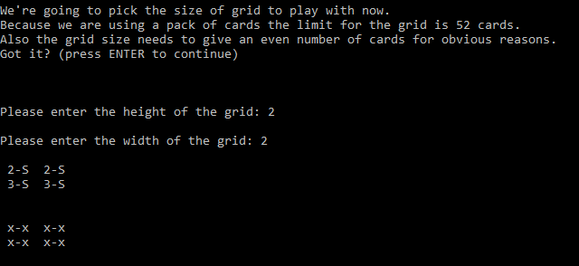
Result: Program ran and displayed values correctly.

Grid too large
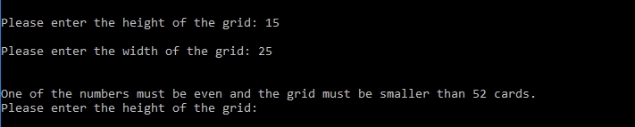
Result: Values rejected, and user asked to input size again.

Grid gives an odd number
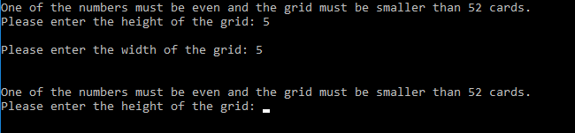
Result: Values rejected, and user asked to input size again.

Grid has negative size
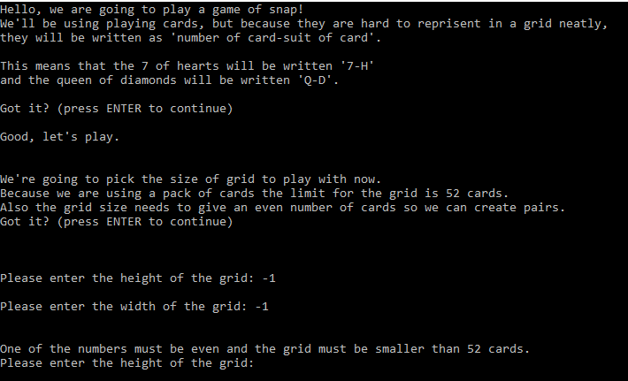
Result: Values rejected, and user asked to input size again.

Picking grid coordinates

Valid coordinates but incorrect guess
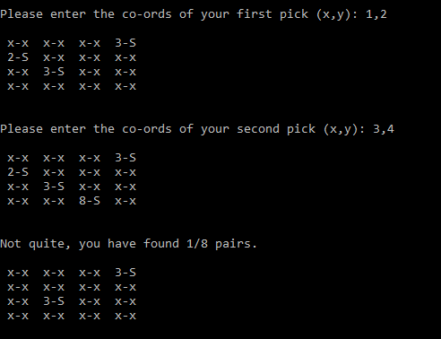
Result: Values accepted, selected cards are flipped, score is not incremented, and cards are flipped back over.

Valid coordinates and correct guess
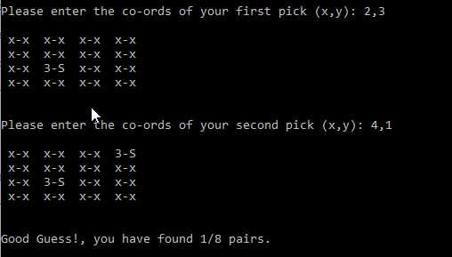
Result: Values accepted, selected cards are flipped, score is incremented, and cards stay flipped.

Coordinates of card already flipped over
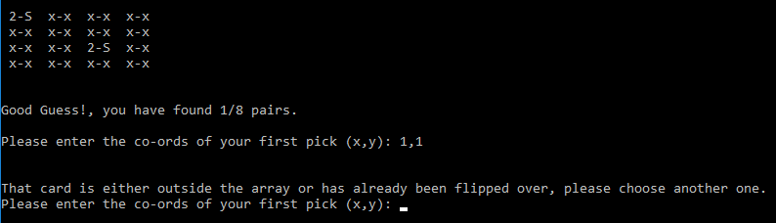
Result: Values rejected, and user asked to input coordinate again.

Coordinates outside grid
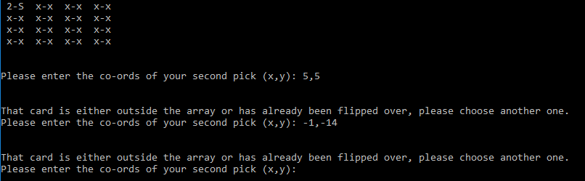
Result: Values rejected, and user asked to input coordinate again.

Invalid coordinates
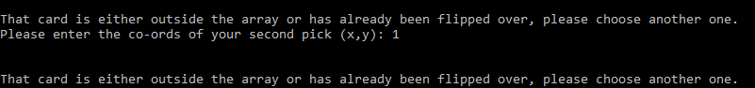
Result: Values rejected, and user asked to input coordinate again.

Coordinates entered with wrong type
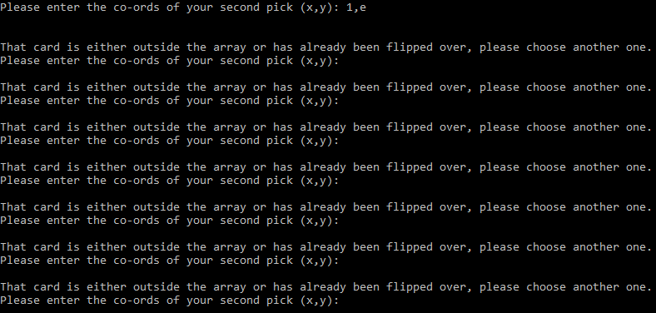
Result: Program gets stuck in loop of asking for coordinates.

Completing the game

Scoring
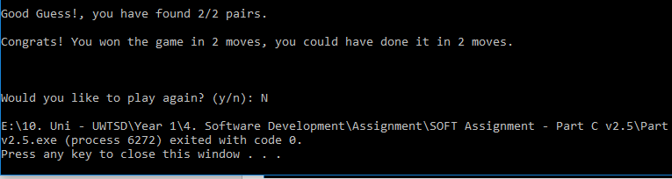
Result: Program tells user how many turns it took them to win and the minimum number of turns possible, then asks if the user wants to play again.

User answers “No”
Result: program ends as expected.

User answers “no”
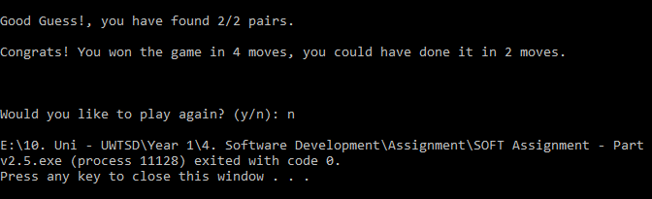
Result: program ends as expected.

User answers “yes”
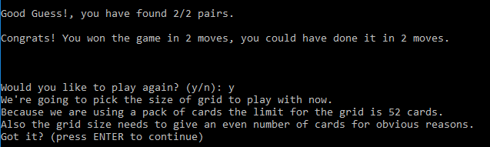
Result: program loops as expected.

User answers “Yes”
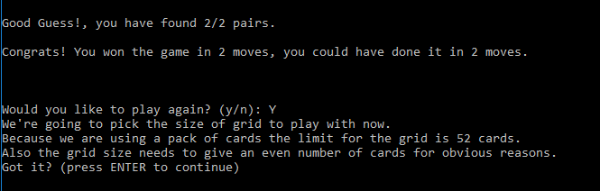
Result: program loops as expected.

