
BA Business Management
The Global Business Environment
LCB4005_BIRM

Student Name: Alexandru Mihai Ilie
Student ID: 2113107

Table of Contents
Introduction 3
Overview of selected global business 4
Pestel framework 5
Porter five forces 8
The threat of new entrants- 8
The threat of substitute- 8
Market competition 8
The bargaining power of suppliers- 9
The reasons why organisations engage in international trade 9
Customer power 9
Influence on firm strategy 9
Conclusion 11
References 12
Appendices 13

Introduction
Global business is a very important term for any country’s economy. Germany, Japan Switzerland, etc is the world's largest as well as strongest country in the world in the context of the business environment. In the below report the chosen organization is the UK-based hospitality company named The Premier Inn. In the below report the analysis of the macro environment will be done by use of the PESTEL model. The discussion of porter's five forces model has also been discussed in the below report.
Figure:01
(Source: premierinn.com, 2022)

The company Premier Inn is a UK-based hospitality company who has been founded in the year 1987 by the Whitebread. The headquarter of the company is in Dunstable, England, UK.

Overview of selected global business
The company which is chosen in this report is the hospitality company known as The Premier Inn which is founded in 1987 by the Whitebread. The headquarter of the company is in Dunstable, England, UK. The region where the company provides services in the United Kingdom, United rab Emirates, Republic of Ireland, Isle of Man, Germany, Guernsey, Qatar, and Jersey. The CEO of the company is Alison Brittain. They have a total of 800 hotels with almost they hav 72000 rooms all acorss the UK.
Figure:02
(Source: Zdończyk,2021)


Pestel framework
The macro environment of the company Premier Inn is delegated into six headings known Political factors, Economical factors, Social factors, Technology factors, Environmental factors, and legal factors which are given in the below report.
Political factors-
The rules and regulations which were made by the government of the UK will affect the business. In every country, the government rules and regulations are more important in governing. The hotel business in the UK is highly dependent on the rules and regulations which were made by the legislation of t country. The taxes, competition, and immigration laws that will be made by the government will affect the hotel industry. The main control over the Premier Inn hotel is of government. The prohibition and banning of people from coming into the country have affected the company's premier inn. For example, if the government of the UK due to any situation like a war or some pandemic will set a rule and travel ban then the hotel industry will be affected badly and can affect drastically. Due to the travel ban not only hotel industry will get affected but also the economy of the country will be affected badly. Optimistic and practical teamwork with the UK administration has carried the hotel industry the key to the achievement area of financial growth in the UK. In the UK the hotel industry is the fifth biggest business all over the UK. As it gives employment to the people of UK. Approximately 2.4 million people are doing work in the hotel industry. Over 34 Billion in tax revenue has been collected from the hotel industry. (Brendel et al.,2021)
Economical factors-
All over the world, the hospitality industry is the one industry that supports the economy of every country by a good amount of percentage. The fluctuations of the economy of every country will depend upon the demand for tourist places. The hospitality business is one of the most subtle industries when it permits from the newer series. A low-slung degree of attention will promote cheaper loans and it will demotivate the saving of money to make the customer's budget which will help the hospitality industry as a Premier Inn. The challenges which have affected the British Sterling pound the impact of covid19 has affected the company, Premier Inn, as it restricted the hotel bookings of Premier Inn. Though, some people have managed to book the hotel for their relaxation time by following all the rules and regulations which were made by the government of the UK. Although there are people who are still not motivated t book rooms to spend their money in the hotels like Premier Inn because of the high pound. ( Adams et al., 2021)
Social factors
The Premier Hotel is in trouble because of Airbnb. The biggest competition of the Premier Inn hotel is Airbnb. The lifestyle and standards of living of the people are increasing day by day which has brought many changes in society and culture of the people all across the world. As the cost of living is rising people are favoring fewer products of price and services with a high set of money of prices. The changes in society are bringing kinds and varieties of money. The changes that happened in society have changed the mindset of the people. The changes in society are affecting the hotel industry all over the world. Certain things are affecting the behavior of customers which are preferences for strong brand products, the value of money increased, easy accessibility, giving responsibility for the customer need, making online reservation systems, varieties in the price of the room, providing security, giving good service to their customers in terms of quality. By providing offers and sales for the people and taking feedback from the customer. The company Premier Inn mainly focuses on the satisfaction of the customers and they change their methods of business by altering communal standards and client favorites. The Premier Inn is providing a 100% refund to their customer for cancelation procedures.( AlShurman, et al., 2021).
Technology factors.
Technology is one of the factors which will affect the company either directly or indirectly in its business operations. In the processes of the hotel industry, the use of technology is not used. The main use of technology in the hospitality sector is directly linked to the use and availability of the electric use of instruments which is used by the IT services which will benefit the customer's comfort. The use of technology will also help the chain of supply management systems. By the use of technology, the company will influence the people by using different types of advertising and marketing strategies for their products. The Premier Inn hotel can use its advertising strategies by use of various platforms like Instagram, Facebook, and Twitter. The company Premier Inn is using the 5G technology so that the rate of the booking will be increased. They can provide free wifi for the customers who are coming for work and seminars which will attract the customers.
Figure: 03
(Source: Instagram, 2022)
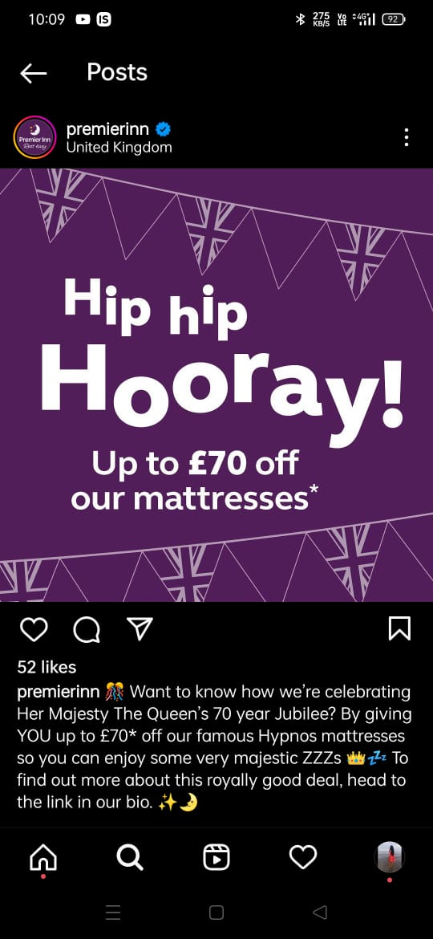
Environmental factors
The saving of environment and the social responsibility is considered the center of attraction for customers nowadays. The customers are more into the saving environment and making the country eco-friendly. Some things have been used y the Premier Inn which has decreased the pressure on the government of the UK. The company Premri Inn has made use of solar panels which will make an eco-friendly environment. BY using solar panels the company will save electricity as they are providing energy-saving lights and solar water heaters to their customers. The use of solar a\panels has increased the engagement of the customers. (Babić et al., 2021)
Legal factors.
Changes in rules and regulations the government has made have created varieties of barriers for the Premier Inn hotel in their business. The main legal factor which has affected the company is that the clients have claimed that the privacy of the person is getting leaked which has caught attention. The customers who have faced this issue have used the General Data Protection Act which will protect the data and privacy of every citix=zen in the UK from breaching data. Every customer wants to stay safe and their data will not get breached by any company. The rich people are more concerned about their booking in the company Premier Inn due to a breach of data. ( Guenaoui et al., 2022)

Porter five forces
The five forces which are used by the company which is made by Michael Porter is the business method tool which is used to make the expansion method. This model consists of Supplier power, customer power, threats of new entrants, the threat of substitutes, and market competition.
The threat of new entrants- As the country is developing the government of the Uk is also making efforts and cheering the sectors as they are giving opportunities to the businesses to expand their company in new areas. The threat of new entrants to the market for the premier inn is very high as many hotels are opening in the hospitality sector. The main competitors of the Premier Inn hotel are Airbnb. Although for sustainability in the hospitality sector as the for running business a huge amount of capital is required. ( Tongdaeng et al., 2022).

The threat of substitute-
The threat of substitutes is rising day by day. The major threat to the company Premier Inn is that they are not giving good services to their customers and they are not even giving proper services to their customers. They can provide their customers with free wifi which increases their engagement with the customers. They should provide budget-friendly foods for their customers as now people are preferring and wanted budget friendly food.
Figure:04
(Source: premierinn.com, 2022)
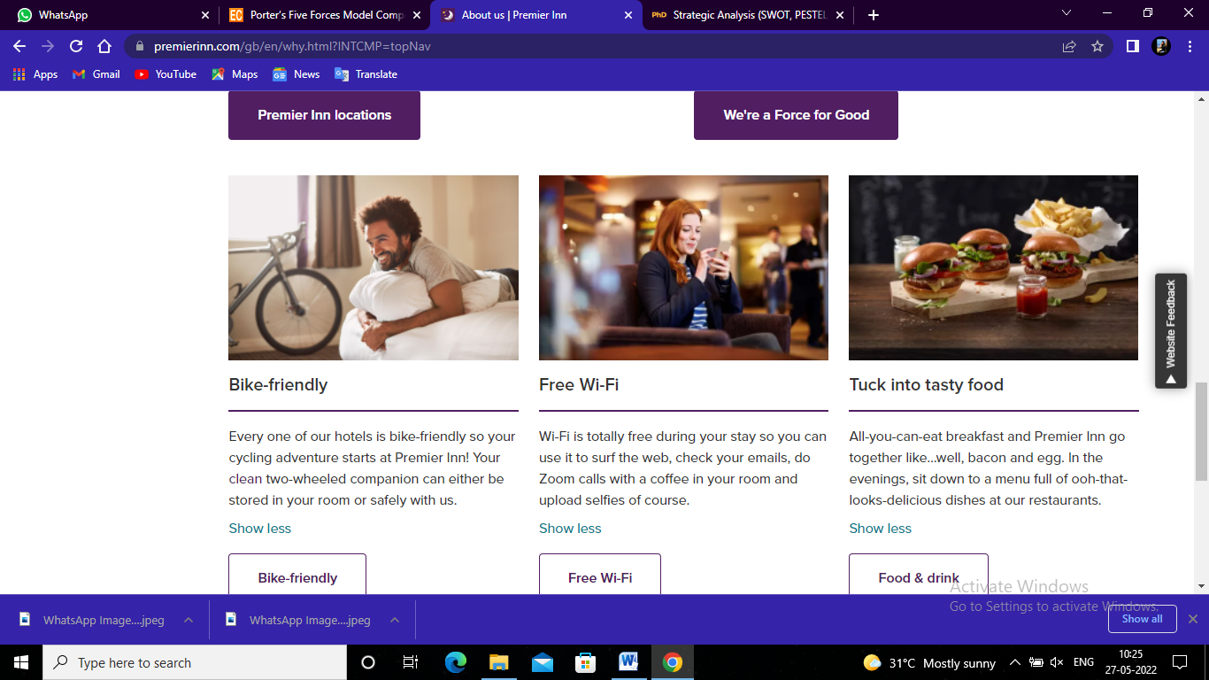

Market competition
In this sector, the marketing and advertising competition are much high as compared to another. The Premier Inn hotel is the highest chain range all over the UK as they have around 800 outlets across the country which is a positive point against the competitors. Although the competition in the hospitality sector is very high. The high the number of hotels in the specific area provided with the new products and service offers the less modest power the company will have.

The bargaining power of suppliers-
The factor of supplier on the company is not more as compared to the other factors. It goes like this the lower the supplier power so the more people will get engaged in the company and eventually it will result in an increase in sales and profits of the company. The company Premier Inn should do a contract with the supplier so that they will not exceed their words and they will not be able to back out from the customer.
The reasons why organisations engage in international trade
In the business market, there is a total of seven reasons why every organization should do trading at the international level it decreases the dependent on the market which is present locally, it also increases the success rate, it will increases the rate of effeiveient and productivity in the business which will eventually increase sales and profits of the company. The cons of the international trade are like the depenedence on economy will increase, the dependency on the political parties will get increased, the rash utilization of natural resources will be increased, the import od the goods which are dangerous for the conomy will be increased and also the international peace will be get disturbed.

Customer power
In the hotel industry, the power of customers is very high as it is dependent on the things such as places of the outlets some of the places in the UK are known as tourists places as these areas are having more hotels near them as the customers have the power to demand the hotel as the option for the people are increasing day by day. The company Premier Inn can resolve this problem as they should advertise their room services which they are providing and they should change the range of the rooms and they can provide the complimentary things to the people. They can make offers to the customers and it will increase the engagement of the company.

Influence on firm strategy
The business which will be affcetd by the business which is known as customers, staff, competition, media, shareholders, and supplier comes under the micro environment of the company and the macro environment of the company is known as which affect the company externally the company Premeir Inn can be affected by the growth of economic rates and rates of interest and unemployemnet and also the trading at global level.

Conclusion
In the above report, the chosen global business environment of UK bases hospitality industry company is named The Premier Inn hotel. In the above report, the analysis of the macro environment is done by Porter’s five forces of models which is further delegated into sic steps which re Pestel, Economical, Society, Technology, Environmental, Legal. In the above report, the reasons why any organization would get engaged in international trading are evaluated critically.

References
ZdończykZdończyk, M., Potaniec, B., Skoreński, M. and Cybińska, J., 2021. Development of Efficient One-Pot Methods for the Synthesis of Luminescent Dyes and Sol–Gel Hybrid Materials. Materials, 15(1), p.203
Brendel, A.B., Mirbabaie, M., Lembcke, T.B. and Hofeditz, L., 2021. Ethical management of artificial intelligence. Sustainability, 13(4), p.1974.
Adams, S., Brown, D., Cárdenas Álvarez, J.P., Chitchyan, R., Fell, M.J., Hahnel, U.J., Hojckova, K., Johnson, C., Klein, L., Montakhabi, M. and Say, K., 2021. Social and economic value in emerging decentralized energy business models: A critical review. Energies, 14(23), p.7864.
AlShurman, B.A., Khan, A.F., Mac, C., Majeed, M. and Butt, Z.A., 2021. What demographic, social, and contextual factors influence the intention to use COVID-19 vaccines: A scoping review. International Journal of Environmental Research and Public Health, 18(17), p.9342.
Babić Leko, M., Gunjača, I., Pleić, N. and Zemunik, T., 2021. Environmental factors affecting thyroid-stimulating hormone and thyroid hormone levels. International Journal of Molecular Sciences, 22(12), p.6521.
Guenaoui, A.S., Dobbi, A., Lebtahi, H. and Zerrouki, A.A., 2022. Experimental simulation of proppant permeability in hydraulic fracturing at extended time under bottom-hole conditions. Journal of Petroleum Exploration and Production Technology, 12(4), pp.1009-1021.
Tongdaeng, W. and Mahakanjana, C.N., 2022. Thai SMEs’ Response in the Digital Economy Age: A Case Study of Community-Based Tourism Policy Implementation. Social Sciences, 11(4), p.180.
premierinn.com[Online] Available at https://www.premierinn.com/gb/en/home.html [Accessed on 05th July 2022]

Appendices

