

Programme: Master of Business Administration
Module: International Marketing: Principles and Practices
Module code: LCMB7026
Assignment Title: Assessment component 1: Individual report of Zara

Name of the Student: Manikandan Gopalakrishnan
Student ID: 2507423
Wordcount: 5101
Lecturer: Dian Mayasari
Executive Summary
The discussion suggests that the performance of Zara in India and the United Kingdom is highly influenced by the opposite conditions of the macro-environment and consumer demands. India has a high growth potential due to the rising middle class and adoption of digital platforms, although it must be price sensitive, localised and selective in its expansion. Conversely, the UK is a highly competitive market which is mature, and it would require premium positioning, innovation and good sustainability practice to succeed. Another key point of the analysis is that Zara's fast-fashion model provokes certain ethical issues, especially concerning environmental issues and supply chain transparency. Although the brand exhibits flexibility in its STP and marketing mix approaches, the company needs to incorporate sustainability more deeply in its future to be successful and attain higher success by increasing transparency and increasing the omnichannel capabilities to fulfil the dynamic global consumer demands.
Table of Contents
Section 1 3
1. Introduction 3
2. Macroenvironment of Zara in India and the UK 3
2.1 PESTLE (India) 3
2.2 PESTLE (UK) 4
2.3 Comparative evaluation of the external environment of Zara between India and the UK 6
3. Segmentation, Targeting, and Positioning (STP) and International Marketing Mix (7Ps) strategies in both countries 8
3.1 India 8
3.1.1 STP 8
3.1.2 7Ps 9
3.2 UK 11
3.2.1 STP 11
3.2.2 7Ps 12
4. Brand development strategy in one of the countries 13
5. Ethical issues of Zara in one/both countries 14
6. Recommendations 15
7. Conclusion 16
Section 2 18
References 22

Section 1

1. Introduction
Zara is a famous international fast-fashion retailer that is characterised by quick production and trend-driven designs. The brand has been operating in a wide range of international markets, such as India and the United Kingdom (UK), with each having a different macro-environmental environment. It is vital to analyse these environments to know how Zara is adjusting its international market entry and marketing strategies. In this report, the PESTLE framework is used to analyse the macro-environment of Zara in India and the UK and then compare them. The analysis identifies some of the strategic opportunities and threats to the strategic positioning of Zara within both markets.

2. Macroenvironment of Zara in India and the UK

2.1 PESTLE (India)
Factor | Description | Opportunity/Threat
Political | - Policymaking in the retail industry on FDI by the government (Deloitte, 2026)  - Intricate regulations and bureaucratism.  - Trade tariffs and duty of imports (WTO, 2024) | Threat: Market expansion is hurt by regulatory uncertainties
Economic | - Speedy increase in GDP in 2026 (7.6% higher than 2025) (PIB, 2026) (Refer to figure 1).  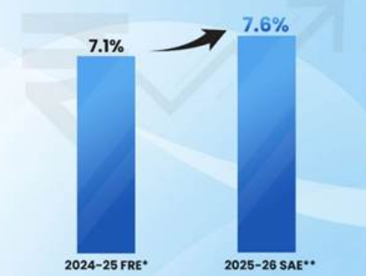  Figure 1: Increase in Indian GDP  (Source: PIB, 2026)  - Growing expendable income of city consumers.  - Market conditions which are price-sensitive (International Trade Administration, 2024)  - The retail inflation has dropped low in India (Ohri, 2025) (Refer to figure 2).  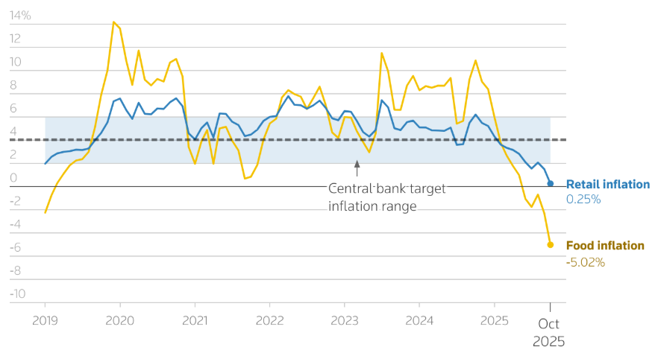  Figure 2: Drop in Indian retail inflation  (Source: Ohri, 2025) | Opportunity: Emerging middle-class demand
Social (Consumer behaviour & culture) | - Various cultural tastes in terms of clothing (Thakur and Atre, 2024).  - Increased fashion awareness among the young people.  - Favour towards low-cost but trendy Western fashion clothing in the country (Chakraborty and Sadachar, 2020). | Opportunity: There is strong demand for fast fashion.
Technological | - Expanding e-commerce and online payments (Kumar, 2021).  - Growing Smartphone penetration.  - Omnichannel retailing adoption.  - Efficiency through digitisation of the supply chain (Avadanei et al., 2023). | Opportunity: Growth via the Internet.
Legal | - Working regulations and legalities.  - Consumer protection laws (Government of India, 2024).  - The issue of intellectual property. | Threat: Businesses face high compliance costs
Environmental | - Getting more aware of sustainable fashion (Sankar, 2023).  - Pressure to minimise wastage in the textile industry (Pranta, Rahaman and Repon, 2025).  - Environmental government regulations. | Threat: Sustainability pressure on fast fashion
Table 1: Pestle analysis of India

2.2 PESTLE (UK)
Factor | Description | Opportunity/Threat
Political | - Brexit trade effect on the businesses (Du, Satoglu and Shepotylo, 2023).  - No political instability (0.26 points) (The Global Economy, 2025) (Refer to figure 3).  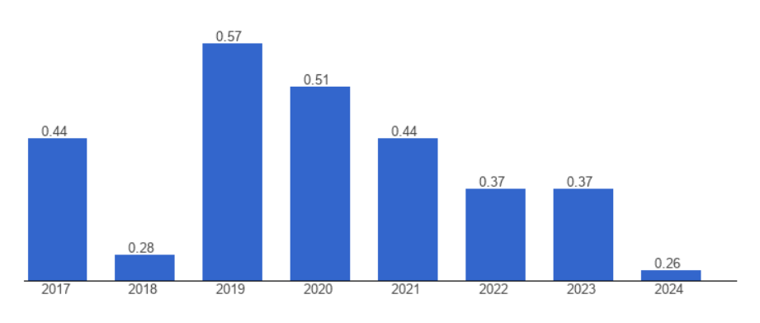  Figure 3: Political instability of the UK  (Source: The Global Economy, 2025a).  - The retail industry is supported by the government. | Threat: Brexit-based barriers to trade.
Economic | - Purchasing power has dropped in the country (ONS, 2023).  - Foreign exchange risk on imports.  - Inflation affects consumer expenditure (Clark, 2026) (Refer to figure 4).  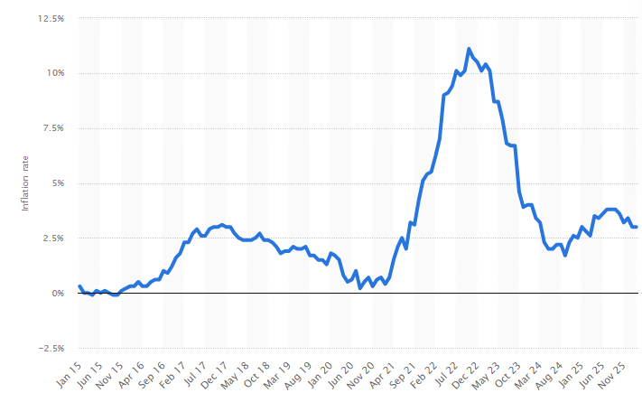  Figure 4: Inflation rate in the UK  (Source: Clark, 2026)  - A competitive retail market that is mature. | Threat: Competition and saturation in the market.
Social (Consumer behaviour & culture) | - High fashion consciousness and brand awareness (Devita and Sahara, 2018).  - Tendency to purchase sustainable and ethical clothes (Zhang, Zhang and Zhou, 2021).  - Strong demand for a high shopping experience. | Opportunity: Customers' demand for trendy and premium fashion in the country
Technological | - Premium retail technologies (AI, data analytics) (Nwobodo, 2024).  - High e-commerce penetration  - Online and offline retail channel integration (Gornostaeva, 2023). | Opportunity: Tech-driven retail efficiency
Legal | - Tough labour and employment regulations.  - Laws of consumer protection and the Data Protection Act (UK Government, 2025).  - Protection of intellectual properties.  - Adherence to trade laws after Brexit. | Threat: Costs of regulatory compliance are high.
Environmental | - Robust environmental laws for the fashion industry  - Sustainability in consumer demand for fashion (Mintel, 2024).  - Lasting pressure to cut carbon footprint (Millward-Hopkins, Purnell and Baurley, 2023).  - Practices that focus on a circular economy. | Threat: The sustainability expectations are high.
Table 2: Pestle analysis of the UK

2.3 Comparative evaluation of the external environment of Zara between India and the UK
The macro-environmental factors within India and the United Kingdom (UK) pose different opportunities and challenges to Zara, and the international markets approach in both countries will be different. Politically, the UK offers a clear and stable regulatory system, which facilitates easy business activities. Nonetheless, these effects of Brexit have brought about trade barriers, inspection of goods, and high costs of imports, which have influenced the efficiency of Zara's supply chain (Du, Satoglu and Shepotylo, 2023). Conversely, the Indian political environment can be characterised by complex regulatory frameworks and bureaucracies, especially in the retail industry. Despite these, policies by India to permit foreign direct investment (FDI) in single-brand retail have opened up possibilities for Zara to have a stronger presence, even though these factors could postpone the success of expansion. Therefore, the UK has a stable political climate, however, long-term growth prospects in India can be affected by regulatory hurdles.
The two markets are quite different regarding their maturity and growth potential, economically. India is a developing economy with a fast-rising middle class and disposable income and this presents a high market demand for low-end and fashionable fashion (Chakraborty and Sadachar, 2020). Nonetheless, the market is quite price-elastic, and Zara has to implement competitive pricing policies. However, the UK has a high purchasing power and a developed economy, and hence Zara can afford to charge high prices. However, the UK market has been saturated with intense competition both in the fast fashion segment and in the luxury brands, which restricts growth prospects. Thus, India is a high-growth market, whereas the UK is a competitive and mature market. There are other social factors that bring out the difference between the two countries, including consumer behaviour and cultural preferences. In India, consumer tastes are very multicultural in light of cultural and regional differences. Western fashion trends are taking hold of customers who continue to put a value on money. This demands that Zara juggle between the global fashion trends and the local taste. Meanwhile, the UK consumers are brand-sensitive and fashion-conscious, whereas the focus on quality, sustainability, and ethical sourcing is quite strong (Zhang, Zhang and Zhou, 2021). Environmentally friendly fashion is needed much more in the UK, which prompts Zara to pay attention to sustainable development and clear supply chains in this country.
The UK is technologically more developed and has a more developed retailing infrastructure, with a large level of e-commerce, artificial intelligence, and data analytics adoption (Nwobodo, 2024). This enables Zara to practice effective inventory control and customised marketing approaches. One of the challenges that India has been experiencing within the context of digital adoption is still the lack of uniform internet penetration and logistical issues in some parts of the country. Nevertheless, the growing adoption of smartphones and electronic payment methods in India gives Zara a chance to increase its online presence and implement omnichannel retailing methods. Law-wise, the two markets must adhere to stringent regulations, the UK has more formal and rigorous laws, specifically in labour laws, consumer protection, and privacy of information (UK Government, 2025). These regulations are costly to operate and are also useful in providing a fair business environment. The legal system in India is not as strict in certain sections, but may prove to be a complicated and time-consuming system with regard to administrative processes. This poses more compliance and operational efficiency challenges to Zara.
Both countries are concerned with the issue of sustainability in the environment, but the degree of awareness and expectations is different. Consumers and the regulating bodies in the UK put a lot of pressure on the brands to be more sustainable, cut down on carbon emissions and encourage circular fashion. Sustainability efforts must thus be given first priority to help keep Zara in the market. Environmental awareness in India is on the increase, and affordability and accessibility of fashion items are preferred by consumers (Sankar, 2023). Consequently, sustainability is less important in the purchasing process than price and style. Therefore, India provides Zara with a high-potential and opportunity-filled environment that needs to be localised and mindful of costs, where the UK is a mature and highly competitive market and obliges innovation, sustainability, and premium positioning. Such variations require unique approaches to be in a position to handle the macro-environmental factors unique to each market.

3. Segmentation, Targeting, and Positioning (STP) and International Marketing Mix (7Ps) strategies in both countries

3.1 India

3.1.1 STP
Elements | Details
Segmentation | - Demographic: young population, middle to upper-middle could be made up of income groups.  - Geographic: Metro cities of the country have been targeted  - Psychographic: Style-sensitive, trendy shoppers (Rahman and Kharb, 2018).  - Behavioural: Social media trendy, price sensitive, frequent shoppers.
Targeting | - Urban consumers aged 18-35  - Middle and upper-middle income with increasing disposable income  - People with the desire to own affordable luxury and world fashion trends.
Positioning | - Positioned as a high-end and affordable fast-fashion brand.  - Sells global runway-inspired products at fairly low costs (Jackson, 2025).  - Focuses on trendiness, speed and exclusiveness of collections.
Table 3: STP analysis of India

3.1.2 7Ps
The marketing mix Zara uses in India is well adjusted to the country with its diverse and price-sensitive, and highly changing retail market. The brand strikes a balance between its global fast-fashion outlook and expectations of the local markets to make it competitive and relevant.
Product:
Zara in India has a wide brand range of products, such as menswear, womenswear, and accessories, that mirror fashion around the world. Nonetheless, the brand makes slight localisation of its products to meet the Indian taste. It presents less drastic silhouettes, bottoms, and loose garments like cotton and linen due to the tropical weather (Zara, 2025) (Refer to figure 5). The seasonal lines are also modified to incorporate festival-related fashions on special events such as Diwali and wedding seasons. The company keeps its fast-fashion concept, but still provides the frequent replenishment of its products, which would attract Indian customers to visit Zara repeatedly and buy things on impulse.
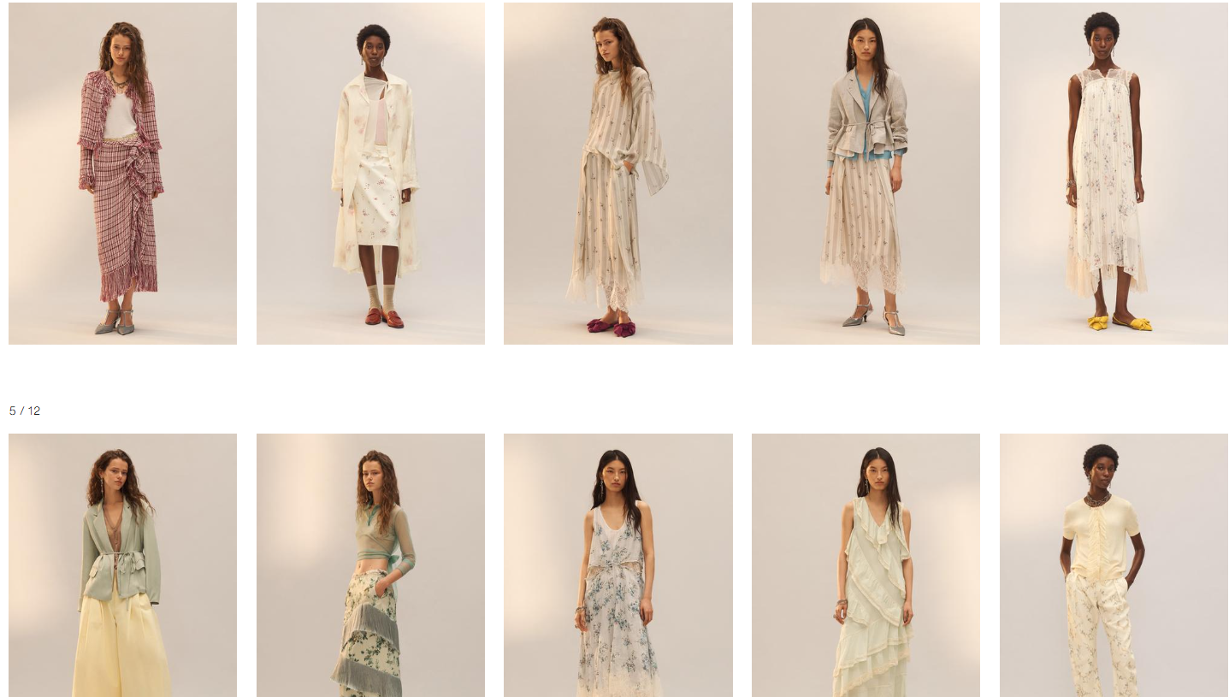
Figure 5: A few collections of Zara for India
(Source: Zara, 2025)
Price:
In India, Zara operates a premium but affordable pricing policy. The prices of its products are relatively high compared to local brands, and they also faced criticism due to overcharging during sale times (Bedi, 2018). Taxes, importation charges and transport expenses make the prices relatively high. Consequently, the main consumers to whom Zara is directed are the middle and upper-middle-class citizens. This price sensitivity can be managed by the brand through strategic end-of-the-season sales and discounts to make the inventory and appeal to low-budget consumers.
Place:
Zara’s distribution strategy in India is focused on selective expansion in prime urban locations. Its stores are located in premium malls and high-end shopping districts in metropolitan cities such as Mumbai, Delhi, Kolkata and Bangalore (Zara, 2020). This ensures visibility among its target audience with higher purchasing power. In addition to physical stores, Zara has significantly strengthened its e-commerce presence, offering online shopping with home delivery across multiple cities (Gil‐Cordero, Ledesma‐Chaves and Baena‐Luna, 2023). The integration of online and offline channels enables Zara to expand its reach beyond metros and tap into emerging urban markets.
Promotion:
Zara uses a low-cost, low-promotion strategy in India, which is similar to its international strategy. The brand does not spend a lot of money on advertising but uses displays at the store, visual merchandising, and positioning of products (Roll, 2021). Social media platforms like Instagram are becoming an increasingly crucial tool to attract the attention of consumers, as India has the highest number of Instagram users (460 million) (Chaudhary, 2021; Thuy, 2025)
). Brand visibility is also promoted by influencer collaborations and user-generated content.
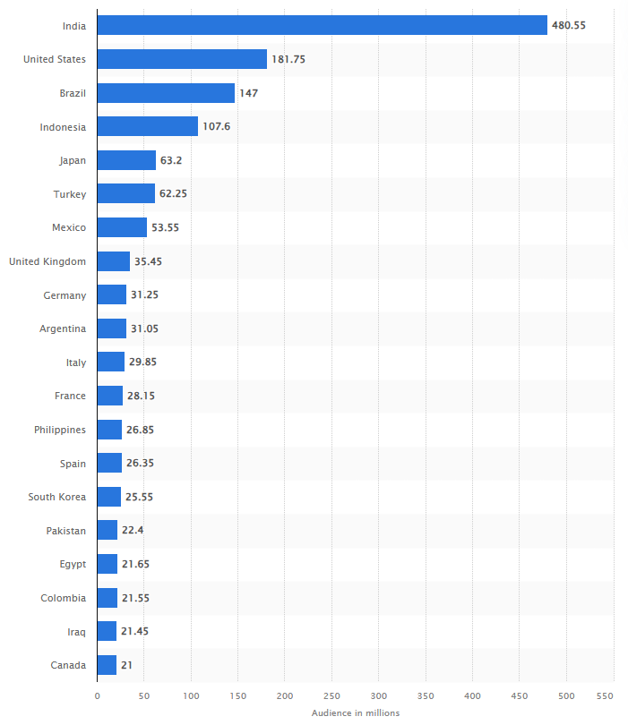
Figure 6: Instagram users in India
(Source: Thuy, 2025)
People:
Zara pays special attention to customer service and hires trained personnel who are familiar with fashion trends and customer preferences. In India, the staff contribute significantly to helping customers shop by giving them tips on how to dress themselves up, and providing them with a smooth shopping experience. This is because of cultural sensitivity and communication skills due to the diversity of customers. Staff training is aimed at retaining the global level of service of Zara without sacrificing its ability to adjust to regional demands, which will increase customer satisfaction and brand loyalty.
Process:
Zara is based on a fast-response supply chain as the basis of its fast-fashion business model (Aftab et al., 2018). The company has elaborate inventory management systems and data analytics in India to track consumer demand and make appropriate stock adjustments. The products are frequently replenished, meaning that the stores are well equipped with the current trends (Aftab et al., 2018). The online and offline systems are integrated such that customers are able to check the availability of products, and various methods of purchase are available. Zara keeps up with the competition in the dynamic market and has done so with the help of efficient logistics and lean processes.
Physical Evidence:
The Zara outlets in India are meant to create a sleek, streamlined, and luxurious shopping experience. The arrangement of the store is big and well arranged with well-arranged displays which show the new collections (Roll, 2021). Light, music and general atmosphere will add to a high-level retail environment. The brand remains consistent with its design in the global stores but makes the Indian customers comfortable. Zara is a low-end luxury fashion brand, which is also reinforced by packaging, branding and visual identity.

3.2 UK

3.2.1 STP
Element | Details
Segmentation | - Demographic: The middle and high-income adults and professionals.  - Geographic: London, Manchester, and Birmingham are mostly targeted by the brand (Zara, 2026).  - Psychographic: Consumers who are brand-conscious, trendy and sustainable.  - Behavioural: Trend followers, value quality and brand image, buy frequently.
Targeting | - Young people who are trendy between the ages of 20 and 40 years.  - Lifestyles: middle and high-income.  - Customers who demand fashionable, high-quality and sustainable wear.
Positioning | - Placed as a high-end fast fashion brand that is highly trend-setting.  - Emphasise good design, quick product turnover and international attractiveness. (Basak, 2018)  - Growing interest in sustainability and ethical fashion.
Table 4: STP analysis of the UK

3.2.2 7Ps
The marketing mix used by Zara in the United Kingdom depicts the nature of a mature, highly competitive and fashion-oriented retail market. The brand is based on the principle of innovation, quality and sustainability to satisfy the needs of the UK consumers.
Product:
Zara in the UK has an advanced and fashion-oriented product offering that is very close to the global fashion trends. The brand also unveils new collections often, which keeps it topical in a rapidly evolving market. UK customers are not only after style, but also quality and sustainability (Mintel, 2024). Consequently, Zara has increased its range of sustainability products, including organic cotton, recycled materials and sustainable production processes (Zara, 2024). All collections are aimed to serve casual and formal wear, and modern and diversified fashions that are attractive to the professionals in the city are given significant focus.
Price:
Zara uses a luxury pricing strategy in the UK, which is according to the increased purchasing power of buyers. The prices are above those of mass-market fast fashion manufacturers like Primark and below those of luxury fashion producers. This enables Zara to be at the middle ground between exclusivity and affordability. The UK consumer is not price sensitive and more concerned with quality and brand value (YouGov, 2025). Zara does not indulge in too much discounting on its products in order to maintain its luxury reputation, but it still does seasonal sales to clear its products.
Place:
Zara is well-represented in the retail business of large UK cities, such as London, Manchester, and Birmingham. The outlets are placed in high street and shopping centres of good locations, and there is high foot traffic, and the brand will be seen. Zara can take advantage of the UK-developed retail infrastructure, where it can have its efficient omnichannel distribution system that incorporates both physical stores and its online store system.
Promotion:
Zara has maintained its low-profile promotional approach in the UK, which is based on brand recognition and not on conventional advertising. The company spends a lot of money on visual merchandising, store image and online platforms to translate its brand image (Roll, 2021). Social media is an important factor in the demonstration of new collections and communication with fashion-sensitive customers. The fact that Zara can respond to trends very fast is itself a way of promotion because customers do not always leave the stores without trying something new.
People:
The UK customer service is a vital ingredient of Zara's marketing mix. There are well-skilled, educated and competent employees who can offer personalised services. Zara puts a significant focus on inclusiveness and cultural sensitivity among its employees in the light of the diversity of the UK market. The employees also help in ensuring that the shopping experience is premium with the provision of styling tips and excellent standards of service as a way of improving customer loyalty.
Process:
The UK has a strong operational efficiency of Zara owing to the well-developed logistics and supply chain systems. Real-time data analytics help the brand to monitor trends, sales, and re-order inventory (Nwobodo, 2024). This helps in fast product rotation as well as maintaining the stores with up-to-date fashion products. The effective combination of online and offline operations also enhances efficiency, and customers will have a convenient and flexible shopping experience.
Physical Evidence:
Zara outlets in the UK are aimed at providing a high-end and modern retail experience. The rooms are airy, bright and beautifully designed with simplicity and grace emphasised. The shopping experience is improved with the use of digital screens, organised layouts and quality fixtures. Moreover, Zara also includes green services in the design of its stores, including energy-saving lighting and materials that are environmentally friendly (Zara, 2023). Its image of being a high-quality, modern, and environmentally responsible fashion brand is also supported by packaging and branding.

4. Brand development strategy in one of the countries
The directional development strategy of Zara in India is best perceived in terms of growth and expansion in an emerging market. The brand mainly uses a market penetration and market development approach, and in that, the brand focuses on consolidating its market in the urban centres and slowly spreading to new geographic and digital areas (Saraswat, 2018). Market penetration is one among the strategies of Zara in India that entails expanding the market share of the company in the contemporary metropolitan markets like Mumbai, Delhi and Bangalore. The brand does this through upgrading store experiences, providing more product mix, and constantly changing collections as repeat buying motivators (Roll, 2021). The fast-fashion business model of Zara, which has been characterised by a high inventory turnover and less stock holding, generates a sense of urgency among consumers and consequently prompts them to increase the level of volume purchases (Aftab et al., 2018).
Besides penetration, Zara uses a market development approach through the expansion into other cities and regions. Although the brand started with Tier 1 cities, it is slowly expanding its Tier 2 city opportunities via its online shopping platform (ET, 2024b). This allows Zara to cover a wider audience without necessarily having to invest heavily in physical shops. This expansion is further enhanced by the growth of digital infrastructure and the growing online shopping behaviour in India. The other noteworthy factor regarding the directional development of Zara is the strategic partnership model. In India, Zara is present in the country in the form of a joint venture with the Tata Group that offers local market experience, regulatory backing, and cost-effectiveness (ET, 2024a). The partnership allows Zara to penetrate the complicated Indian retail sector more effectively.
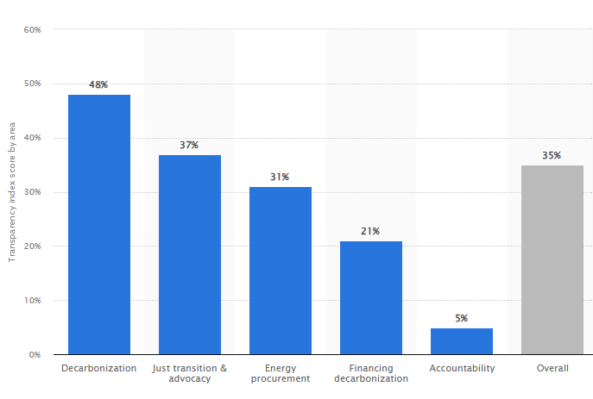
Figure 7: Transparency by Zara in different areas
(Source: Rocco, 2025)
Moreover, Zara is more and more oriented towards sustainable development, balancing both with the global sustainability perspective and improving transparency across various business areas by 35% (Zara, 2024; Rocco, 2025) (Refer to figure 7). Even though the sustainability concept in India is in its infancy, Zara is slowly launching eco-friendly products and initiatives that are socially responsible (Zara, 2024). Altogether, the Zara directional development in India can be characterised by a balanced strategy, which includes market penetration, geographic and digital growth, to guarantee the company's competitiveness in the long term in a high-potential and dynamic market.

5. Ethical issues of Zara in one/both countries
The marketing mix employed by Zara in India and the United Kingdom creates a few ethical issues, especially when it comes to sustainability and labour, as well as consumerism. Being a fast-fashion retailer, Zara has a business model that promotes repeated purchases of its products by the novelty of the production cycle and its velocity. Although Zara has implemented sustainable practices like eco-friendly collections, critics claim that the practice might be viewed as greenwashing unless it is applied to the whole supply chain (Hardcastle, 2022). Regarding the aspect of production, there are ethical issues related to the labour practices in the global supply chains. Nevertheless, despite Zara keeping up with the international labour standards, industry-wide issues of labour wage, working conditions and outsourcing to other low-cost manufacturing areas have continued to raise concerns. Such concerns are specifically important in such markets as India, where labour laws may be different and their enforcement may not be the same.
Prices wise, the approach of Zara to India can be ethically questionable on the grounds of accessibility and value. The brand is marketed as relatively cheap luxury, but the pricing point is rather high in comparison to H&M, which might introduce exclusionary consumption habits (Duoyan, 2021). However, in the UK, sustainability and transparency are being given more consideration as ethical issues because consumers are becoming more conscious of the environmental and social effects. Such a low advertising strategy at Zara makes less information available on sourcing and sustainability practices, which is potentially a limiting implementation of informed decision-making by consumers. On the whole, even though Zara has made some steps in the direction of ethical enhancement, both markets still face the problem of finding a compromise between profitability and environmental responsibility and social accountability.

6. Recommendations
In order to reinforce its global marketing strategies, Zara ought to be more sustainable, open, and responsive locally in India and the United Kingdom. Zara needs to become more sustainable and not only increase the number of its eco-friendly collections but also implement a sustainable strategy throughout its product lifecycle. This would involve the use of more recycled materials, less wastage, and the use of recycling and resale programs to promote cyclical fashion (Shamsuzzaman et al., 2025a). This would enhance brand credibility in the UK, where sustainability expectations are high, and in India, it would assist in creating an early awareness and long-term consumer trust. Secondly, Zara needs to raise deeper transparency in their supply chain. Ethical issues such as sourcing, manufacturing processes, and labour conditions can be addressed by providing clear information that would enhance consumer confidence (Aakanksha and Aravendan, 2023). The use of digital technologies like QR codes on labels on their products might enable customers to track the origins of products, which would be quite attractive to the ethically conscious customers (Le, 2024).
Thirdly, it needs to have a more localised marketing approach for the brand. In India, Zara will be able to implement more culturally appropriate models and pricing procedures to enhance accessibility and attract more people. Market expansion that will be achieved by incorporating physical shops and online shopping in Tier 2 cities will also facilitate market growth. Zara in the UK should remain with the premium positioning, as it should concentrate on sustainability and innovation. More so, Zara ought to use digital transformation by strengthening its omnichannel experience. Customer engagement in both markets can be enhanced by investing in AI-driven personalisation, mobile applications, and flawless online-offline integration (Mehmood et al., 2025). Lastly, Zara would need to ensure responsible consumption, whereby it encourages its customers to purchase quality rather than quantity. Through these strategies, Zara will enjoy growth in the long-term and still satisfy ethical issues and be better able to adapt in various foreign markets.

7. Conclusion
As per the above analysis, the operations of Zara in India and the United Kingdom show that global marketing strategies should be adjusted to the macro-environmental conditions. India has become one of the largest growth opportunities due to the presence of a growing middle-income population and the adoption of the digital environment, whereas the UK is a stable and competitive market with high sustainable and quality expectations. The key to Zara is to be equally global and at the same time local. Nonetheless, sustainability and labour-related ethical issues point to the necessity of ongoing improvement. Zara will be able to enhance its position in the global market and guarantee its success in the long-term by becoming more transparent, sustainable, and customer-oriented.

Section 2
The Gibbs’ reflective model has been used to structure the reflection in six stages about the research on Zara (Gibbs, 1998) (Refer to figure 8).
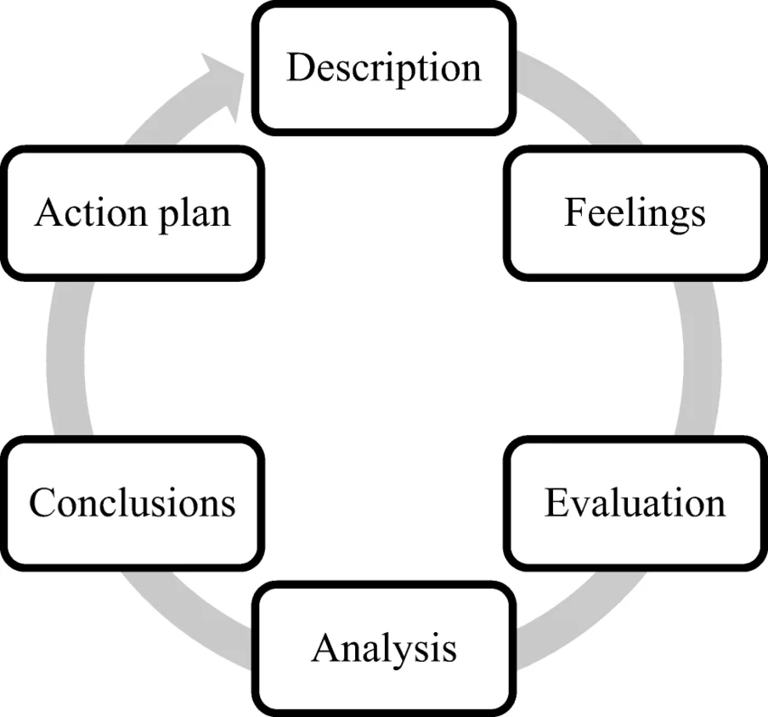
Figure 8: Gibbs’ reflective learning model
(Source: Gibbs, 1998)
Description
In this analysis, I was required to carry out research and to analyse the strategy of international market entry by Zara and the marketing mix through two countries, India and the United Kingdom. This was to be done utilising the theoretical frameworks, such as the PESTLE analysis, STP, and the 7Ps marketing mix. I was also required to examine ethical issues and propose an action plan for the future. To achieve this task, I resorted to scholarly sources, industry reports, and other quality online materials to get acquainted with the operations of Zara in both markets. I had structured the report according to the given guidelines, and every part of the report contained the required number of words and the format (PESTLE and STP). This was achieved through comparison of the macro-environmental factors, analysing the consumer behaviour and formulating strategic differences between the UK and India.
Feelings
At the start of the assignment, I felt a bit overwhelmed knowing how extensive the task was going to be and how many different frameworks I would need to use in two countries. There were challenges in balancing theory and practice. However, further down the line, I became more confident about my abilities in information management and applying tools of analysis. Particularly, the comparative analysis interested me since I managed to gain an insight into how the same brand is adapted to the various cultural and economic settings. Nor was there wanting in the order of the report and the satisfaction of the scholastic needs. However, there were instances when I was not convinced about the severity of my analysis when analysing ethical issues and giving recommendations.
Evaluation
One of my strengths was the logical implementation of the framework, such as the PESTLE and marketing mix, which provided me with an opportunity to organise my analysis. The comparison between India and the UK assisted me in formulating certain clear differences in the consumer behaviour, economic status and strategies. In addition, the table arrangement and paragraphs simplified comprehension and reading. However, I also used generalised information on the fast fashion industry to some degree, rather than more precise information at Zara. This was likely to reduce the level of analysis in certain spheres. Moreover, the restriction of words in the text and the need to fit everything in were confusing, which consequently led to the need to read through the text carefully and to select the most significant issues. Another area which could be improved was critical evaluation. I could have explained strategies effectively, but I would have included more critical views and arguments with a wider range of academic references.
Analysis
Writing this assignment allowed seeing the necessity of integrating theory and working in the business world. PESTLE frameworks enabled me to analyse business decisions in their impact by the outside elements, and the STP and 7Ps enabled me to evaluate internal marketing decisions. I discovered that the international marketing sector is very flexible. In India, Zara is undertaking the strategy of affordability and localisation strategy, whereas in the UK, it is undertaking the strategy of sustainability and up-market positioning. This illustrates the possibilities of using the principles of market segmentation and cultural adaptation in the global business. Yet another feature that increased my understanding of the problems of the fast-fashion brands relates to the section of ethical evaluation. The issues, such as sustainability and labour practices, are intricate and require some form of trade-off between profitability and social responsibility. The other matter of concern in the process was time management. The work was broken into small sections, and this helped me to be in order and ensure that each section of the assignment was given attention.
Conclusion
Overall, this assignment has been an opportunity to learn and to master my research, analysis and writing skills. I also acquired a more in-depth understanding of how international marketing approaches are developed and adapted to different markets. The organising systems helped me to improve my ability to process complex information and deliver it in a clear and effectively articulated manner. However, the process also showed what could be done better, especially to develop a more analytical approach and use a wider range of academic materials. I also understood that I needed to train my skills in becoming more assured when it comes to making ethical decisions and providing justified advice.
Action Plan
Action Area | Plan | Time frame
Research Improvement | The next thing that I will improve in my next assignments is that I will utilise additional academic journals and industry data to develop a more substantive and credible research process. | 3 months
Critical Thinking | I will also invest in the development of better critical thinking abilities, such as doubting assumptions and giving more balanced arguments. | 4 months
Time Management & Organisation | To be more organised to handle such tasks, I will prepare a detailed schedule and set particular timeframes to complete all sections, such as research, writing, and revision. | 4 months
Feedback & Collaboration | I will also consult with other peers or tutors to get a chance to identify areas of improvement before the final submission. | 2 months
Subject Knowledge Enhancement | Additionally, I would like to improve my knowledge in the field of international marketing, exploring the case studies and practical examples. | 2 months
Application of Theory | This will enable me to put theoretical ideas to better use and form a more realistic view. | 1 month
Table 5: Action plan

References
Aakanksha, L. and Aravendan, M. (2023) ‘Impacts of Transparency and Traceability on Fashion Supply Chain System’, Intelligent Information Management, 15(03), pp. 100–119. doi: https://doi.org/10.4236/iim.2023.153006.
Aftab, M. A. et al. (2018) Super Responsive Supply Chain: The Case of Spanish Fast Fashion Retailer Inditex-Zara, ResearchGate. Available at: https://www.researchgate.net/publication/324702528_Super_Responsive_Supply_Chain_The_Case_of_Spanish_Fast_Fashion_Retailer_Inditex-Zara (Accessed: 24 March 2026).
Avadanei, M. et al. (2023) ‘Digitalisation in the Supply Chain of the Fashion Industry- Study Case’, Sciendo eBooks, pp. 194–201. doi: https://doi.org/10.2478/9788367405133-031.
Basak, S. (2018) Zara: Study of a luxury fast fashion brand ; with respect to two different countries, ResearchGate. doi: https://doi.org/10.13140/RG.2.2.29717.23528.
Bedi, A. (2018) Zara store to pay ₹6,500 to customer for overcharging during sale | Hindustan Times, Hindustan Times. Available at: https://www.hindustantimes.com/punjab/zara-store-to-pay-6-500-to-customer-for-overcharging-during-sale/story-3lhIWjtMsQYkEHuHi00j0K.html (Accessed: 24 March 2026).
Chakraborty, S. and Sadachar, A. (2020) ‘Predicting Indian consumers’ purchase intention from Western apparel brands’, Journal of Fashion Marketing and Management: An International Journal, ahead-of-print(ahead-of-print). doi: https://doi.org/10.1108/jfmm-02-2020-0017.
Chaudhary, M. U. (2021) ‘Impact of Instagram as a tool of Social Media Marketing’, Media and Communication Review, 1(1), pp. 17–29. doi: https://doi.org/10.32350/mcr.11.02.
Clark, D. (2026) UK inflation rate 2026| Statista, Statista. Available at: https://www.statista.com/statistics/306648/inflation-rate-consumer-price-index-cpi-united-kingdom-uk/?srsltid=AfmBOoou3BOJba0lGj09vRj8GFUaXWNu2K8RVKdKqCACrCiMtOGXKlVx (Accessed: 24 March 2026).
Deloitte (2026) Retail FDI in India, Deloitte. Available at: https://www.deloitte.com/in/en/Industries/retail/research/retail-fdi-in-india.html (Accessed: 24 March 2026).
Devita, L. D. R. and Sahara, A. (2018) ‘THE INFLUENCE OF FASHION CONSCIOUSNESS AND BRAND IMAGE ON PURCHASE DECISION: A SURVEY ON FEMALE CONSUMER AT HOUSE OF RIA MIRANDA’, Russian Journal of Agricultural and Socio-Economic Sciences, 77(5), pp. 54–59. doi: https://doi.org/10.18551/rjoas.2018-05.07.
Du, J., Satoglu, E. B. and Shepotylo, O. (2023) ‘How Did Brexit Affect UK trade?’, Contemporary Social Science, 18(2), pp. 1–18. doi: https://doi.org/10.1080/21582041.2023.2192043.
Duoyan, H. (2021) ‘Research on ZARA Strategy from the Perspective of SWOT Analysis Method’, Proceedings of the 2021 6th International Conference on Social Sciences and Economic Development (ICSSED 2021), 543(1). Available at: https://www.researchgate.net/publication/350916569_Research_on_ZARA_Strategy_from_the_Perspective_of_SWOT_Analysis_Method (Accessed: 24 March 2026).
ET (2024a) From Zara to Starbucks: Poplular brands owned by Ratan Tata’s Group, The Economic Times. Economic Times. Available at: https://m.economictimes.com/news/company/corporate-trends/from-zara-to-starbucks-poplular-brands-owned-by-ratan-tatas-group/starbucks/slideshow/114121891.cms (Accessed: 24 March 2026).
ET (2024b) Global biggies Zara, H&M and Adidas bet big on tier-2 cities to drive growth, The Economic Times. Economic Times. Available at: https://m.economictimes.com/industry/services/retail/global-biggies-zara-hm-and-adidas-bet-big-on-tier-2-cities-to-drive-growth/articleshow/107230074.cms (Accessed: 24 March 2026).
Gibbs, G. (1998) Learning by Doing: A Guide to Teaching and Learning Methods. Oxford Brooks University, Oxford.
Gil‐Cordero, E., Ledesma‐Chaves, P. and Baena‐Luna, P. (2023) ‘Acceptance Factors of Zara’s Shopping App among Fashion Consumers During COVID ‐19’, Journal of Consumer Behaviour, 22(4). doi: https://doi.org/10.1002/cb.2134.
Gornostaeva, G. (2023) ‘The development of digital commerce in the fashion industry: The typology of emerging designers in London’, Technological Forecasting and Social Change, 186(0040-1625), p. 122122. doi: https://doi.org/10.1016/j.techfore.2022.122122.
Government of India (2024) Consumer Protection Act, Consumeraffairs.gov.in. Available at: https://consumeraffairs.gov.in/pages/consumer-protection-acts (Accessed: 24 March 2026).
Hardcastle, K. (2022) Zara’s Pre-Owned Launch Met With Mixed Reactions As Fast-Fashion Tries To Go Green, Forbes. Available at: https://www.forbes.com/sites/katehardcastle/2022/10/26/zaras-pre-owned-launch-met-with-mixed-reactions-as-fast-fashion-tries-to-go-green/ (Accessed: 24 March 2026).
International Trade Administration (2024) India - Market Challenges, International Trade Administration. Available at: https://www.trade.gov/country-commercial-guides/india-market-challenges (Accessed: 24 March 2026).
Jackson, L. (2025) The Best Zara New Arrivals to Shop for Winter 2026, Vogue. Available at: https://www.vogue.com/article/best-zara-finds (Accessed: 24 March 2026).
Kumar, D. S. (2021) Consumer behaviour in fashion retail industry- Role of Ecommerce in Indian fashion retail industry, ResearchGate. Available at: https://www.researchgate.net/publication/357352889_Consumer_behaviour_in_fashion_retail_industry-_Role_of_Ecommerce_in_Indian_fashion_retail_industry (Accessed: 24 March 2026).
Le, M. T. H. (2024) ‘Fostering product quality and Brand Trust by QR code traceability and customer reviews: The moderating role of brand reputation in Blockchain’, Journal of high technology management research, 35(1), pp. 100492–100492. doi: https://doi.org/10.1016/j.hitech.2024.100492.
Mehmood, M. M. et al. (2025) ‘AI-Driven Personalisation: Transforming Consumer Purchasing Dynamics in Custom-Garment Retail’, Research Journal for Social Affairs, 3(6), pp. 685–691. doi: https://doi.org/10.71317/rjsa.003.06.0497.
Millward-Hopkins, J., Purnell, P. and Baurley, S. (2023) ‘Scenarios for reducing the environmental impacts of the UK clothing economy’, Journal of Cleaner Production, 420, p. 138352. Available at: https://www.sciencedirect.com/science/article/pii/S0959652623025106 (Accessed: 24 March 2026).
Mintel (2024) UK Fashion and Sustainability Market Report 2024, Mintel. Available at: https://store.mintel.com/report/uk-fashion-sustainability-market-report (Accessed: 24 March 2026).
Nwobodo, L. K. (2024) ‘The Importance of Data Analytics in Modern Fashion Industry’, Global Journal of Economic and Finance Research, 01(05). doi: https://doi.org/10.55677/gjefr/04-2024-vol01e5.
Ohri, N. (2025) India’s inflation tanks to record low, boosting December rate-cut hopes, Reuters. Available at: https://www.reuters.com/world/india/indias-retail-inflation-slows-record-low-025-october-2025-11-12/ (Accessed: 24 March 2026).
ONS (2023) The purchasing power of GDP, UK - Office for National Statistics, www.ons.gov.uk. Available at: https://www.ons.gov.uk/economy/grossdomesticproductgdp/articles/thepurchasingpowerofgdpuk/2022 (Accessed: 24 March 2026).
PIB (2026) Redefining Growth: India’s Revised GDP Estimates and the New Measurement Framework, Pib.gov.in. Available at: https://www.pib.gov.in/PressReleasePage.aspx?PRID=2233792®=3&lang=1 (Accessed: 24 March 2026).
Pranta, A. D., Rahaman, M. T. and Repon, Md. R. (2025) ‘Sustainable Waste Management of Textiles and Apparel in a Circular Economy: Recent Advances and Future Prospects of Life Cycle Assessment’, Materials Circular Economy, 7(1). doi: https://doi.org/10.1007/s42824-025-00167-8.
Rahman, O. and Kharb, D. (2018) ‘Fashion innovativeness in India: shopping behaviour, clothing evaluation and fashion information sources’, International Journal of Fashion Design, Technology and Education, 11(3), pp. 287–298. doi: https://doi.org/10.1080/17543266.2018.1429498.
Rocco, B. (2025) Zara transparency score, by area 2025| Statista, Statista. Available at: https://www.statista.com/statistics/1498676/zara-transparency-index/?srsltid=AfmBOooYipUCYAL_Nae8cgIXko3Z6kXnCd8tAwjiT421ef6oS7VuGOV4 (Accessed: 25 March 2026).
Roll, M. (2021) The secret of Zara’s success: A culture of customer co-creation, Martin Roll. Available at: https://martinroll.com/resources/articles/strategy/the-secret-of-zaras-success-a-culture-of-customer-co-creation/ (Accessed: 24 March 2026).
Sankar, S. (2023) ‘The sustainable fashion market in India: An overview’, The Times of India, 7 April. Available at: https://timesofindia.indiatimes.com/blogs/voices/the-sustainable-fashion-market-in-india-an-overview/ (Accessed: 24 March 2026).
Saraswat, S. (2018) ‘Strategies versus Consumer Perception of Brand Zara- India’, ResearchGate, Volume 9 issue 2, p. 68. Available at: https://www.researchgate.net/publication/335464169_Strategies_versus_Consumer_Perception_of_Brand_Zara-_India (Accessed: 24 March 2026).
Shamsuzzaman, M. et al. (2025) ‘Fashion and Textile Waste Management in the Circular Economy: A Systematic Review’, Cleaner Waste Systems, 11, pp. 1–19. doi: https://doi.org/10.1016/j.clwas.2025.100268.
Thakur, M. N. and Atre, A. (2024) ‘STUDY OF IMPACT OF INDIAN TRADITIONS & CULTURAL PRACTICES FOR PROMOTING SUSTAINABLE FASHION INDUSTRY’, ShodhKosh: Journal of Visual and Performing Arts, 5(4). doi: https://doi.org/10.29121/shodhkosh.v5.i4.2024.6392.
The Global Economy (2025) United Kingdom Political stability - data, chart | TheGlobalEconomy.com, TheGlobalEconomy.com. www.theglobaleconomy.com. Available at: https://www.theglobaleconomy.com/United-Kingdom/wb_political_stability/ (Accessed: 24 March 2026).
Thuy, D. (2025) Countries with most Instagram users 2025| Statista, Statista. Available at: https://www.statista.com/statistics/578364/countries-with-most-instagram-users/?srsltid=AfmBOopiyXNLf-7H-dIpqyPec_ZvAYNgFEAiX4K_vad4Q7jugYWdbTDA (Accessed: 25 March 2026).
UK Government (2025) Data Protection Act, Gov.uk. www.gov.uk. Available at: https://www.gov.uk/data-protection (Accessed: 24 March 2026).
WTO (2024) India Part A.1 Tariffs and imports: Summary and duty ranges. Available at: https://www.wto.org/english/res_e/statis_e/daily_update_e/tariff_profiles/IN_E.pdf (Accessed: 24 March 2026).
YouGov (2025) What drives British shoppers: quality, brand reputation, or sustainable packaging?, Yougov.com. Available at: https://yougov.com/en-gb/articles/53417-what-drives-british-shoppers-quality-brand-reputation-or-sustainable-packaging (Accessed: 24 March 2026).
Zara (2020) Find your Zara Store | Explore our New Arrivals | ZARA India, Zara.com. Available at: https://www.zara.com/in/en/z-stores-st1404.html (Accessed: 24 March 2026).
Zara (2023) Decarbonisation, Zara.com. Available at: https://www.zara.com/in/en/woman-decarbonization-mkt17310.html (Accessed: 24 March 2026).
Zara (2024) ABOUT-JOIN LIFE | ZARA United Kingdom, www.zara.com. Available at: https://www.zara.com/uk/en/z-join-life-mkt1399.html (Accessed: 24 March 2026).
Zara (2025) Women’s Clothes, Zara.com. Available at: https://www.zara.com/in/en/woman-new-in-l1180.html?v1=2546081 (Accessed: 24 March 2026).
Zara (2026) Stores + Info + Info | ZARA United Kingdom, www.zara.com. Available at: https://www.zara.com/uk/en/z-stores-st1404.html (Accessed: 24 March 2026).
Zhang, B., Zhang, Y. and Zhou, P. (2021) ‘Consumer Attitude Towards Sustainability of Fast Fashion Products in the UK’, Sustainability, 13(4), pp. 1–23. doi: https://doi.org/10.3390/su13041646.

