

My Dream Job

Student ID: 1909223

Module Leader: Tanya Nathan
Module Code: ACCC4000

Table of Contents
Introduction 3
Personal Overview 3
Strengths 3
Weaknesses 4
Goals 5
Career goals 5
Opportunities 6
Threats 6
Self-еvaluation 7
Advanced use of forensic software and tools 7
Analytical and diagnostic skills 7
Up to date knowledge of web vulnerabilities 7
Personal development planning 7
Short-term goals 8
Mid-term goals 8
Long-term goals- three or more years 8
Action plan 8
Data backup strategies 8
Time management and organization skills 9
Conclusion 9
References 10

Introduction
The aim of this report is to explain about the details about my dream job. The report will look into the description about myself regarding the strengths and my weaknesses. My goals in line with my career shall also be outlines. Career goals shall that propel me towards pursuing the career shall be explained. The variety of opportunities that are laid before me towards getting my dream job shall be explores. The threats on the other hand shall be explained too. In addition, I shall provide a thorough description of the skills I possess. The skills identified shall be in light with my dream job in mind. The skills shall be used in the evaluation of my employability. Further, personal development plan shall be outlined in the report including the short, medium, and long-term goals.

Personal Overview
I am Teodora and I have an aspiration to become a Cyber Security Analyst. In this job, I shall be expected to plan and operate security measures in order to protect computer systems and networks in a particular company. The profession is expected to constantly be in a position to identify threats and monitor the computer networks in an organization for any possible data breach (McGettrick, 2013). To achieve my job role as a cyber security analyst, I shall be installing encryption and software, researching trends in IT, reporting breaches, and providing the other workers with knowledge on security. Further, I shall work to simulate security attack so as to find potential vulnerabilities.
As a Cyber Security Analyst, I shall plan for potential problems and develop contingency plan that the particular firm shall implement when need arise. Therefore, I shall put the company in a good position to face security attacks on computer systems and networks. For effectiveness in this job role, I shall be expected to continuously employ the latest tools and strategies that are trending in the field. There is need to build a strong defence through employing the latest tactics and use of up to date tools. As an Analyst, I can use the help of security information professionals to educate the organizational members regarding the security vulnerabilities in place and the best practices to be adopted to protect the systems. This way, the reckless behaviour of employees that put the computers systems and networks at risk are easily curbed.
Below are screenshots of my initial presentation regarding my dream job outlining my skills, strengths, weaknesses, and opportunities. As I prepared and made the presentation, I was able to learn several aspects including ways to design power point slides. I was able to learn ways to present information in a brief and attractive manner for the audience. Besides, I identified my skills and capabilities that make me fit for the job in Cyber Security Analyst. Further, I identified my weaknesses, the knowledge that shall help me to improve myself for the future.

Strengths
I have several strengths that give me an advantage when pursuing my dream job. The strengths compliment the career in Cyber Security. They include inquisitive and curious nature that enable me to find out more and new knowledge in the field. The curiosity and inquisitiveness make me want to find out about new things. I feel propelled to gain new knowledge and try out new trends and strategies to see if they work to my advantage. With this strength, I can look for a weakness in the computer systems and networks and find new ways to handle it. The curiosity is required in finding possible attacks and threats and take actions as early as possible. The strength shall be used for the advantage of the company that I will work for in the future. By poking around the computer systems and networks, I shall be able to find out the vulnerability areas before the hackers find them. After finding them, I can use creativity to create a defensive system for the computer networks and systems.
I am attentive to details as it is important in the career. There are many systems and networks concepts that I am supposed to understand clearly so as to take the appropriate actions regarding protection of systems and networks. In addition, the field is constantly evolving in terms of new trends arising. On the other hand, the threats are equally increasing daily in the field. My attention to all the details including the new elements and components arising shall help me in developing equally strong defence systems. Also, the strength shall enable me to identify all the existing vulnerabilities in the system and in turn take the required precautions to handle them.
I am skilled in coping with stress considering the fact that the career can be stressful to a good extent. The stressful aspects of the job include the pressing need to keep up with the security needs as well as the upcoming trends in the field. On the other hand, there is still a continuous need to identify the threats, risks, and vulnerabilities of the systems. Besides, I am required to come up with updated defensive systems for the computer systems and networks. The kind of stressful working environment can be unbearable for an individual who does not know how to handle stress. With the ability to cope with stress, I shall prohibit the flexibility required to work under pressure.
I am able to learn continuously in the line of my profession. With the increasing changing trends in the field of cyber security, it is fundamental for the professional in the field to learn continuously (Czosseck and Geers, 2010). Effectiveness as a cyber security analyst is partially reflected by keeping informed and updated on the current trends, threats, and defensive systems for computers. This is because as the technology increasingly advances, so are the hackers and security attackers. Thus, the hackers are in a position to take advantage of the advanced technology to outwit the analysts. Due to this concern, my strength shall be of great essence as I will be able to continuously develop my competence through seeking to improve my knowledge and skills.

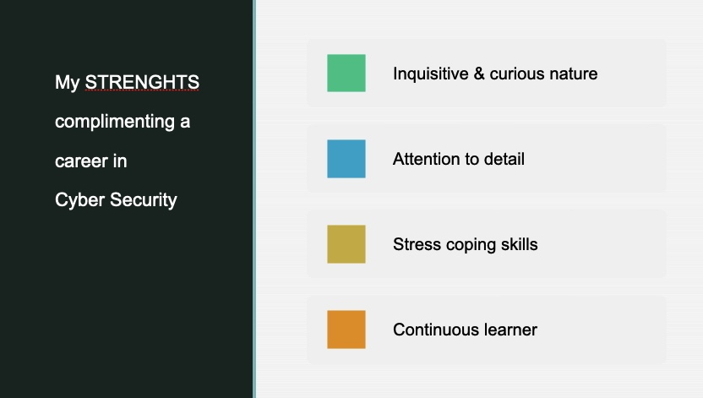

Weaknesses
I have several weaknesses that might hinder me from pursuing my dream job if am not careful. The weaknesses include inability to accept failure. In the instances when I experience failure in my life, I do not accept and move on to other things. Rather, I keep putting effort on the issue until I see results. This in turn cause negative impacts on me because at some instances I do not acquire positive impacts ultimately and therefore I end up wasting a lot of time. In addition, I do not like change due to the need to restructure systems and operations and having to adopt to the new way of doing things. I prefer sticking to the old way typical way of conducting operations.
Considering the field of Cybersecurity, and the continuous changes in trends and systems, the weaknesses is going to implicate my productivity greatly. I will have to develop a way to cope with change and embrace it so that I can be an effective Cyber Security Analyst. Besides, I am impatient and impulsive whereby I act fast without considering the consequences of the actions and I do not wait for things to happen. Rather, I go ahead to pursue the things I want if I see them taking too long. The weaknesses can cost me both in my daily events and in my line of career. This is because the work of Cyber Security Analyst requires critical thinking regarding an issue before acting on it (Hsu and Marinucci, 2013). This ensures that the appropriate decision is taken while considering all the available alternatives before doing an action.

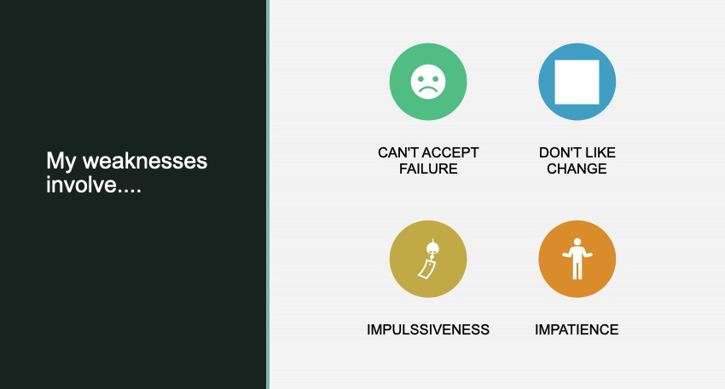

Goals
I have numerous goals that will guide my actions as I aim to achieve them in the line with my profession. The goals enable me to keep focused in the work so as I have a certain target at the back of my mind. I seek to achieve objectives namely ability to work in a team, knowledge of solutions and risks in IT, and knowledge in security vulnerabilities. All the goals are essential for effective execution of the Cyber Security Analyst goals.
Career goals
Knowledge on security vulnerabilities
In my job as a Cyber Security Analyst, it shall be of benefits to be knowledgeable on security vulnerabilities. Vulnerabilities are potential weaknesses in the security systems and architecture. The vulnerabilities expose an individual or an organization system to possible threats and cyberattacks. As my job role shall be to plan and maintain security measures for the protection of computer systems and networks, having the knowledge on the security vulnerabilities shall enable me to be effective in my role. I aim to gain knowledge on security vulnerabilities so as I can be effective in developing security systems for the company I will work for through early detection of vulnerabilities and working on them before they develop to weaknesses for the computer systems.
Ability to work in a team
It is important for all the people across different organizations to work in teams so as to be effective (Hsu and Marinucci, 2013). Even in cyber security team of an organization, I shall be required to take part appropriately so that our efforts shall bear fruits. Therefore, I aim to contribute positively within my own capacity in order to compliment the other professionals in the team. I aim to develop certain traits to enable me to be a team player. The traits include flexibility and reliability as well as commitment. In addition, I aim to be responsible of my actions rather than staying in the shadows in the team.
Knowledge in proper risk management
It is fundamental for every Cyber Security Analysis to be inclusive of proper risk management. I aim to achieve the knowledge in my career as the job role requires me to identify the existing risks in the computer systems and networks and in turn implement ways to mitigate the risks. The main aim is to ensure that the computer systems of a company remain protected by all means. The ability to identify the risks shall enhance my effectiveness as I can be able to protect the negative fate before it occurs. I can develop a risk management plan that helps save the particular organization’s resources and potential loss.
Opportunities
There are numerous opportunities that are available in the field of Cyber Security. Firstly, there is diversity of positions within the field. The positions include incident response agent, security manager, and forensic expert among others. the diversity of the opportunities gives the professionals chances to explore various positions. Also, it gives the individuals flexibility to seek for a position that suits their passion. Secondly, the job has high demand globally and therefore I shall have the opportunity explore culture, go to new places, and meet with new people. Besides, it is safe for the professionals as it is easy for them to secure job opportunities. In addition, there is an opportunity for daily intellectual stimulation. Beyond, Cyber Security presents a financially rewarding career for me. Having the ability to have a financially stable lifestyle, I am likely to be more effective and productive in my line of work.

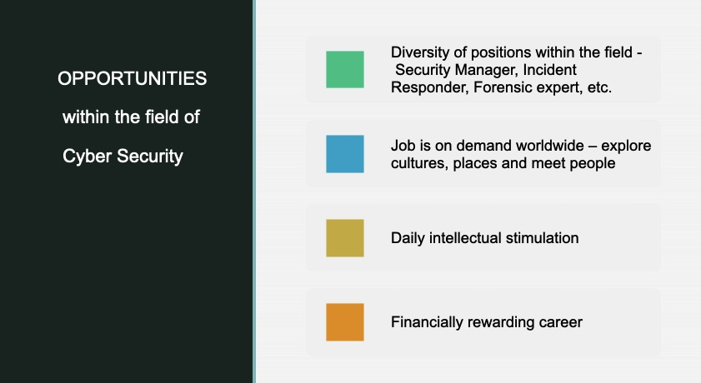

Threats
The career of Cyber Security contains some threats that I will have to encounter and mitigate ways to deal with them. The nature of job is a sedentary one and therefore poses a hazard to my health due to the sedentary lifestyle I will have to live. The nature of the job majorly requires office work that takes more of sitting on a desk for the whole day. This means that the work involves little or no physical exercise. Research has associated the kind of lifestyle with lifestyle diseases including overweight, diabetes, and hypertension (Tabish, 2017). Additionally, the job involves long screen time and exposure to blue light. The long exposure to screen and blue light also poses a health hazard as I can be vulnerable to eye problems. Moreover, the career is demanding and stressful in nature due to the many roles and the continuous need to remain up to date with trends. Further, I shall experience long working hours thereby having minimal time for my personal activities.
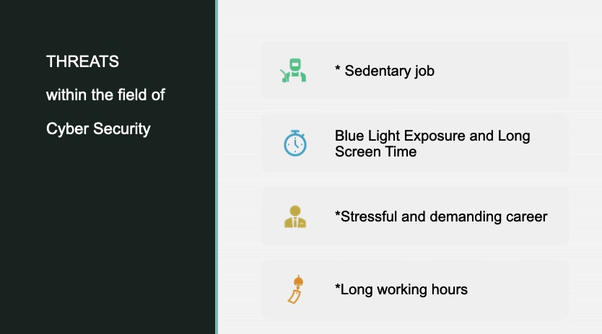

Self-evaluation
Advanced use of forensic software and tools
I am skilled in the use of software forensics and tools in conducting analysis of software source code. With the skill, I am able to determine whether an intellectual property’s theft or infringement has happened. With the skills, I shall be able to protect the rights of intellectual property of the systems and networks in the company I shall be working.
Analytical and diagnostic skills
I contain analytical skills that enable me to think critically and solve the problems at hand. I am able to identify and evaluate the alternatives in place and decide on the best course of option. Thus, I shall be able to effectively study the computer systems and assess any available risks and consider the possible solutions to address them (Friedberg et al. 2014). In addition, I have diagnostic skills that enable me to evaluate the situation at hand and identify the existing problem. Working as a cyber security analyst, I shall be able to easily identify the threats and vulnerabilities in the computer systems and networks.
Up to date knowledge of web vulnerabilities
I am highly skilled in identification and management practices of web vulnerabilities. I ensure to conduct research from time to time to gain the latest knowledge in the vulnerabilities trending. I am experienced to evaluate different ways to identify flaws in software and in turn patch them so as to prevent the unauthorized access. The strength of my skill in handling web vulnerabilities is enhanced through continuous monitory and integration of configuration.
Personal development planning
Through the identification of my weaknesses in line with my profession, I have identified the skills that I can improve on some professional skills that I contain weaknesses. I can improve in my operation as a Cyber Security Analyst through working on the skills to improve them. The skills are incorporated in goals that I shall guide my work towards achievement of the specific skills.

Short-term goals
- Flexibility: I require to be flexible so that I can easily adopt to new processes in the job as a Cyber Security Analyst. Time required for the achievement of the skill is two months.
- Critical thinking: Critical thinking shall enable me counter impulsiveness. Time required for the goal is two months.
Mid-term goals
- Time management: time required to achieve the goal is one year.
- Effective communication: time required to develop the skill is two years.
Long-term goals- three or more years
- Administering information security controls and software: the time required for the achievement of the goal is three years.
- Development and updating systems for intrusion detection: the achievement of the skills shall be acquired in four years.
Action plan
Goals | Nature of goal | Resources required | Action required | Time frame
Flexibility | Short-term | Time, learning resources | Research, practice | 2 months
Critical thinking | Short-term | Time, colleagues | Practice, observing others | 2 months
Time management | Medium-term | Learning resources, time | Training, practicing | 1 year
Effective communication | Medium-term | Time, colleagues | Training, practicing | 2 years
Administration of security controls and software | Long-term | Educators, trainers | Education advancement, training | 3 years
Managing systems for detecting intrusion | Long-term | Educators, trainers | Education advancement, training | 4 years

Data backup strategies
Various data backup strategies are useful in storing data so as to enhance the protection of information for individuals and companies. As a cyber security analyst, I shall employ the strategies so that to enhance the protection of computers systems and networks. The strategies used include external hard drives. In addition, recovery disks shall be used to store information in case the hard disks crashes. The recovery disks shall be important to reinstall operating systems when the systems fail. In addition, online data backup systems can be used to achieve the same roles.

Time management and organizational skills
Time management skills are the capabilities that enable an individual to use and organize their time well. Proper management of time ensures that an individual achieves all their individual goals and objectives. Throughout the process of self-evaluation, I prioritized my tasks to ensure that I achieve all the aims of the report. I ensured to tackle all the requirements of the report. On the other hand, I organized myself by coming up with a plan to execute my tasks effectively and execute them in the right way.

Conclusion
I was able to critically evaluate myself in terms of skills, strengths, weaknesses, opportunities, and threats. The report also addressed the ways I can improve my weaknesses and tackle threats. Additionally, I explored opportunities in place to lead me towards personal improvement. According to my evaluation, the rewards and opportunities of the career outweigh the threats and challenges that I am likely to face. I also think that the skills I contain fits properly in the requirements of the career. As I get to work as a Cyber Security Analyst, I shall work towards improving my knowledge and technical set of skills. My plan for skills improvement shall be done in an organized manner to include activities such as training, practicing, and advancement in education. On the other hand, I shall use resources including time, trainers, learning resources, and colleagues to enable me to achieve the set goals. Ultimately, I believe that with time I shall sharpen my skills and acquire the necessary competence to be effective in my job role.

References
Czosseck, C. and Geers, K. (2010) ‘Borders in cyberspace: can sovereignty adapt to the challenges of cyber security’, The Virtual Battlefield: Perspectives on Cyber Warfare, 3, pp.88-92.
Friedberg, I., McLaughlin, K., Smith, P., Laverty, D. and Sezer, S. (2017) ‘STPA-SafeSec: Safety and security analysis for cyber-physical systems’, Journal of Information Security and Applications, 34(2), pp.183-196.
Hsu, D.F. and Marinucci, D. (2013) ‘Advances in cyber security: Technology, operation, and experiences’. New York: Fordham University Press.
McGettrick, A. (2013) ‘Toward effective cybersecurity education’, IEEE Security and Privacy, 11(6), pp.66-68.
Tabish, S.A. (2017) ‘Lifestyle diseases: consequences, characteristics, causes and control’, Journal of Cardiology and Current Research, 9(3), pp.326-340.

