An Approach for the InfoSec Management of CoffeeBlend Company
Xu Yang
University of Wales Trinity
Saint David
2200550@student.uwtsd.ac.uk

Abstract—With the continuous development of information technology, enterprises rely more and more on the network. While enjoying the convenience provided by information services, they also increase the risk of information leakage and being attacked. This paper provides an information security management method for CoffeeBlend, an international coffee sales company, by studying various information security frameworks and models, such as ISO 27000, COBIT, etc., and discusses why the information management method needs to be continuously updated and improved.
Keywords—InfoSec; ISO 27000; Approach;Risk Management

Introduction
The ubiquitous Internet network connection and the booming emerging technologies have brought convenient information communication channels for enterprises, and the network has become an indispensable component in work and life. The emergence of new information technologies, such as cloud services, has brought benefits to the operation and management of enterprises, but at the same time, it also increases the probability of enterprises suffering from various malicious attacks[1].
Information security is not just a technological concern, it is also a management and awareness issue. By enhancing security management procedures, enterprises must organize and enhance their security management skills. They must create an information security system that complies with enterprise requirements and policies, aids enterprises in resolving security issues, and aids enterprises in developing quickly. This system should be guided by the information security management model, with information resource security management as the goal and risk management and control as the process.
This paper conducts research into various information security frameworks and models, to provide CoffeeBlend with a method to meet its information security needs through the research results. Finally, the reason why the information security model is constantly updated and iterated is discussed.

IT frameworks & models
According to the International Organization for Standardization's ISO/IEC 27000:2016, information is a resource that can be held in a variety of ways, including digitally, physically, and as employee knowledge that is not publicly shown. Information security is the maintenance of confidentiality, integrity and availability of information.
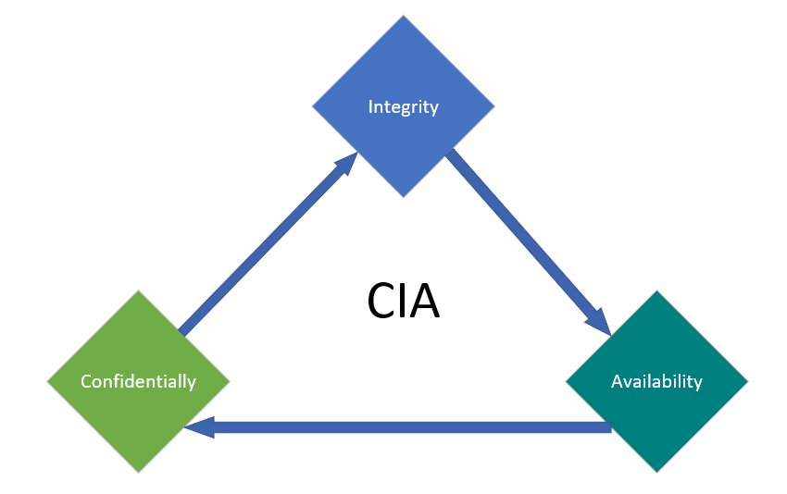
- Three core factors of Information Security
People, management, and technology are the three major elements that affect enterprise information security. All three are indispensable. Relying solely on people, technology, or management cannot effectively protect enterprise information security.
In the field of information security management, scholars have carried out in-depth and extensive research, and put forward some mature and authoritative information security management standards and models in terms of concepts, theories, processes, systems, risk assessment and practical applications, such as ISO 27000, ITIL, COBIT, etc[2].

ISO 27000 Series of Standards
In 2005, on the basis of fully absorbing and referring to BS7799-2 Information Security Management System Specification, the International Organization for Standardization formed the current international popular information security management system standard family: ISO/IEC 27000. Among them, ISO/IEC 27001 Information Security Management System Requirements is a general requirement in the family of standards, covering five aspects of personnel, equipment, information, process and environment, as well as 14 major items such as information security policy, information security organization, information security incident management, information security business continuity management, compliance with laws and regulations， etc. The majority of businesses and corporations today use ISO27001 as a reference standard, and they are free to set up and run their own information security management systems depending on their own requirements.
ISO 27001 sums up the operation mode of the information security management system(ISMS). It adopts the commonly used Deming cycle in management, that is, the PDCA process model, and continuously updates and optimizes the ISMS. The closed loop formed is as follows:

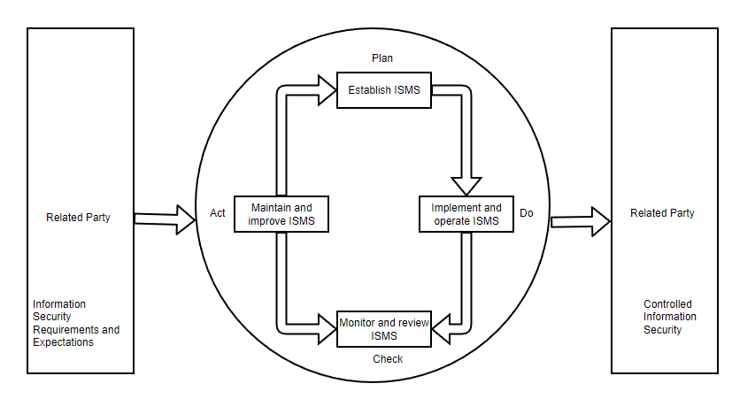
- PDCA process
The goal of ISO 27001-2013 is to create a set of standards and guidelines that organizations can use to develop, implement, operate, optimize, and improve their information security management systems in accordance with their actual environments. It also lays out the standards for information security assessment and risk management that organizations should follow. Standards were developed specifically from seven factors, including the business environment, leadership, system planning, support programs, system operation, performance evaluation, and continual optimization[3].
For the organization itself, building an ISMS through the implementation of ISO/IEC 27001 will help the organization standardize the information security work behavior of employees, reduce the organization's information security risk, improve the organization's business continuity management awareness, and enable the organization to prevent and avoid losses caused by information security incidents.

IT Infrastructure Library
IT Infrastructure Library, referred to as ITIL, originated from a set of very effective IT management methods developed by the UK Government’s Central Computer and TeleCommuications Agency(CCTA) in the 1980s. ITIL has since evolved into the industry-wide standard for IT administration. In reality, it is a public framework that any unit or person can use without charge and is not a standard that can be utilized directly. Enterprises can use ITIL as a guide for planning and developing service management to guarantee that it can better support the operation of the business and maximize return on investment. In the end, the goal is to create and maintain IT systems with the company at their center.
Since ITIL was created, it has undergone several improvements and has four versions. The earliest V1 version is based on IT management functions; V2 version adds process management practices; V3 version incorporates the concept of life cycle; Now widely used V4 version adds project management concepts, such as agile project management and DevOps, etc. With the update and iteration of ITIL, providing reference standards for the construction of many service systems, ITIL has become the best path to improve IT service levels worldwide. Currently, more than 20,000 companies and government agencies have successfully implemented ITIL through the introduction of tools or platforms The landing of IT management has reached a new height[4].

COBIT
Control Objectives for Information and Related Technology is the full name of COBIT. COBIT is a framework for IT governance and control that connects business risks, control requirements, and technical challenges. It can help management carry out IT governance by directing the company to efficiently use its information resources and manage information-related risks.
COBIT mainly focuses on "what needs to be achieved", not "how to achieve it". Its objectives are to conduct research, create, disseminate, and promote an authoritative, current, and widely accepted IT governance control framework that business managers, IT professionals, and quality assurance specialists may utilize in their day-to-day work.[5].
In the COBIT model, when enterprises control IT, they closely link IT processes, IT resources and IT criteria to form a three-dimensional COBIT architecture. IT procedures are the means of managing IT resources under the direction of the guidelines, IT resources serve as the primary objects of information control, and IT guidelines represent the strategic goals of businesses.

APPROACH FOR COFFEEBLEND INFOSEC
As one of the best and most well-known coffee suppliers in the world, CoffeeBlend, has a significant global footprint. The company's network is 95% wireless, and it uses cloud services to provide IT services to customers and employees. Because the employees and international customer base are too large and many external devices need to be connected to the company network, which increases the risk of information leakage and attack. Therefore, information security is particularly important for the development of CoffeeBlend company.

Information Security Organizational Structure
The information security management organization is the advocate and main force of the information security construction, the maker of the security management strategy, and the main promoter and executor of the follow-up publicity and training.
The information security management organization is the first responsible department for the security management. It should have the power and ability to promote the construction of the information security management system from top to bottom. Only relying on the company's current information department is unable to complete the goal of building the company's information security management system. Only by establishing a comprehensive cross-departmental information security management organization can we ensure the continuous advancement of the company's information security management system construction[6].
Considering that Coffee, as a large-scale company, should have a relatively complete information security management organizational structure, it tends to form and restructure internal teams to deal with future long-term risks and challenges. CoffeeBlend can establish a corresponding information security management department organization according to its organizational structure and staffing. A top-down management system can be formed, for example,as shown in the figure.
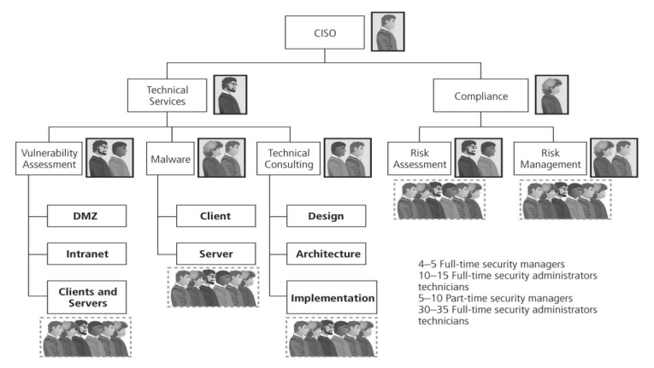
- An example of Security Staffing

Strategic Planning and Governance for Security
The information security management strategy serves as the foundation of a company's information security management system. It outlines the objectives for the design of the company's information security management system and offers information security assistance for the execution of the company's business development plan. In the ISO/IEC 27001 ISMS document requirements, it should be made apparent that an information security management strategy is necessary, and that it should be made sure to align with the company's development strategy.
CoffeeBlend can formulate corresponding management policies based on the development strategy of its main business and the needs of information security management, for example, as follows:
- Strictly compliance with laws and ethical
- Form a good working atmosphere for information security.
- Ensure the strict protection of the secrets of the company and related parities.
The company's information security management objectives are developed in accordance with the company's information security management policy, taking into account the actual needs of enterprise development and making reference to the information security management needs of the company's related parties.
Enterprise should builds a suitable information security management system from top to bottom, and establishes and trains a professional and sustainable information security management team. It is also necessary to enhances the company's employees' information security awareness and strengthen the organization's capacity for both preventing and responding to information security problems.

Security Policies
In the system of information security, policy is crucial. CoffeeBlend should have a detailed understanding of the operation status of its internal information management mechanism. On this basis, management system should be improved from the following levels to formulate a more reasonable and efficient policy.
- User type optimization
First of all, it is necessary to strengthen the control of network information storage and extraction, and differentiate the authority settings for different types of users to prevent the risk of exceeding authority. Secondly, install anti-virus software with a higher security level in the internal network to ensure the security of the entire network. Finally, the company also needs to improve the supervision of LAN access, avoid using local terminals as much as possible, and reduce the number of super users.
- Data classification optimization
According to the theory of employee access control, access control management includes monitoring the terminals and equipment in the network system and the access behavior of personnel access. Coffee Company can further optimize and improve data capture by introducing advanced network security technology and building a highly specialized network management and evaluation team.
- Access Rights Optimization
For the setting of access rights, the company can carry out more perfect optimization, mainly in the comprehensive protection of the information and data of this system, which can be divided into three parts: subject, object and authorized access. Authorized access needs to be restricted, regardless of subject or object. Access technologies can be divided into: autonomous access, mandatory access, and role-based access.
- Privacy isolation optimization
By encrypting and protecting the information and data transmitted in the network, the security of the company's internal files, data and passwords is ensured.

Risk Management
Information security risk management entails performing risk assessment and risk identification procedures on current information security hazards in the company's ongoing business activities. Through the application of risk treatment measures, the detected risks are decreased to the company-acceptable level of risk and ensure that this level of risk can be sustained[7]. It is possible to control risks in accordance with the figure below.
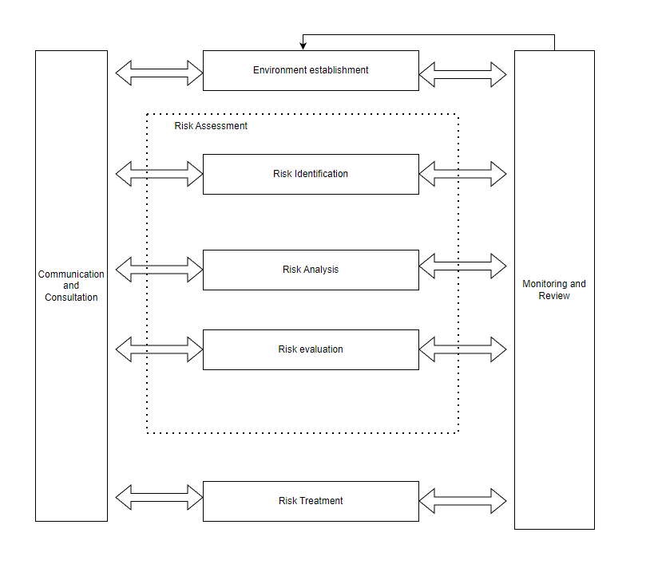
- Risk management process
- Risk Identification
The purpose of risk identification is to generate a comprehensive risk list. The work process generally includes four processes: determining the assessment object, selecting the risk source, generating the risk assessment list and implementing risk identification. In the ISO/IEC27005 standard system, the corresponding workflow can also be found,as shown in the table below.
project | ISO/IEC 27005 process | Working Process
Risk Identification | Asset Identification | Determine the evaluation object
Risk Identification | Threats Identification | Select risk source
Risk Identification | Controls Identification | Generate a risk Identification checklist
Risk Identification | Vulnerability Identification | Select risk source
Risk Identification | Consequence Identification | Implement risk Identification
Table.1. Corresponding relationship of risk identification process
CoffeeBlend needs to classify relevant information assets by category for subsequent management. Through risk identification, threat subjects are screened, and threat lists and threat scenarios of key information assets are output[8]. In the vulnerability identification process, through the combination of manual and automatic tools, output the corresponding identification results and vulnerability analysis reports. The company's existing prevention and response measures to deal with risks can be known through the identification of existing controls.
- Risk Analysis
Risk analysis can assist enterprises to perfectly integrate information security management objectives into the overall business objectives of the enterprise. Relevant personnel will perform quantitative risk analysis on information assets with clearly defined values, compute their single loss expected value (SLE) and annual loss expected value (ALE), and provide conditions for the company's management to create an information security management planning budget.
- Risk Evaluation
Enterprises can successfully integrate information security management goals into their total business goals with the aid of risk analysis. The company ultimately decides whether to accept the risk or take appropriate action to deal with it after the risk assessment is complete. The asset value can be evaluated according to the level of secrecy and the three elements of the CIA, and the risk value can be calculated to divide the risk level[9].
- Risk Treatment
After completing the risk assessment of the identified information security risks, we need to implement corresponding risk response measures for the identified information security risks according to their corresponding risk levels and in combination with the risk acceptance criteria determined by the company.
Generally speaking, the following four categories of measures are used to address information security risks: risk transfer, risk avoidance, risk mitigation and risk acceptance.The risk treatment process is shown in the figure.
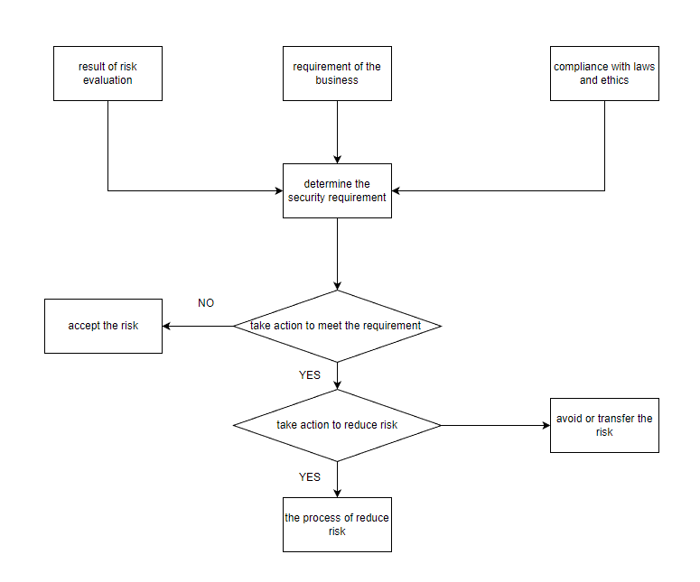
- The process of risk management

Business Continuity Management
Business continuity management integrates the company's business resilience and effective response to unexpected events to protect the core business interests of key stakeholders in the organization[10].
In the ISO/27031:2011 Information and Communication Technology Preparation Guide for Business Continuity, the business continuity planning guide is expounded, and its main contents include the following aspects[3]:
1.Integrate the requirements of relevant laws and regulations, define the scope, objectives and functions of business continuity management, and the company's management will approve the business continuity strategy.
2.Determine the key capabilities and functions of the business, determine the key resources required by the business, calculate the maximum allowable interruption time, identify threats, calculate risks, determine the backup plan, etc.
3.Determine the control measures selected for the implementation of preventive control measures to reduce risks.
4.Formulate recovery strategies to determine recovery business processes, recovery facility preparations, supply capabilities and technical reserves, users and user environments, and data recovery preparations.
5.Prepare a business continuity plan, including: work procedures, recovery solutions, personnel roles and tasks, and emergency response plans, etc.
6.Compile the test plan and improvement plan. Every year, the company regularly organizes the drill test plan and conducts corresponding training for employees
7. Through the development of the plan change process, strictly follow the PDCA cycle management model, and update the business continuity plan and release it in time when necessary
CoffeeBlend can combine the original business continuity management system documents to further incorporate information security management-related content into the enterprise's business continuity management, standardizing the enterprise's business continuity management.

Standards and models need to be constantly updated and improved
In information exchange, "safety" is relative, while "unsafe" is absolute. With the development of society and technological progress, information security standards continue to improve, so information security issues will always be a brand new issue. "Development" and "change" are the most important features of information security. Only by firmly grasping this feature can we correctly handle and treat information security issues and use new defense technologies to prevent new attack methods. The current development of information security technology presents the following trends:
1.Information security is becoming more and more important
The information security system is an indispensable part to ensure the economic security and sustainable business development. The rapid advancement of digitalization, networking, and intelligence has allowed information network technology to fully permeate all spheres of social production and living. Data security has become increasingly crucial as humans rely on the network to previously unheard-of levels.Traditional data security management and methods also need to be updated and changed continuously with the progress of the times. Data information security is a comprehensive system engineering, which requires the support of the latest scientific and technological achievements, and more advanced management methods and systems to support it.
2. Information security standards are constantly updated
Information security standards should be constantly updated according to the needs of technological development and actual social development. Scientific and reasonable security standards are the first step in ensuring information security. It is necessary to pursue how to have an architecture that protects information security when designing and manufacturing information systems, so that Standards adapt to advances in technology and enhancements in demand.
3.The concept of information security is constantly expanding
The pursuit of information security by human beings is a long and deepening process. Information availability, confidentiality, and integrity are all parts of the classic definition of information security. With the acceleration of the pace of social informatization, the scope of information security will become wider and wider, and security methods do not need to be constantly updated. Information security requires at least the study of basic theories and implementation techniques in attack, defense, measurement, control, evaluation and management.
4.Information security is a huge complex system
Information security is a new problem brought about by the development and application of modern information systems. Its solution also requires the support of modern high-tech. Traditional methods cannot solve problems, so new technologies for information security are always emerging. In the field of information security, the latest information security technologies such as encryption technology, firewall technology, virtual private network technology, virus and anti-virus technology, and database security technology will be further developed. These new technologies also need to be integrated into the new information security system to protect the information security of individuals and enterprises.

conclusion
As a large international coffee sales company, CoffeeBlend has suffered from information security threats while benefiting from the convenience provided by the Internet. Based on the ISO/IEC27001 information security management system and combined with the specific situation of CoffeeBlend, this paper provides an information management method.
With the continuous changes in the external environment of enterprises and the continuous in-depth application of new information technologies, enterprises need to continuously build and update their own information security management systems, introduce new technologies and establish new standards, and continuously improve and upgrade. In order to ensure that the company wins the construction of relevant parties and the public in terms of information management, it will go further and further on the road of enterprise development.

References

[1] A. Patel, M. Taghavi, K. Bakhtiyari, and J. C. Júnior, "An intrusion detection and prevention system in cloud computing: A systematic review," Journal of network and computer applications, vol. 36, no. 1, pp. 25-41, 2013.
[2] D. Ramalingam, S. Arun, and N. Anbazhagan, "A novel approach for optimizing governance, risk management and compliance for enterprise information security using DEMATEL and FoM," Procedia Computer Science, vol. 134, pp. 365-370, 2018.
[3] ISO/IEC, "Information technology —— Security techniques ——Guidelines for information and communication technology readiness for business continuity.," International Standards Organization, 2013.
[4] M. Gërvalla, N. Preniqi, and P. Kopacek, "IT Infrastructure Library (ITIL) framework approach to IT Governance," IFAC-PapersOnLine, vol. 51, no. 30, pp. 181-185, 2018.
[5] S. J. Hussain and M. Siddiqui, "Quantified model of COBIT for corporate IT governance," in 2005 International Conference on Information and Communication Technologies, 2005: IEEE, pp. 158-163.
[6] Y. Chen, K. Ramamurthy, and K.-W. Wen, "Impacts of comprehensive information security programs on information security culture," Journal of Computer Information Systems, vol. 55, no. 3, pp. 11-19, 2015.
[7] R. K. Abercrombie, F. T. Sheldon, and A. Mili, "Managing complex IT security processes with value based measures," in 2009 IEEE Symposium on Computational Intelligence in Cyber Security, 2009: IEEE, pp. 69-75.
[8] P. Shedden, A. Ahmad, W. Smith, H. Tscherning, and R. Scheepers, "Asset identification in information security risk assessment: A business practice approach," Communications of the Association for Information Systems, vol. 39, no. 1, p. 15, 2016.
[9] R. K. Rainer Jr, C. A. Snyder, and H. H. Carr, "Risk analysis for information technology," Journal of Management information systems, vol. 8, no. 1, pp. 129-147, 1991.
[10] R. C. Mitchell, R. Marcella, and G. Baxter, "Corporate information security management," New Library World, 1999.

