

Changemakers: Creativity and Value Creation
Professions (BMHP5014)

Component 2: Poster and Pitch

Student name: Tita Panio Catapang
Student number: 2431420
Lecturer’s name: Mr Soban Sadiq

Date: August 7, 2026

TABLE OF CONTENTS

Cover page Page 1
Table of Contents Page 2
Design Poster Image Page 3
Introduction Page 4
Innovation Overview Page 4
The Problem Page 4
Target Audience Page 5
Benefits Page 5
Implementation Page5
Timeline Page 6
Regulations Page 6
Technology Page 6
Dissemination Page6
Conclusion Page 7
Reference List Page 8

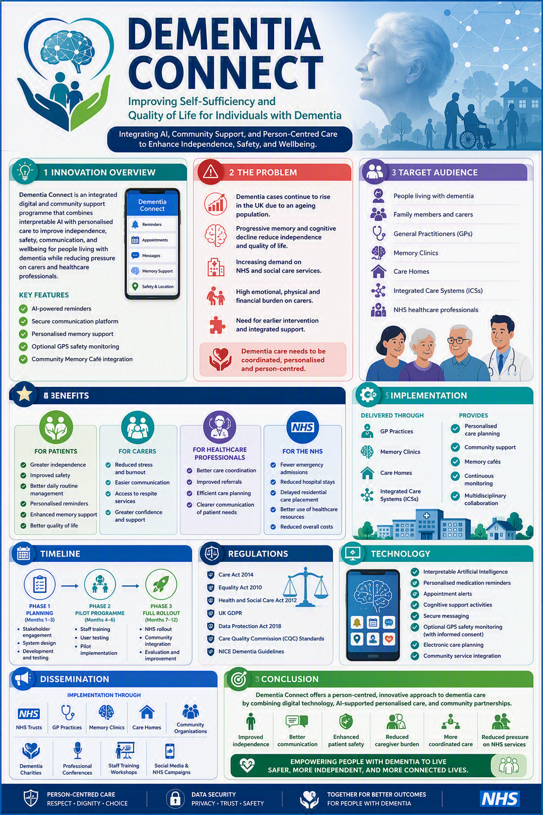

Dementia Connect: Improving Self-Sufficiency and Quality of Life for Individuals with Dementia

Introduction

Dementia Connect is an innovative, person-centred programme that combines, digital technology, interpretable artificial intelligence (AI), and community support to enhance dementia care. It addresses the current fragmentation of health and social care services which often makes it difficult for people living with dementia and their carers to access timely, coordinated, and personalised support. By improving communication, promoting independence, and facilitating integrated care, the programme aims to reduce caregiver burden and healthcare pressures. People living with dementia, family carers, healthcare professionals, and the NHS all benefit through improved care coordination, enhanced quality of life, and more efficient use of healthcare resources.

Innovation Overview

Dementia Connect is a person-centred care digital and community support programme designed to improve independence, safety, wellbeing, and communication for people living with dementia while reducing pressure on family carers and healthcare professionals. The programme provides personalised, non-clinical guidance to help individuals and their families understand their condition and access appropriate health, social care, and community services (Giebel, 2023).

The Innovation also incorporates interpretable artificial intelligence (AI), personalised reminders, secure communication, and digital support tools to encourage independence while enabling healthcare professionals to deliver transparent and personalised care. By integrating these technologies with existing NHS and community services. Dementia Connect promotes coordinated, proactive, and person-centred dementia care that supports people to remain independent for longer (Martin, 2023).

The Problem

Dementia is one of the UK’s greatest public health challenges, with increasing prevalence driven by an ageing population. Progressive cognitive decline affects memory, communication, decision-making, and the ability to perform everyday activities. Often resulting in reduced independence and increased reliance on health and social care services. Family carers also experience significant emotional, physical, and financial strain, while the NHS faces rising demand for memory services, emergency admissions, and long-term care. Current services are often fragmented, making it difficult for individuals and carers to navigate available support, highlighting the need for more integrated and personalised care solutions (Martin, 2023; NICE, 2022).

Target Audience

Dementia Connect is designed for people living with dementia across all stages of the condition, together with their families. Informal carers, and the healthcare professionals. General practitioners, memory clinics, community nurses, social workers, care homes, and integrated Care Systems (ICSs) would use the platform to coordinate care, improve communication, and facilitate timely referrals. By supporting both service users and professional, the programme strengthens continuity of care and encourages collaborative decision-making across health and social care settings (Department of Health and Social Care, 2014; Giebel, 2023).

Benefits

The programme offers benefits for all stakeholders. Individuals with dementia receive personalised reminders for medication, appointments, and daily routines, together with cognitive support activities that promote independence and confidence. Family carers gain easier access to respite services, education, and peer support, reducing caregiver burden and improving wellbeing. Healthcare professionals’ benefit from secure communication, clearer referral pathways, and more efficient care planning. For the NHS, improved community support may reduce avoidable hospital Admissions, delays in care, and premature placement into residential care, contributing to more efficient use of healthcare resources and improved patient outcomes (O’Shea, 2019; Chun, 2022).

Implementation

Implementation would be delivered through GP practices, memory clinics, care homes, and Integrated Care Systems to ensure coordinated service delivery. Following diagnosis, healthcare professionals would introduce eligible patients to dementia Connect, where personalised care plans would be developed using routinely collected clinical information. AI- powered tools would provide medication reminders, appointment alerts, cognitive prompts, and optional GPS monitoring for individuals at risk of becoming lost, while secure messaging also connects users with local Memory Cafés and community organisations to reduce social isolation and improve emotional wellbeing (Chun, 2022; Giebel, 2023).

Timeline

Implementation would occur in four phases over 12 months. Months 1-3: stakeholder engagement, system development, and staff training. Months 4-6: pilot implementation with selected GP practices and memory clinics to evaluate usability and patient engagement. Months 7-9: evaluation of pilot outcomes, refinement of digital features, and additional workforce training base on stakeholder feedback. Months 10-12: wider rollout across Integrated Care System, with continuous monitoring of patient outcomes, service utilisation, and user satisfaction to support long-term sustainability (NICE, 2022).

Regulations

Dementia Connect will comply with UK legislation and professional standards to ensure safe, ethical, and person-centred care. The programme supports the principles of the Care Act 2014 by promoting wellbeing and safeguarding vulnerable adults. Compliance with the Equality Act 2010 ensures equitable access without discrimination, while the Health and Social Care Act 2012 support integrated service delivery. Personal information will be processed in accordance with the UK General Data Protection regulation UK GDPR) and the Data Protection Act 2018, and services will meet the quality standards established by the Care Quality Commission (CQC) for sale, effective, and responsive care (Department of Health and Social Care, 2014; Care Quality Care, 2024).

Technology

The Innovation uses interpretable AI to analyse routinely collected clinical information and personalise support according to an individual’s cognitive needs. Unlike traditional “black box” AI systems, interpretable AI improves transparency by allowing healthcare professionals to understand how recommendations are generated, increasing trust and supporting informed clinical decision-making. Additional technologies include secure cloud-based communication, electronic care planning, personalised reminders, cognitive support tools, and consent-based GPS monitoring, creating an integrated digital ecosystem that supports independence while protecting patient privacy (Martin, 2023; Chun, 2022).

Dissemination

Successful implementation will be promoted through NHS organisations, integrated Care Systems, memory clinics, GP practices, professional conference, and academic publications. Information sessions for healthcare professionals, carers, and voluntary organisations such as Memory Cafés will increase awareness and encourage adoption. Digital resources, social media campaigns, and partnership working with dementia charities will further support engagement and facilitate the sharing of best practice across health and social care services (NICE, 20222; Giebel, 2023).

Conclusion

Dementia Connect offers an innovative, integrated, and person-centred approach to dementia care by combining AI-enabled technology with coordinated community support through personalised interventions, improved communication, and stronger links between health and social care, the programme has the potential to enhance independence, reduce caregiver burden, improve quality of life, and promote more efficient use of NHS resources. By addressing current gaps in dementia care. Dementia Connect supports the delivery of compassionate, evidence-based, and sustainable services for people living with dementia and their families (NICE, 2022: O’Shea, 2019).

References

Care Quality Commission (CQC) (2024) Regulation and inspection. Available at: https://www.cqc.org.uk

Chun, M.Y., Park, S., Lee, H., et al. (2022) ‘Prediction of conversion to dementia using interpretable machine learning in patients with amnestic mild cognitive impairment’, Frontiers in Aging Neuroscience, 14, Article 898940. Available at: https://doi.org/10.3389/fnagi.2022.898940

Department of Health and Social Care (2014) Care Act 2014. Available at: https://www.legislation.gov.uk/ukpga/2014/23/contents

Giebel, C., Hanna, K., Cannon, J., et al. (2023) ‘Dementia care navigation: A systematic review on different service types and their prevalence’, International Journal of Geriatric Psychiatry, 38(8). Available at: https://doi.org/10.1002/gps.5977

Information Commissioner’s Office (ICO) (n.d.) Guide to the UK General Data Protection Regulation (UK GDPR). Available at: https://ico.org.uk/for-organisations/uk-gdpr-guidance-and-resources/

Martin, S.A., et al. (2023) ‘Interpretable machine learning for dementia: A systematic review’, Alzheimer’s & Dementia, 19(5), pp. 2135–2149. Available at: https://doi.org/10.1002/alz.12948

National Institute for Health and Care Excellence (NICE) (2022) Dementia: Assessment, management and support for people living with dementia and their carers (NG97). Available at: https://www.nice.org.uk/guidance/ng97

O'Shea, E., O'Reilly, S., O'Connor, M., et al. (2019) ‘Multiple stakeholders’ perspectives on respite service access for people with dementia and their carers’, The Gerontologist, 59(5), pp. e490–e500. Available at: https://doi.org/10.1093/geront/gnz095

UK Government (2010) Equality Act 2010. Available at: https://www.legislation.gov.uk/ukpga/2010/15 (Accessed:

UK Government (2012) Health and Social Care Act 2012. Available at: https://www.legislation.gov.uk/ukpga/2012/7/contents/enacted

UK Government (2018) Data Protection Act 2018. Available at: https://www.legislation.gov.uk/ukpga/2018/12/contents/enacted

