BUSINESS MANAGEMENT
Introducing the Modern Workplace
MIRCEA OCTAVIAN OLTEANU
2017632@student.uwtsd.ac.uk

Table of Contents
Introduction 1
Unilever and Tesco’s organisational structure and Culture 2
Unilever’s organisational structure & culture 2
Tesco’s organisational structure & culture 5
Explanation of how Unilever and Tesco’s structure and culture impact the employee and organisational performance: 7
Impact of organisational structure and culture on the employees of Unilever 7
Impact of organisational structure and culture on the employees of Tesco 7
Identification of factors that influence employee behaviour and motivation in Unilever and Tesco 8
Factors that influence employee behaviour of Unilever and Tesco 8
Motivation in Unilever and Tesco 9
Conclusion 11
References 12

Introduction
The structure of an organisation refers to the hierarchy which the organisation follows to achieve its ultimate goal of sustainable profitability and growth and the organisation's structure mainly determined based on the size and type of the business and the number of management-level that the organisation needs (Verdugo, Cadena and Armenta, 2017). On the other hand, an organisation’s culture is the combination of a set of values, rules-regulation, attitudes which works as a backbone of the organisation as it refers to the internal environment of an organisation that helps the organisation to achieve success (Frost, 2018). An organisation’s culture gives the employees a clear idea about to whom to report, how to work, what to do, why the work is important etc. An organisation’s culture and structure are interconnected that put an impact on the organisations' performance and goal achievement. Throughout this report, the relationship between the organisational structure and culture of Unilever and Tesco and how the organisational structure and culture put an impact on the performance of these two organisations will be discussed. Some factors influencing the employee’s behaviour of Tesco and Unilever will also be discussed with examples in the last part of this study.

1.0 Organisational structure and Culture
Organisation’s goal achievement, employee’s performance is strongly related to the structure that the organisation has and the culture of the organisation. So, the organisations make its structure in such a way based on the size, type of operation and the number of management-level need that helps the organisation to perform well (Murgatroyd, 2011). It also creates a culture within the organisation that controls the organisation’s internal environment of role-playing and helps to achieve its goal (Frost, 2018). In this part of the report the organisational structure and culture of two UK based multinational company Unilever and Tesco will be discussed respectfully:

1.1 Unilever’s organisational structure & culture
An organisational structure is a process through which the organisation outlines the way of direction to achieve the ultimate goal which is the sustainability of the business organisation. It defines the flow of information, data and work within the organisation. An organisation can follow hierarchical, functional, divisional, horizontal or flat, matrix, team-based or network organisational structure based on its size, types of operation and the required number of levels of management within the organisation.
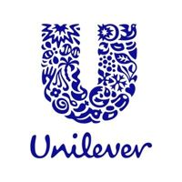
Figure 1: Logo of Unilever
Source: (unilever.com, 2021)
Unilever is a British Multinational company which sells consumer goods product in 190 countries around the world. The company has it headquarter in London, England (unilever.com, 2021). The organisation is producing and selling products like food, confections, drinks, beauty products such as cream, face wash, etc., personal care products, pharmaceutical products, soft drinks, healthcare products worldwide. Unilever follows a Divisional or multidivisional structure as the multinational company has many business units (Willmott, 2016). The divisional structure method helps Unilever to structure its leadership team depending on the products it is selling, the project it is working on and the subsidiaries which they operate.
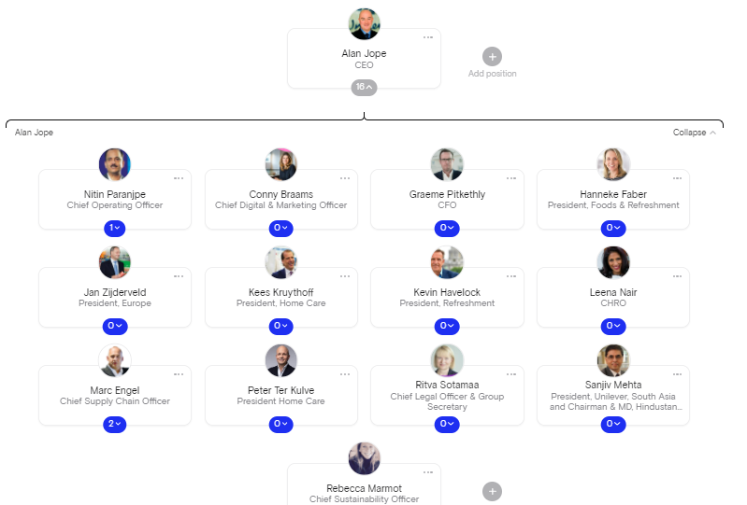
Figure 2: Organisational Structure of Unilever
Source: (Unilever - Org chart | The Org, 2021)
The divisional structure that Unilever follows allows the company to accept more autonomy within the groups that exist in the company. Unilever has 3 different division which is foods and refreshments under which beverages and ice creams are produced, home care and beauty & personal care (unilever.com, 2021). Through following this structure, the company is offering greater flexibility to every division it operates and allowing every division to work as its own where one or two respective person reports the progress to the company’s CEO. The divisional structure’s feature of Unilever can be divided into 3 characteristics which are product type divisions, corporate executive teams and geographical division where product type division is the most significant feature whereas geographical divisions are the least significant feature. Product type division assists Unilever to manage and control the improvement, manufacturing, distribution and sales of the produced consumer goods (Schiffman, Kanuk and Hansen, 2013). The corporate manager of Unilever applies this feature of divisional structure to identify the market needs of the customer of the product they are producing and selling. The corporate executive team feature of this structure helps Unilever to properly set its function. Through the geographical division of Unilever’s structure, the organisation supports its regional strategies. As Unilever is a multinational company, it formulates and implements different strategies based on different region’s consumer goods market demand (unilever.com, 2021).
Organisational culture is the combination of organisation’s expectation, experiences, values which assists the member’s behaviour of the organisation and make the employees interact, work inside and outside the organisation in such a way that meet up the organisation’s expectations (Frost, 2018). According to Charles Handy Model of organization culture, organisational culture can be divided into 4 types which is power culture, role culture, task culture and person culture (Marshall, 2013).

Figure 3: Charles Handy Model of Organization Culture
Source: (Schein, 2019)
Unilever is following a task culture where the organisation forms teams to achieve a common goal or targets. Here Unilever combines individual employees with the same interest and specialisation and form teams to achieve the organisation’s ultimate goal. This type of culture ensures that every team member is contributing toward achieving the team target or goal in a possible innovative way (Schiffman, Kanuk and Hansen, 2013). Through this culture, Unilever makes sure that the power is driving from the expertise of the employees to the team that needs expertise. The team here develops its objective based on the region’s market need as Unilever is a multinational company the culture varies from country to country (Schneider and Smith, 2014). The team has the power to make the decision and the achievement of the target depends on the teams.

1.2 Tesco’s organisational structure & culture
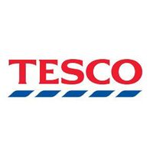
Figure 4: Logo of Tesco
Source: (tescoplc.com, 2021)
Tesco is one of the biggest grocery retailer company in the UK which is a British multinational company whose headquarter is in Welwyn Garden City, England. The company is a retailer of books, clothing, telecoms, internet services, toys, furniture, petrol etc. (tescoplc.com, 2021). The company has positioned itself as a high-volume low-cost retailer in the market.
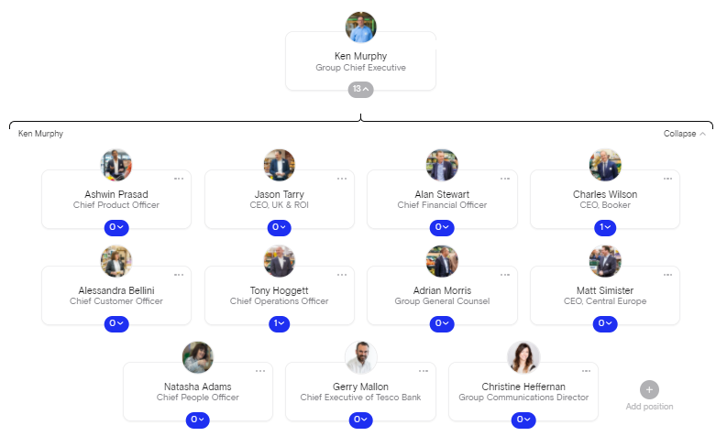
Figure 5: Tesco's Organisational Structure
Source: (Tesco - Org chart | The Org, 2021)
As one of the biggest grocery retailer company, Tesco is following a hierarchical organisational structure. The hierarchical organisational structure helps the management of Tesco to ensure the top-down flow of information within the organisation (CEO to the manager to low-level employees). The hierarchical organisational structure of Tesco assists the organisation to define the level of responsibility and authorisation to the employees tescoplc.com, 2021). Throughout this organisational structure, Tesco clearly defines the flow of information and accountability like to whom the employee should report or make suggestions about their work (Willmott, 2016). It provides a clear vision to the employees which make them more competent and gives them a chance for getting promoted.
Tesco is following role culture according to Charles Hand’s organisational culture model where every employee’s role is well defined. Each of the employees is bound to complete his role and there is little chance to show creativity (Murgatroyd, 2011). Through following the culture Tesco clearly defines who is accountable to whom, who has to report to whom etc. As Tesco is following role culture, the decision-making process of Tesco is often slow. Here the power derives from the position on which the employee is working in the Tesco. Here exists hierarchical bureaucracy.

2.0 Explanation of how Unilever and Tesco’s structure and culture impact the employee and organisational performance:

2.1 Impact of organisational structure and culture on the employees of Unilever
Unilever has adopted task culture according to the Charles Handy Model of organization culture and it is following divisional organisational structure (Frost, 2018). The company is producing and selling consumer goods products in around 109 countries and basically, it is producing and selling three division of product such as foods and refreshments under which beverages and ice creams are produced, home care and beauty & personal care (Kondalkar, 2017). Different country has a different culture and different market demand for a different product. The task culture helps the organisation to focus on the performance of each team, ensure efficient quality and efficiency. Unilever is operating a multinational business; the management of the organisation first do market research on each country considering the culture of the country then the organisation divides its employees into several groups and set team targets for each team which ultimately results in goal achievement (Koornstra, 2017). Based on the divisional structure of the company, the organisation formulates and implement different strategies through using team culture and as the power of decision-taking holds the team leader, and the target achievement depends on the teamwork it helps to ensure efficiency and sustainable profitability (Marshall, 2013).

2.2 Impact of organisational structure and culture on the employees of Tesco
Tesco has adopted role culture according to the Charles Handy Model of organization culture and it is following a hierarchical organisational structure (tescoplc.com, 2021). The hierarchical organisational structure of Tesco defines the order and flow of information from top to down (CEO to lower-level management) whereas the role culture clearly explains every employee’s role. Tesco is a grocery multinational company which sells grocery product at a high-volume low-cost price. the organisation's flow of information is well defined and the lower-level staff mainly the salesman doesn’t have the power to show creativity (Frost, 2018). All of the employees have to complete their role as determined by the higher authority. As the higher authority holds the power of taking a decision, Tesco’s decision-making process is often slow (Schein, 2019). The well-defined hierarchical organisational structure and the well-defined role of every employee help the organisation to increase its employee's productivity and ensure sustainable growth and profitability.

3.0 Identification of factors that influence employee behaviour and motivation in Unilever and Tesco

3.1 Factors that influence employee behaviour of Unilever and Tesco
An organisation is the combination of individual employees who come to work in the organisation to achieve a common goal as a whole (Schneider and Smith, 2014). The employee's behaviour within an organisation can get influenced by various factors like environmental factors, cultural factors etc. Some of those factors are discussed below:
1. Communication Skills
Unilever and Tesco both are multinational companies and operating their business all around the world. People who don’t like to talk too much mainly seen to prefer to do paperwork job whereas people whose communication skills are very good tends to work in such job where communication skills are must like salesmen job, public relation officers etc. (Schneider and Smith, 2014). Unilever and Tesco recruit their salesman based on their communication skills.
2. Tolerance
It has been seen that intolerant people couldn’t sustain in a job like public relation, salesman as they have to deal with lots of customer per day with thousands of queries, different behaviour (Willmott, 2016). Both Unilever and Tesco require those candidates as their employees whose tolerance level is moderate to high.
3. Self-Esteem
Self-esteem is another factor that influences employee behaviour. Those people who have a higher level of self-esteem aren’t much interested in routine and mundane jobs. Even if they join to work in routine and mundane jobs, they are highly likely to switch the job whenever they get the chance to do a challenging job in another organisation (Marshall, 2013). Unilever requires these types of employees who love to work in a challenging environment whereas Tesco prefers these types of employees for their higher-level management.
4. Achievement Need
Achievement need is another factor where the employee gets motivated the result of the achievement of the task or assignment he is assigned to (Frost, 2018). Unilever recruits these types of employees mostly in their leadership program as an intern.
5. Type A and Type B personality
As per the behavioural experts, there exist 2 types of the individual based on their personality traits which us type A and type B people. Type A people are always goal-oriented whereas type B people are seeming to be more relax and easy-going (Verdugo, Cadena and Armenta, 2017). Both Unilever and Tesco prefer type A personality contained people as their top-level management employee.

3.2 Motivation in Unilever and Tesco
Motivation refers to the process of directing employees in such a way that increase their productivity and sustain their effort. Both the Unilever and Tesco are a multinational company that operates its business operation in a multinational manner (Verdugo, Cadena and Armenta, 2017). A multinational company with a huge number of employees from a different country, different culture, different race, ethnicity made the companies adapt different motivation process for different people based on their personality behaviour, self-esteem, needs etc. (Koornstra, 2017). Both Unilever and Tesco can use Maslow motivation theory “The Hierarchy of Needs” which is the combination of 5 steps such as physiological needs, safety needs, social needs, esteem needs and self-actualisation need to motivate its employees based on their behaviour.
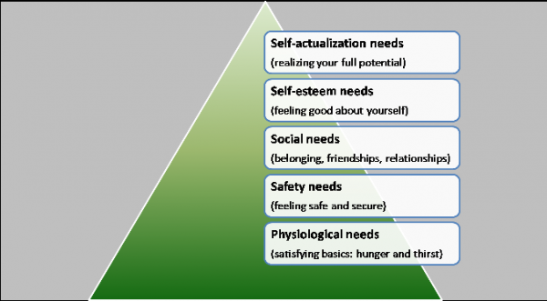
Figure 6; Maslow’s Hierarchy of needs
Source: (Schneider and Smith, 2014)
Unilever and Tesco can motivate its lower-level employees like a security guard, salesman, cleaner employees through ensuring physiological needs like hunger and thirst and safety needs like providing the feeling of security through ensuring permanent job of the employee. Both Unilever and Tesco can motivate its mid-level employees by ensuring their social need like friendship, better relationship and higher-level employees ensuring their self-esteem needs like praising their work effort, give them promotion and fulfilling self-actualisation needs. Proper motivation increases the productivity of employees which ultimately helps the organisation to ensure sustainable growth (Murgatroyd, 2011).

Conclusion
An appropriate organisational structure with a proper organisational culture can help an organisation to set its goal and make the employee work in such a way that ultimately results in an organisation’s goal achievement (Murgatroyd, 2011). A well-defined organisational structure helps the organisation to set the flow of information toward every employee within the organisation (Kondalkar, 2017). Organisational culture makes the employee know about their responsibility properly. Different factors put an impact on the individual employee's behaviour so the higher-level management should motivate the organisation’s employees in such a way that increase their productivity and ensures sustainable profitability.

References
Verdugo, V., Cadena, C. and Armenta, M., 2017. Psychological approaches to sustainability.
Frost, P., 2018. Organizational culture.
Kondalkar, V., 2017. Organizational behaviour. New Delhi: New Age International (P) Ltd., Publishers.
Koornstra, M., 2017. Changing choices. [Leiden]: Leiden University Press.
Marshall, S., 2013. Managing the Culture: the key to effective change. School Organisation, 13(3), pp.255-268.
Murgatroyd, S., 2011. Strategy, Structure and Quality Service: developing school wide quality improvement. School Organisation, 11(1), pp.7-19.
Schein, E., 2019. The corporate culture survival guide. San Francisco, Calif.: Jossey-Bass.
Schiffman, L., Kanuk, L. and Hansen, H., 2013. Consumer Behaviour. Pearson Education UK.
Schneider, B. and Smith, D., 2014. Personality and organizations. Mahwah, N.J.: Lawrence Erlbaum Associates.
Tesco Plc. 2021. Our history. [online] Available at: <https://www.tescoplc.com/about/our-history/> [Accessed 22 February 2021].
THE ORG. 2021. Tesco - Org chart | The Org. [online] Available at: <https://theorg.com/org/tesco/org-chart> [Accessed 21 February 2021].
THE ORG. 2021. Unilever - Org chart | The Org. [online] Available at: <https://theorg.com/org/unilever/org-chart> [Accessed 21 February 2021].
Willmott, R., 2016. Structure, Culture and Agency: Rejecting the Current Orthodoxy of Organisation Theory. Journal for the Theory of Social Behaviour, 27(1), pp.93-123.
Unilever global company website. 2021. Our History. [online] Available at: <https://www.unilever.com/about/who-we-are/our-history/#timeline+3D+none+closed> [Accessed 22 February 2021].

