Name:Liam Jenkins

Student Number:2502497
__________________________________________________________

WORKSHEET 4 – TESTING (Dice Duel)

- Original code:
import random

user=[]
computer=[]
rounds=[]
userWins = 0
computerWins = 0

flag = 0
while flag == 0:

yesNo = input("Are you ready to roll your dice? (y/n)")

if yesNo == "y":

for counter in range(3):
user.append(random.randint(1,6))
computer.append(random.randint(1,6))

userTotal = sum(user)
computerTotal = sum(computer)

print("You rolled...")
for counter in range(3):
print(user[counter], end =" ")
print("\nThe computer rolled")
for counter in range(3):
print(computer[counter], end=" ")

print(f"\nin total you rolled {userTotal} and the computer rolled {computerTotal}")

if userTotal > computerTotal:
print("You won!")
userWins = userWins + 1
rounds.append(1)
elif computerTotal > userTotal:
print("You lost.")
computerWins = computerWins + 1
rounds.append(2)
else:
print("Draw no points")
rounds.append(3)

print(f"Current scores are: you:{userWins} Computer:{computerWins}")

if userWins == 5:
flag = 1
print("congrats you got to 5 wins first you win!")
elif computerWins == 5:
flag = 1
print("Unluck the computer beat you maybe next time")

else:
flag2 = 0
while flag2 == 0:
again = input("Would you like to play again? (y/n)")

if again == "y":
print("Lets go again \n")
user.clear()
computer.clear()
flag2 = 1
elif again == "n":
print("Ok, bye")
flag = 1
flag2 = 1
else:
print("please enter either y or n")

elif yesNo == "n":
print("Ok, bye")
flag = 1
else:
print("Please enter either y or n")

for counter in range(len(rounds)):
if rounds[counter] == 1:
print(f"Round {counter + 1}: was won by the user")
elif rounds[counter] == 2:
print(f"Round {counter + 1}: was won by the computer")
else:
print(f"Round {counter + 1}: was a draw")

- Code Testing
For each test below (i – ix), run your code and show the results of the scenarios below. Present a screenshot of what happened when the programme ran. Did the programme behave correctly or did it do something unexpected, and if so, why?

Part a)
- Computer wins round
- User wins round
- Draw
- “Go again” – enter y
- “Go again” – enter n
- “Go again” – enter Y
- “Go again” – enter b

Part b)
- Show score/score tracking (depending on how you have implemented your program)
- Show an overall win (however this is achieved eg first to 5, best of 12 etc)

Part c)
x. Analyse your code and write a short paragraph commenting on the efficiency of the original code. Could efficiency be improved and if so comment on what is currently inefficient?

Template for tests:
Test:
Computer wins a round

Screenshot(s) of output:
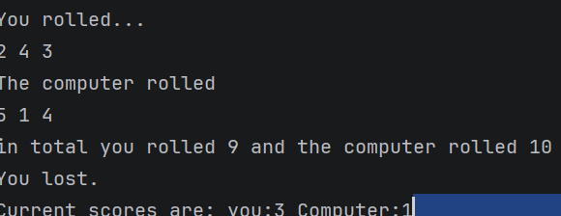
Result: Did the programme behave as expected ie syntactically and logically correct?
YES
If YES, comment on what happened.
When the computer won their wins were added to the total

Test:
User wins a round

Screenshot(s) of output:
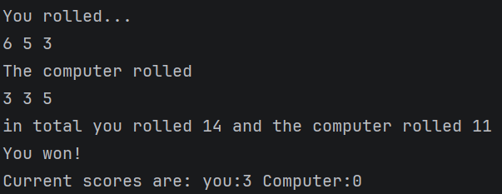
Result: Did the programme behave as expected ie syntactically and logically correct?
YES
If YES, comment on what happened.
When the user won a round the value was added to the current scores

Test:
A draw

Screenshot(s) of output:
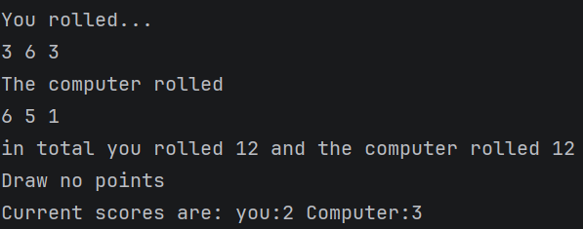
Result: Did the programme behave as expected ie syntactically and logically correct?
YES
If YES, comment on what happened.
When a draw occurred a message is displayed and the games won for each player is not affected

Test:

Go again enter “Y”
Screenshot(s) of output:
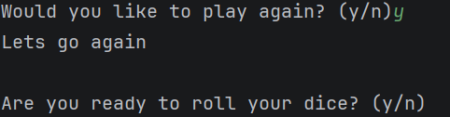
Result: Did the programme behave as expected ie syntactically and logically correct?
YES
If YES, comment on what happened.
When entering to go again it allows the input and asks if your ready for the next roll

Test:
Go again enter n

Screenshot(s) of output:
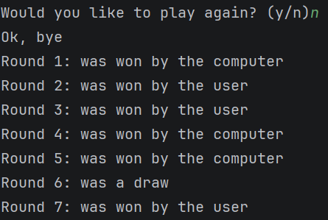
Result: Did the programme behave as expected ie syntactically and logically correct?
YES
If YES, comment on what happened.
Once the user says “n” another game is not started and the results of the previous rounds are displayed

Test: enter “Y”

Screenshot(s) of output:
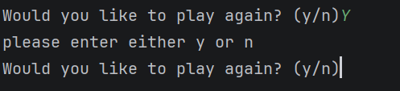
Result: Did the programme behave as expected ie syntactically and logically correct?
NO
If NO, what went wrong and why? Suggest how things could be improved
Didn’t allow the letter “y” as an uppercase, should allow for both uppercase and lowercase

Test:
Enter “b”

Screenshot(s) of output:
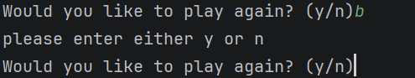
Result: Did the programme behave as expected ie syntactically and logically correct?
YES
If YES, comment on what happened.
Doesn’t allowed “b” to be entered and instead asks for y/n to be entered again

Test:
Show score tracking

Screenshot(s) of output:
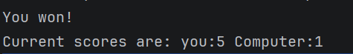
Result: Did the programme behave as expected ie syntactically and logically correct?
YES
If YES, comment on what happened.
Shows running score for each round played so far

Test: Show an overall win

Screenshot(s) of output:
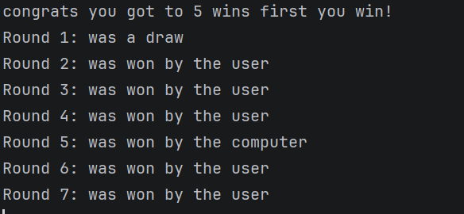
Result: Did the programme behave as expected ie syntactically and logically correct?
YES
If YES, comment on what happened.
Once one party gets to 5 wins the program says if you won or were beaten and gives a history rundown for each round

Part C analysis

The code is efficient working with the knowledge at the time. If I was more advanced efficiency could be improved by using functions. There are no large “rabbit holes” where if statements branch out far and it becomes difficult to re enter the main program. Loops were used to run the game code multiple times until an ultimate winner was decided heavily cutting back on code needing to be written.
- Consider the results of the above tests and your analysis of program efficiency and revisit your original code in order to address any tests that failed and/or improve code efficiency.

(Note: you may not be able to solve all of the problems that were encountered, but solve as many as you can.)

Paste your full revised code here :

import random
user=[]
computer=[]
rounds=[]
userWins = 0
computerWins = 0
flag = 0
while flag == 0:
yesNo = input("Are you ready to roll your dice? (y/n)").lower()
if yesNo == "y":
for counter in range(3):
user.append(random.randint(1,6))
computer.append(random.randint(1,6))
userTotal = sum(user)
computerTotal = sum(computer)
print("You rolled...")
for counter in range(3):
print(user[counter], end =" ")
print("\nThe computer rolled")
for counter in range(3):
print(computer[counter], end=" ")
print(f"\nin total you rolled {userTotal} and the computer rolled {computerTotal}")
if userTotal > computerTotal:
print("You won!")
userWins = userWins + 1
rounds.append(1)
elif computerTotal > userTotal:
print("You lost.")
computerWins = computerWins + 1
rounds.append(2)
else:
print("Draw no points")
rounds.append(3)
print(f"Current scores are: you:{userWins} Computer:{computerWins}")
if userWins == 5:
flag = 1
print("congrats you got to 5 wins first you win!")
elif computerWins == 5:
flag = 1
print("Unluck the computer beat you maybe next time")
else:
flag2 = 0
while flag2 == 0:
again = input("Would you like to play again? (y/n)").lower()
if again == "y":
print("Lets go again \n")
user.clear()
computer.clear()
flag2 = 1
elif again == "n":
print("Ok, bye")
flag = 1
flag2 = 1
else:
print("please enter either y or n")
elif yesNo == "n":
print("Ok, bye")
flag = 1
else:
print("Please enter either y or n")
for counter in range(len(rounds)):
if rounds[counter] == 1:
print(f"Round {counter + 1}: was won by the user")
elif rounds[counter] == 2:
print(f"Round {counter + 1}: was won by the computer")
else:
print(f"Round {counter + 1}: was a draw")

