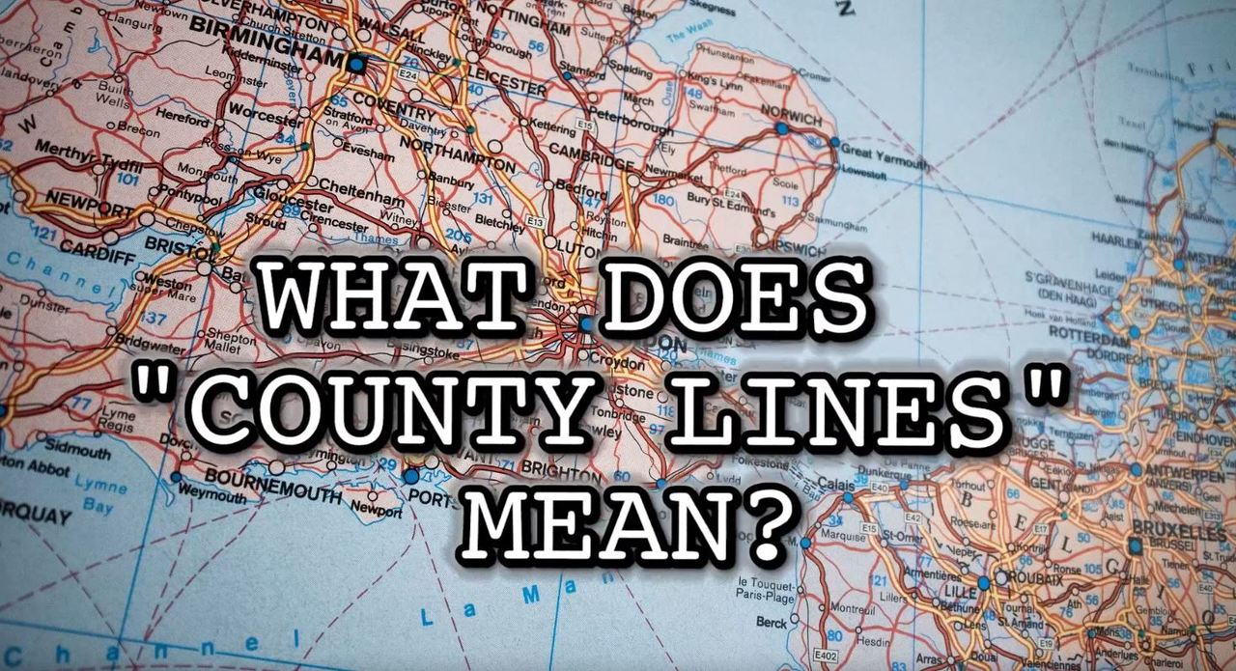
County lines
(Wales Online, 2019)

Introduction
Within this practice log I will be looking into ‘County Lines’. County lines has become a big problem within today’s society, with one of the biggest problems being that children are being recruited into these drug gangs. The aim of this log is to explore and educate about county lines and discuss the issues within this subject. Fearless (2019) discussed what County Lines is and notes

County lines is a very serious issue where criminal gangs set
up a drug dealing operation in a place outside their usual
operating area. Gangs will move their drug dealing from big
cities to smaller towns in order to make more money.
Fearless, (2019)

When discussing County Lines, if you asked me to think of an area that is highly affected, I would never have said Wales as my chosen country. I will also admit before researching into it and discussing it as part of this module, I was unaware of the major issues with regards to gangs and sexual exploitation that seems to be happening in our towns. Branches deliberately target vulnerable children, those that are homeless, living in care homes or trapped in poverty. (The Children’s Society, 2019). These children are unsafe, unloved or unable to cope, and the gangs seize their opportunity to take advantage of this vulnerability. (Crime stoppers, 2019)

County lines was a term believed to have been started in 2013 which represents gang members use of phone lines to target rural areas in which there is believed to be profit made from selling drugs. A vast majority of Wales have either an emerging problem or have been reported to having an established issue with County Lines. (Williams & Fiona, 2019). The way drug dealers and gang members run these lines have been described as an enterprise, where experienced members from big citied areas such as London or Birmingham recruit young and vulnerable people to deliver drugs to more rural areas.

For many young people, they may see this as a quick and easy way of making money, it may also seem even more tempting if they come from a poverty-stricken background. The main danger of young people being involved in this, is that they may become addicted to the drugs themselves or they may also become too scared to be able to leave. They may also feel that if they do leave, the gang may do something to hurt them or hurt someone close to them.

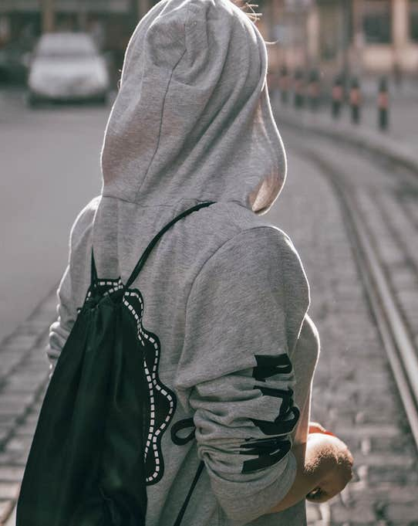
They are recruiting these children and young people by manipulation, intimidation and violence or by offering forms of payments or gifts to coerce them into crossing County Lines in order to sell drugs. (South Wales Police, no date). It is also believed that children as young as 12 have been recruited to join these enterprises, in order to aid gang members detection and being arrested. (Robinson, McLean & Densley, 2018).
(Independent, 2019)
Personally, I find it heart-breaking the age of some of the young people involved in County Lines. The National Crime agency (2017, p.15) notes that ‘65% of forces reported that within child exploitation, the youngest child reported was 12 years old.’ One of the reasons why these gangs use young people is that police will not suspect them of carrying drugs.
(Independent, 2019)
Trapped Stage
The targeted children and young people
Hooked Stage
Experience Stage
Targeting Stage

The criminal groups frequently target children and young people from all backgrounds; often with mental health or addiction problems. (NCA, no date) but mostly are deprived or troubled, and even includes some from private schools according to Dodd, (2019). There is one thing that seems to be in common with them all and that is a sense of hopelessness or vulnerability. Risks to children are becoming more and more complex, especially since the increase in use of technology. Social media is reported as some of the methods used to groom and recruit new members of the gangs. NSPCC (no date) also report that children and young people have even been groomed in shopping centres and schools. I have recently been watching ‘Hollyoaks’ and they are currently running a County Lines story. It has been fascinating to watch to gain some further information and to watch how these gangs do ‘their work’. It is also great to see TV programmes making people more aware of what is going on around them and to allow the younger generation to gain support on what they can do to avoid or get out of the situation and to seek guidance.

Children involved in County Lines are exploited and removed from their rights. The UNCRC states in Article 32, that ‘government should provide ways to protect children from dangerous drugs and exploitation.’ (Alderson, 2008, p.18). However, there are limited options for these said children and young people connected by County Lines. Financial pressures have made a serious impact on Youth Workers over the previous years. According to the Welsh Government’s Statistical Release, total budgeted expenditure for Youth Workers has fallen by nearly 25% during the last 4 years. Although the work sector has statutory youth access to other sources of funding, this is their primary source. (National Assembly for Wales, 2016). Children involved in County Lines are scared for their safety and their family members. (Fearless, 2019). UNCRC, Article 32, states that children have the right not to be exploited, (Alderson, 2008, p.18) however this is exactly what the gangs do.

Typically, children and young people which are groomed for drug running are already vulnerable due to the already mentioned aspects of their background. Children and young people that are from care homes are said to be incredibly vulnerable to grooming, with around half of the police forces claiming that children and young people which have been found to have been involved were from care homes. Along with this, young people with learning difficulties, mental health issues or those which have suffered severe trauma are also high risk in being vulnerable to County Lines recruiters. (Islington Safeguarding Children’s Board, 2016). Although males are more likely to be involved, so you would think, young girls are also at risk of being exploited by gang member. It is believed that young females are being sexually exploited without knowing they are. This is due to the fact that the girls believe they are loved by the gang members and have a sense of emotional financial security as well as the social status. This will often result in compliance in illegal on-goings as well as entering into an abusive relationship which has a detrimental effect on their emotional and physical well-being. (CSJ, 2014).

The Violence and Vulnerability Unit reported in 2018 that ‘young males were more likely to be involved in criminal gangs and make up 86% of the typical 14-17-year-old boys that are involved (NCA, 2016). Coomber and Moyle (2018) report that ‘the use of the boys is more common practice. However, Bulman (2019) explains that girls are being used for sexual exploitation, shoplifting or money laundering and referred to as ‘victim associates’;’ it is argued that they are recruited because they are less likely to be viewed as offenders by the police. (NCA, 2018).

Nobody is 100% sure of the exact reasons for girls becoming involved with criminal activity and violence, however some of it may be due to the excitement or possibly simply because they are attracted to the male members of the gangs. (Densley, 2014). You could also argue that they feel a sense of belonging and/or possibly being wanted or needed because of the attention they receive from the boys. However, according to Storrod and Densley (2017), the girls may not be fully aware of the consequences or the intentions of the gang members whose attention may not last long after the initial testing of their viability for recruitment into the County Lines establishment.

So, you may be wondering, ‘What is being done in Wales to stop County Lines?’ The United Kingdom government released a guidance for practitioners document in 2019 which was aimed to ensure the safeguarding of every child in regard to County Lines was taken into consideration by agencies. Along with this, the County Lines working group was set up in 2016, however it is also believed to have been started earlier, with the hope that working with multi agencies and government, they would raise awareness and tackle issues and cases as well as providing training for relevant practitioners. (Ministry of Justice, 2019). However, I have found through researching County Lines that there is little to no guidance or policy documents directly from the Welsh Government themselves. County Lines has been known to be described as an ‘Epidemic’ which has been known to put children and young people at risk, (The Telegraph, 2019), bearing this in mind I was deeply shocked to find that this was the case and that there are little or no documents at all. However, despite there being very little guidance from the Welsh Government, I have found one example from the Dyfed Powys Police department’s called Operation Guardian. This campaign is in place to try and tackle County Lines by working with agencies to safeguard the children and young people who are at risk of being exploited. This type of long-term approach is aiming to pursue perpetrators rather than the victims. (Dyfed Powys Police, no date).

You may question whether or not this is enough? As someone who has worked with vulnerable children for many years, I am deeply saddened and shocked that I was not made aware of County Lines. After learning about County Lines in university I questioned others who work alongside me and discovered that their knowledge was also minimal if anything at all. It made me question, whilst working in an education sector with children and young people, why are we not being made aware of this more? Why is it not discussed in PSHE lessons? How are more people not made aware of County Lines and the exploitation carried out around us, taking part where we live, where we work and where our children and families grow up? Donovan (2019) suggests that many have a similar view to myself at the beginning of this module, that this sort of thing does not happen in Wales, how wrong were we!

So, what has this got to do with poverty? You may find yourselves asking, is there a link between poverty and criminal activity? McAra and McVie (2010), argue that there is a definite link with poverty and violent offending amongst young people; blaming poor family functioning, neighbourhood deprivation and drug use. Contrast to this, they also argue that violence is part of the identity of poor young people. However, we cannot directly blame young people living in poverty for all the crimes every time!

The national crime agency (2016, p.9) discuss the types of children and young people that these County Lines gangs recruit, and notes that;
Most commonly children from poor backgrounds engaged in offending behaviour, facing difficulties at home or in care of social services are amongst those most vulnerable to gangs. They are often listed as a missing person and/or have poor school attendance.
(National Crime Agency, 2016, p.9)

These group of children and young people are especially at risk of being targeted as they are more vulnerable than others. The article carries on to state that ‘No one really knows how many young people across the country are being forced to take part, but the Children’s Commissioner estimates there are at least 46,000 children in England who are in gang activity’. Things are put into place to protect children from things like this happening. One of them being UNCRC. Article 33 states that ‘Governments must protect children from the illegal use of drugs and from being involved in the production or distribution of drugs.’
While county line reports by UK police forces began around 2016, it is thought that they had been established long before this, and escaped authorities’ notice because of insufficient information and lack of resources to build a national picture of the issue (National Crime agency, 2017). In England and Wales, the age for criminal responsibility is ten years and there is a general reluctance to ‘’criminalize’’ minors, with offenders often being referred to youth services and restorative justice. The result of this is reports of children as young as ten years being used to carry out drug related activity. Children who are victims of county lines often remain under the radar until there are triggers, such as going missing regularly, being victims of child sexual exploitation, truanting, perpetrators of antisocial behaviour, petty crimes and drug use among others (The Children's Society, 2019) .

County lines have been linked to an increase in knife crime. Home Office reports show an increase in knife crime in Wales, with the three police forces reporting more than 100% increase in cases. South Wales Police made more than 100 arrests in knife crime in Cardiff between February and July 2019. Larger cities like London, Birmingham and Manchester report significantly higher numbers of knife crime.
According to the NCA (2019), police statistics on knife crime from an ethnicity point of view were mixed with many forces reporting ‘no clear link’. However, most forces reported more cases from the prevalent ethnicity groups. Community perception of crime types, particularly when ‘authority figures’ seem to care more about being politically correct, often revert to stereotypes.
In 2019, BBC ran a documentary on knife crime among black youths in London titled ‘’ London teens sent to Africa to escape knife crime’’. This was rather interesting as knife crime and its spread in Wales was an issue that had been highlighted by local charities that had recently been publicised. The documentary interviewed parents and young people (teens) that had been victims of knife violence and felt that the only means of escape was to return the teens to their country of origin. According to the documentary, 8% of the 100 people stabbed in the UK in 2019 were of Somali origin. Watching the documentary, one of the main issues that stood out to me was the lack of community attachment and involvement. Of the parents interviewed, most were single female parents or if there was a male parent, they were often absent and not involved in the children’s upbringing. There was a sense that the children’s welfare (i.e. nurturing, education, guidance) took second place to status and ‘monetary’ success (i.e. appearing to ‘make it’). Maybe it was not intentional however, as a result of sometimes not understanding the local and educational systems, lack and reluctance to ask for support etc.
Some of the teens stated they were drawn into drug and knife culture because they wanted ‘’good stuff’’ like their associates had and crime was the only option open to them. Also, that within their gangs there was a sense of belonging. Both parents and children quoted feeling let down by their communities/local authorities and feeling the communities had no support to offer. The families all lived in ‘ghetto’ areas well known for the increase in poverty and poor education/life outcomes. Of the teens that had been ‘’sent back’’ most were first generation and were sent back to stay with other family members while their parents/other siblings remained in the UK. Though reported as a solution to an ongoing social problem, I could not help but wonder if these ‘exported’ teens have become someone else’s ‘problem’ and the cycle will be repeated throughout their lives wherever they may end up.
Sometimes branches use violence to intimidate children and young people when recruiting them. Branches also violently attack children and young people who work for them if they find that their drugs or money are missing (The Children 's Society, 2019). Sometimes weapons like weapons, knives, bats, acid are used to make violent threats (Fearless.org, 2019).
Branches recruit and use children and young people to move drugs and money for them. Children as young as 11 are also often recruited, often using social media. They are exploited and forced to carry drugs between locations, usually on trains or trainers. They are also forced to sell drugs to local consumers (Crimestoppers-uk.org, 2019).

No one knows how many young people across the country are being forced to take part, but the Children's Commissioner estimates that there are at least 46,000 children in England who take part in gang activity (The Children's Society, 2019). An estimated 4,000 London teenagers alone are exploited through criminal exploitation of children, or county lines (The Children's Society, 2019). Tragically, young people exploited through 'county lines' can often be seen by professionals as criminals.

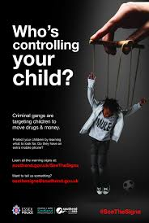
It is clear that county lines are a national issue for many reasons. One reason is that illegal substances travel around the UK in our communities (The Children's Society, 2019). However, an obvious issue is the fact that children are exploited because adults have this control over children. Yes, county lines are policing issues, however, there are limited options if there are no other options for children and young people (Clark, 2010). By targeting vulnerable children, the gangs know that they have full control over the children and young people involved (Crimestoppers-uk.org, 2019).

Unfortunately, some children grow up in these circumstances, so they do not know anything different (Gill, 2012). As a society it is difficult to withdraw children from county lines. They are not in education, so getting them into education is more difficult. There are no youth clubs and limited youth workers who can work with these children and young people so how do the government expect us to resolve this issue? Steve Rodhouse, director general of operations of the National Crime Agency, said the centre would go beyond police work to help develop a multi-agency approach to identify and protect vulnerable young people held in custody drug trade, and understanding what drives the demand for drugs (GOV.UK, 2018).

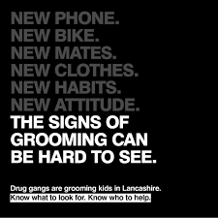
Children involved in county lines are often seen as criminals, however, this is not always the case. These children are exploited and used to persuade illegal acts for the sake of the gangs (Clark, 2010, p 122). The UNCRC states in article 40 that children who are considered to be breaking the law should receive legal aid (Alderson, 2008, p 20). This is a serious issue, as some children have no other choice but to perform unlawful acts for the safety of their families, their safety and their lives.
So, what can you do about it?
Cleary there is a problem in the UK of girls being exploited and groomed into County Lines activity, but it appears to be an area where little research has been carried out. Or does society not believe that girls can become part of these gangs and mirror the operations of their male counterparts? Therefore, this is not a problem? We all need to be more observant in our daily lives; challenge and question the vulnerability of girls as well as boys. More and more girls are forming parts of gangs and we must question why?

It is believed that the ‘Home Office’ is looking to provide nearly £100,000 in funding to help tackle this issue. Is this enough? Is there no more money to spare? Government is also looking at providing gang members with an alternative, in the form of education, training and employment to help steer them from the impact they are having on society. (Newton, 2017). I also believe that schools need to do more to try and safeguard young people from this. North Yorkshire Police (2018) discuss how police are working alongside schools to raise an awareness of county lines and note that ‘Police across York and North Yorkshire are working with local schools to help raise awareness of “county lines” drug dealing and the impact it has on vulnerable young people’. It is good to see that both Government, police service and schools are working to stop children and young people going into these gangs before it is too late and helping gang members themselves by providing them with a second chance. However, I do believe putting money back into the youth work is the best way forward to help these youths.

Despite of the £20million government funding which was given at the end of 2019 in order to combat County Lines, there is no quick fix, although it is suggested that a national as well as local plan desperately needs to be put in place so that there is opportunity to save these children and young people from a life of exploitation, gangs and drugs (The Guardian, 2019).
Personally, whilst working in an education sector with vulnerable children and young people, I would expect to be further educated on such a topic as important as this. It is quite scary to think we are hidden from the pure reality of what goes on around us in our local areas. After having spoken with the youth worker who works as part of our school, the harsh reality of what goes on around us frightens me for our children and their children and generations to come. I feel we have been blinkered in society and only see what is in front of us and not what is hidden or behind closed doors. Having lived in a deprived rural area surrounded by poverty, looking back now it is frightening to think about some of the children and young people that I would now worry about being involved in the County Lines gang. For how long can this continue before it ends? Will it ever end?
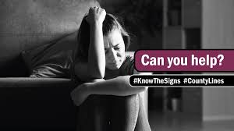

References
Alderson, P. (2008). Young children's rights. London: Jessica Kingsley Publishers.

Bulman, M. (2019) ‘Sex aged 10, drug dealing and brutal violence: The hidden epidemic of vulnerable girls being exploited by county lines gangs’, The Independent,16 February [Online]. Available at: https://www.independent.co.uk/news/uk/home-news/girls-gangs-drugs-county-lines-uk-young-women-sexual-abuse-a8748096.html (Accessed: 15 February 2020).
Clark, R. (2010). Childhood in society.
Coomber, R. & Moyle, L. (2018) ‘The changing shape of street-level heroin and crack supply in England: Commuting, holidaying and cuckooing drug dealers across ‘County lines’. British Journal of Criminology, 58(56), pp. 1323–1342. [Online] Available at: https://doi.org/10.1093/bjc/azx068 (Accessed: 23 June 2020).

Crimestoppers-uk.org (2019). [online] Crimestoppers-uk.org. Available at: https://crimestoppers-uk.org/campaigns-media/campaigns/drug-gangs-and-recounty-lines [Accessed 5 May 2020].

Densley, J. (2014) ‘It’s Gang Life, But Not As We Know It: The Evolution of Gang Business’. Crime & Delinquency, 60(4), pp. 517– 546. [Online] Available at: https://www.doi.org/10.1177/0011128712437912 (Accessed: 16 June 2020).

Dodd, V (2019) ‘Children as young as seven 'being enslaved by UK drug gangs', The Guardian, 5th July. Available at: https://www.theguardian.com/society/2019/jul/05/children-as-young-as-seven-being-enslaved-by-uk-drug-gangs (Accessed: 17 June 2020).
Documentary : BBC (2019) London teens sent to Africa to escape knife crime. Available at; https://www.bbc.co.uk/news/uk-48353960 (Accessed 16 June 2020)
Donovan, S. (2019) I’ve seen the child slavery of county lines up close. £20m won’t save it. Available at: https://www.theguardian.com/commentisfree/2019/oct/04/child-slavery-county-lines-criminals-provincial-towns Accessed: 29th May 2020

Dyfed Powys Police (no date) Operation Guardian. Available at: https://www.dyfed-powys.police.uk/media/6066/op-guardian-info-booklet.pdf Accessed: 29 May 2020

Fearless.org. (n.d.). County Lines. [online] Available at: https://www.fearless.org/en/campaigns/county-lines [Accessed 29 May 2020].

Gill, T. (2012). No fear. London: Calouste Gulbenkian Foundation.
GOV.UK (2018). National County Lines Coordination Centre to crack down on drug gangs. [online] Available at: https://www.gov.uk/government/news/national-county-lines-coordination-centre-to-crack-down-on-drug-gangs (Accessed 5 June 2020)
Islington Safeguarding Children Board (2016) Safeguarding children affected by gang related activity and/or gang-related serious youth violence. Available at: https://www.islingtonscb.org.uk/SiteCollectionDocuments/Gangs%20Safeguarding%20Protocol%20and%20Appendices.pdf Accessed: 29 May 2020

McAra, L & McVie, S. (2010) ‘Youth crime and justice: Key messages from the Edinburgh Study of Youth Transitions and Crime’. Criminology & Criminal Justice, 10(2), pp. 179-209 [Online]. Available at: https://doi.org/10.1177/1748895809360971 (Accessed: 29 May 2020).

Ministry of Justice (2019) County Lines Exploitation. Available at: https://assets.publishing.service.gov.uk/government/uploads/system/uploads/attachment_data/file/839253/moj-county-lines-practical-guidance-frontline-practitionerspdf.pdf Accessed: 29 May 2020

National Crime Agency: County Line Gang Violence. Exploitation & Drug Supply. (2016). [online]. Available at: http://www.nationalcrimeagency.gov.uk/publications/753-county-lines-gang-violence-exploitation-and-drug-supply-2016/file [Accessed 10 June 2020].

National Crime Agency: County Lines Violence, Exploitation & Drug Supply. (2017). [online] National Crime Agency. Available at: http://www.nationalcrimeagency.gov.uk/publications/832-county-lines-violence-exploitation-and-drug-supply-2017/file [Accessed 10 June 2020].

National Crime Agency (NCA) (no date) County Lines. [Online] Available at: https://www.nationalcrimeagency.gov.uk/what-we-do/crime-threats/drug-trafficking/county-lines (Accessed: 29 May 2020).

NSPPC (no date) Every Childhood is Worth Fighting for. [Online] Available at: https://www.nspcc.org.uk/what-is-child-abuse/types-of-abuse/grooming/ (Accessed: 16 June 2020).

Robinson, G., Mclean, R., and Densley, J. (2018) ‘Working County Lines: Child criminal exploitation and illicit drug dealing in Glasgow and Merseyside.’, International Journal of Offender Therapy and Comparative Criminology. 63 (5), pp. 694-711.

South Wales Police (no date) County Lines Criminality. Available at: https://www.south-wales.police.uk/en/advice/county-lines-criminality-drug-dealing-exploitation-vulnerable-people/ Accessed: 28 June 2020

Storrod, M. & Densley, J.(2017) 'Going Viral' and 'Going Country': The Expressive and Instrumental Activities of Street Gangs on Social Media’, Journal of Youth Studies. [Online]· DOI: 10.1080/13676261.2016.1260694. (Accessed: 23 May 2020).

The Centre for Social Justice (2014) Girls and Gangs. Available at: https://www.centreforsocialjustice.org.uk/library/girls-and-gangs Accessed: 29 May 2020

The Guardian (2019) The Guardian view on county lines. Available at: https://www.theguardian.com/commentisfree/2019/sep/16/the-guardian-view-on-county-lines-victims-villains-and-everything-in-between Accessed: 29 June 2020

The Telegraph (2019) County Lines epidemic blamed as number of children missing or linked to drug gangs doubled. Available at: https://www.telegraph.co.uk/news/2019/09/15/county-lines-epidemic-blamed-number-children-missing-linked/ Accessed: 29 June 2020

The Children's Society. (2019). County lines, criminal exploitation and trafficking. [online] Available at: https://www.childrenssociety.org.uk/what-we-do/commission-us/our-work/criminal-exploitation [Accessed 8 May 2020].

The Children’s Society (2018) Criminal Exploitation: Stages of Recruitment Children At Risk of Exploitation (CARE). [Online] Available at: www.childrenssociety.org.uk>sites>default>files>childrenatrisk
(Accessed: 16 May 2020).

The Children’s Society. (2019) What are county lines? [online] Available at: https://www.childrenssociety.org.uk/what-is-county-lines (Accessed 15 May 2020)

United Nations (1989) Convention on the Rights of the Child. [Online]. Available at https://www.unicef.org.uk/what-we-do/un-convention-child-rights/. [Accessed 23 June 2020]

Violence and Vulnerability Report (2018) County lines - a national summary & emerging best practice. [Online] Available at: https://vvu-online.com/ (Accessed: 16 June 2020).

Wales Online (2019) The county lines routes continuously feeding Wales with drugs. Available at: https://www.walesonline.co.uk/news/wales-news/county-lines-routes-continuously-feeding-16288294 Accessed: 28 May 2020

Williams, A., and Fiona, F. (2019) ‘County Lines: How gang crime is affecting our young people.’, Archives of Disease in Childhood. 104 (8).

Windle, J., Moyle, L. & Coomber, R. (2020) ‘Vulnerable’ Kids Going Country: Children and Young People’s Involvement in County Lines Drug Dealing. Youth Justice, pp. 1 – 15. [Online] DOI: 10.1177/1473225420902840 Available at: http://livrepository.liverpool.ac.uk/id/eprint/3073822 (Accessed: 15 June 2020).

