DIGITAL SKILLS AND RESEARCH METHODS

By Shamim Uddin

Student ID: 1711212

Assignment part 1
In the first part of the assignment I will evaluate the appropriate uses of technology (including mobile devices) and discuss how they improve workplace efficiency and employability.

Introduction
In this report I will indicate the use of appropriate technology in a workplace such as smart phones, tablets and web-based email. I will explain and discuss how they effect the workplace and the cons and pros of them being used.
Workplace
Smart phones and tablets are essential to a business because it helps employees to be up to date and it ensures that everyone will know what to do and will not miss out on anything as everyone uses smartphones and tablets in everyday life and the business knows this therefore they will ensure on there policy that smartphone messages/email can be checked, and employees will keep an eye on it.
Web based email - Webmail, as its name suggests, is web-based email. To use webmail, you do not need any email software - just a computer connected to the Internet and a browser. Webmail accounts are usually free. Google mail inbox, Email accessed from within a web browser, i.e. webmail Users simply sign up to a webmail service such as Google mail, Hotmail or Yahoo. They are then given a unique user name, password and a personal mailbox. The mailbox is accessed by visiting a specific web address and logging in. Once logged in, users can send and receive messages. Businesses use this to inform and instruct employees what they missed or tell them where to go or where the meeting is. This is a very useful tool as they can ley the person knows in seconds without delay.
The advantage of webmail is that users can receive and send email from any computer in the world with Internet access and a browser. The emails are saved, and they do not have to be deleted/erased.
Technology is a fantastic tool for some people with disabilities and can make a huge difference to them and their lives. However, people need to remember that it is not a one size fits all approach. Some people with disabilities just do not like technology or may find it more of a hindrance than a help. This is the exact reason that it is essential to get an assessment done prior to purchasing any mobile device for a person with a disability. The assessment will show you whether someone is suitable to use this technology and if so, what device suits them best. In a workplace these help to communicate with clients fast and effectively and saving time without having to call the employee and wait until they pick up.

Assignment part 2
In the next part I will demonstrate the appropriate use of technology and its applications in a workplace.
In this part of the assignment I will open a Facebook account, twitter and LinkedIn and discuss how this is used and how it helps.
Facebook
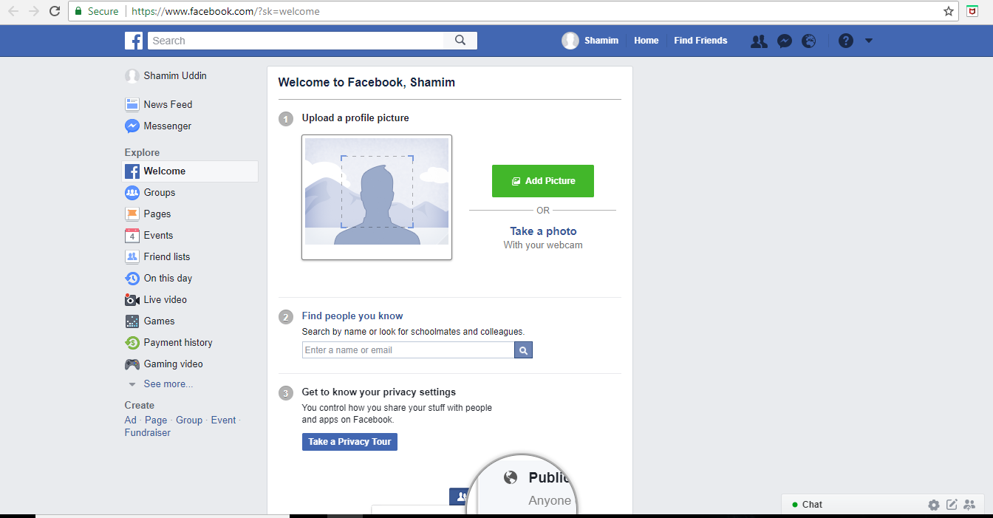
I have created a Facebook page and Facebook helps to Raise brand awareness and promote positive word-of-mouth. You can increase your business's profile on Facebook by encouraging existing and potential customers to click the 'Like' button on your Facebook page. Facebook is a social media where it helps to communicate with others and it allows you to search for what you desire however this is not a platform where you can have a job search although there are some Facebook posts that include job searches they do not essentially do that but in this case I would personally not advice to use Facebook as a job search platform.
Advantages of using Facebook
Facebook for Business - Facebook is one of the largest sites in the world where we are not only allowed but encouraged to connect with everyone. Anyone can take advantage of Facebook to maintain a good relationship with others who identify with certain tastes or products. This is very important because as a business, you can sell or promote a product/service to a highly targeted audience, thus increasing the possibilities of making money on the internet.
Facebook Video Chatting - Facebook can also be used as video chat tool. Recently, Facebook implemented the Facebook video chat feature in partnership with Skype. Now you can make video calls to your friends using Facebook’s inbuilt video chat service.
Facebook for Image and Video Hosting - You can also use Facebook as a site to host images and videos. You can set privacy levels for individual albums to control who can see what you share. Moreover, you can always download your complete collection of Facebook photos and videos using the Facebook backup account feature.
Facebook for News & Information - The real advantage of Facebook is that it’s a real-time social networking site. This makes it one of the best sources to stay updated with the latest news and information. Major news usually goes viral on Facebook, and most brands use it to announce important things regarding their products/services.
Facebook as a Personal Portfolio - Facebook’s Timeline gives a completely new look regarding your personal profile branding.
Disadvantages of using Facebook
Facebook Privacy - All throughout the internet, we should always keep in mind the privacy of our personal data. After it’s placed online, we lose all control.
Private Status Published Publicly - Even though Facebook has simplified its privacy settings, many unknowing users still end up publishing private images and status updates publicly. Also, people usually keep their Facebook friends list visible to the public, and this helps Facebook stalkers find more information about you.
Fake profiles: Facebook is full of fake profiles. There is no limit to these profiles. Most of them are created by stalkers or marketers looking to gain more friends and use it for their marketing purposes.

TWITTER
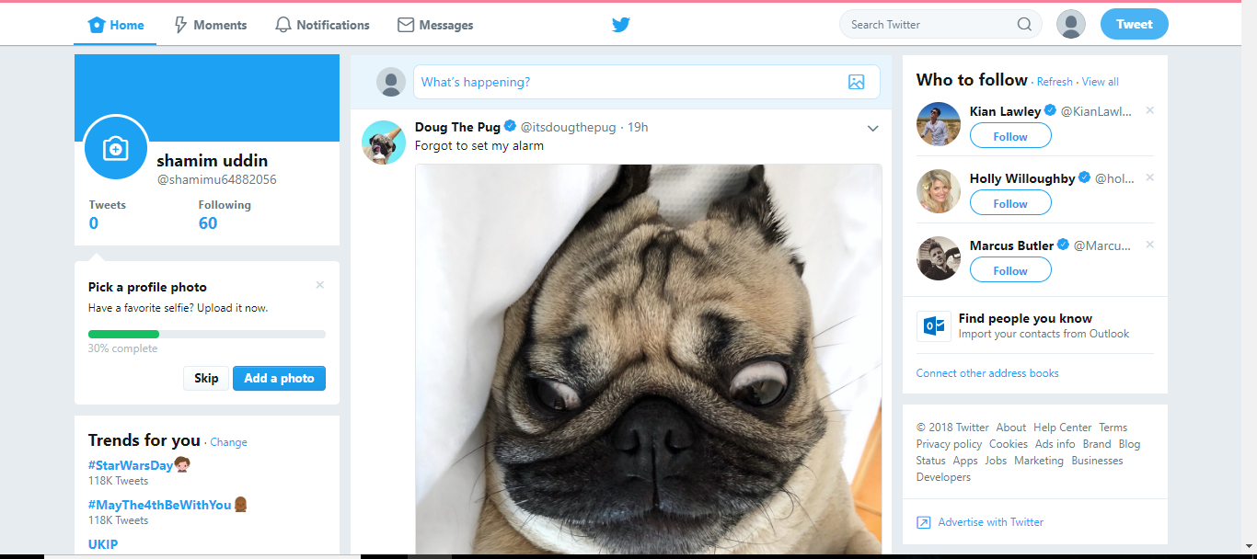
I have opened a twitter account which is like Facebook however the use of twitter is more about posting and searching what you love, not about people and getting to know people like Facebook. Twitter in work wise is not helpful therefore twitter does not apply to this.
Advantages using Twitter
- Twitter is a social network that helps you connect with people that you know and people that you want to know easily. Since it has a massive number of users, Twitter is a good choice for business owners seeking to find a new audience for their business.
- Twitter’s features and the interface are very user-friendly. The web-version is elegant in its simplicity. The basic every day features you need are follow, tweet, and retweet.
- The Twitter app is probably my favourite when compared to Instagram and Facebook. It’s very easy to use… making it one of the big advantages of Twitter.
- Twitter also recently improved their direct messaging algorithm. It now has a very user friendly direct messaging feature that allows you to easily communicate with customers and other business owners.
- This platform is a great source of lead generation and traffic. Every tweet that gets posted publicly on Twitter will be indexed by search engines like Google. So, make sure you take advantage of hashtags.
- Twitter serves as a good tool for search engine optimization and connecting websites through links. It’s one way many ways Twitter helps your business grow for free.
- Twitter is also good for visual content… though that’s not the primary focus of Twitter.

Disadvantages of using Twitter

- Having a massive number of users may also be one of the disadvantages of Twitter. In my opinion, there are quite a lot of fake accounts all over Twitter. And in most cases, these accounts are not just fake accounts but are also spam accounts. These spam accounts may end up annoying you with their non-stop posts and messages about the same thing repeatedly.
- That means you should be careful on who you follow on Twitter. And not just that… You should also check if there are spam or fake accounts following you on Twitter.
- The biggest disadvantage of Twitter is that, unfortunately, Twitter has a limited word count for every post. The social network only allows 140 characters per post. This is tough for business owners who enjoy sharing a lot of information with their customers. This is mainly the reason why Twitter is link-based. Most of its users will provide their followers the links where people can click to read the complete content.

LinkedIn
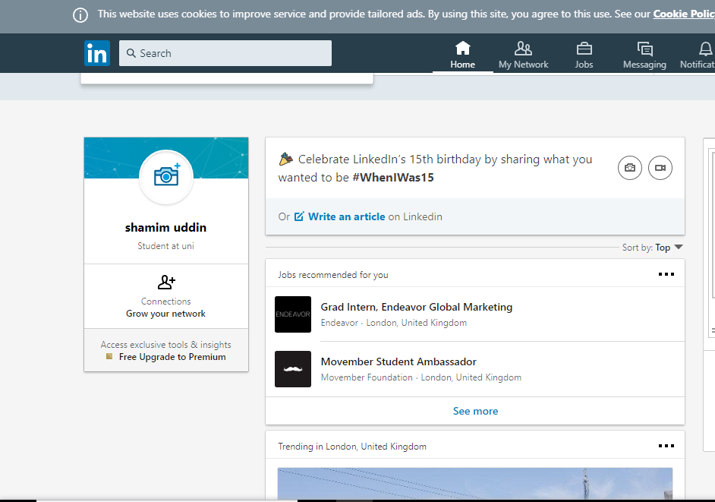
LinkedIn is a very useful source as it comes in all forms in a app for smartphones and android phones and this is a web site that allows people to register and fill in there skills and where they worked before and then the site searches for the appropriate job that matches your skill set and experience.
Pros
- The first, most obvious benefit from using LinkedIn comes from the algorithmic realm of SEO (search engine optimization). It’s yet another avenue that search engines use to bring businesses in search query results. It’s the perfect tool to give a business more exposure while also allowing it to expose the most crucial parts of its business – the mission, the background, the members of the team
- LinkedIn is also a great way to stay up-to-date with the news from your industry or field of interest. This is a major benefit it keeps you in the current loop, indicates upcoming trends or big ideas, and provides a ripe stomping ground for sharing experiences and advice among experts surrounding topics that are important to the business. These easily accessible resources are invaluable to a company, particularly smaller ones, due to its low cost and high beneficial value.
- LinkedIn is also a great asset because of the amount of information it gives about a company or business. Like Facebook, LinkedIn will tell you all the major data you need to know about a company as well as give you the professional profiles of the individuals associated with the business – from employees to investors. Access to this type of specific data and information allows users to easily find potential partners or recruit new employees, saving you a lot of time, energy, and resources.
- LinkedIn Answer also gives users the chance to demonstrate their knowledge and skills in their respective field to establish themselves as credible experts with vast knowledge and expertise. In turn, this is beneficial for LinkedIn users as it positions them as experts and boost the company’s credibility.

Cons
- When looking at LinkedIn, it’s also important to be aware of and acknowledge its cons. One of the major negatives is the way users use LinkedIn as an advertising megaphone via SPAM so brace yourself for the slew of SPAM coming your way.
- Once established, LinkedIn is a major timesaver. But in the beginning, it requires a lot of personal time and work to get your connections flowing and conversations started. Users need to constantly ask others to be introduced to companies and individuals they are interested in connecting with, which can be cumbersome at times. Always keep in mind that LinkedIn is a platform for connections and conversations so approach these tasks with the outcome of building a business relationship in mind. This task can be sidestepped with the paid version of LinkedIn, but that might not be an option for smaller companies with a limited budget.
Conclusion
Weighing the scales, where we put the advantages and disadvantages of Facebook, we can conclude that, if Facebook is used in the right proportions, and with proper care, it can be a powerful tool for marketing and networking. Twitter has also disadvantages which could be harmful to the user. So, you must use Twitter carefully to avoid these disadvantages. Overall, LinkedIn is a solid platform for businesses and individuals. If you know what you are searching for your relationship and experience with LinkedIn will prove beneficial. I say LinkedIn is the best platform for business and it is what I would recommend.
Bibliography
(shamim uddin, 2018) image 2
(shamim uddin, 2018) image 3
(shamim uddin, 2018) image 1
(emails, 2017)“just a computer connected to the Internet and a browser. Webmail accounts are usually free. Google mail inbox, Email accessed from within a web browser, i.e. webmail Users simply sign up to a webmail service such as Google mail, Hotmail or Yahoo.”
(facebook, 2018) “Facebook can also be used as video chat tool. Recently, Facebook implemented the Facebook video chat feature in partnership with Skype. Now you can make video calls to your friends using Facebook’s inbuilt video chat service”
(twitter pros and cons, 2017) “This platform is a great source of lead generation and traffic. Every tweet that gets posted publicly on Twitter will be indexed by search engines like Google. So, make sure you take advantage of hashtags. Twitter serves as a good tool for search engine optimization and connecting websites through links.”
(linkedin pros and cons, 2016) “When looking at LinkedIn, it’s also important to be aware of and acknowledge its cons. One of the major negatives is the way users use LinkedIn as an advertising megaphone via SPAM so brace yourself for the slew of SPAM coming your way.”

