Managing Projects in the Organization

BMSW5104
Student id:2112789
Elvis Liviu Nassiri Basti
Lecturer: Aderemi Ojebode

Table of Contents
Task 2: Project Management Plan: Project Management Plan for Building a New Hostel. 3
Introduction 3
Project description 3
Scope 6
Work breakdown structure 8
Quad Chart 9
Gantt chart 11
Stakeholder’s involvement 12
Resource Allocation 14
Risk Analysis 15
Conclusion 16
References 17

Task 2: Project Management Plan: Project Management Plan for Building a New Hostel.

Introduction
Project management at its core indicates robust planning, organization, and overseeing overall project execution from its initial phase to final closure. Consideration of the project management triangle during project proceedings highlights "triple constraints"-the requirement to balance cost, time, and scope for maintaining high-quality products and contributing towards project success. The project leaders need to ensure that the project goes through all phases of the "project lifecycle" while maintaining a fine balance between meeting the needs of the end user, sticking to the final allocated budget, resource optimization, maintaining project quality, and its completion on time. The current study has focussed on analysing the aspects of project management in the context of the construction of 6 new blocks of hostel accommodation for students by UWTSD. The main purpose of constructing a hostel is to accommodate the increasing number of students and provide them with outside learning experiences. The study has further shed light on the project scope, resources allocated, and risk involved with constructing a hostel for student's benefit. Furthermore, risk analysis has been also depicted in the study along with the major role played by varied stakeholders while completing projects on time.

Project description
Developing a detailed project plan is one of the first and foremost steps undertaken by project managers and leaders while commencing a new project. As opined by Crawford (2021), formulating a well-designed project plan can be easy but at the same time is often complicated and is prepared out of procedures. Project planning boosts project performance by detailing comprehensive mapping of the construction project goals, tasks, schedules, and resources that enhance the project success rate.
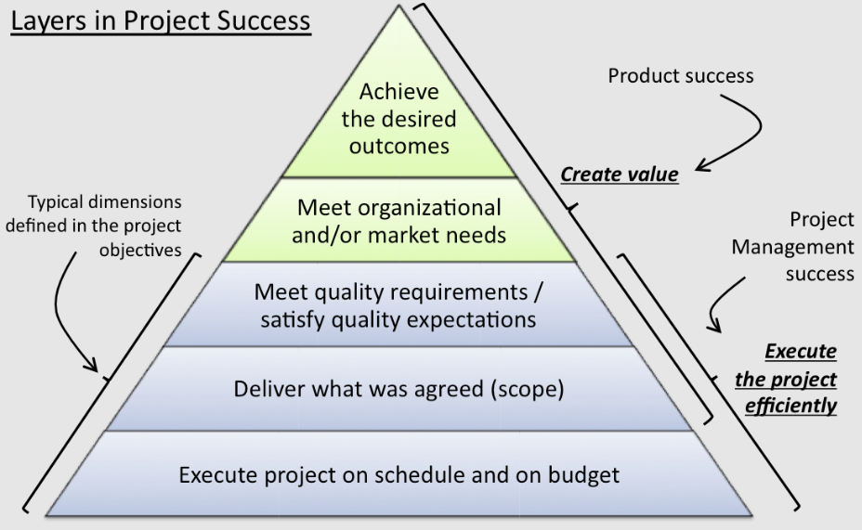
Figure 1: Project management and its success attributes
(Source: Nicholas and Steyn, 2020)
UWTSD is a well-reputed educational institution in the UK, operating with the mission of transforming lives through transforming education. The institution is expanding globally and thus it has aimed at constructing 6 new blocks for accommodating an increasing number of students while providing them with the best learning opportunities and living experiences. The planning phase regarding the construction of the UWTSD hostel involves meticulous planning with the inclusion of identified project resources, risks, costs, and stakeholders. The hostel will be constructed in Bloomsbury, central London within a total area of 35000 square feet and proper feasibility studies involving resources, environmental assessment, and market analysis will be conducted to ensure project risk reduction and attainment of project goals. The planning phase further involves detailed communication among stakeholders to ensure increased awareness among the stakeholders regarding their roles and responsibilities (Lock, 2020). According to Pinto (2020), working in close collaboration with the government, and community members along with strengthening relationships with corporate partners can help project managers obtain required investments that would further facilitate project success. Thus, inclusion of stakeholders during the early phase of hostel construction would foster a sense of shared ownership and mutual benefits among the organizational leaders and contribute towards enhancing project profitability.
Budget allocation and planning are other vital factors associated with estimating the total cost required during construction while preventing the wastage of financial resources. In context to the current project, nearly £1000, 000 has been allocated for designing a hostel with a comfortable ambiance including a reception, 2 common rooms, a party room, laundry facilities, a fully equipped kitchen, and 300 rooms in all six blocks.
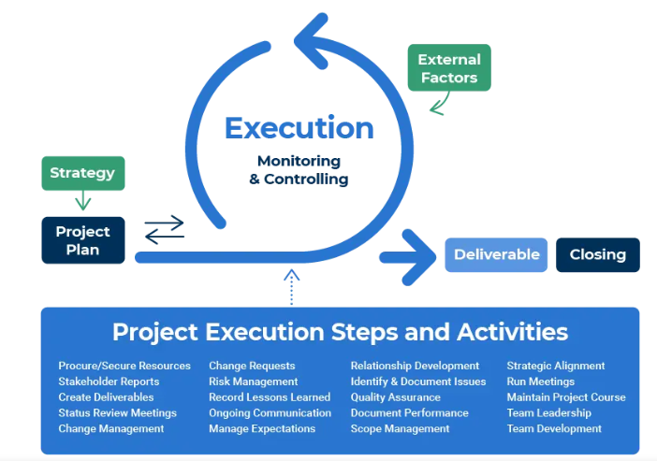
Figure 2: Project management and its execution
(Source: Nicholas and Steyn, 2020)
Project execution is the lengthy and complicated part of the project lifecycle where the plan developed is implemented depending upon the work breakdown. Project execution is the primary focus to deliver value to stakeholders while meeting business goals. A properly executed project ensures fulfilment of project goals, and schedule and delivers expected quality Thesing et al. (2021). According to Stanislas et al. (2021), consistent evaluation and communication with the stakeholders are maintained during the execution phase for delivering project output as per specification. The project has been allocated to be completed within 3 years and is divided into two phases including infrastructural development (Phase 1) and interior decoration along with the development of a support system (Phase 2). It is the responsibility of the project leaders to ensure the appropriate usage of project software and tools for smooth management of the workflow while preventing the occurrence of loopholes.
Project monitoring and control is one of the vital phases during the project lifecycle phase that requires detailed monitoring, keeping a check on project constraints including resources, time, cost, scope, and quality. In the context of the construction of the UWTSD hostel, project managers are required to implement "cutting-edge software and management techniques" for effectively monitoring project progress. According to Burress and Rowell (2020), unexpected challenges for instance cost and time overrun, machinery default, technical glitches, and occupational injuries can affect project proceedings. It is essential to identify the risk and accordingly implement "change control procedures" during the control phase to prevent scope creep and set KPIs for accurately assessing project performance. The final closure phase includes rectification of the loopholes, documenting the vital outcome, and making pepper closure after releasing the project stakeholders.

Scope
Project scope is the crucial aspect during project management that successfully defines the project boundaries by illustrating project goals through task, objective, and deliverables specification. As opined by Alzoubi (2022), a well-defined project scope helps project leaders strategize, execute, and effectively control projects while ensuring the fulfilment of stakeholders' expectations and project objectives.
Project objectives | To construct six blocks of hostels for accommodating the increasing number of students of UWSTD while ensuring easy access and providing basic amenities to the students
Project Deliverables | - Hostel with large spacious outdoor area and comfortable room with bedding and Wi-Fi facilities.  - Provision of library rooms and study rooms to promote the best learning opportunities for the students.
Phase | Activities | Days
Phase 1 | Site selection | 30
Phase 1 | Land preparation | 35
Phase 1 | Roof Construction | 200
Phase 1 | Plumbing | 60
Phase 1 | Electrical work | 30
Phase 1 | Inspection | 30
Total days for Phase 1 completion = 385 days
Phase 2 | comfortable beds and storage space design | 100
Phase 2 | cleaned bathroom area | 30
Phase 2 | Common kitchen and lounge area development | 60
Phase 2 | TV unit and washing machine installation | 45
Phase 2 | paint and ventilation area | 30
Phase 2 | Library room, | 60
Phase 2 | Reliable Wi-Fi connection | 20
Total days for Phase 2 completion = 345 days
Table 1: project scope of UWSTD hostel construction
(Source: Self-developed)
Main objectives of UWTSD hostel construction include constructing rooms with provision of basic amenities, and facilities that can be easily accessed by students. Major activities involve site selection, preparing land for initiation hostel construction, roof construction, plumbing, electrical work, and inspection during phase 1. However, during phase 2 development of secure accommodation with comfortable beds and safe storage, a cleaned bathroom area, a common kitchen, lounge area. Installation of washing machines, TV units, paint and ventilation area, library room, and reliable Wi-Fi connection are also included within the project scope. However, increased cost, technical failure, resource shortage, and lack of communication among stakeholders can affect project quality and hinder project completion within the scheduled time.

Work breakdown structure
WBS is the "hierarchical decomposition" of the construction projects into smaller and manageable components to ensure the execution of the task deliverables through the accomplishment of project objectives and deliverables. As opined by Errida and Lotfi (2021), the construction of WBS results in performing the project task in a clear and organized manner with detailed specifications of the task requirements and ensuring the maintenance of project quality.
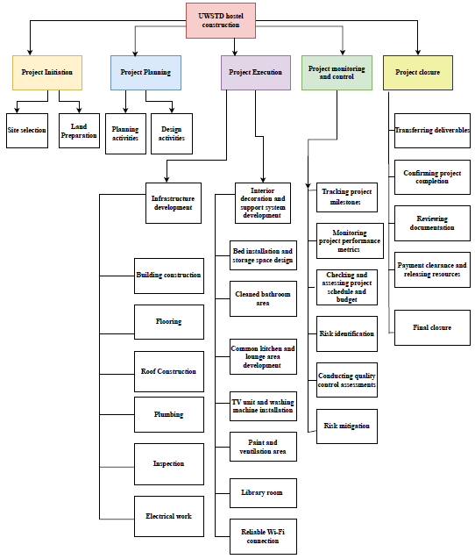
Figure 2: UWSTD hostel construction: Work breakdown structure
(Source: Self-developed)
The project life cycle phase of the hostel construction works has been divided into the initial, planning, execution, monitoring and control, and closure phases. During the initial phase, site selection along with land preparation are performed. Site preparation includes several activities involving site evaluation, site clearance, land grading, and soil compacting for laying the foundation and safe construction. Primary activities during the planning phase include all planning regarding cost, budget, stakeholder meetings, and providing clarity to the project members for enhancing project success.
Designing activities on the other hand include numerous activities regarding interior decoration, furniture installation, and flooring. The execution phase includes the major tasks involving laying the foundation, roofing, flooring, and plumbing. It also includes interior design works involving bed installation, kitchen and lounge area development, TV unit installation, and setting up of library rooms. During the execution phase, stakeholders are communicated about their respective roles and responsibilities to ensure proper execution without any error occurrence. Furthermore, project monitoring involves closely checking on the project task conduction through performing risk assessment and conduction of quality assessment while implementing strategies to mitigate the risks. During the final project closure steps, the project is delivered only after reviewing documentation, clearing payments, and releasing resources.

Quad Chart
Quad Chart is the visual tool utilized for organizing complicated information into concise and clear visual representations indicating goals, milestones achieved, project constraints, cause behind the constraints, and strategies that can be implemented for its resolution. According to Tam et al. (2020), structured visualization of complicated information helps stakeholders in grasping vital details without delivering much into lengthy reports.
Project Summary  - The project involves the construction of a "UWSTD hostel" within an area of 35000 square feet in Bloomsbury, central London for accommodating students from all across the globe.  - Total time duration 2 years.  - Budget allocated: £1000,000 | Milestones  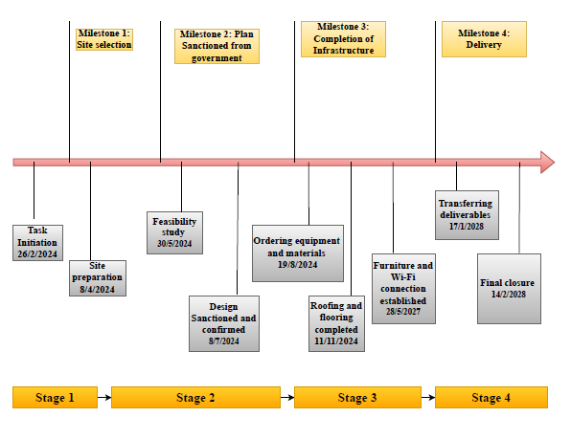
Overall Assessments  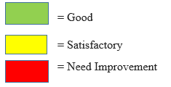 | Accomplishments and upcoming events  Accomplishments  - Successful site selection and granted permission from local authorities and governments  - Infrastructure development  - Completion of resident room, study rooms, hall areas, and library  Upcoming events  - Detailed monitoring and reviewing of overall project quality  - Error rectification  - Project delivery and collecting review  - Final documentation
  Attributes
  Project cost
  Technical support
  Cooperation and coordination among team-members
  Meeting project objectives
  Stakeholder’s Satisfaction
Figure 3: UWSTD hostel construction: Quad Chart
(Source: Self-developed)
Quad Chart in context to hostel construction thus highlights the project objectives and the milestones already achieved. It has further displayed the areas that need improvement including stakeholder satisfaction while conducting the project activities.

Gantt chart
The project management tool, Gantt chart is the graphical representation used for planning and scheduling projects and accordingly monitoring tasks. Gantt chart about hostel construction includes a clear depiction of the activities and allocated time required for the completion of each activity. As opined by Denicol et al. (2020), proper communication regarding project status can help in identifying the loopholes during the early phase and can help managers implement robust strategies for mitigating the issue at the earliest. Proper construction of the Gantt chart further helps in keeping track of the project and accordingly ensuring its completion within the scheduled period.
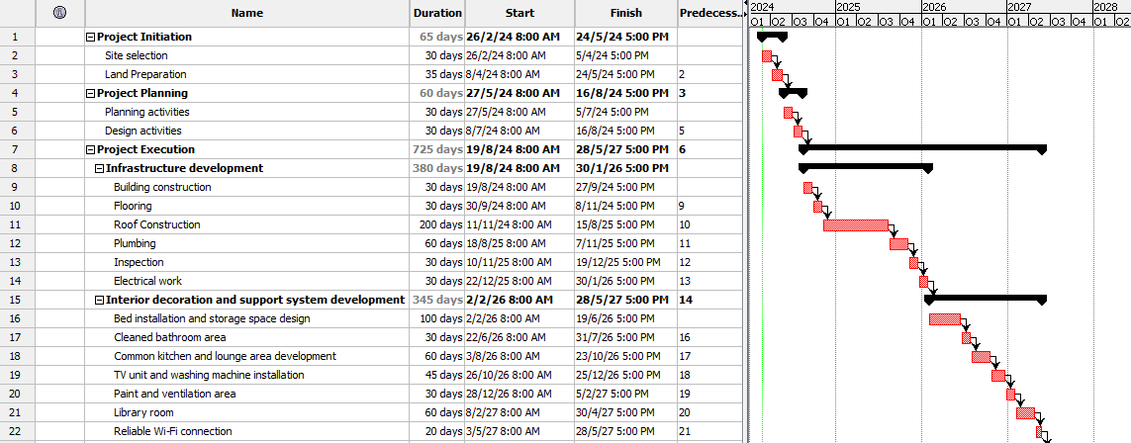
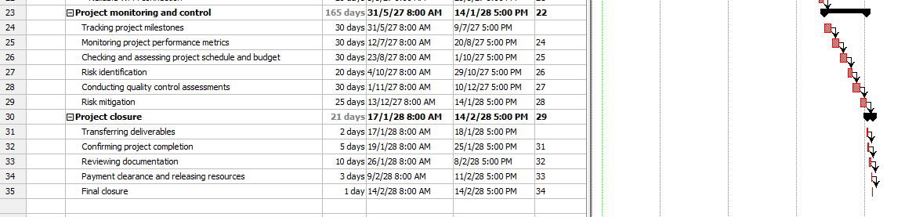
Figure 4: UWSTD hostel construction: Gantt chart
(Source: Self-developed)
The construction project will start from 26/2/2024 and will be completed on 14/2/2028 thus indicating its completion within 3 years and 2 months. Project bottlenecks can act as major hindrances preventing the successful execution of the project and its completion within time further results in exceeding project budget raising questions against project quality. Proper construction of the Gantt chart further helps project managers identify the bottlenecks during hostel construction and accordingly meet project deadlines.

Stakeholder’s involvement
Stakeholders are the crucial members during project conduction who are responsible for executing the task and ensuring its completion within scheduled time deadlines by maintaining quality. Proper communication among project stakeholders is crucial for preventing any miscommunication and execution of the allocated responsibilities for project goal attainment (Xue et al. 2020).

Stakeholders | Impact | Influence | Roles/ Responsibilities
Project Manager | High | High | Formulate strategies as per project objectives and ensure their accurate implementation for successful delivery
Employee | High | High | Responsible for executing the allocated task with greater accountability
Shareholder | High | Medium | Do not have a direct role in managing daily business operations but are required to participate in certain major decisions including budget allocation and project scope discussion.
Suppliers | Medium | High | Required to ensure on-time delivery of raw materials in the right place and maintain proper communication with project managers
Community members | High | Low | Need to cooperate with the project management team to ensure successful completion of the project on time.
Government and local authorities | Low | High | Need to Grant permission and monitor project proceedings
Table 2: Stakeholder Matrix
(Source: Self-developed)
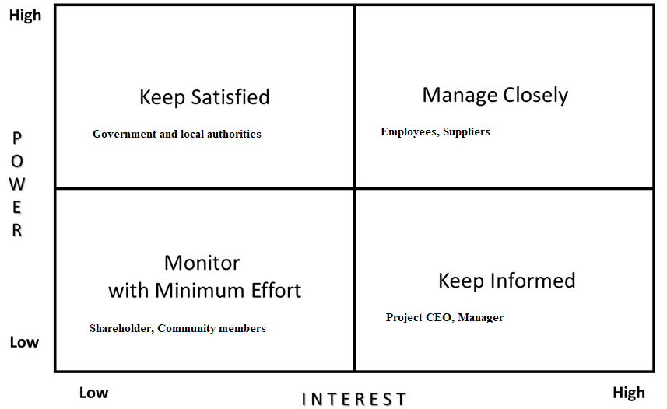
Figure 5: Stakeholder mapping
(Source: Self-developed)
Stakeholder mapping along with matrix analysis has successfully highlighted the role and responsibilities performed by the project stakeholders in ensuring its completion. The government along with local authorities is to be kept satisfied during project conduction to prevent actions are conducted as per rules and regulations (Borkowski et al. 2021). Employees and suppliers are to be closely monitored while maintaining open communication and understanding the challenges faced during task execution. Clear communication can help in resolving the issue at the earliest thorough undertaking informed decisions (Heckert et al. 2020). The project manager on the other hand is required to be kept informed about the issues encountered, activities needed to be completed and areas to be focussed upon for further improvement.

Resource Allocation
Resource allocation highlights the crucial strategies involved in assigning human, technological, and financial resources while conducting construction work. Appropriate resource allocation after detailed planning optimizes productivity through prioritizing initiatives and managing risk (Cruz Villazón et al. 2020). It also helps in cutting down additional costs and emphasizes project completion within the scheduled time.
Particulars | Budget
Site selection | £10,000
Land excavation | £20,000
Brickwork | £35,000
Designing and planning | £35,000
Roof construction | £50,000
Plumbing and electric work | £80,000
Books, Washing machine, Kitchen equipment installations | £170,000
Labour costs | £180,000
Interior decorations | £150,000
Furniture Costs | £200,000
Control | £70,000
Total | £1,000,000
Table 3: Resource allocations
(Source: Self-developed)

Risk Analysis
Project risks are the major setbacks that affect the successful completion of a project within the scheduled time. Detailed risk analysis helps in identifying the loopholes and accordingly implementing risk management strategies (George, 2020).
Risk | Status |  |  | Remedial strategies
Risk | High | Medium | Low | Remedial strategies
Financial risk- cost overrun |  |  |  | Proper conduction and analysis of the project cost and accordingly allocating financial resources.
Technical failure |  |  |  | Monitoring and checking the condition of equipment on a regular or weekly basis to ensure its proper maintenance and prevent its failure
Resource shortage |  |  |  | Proper evaluation and examining the availability of the internal pool of resources and accordingly securing resources in advance. Furthermore, monitoring resource availability regularly and contingency plan development can mitigate the resource shortage issue.
Communication issues among stakeholders |  |  |  | Maintaining open communication with internal stakeholders and identifying their problems to mitigate any communication gap
Increased employee turnover rate |  |  |  | Looking after the needs of the employees and motivating them through rewards and praises for their hard work.
Table 4: Risk analysis
(Source: Self-developed)
Risk Matrix in the context of construction projects highlights financial risk, technical failure, and labour shortage as major hurdles that could affect the successful conduction of the projects. However, it is the responsibility of the project managers to closely monitor and evaluate the situation and implement remedial actions to ensure long-term project success.

Conclusion
Successful conduction of the project required in-depth planning and implementation of strategic initiatives while encouraging collaboration among the team members for better execution of the project tasks. The study has successfully highlighted the aspects, scope, and outcome of the hostel construction of UWSTD. The project has been scheduled to be completed within two years and accordingly, the project has been initiated through conducting detailed research, identifying stakeholders, and communicating project goals to the team members. The study has elaborately discussed the activities to be undertaken for the completion of the construction work while emphasizing the role of the individual stakeholders and cost allocations. High-risk factors, for instance, financial risk, raw materials, or labour shortage can negatively affect project completion within the scheduled time. However, irrespective of the successful implementation of the project work, risk assessment and implementation of mitigation strategies can prevent the degradation of project quality. Thus, budget analysis along with the development of contingency plans can result in resolving the issues and ensure the successful fulfilment of project objectives through meeting project deliverables.

References
Book
Crawford, J.K., 2021. Project management maturity model. CRC Press.
Lock, D., 2020. Project management. Routledge.
Nicholas, J.M. and Steyn, H., 2020. Project management for engineering, business and technology. Routledge.
Pinto, J.K., 2020. Project management: achieving competitive advantage. Pearson.
Journals
Alzoubi, H.M., 2022. BIM as a tool to optimize and manage project risk management. International Journal of Mechanical Engineering, 7(1).
Borkowski, K., Borkowski, J. and Durmala, M., 2021. Construction of green hostels based on biologically renewable construction materials and natural economic media network. Ecocycles, 7(1), pp.24-33.
Burress, T. and Rowell, C.J., 2020. Project management for digital projects with collaborators beyond the library. In The Digital Humanities (pp. 166-187). Routledge.
Cruz Villazón, C., Sastoque Pinilla, L., Otegi Olaso, J.R., Toledo Gandarias, N. and López de Lacalle, N., 2020. Identification of key performance indicators in project-based organisations through the lean approach. Sustainability, 12(15), p.5977.
Denicol, J., Davies, A. and Krystallis, I., 2020. What are the causes and cures of poor megaproject performance? A systematic literature review and research agenda. Project management journal, 51(3), pp.328-345.
Errida, A. and Lotfi, B., 2021. The determinants of organizational change management success: Literature review and case study. International Journal of Engineering Business Management, 13, p.18479790211016273.
George, C., 2020. The essence of risk identification in project risk management: An overview. International Journal of Science and Research (IJSR), 9(2), pp.1553-1557.
Heckert, A., Forsythe, L.P., Carman, K.L., Frank, L., Hemphill, R., Elstad, E.A., Esmail, L. and Lesch, J.K., 2020. Researchers, patients, and other stakeholders’ perspectives on challenges to and strategies for engagement. Research Involvement and Engagement, 6(1), pp.1-18.
Stanitsas, M., Kirytopoulos, K. and Leopoulos, V., 2021. Integrating sustainability indicators into project management: The case of construction industry. Journal of Cleaner Production, 279, p.123774.
Tam, C., da Costa Moura, E.J., Oliveira, T. and Varajão, J., 2020. The factors influencing the success of on-going agile software development projects. International Journal of Project Management, 38(3), pp.165-176.
Thesing, T., Feldmann, C. and Burchardt, M., 2021. Agile versus waterfall project management: decision model for selecting the appropriate approach to a project. Procedia Computer Science, 181, pp.746-756.
Xue, J., Shen, G.Q., Yang, R.J., Wu, H., Li, X., Lin, X. and Xue, F., 2020. Mapping the knowledge domain of stakeholder perspective studies in construction projects: A bibliometric approach. International journal of project management, 38(6), pp.313-326.

