Quando me’n vo (Musetta’s Waltz):
A Case Study

Translations
When learning a song in a different language it can be difficult to get a real sense of character and what the piece is about if a performer does not take the time to conduct their own research on the character, the meaning of the lyrics and a word for word translation and how the music markings written by the composer may affect a performers interpretation of the character. In this case study I will discuss all these components and compare research to my own findings when learning the song.

When learning this song, I found it helped when learning it a section at a time but before I do that, I write a word for word translation or so I can make sense of what I’m going to be singing about. Sometimes, when you download a piece of sheet music it may come with a translation already written beneath the Italian lyrics however these translations are not always accurate and sometimes different versions of the score will have various translations for example, the sheet music of Quando me’n vo that I have translates to “As thro’ the street” (Appendix A: Photo of the score) and when looking at different translations it says “When walking alone” (Green A, 2018).

Word for word translations is the most effective way to get the translation as close to the actual meaning of the piece as possible (Polilingua, 2021). Although it may not make sense when writing the meaning of each word down separately it allows me to find a way to make it make sense while keeping the context of the song in its original language, in this case, Italian.

Characterisation
If you know the opera La Bohème then you know that the character Musetta is a very flirtatious woman, and she enjoys the attention she gets from both males and females alike whether it be jealous stares or looks of admiration (Appendix B: English translation of Quando me’n Vo). Quando me’n vo is the aria in the opera that proves just that. In all productions Quando me’n vo comes in act 2 and Musetta is seen entering a restaurant with her wealthy, elderly boyfriend Alcindoro, where she makes a scene to catch the attention of her former lover Marcello, whom she is still in love with (Metropolitan Opera, 2021).

In the 2010 Royal Opera production of La Bohème, Musetta played by Inna Dukach (IMBD, 2010) can be seen joining a group of males to play a game of pool in an attempt to make Marcello jealous, she then continues to flirt with all of the men which annoys both Alcindoro and Marcello (Alexandra Street, 2010). In the 2006 Opus Arte production Musetta can be seen climbing up onto the bar of the restaurant and singing of her popularity to again, make Marcello jealous (Alexandra Street, 2006).

Musetta has lots of confidence and she also has an air of grace and elegance about her too. When looking at the translated lyrics, it becomes very clear very quickly that Musetta is a very confident lady who knows exactly what she wants (Green A, 2018). Musetta can also been seen as having a bit of a bad temper and we can see this when Marcello doesn’t give her the attention that she craves off him (Appendix C: English Translation). Musetta is also known for her good looks, and she acknowledges that during the very beginning of the aria when she sings ‘la gente sosta e mira, e la bellezza mia tutta ricerca in me’ which translates to ‘people stop and stare and examine my beauty’ (Appendix D: Lyrics and translation).

The point here is that Musetta has something special that men are drawn to, and its important in playing the role not that you be stunningly beautiful, but that, as Musetta, you know what your gifts are and make the most of them. We don’t know from the libretto that Musetta is a great beauty. What we know for sure is that Musetta is attractive.

(Houston L, 2018)

To summarise the characterisation of Musetta, she is flirtatious, confident, elegant, graceful, temperamental, and good looking. Musetta would not be Musetta without these characteristics being portrayed by the actress.

Music Theory
This aria is written in A+B+A form (Appendix E: Quando me’n Vo score), this is also known as ‘ternary form’ which means the sections written in form A adopt the same melody and section B has a different melody (DeVoto M, 2021).

In the first 8 bars, of section A, there is a fluctuation of tempo changing from ‘quasi rit.’ to ‘a Tempo’ (Appendix F: Proof of changing tempo). ‘Quasi rit.’ means to resemble slowing down and ‘a Tempo’ means that the music/singing should return to the original speed after slowing down or accelerating (MusicTheory, 2021). The change of tempo whilst singing is a form of word painting. This change in tempo is to signify that Musetta is trying to tell Marcello she’s happy without him, in the bars when the music marking is ‘a tempo’, because she gets plenty of people looking at her without him by her side while flirting with other men to make Marcello jealous when singing at ‘quasi rit.’ tempo. This kind of tempo change also allows the actress playing Musetta to act through the song because they will be able to play with the words and their actions more as different tempo markings often help the listener/singer feel different emotions (Hevner K, 1937, p.621-630).

Section B starts with the music marking ‘sottolineando e rit.’ which means ‘pointing out and delaying’ (Appendix G: Photo of section B). Because of this music marking, Musetta starts to slow down what she is singing to really make a dig at Marcello when she sings about how much she loves to be looked at by other people and how the scent of desire makes her happy (Green A, 2018).

Section A(2) has the same music markings as the original section A, but this time they are used to signify Musetta’s frustration towards Marcello because she is not getting the reaction she craves from him (Appendix H: Section A2).

Technique
Technique is a very important factor when learning any song/aria. As a singer, you need to support your breath, have your voice placed right, have your soft palate in the right place and you must know where and how to place the notes you’re about to sing along with so many more things, but these are the things I, personally, have to focus on most when singing.

Supporting while singing is one of the most important things to do otherwise you will either not start strong enough or not have enough breath to make it through the phrase.
The purposes of 'supporting the voice' are to exercise control over the amount of air being expelled from the lungs during singing tasks and to maintain a steady flow of air (and thus create a steady singing tone).
(SingWise, 2020)
I find that I support my breath the best when I pull my abdomen inwards and upwards to take a low diaphragmatic breath (SingWise, 2020). I create the best sound I can when doing this and it helps me to place my soft palate in the right place. The phrase “smell the flowers” often helps me create the right amount of support for the beginning of the aria and allows me to sing right through the phrase however, when between the phrases there isn’t always time to take a deeper breath, so I need to take a controlled but snatched breath that gives me enough breath to get through the next phrase.

By supporting my breath, the inhalation naturally lifts the soft palate (Knoikoff Dentistry, 2022), this helps to put my voice in the right place. If I don’t support and raise my soft palate the sound that comes out doesn’t sound right and it sounds nasally.
It's really important to lift the soft palate while singing if we don't want the sound to become nasal. In fact, a low palate represents a sort of obstacle to the resonance of the voice, which, instead of channelling directly into the oral cavity alone, it also ends up in the nasal cavity. The result is a shrill and whiny tone, the loss of intelligibility, and the poor sound projection.
(Losito K, 2021)
Even though I know how to support, when it comes to singing actual lyrics of a new piece, I find that the lyrics often make me lose my support system and the sound has too much air flowing through it. To overcome this problem, I sing the melody on a vowel sound and engage my support so I can put my voice in the right place and by repeating the melody on a vowel sound I can then retain the memory of where my voice needs to be placed in order to sing the lyrics with the right support.

When practicing the higher notes, like the top C note, in this piece I think of placing the note low and grounding myself to be able to reach the note comfortably. If I try to reach up to the note, I will struggle to reach it but if I think of lowering on to the note, I can reach it with ease. This is because larynx is more stable, and the breath support is grounded and strong (Burnley R, 2017).

Learning a song/aria with the right techniques is crucial to keeping a healthy voice and to having a sustainable career. There is no ‘right technique’ that suits everyone so that is why it’s important to find what works for you.

To conclude, Quando me’n Vo is a very stylised aria and it has lots of elements to work through before singing it. Musetta is a very intricate character and that shows through both acting and the music/lyrics of this piece.

Bibliography

Aaron Green (2018), liveaboutdotcom [article]
Available at: https://www.liveabout.com/quando-men-vo-lyrics-and-text-translation-724066
(Accessed on: 15th December 2021)

Giacomo Puccini (1895), Vdocument [PDF], p. 2 - 6
Available at: https://vdocument.in/quando-men-vo-la-boheme-puccinipdf.html
(Accessed on: 15th December 2021)

Polilingua (2021), Song Translation: what to consider and which technique to choose
Available at: https://www.polilingua.com/blog/post/song-translation-what-to-consider-and-which-technique-to-choose.htm
(Accessed on; 16th December 2021)

Metropolitan Opera (2021), Synopsis: La Bohème
Available at: https://www.metopera.org/discover/synopses/la-boheme/
(Accessed on: 16th December 2021)

IMBD (2010), La Bohème
Available at: https://www.imdb.com/title/tt3440246/?ref_=vp_back
(Accessed on: 16th December 2021)

Alexandra Street (2010), La Bohème [Video]
Available at: https://video-alexanderstreet-com.ezproxy.uwtsd.ac.uk/watch/la-boheme-2?utm_campaign=Video&utm_medium=MARC&utm_source=aspresolver
(Accessed on: 17th December 2021)

Alexandra Street (2006), La Bohème [Video]
Available at: https://video-alexanderstreet-com.ezproxy.uwtsd.ac.uk/watch/la-boheme?utm_campaign=Video&utm_medium=MARC&utm_source=aspresolver
(Accessed on: 17th December 2021)

Louisa Houston (2018), singerspirit, Aria Study: Musetta’s Waltz
Available at: https://www.singerspirit.com/musettas-waltz.html
(Accessed on: 19th December 2021)

Mark DeVoto (2021), Britannica, Ternary form
Available at: https://www.britannica.com/art/ternary-form
(Accessed on: 2nd January 2022)

MusicTheory (2021), Italian Musical Terms
Available at: http://www.musictheory.org.uk/res-musical-terms/italian-musical-terms.php
(Accessed on: 2nd January 2022)

Kate Hevner (1937), ‘The Affective Value of Pitch and Tempo in Music’, The American Journal of Psychology, Vol. 49, p. 621-630
Available at: https://www-jstor-org.ezproxy.uwtsd.ac.uk/stable/1416385?seq=1#metadata_info_tab_contents
(Accessed: 2nd January 2022)

SingWise (2020), Breath Management (‘Support’ of the singing voice)
Available at: https://www.singwise.com/articles/breath-management-support-of-the-singing-voice
(Accessed on: 7th January 2022)

SingWise (2020), Correct Breathing and “Support” for Singing
Available at: https://www.singwise.com/articles/correct-breathing-and-support-for-singing
(Accessed on: 9th January 2022)

Konikoff Dentistry (2022), Understanding Mouth Anatomy: Tips for Singers
Available at: https://konikoffdental.com/understanding-mouth-anatomy-tips-for-singers/
(Accessed on: 10th January 2022)

Katia Losito (2021), Lifting the soft palate while singing: why it is important and how to do it
Available at: https://en.katialosito.com/post/lifting-the-soft-palate-while-singing-why-it-is-important-and-how-to-do-it-1
(Accessed on: 10th January 2022)

Rodger Burnley (2017), 1 Great Trick to Help You Sing High Notes [Article]
Available at: https://www.backstage.com/magazine/article/great-trick-help-sing-high-notes-5337/
(Accessed on: 12th January 2022)

Appendix

Appendix A:
Photo of the score
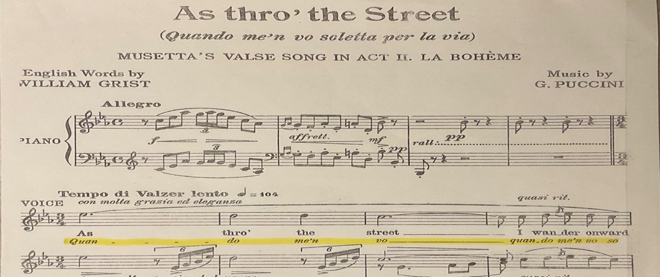

(Puccini G, 1895)

Appendix B:
English translation of Quando me’n Vo

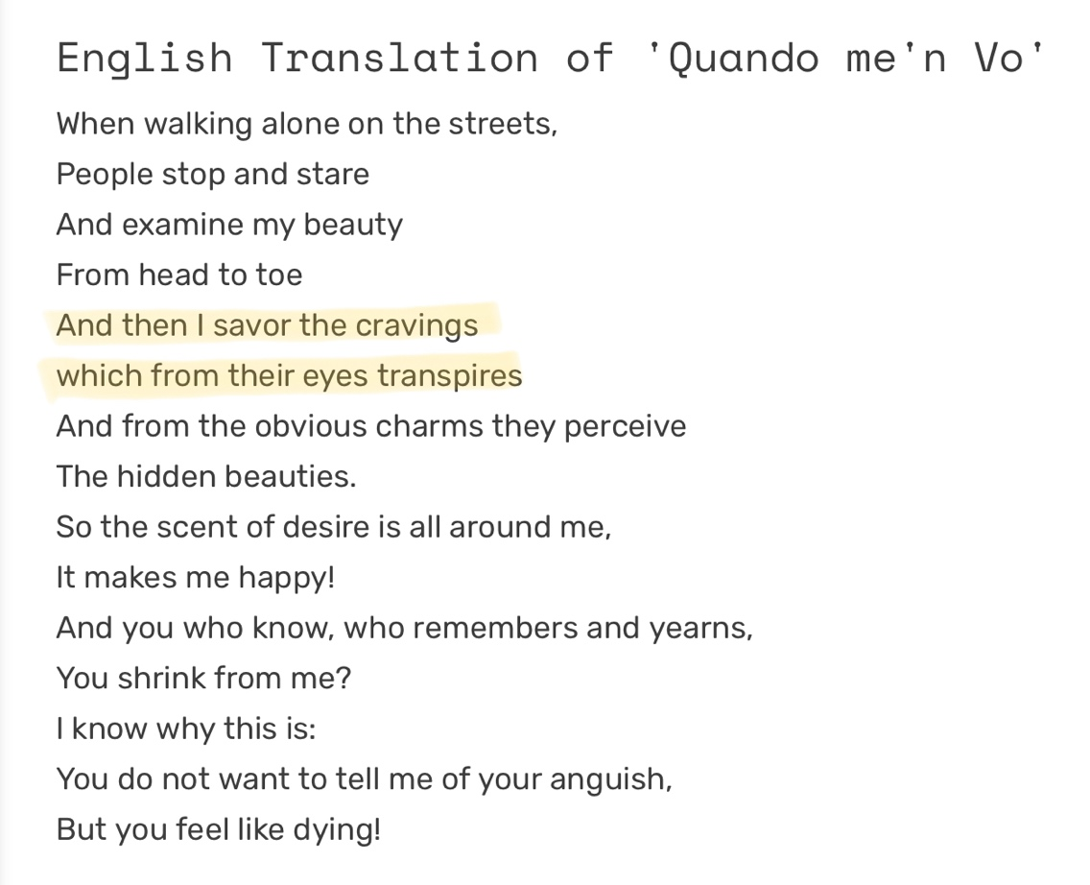

(Green A, 2018)

Appendix C:
English translation of Quando me’n Vo

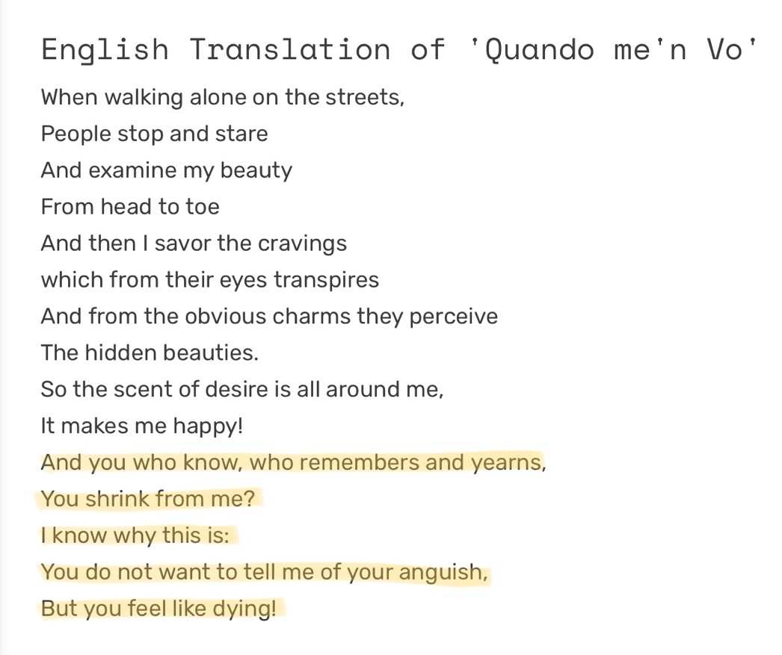

(Green A, 2018)

Appendix D:
Lyrics and translation

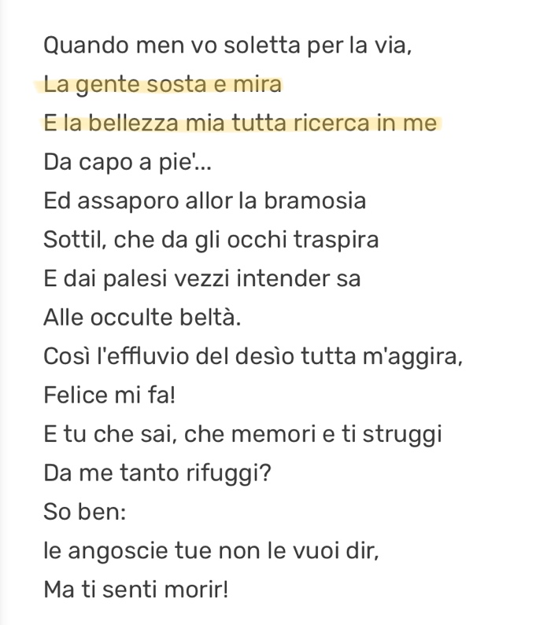
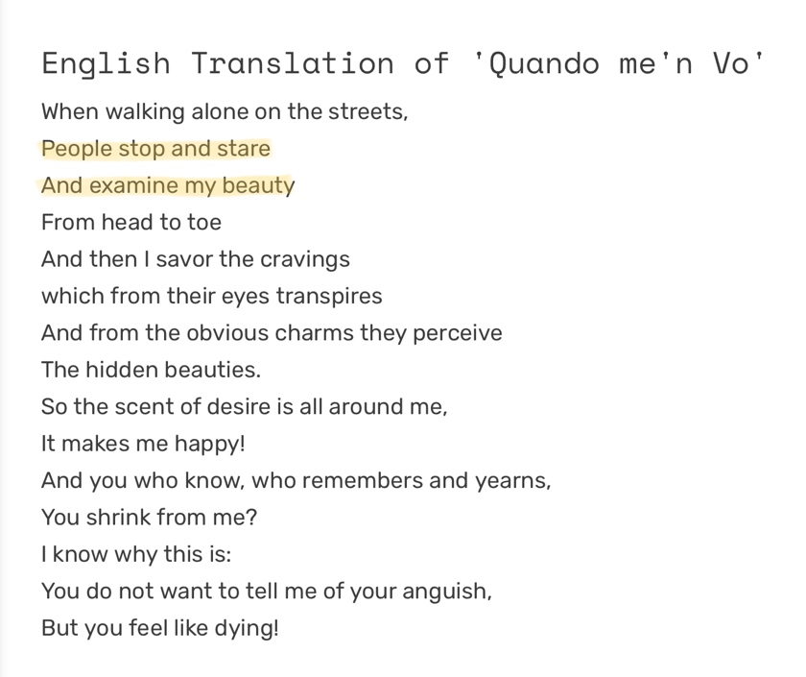

(Green A, 2018)

Appendix E:
Quando me’n Vo score
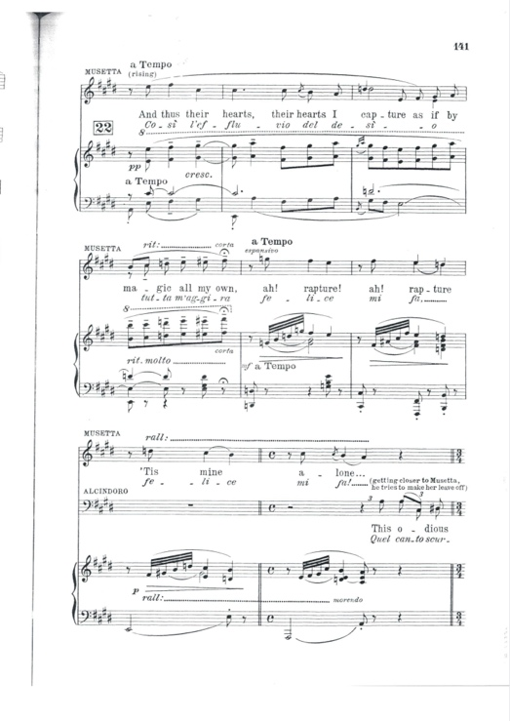
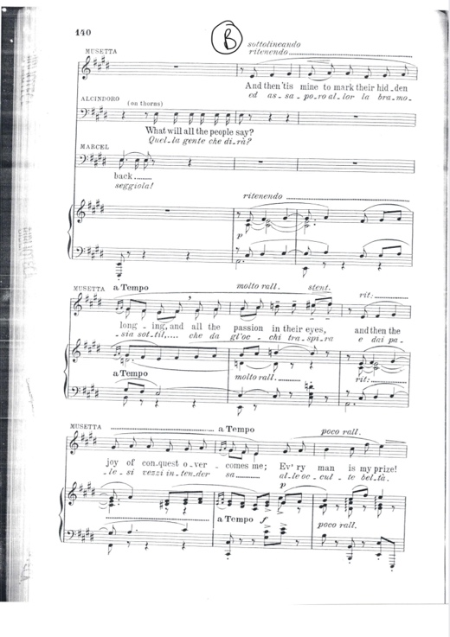
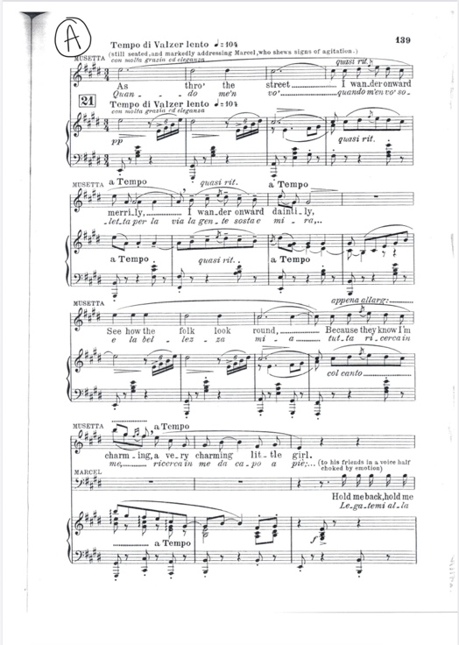

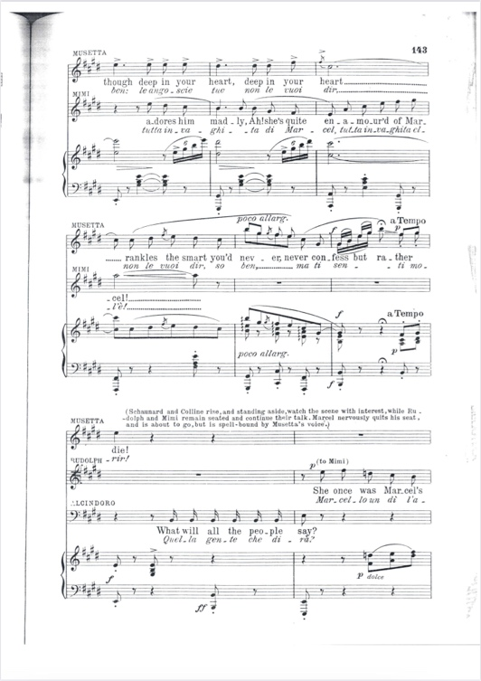
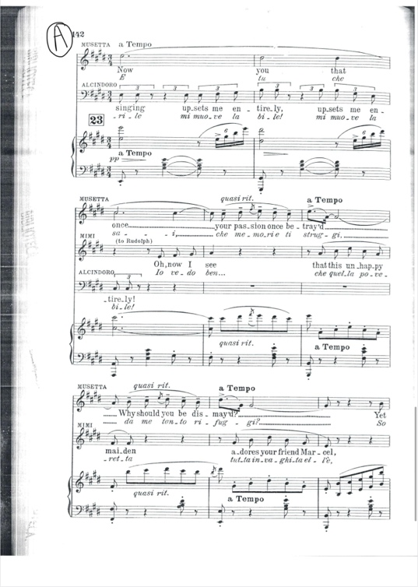
(Puccini G,1985)
Appendix F:
Proof of changing tempo

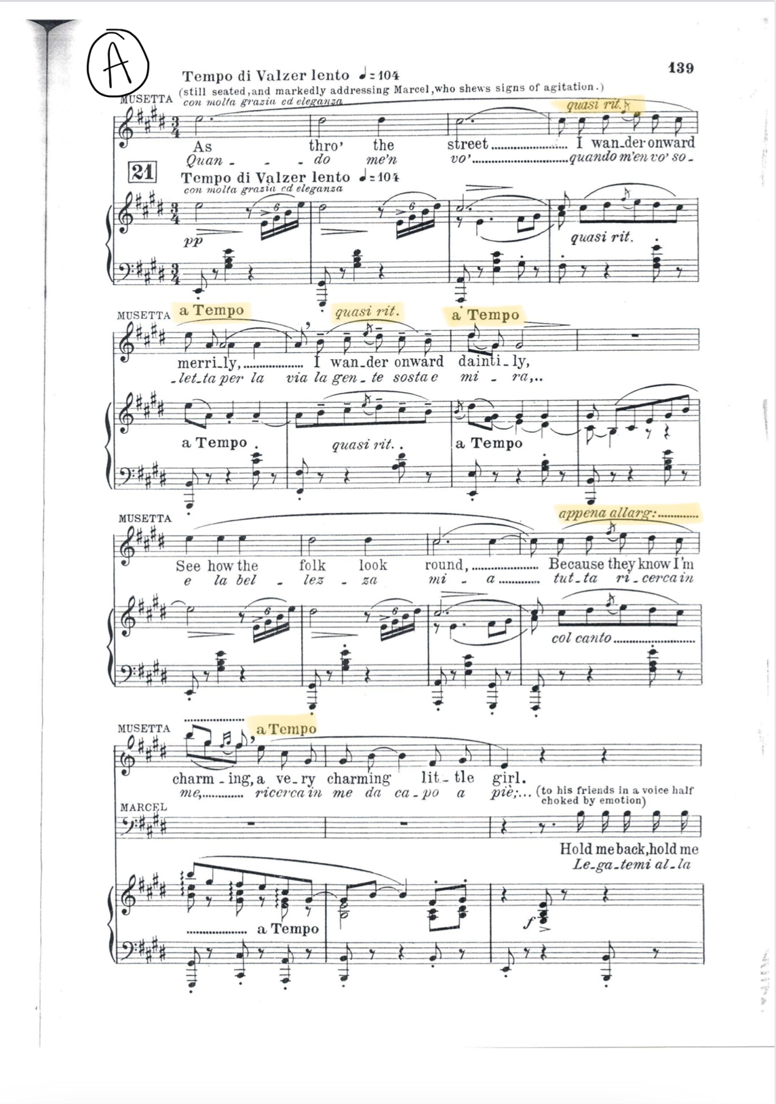

(Puccini G, 1895)

Appendix G:
Photo of section B

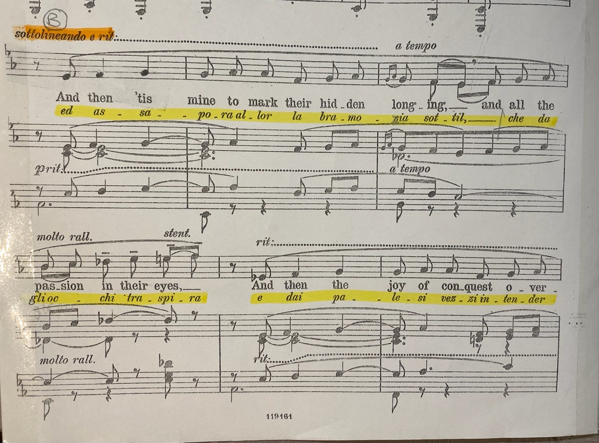

(Puccini G, 1895)

Appendix H:
Section A2

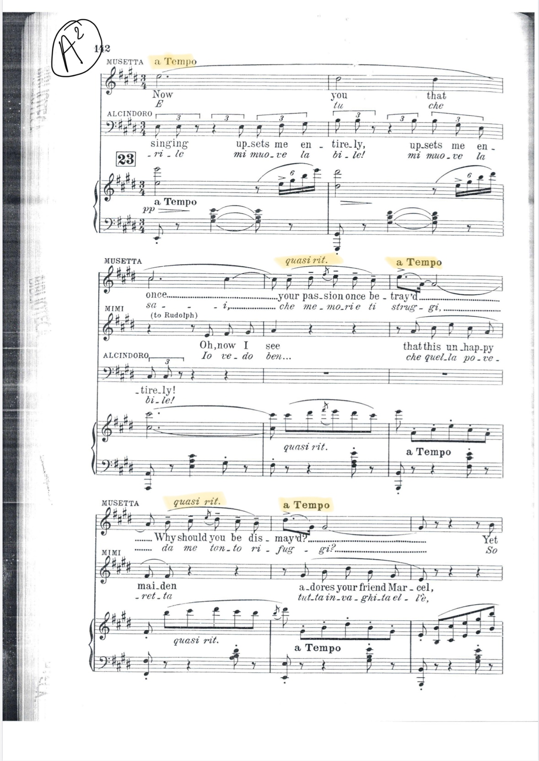

(Puccini G, 1895)

